

Discussion Paper
A new Green Wedge Management Plan for Yarra Ranges
Acknowledgement of Country
Yarra Ranges Council acknowledges the Wurundjeri and other Kulin Nation peoples as the Traditional Owners and Custodians of these lands and waterways.
We pay our respect to all Elders, past, present, and emerging, who have been, and always will be, integral to the story of our region.
We proudly share custodianship to care for Country together.

Published by Yarra Ranges Council August 2026.
This document and associated documents are available on our website.
Hard copies are available on request at any of our five Community Links. To request a copy, email or phone our Customer Service Centre using the details below:
yarraranges.vic.gov.au
mail@yarraranges.vic.gov.au
Phone: 1300 368 333
Contents
EXECUTIVE SUMMARY 5
1. INTRODUCTION 6
What is a Green Wedge Management Plan 7
Progress and Achievements Since 2010 7
Developing a new Plan 7
Purpose of the Discussion Paper 8
2. OVERVIEW of the YARRA RANGES GREEN WEDGE AREA 10
Upper Yarra Valley and Dandenong Ranges Regional Strategy Plan 13
Key Features and Values 15
Emerging Issues for a new Green Wedge Management Plan 19
3. VISION 21
4. ENVIRONMENT & BIODIVERSITY in the GREEN WEDGE 22
Achievements 23
Challenges 25
Opportunities 26
5. AGRICULTURAL VIABILITY in the GREEN WEDGE 28
Challenges 32
Opportunities 32
6. LAND USE & RURAL LIVING in the GREEN WEDGE 35
Rural Living 36
Subdivision 37
Tenements 39
7. HERITAGE & COMMUNITY in the GREEN WEDGE 42
Challenges 44
Opportunities 45
8. SUSTAINABLE TOURISM & RECREATION in the GREEN WEDGE 47
Tourism in the Green Wedge and the Planning Framework 48
Challenges 51
Opportunities 51
9. CLIMATE RESILIENCE in the GREEN WEDGE 53
Challenges 55
Opportunities 55
Have Your Say 57
APPENDIX 1 - Policy and Strategic Context 58
APPENDIX 2 – Green Wedge Zones 64

EXECUTIVE SUMMARY

The Yarra Ranges Green Wedge is a landscape of exceptional environmental, cultural and economic significance, encompassing approximately 95% of the municipality. It contains some of Victoria’s most important forests, waterways and biodiversity assets, including water catchments that supply approx. 70% of Melbourne’s drinking water. Home to the iconic Dandenong Ranges and extensive native forests, the area is often regarded as the “lungs of Melbourne” for its role in providing clean air, supporting biodiversity and maintaining vital open green space.
The area has been cared for by Aboriginal and Torres Strait Islander peoples for thousands of generations, and this ongoing connection to Country remains fundamental to its stewardship, reminding us that we are all part of the one continuing story of this land. Today, the Green Wedge continues to deliver significant environmental benefits while supporting a diverse range of land uses including agriculture, tourism, rural living, rural industry and conservation.
Balancing these often competing interests is an ongoing challenge. Protecting natural resources, biodiversity and landscape character must be carefully managed alongside changing agricultural practices, tourism growth, recreation demands and appropriate development. Yarra Ranges Council, together with Traditional Owners, public land managers and the community, play a critical role in managing these pressures and ensuring the long-term sustainability of the Green Wedge.
Under Part 3AA of the Planning and Environment Act 1987, councils within Melbourne’s Green Wedge areas are required to prepare Green Wedge Management Plans. Council’s current plan, adopted in 2010, has successfully guided planning policy, land use controls and Council programs for the past 16 years, embedding a long-term vision across a range of strategies and initiatives.
Building on this foundation, Council is developing a new Green Wedge Management Plan to guide the area over the next 15 years. The plan will take a coordinated, whole-of-Council approach that aligns existing strategies while focusing on areas where Council has the greatest influence, particularly through its planning and statutory responsibilities related to land use and development.
This discussion paper represents the first stage in developing the new plan with the community. It aims to build a shared understanding of the Green Wedge and identify key issues and opportunities, including supporting the long-term viability of agriculture, accommodating growing visitor numbers, and protecting the environmental and landscape values that underpin the region’s future.
We want to hear from all sections of the community about the future of the Yarra Ranges Green Wedge.
What do you see as the most important challenges and opportunities over the next 15 years, and how can we work together to address them?
Whether you live, work, farm, run a business, visit, or care for this landscape, your feedback will help shape the priorities, strategies and actions that guide the long-term management of this unique and valued landscape.

INTRODUCTION
Green Wedges are the rural areas of metropolitan Melbourne that lie outside the Urban Growth Boundary (UGB). They are places for agriculture, major infrastructure (airports, water treatment plants, quarries), rural living, cultural heritage, biodiversity and tourism.
In Victoria there are 12 designated green wedge areas located within 17 peri-urban local government areas. The Shire of Yarra Ranges includes most of the Yarra, Yarra Valley and Dandenong Ranges Green Wedge and a small area of the Southern Ranges Green Wedge. The Yarra, Yarra Valley and Dandenong Ranges Green Wedge is the largest of Melbourne’s 12 green wedges.

Map 1: Melbourne’s Green Wedges
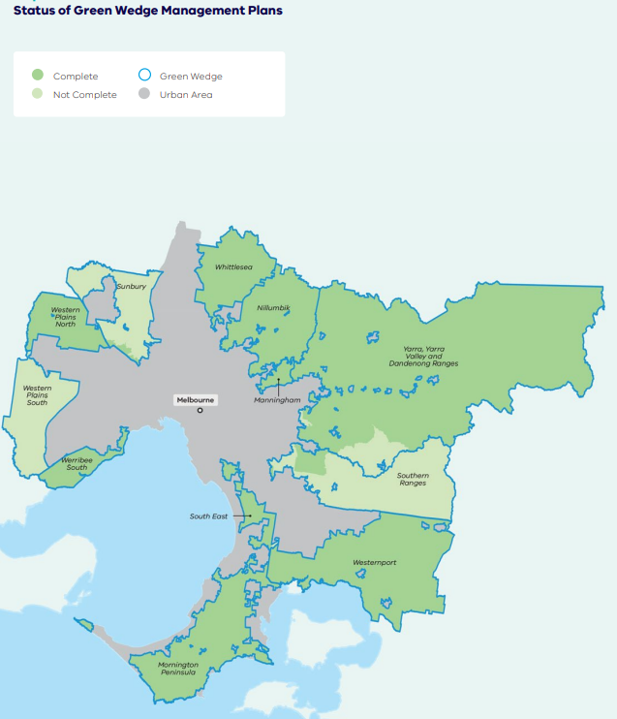
Source: Planning for Melbourne’s Green Wedges and Agricultural Land Consultation Paper, 2020

What is a Green Wedge Management Plan (GWMP)
A GWMP is a Council adopted strategy that identifies a vision, objectives and actions for the sustainable use and development of each green wedge. It enables Council and its community to clearly articulate the kinds of development or activities that are likely to be supported in the Green Wedge. All Councils within green wedges must prepare a GWMP under the Planning and Environment Act 1987.

Progress and Achievements Since 2010
Yarra Ranges current GWMP was adopted in July 2010 and has been a major strategic policy document for the rural areas for the past 16 years. The plan identified 50 actions across key themes, including climate change, fire risk, planning, agriculture, biodiversity, landscape management, tourism and leisure. Most of these actions have now been implemented, with 24 completed, 22 ongoing, and four not progressed.

Key achievements include:
- In partnership with peak industries, we advocated for changes to farm gate sales to include processed goods made substantially from produce grown on the farm, in the Planning Scheme.
- Advocating for crop protection structures (hail netting and shade structures) to be exempt from planning permits.
- Applying a new Environmental Significance Overlay to the rural areas.
- Introducing new Significant Landscape Overlays with built form requirements for the rural areas, including major tourism developments and agricultural structures.
- Updates to the planning framework in the Yarra Ranges Planning Scheme to align with the Upper Yarra and Dandenong Ranges Regional Strategy Plan.
The four items that have not progressed will be explored through the preparation of the new GWMP to determine whether they remain relevant, and if so, should be carried forward into the new Plan.

For more information see the 2010 Green Wedge Management Plan Review at https://shaping.yarraranges.vic.gov.au/
As the existing GWMP has largely been implemented, it is time to prepare a new GWMP that responds to the current challenges and opportunities and provide direction for how the Yarra Ranges Green Wedge is managed and developed over the next 15 years.

Developing a new GWMP
Project stages
Background work
- Information gathering
- Initial key stakeholder engagement
Prepare Discussion Paper
Community Consultation on the Discussion Paper *we are here
Prepare draft GWMP incorporating discussion paper feedback
Community Consultation on the draft GWMP
Final GWMP
- Prepare final GWMP incorporating feedback on draft Plan
- Council meeting to adopt

Overview of legislative and policy context - The GWMP is prepared within a statutory and strategic planning framework that extends from the Planning and Environment Act 1987 and State planning policy through to local planning schemes, as illustrated below.
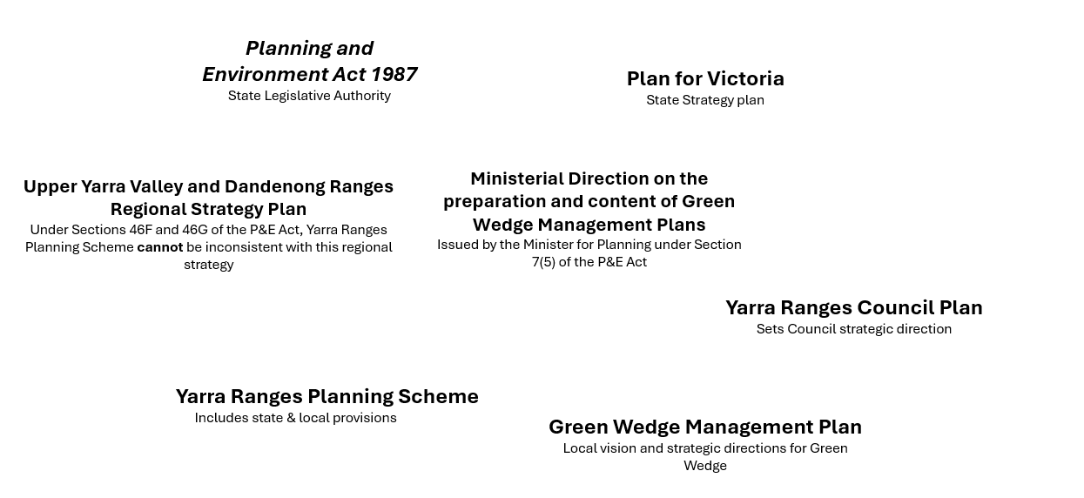
See Appendix 1 for more information on legislative and policy context.
“Green wedge land - areas in Melbourne designated for protection of the natural environment, agricultural land and significant resources from inappropriate development. This aims to preserve their environmental, economic and social values, including agricultural productivity, biodiversity and scenic landscapes.”
– Plan for Victoria, State Government, 2025

Purpose of the Discussion Paper
Council is seeking to understand the priorities of our community and stakeholders for the future of the Yarra Ranges Green Wedge. It aims to:
- Generate and collect feedback on the identified key issues and opportunities for the sustainable management of our Green Wedge.
- Inform the development of a refreshed vision and priorities for the new Green Wedge Management Plan 2027 – 2042 (GWMP 2027-2042)

Have Your Say
You can help shape the future of the Green Wedge by telling us what you feel should be the key priorities. Once all feedback has been reviewed, Council will return to the community with a draft Green Wedge Management Plan (GWMP) for further consultation. A consultation report will also be prepared, outlining how feedback from this phase has informed the development of the draft GWMP.

What can be changed/influenced? (negotiables)
- Local land use planning policy directions for the Green Wedge
- Vision for the Green Wedge
- Priorities for the Green Wedge

What can’t be changed/influenced? (non-negotiables)
While the GWMP can set local policy and directions for green wedge areas within the municipality it must operate within the overarching Victorian legislative and policy framework. It cannot override any other policies or controls set out by the State Government, including:
- Changes to the Urban Growth Boundary (UGB)
- Land uses allowed under Green Wedge Planning Zones – these are determined by State Government and Council’s role would be limited to advocacy
- Management of State and Federal Government land such as Yarra Ranges National Park, Yarra State Forest and Upper Yarra Reservoir

Towns
Townships within the UGB are not part of the Green Wedge and, as such, the GWMP will not consider or make recommendations for towns and urban areas. However, it is recognised that these townships play an important role in supporting and servicing the Green Wedge, and that strong interconnections exist between towns and their surrounding rural landscapes.

OVERVIEW of the YARRA RANGES GREEN WEDGE AREA
The Yarra Ranges Green Wedge covers approximately 95% of the municipality’s total land area. It features rich volcanic soils, extensive forest cover and relatively high rainfall. Around 70% of the Yarra Ranges Green Wedge is publicly owned and managed by state and government agencies including a large portion that was originally set aside to protect Melbourne’s water supply catchments.
The Yarra Ranges Green Wedge includes all land outside the UGB as shown on Map 2. This area encompasses both privately and publicly owned land across rural settings, including land zoned as Green Wedge, Green Wedge A, Rural Conservation, Special Use, Public Park and Recreation, Public Conservation and Resource, and Public Use.
Urban Growth Boundary
The UGB, established in 2002, is a clearly defined line that sets the limits of urban development across metropolitan Melbourne. Its purpose is to contain urban expansion and protect surrounding agricultural land and areas of environmental significance. The UGB is determined by the Victorian Government and cannot be changed by Council. Any change requires approval by a majority vote in both houses of State Parliament.
Map 2: Yarra Ranges Green Wedge
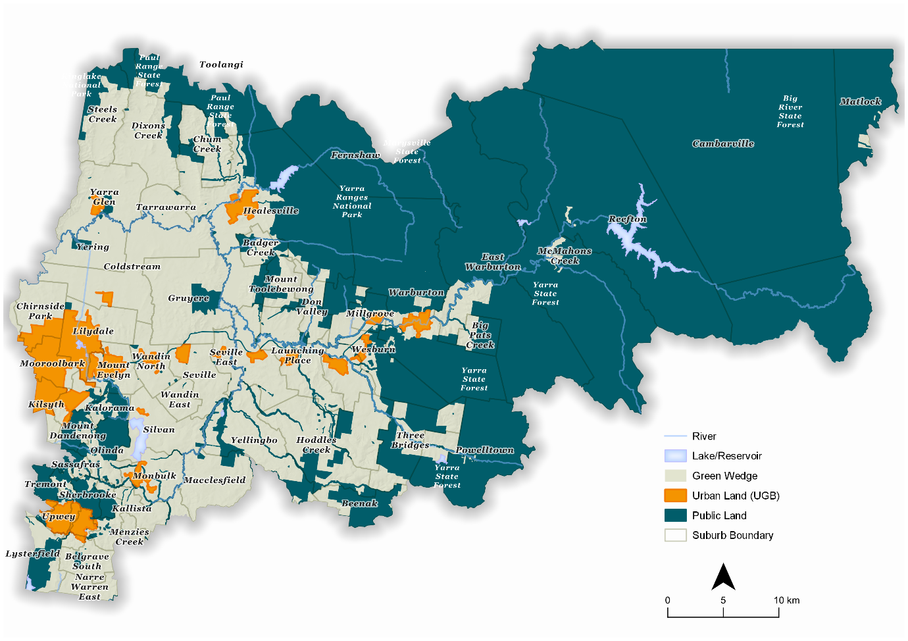

There are approximately 21,000 properties within the Yarra Ranges Green Wedge. This compares with approx. 53,900 properties within the urban areas of Yarra Ranges.
Yarra Ranges | Properties | % | Land | %
Green Wedge | 21,000 | 28.5% | 238,703 hectares | 96.7%
Urban Areas | 52,900 | 71.5% | 8,111 hectares | 3.3%

Land uses in Yarra Ranges
Land use in the municipality is dominated by conservation and rural activities, with non-agricultural uses accounting for most of the land area. Together, nature conservation and managed resource protection comprise over 62% of the municipality, reflecting the region’s extensive public land, forests and water catchments, which are located within the Green Wedge.
Agricultural uses occupy around 17% of land, largely focused on grazing modified pastures and horticulture, including both dryland and irrigated production.
Residential and other intensive uses account for a relatively small share of land, with rural residential uses (8.6%) exceeding urban residential areas (4.2%). Overall, the land use pattern highlights the Yarra Ranges’ dual role as a significant environmental asset and a productive rural landscape on Melbourne’s fringe.
Table 1: Land use summary for Yarra Ranges
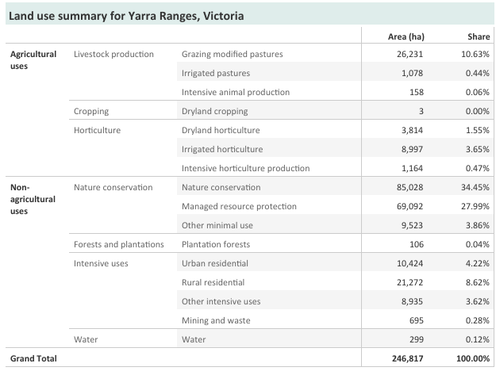
Map 3: Land uses in Yarra Ranges rearrange however works best
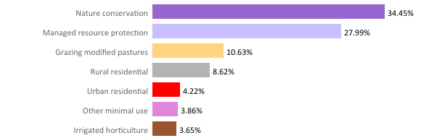

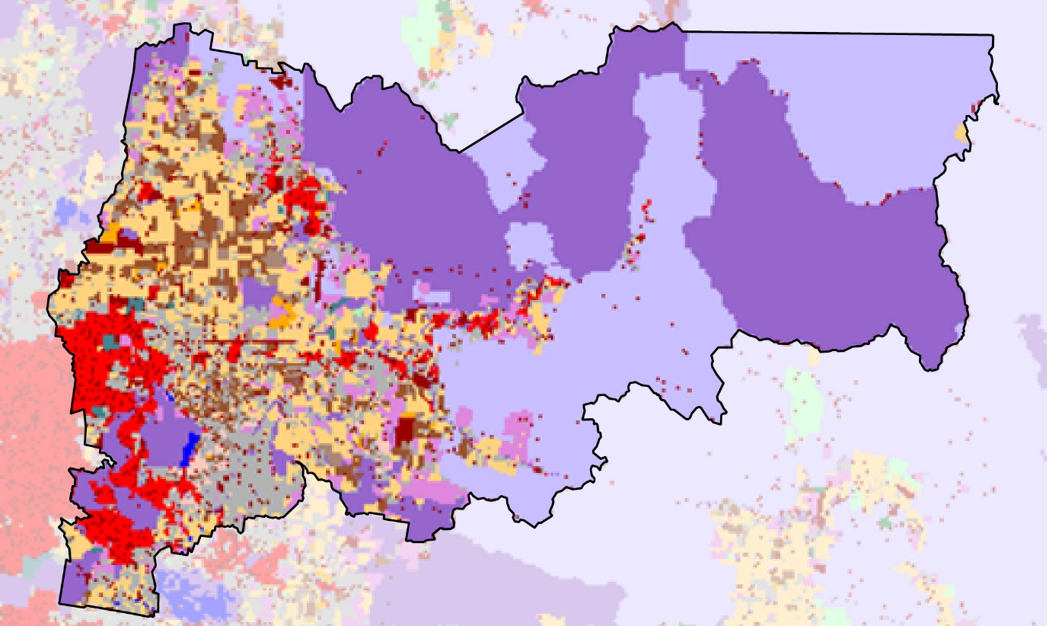

Upper Yarra Valley and Dandenong Ranges Regional Strategy Plan

A key to understanding planning in the Yarra Ranges

Prior to the introduction of planning scheme controls in the mid-late 1950s, there had been a spate of relatively uncontrolled residential subdivisions on Mt Dandenong and the surrounding foothill townships, largely because of post-war land speculation. By the 1970s, Melbourne’s expansion to the east and improved road networks increased development pressure on the area. At the same time, growing community advocacy, including the work of the Save the Dandenong’s League and the broader environmental movement, highlighted the need to protect the region’s natural values.

In response, the Upper Yarra Valley and Dandenong Ranges Regional Strategy Plan (the RSP) was introduced in 1982 by the former Upper Yarra Valley and Dandenong Ranges Regional Authority to protect the area’s distinctive character and features. Following local government amalgamations in 1994, the Authority was dissolved and the RSP became a Victorian Government policy, which remains in place today.

A Changing Planning Framework

The Regional Strategy Plan (RSP) has played a significant role in limiting subdivision and fragmentation of agricultural land. This has supported the success of horticulture, viticulture, farming and tourism industries across the region. At the time of its introduction, it was considered forward-thinking, addressing issues such as environmental and cultural values, significant landscapes, floodplain management and bushfire risk.

Since then, however, planning policy at both state and local levels has evolved considerably. Planning Schemes now include state and regional policies that reinforce the need to protect sensitive green wedges environments (clause 11.01-1R), water bodies and wetlands (clause 12.03), and significant environments and landscapes (clause 12.05). State policy also seeks to conserve and appropriately use natural resources and ensure agricultural land is managed sustainably (clause 14.01). Likewise other planning instruments have been strengthened with the inclusion of tools such as the Heritage Overlay, Significant Landscape Overlay and Bushfire Management Overlay. As a result, much of the RSP’s content is superseded by the current Planning Scheme.

Strengths and Limitations

The RSP is mainly put into effect through the Planning Scheme. The Planning and Environment Act 1987 requires the Planning Scheme be consistent with the RSP. The Planning Scheme includes a dedicated provision (Clause 51.03 Upper Yarra Valley and Dandenong Ranges Regional Strategy Plan) that ensures it aligns with RSP by addressing matters outside the scope of standard planning tools. While this helps integrate the RSP into the planning framework, it also adds complexity, reducing transparency and creating challenges for both applicants and Council planners.

Unlike the Planning Scheme, which can be updated through amendments, changes to the RSP require approval from both houses of Parliament and are less subject to change or shifts in political will. While this has helped provide long-term policy stability, it can significantly delay updates to the Planning Scheme and limit its ability to respond to emerging issues.

Looking forward

Although the intent and overall direction of the RSP remain relevant, its structure and application are outdated. A contemporary approach used elsewhere in Victoria is the designation of Distinctive Areas and Landscapes, supported by a Statement of Planning Policy, which provides a more flexible and up-to-date framework for managing areas of significant value. There is an opportunity through the adoption of the GWMP to advocate to, and work with, the State Government on updating the Regional Strategy Plan.

Key Features and Values

The Yarra Ranges landscape is shaped by millions of years of volcanic activity, tectonic uplift, and erosion, forming the dramatic ridgelines, valleys, and ecosystems we see today. Every community that has lived on, arrived at, or cared for this place has been shaped by this deep, ancient Country. Understanding geological time helps us appreciate not only the land itself, but the profound relationships between place, memory, and identity that continue to grow across generations.

Into this landscape came the Kulin Nation Peoples who walked these ranges with deep knowledge and reverence. Much of the region is Wurundjeri Woi-wurrung Country, with smaller areas of Bunurong and Taungurung land. Their songlines (oral maps of Country) traced the contours of the land over thousands of years, connecting sacred sites, seasonal food sources, and stories of creation. Every mountain, tree and stream held meaning, woven into a living culture that continues today. Each feature of the landscape speaks in the language of Country, carrying its own voice and story, echoing the deep connection between people and place.

From the 1830s, European settlers arrived in the Yarra Ranges, drawn by its fertile soils, towering forests and waterways. They brought with them agriculture, new industries, timber harvesting and tourism, reshaping the land and establishing towns and livelihoods.

Today the Green Wedge reveals a hybrid landscape, with large tracts of preserved Indigenous ecosystems alongside heavily modified and activated fields and settlements. In Yarra Ranges it delivers diverse value, providing water, agricultural land, scenic landscapes, plant and animal communities, cultural connection and an extensive range of recreational and tourism opportunities. These serve natural systems, communities and economies that stretch well beyond the municipal boundaries. The majority of the municipality’s 160,900 population value living near or within its scenic and bushland environment.

Map 4: Key Features

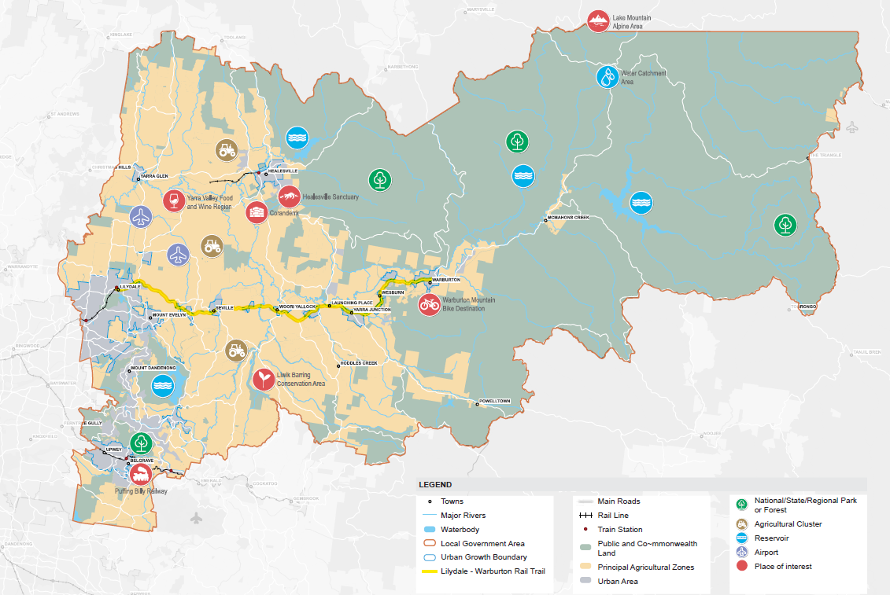

Key Features

The landscapes of Yarra Ranges include mountain ranges, valleys, waterway and forests with significant biodiversity and conservation value.

The area includes places of deep cultural significance, reflecting thousands of generations of custodianship, knowledge and cultural practice. Notable among these is Coranderrk, an Aboriginal reserve established in 1863 near Healesville, which remains an important site in the history of Aboriginal self-determination and cultural resilience in Victoria.

The environmental assets of the Yarra Ranges Green Wedge are embodied in the Dandenong Ranges and Yarra Ranges national parks, Pauls Range and Yarra state forests, Kurth Kiln Regional Park, and the Liwik Barring Conservation Area (Yellingbo). The region also contains areas of modified rural landscapes, such as cultivated croplands and rolling pastures.

The Yarra Ranges Green Wedge contains state significant waterways, water catchments and storage areas, including around 54% of the Birrarung (Yarra River). These landscapes hold deep cultural significance for Traditional Owners and continue to support important ecological, recreational and community values.

The Upper Yarra, Silvan, Maroondah and O’Shannassy reservoirs provide over 70% of Melbourne’s drinking water and are renowned for both their vital water supply function but also for their loved recreational and natural offerings.
This aspect of the Green Wedge is not always well understood and elevates the water catchments and storage facilities in this region as regionally significant assets and critical for liveability across greater Melbourne.

Agricultural produce from the region comprises flowers and nursery plants, berries and orchard fruits including the classic Monbulk Jams, wine grapes and wineries that are internationally famous, as well as beef and grain. The region holds a range of cultural values, with a visitor economy that is based on its quality local wine and food, artisanal farmers and makers markets, bed and breakfast accommodation, environmental walks, parklands and river corridors, cycling and horse-riding trails, and major tourist destinations of Healesville Sanctuary and the recently launched Warburton Bike Park.

The development of the railway network has also played an important role in shaping the landscape and settlement patterns of the Yarra Ranges. Heritage railway operations, including Puffing Billy Railway and the Yarra Valley Railway, continue to celebrate the region's rail history and attract visitors. Former railway corridors have also found new life as recreational trails, such as the Lilydale-Warburton Rail Trail, which has become a significant tourism and active recreation asset.

There are two airports and four quarries currently operating within the Yarra Ranges Green Wedge. These uses are supported by State planning policy that recognises the importance of green wedges in the provision of state and regional infrastructure, which includes airports and quarries, as well as waste and resource recovery centres, water treatment and energy facilities. These facilities provide important services for the population and are vital to the ongoing functioning of the city and state.

Community Values

To understand what our community values, we reviewed findings from recent Council-wide surveys. While these surveys were not specifically focused on the Green Wedge, they provide valuable insights into the qualities and characteristics that residents value most in Yarra Ranges.
These surveys found that residents highly value safety, access to the natural environment, and a strong sense of community. Residents also reported positive lived experiences in each of these areas, with similar results across both urban and rural communities.
Access to the natural environment is a defining aspect of liveability in Yarra Ranges. With the Dandenong Ranges, Yarra Ranges National Park, and expansive green spaces, residents enjoy a wealth of natural amenities. Younger residents place even greater importance on this attribute than older residents with around 69% of people aged 18–34 identifying it as important, compared with 62% of those aged 35–59 and 53% of those aged 60 and over. This highlights the ongoing importance of environmental access for future generations.

Table 2 below summarises what our green wedge communities identified as the top five things Yarra Ranges should retain, highlighting the key attributes and values that are considered most important. These results indicate a strong and consistent community priority to protect environmental values and green spaces, maintain the region’s rural character, and balance infrastructure improvements with careful management of development.

Figure1. What’s Valued in our Green Wedge Areas

Area | Top five things Yarra Ranges should keep
Hills | 1. Parks, green spaces preservation  2. Protecting the environment, bush regeneration and land management  3. Small community feel and character/beauty  4. Maintenance/upgrade of roads and trails  5. Regulation around development (mixed views)
Healesville–Yarra Glen | 1. Parks, green spaces preservation  2. Maintenance/upgrade of roads and trails  3. Small community feel and character/beauty  4. Regulation around development (mixed views)  5. Local economy
Yarra Valley | 1. Parks, green spaces preservation  2. Small community feel and character/beauty  3. More/upgraded public amenity  4. Transparency and accountability in Council  5. Protecting the environment, bush regeneration and land management

Emerging Issues for a new Green Wedge Management Plan

In 2025, Council undertook consultation with key community, industry, and advisory groups to help inform this Discussion Paper.
Through this engagement, we heard that the Green Wedge is facing a range of challenges. Long-standing planning objectives to support agriculture and preserve environmental values are being challenged by changing economic conditions, climate change and its impacts, and evolving community expectations. This creates an opportunity to take a fresh, forward-looking approach to how we plan for and care for this important region.

The following challenges and opportunities were identified:

- Climate Change impacts are making it harder to manage land and maintain agricultural production, with the region experiencing more extreme weather events, including droughts, floods, and increased bushfire risk.

- Environmental health and biodiversity are under pressure from pest animals, inadequate weed management, soil dumping and unmanaged land, which can reduce habitat quality and increase biosecurity risks.

- There is an opportunity to embed Traditional Owner knowledge and perspectives, and ways of knowing, being and doing into the management of the Green Wedge, including Caring for Country practices, recognition of cultural landscapes and the integration of Traditional ecological knowledge.

- Visitor numbers are expected to keep growing which may place pressure on the landscape and local amenity, highlighting the need for careful management. At the same time, limited accommodation, infrastructure constraints (including roads), and planning controls can make it difficult to support sustainable tourism growth. There is also a risk that poorly located or designed dispersed tourism uses, particularly short-term accommodation, could impact rural character.

- Agriculture faces several challenges towards its ongoing sustainability, including declining profitability, rising land values, and high entry costs for new farmers. An increasing number of lifestyle residents in rural areas can also create land use conflicts, while regulatory pressures, water security concerns, and limited seasonal worker accommodation are further constraining operations. At the same time, farmers are adapting and responding to climate change impacts and market demands through new technologies and farming practices which can mitigate losses yet often require additional infrastructure and capital.

Many of these challenges are not limited to Yarra Ranges. The State have identified the following issues for Melbourne’s green wedge and peri urban areas:
- increasing land speculation and pressure to convert farmland to other uses
- increasing appetite for rural lifestyles and use of these areas for a range of urban activities
- incremental and irreversible loss of land that is agriculturally productive or has important nonurban uses
- more land use conflicts, particularly where urban areas adjoin rural areas.

These challenges are discussed in more detail under the Key Themes in this paper.

Agricultural viability underpins multiple Green Wedge outcomes
Feedback from industry groups highlights that agriculture is often seen as more than just an economic activity, rather it is foundational to the Green Wedge’s landscape character, scenic amenity, tourism appeal, regional identity, environmental stewardship, and local food production. As the viability of traditional agriculture declines, these interconnected values and benefits are also at risk, highlighting the important role farming plays in shaping, evolving and sustaining the broader landscape.

VISION
The long-standing recognition of the Yarra Ranges Green Wedge has delivered clear benefits to the region. It has provided planning certainty, limited land speculation, and reduced development pressures experienced in other green wedge areas. It has also helped attract and retain a community that values the area’s unique environmental and rural qualities.
A clearly defined and shared long-term vision is critical to ensuring the Yarra Ranges Green Wedge continues to be valued and protected into the future.
The Yarra Ranges Green Wedge supports a diverse range of activities, including rural living, agriculture, tourism, water catchments, national parks, and state forests. A strong vision should recognise and balance these elements, which together underpin the Green Wedge’s importance as a valued asset for both the local community and greater Melbourne.
The 2010 GWMP set out the following vision for the Green Wedge:
The Yarra Ranges community will encourage and support sustainable farming, a healthy biodiversity, and valued landscapes in its Green Wedge. These are the primary green wedge values and are what make it attractive for other activities such as tourism, recreation, and rural living. Council will work with the community and other stakeholders to protect and enhance these primary values. Other activities will only be accommodated if they positively contribute to the primary values.
Does the 2010 Vision still describe the future you want for the Yarra Ranges Green Wedge? Why or why not?
What changes, additions, or priorities would you like to see included in the updated Vision?

ENVIRONMENT & BIODIVERSITY in the GREEN WEDGE
Our Green Wedge supports some of the most significant environmental areas in Victoria. These include the iconic Mountain Ash forests of the Dandenong Ranges and Central Victorian Highlands. These expansive forests nurture rich wildlife while absorbing and storing immense amounts of carbon.

The layers of native vegetation in these areas are home to an abundance of iconic species such as the Powerful Owl, the Helmeted Honeyeater and Leadbeater’s Possum. Our municipality supports 188,000 hectares of native vegetation and is home to at least 1790 native flora and 968 native fauna species.

The upper half of the Birrarung and its tributaries support a diverse range of plants and animals including significant populations of platypus, frogs and fish. These waterways and key water reservoirs such as O’Shannassy, Upper Yarra, Maroondah and Silvan, provide about 70% of Melbourne’s drinking water.

The natural environment, including scenic rural valleys and forested mountains are features which draw many people to live, work and visit our Green Wedge area.

The new Green Wedge Management Plan will align with and support the delivery of Council’s key environmental strategies, ensuring a coordinated and consistent approach to environmental planning and management.

Council’s key environmental strategies include:
- Climate and Environment Strategy 2026-2036 (under development)
- Nature Plan 2024-2034
- Community Waste and Resource Recovery Plan 2023-2030
- Integrated Water Management Plan 2017

Partnerships are key
Of the total area of Yarra Ranges, 2% is owned by Council, 30% is in private ownership and the remaining 68% is Crown land. Council’s own land management practices are limited to this 2%, which includes management of roadsides and Council-owned bushland reserves. However, in its role as responsible planning authority, and through partnerships with Crown land managers such as Parks Victoria, Melbourne Water, Department of Energy, Environment and Climate Action, Council can advocate for and have influence over flora and fauna protection, habitat management, restoration and enhancement.
Local volunteer groups are also important partners for Council. Landcare, environmental groups and friends of specific reserves significantly broaden the amount and variety of environmental work being undertaken across the municipality. These groups, along with Council, promote environmental responsibility and provide opportunities for residents to be involved in local initiatives.

Achievements
Since 2010, Council has made strong and consistent progress in improving environmental outcomes, delivering a wide range of initiatives focused on protection, restoration and sustainable development. These efforts have led to real benefits, including improved habitat condition, expanded environmental programs, and stronger community involvement. Council also recognises that this work is ongoing. It requires continued effort, adaptive approaches and long-term investment to build on these achievements and secure lasting outcomes for the future.
More than $18 million in external grant funding has supported key projects focused on resilience, biodiversity, water and energy. This includes flagship initiatives such as the Biochar Facility and the Yering Billabongs Restoration.
Of this, $6 million was provided by the Federal Government in 2022 which funded the Resilient Yarra Ranges program to reduce disaster risk and strengthen community resilience to fires, floods, storms and landslides.
These grants have helped deliver projects aimed at environmental conservation, improving biodiversity, and promoting more sustainable practices.
“Partnerships are critical – most significant outcomes were achieved through regional and local collaboration” Yarra Ranges Environment Strategy 2015-2025 Evaluation Report
Flagship projects
The following projects showcase Council’s approach to sustainability in the Yarra Ranges Green Wedge. Their impacts range from tangible environmental outcomes, such as carbon sequestration, water savings, biodiversity gains, to less tangible but equally critical outcomes such as community empowerment and cultural recognition.
The projects are dependent on partnerships, and many have also benefitted from external funding to facilitate the project.
Biochar Facility (2023–ongoing): a facility that converts organic waste into biochar, a carbon-rich, soil-enhancing product.
Yering Billabongs Restoration (2020-2025): ecological restoration of the Yering Billabongs, a key wetland habitat.
Biodiversity Offset Program (2012 – ongoing): by securing and managing offset sites, Council ensures no net loss of biodiversity while also creating long-term ecological value.
Ribbons of Green (2008–ongoing): one of the longest-running programs, it provides seedlings, technical advice, and coordination to restore landscapes across the municipality.
Weed Wipe-out Voucher Program (2015 – ongoing) – the program has expanded considerably over the decade and includes just under 800 participants in 2024/25. Weed control is vital to preserving the natural character of forests, waterways, and agricultural lands, as invasive species pose a significant threat to biodiversity.
A Decade of Environmental Outcomes
Council has recently assessed environmental outcomes across the municipality drawing on multiple data sources, highlighting positive progress in the areas outlined below.

Protection of Native Plants, Animals, and Habitat Enhancement
Overall, the data reflects significant investment in protecting biodiversity, enhancing habitat, and addressing major threats such as invasive species and vegetation loss. While pressures from land use change and weeds remain, there has been steady progress in conserving native plants and animals and improving habitat quality.
While Council has a vital role to play, this responsibility is shared with other agencies, in particular DEECA, which are the primary lead in biodiversity conservation.

Invasive Species Management
Weed control is essential for protecting forests, waterways, and agricultural land, as invasive species are the second largest threat to biodiversity after land clearing. Since 2010, Council’s ongoing weed management program has reduced high-threat weeds through targeted action at high-conservation-value sites and collaboration with key partners, including the Department of Environment, Energy and Climate Action, Melbourne Water, and environmental volunteers.
There have also been significant advances in the efforts to control increasing deer populations which pose major threats to native flora and fauna. The State Funded local program has expanded to cover 30,000 hectares of land by 2024/25, with 335 deer controlled annually in recent years. Partner programs have extended this impact. This large-scale response shows a coordinated approach that reduces browsing pressure on vegetation and protects native ecosystems from degradation.

Revegetation and Habitat Expansion
Revegetation efforts with plants of local provenance and selected for the respective habitat type have been substantial. The Ribbons of Green program planted over 70,000 plants in 2024/25, more than doubling outputs compared to 2015/16 and more than 500,000 over the decade.
Our Bushland Reserves recorded over 105,000 plantings in 2024/25, further contributing to biodiversity restoration. Together, these programs significantly expand habitat corridors, strengthen ecological resilience, and provide resources for native animals, including pollinators and birds.

Wildlife Support
Direct measures to support wildlife habitat are evident through the installation of nest boxes and artificial hollows which grew from 96 to 288 over four years to 2025. These provide crucial shelter for hollow-dependent species, offsetting storm damage from 2021 and the slow natural formation of tree hollows. Cultural and ecological burns, though only recently initiated, mark another step toward restoring habitat dynamics that many native species rely upon.

Riparian and Habitat Restoration
Riparian vegetation plays an important role in protecting the health of waterways by acting as a natural buffer. Available data is limited, with only two data points and no information recorded after 2018/19.
However, these data points show a significant increase in high-quality riparian vegetation in the Yarra Catchment, rising from 245 hectares in 2015/16 to 1,477 hectares in 2018/19.
This expansion signifies substantial investment in habitat restoration and a direct contribution to improved water quality and ecological resilience. However, the lack of recent data, along with limited information on billabong and wetland rehabilitation, makes it difficult to draw firm conclusions about ongoing trends.

Community Support
From 2015–2016, four sustainability workshops were delivered annually, but in later years these evolved into more targeted events such as “Farming Solutions for a Changing Climate,” “Healthy Horses, Healthy Land,” and pest preparedness workshops. Council, in partnership with others, has also delivered two ‘’Managing Your Rural Property’’ conferences in 2019 and 2026, supporting rural landholders to manage their properties sustainably and productively, with a focus on regenerative agriculture and land management. These programs not only encouraged sustainable land management but also provided landholders and small business operators with practical skills to adapt to changing environmental and economic conditions.

Challenges
Despite the achievements above, the following issues/challenges still face the Green Wedge and its long-term sustainability.

Climate change & extreme events
Current climate projections indicate more frequent and intense wildfires, storms, floods and extreme heat. These changes, along with shifting rainfall patterns, can lead to local species loss and broader ecosystem decline.

Habitat loss & fragmentation
Housing, farming and road construction are changing the landscape and fragmenting natural habitats, leaving wildlife in smaller, isolated areas.
When habitats are no longer connected, many species struggle to spread into new areas or mix with other groups. Over time, this reduces genetic diversity, which can make populations less resilient and increase the risk of long-term decline.

Invasive species, disease & pathogens
Invasive weeds, pest plants and animals, along with disease, can harm both farming and the natural environment. They displace native species, damage land, pollute waterways, reduce the food, and shelter available for wildlife.
The impacts of pest animals vary, rabbits and feral cats are a major problem, with deer becoming a more prominent issue in recent years. Diseases and pathogens can also impact plant health, with consequences for both agriculture and biodiversity.
Further challenges remain including declining water quality in our rivers and creeks, increased incidences of dumped rubbish, and unregulated removal of native vegetation.
Dumping of Soil/Fill in Green Wedge Areas
An increasing issue in Yarra Ranges is the large volumes of soil and fill material being dumped in the Green Wedge as a biproduct of construction and development. This material can include building waste, and when it is not properly regulated, it can harm the environment and local communities. Potential impacts include water pollution, changes to natural water flows, loss of habitat, contamination of land, degraded soils and reduced agricultural productivity. The transport of this material also brings a high number of heavy truck movements, which can damage rural roads, import weeds and disease, and create safety and amenity concerns for residents.
This issue is occurring across many metropolitan and peri-urban areas. While councils are working to manage it, enforcement can be challenging due to limited resources. Council has strongly advocated for greater State Government action, and although recent State Government planning initiatives, such as the ability for Councils to introduce a permit trigger for earthworks of more than 100 m³ of fill, are a positive step, they do not fully address the complexity of the issue. Yarra Ranges considers a more comprehensive approach is needed, including the development of clear guidelines which addresses the impact of soil dumping on surface and ground water movement, flooding, erosion, spread of weeds, contamination, traffic and amenity. Clearer guidelines would also assist where landowners seek to modify slopes for agricultural use.

Opportunities
Building on Council’s existing work in this area, a range of opportunities and priority actions have already been identified and supported in Council adopted strategies. Opportunities exist to strengthen biodiversity, improve landscape resilience, reconnect habitat, support sustainable land management and foster community stewardship of the Green Wedge’s natural environment.
Council’s Nature Plan 2024–2034 sets out four targeted strategies that apply to the Green Wedge:
- Landscapes and Ecosystems: understanding local biodiversity enhances resilience and connectivity, enabling ecosystems to flourish.
- Land Use and Changing Climate: best practice land management through integrated planning and stewardship.
- Pest Plants and Animals: managing pest plants and animals to reduce their impacts
- People and Nature: empowering community to connect with culture and nature.
Key steps identified include:
- Development and implementation of a Council Biolinks Plan. This will be a roadmap for the re-connection of habitat through the Yarra Ranges landscape.
- Expanding biodiversity extension programs and providing the community access to education, advice, support and incentives to get involved.
- Collecting detailed information on vegetation removal (illegal and legal) to inform progress towards goals)
- Monitoring programs to ensure environmental decisions are evidence based and adaptive.
- Embedding indigenous cultural practices into how we manage the natural environment.
Another action is to use information from a range of sources, including Council’s own monitoring programs, to inform possible updates to environmental planning overlays in the Planning Scheme.

What further environmental opportunities could be explored in the new GWMP?

Case Study: Ribbons of Green

One of Council’s longest-running programs, Ribbons of Green supports private
landholders, Landcare groups, and Melbourne Water to revegetate land with indigenous
species. It provides seedlings, technical advice, and coordination to restore landscapes
across the municipality. Impacts include:
- Scale: since 2008, millions of plants have been established, creating extensive corridors for wildlife.
- Carbon storage: new vegetation contributes to Council’s emission reduction targets by sequestering carbon.
- Erosion control: planting stabilises soils, reducing land degradation and protecting waterways.
- Community ownership: by empowering landholders, the program embeds biodiversity outcomes across both public and private land.

Ribbons of Green is recognised as a flagship community-environment partnership with
enduring benefits for biodiversity and climate.

AGRICULTURAL VIABILITY in the GREEN WEDGE
Farming and land management are a vital part of the identity of the Yarra Ranges Green Wedge’s economy and food system. A combination of mild climate, high and well distributed rainfall and a variety of good soils have made the region well suited to a diverse range of farming activities, supporting vegetable, fruit, grapes and wine, floriculture, nursery and livestock production.
Agricultural production in Yarra Ranges has an estimated total value of $400 million, with agricultural land comprising approximately 17% of the municipality. It is characterised by high yields per hectare from predominantly small farming businesses. While most farms are under 20 hectares, Yarra Ranges is a major component of Melbourne’s food bowl. The Yarra Valley is a major Victorian producer of strawberries, blackberries, blueberries, raspberries, apples, pears, cherries and grapes. In addition to producing a diverse range of food, Yarra Ranges is a key producer of nursery products and cut flowers.
Table 3 below summarises the leading agricultural sectors by sales value alongside the most common farm types by count in the region.
Table 3: Agricultural Sales & Farm Types in Yarra Ranges
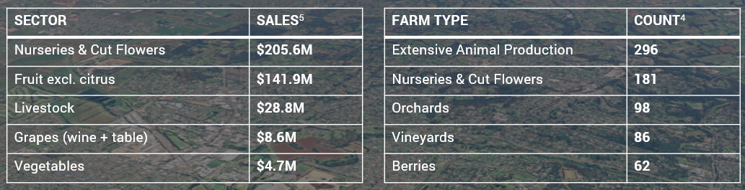
*Extensive Animal Production refers to broadacre farming, typically sheep, beef cattle and grain farming.
As shown in the chart below, the value of agricultural production in the Yarra Ranges reflects a distinctive profile, with strong contributions from horticulture and nursery production relative to Victoria.
Figure 2: Value of Agricultural Production 2020/21

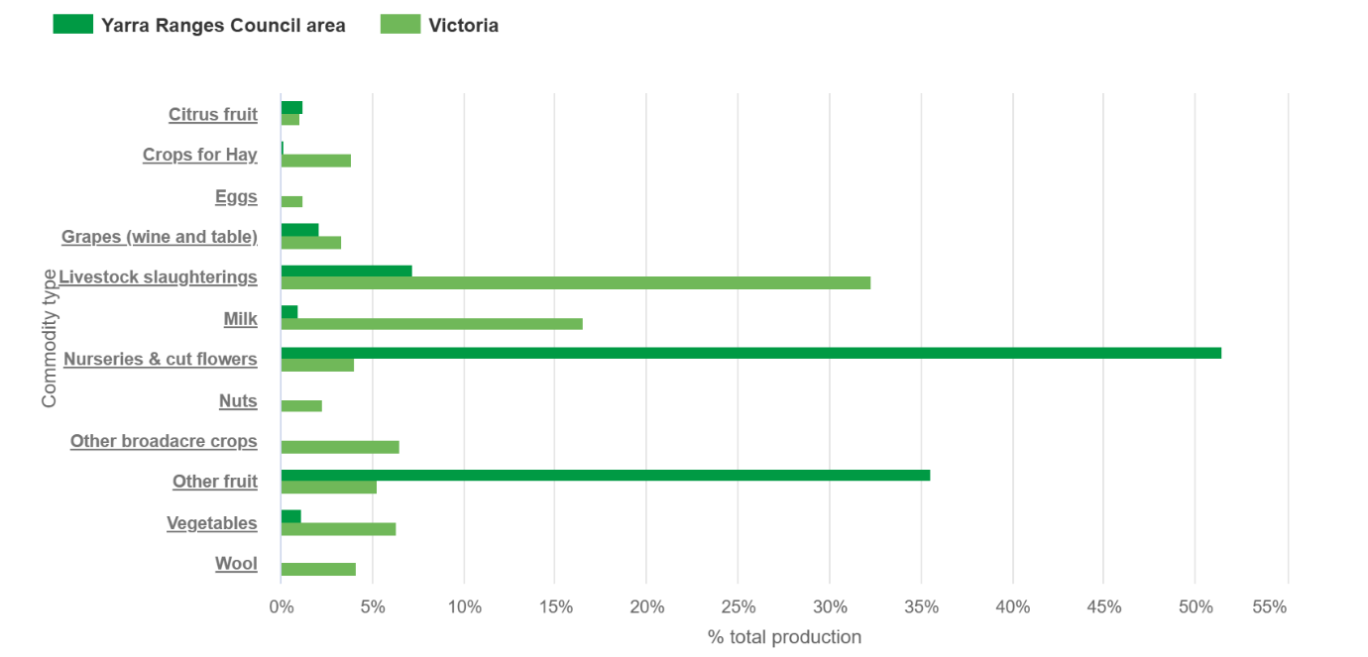

Declining agriculture
While the total value of agricultural production has increased over the past decade, other indicators show the agricultural sector in the Yarra Ranges is under ongoing pressure. These trends are evident in declining agricultural land use, employment, and the number of active farming properties, and are also reflected in feedback from local farmers and industry representatives.
Between 2006 and 2016, total agricultural land in the Yarra Ranges declined by 22%, falling from approximately 65,500 hectares to 51,000 hectares. Over the same period, the number of properties claiming the farm rate has steadily decreased, from 2,069 properties in 2010 to 1,526 in 2026, representing a 26% decline. More than 70% of these farm-rate properties are small holdings of less than 20 hectares.
Employment in agriculture has also fallen, decreasing from 2,531 jobs in 2016 to 1,920 jobs in 2023. The decline in grazing on modified pastures is of particular concern, as this land use plays an important role in maintaining the Yarra Ranges Green Wedge’s valued rural landscape character, sense of openness and environmental management.
Table 4: Total agricultural land use change in Yarra Ranges 2006 -2017
Year | 2006-07  (000s) | 2008-09 | 2010-11 | 2012-13 | 2014-15 | 2016-17
Area | 65.5ha | 66.9 | 68.1 | 39.4 | 47.4 | 51.0

A changing Agricultural landscape
While overall agricultural activity in the Green Wedge is declining, it is also becoming increasingly diverse. Over the past 15 years, agriculture in the Yarra Ranges has shifted toward higher-value horticulture and niche production. Traditional broadacre and grazing activities have declined, while industries such as nurseries, cut flowers, orchards, and viticulture have expanded. This is reflected in recent data showing that nursery production and cut flowers now account for over half of the total value of agricultural output in the municipality, with other horticulture (including fruit) also making up a significant share.
At the same time, the Yarra Valley has continued to consolidate its role as a leading wine-producing region, with ongoing innovation in grape growing and a strong link to tourism, cellar doors, and the visitor economy. These shifts reflect a broader move toward intensive, market-driven agriculture that can operate viably on smaller landholdings close to Melbourne.
Alongside this, structural and land-use changes have altered traditional farming patterns. Many agricultural sectors are experiencing ongoing cost-price pressures, with rising costs, workforce challenges and industry consolidation driving structural changes in land-use. In the case of forestry, government-led phase-out policies are also reshaping local economies, creating both challenges and new opportunities for communities linked to the sector.
More broadly, the expansion of lifestyle properties and rural-residential living has increased competition for land, contributing to fragmentation and reducing the availability of large, contiguous farming areas. This has encouraged a shift toward smaller-scale, boutique, or part-time farming enterprises, often integrated with tourism or direct-to-consumer sales. Taken together, these trends show a transition from traditional production agriculture toward a more mixed rural economy, combining commercial horticulture, agritourism, and lifestyle land use, which presents both opportunities and challenges for the long-term sustainability of farming in the Yarra Ranges, including land use planning conflicts.
While agriculture in Yarra Ranges is identified as having strong natural competitive advantages, growth has not kept up with other industries. Agribusiness is identified as one of the five top opportunity sectors in Councils Economic Development Strategy 2022-2032.

In 2020/21, the total value of agricultural output in Yarra Ranges Council area was $400 million. The largest commodity produced was Nurseries & cut flowers, which accounted for 51.5% of Yarra Ranges Council area’s total agricultural output in value terms

Seasonal worker accommodation
In Yarra Ranges, the limited availability of affordable worker accommodation presents a significant challenge for agricultural businesses, reducing their ability to attract and retain both permanent and seasonal workers. While seasonal worker accommodation can be provided in the Green Wedge Zones, it is subject to a range of restrictions, including requirements that it be used in conjunction with an approved rural land use, such as agriculture, and be located on a lot that meets the minimum subdivision area requirement (or is at least 40 hectares where no minimum is specified).
This contrasts with the Farming Zone, where rural worker accommodation for up to ten workers can be provided without a planning permit. Recognising these constraints, Yarra Ranges has consistently advocated, and will continue to advocate, to the State Government for changes to the planning scheme to allow permit exemptions in green wedge areas, similar to the Farming Zone, in order to introduce greater flexibility for seasonal workers accommodation.

What is the ‘right to farm’
As farming and residential areas increasingly exist side by side, conflicts can arise when neighbouring land uses are incompatible. Farming activities can generate noise, dust, odours and traffic from normal operations such as using farm machinery, moving livestock and applying fertilisers or chemicals. While these activities are a normal part of agricultural production, they can lead to complaints from nearby residents.
The ‘right to farm’ is the principle that farmers should be able to carry out lawful agricultural activities without unreasonable interference from neighbouring landowners or new residents. This issue is particularly relevant in peri-urban areas such as Melbourne’s Green Wedge, where people are attracted to the rural lifestyle but may be less familiar with the impacts of living near working farms.
There are different approaches to protecting farming operations and reducing land-use conflict. One approach is through legislation that specifically protects farming activities. Another is through the planning system, which can help avoid conflicts by ensuring that new development is appropriately located and designed. Measures such as buffer distances between farms and sensitive uses, and the ‘agent of change’ principle, are commonly used to manage these issues.
What is the ‘agent of change’ principle?
The agent of change principle places responsibility for managing potential impacts on the person or organisation introducing a new use into an established area. In the case of farming, this means that if a new sensitive use, such as housing, is developed near an existing farm, the developer or landowner is responsible for addressing potential impacts such as noise, dust and odour, rather than the farmer having to change their lawful operations.
In practice, this encourages new development to be designed in a way that recognises and accommodates the existing farming environment, helping to reduce future conflicts between farmers and residents.
The Victorian Government has recently implemented planning scheme changes to strengthen policy protections for productive agricultural land and manage land use conflict in rural agricultural zones, including green wedge.

Challenges
The Green Wedge's agricultural sector is facing a range of pressures and emerging challenges that will need to be addressed to support its long-term sustainability and resilience. These include:
- Declining agricultural viability due to rising costs, market pressures, and reduced profitability
- High land costs make it increasingly difficult for new entrants to establish themselves in agriculture
- Ongoing land use conflict between farming activities and tourism businesses, and residential expectations
- Increasing frequency and severity of climate-related events, including drought, flood, and bushfire, and the arrival of climate change impacts which will continue to escalate in severity over the coming decade
- Persistent water security challenges impacting both productivity and long-term planning
- Growing pest and disease risks, raising biosecurity concerns
- Pressures on biodiversity and pollination systems essential for agricultural production
- Fragmentation of agricultural land into smaller, less viable parcels

Land Fragmentation
In the context of agriculture, land fragmentation occurs when farmland is broken up by other uses over time. In areas affected by land fragmentation, farmers sometimes undertake agricultural production across multiple, disconnected properties, which can be a barrier to efficiency and productivity. It also increases the potential for land use conflicts between farming activities and residential expectations.

Opportunities
Looking ahead, there are several opportunities to strengthen and future-proof agricultural uses in the Yarra Ranges Green Wedge by supporting innovation, adaptation and land stewardship. These might include:
- Supporting new and emerging farming practices
- Support and facilitate the transition of food production to the more resilient vertical farming, greenhouses and protected cropping which can endure climate variability and the increasing impacts of climate change recognising that these practices are likely to additional built form and infrastructure.
- Support the growth of regenerative and small-scale farming enterprises that contribute to local food production, environmental outcomes, healthier soils and rural livelihoods.
- Consider new policies that support the modernisation of existing rural industries and land uses, including the adoption of emerging technologies such as drones and automated parking.
- Consider if specific areas should be identified and planned for more intensive agricultural activities.
- Continued advocacy for permit exemptions in green wedge areas to support of seasonal workers accommodation
- Exploring ways to support agricultural businesses to value-add and diversify.

Agribusiness Yarra Valley
Agribusiness Yarra Valley plays an important role in supporting sustainable land management across rural areas of the Yarra Valley. The organisation works closely with local farmers, landowners, and industry groups to promote best-practice agricultural methods. This includes providing advice and information on soil health, water management, farm planning, pest control, as well as encouraging environmentally responsible practices such as reducing chemical use and improving biodiversity on farms. They undertake a range of initiatives, including supporting the seasonal workforce and helping Yarra Valley farmers improve crop resilience to climate change and weather extremes through better soil, water, and biodiversity management. Agribusiness Yarra Valley also supports local producers through networking opportunities, training, and advocacy, helping to strengthen the regional agricultural economy.
This work is supported through a mix of funding sources, including contributions from State Government, Melbourne Water, Yarra Ranges Council, as well as partnerships with industry and other stakeholders.

The Upper Yarra Development Strategy
In 2022, Yarra Ranges Council was successful in applying to State Government to host a Local Development Strategy project for the Upper Yarra, with a focus on the communities of Yarra Junction, Warburton and Powelltown.
The purpose of the Local Development Strategy is to assist communities directly affected by the Victorian Forestry Plan to develop a local development strategy that supports their transition from commercial native timber harvesting, leading to the creation of new jobs in sustainable industries, and resulting in long-term economic and social benefits for each community. The preparation of the Local Development Strategy has been locally led and undertaken in partnership with key stakeholders
Part of this work focuses on strengthening and showcasing the Upper Yarra’s local food system through a range of initiatives, including scoping a proposal for a small-scale multi-species micro-abattoir.
This initiative aims to support local farmers by reducing the need to transport livestock over long distances, improving animal welfare and strengthen the local food production system.

How can we support and strengthen agriculture in the Green Wedge to ensure it remains productive, resilient, and sustainable into the future?

Case Study:

The Mornington Peninsula Food Economy and Agroecology Strategy 2022-2028 provides a useful case study for Yarra Ranges in demonstrating how a Green Wedge municipality can support agricultural productivity, strengthen local food systems and improve environmental outcomes through a coordinated strategic framework.
Developed in response to the economic importance of the region's $1.3 billion agriculture, food and beverage sector, the strategy integrates economic development, climate resilience, biodiversity enhancement and regenerative farming practices within a single vision for the future of rural land use.
Key initiatives include strengthening regional food branding, supporting producers to adopt sustainable farming practices, facilitating industry collaboration through a dedicated taskforce, and building local food supply chains and market opportunities.
Importantly, the strategy complements the municipality's Green Wedge planning framework by recognising agriculture as both an economic driver and a key contributor to landscape and environmental values.
A similar approach in Yarra Ranges could help support farm viability, promote local food production, encourage regenerative land management practices, and strengthen the role of the Green Wedge as a productive and sustainable rural landscape.
Case Study:
The Tatura SmartFarm in Victoria's Goulburn Valley provides a case study for how innovation, research and technology can support the long-term productivity and sustainability of agriculture. Operated by Agriculture Victoria, the SmartFarm is one of a network of SmartFarms supporting delivery of the Future Ready Agriculture: A Research and Innovation Strategy 2026-30 and brings together industry, researchers and government to trial and demonstrate new farming practices, climate adaptation measures, irrigation technologies, pest management approaches and orchard production systems.
Research is focused on helping growers improve productivity, profitability and resilience while using natural resources more efficiently and adapting to changing climate conditions. The facility also demonstrates the benefits of knowledge sharing and on-farm innovation through field days, demonstrations and collaborative research projects

LAND USE & RURAL LIVING in the GREEN WEDGE
Land use, development and subdivision in the Yarra Ranges Green Wedge is guided primarily by the three main rural zones:

Zone | Description
Rural Conservation Zone | a conservation zone that caters for rural areas with special environmental characteristics
Green Wedge Zone | a zone that provides for all agricultural uses and limits non-rural uses to those that either support agriculture or tourism, or that are essential for urban development but cannot locate in urban areas for amenity or other reasons
Green Wedge A Zone | a zone that provides for all agricultural uses and limits non-rural uses to those that support agriculture, tourism, schools, major infrastructure and rural living

The Rural Zones in Yarra Ranges have been applied to implement the directions of the Regional Strategy Plan (discussed on page 13). Planning zones regulate what uses are allowed, as well the development (built form) on the land. Depending on the type of activity and the zone that applies, some uses can occur without a planning permit, some require a planning permit and assessment by Council, and others are prohibited. Similarly, buildings and works often require a planning permit to ensure they are appropriately designed and located, and that impacts on environmental, landscape and agricultural values are carefully considered.
Traditional rural zones, such as the Farming Zone, generally allow a wider range of farming activities without the need for planning permits, however there is very little Farming Zone in Yarra Ranges. Instead, within Green Wedge areas, permits are often required to manage amenity considerations associated with agriculture uses. This can create challenges for agricultural operators in Yarra Ranges.

Refer to Appendix 2 for more information on the uses in each zone.
Use vs Development: What is the Difference?
The Planning Scheme sets controls for the use and development of land.
- Use = what happens on the land
- Development = what is built or changed on the land
A planning permit may be required for the use, the development, or both, depending on the zone and overlays that apply. For example, converting a house to a hotel is a change of use, while building an extension for more rooms is development.

Map 5: Rural Zones in Yarra Ranges
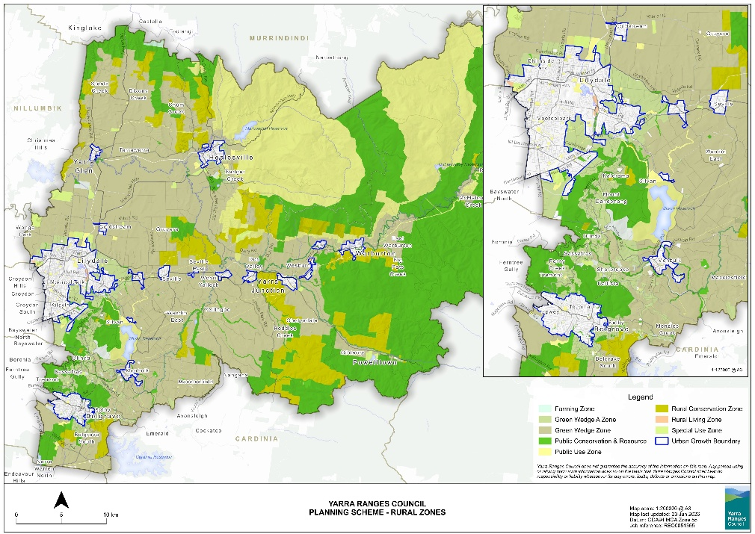

Rural Living
People choose to live in the Green Wedge for a range of reasons, including the peaceful rural lifestyle, larger properties, opportunities for small-scale farming, and a close connection to nature while remaining within reach of metropolitan Melbourne.
Living in the Green Wedge has historically been enabled by many thousands of small lot rural subdivisions that were mostly created before the introduction of effective planning controls. These subdivisions have resulted in the widespread dispersal of rural residential properties throughout the Green Wedge. Many intermingle with larger properties managed for productive agricultural use. This situation has led to conflicts between farmers and the expectations of those seeking a rural residential lifestyle. Other rural residential subdivisions are concentrated in highly fire prone and environmentally sensitive locations such as the Dandenong Ranges and the upper reaches of the Yarra Valley.
In recognition of these challenges, the introduction of strict subdivision controls based on the Regional Strategy Plan has largely curtailed the creation of new residential subdivisions.
While dwellings remain a permitted use in the Green Wedges zones, Council policy seeks to manage the impacts of development on biodiversity, environmental and landscape values and to protect productive agricultural land from inappropriate residential development that may create conflicts between farming and rural residential activities. As a result, applicants are often required to demonstrate how a proposed dwelling will support agricultural use of the land, with farm management plans commonly requested through the permit process.

Subdivision
Subdivision within the Yarra Ranges Green Wedge is a contested issue, attracting a wide diversity of views within the community and among stakeholders. On one hand, some landowners seek greater flexibility to subdivide land to facilitate additional housing opportunities, diversify income streams, or enable small-scale business uses aligned with changing economic conditions. On the other, many advocate strongly for the retention of larger rural land parcels to protect agricultural viability, landscape character, and the environmental values that underpin the Green Wedge’s purpose.
Subdivision controls in the Yarra Ranges Green Wedge are primarily guided by state government zoning, which sets the overarching rules about how land can be used and developed. These zones, such as Green Wedge Zone, Green Wedge A Zone and Rural Conservation Zone are designed to protect non-urban land from inappropriate subdivision and development. At the local level, Councils can apply zone “schedules” that sit under these state government zones. These schedules can include local variations including the minimum subdivision area that must be achieved. In Yarra Ranges the subdivision provisions are a direct translation from the RSP.
The minimum subdivision size varies for each local schedule to the zone is shown below.
Rural Zone | Minimum subdivision area  (except as provided for clause 51.03 – RSP)
 | Minimum (hectares) | Average  (hectares) | Maximum  (hectares)
Green Wedge - 1 | 6 | 8 | 14
Green Wedge - 2 | 12 | 16 | 28
Green Wedge - 3 | 15 | 20 | 35
Green Wedge - 4 | 18 | 25 | 44
Green Wedge - 5 | 30 | 40 | 70
Green Wedge - 6 | 40 | 50 | 60
Green Wedge A - 1 | 1 | 2 | 3
Green Wedge A - 2 | 3 | 4 | 7
Rural Conservation –1 | 30 | 40 | 50
Rural Conservation –2 | 40 | 50 | 60
Rural Conservation –3 | 50 | 60 | 70

These controls are fundamentally about managing growth and protecting what makes the Green Wedge special. They aim to prevent the gradual breakup of rural land into smaller lifestyle lots that can undermine farming, damage environmental values, and increase pressure for urban-style services. In practical terms, this means subdivision is often limited or carefully assessed to ensure it supports long-term land use rather than short-term development gain, helping preserve the area’s rural character and environmental health for future generations.

Unique and Complex Subdivision Controls
Subdivision controls in the Yarra Ranges Green Wedge are unusual compared to most other parts of Victoria because they not only include minimum lot sizes, but also maximum and average lot size requirements. This approach creates complexity and has at times resulted in unintended outcomes, including subdivision patterns that technically meet the numeric controls but do not support the broader strategic intent of protecting agriculture and landscape values. The use of average and maximum lot size controls also departs from the standard format of Victorian planning schemes, which rely on minimum lot sizes, making the provisions harder to interpret and administer.

Legislative Constraints on Green Wedge Subdivision

Any change to green wedge subdivision controls in Victoria is subject to a particularly high level of scrutiny, reflecting the importance of protecting these areas. Under the Planning and Environment Act 1987, any planning scheme amendment that would increase subdivision potential must be ratified by the Parliament of Victoria, ensuring local councils cannot make ad hoc changes to green wedge areas. For Yarra Ranges there is a further requirement as the Planning Scheme must remain consistent with the RSP meaning any change to subdivision controls also requires amendments to the RSP, which also requires Parliamentary approval. While this framework provides a robust layer of protection, it also introduces rigidity, making it difficult to update planning controls, such as removing the maximum lot size, without a complex and lengthy approval process.

Old and Inappropriate Subdivisions
As early as the 1920s, some land in the Yarra Ranges was subdivided for residential development without a full understanding of important environmental constraints such as steep terrain, bushfire risk, significant vegetation, and landslip. As a result, many areas were divided into lots that provided for a much higher level of development than is appropriate or safe.
To address these inappropriate subdivisions, restructure controls have been applied in Yarra Ranges since the mid 1970’s. These controls have successfully limited new development in highly constrained areas. Today, these areas are covered by a Restructure Overlay, which requires smaller lots to be combined into larger, more suitable parcels before a dwelling can be built.
Over time, many lots have already been consolidated or restructured, making the Overlay redundant. By progressively removing the overlay where consolidation has been achieved the number of properties in the Restructure Overlay has decreased from 2,845 properties in July 2000 to approx. 1,120 properties today. This figure includes 272 properties in the Ben Cairn Estate in Don Valley.

Historic subdivision of Ben Cairn Estate
The Ben Cairn Estate is a large subdivision in Don Valley that was first approved in 1923. It comprises 272 lots; however, development did not begin until the early 1970s. The estate is in an area affected by significant environmental constraints, including bushfire risk, landslip susceptibility, and substantial native vegetation.
Development within the estate ceased in 1975 following the introduction of restructure controls under the former Upper Yarra Planning Scheme. By that time, only 16 houses had been constructed.
Today, these controls are reflected in the Yarra Ranges Planning Scheme through the Restructure Overlay (RO81). This overlay requires all 272 lots within the estate to be consolidated into a single lot. As a result of the Restructure Overlay, no new buildings -including houses - can be constructed on any lot within the estate. It also means that if an existing building is damaged or destroyed, there is no automatic planning entitlement to rebuild.
Following the 2009 Black Saturday bushfires and the subsequent Bushfires Royal Commission, Council advocated to the State Government for a land buyback program for the Ben Cairn Estate; however, this proposal was not supported.
Given the large number of individual landowners and the presence of existing dwellings, achieving the intended lot consolidation is difficult. Identifying a suitable long-term outcome is also challenging due to the complex pattern of land ownership and the range of environmental risks affecting the site.
The Restructure Overlay continues to generate enquiries from landowners and prospective purchasers. Council is committed to working with landowners to explore potential future options for the estate. However, any outcome must carefully balance land use planning objectives with the need to manage significant environmental hazards. Investigations into the future of the Ben Cairn Estate remain part of Council’s long term strategic planning program.

Tenements
Tenement controls in Victoria have historically been used to limit development and rectify a legacy of inappropriate subdivisions. A tenement is a landholding (a group of contiguous lots, parcels of land or Crown Allotments) held in single ownership. Tenement controls work by restricting development to one dwelling per tenement (or specified land size within a tenement). Tenement controls have been used in Yarra Ranges for decades; they form part of the RSP and are one of several historic initiatives used to rectify a legacy of old and inappropriate subdivision.
However, they present complications for property purchasers as tenements are not mapped anywhere in the Planning Scheme and therefore do not appear on a Planning Property Report. As a result, a property owner may not be aware of the tenement and its limitations until they seek a Planning Permit for a dwelling.
Dwellings on tenement holdings were prohibited until the early 1990s when the RSP was amended to allow Council discretion to approve permits for dwellings on tenement lots. However, they must still form part of Council’s assessment of applications for a rural dwelling in prescribed areas. This ambiguity makes decision making difficult for Council, and despite efforts by Council over the years the administration of tenements can be complex, difficult to manage and lack transparency in the planning system.

The challenge with Dwellings in the Green Wedge
Dwellings (houses) are a permitted land use within the Green Wedge Zone, with land use provisions set by the State Government. However, not all vacant lots within the zone are suitable for residential development, and a planning permit is required to establish a dwelling on rural land. There are many considerations in assessing such applications, including whether the dwelling is genuinely associated with and supportive of agricultural use on the land. A key challenge is that this justification is made at a single point in time. While a dwelling may be approved to support an agricultural activity initially, over time that activity may decline or become unviable. The dwelling, however, still remains a permanent feature, effectively resulting in a shift to ‘Residential’ becoming the primary land use and undermining the intent of the Zone. The construction of a dwelling on a rural lot can therefore informally transition the land from a purely agricultural use to a higher-value residential or lifestyle asset.
Small Second Dwellings and Tiny Homes –
Small Second Dwellings (SSDs) and tiny homes present both opportunities and challenges in the Yarra Ranges Green Wedge. They can provide more affordable and flexible housing options for family members, farm workers and older residents wishing to age in place, while helping to address housing shortages in rural areas. However, there are concerns that an increase in small dwellings could result in incremental residential intensification, undermine the non-urban character of the Green Wedge, place additional pressure on services and infrastructure, increase exposure to bushfire risk, and contribute to land-use conflicts where residential expectations are not compatible with farming activities. There is also uncertainty surrounding tiny homes due to the lack of clear State Government policy guidance and a consistent definition.
The Victorian Government introduced provisions for SSD’s in 2023, making them a permitted use in the Green Wedge Zone. However, no accompanying policy guidance was provided to assist councils in assessing proposals or ensuring SSDs are appropriately located. A key consideration is avoiding the fragmentation of rural land and dispersed development patterns that erode landscape character. SSD’s in the Dandenong Ranges are also contrary to the RSP which states that There shall be no net increase in the total provision for residential development in the Dandenong Ranges. Poorly sited SSDs can also impact native vegetation and habitat, require additional driveways and infrastructure, and reduce the long-term viability of agricultural land by introducing additional residential uses.
In the absence of State Government guidance, there is an opportunity to develop local policy for the Yarra Ranges Green Wedge that supports the appropriate location and design of SSDs. This could encourage SSDs to be clustered with existing dwellings including shared accessways, services and wastewater treatment systems.

How should planning policy respond to demand for lifestyle properties?
What should rural living in the Yarra Ranges Green Wedge look like in 2050?
What are the greatest risks and opportunities associated with rural living in the future?

HERITAGE & COMMUNITY in the GREEN WEDGE

As the story of Waa, the crow frames our commitment to Reconciliation through local culture and Lore, it also reminds us of our responsibility and accountability to Country and to all who reside on this land. Connection to Country speaks of how we see ourselves, not as stand-alone individuals but rather as integral parts of the full natural system. We are immersed in the whole, one element in a fully connected landscape, a universe with an awareness of self, together with every other element in the natural world. This is a connection Indigenous peoples have experienced for tens of thousands of generations.
For at least 35,000 years, the Wurundjeri have inhabited, cared for, danced on, and sung to the lands that lie within the inner city of Melbourne, north to the Great Dividing Ranges, east to Mt Baw Baw, and south to Lysterfield and Belgrave South. Extending to a small area of Bunurong Country in the south, and including Taungurung Country in the north-east, Yarra Ranges is nestled within an area within which the Creator spirit Bunjil (the Wedge Tailed Eagle) watches over and guides us as a community. A community on the Ancestral lands of the Wurundjeri of which their ways of Knowing, Being, and Doing were and always have been unmatched as a model for environmental sustainability and meticulous care.
For the community today, the Yarra Ranges represents a layered cultural landscape, where Indigenous heritage and colonial histories are interwoven, shaping contemporary connections to Country. For Traditional Owners, these landscapes hold enduring cultural, spiritual and ecological significance, while European settlement patterns, farming practices and historic townships have further shaped the physical and social fabric of the region.

Embedding a Caring for Country Approach
Since the previous GWMP in 2010, there has been growing recognition of Traditional Owners’ cultural history and land management knowledge, providing an opportunity to reframe the new plan around a “Caring for Country” approach. This perspective is grounded in the principle of “healthy Country, healthy people,” recognising that people are part of the landscape - not separate from or above it - and that the wellbeing of communities is intrinsically linked to the health of natural systems. Framing the plan in this way would emphasise respect for and integration with Country, guiding land use, biodiversity protection, climate adaptation, and the stewardship of landscapes and natural assets through a holistic lens. It would also connect all themes of the plan back to the natural world, fostering a stronger sense of place and ensuring that decisions are mindful of the landscapes and ecosystems that sustain both environment and community.

Birrarung (Yarra River) Protection
In 2025, two important changes were introduced to the Yarra Ranges Planning Scheme to strengthen the protection of the Birrarung (Yarra River). These changes help implement the Burndap Birrarung, Burndap Umarkoo (Yarra Strategic Plan) by ensuring that planning and development along the Birrarung corridor protects its environmental, cultural, and landscape values. The updated controls encourage the protection of cultural heritage, landscapes, and natural systems that are important to Traditional Owners, while also promoting respect for their ongoing connection to Country. They also seek to improve how development is assessed by introducing specific requirements and decision guidelines, helping ensure that proposals respond appropriately to the river’s sensitive and highly valued setting. With around 54% of the Birrarung winding its way through Yarra Ranges it becomes a central element in preserving and elevating Indigenous culture and its significance.

Green wedge areas have a rich and diverse heritage that includes places that are significant to First Nation peoples, as well as post-colonial homesteads, farms and industrial places and significant landscapes. Many places within Yarra Ranges are formally recognised and protected in the Planning Scheme.
Protected places in Yarra Ranges
- 443 local heritage places and precincts identified in the Heritage Overlay to the Yarra Ranges Planning Scheme
- 26 places of state significance on the Victorian Heritage Register
- One place, Coranderrk Aboriginal Reserve, on the National Heritage List

Noteworthy places in the green wedge
The Yarra Ranges Green Wedge contains a notable collection of heritage sites that reflect the region’s cultural history, early settlement, and longstanding connections to the landscape, this includes:
- Burnham Beeches, Sherbrooke
- Mt Dandenong Observatory
- Maroondah Water Supply System
- Gulf Station, Yarra Glen
- Mont De Lancey Historic Homestead & Museum, Wandin North
- Chateau Yering Historic House, Yering
- Puffing Billy Railway
- Coombe Cottage, Coldstream
- William Ricketts Sanctuary, Mount Dandenong
- Birdland Reserve, Belgrave Heights
- Wanderslore Sanctuary, Launching Place
- Sherbrooke Forest, Sherbrooke
- Kokoda Track Memorial and Thousand Steps, Upper Ferntree Gully
- O'Shannassy Weir and Aqueduct
Escape the city – heritage retreats
The Yarra Ranges became a destination for those wanting to escape the city. From the late-19th century onwards, people came to the region to find leisure, relaxation and connection natural beauty.
The Dandenong's, Healesville and Warburton became popular retreats leading to the rise of grand guest houses and modest weekenders. Guest houses offered formal dining, ballrooms, tennis courts and scenic walks, while weekenders provided simple bungalows for lower-middle-class families.
Some made the move permanent establishing iconic properties with architectural elegance and landscaped gardens like Burnham Beeches and Dame Melba’s Coombe Cottage. Places like Edna Walling’s Bickleigh Vale Village and the commune at Sunnyside became havens for artists, writers and creatives.

Coranderrk: Cultural Strength, Resistance and Legacy
Established in 1863 near Healesville, Coranderrk Aboriginal Station became a thriving, self-sufficient community of Aboriginal people. There was a broad array of Peoples who had been dispossessed from their lands and subsequent Missions from across Victoria and Australia, and many converged towards the cultural safe haven in Healesville. Coranderrk stood as a beacon of cultural strength and determination and became renowned for its highly successful hops and agriculture built from an intimate knowledge of Country. When threatened with closure, residents launched a bold campaign for justice, leading to the historic 1881 Parliamentary Inquiry—the only time in 19th-century Victoria that Aboriginal people were invited to give evidence directly to a parliamentary commission about their own lives, rights, and governance.
The reserve was eventually closed in 1924, however a reduced area was eventually returned to the Aboriginal community. Coranderrk remains to this day a powerful symbol of resistance, cultural pride, and healing. Now, under the management of Wandoon Estate, Coranderrk continues to connect people to Country and inspire hope for a shared future.

Community and Sense of Place
Green wedge areas are valued not only for their environmental and agricultural roles, but also for the strong sense of place they foster for both local communities and the broader metropolitan population. This sense of connection to place is something that resonates with all people, shaping cultural identity and community belonging. This identity is shaped by scenic landscapes - rolling hills, open pastures, remnant bushland and ridgelines - that provide visual relief from urban development and contribute to the distinctive character of the Yarra Ranges.
Beyond their visual and heritage values, green wedge areas play a critical role in supporting local amenity and community life. They provide spaces for recreation, social connection and small-scale rural enterprise, contributing to a diverse and resilient local community. These areas also offer wider benefits to the metropolitan population, functioning as accessible destinations for tourism, leisure and respite from urban pressures. Sometimes referred to as “the lungs of Melbourne”, the Yarra Ranges Green Wedge’s combination of natural beauty, open space and community activity fosters both mental and physical health, offering opportunities for exercise, relaxation and connection to nature. In this way, the green wedge is not only a protected landscape but a living social and cultural asset, delivering ongoing wellbeing benefits and reinforcing its value to both local residents and the broader Victorian community.

Challenges
Drawing on challenges identified in the draft Yarra Ranges Heritage Strategy and key stakeholder engagement undertaken to date, several key issues have emerged:
- Some stories and histories are not well recognised or shared, particularly those that are complex, under-represented, or reflect diverse community experiences.
- There are missed opportunities to better promote local heritage, share stories, support tourism, and build stronger partnerships across the community.
- Community members have limited engagement with Traditional Owners which makes it harder to fully understand, protect and respect First Nations heritage places, and to learn how Caring for Country practices could improve how land is managed.

Opportunities
The following opportunities have been identified to enhance partnerships, strengthen cultural recognition, and improve land management across the Yarra Ranges Green Wedge. A number of these opportunities align with the draft Heritage Strategy, highlighting the strong connections between the protection of cultural heritage and landscape values.
- Broaden recognition and interpretation of diverse and complex histories, supporting a more inclusive, equitable and comprehensive understanding of the region’s heritage
- Support heritage tourism opportunities and partnerships.
- Work collaboratively with Traditional Owners, local growers, peak bodies, and land managers to promote and support resilient land management and regenerative agriculture practices.
- Implement sustainable bushfire risk reduction strategies, including the incorporation of cultural burning practices.
- Continue partnering with First Peoples to undertake cultural values recordings and assessments, improving understanding and documentation of cultural knowledge across the Yarra Ranges.
- Collaborate with relevant stakeholders to develop and enhance interpretation of places with First Nations heritage values, such as the Birrarung (Yarra River), Coranderrk Station, and Yering Station.
Opportunity to align GWMP objectives with Traditional Owner priorities
In developing this discussion paper Council met with members of the Wurundjeri Woi Wurrung Cultural Heritage Aboriginal Corporation to better understand their priorities and ensure Traditional Owners’ values and aspirations for Country are incorporated.
With regards to the Green Wedge, these values and priorities include:
- Recognition that Yarra Ranges is highly significant to Wurundjeri, particularly as many other parts of Country have been developed and suburbanised.
- Bringing Indigenous perspectives to the forefront by embedding culture, and ways of knowing, being and doing into planning, underpinned by the principle of “healthy Country, healthy people.”
- Supporting the movement of animals across landscapes by protecting and strengthening habitat connections and creating fauna corridors.
- Promoting sustainable, low-impact tourism, with education about caring for Country and the importance of being culturally sensitive—particularly within the Green Wedge—so that people tread lightly on the earth.
- Addressing concerns about the impacts of agriculture and private land use, alongside recognition that the planning system is not well equipped to adequately consider cultural heritage.
- Prioritising areas for rewilding and ecological restoration, with a focus on rebuilding forests and increasing biodiversity.
- Understanding that Country, and knowledge, story, language, song and culture are deeply embedded within cultural landscapes.
- Acknowledging that this place has long been one of wellbeing for both Aboriginal and non-Aboriginal people, grounded in a holistic understanding of Country.
- Supporting a strong desire for Wurundjeri stories to be told, including place naming in Woi-wurrung and making culture more visible in the landscape.
- Recognising the importance of the bush and waterways, particularly the Birrarung, as central to the story of Wurundjeri people.

How can we strengthen understanding of the many layers of history that have shaped the region, including Aboriginal, agricultural, environmental and community stories?
How can the Green Wedge foster a stronger sense of connection to Country, nature and place for current and future generations?
How can Council and the community work together to care for the landscapes, stories and heritage that make the Yarra Ranges unique
Case Study: Gulf Station Historic Farm, Yarra Glen
Gulf Station is one of many significant heritage places in the Yarra Valley and provides a tangible link to the region’s agricultural and settlement history. Established in the 1850s by Scottish settlers Agnes and William Bell, the property operated as a working farm for nearly 100 years, supplying produce to the district and supporting the growing local economy.
Today, Gulf Station is recognised as one of the oldest and most intact pioneer farm complexes in Victoria, retaining its original homestead, outbuildings, gardens and rural setting. Managed by the National Trust, the property demonstrates how farming shaped the landscape, economy and communities of the Yarra Valley and continues to provide opportunities for locals and visitors to connect with the region’s rich rural heritage.

SUSTAINABLE TOURISM & RECREATION in the GREEN WEDGE
In 2036 Yarra Ranges is a wonderful place to live, and a world-class destination for visitors and investors who make a significant contribution to prosperity within the region.
Vision Statement – Yarra Ranges Council Community Vision 2036
Tourism is a key component of the Yarra Ranges Green Wedge, building on the area’s natural beauty, rural character and close proximity to metropolitan Melbourne. It makes a significant contribution to the regional economy by supporting local businesses, generating employment and providing a diverse range of attractions for residents and visitors alike. The region is home to internationally recognised destinations and experiences, including Healesville Sanctuary, Puffing Billy and the renowned Yarra Valley food and wine industry.
Visitors are drawn to the Green Wedge’s scenic landscapes, cool-climate environments and opportunities to connect with nature. Attractions such as the recently opened ngarruk barring trail in Corhanwarrabul (Mount Dandenong) showcase the region’s rich natural assets, linking national parks, forests, walking trails and iconic lookout points. These landscape qualities underpin the Green Wedge’s strong reputation as a destination for nature-based tourism, complemented by agritourism experiences such as wineries, farm gate sales and local produce offerings that reflect the region’s productive rural economy.
The Yarra Valley is Victoria’s most internationally recognised wine region and one of Australia’s leading food and wine destinations, supplying fresh produce to Melbourne and premium products to domestic and international markets.
As visitation continues to grow, ensuring tourism is managed sustainably becomes increasingly important. Balancing economic opportunities with the protection of environmental values, landscape character, agricultural land and local amenity is critical to maintaining the qualities that attract visitors in the first place and ensuring tourism remains aligned with the long-term vision for the Green Wedge.

Yarra Valley and Dandenong Ranges Destination Management Plan
The Yarra Valley and Dandenong Ranges Destination Management Plan prepared in 2023 by Tourism East (formally Yarra Ranges Tourism) and supported by Council, is the region’s major tourism plan. It identifies the region’s strong connection to nature as one of its defining strengths that underpins its visitor experience and destination identity. It seeks to position the Yarra Valley and Dandenong Ranges as a memorable, eco-friendly and thriving tourism destination, welcoming visitors to experience its natural wonders, diverse attractions, and rich cultural heritage while ensuring the well-being of residents, renewal of public spaces and protection of the environment.
The Destination Management Plan estimates day trip visitation will grow from 4.5million in 2023 to 9.1 million by 2033 as Melbourne continues to grow. The Plan aims to promote sustainable tourism by encouraging mid-week, overnight and longer stays. It outlines initiatives across various sectors, including transportation, accommodation, and leveraging existing tourism assets (spaces and places) and creating new infrastructure to provide world-class experiences, while balancing visitation with liveability and protecting natural and cultural values.

Tourism in the Green Wedge and the Planning Framework
Tourism uses within the Yarra Ranges Green Wedge are primarily managed through the planning scheme zones and supported by planning policy, which together seek to balance economic opportunities with the protection of environmental, landscape and agricultural values.

Planning Zones
The zones set out the overarching intent for land use, generally limiting development to uses that are compatible with the non-urban character and function of the area. Within this framework, tourism-related uses such as accommodation, eateries, cellar doors and function centres are typically considered through permit processes, with applications assessed against decision guidelines and local policy.
Any activity carried out can be classified as a use defined in the Planning Scheme. Some of these uses are considered ‘as-of-right’, some need to be assessed and given specific permission, and others are prohibited (see discussion on page 35). Uses within zones are set by the State Government and cannot be altered by Local Government.
Table 3: Tourism uses in GWZ, GWAZ & RCZ
Use | Green Wedge Zone | Green Wedge A Zone | Rural Conservation Zone
Bed and Breakfast  within a dwelling | No more than 10 persons without a permit | No more than 10 persons without a permit | No more than 10 persons without a permit
Exhibition Centre  Land used to display works of art, artefacts, or historical, cultural, or other like works or artefacts, includes art gallery & museum | Permit required  Maximum 150 patrons at any time | Permit required  Maximum 150 patrons at any time | Prohibited
Function Centre  Land used to cater for conferences, private functions, and in which food and drink may be served. Includes conference centre & reception centre | Permit required  Must be used in conjunction with Agriculture, Natural systems, Outdoor recreation facility, Rural industry or Winery. Minimum lot size as per zone schedule. Maximum default of 150 guests. | Permit required  Must be used in conjunction with Agriculture, Natural systems, Outdoor recreation facility, Rural industry or Winery. Minimum lot size as per zone schedule. Maximum default of 150 guests | Prohibited
Group accommodation  Land, in one ownership, containing a number of dwellings used to accommodate persons away from their normal place of residence. | Permit required  Must be used in conjunction with Agriculture, Natural systems, Outdoor recreation facility, Rural industry or Winery. Minimum lot size as per zone schedule. Maximum default of 40 dwellings. | Permit required  Must be used in conjunction with Agriculture, Natural systems, Outdoor recreation facility, Rural industry or Winery. Minimum lot size as per zone schedule. Maximum default of 40 dwellings. | Permit required
Market  Land used to sell goods, including foodstuffs, from stalls. | Permit required | Permit required | Permit required
Restaurant | Permit required  Must be used in conjunction with Agriculture, Natural systems, Outdoor recreation facility, Rural industry or Winery. Minimum lot size as per zone schedule. Maximum default of 150 guests. | Permit required  Must be used in conjunction with Agriculture, Natural systems, Outdoor recreation facility, Rural industry or Winery. Minimum lot size as per zone schedule. Maximum default of 150 guests. | Permit required
Residential Hotel  Land used to provide accommodation in serviced rooms for persons away from their normal place of residence. If it has at least 20 bedrooms, it may include other corresponding uses | Permit required  Must be used in conjunction with Agriculture, Natural systems, Outdoor recreation facility, Rural industry or Winery. Minimum lot size as per zone schedule. Maximum default of 150 guests. | Permit required  Maximum 80 bedrooms | Permit required  Maximum 80 bedrooms

For a more detailed list of uses see Appendix 2.

Local policy
Policies in the planning scheme guide land use and development by setting objectives, strategies, and decision-making criteria to achieve desired planning outcomes. Local policies are an opportunity to customise guidance to respond to the specific characteristics and needs of the Yarra Ranges municipality. These policies come into play when a use requires a planning permit.
The current policy relating to tourism in the Yarra Ranges Green Wedge is to:
- Support well-sited tourist development that minimises loss of agricultural land and maintains rural character
- Ensure developments minimise impacts on adjoining land and environmental values (including flora, fauna, and waste management).
- Discourage tourism in high-risk locations, particularly areas prone to fire, flooding, or landslip hazards.
- Provide visitor accommodation, restaurants, cafes and function centres in established towns.

Accommodation, restaurants, cafes and function centres
Under the Planning Scheme, accommodation, restaurants, cafes and function centres in Green Wedge zones are generally only allowed when linked to certain approved uses, typically referred to as being “in conjunction with” or “ancillary” to another activity such as a winery or similar agriculture. Importantly, they are not the primary use on the land. They also need to be located on lots that meet minimum size requirements, and patronage is limited to a maximum of 150 people.
Local policy also encourages these uses to be located within established towns. However, this policy has not been applied consistently, which has led to varying outcomes over time.
Overall, the combined effect of zoning and policy in the Yarra Ranges places significant limits on these types of development in Green Wedge areas. These controls are intended to protect the area’s environmental, landscape, and rural character.
There are differing views on whether this approach remains appropriate. Some believe these Uses are essentially urban uses that should remain in towns, where they can support local businesses and strengthen township centres. Others argue that greater flexibility may be needed to allow carefully designed tourism developments in the Green Wedge that build on the region’s competitive strengths, while supporting the economic development and the long-term viability of the region.

Is the current approach of directing most tourism-related development to towns still appropriate, or should there be greater flexibility for tourism in the Green Wedge?

Special Use Zones: Origins, Challenges and Opportunities
Planning controls in Victoria allow for the application of Special Use Zones (SUZs) where standard zones cannot adequately address the specific circumstances of a site. In the Yarra Ranges, SUZs have been applied within green wedge areas to manage land with particular or complex purposes—such as airports, quarries and major tourism facilities—by providing a tailored planning framework that can accommodate a mix of uses and site-specific conditions. Many of these zones originate from earlier municipal planning schemes prior to amalgamation in the 1990s, where site-specific controls were applied to large or important landholdings and did not cleanly align with the Green Wedge Zone provisions. Most SUZs in Yarra Ranges are a continuation or translation of these legacy provisions into the current planning scheme.

Major Tourist Facilities
SUZ Schedule 2 (SUZ2) applies to major tourist facilities in Yarra Ranges and currently covers 15 properties. When the new format planning scheme was introduced in 2000, it was intended that SUZ2 would be removed over time and replaced with the underlying zoning and permit-based controls. However, due to time constraints during the transition, this review was not undertaken, and most SUZ2 sites remain in place.
In some instances, the historical land use intentions embedded in these controls no longer align with contemporary policy considerations, including bushfire risk. For undeveloped sites in particular, this can result in planning controls that are no longer appropriate. This presents an opportunity to review SUZ2 land to determine whether the zone remains appropriate or whether a transition to standard zoning is warranted. Such a review would support a more consistent, strategic and contemporary approach to managing green wedge land, while retaining flexibility where it is genuinely required.
Restaurants with expired existing use rights
Yarra Ranges includes a number of well-known hospitality businesses, particularly in the Dandenong Ranges, that have historically operated under existing use rights in Green Wedge areas where restaurants would not otherwise be permitted. Under current planning controls, restaurants in the Green Wedge must be in conjunction with another approved use and located on land that meets the minimum lot size requirements of the zone. Many of these sites are too small or in locations that cannot support another use that would be permitted under current planning controls.
Some of these restaurants closed during the COVID-19 pandemic and have now been inactive for more than two years, meaning their existing use rights no longer apply. As these venues are valued parts of the local community and visitor experience, options for their future use need to be considered to provide greater long-term certainty for these sites.

Challenges
The key challenge is to support a sustainable tourism sector that strengthens the local economy while protecting the Green Wedge’s distinctive character, productive land and natural assets for future generations. Challenges include:
- Limited accommodation, transport and visitor infrastructure can constrain overnight stays and associated economic benefits
- Existing State Government planning controls regarding uses create challenges for tourism investment and business viability
- Growing visitation will increase pressure on roads, parking, trails, public facilities, natural assets and local communities if not carefully planned and managed
- Poorly located tourism development can fragment agricultural land, create land use conflicts and diminish rural character
- Community expectations regarding traffic, noise and amenity can create tensions where tourism activities expand in rural areas, including increasing demand for helicopter access associated with wineries
- Event permit requirements can create barriers for wineries, farms and tourism businesses seeking to diversify income streams and enhance visitor experiences

Opportunities
The Green Wedge’s natural assets provide a strong foundation for sustainable tourism growth. Opportunities exist to improving visitor experiences, support farm-based tourism, encourage investment in appropriate locations and enhance recreational infrastructure that benefits both visitors and local communities. Opportunities include:
- Promote longer stays, mid-week visitation and greater dispersal of visitors, consistent with the objectives of the Destination Management Plan.
- Enable agritourism opportunities that diversify farm income, strengthen agricultural viability and provide authentic visitor experiences connected to local food, wine and produce.
- Strengthen planning policy to provide greater clarity on where tourism development is supported
- Continue investment in regionally significant recreational infrastructure, including the Yarra Valley Trail and Warburton Bike Park
- Updated visioning of key Special Use Zone 2 sites to facilitate investment and appropriate development
What types of agritourism, food and wine, outdoor recreation, events or accommodation are appropriate in different parts of the Green Wedge?

Where should larger tourism or event activity be encouraged, and where should it be avoided?

Are the current planning controls achieving an appropriate balance between supporting tourism and protecting Green Wedge values?

Are there opportunities for additional accommodation and agritourism in the Green Wedge? If so, where and under what conditions?

Case Study: Cycling Vine Tours
Cycling Vine Tours provides an example of sustainable tourism in the Yarra Valley by combining active recreation with locally based food and wine experiences. The business offers guided bicycle tours along the Warburton Rail Trail, providing visitors with an immersive way to experience the region’s scenic rural landscapes, vineyards and farms . Tours incorporate visits to local wineries, cellar doors and hospitality venues, supporting local producers and encouraging visitors to engage directly with the region’s agricultural economy. By leveraging existing trail infrastructure and promoting low-impact recreation, the business demonstrates how tourism can contribute to the local economy while minimising environmental impacts and showcasing the natural and rural character that makes the Yarra Ranges Green Wedge a sought-after destination.

CLIMATE RESILIENCE in the GREEN WEDGE
Yarra Ranges Council has long accepted the scientific evidence for climate change caused by human activity. Council recognises that global efforts to reduce greenhouse gas emissions have so far been inadequate, and that we are now in a state of accelerating climate change that requires urgent action by all levels of government and all sectors of the community.
Extreme weather events, market uncertainty, health implications and social, environmental and economic impacts have already been felt in the region over the last ten years – as the climate continues to change, the impacts will be felt right across our community.

A Changing Climate
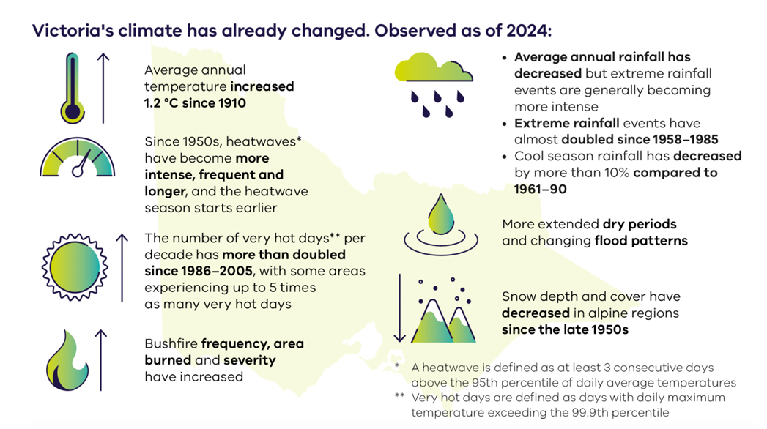
Source: Victorian Government

Impacts of Climate Change on Yarra Ranges
- Hotter days, more extreme weather and shifting rainfall patterns are already affecting the community. Increased risks such as bushfire, storms, flooding and habitat loss.
- An increase of hot days will result in cancelled outdoor events, earlier fire readiness, health impacts and higher cooling bills. More fires will result in more smoke-affected days.
- Short, heavy downpours are more common, causing flash flooding, culvert surges, erosion and landslip.
- The increasing intensity of weather events is making agriculture more challenging and threatens future food production in the region, with impacts on food security and affordability across Melbourne
- Snow fall in areas such as Mount Donna Buang to be less than in past years affecting alpine animals and plants and reducing snow ‘play’ access.
- Forests show increasing stress from heat, wind and fire.
- Yarra Ranges is among the most disaster-affected LGAs in Australia, with 42 federal disaster-recovery activations since 2006, reflecting compounding storms, floods and fire weather.

Climate Change, Stormwater and Flooding
Climate change is expected to reduce local runoff patterns while increasing the frequency and intensity of severe storm events, placing additional pressure on stormwater infrastructure and natural waterways. More extreme rainfall events can also lead to localised flooding as water follows its natural flow paths across the landscape. To better understand and manage these risks, flood mapping is used to identify areas predicted to flood, now and in the future. Council is working with Melbourne Water to deliver its Flood Mapping Program that updates flood information to reflect different sources of flooding. This information will support future planning for infrastructure, housing and emergency management.

Climate Change and Landslide Risk
Many areas of the Yarra Ranges Green Wedge are susceptible to landslides, and changing climate conditions may increase this risk. More frequent and intense storm events can result in short periods of heavy rainfall that destabilise slopes and trigger landslides. More frequent bushfires may also contribute to landslide risk by removing vegetation that helps stabilise soil and by damaging infrastructure such as retaining walls and drainage systems.
To help reduce risks to people, property and the environment, a planning control, known as the Erosion Management Overlay (EMO) is applied to land identified as susceptible to landslides. The control helps to manage development by minimising land disturbance and inappropriate development. Council has recently updated the EMO mapping to ensure it is appropriate and up to date.

Emergency Preparedness and Resilience
In response to climate change events Council has continued to invest in initiatives to support communities to prepare for and respond to extreme weather. This includes expanding Emergency Management Township Plans to help communities better understand local risks and prepare for emergencies, as well as undertaking significant roadside vegetation management works, including approximately 2,500 kilometres of roadside slashing and 7–11 kilometres of fuel reduction annually to reduce bushfire hazards. Council also supports a strong network of local emergency management groups across the Hills, Upper Yarra, Valley and urban areas, which play a vital role in building community awareness, preparedness and emergency response capacity.
While these initiatives have strengthened community resilience to climate change and extreme weather events, continued action will be needed to address growing climate risks and support community preparedness into the future.

The Adaption Game
Launched in 2024, the Adaptation Game (TAG) is an innovative board game designed to help individuals and communities better understand extreme weather events – such as heatwaves, floods, and fires – and identify practical actions to build personal and community resilience to weather-related challenges. It is based on scientific evidence about how climate change will affect the Yarra Ranges, exploring practical ways to adapt and contribute to community resilience, as well as understand the projects and programs already being implemented by council. TAG is a cooperative game where all the players work together with a facilitator who guides you through the game

Challenges
Climate impacts are intensifying existing challenges for land management and agricultural production in the Yarra Ranges Green Wedge. This places increased emphasis on the need for adaptive farming practices, water security solutions, and renewable energy and emissions reduction.
What we heard:
- Increased frequency of drought, flood, and bushfire events
- Ongoing water security challenges
- Increasing pest and disease risks (biosecurity)
- Pressures on biodiversity and pollination systems
- Bushfire risk reduces tourism on high fire danger days
- Impacts on grape crop viability due to smoke taint
- Traditional agricultural practices are becoming inadequate to withstand the intensity of Climate Change impacts

Opportunities
The Yarra Ranges Green Wedge can play a key role in responding to the changing climate.
Potential directions include:
- Supporting climate-resilient and environmentally sensitive agricultural systems, including contemporary large scale greenhouse solutions
- Work in partnerships to improve water management and security
- Enabling renewable energy and emissions reduction
- Integrating disaster risk reduction into planning
- Protective cropping – growing demand to protect crops with netting, sheds due to increased damaging weather events. This investment allows for consistency in production and profitability.

What opportunities exist to support climate-resilient agriculture, biodiversity and rural economies?
What role should renewable energy, water security and emissions reduction play in the future of the Green Wedge?
How can Council, landowners and community organisations work together to build a more climate-resilient Green Wedge?

Case study: Firesticks – the practice of cultural burning
As climate change increases the frequency and intensity of bushfires and places growing pressure on ecosystems, there is increasing interest in land management practices that build resilience and support healthier landscapes. Cultural burning is a traditional First Nations land management practice that involves deliberately lighting slow-moving, low-intensity fires to clean up dry brush, reduce wildfire hazards, and encourage ecosystem regeneration. The practice is based on a deep, intimate understanding of the natural world that enables all things to survive and thrive. It is a model of environmental sustainability based on the meticulous care for Country provided by Aboriginal and Torres Strait Islander people over thousands of generations.
Yarra Ranges Council is proud to be in the process of expanding its planned burning program. The Firesticks Project seeks to share the wisdom and connection with the environment and cultures that cultural burning brings. By reframing our relationship with the natural world, it highlights the importance of applying practical Aboriginal and Torres Strait Islander land management practices to heal Country.

Have Your Say
The Yarra Ranges Green Wedge is an important part of our community, environment and local economy. As we plan for its future, we want to hear what matters most to you.
Your feedback will help identify the key priorities, opportunities and challenges that should be addressed in the Green Wedge Management Plan. Whether you live, work, farm, visit or invest in the Green Wedge, your insights will help shape a shared vision for its future.
Once feedback has been reviewed, Council will prepare a draft Green Wedge Management Plan and return to the community for further consultation. A consultation report will also be published, outlining what we heard and how community feedback has informed the development of the draft plan.
Tell us:
- What needs to be prioritised in the Yarra Ranges Green Wedge?
- What are the key challenges facing the Green Wedge over the next 15 years?
- Are there issues or ideas not covered in this discussion paper that should be considered?
Have your say and help shape the future of the Yarra Ranges Green Wedge.

APPENDIX 1 - Policy and Strategic Context
This section outlines the state and local legislative policy framework within which a GWMP operates.

Planning and Environment Act 1987
Under Part 3AA of the Planning and Environment Act 1987, each council must prepare, adopt and review a GWMP for green wedge land in its municipality.
Section 46AD of the Planning and Environment Act 1987 outlines objects of green wedge management plans:
(a) to recognise the importance of green wedge land; and
(b) to protect, enhance and promote non‑urban values and non‑urban uses of green wedge land, and to give primacy to those values and uses; and
(c) to enable strategic planning for and management of green wedge land; and
(d) to provide for the beneficial use of green wedge land that contributes to the sustainability, prosperity, health and wellbeing of Victorians; and
(e) to support primary production on green wedge land and to enable its growth by preventing incompatible uses and development; and
(f) to manage threats of land use change that would detract from non‑urban values and non‑urban uses of green wedge land; and
g) to recognise the connection and stewardship of traditional owners in relation to land that is green wedge land.
The Ministerial Direction on the Preparation and Content of Green Wedge Management Plans requires councils to:
- Identify the non-urban values and uses of green wedge land to be protected, enhanced and promoted
- Develop strategies for protecting, enhancing and promoting these values and uses
- Managing land sustainably in line with the objectives in section 46AD of the Planning and Environment Act 1987.
- Consult with Traditional Owners, the community and other key stakeholders.

Plan for Victoria
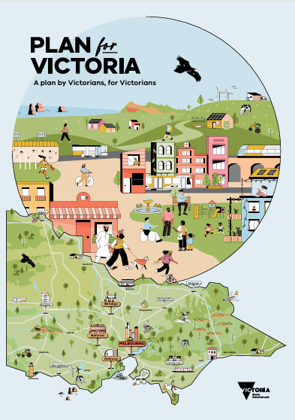 | Plan for Victoria is the State Governments long term plan for Victoria. It sets the state-wide vision for how Victoria will grow over time.  It identifies the State Government’s Green Wedge Action Plan as an action that’s already happening to support the plan.

Green Wedge Action Plan 2024
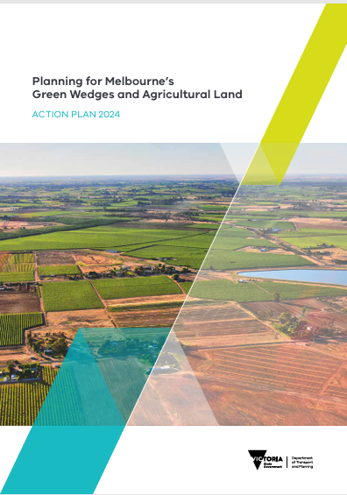 | The Green Wedge Action Plan is a State Government plan to protect Victoria’s green wedges and agricultural land. It includes 20 actions under six themes:

- Protecting Melbourne’s food bowl – new protections to help farmlands close to Melbourne remain productive and resilient.
- Planning for future farming – clearer guidelines and advice to councils on planning future farming activities.
- Securing the right to farm – new measures to prevent land-use conflict and incompatible green wedge land use and development.
- Establishing stronger protections – improved guidance and directions for councils in land use strategy and land management.
- Adopting smarter land use – review and update planning decision guidelines and planning application requirements to support appropriate land use and development.
- Setting tighter controls – strengthening planning controls in green wedges and prohibiting and restricting discretionary uses
Burndap Birrarung burndap umarkoo (Yarra Strategic Plan)

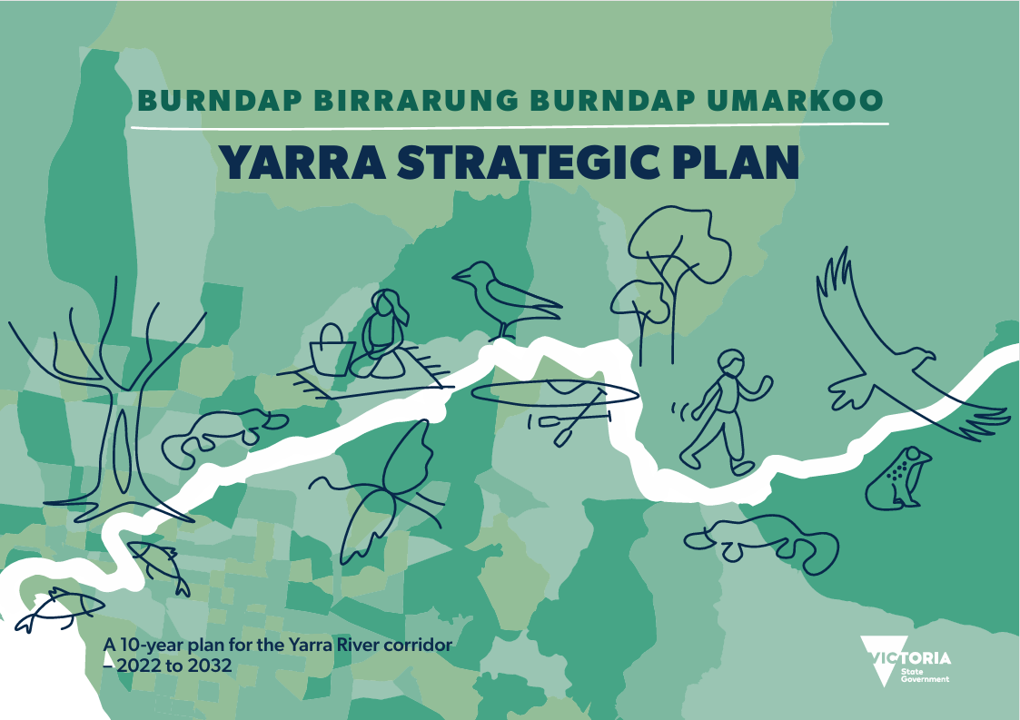 | The Burndap Birrarung burndap umarkoo, Yarra Strategic Plan, aims to protect and enhance the Birrarung (Yarra River) and its parklands. The actions in the plan respect and support the Wurundjeri Woi Wurrung and Bunurong Traditional Owners to co-manage the river and lands on their Country.  Approximately half of the Birrarung is in the Shire of Yarra Ranges.

Port Phillip & Western Port Regional Catchment Strategy 2021-2027

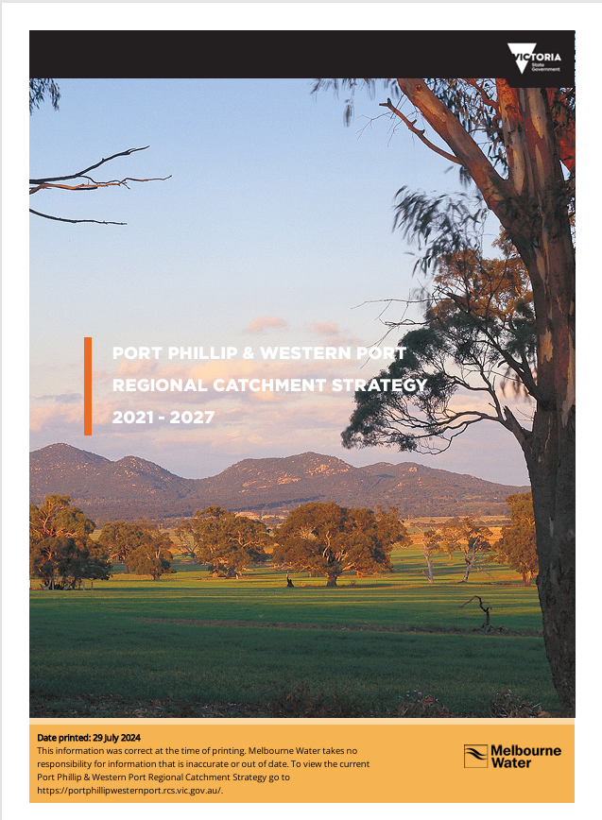 | The Port Phillip and Western Port Regional Catchment Strategy describes how land, water and biodiversity is managed across the region, highlighting the connections between them, and identifies targets for the future health and resilience of the region’s environment.

Local
Yarra Ranges Council Plan
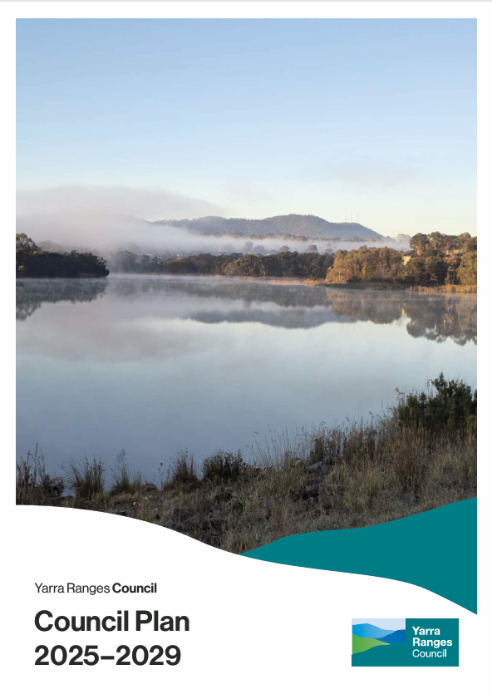 | Developing a new Green Wedge Management Plan is one of 16 key initiatives in the Council Plan 2025-2029  Action 16: Develop a new, contemporary Green Wedge Management Plan that addresses emerging agricultural practices and industry needs related to land use.

Yarra Ranges Community Vision 2036

Whether you live here or visit, you will see how much we care for Country, how inclusive and connected our communities are, and how balanced growth makes this the best place in the world.

The Vision statement reflects the community’s future aspirations for the municipality and includes

- Being a wonderful place to live, and a world-class destination for visitors and investors, with community members proud of where they live.
- Natural beauty, stunning landscapes and a reputation for exceptional local produce are enhanced.
- A focus on responsible eco-tourism, access to digital services, networks and infrastructure, and balanced economic development has improved quality of life.
- ‘Gateways’ strengthen the identity of First Nations people, their culture, stories, history and progress towards reconciliation.
- Sustainability is prioritised, with protection of biodiversity and habitat, regenerative farming practices, and action on climate change and natural disaster preparedness

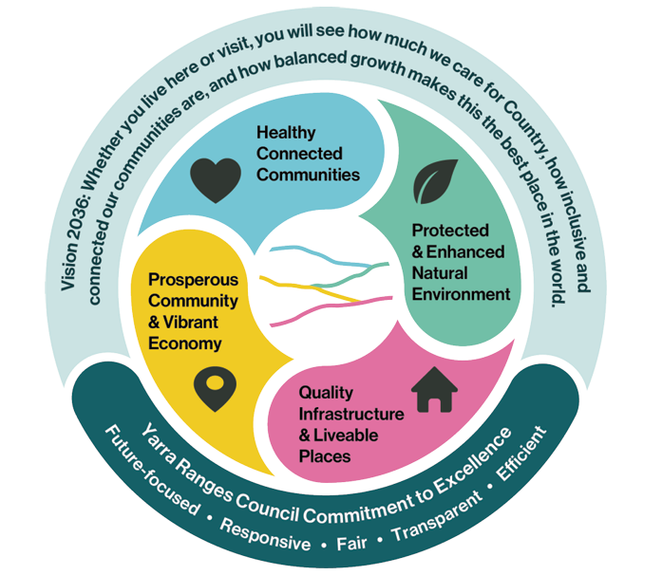

Yarra Ranges Strategies

In developing a whole of Council approach for managing our Green Wedge, the new GWMP needs to recognise and complement a range of other Council strategies and plans that all play an important role in facilitating ongoing rural sustainability and prosperity.

- Climate & Environment Strategy 2026-2036 (under development)
- Nature Plan 2024-2034
- Liveable Climate Plan 2020-2030
- Health and Wellbeing Strategy 2025-2029
- Economic Development Strategy 2022-2032
- Investment Attraction Strategy (under development)
- Destination Management Plan 2023 (by Yarra Ranges Tourism)
- Paths and Trails Plan 2025-2035
- Innovate Reconciliation Action Plan 2024-2026
- Draft Heritage Strategy 2026-2036 (under development)
- Recreation and Open Space Plan (under review)
- Housing Strategy 2024

Yarra Ranges Planning Scheme
The Yarra Ranges Planning Scheme contains both local provisions and broader state and regional provisions that apply across all relevant municipal planning schemes.
The Yarra Ranges Planning Scheme contains the following state and regional provisions relevant to Green Wedges:
- Clause 11.01-1R Green Wedges – Metropolitan Melbourne
- Clause 11.03-5S Distinctive areas and landscapes
- Clause 11.03-3S Peri-urban areas
- Clause 12.03-1R Birrarung (Yarra River)
- Clause 14.01-1S Protection of agricultural land
- Clause 14.01-1R Protection of agricultural land – Metropolitan Melbourne
- Clause 51.02 Metropolitan Green Wedge Land

The Yarra Ranges Planning Scheme also contains the following local policies relevant to Yarra Range’s Green Wedge:
- Clause 02.03 Municipal Planning Strategy
- Clause 11.01-1L-03 Residential development in the green wedge
- Clause 11.01-1L-04 Green Wedge
- Clause 11.01-1L-05 Green Wedge - subdivisions
- Clause 12.01-1L Biodiversity
- Clause 12.03-1L Yarra River
- Clause 12.05-2L Rural landscapes
- Clause 14.01-2L-02 Sustainable agriculture
- Clause 14.02-1L Catchment systems
- Clause 17.04-1L Tourism in the Yarra Ranges Green Wedge
- Clause 51.03 Upper Yarra Valley and Dandenong Ranges Regional Strategy Plan

Yarra Ranges Localised Planning Statement, 27 June 2017

Registered Aboriginal Parties
The Yarra Ranges region sits over three Registered Aboriginal Party (RAP) areas. The significant majority of the region is on the lands of the Wurundjeri Woi-wurrung Cultural Heritage Aboriginal Corporation. There is a small area of Bunurong Land Council Aboriginal Corporation land to the south, and two areas of Taungurung Land and Waters Council in the forested north-east. The Taungurung regions sit wholly on Parks Victoria land and are therefore not managed by Council. Council works within the framework of RAP areas as specified by the Victorian Aboriginal Heritage Council but acknowledges the complexities of reviving ancient boundaries.
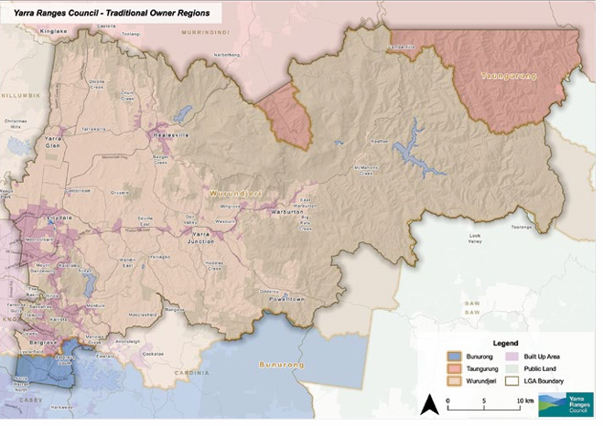

Glossary & Abbreviations
DEECA | The Department of Environment, Energy and Climate Action is the Victorian Government department responsible for environmental matters and legislation at the state level.
DELWP | Former Department of Environment, Land, Water and Planning
DTP | Department of Transport and Planning
GWZ | Green Wedge Zone
GWAZ | Green Wedge A Zone
GWMP | Green Wedge Management Plan
MW | Melbourne Water is the agency responsible for integrated water management, waterways and catchment management for the Melbourne region.
Landcare | Landcare Australia is the name for a community not-for-profit organisation which involves local groups of volunteers repairing the natural environment. Yarra Ranges Council has a number of registered Landcare networks and affiliated groups.
RCZ | Rural Conservation Zone
RSP (Regional Strategy Plan) | Upper Yarra Valley and Dandenong Ranges Regional Strategy Plan
SUZ | Special Use Zone
UGB | Urban Growth Boundary

APPENDIX 2 – Green Wedge Zones
Table of Key Uses in the Green Wedge Zone, Green Wedge A Zone and Rural Conservation Zone –

USE | GWZ | GWAZ | RCZ
Abattoir | Permit not required with certain conditions | Prohibited | Prohibited
Bed and breakfast (within a dwelling) | No more than 10 persons without a permit | No more than 10 persons without a permit | No more than 10 persons without a permit
Camping and caravan park | Permit required | Permit required | Prohibited
Cattle feedlot | Permit required | Prohibited | Prohibited
Crop raising | No permit required | No permit required | Permit required
Domestic animal husbandry (animal keeping) | No more than 5 animals without a permit | No more than 2 animals without a permit | No more than 2 animals without a permit
Domestic animal husbandry (animal keeping) | Permit required for Domestic animal boarding | Permit required for Domestic animal boarding | Permit required for Domestic animal boarding
Dwelling | Permit required, only 1 per lot | Permit required, only 1 per lot | Permit required, only 1 per lot
Exhibition Centre  Land used to display works of art, artefacts, or historical, cultural, or other like works or artefacts, includes art gallery & museum | Permit required  Maximum 150 patrons at any time | Permit required  Maximum 150 patrons at any time | Prohibited
Function Centre  Land used to cater for conferences, private functions, and in which food and drink may be served. Includes conference centre & reception centre | Permit required  Must be used in conjunction with Agriculture, Natural systems, Outdoor recreation facility, Rural industry or Winery. Minimum lot size as per zone schedule. Maximum default of 150 guests. | Permit required  Must be used in conjunction with Agriculture, Natural systems, Outdoor recreation facility, Rural industry or Winery. Minimum lot size as per zone schedule. Maximum default of 150 guests. | Prohibited
Golf Course | Permit required | Permit required | Prohibited
Grazing animal production | No permit required | Permit required | Permit required
Group accommodation  Land, in one ownership, containing a number of dwellings used to accommodate persons away from their normal place of residence. | Permit required  Must be used in conjunction with Agriculture, Natural systems, Outdoor recreation facility, Rural industry or Winery. Minimum lot size as per zone schedule. Maximum default of 40 dwellings. | Permit required  Must be used in conjunction with Agriculture, Natural systems, Outdoor recreation facility, Rural industry or Winery. Minimum lot size as per zone schedule. Maximum default of 40 dwellings. | Permit required  Maximum of 40 dwellings
Horse husbandry | No permit required | No permit required | Permit required
Host Farm | Permit required  Must be used in conjunction with Agriculture or Winery | Permit required  Must be used in conjunction with Agriculture or Winery | Permit required  Must be used in conjunction with Agriculture or Winery
Intensive dairy farm | Permit required | Prohibited | Prohibited
Manufacturing  sales | Permit required,  must be incidental  part of Rural  industry | Prohibited | Prohibited
Market | Permit required | Permit required | Permit required
Materials recycling | Permit required & only in conjunction with Refuse disposal or Transfer station | Prohibited | Prohibited
Office | Prohibited | Prohibited | Prohibited
Pig farm | Permit required | Permit required | Permit required
Plant nursery | Permit required | Permit required | Permit required
Poultry farm | No more than 100 poultry without a permit | No more than 100 poultry without a permit | No more than 100 poultry without a permit
Primary produce  sales | No permit required if not within 100m of a Dwelling, display area less than 50 sqm and produce grown on own/adjacent land. | No permit required if not within 100m of a Dwelling, display area less than 50 sqm and produce grown on own/adjacent land. | Permit required  Display area less than 50 sqm
Primary School | Permit required | Permit required | Permit required
Residential Hotel  Land used to provide accommodation in serviced rooms for persons away from their normal place of residence. If it has at least 20 bedrooms, it may include other corresponding uses | Permit required  Must be used in conjunction with Agriculture, Natural systems, Outdoor recreation facility, Rural industry or Winery. Minimum lot size as per zone schedule. Maximum default of 150 guests. | Permit required  Maximum 80 bedrooms | Permit required  Maximum 80 bedrooms
Restaurant | Permit required Must be used in conjunction with Agriculture, Natural systems, Outdoor recreation facility, Rural industry or Winery.  Minimum lot size.  Maximum default of 150 guests | Permit required Must be used in conjunction with Agriculture, Natural systems, Outdoor recreation facility, Rural industry or Winery.  Minimum lot size. Maximum default of 150 guests. | Permit required
Research and development centre | Permit required Must be used in conjunction with Agriculture, Natural systems, Outdoor recreation facility, Rural industry or Winery. Minimum lot size. | Prohibited | Prohibited
Rural store | No permit required if used in conjunction with agriculture.  Area less than 100 sqm. Only Rural store on the lot. | No permit required if used in conjunction with agriculture.  Area less than 100 sqm. Only Rural store on the lot. | Permit required
Rural worker accommodation | Permit required  Must be used in conjunction with Agriculture, Natural systems, Outdoor recreation facility, Rural industry or Winery  Minimum lot size required | Permit required  Must be used in conjunction with Agriculture, Natural systems, Outdoor recreation facility, Rural industry or Winery  Minimum lot size required | Prohibited
Sawmill | Permit required | Prohibited | Prohibited
Secondary school | Permit required | Permit required | Permit required
Shop | Prohibited | Prohibited | Prohibited
Small second dwelling | Permit required | Permit required | Permit required
Veterinary centre | Permit required | Permit required | Permit required
Winery | Permit required | Permit required | Permit required

Definitions of land use terms are provided at Clause 73.03 Land Use Terms in the Yarra Ranges Planning Scheme

Note that Melton Council have since completed a Western Plains South GWMP in 2024
Catchment scale land use profile dashboard – Local government areas - DAFF Australian Bureau of Agricultural and Resource Economics and Sciences
Catchment scale land use profile dashboard – Local government areas - DAFF Australian Bureau of Agricultural and Resource Economics and Sciences
Adapted from the Draft Yarra Ranges Heritage Strategy
Yarra Ranges: Community Views 2025, Key Insights, .id informed decisions & Shape Your Future, Yarra Ranges Shire Council, Engagement Summary Report, May 2024
Yarra Ranges: Community Views 2025, Key Insights, .id informed decisions
Shape Your Future, Yarra Ranges Shire Council, Engagement Summary Report, May 2024
Green Wedge and Agricultural Land Consultation Paper 2020, DELWP
As outlined in a recent review of Council’s Environment Strategy 2015-2025 – Evaluation Report
Information in this section is drawn from the Yarra Ranges Environment Strategy 15-2025 Evaluation Report. While some measures are for the entire Yarra Ranges Shire they still provide useful indicators for the Green Wedge given its proportion of the municipality.
Noting there may be some uncertainty in how this was measured
Amendment VC322 to all Victorian Planning Schemes
Australian Bureau of Statistics, Value of Agricultural Commodities Produced, Australia,2020/21
Australian Bureau of Statistics, Value of Agricultural Commodities Produced, Australia,2020/21
Australian Bureau of Statistics, 2021 Census & current/active Australian Business Register
Source: Australian Bureau of Statistics, Value of Agricultural Commodities Produced, Australia, 2020/21. Cat. No. 7503.0
Figures are for total employment – Source: National Institute of Economic and Industry Research (NIEIR) ©2025.Compiled and presented in economy.id by.id (informed decisions)
Strategic agricultural land and development in Victoria, Final Report, Sept 2020, Department of Jobs, Precincts and Regions
Economic Development Strategy Renewal 2022-2032 Background Report, Lucid Economics, 2021
Agricultural industry statistics | Yarra Ranges | economy.id viewed 16 June 2026
Right-to-farm legislation has been implemented by Tasmania (the Primary Industries Activities Protection Act 1995) and was recently enacted by New South Wales (NSW) in November 2019 with the Right to Farm Act 2019
Amendment VC322 to all Victorian Planning Schemes
Description based on the Planning Practice Note 42: Applying the Rural Zones 2024, Victorian Government
Clause 11.01-1L-03 Residential development in the green wedge, Yarra Ranges Planning Scheme
Panel Report Yarra Ranges Planning Scheme Amendment C177yran Restructure Overlay update, 5 August 2020
Amendments no. 8 and 29 to the Regional Strategy Plan
Including Amendment C148 which sought to move tenements into a Specific Controls Overlay to make it more visible in the scheme
As noted in the Panel report for Yarra Ranges Planning Scheme Amendment C148 (Victoria Planning Panels 2018)
Upper Yarra Valley and Dandenong Ranges Regional Strategy Plan, clause 2.1 of Schedule 1, page 98.
This section has been reproduced from Yarra Ranges Council Nature Plan 2024-2034
Note these figures are for the entire Yarra Ranges municipality and include urban as well as green wedge areas
Clause 17.04-1L of the Yarra Ranges Planning Scheme
Some are also more recent such as SUZ11 Burnham Beeches that is currently being used to facilitate its redevelopment.
Yarra Ranges Liveable Climate Plan 2020-2030
Primary Production Adaptation Action Plan 2027–31 Draft for Consultation June 2026, Victorian Government

