Yarra Ranges Council

A new Green Wedge Management Plan for Yarra Ranges

Summary Discussion Paper
August 2026

Green Wedge
Green Wedges are the non-urban areas located on the outskirts of metropolitan Melbourne that are protected from urban development to preserve their environmental, economic and cultural values.
Green Wedges provide important open spaces that support biodiversity, farming, tourism, and rural communities, while also offering opportunities for outdoor recreation and connection with nature. They play a vital role in maintaining the distinct separation between urban areas, protecting productive agricultural land, and preserving the unique rural character that is highly valued by residents and visitors.
Planning controls help protect the Yarra Ranges Green Wedge from inappropriate development, ensuring our distinctive rural landscapes, productive farming areas and environmental assets can be enjoyed by current and future generations.

Green Wedge Management Plan
A Green Wedge Management Plan (GWMP) is a Council adopted strategy that identifies a vision, objectives and actions for the sustainable use and development of each green wedge. It enables Council and its community to clearly articulate the kinds of development or activities that are likely to be supported in the Green Wedge.
Map: Yarra Ranges Green Wedge
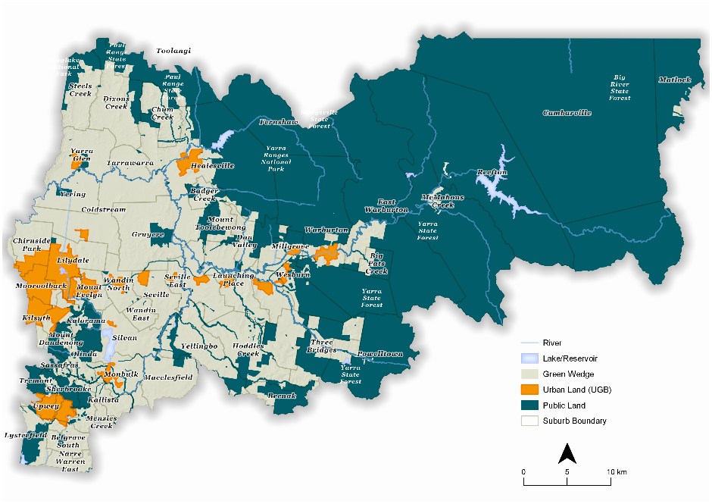

Discussion Paper
A Discussion Paper has been developed to provide context for developing the new Plan with community. It has been developed through research and key stakeholder engagement, to build a shared understanding of the Green Wedge. Identifying key challenges and opportunities, to guide conversations that will help shape a new Green Wedge Management Plan for Yarra Ranges.
This summary document highlights the key themes explored in the Discussion Paper, including supporting the long-term viability of agriculture, accommodating growing visitor numbers, and protecting the environmental and landscape values that underpin the region’s future.

Engagement
We want to hear from the community about the future of the Yarra Ranges Green Wedge. What do you see as the most important challenges and opportunities over the next 15 years, and how can we work together to address them?
Whether you live, work, farm, run a business, visit, or care for this landscape, your feedback will help shape the priorities, strategies and actions that guide the long-term management of this unique and valued landscape.

To learn more about the Green Wedge and how the GWMP review can influence future Policy, please visit the project Shaping Page:
https://shaping.yarraranges.vic.gov.au/GWMP

What can we influence in the new GWMP?
While the GWMP can set local policy and directions for green wedge areas within the municipality it must operate within the overarching Victorian legislative and policy framework. It cannot override policies or controls set out by the State Government.
The GWMP review can change:
- Local land use planning policy directions for the Green Wedge
- Vision for the Green Wedge
- Priorities for the Green Wedge

Project Plan
- Key Stakeholder Engagement - April - July 2025
- Discussion Paper prepared
- Community Engagement - Discussion Paper - November 2026
- Engagement summary report shared with community - early 2027
- Community feedback considered and Draft Plan developed
- Community Engagement - Draft GWMP - October 2027
- Community feedback considered and relevant changes made
- New GWMP for YR considered by Council - 2028

To view the full discussion paper and learn how to have your say,
please visit the project Shaping Page:
https://shaping.yarraranges.vic.gov.au/GWMP

Key themes

Environment and biodiversity
Yarra Ranges Green Wedge area contains some of Victoria’s most significant natural assets, including extensive native forests, waterways and habitats that support a remarkable diversity of plants and animals. These landscapes play a vital role in protecting biodiversity, storing carbon, safeguarding Melbourne’s drinking water supply, and maintaining the highly valued scenic and environmental values that make the Green Wedge an attractive place to live, work and visit.

Challenges
Climate change, habitat fragmentation, invasive species, declining water quality, illegal vegetation removal and soil dumping are increasing pressure on ecosystems and reducing biodiversity resilience.

Opportunities
There are opportunities to strengthen biodiversity through habitat reconnection, improved land stewardship, community education, Traditional Owner knowledge integration and evidence-based environmental planning.
What further environmental opportunities could be explored in the new GWMP?

Agricultural viability
Agricultural viability is a key consideration in the Green Wedge Management Plan because farming is fundamental to the Yarra Ranges’ identity, economy and local food security. The region’s favourable climate, soils and rainfall support a diverse and productive agricultural sector, generating significant economic value and supplying a wide range of fresh produce, viniculture, flowers and livestock. Protecting and strengthening agricultural land and farming businesses helps sustain local jobs, food security, rural character and the long-term productivity of Melbourne’s food bowl.

Challenges
Agricultural businesses are facing declining profitability, rising land costs, climate impacts, water insecurity, biosecurity threats and ongoing fragmentation of productive farmland.

Opportunities
There are opportunities to better support innovation in regenerative and climate-resilient farming practices, enabling diversification, increased profitability, strengthening long-term food production and agricultural viability.
How can we support and strengthen agriculture in the Green Wedge to ensure it remains productive, resilient, and sustainable into the future?

Key themes

Land use and rural living
Yarra Ranges Green Wedge area provides a highly valued rural lifestyle and it will be important to consider land use and rural living as part of the GWMP review. People choose to live in the Green Wedge for many reasons, including its peaceful environment, larger properties, opportunities for small-scale farming, and connection to nature, while still being close to metropolitan Melbourne. Careful planning is needed to manage the impacts of development on environmental and landscape values and to protect productive agricultural land from inappropriate residential development that may create conflicts between farming and rural residential activities.

Challenges
Balancing housing demand with the protection of agricultural, environmental and landscape values remain challenging, particularly due to complex planning controls that address historical land patterns and increasing rural residential pressures.

Opportunities
Opportunity to review local planning policy and housing approaches to better support community needs while maintaining the strategic purpose and character of the Green Wedge.
What are the greatest risks and opportunities associated with rural living in the future?

Heritage and community
Community and heritage need to be considered in Yarra Ranges Green Wedge, recognising the deep and enduring connection of Traditional Owners to Country, the cultural significance of the landscape, and the European, migrant and other histories that has shaped the area over time. Protecting and celebrating our historic places, Indigenous cultural values, and the stories of diverse communities helps strengthen local identity, foster reconciliation, and ensure the Green Wedge continues to reflect the environmental, cultural and social values that are important to current and future generations.

Challenges
Diverse local histories, including First Nations heritage and stories, are not always well recognised or understood, limiting cultural awareness and connection.

Opportunities
Improving heritage interpretation, celebrating diverse stories, building on partnerships with Traditional Owners and incorporating Caring for Country approaches into land management.
What opportunities exist to make cultural heritage more visible and accessible within the landscape?

Key themes

Sustainable tourism and recreation
Sustainable tourism and recreation support the region’s economy, celebrate its natural and cultural assets, and enhances opportunities for residents and visitors to experience the Yarra Ranges’ unique landscapes. Careful management is needed to balance tourism growth and recreational use with the protection of environmental values, landscape character, agricultural productivity and community wellbeing, ensuring these experiences remain sustainable and continue to benefit future generations.

Challenges
Tourism growth can create pressures on infrastructure, natural assets, agricultural land and rural communities if not carefully planned and managed.

Opportunities
Potential to expand agritourism, improve visitor experiences and recreational infrastructure, and provide greater certainty for sustainable tourism investment in appropriate locations.
Are the current planning controls achieving an appropriate balance between supporting tourism and protecting Green Wedge values?

Climate resilience
Climate change is increasing the frequency and severity of extreme weather events, placing growing pressure on communities, ecosystems, agriculture, infrastructure and the local economy. Building resilience in Yarra Ranges Green Wedge will help community adapt to changing conditions, reduce risks from natural hazards, protect environmental and productive landscapes, and support the long-term wellbeing of communities and future generations.

Challenges

Increasing drought, flood, bushfire and other climate-related impacts are placing growing pressure on agriculture, biodiversity, water resources and tourism.

Opportunities
Opportunity to build resilience through climate-adaptive farming, improved water security, renewable energy initiatives, disaster risk reduction and protective cropping systems.
What opportunities exist to support climate-resilient agriculture, biodiversity and rural economies?
To learn more about the key themes of the GWMP review and to have your say,
please visit the project Shaping Page:
https://shaping.yarraranges.vic.gov.au/GWMP

