Appendix 1. Policy Context

Federal and State Policy
Federal policy influences Australian housing outcomes in several ways, through immigration levels, tax provisions and as a provider of social housing. Council can advocate to other tiers of government for affordable housing, social housing and improvements to infrastructure to support residential areas.

Plan Melbourne 2017 - 2050
The State Government’s metropolitan strategy Plan Melbourne 2017-2050 is the most influential planning policy governing housing in Yarra Ranges. It is the basis of the State planning framework for housing which forms part of the Planning Scheme. Council’s residential planning controls must be consistent with current State Planning policy. Policies of relevance to residential development in Yarra Ranges are:
- Policy 2.1.1 - To maintain a permanent urban growth boundary around Melbourne to create a more consolidated, sustainable city
The Urban Growth Boundary (UGB) establishes the limit of developable land in the urban areas and rural towns and prevents further residential encroachment into the rural (green wedge) areas. Fundamentally, the UGB is the division between rural and urban land. It means Yarra Ranges must provide opportunities for new residential development within its existing urban areas (inside the UGB) to protect the green wedge from outward urban sprawl.
- Policy 2.1.3 - Plan for and define expected housing needs across Melbourne’s regions
Yarra Ranges is part of the Eastern Metropolitan Region and must identify housing change areas in a regional context, to facilitate investment and create new housing opportunities near employment, services and transport. This policy directs Council to identify its housing change areas as minimal, incremental or high change. Council’s Residential Planning Framework is consistent with this policy. It identifies a three-tiered hierarchy of areas for further residential development plus a low density residential area.
- Policy 2.1.4 - Provide certainty about the scale of growth in the suburbs
The aim of this policy is to ensure Council identifies where long-term growth will occur. This gives the community confidence that not all areas will be subject to wholesale change. The policy underpins the location of residential development in the Planning Scheme.
Plan Melbourne promotes a 20 – Minute Neighbourhood as a response to future residential development.
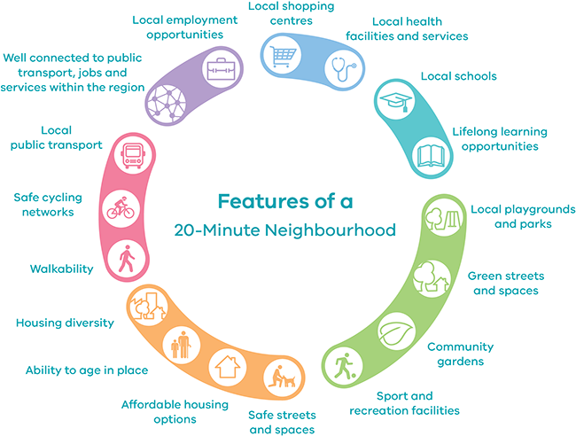

Figure 1 The 20 Minute Neighbourhood Source: Plan Melbourne 2017 -2050

Eastern Metropolitan Land Use Framework Plan (EMLUFP), DELWP – Exhibited August 2021
The State Government has consulted on the EMLUFP to provide a regional framework for the six eastern metropolitan LGA’s including Yarra Ranges. The preparation of the EMLUFP is an action of Plan Melbourne 2017-2050 and will be used to guide the directions of Plan Melbourne at a regional level. The exhibited plan has a chapter on Housing Choice and includes projected housing requirements for the Eastern Region. Of note, it recommends 70 per cent of new housing will be built in established residential areas.
The housing target for the Eastern Region is an additional 78,500 dwellings by 2036. The projected housing figures are apportioned across the local government areas with regard to metropolitan and major activity centres and urban renewal precincts. The majority of new dwellings are to be located in Monash and Whitehorse LGA’s. Yarra Ranges is expected to provide 10,700 new dwellings by 2036. Yarra Ranges’ share of the regional distribution is minimal, around 13 per cent of the total Eastern Region. These figures reflect Yarra Ranges slow population growth, limited activity centres, green wedge areas and outer eastern location. Residential growth in Yarra Ranges is also restricted by the policies of the Upper Yarra Valley and Dandenong Ranges Regional Strategy Plan as discussed in the next section.

The Upper Yarra Valley and Dandenong Ranges Regional Strategy Plan
The Upper Yarra and Dandenong Ranges Authority was established with the proclamation in April 1977 of Upper Yarra Valley and Dandenong Ranges Act 1976. The Regional Planning Authority prepared the Upper Yarra Valley and Dandenong Ranges Regional Strategy Plan (RSP) to protect the unique features of the region. Section 46F of the Planning and Environment Act 1987 (the Act) requires the Yarra Ranges Planning Scheme to be consistent with the Regional Strategy Plan.
Fundamental to the RSP is a containment policy, which ensures no net increase to residential development in the Dandenong Ranges and no significant increase in the Yarra Valley or southern foothills of the Dandenong Ranges. Other objectives of the Regional Strategy Plan are to ensure significant landscapes are protected and adverse impacts on the environment are minimised.
The provisions of the Regional Strategy Plan governing residential development are implemented through the Yarra Ranges Planning Scheme by the Urban Growth Boundary (UGB) and application of zones, which must be consistent with the policies of the RSP. The Urban Growth Boundary specifically limits the spread of residential areas outside of the existing urban boundaries.
Section 46F of the Act prevents the Minister for Planning approving any amendment to the Yarra Ranges Planning Scheme that is inconsistent with the RSP.

Yarra Ranges Localised Planning Statement, 2017 (LPS)
The Victorian Government, in partnership with local governments, introduced Localised Planning Statements, to recognise the most distinctive areas and landscapes in Victoria. Four key areas of Victoria were identified for an LSP, including the Dandenong Ranges and Yarra Valley. Yarra Ranges Localised Planning Statement was approved by the Minister for Planning in 2017.
Localised Planning Statements are high level planning documents intended to influence planning for the region and ensure the distinctive features identified in them are not diminished by poor planning outcomes. The Statements are given statutory effect by Ministerial Direction 17 – Localised Planning Statements and as referenced documents to the State (Victoria Planning Provisions) in the Planning Scheme at Clause 11.03-5S, which means they are considered as part of planning approvals or changes to the Planning Scheme.
Yarra Ranges is familiar with the benefit of regional planning, as the Upper Yarra and Dandenong Ranges Regional Strategy Plan has provided a long history of land use planning controls unique to other areas. Similar to the RSP, the Localised Planning Statement seeks the containment of the urban areas and the prevention of outward expansion into rural areas. In terms of housing the Localised Planning Statement states:
- Identify and articulate preferred areas for housing change.
- Recognise and respond to environmental and landscape considerations and provide access to services and facilities including public transport and employment opportunities.
- Ensure development within existing settlements will be of a type and scale that respects the existing preferred character of each area.
- Recognise residential areas of environmental and landscape significance to ensure new development is compatible with established neighbourhood character values.
The Yarra Ranges Planning Scheme is consistent with the policies of the Localised Planning Statement and any changes to housing policy as a result of this Review, will need to be assessed against LPS directions.

Council Strategies and Plans

Yarra Ranges Housing Strategy 2009
The current Housing Strategy provides the long-term plan for future housing growth in Yarra Ranges. Council’s vision for housing:
To meet the range of individual needs and contribute to attractive, vibrant and safe neighbourhoods while minimising environmental impacts.
The delivery of this Vision is supported by four key themes:
- Sustainable local communities:
  - accommodating future growth in identified centres
  - accessibility to services and infrastructure
  - reducing reliance on private transport
  - certainty about scale and preferred locations for housing (neighbourhood character).
- Sustainable Housing Design
  - well-designed housing for the health and amenity of residents.
- Diversity and Choice
  - a greater range of housing types for all age groups and abilities.
- Affordable Housing
  - accessible and well-located housing
  - facilitating social and community housing
  - identifying opportunities on public land

Yarra Ranges Council Plan 2021-2025 – Working together to shape the future
Council’s vision statement in the Council Plan is based on the ideas of more than 1,000 members of the community and was captured in late 2016.
“Whether you live here or visit, you will see how much we value our natural beauty, how connected our communities are and how balanced growth makes this the best place in the world.”
The strategic objectives of the Council Plan are:
- Connected and Healthy Communities
- Quality Infrastructure and Liveable Places
- Protected and Enhanced Natural Environment
- Vibrant Economy and Tourism
- High Performing Organisation.
The Housing Strategy contributes to the first two objectives and influences the protection of the natural environment.

Health and Wellbeing Plan in Yarra Ranges 2021 -2025
The Health and Wellbeing Plan is the strategic roadmap for Council to support optimal health and wellbeing of communities and meet the requirements of the Public Health and Wellbeing Act 2008. Housing is an integral component of wellbeing and a key social determinant of health. The gap in housing affordability and the shortfall of social housing particularly impact the lowest income bracket of the Yarra Ranges’ community. The impacts on people’s lives, particularly children from insecure housing or homelessness are significant and often mean limited funds for other vital needs such as food, school costs, travel and utilities. In mid-2021 only 5.6 per cent of dwellings in Yarra Ranges were affordable for two adults and a child on Centrelink payments.
To address this, Council is a partner with 12 other councils in the Eastern Affordable Housing Alliance formed to advocate for more social housing, wrap around services for people experiencing homelessness and working in partnership with all levels of government to address housing needs.

Guiding Principles – Housing and Homelessness 2020
Council acknowledged the importance of secure and affordable housing in a set of Guiding Principles for Housing and Homelessness endorsed in 2020. The Guiding Principles are effective ways for Council to work towards preventing homelessness and support the availability of affordable homes for all. The Guiding Principles set out ways of working including in partnership with the community, other levels of government, the housing and private sectors. They also articulate the advocacy role of Council which builds on past efforts to provide a focus for future work.
Key principles of relevance to this Discussion Paper are:
- Advocacy – to advocate to the Victorian Government for mandatory inclusionary zoning to help meet the gap in social housing and to seek changes to the state planning provisions to support more affordable housing in planning schemes and requiring mandatory contributions on large development sites.
- Planning – facilitate more diverse, high quality housing through negotiations with developers for social housing as a component of larger developments. Pursue negotiated agreements for affordable housing as part of planning re-zonings and finally, to consider the use of appropriately located surplus Council land for social housing.

Connected - Yarra Ranges Integrated Transport Strategy 2020-2040
Connected is Council’s key strategic document to guide transport planning. The document responds to the challenge of making Yarra Ranges a more convenient place to get around in, by promoting alternatives such as cycling, walking and public transport. Its vision statement is:
Transport in Yarra Ranges provides safe, efficient access for the whole community, while protecting the natural environment and unique character of its towns and villages.
Supporting and planning for new housing within the 20-Minute Neighbourhood in activity centres and larger towns will contribute to the reduction in car-based transportation. The goal of the transport strategy is closely tied to current planning policy for residential development.

Healthy and Active Ageing Plan 2019 -2023
The Healthy and Active Ageing Plan sets out the direction for Council to support its older residents and helps guide the services Council provides to the community. It is directly aligned with Council Plan action 1 for connected and healthy communities. In the context of planning for residential areas the following is relevant:
Priority area 2 – Age-friendly environments enable people to age in place with dignity and support.
Actions – Enable the availability of a range of housing options to meet the needs across all ages.
This Discussion Paper will look at ways to strengthen and improve policy to deliver better housing outcomes for older residents.

Liveable Climate Plan 2020-2030
The Liveable Climate Plan sets out a framework to support our local community and economy, along with the unique natural environment that makes Yarra Ranges such a great place to live. In the context of planning for residential areas, the follow statements are relevant:
Priority Area 5 – Climate Thinking: We consider climate change in all our strategies, policies, programs and services.
Priority Area 6 – Living Landscapes: Our townships and suburbs are leafy green oases.
Priority Area 8 – Adapting together: No one in Yarra Ranges is left behind in the shift to our low carbon future.
Priority Area 9 – Sustainable Transport: Low-carbon options are integrated throughout the region, to keep everyone active and moving.
These priorities will influence the planning controls for how new residences are developed and the controls which seek to protect our neighbourhood’s leafy character.

Structure Plans and Place Plans
Structure Planning and place planning are tools to facilitate the orderly development of urban areas and provide a long-term land use vision. Council has completed Structure Plans for Mooroolbark, Coldstream, Healesville, Monbulk, and Lilydale since the 2009 Housing Strategy was completed, as well as an Urban Design Masterplan for Chirnside Park.
Chirnside Park Urban Design Masterplan, 2010
This Masterplan was written at a time when the expectations for land use in Chirnside Park were changing, with the previous industrial focus for the area found unviable, necessitating a new vision for the centre. The Masterplan proposed a high-density residential future, set around mixed-use commercial, office and entertainment land uses focussed on a local road precinct in Kimberely Drive and Fletcher Road. While the Plan is formally named and ‘Urban Design Masterplan’, it addresses all the major required content of a Structure Plan and was based on background studies for land use and housing, and an economic analysis.
Mooroolbark Structure Plan, 2011
The Mooroolbark Structure Plan was adopted after adoption of the 2009 Housing Strategy, which identified Mooroolbark as a centre where medium and higher density residential development were encouraged in order to improve housing diversity, due to its location near a railway station and commercial centre with excellent access to services, parks and community facilities, employment opportunities, and schools.
Coldstream Structure Plan, 2016
The Coldstream Structure Plan was prepared to address matters raised through the Coldstream Community Plan, relating to the restricted potential for urban growth and the impact this may have on the town’s range of retail, services and ongoing sporting and community participation. The Structure Plan investigated this issue, including correspondence with the State Government. It found that the expansion of the Urban Growth Boundary to provide for greenfield urban development was not a viable option. The Structure Plan did however look at the town’s opportunities for residential development, including the key site at 638-640 Maroondah Highway, as well as improvements to its traffic and pedestrian connections, open spaces and urban design.
Healesville Structure Plan, 2016
The Healesville Structure Plan, adopted in 2016, underwent extensive community consultation over a two-year period, and was based on expert reports for land use planning, economy, transport and parking, environment, bushfire risk and community infrastructure.
Monbulk Structure Plan, 2017
The Monbulk Structure Plan was prepared following the announcement of Yarra Valley Water works to provide a reticulated sewer connection to the town, meaning limitations on residential growth and development changed. The Structure Plan explored the implications of further residential development, given bushfire and other environmental risks, and preferred locations. It also made recommendations addressing employment, the town centre, the environment and Council owned land, particularly the Moores Road Precinct.
Lilydale Structure Plan, 2022
The Lilydale Structure Plan replaced an earlier Structure Plan from 2006 which was outdated due to significant changes to the centre as a result of the level crossing removal and new train station, the Kinley (former Lilydale quarry) rezoning, and increased levels of public and private investment in the centre. The Structure Plan explored a revised pattern of residential development for the centre, focussed on higher density residential development in the town centre. It also reached a position in favour of the Lilydale Bypass and explored what the Bypass meant for central Lilydale in the medium and long terms.
Warburton Place Plan
The Warburton Place Plan was approved in November 2021 and established Council’s intent for Warburton for the next 20 years. The Plan includes a Housing statement, which is to explore opportunities to improve housing diversity, availability and affordability along with relevant advocacy options and recommended changes to Planning Scheme controls.

State Planning Reform
A number of changes to the State Planning policy have a direct impact on planning for residential development in Yarra Ranges.

Residential Zone Reforms: Amendments V8 and VC100
The State Government has made a series of changes to the residential zones since Council’s residential Planning Framework was implemented into the Planning Scheme in 2013. The reforms are significant for residential development in Yarra Ranges because planning controls are the primary tool to guide residential development.
A full history of changes is documented in Table 1, but the most significant change were Amendments V8 and VC100 – Reformed Residential Zones. These Amendment introduced the current residential zones and, importantly, their associated schedules, which give Council flexibility to tailor planning controls to specific residential areas. The schedules allow for a greater degree of control over built form and landscape settings, which will assist Council in ensuring new development is sustainable and well suited to the neighbourhood character and can address design issues inherent with infill residential development.
VC100 introduced a change to the Low-Density Residential Zone making a minimum lot size of 2,000m² schedule an option – previously the minimum subdivision size for all land in low density was 4,000m².

Further Reforms to Residential Zones
VC110 (2017)
Further changes to the current state standard zones have occurred since 2013, and specifically VC110 introduced changes that altered expectations for how development would occur in the residential zones. Significant changes were:
- The introduction of the ‘Garden Area Requirement’ to the Neighbourhood Residential Zone (NRZ) and the General Residential Zone (GRZ), which specified an area of land per development lot that must be useable as garden and therefore free of certain structures, driveways, car parking areas, and other specified features.
- The garden area requirement does not apply to the Residential Growth Zone (RGZ) as the highest residential growth category, and therefore altered expectations about site cover, permeability and design expectations of development in the RGZ as contrasted against the NRZ and GRZ, giving the RGZ a more urbanised design emphasis.
- Introduction of a mandatory height limit of 9 metres in the NRZ and 11 metres in the GRZ. This raised built form intensity expectations for the GRZ, where three-storey built form was consequently considered a standard outcome, whereas previously a two-storey discretionary limit had applied.
- The removal of the two dwelling per lot cap in the NRZ and removal of the schedule which allowed Council to specify only one dwelling per lot. This changed allowable development densities in NRZ areas.
Planning Practice Note 91 – Reforms to Residential Zones (December 2019)
The release of this Practice Note by the State Government clarified expectations about the application of residential zones. Key aspects of this included:
- Clarification that development in the RGZ may be four stories, or taller if specified in a schedule to the zone.
- Clarification that the GRZ should only be applied in areas where development of 3 stories exists or is planned for, meaning it should not be applied where development under this height is envisaged.
This Practice Note clarified minimum height expectations in GRZ and RGZ areas, and specifically clarified that schedules could not be used to specify lower minimum heights in designated areas, but rather, if lower height limits were sought, a different zone should be used.
Planning Practice Note 90 – Planning for Housing (December 2019)
This Practice Note, released at the same time as PPN91, provides information and guidance about how to plan for housing growth and protect neighbourhood character to ensure a balanced approach to managing residential development in planning schemes.
This Practice Note clarified that a Housing Strategy must consider effects on neighbourhood character, to ensure that the proposed pattern of residential growth complements the preferred neighbourhood character of each residential area.

Bushfire Risk: Amendment VC140
Amendment VC140 strengthened planning measures to give Victoria a more sophisticated and better informed planning response to bushfire that directs settlement and population growth away from areas of extreme bushfire risk and to safer low risk locations. The Amendment was introduced in response to the recommendations of the Royal Commission into the 2009 bushfires to strengthen planning.
VC140 requires a response to bushfire to be assessed if any proposed rezoning facilitates the introduction of more development into identified areas of bushfire risk. VC140 has had a major impact on planning for residential development in Yarra Ranges due to large parts of the municipality being designated Bushfire Prone or within the Bushfire Management Overlay. VC140 and the related changes to Clause 13.02 Bushfire of the Planning Scheme require a robust response to bushfire risk when rezoning land for increased residential use or for planning permits for developments in fire risk areas. It is up to Council and applicants to demonstrate any development proposal or planning scheme change will on balance provide a planning response that is justified in an area of risk.

Table 1. Timeline of Residential Controls/Zones (Discussion Paper Appendix 1 P.95)
Pre 2009 | Residential 1 Zone, Low Density Residential and Residential Zone 3 – only three residential zones available. Residential 1 and Low Density Residential applied throughout Yarra Ranges.
2009 | Council adopts Housing Strategy
2010 | Public exhibition of Amendment C97 implementing Neighbourhood Character Study and Housing Strategy - public exhibition during September and October 2010.
2011 | Minister appoints an independent panel to review Amendment C97. Hearings August 2011 and a further supplementary hearing in October 2011. Panel’s report delivered in November 2011.
2013 /May | Amendment C97 (Housing Amendment) was gazetted 16 May 2013 and introduced a three-tiered hierarchy of residential areas by using the zones and overlays to identify areas for significant, incremental and least change. For the first time, tree controls were introduced in the metropolitan residential areas of Kilsyth, Mooroolbark, Lilydale and Chirnside Park. Vegetation controls in other areas were modified based on recommendations of the Neighbourhood Character Study 2002.
2013 / July | Amendment V8 and VC100 - State reforms the residential zones creating: Residential Growth Zone, General Residential Zone and Neighbourhood Residential Zone to replace Residential zones 1-3. Proposed change to minimum subdivision size in Low Density Residential Zone of 4,000m2 to 2,000m2.
2013 /October | Council prepares Amendment C134 to translate the existing zones into the new residential zones. Minister for Planning approves it without notice (20(4) amendment) given it was a direct translation of the controls applied in the recently approved C97.
2014 | Amendment C134 approved 13 June 2014.
October 2014 | Low Density Residential Zone areas - Council conducts public consultation on the Minister’s change to the minimum subdivision size. Council resolves to seek amendment C143 – Low Density Residential Zone. Some areas were identified for potential further subdivision (2,000m²). Note: no change to the low-density residential areas was proposed in the Housing Strategy 2009 or as part of Amendment C97 but following the changes in July 2013, the community sought a review of the LDRZ.
2015 | Advisory Committee for Managing Residential Zones appointed by Minister to review the application of the ‘new’ residential zones. Yarra Ranges presents to the Advisory Committee.
March 2017 | VC110 – introduces a new general term “Garden Area Requirement” to the Neighbourhood Residential Zone and the General Residential Zone. Amendment removes the two dwelling per lot cap in the Neighbourhood Residential Zone and removes the schedule which allowed Council to specify only one dwelling per lot. Introduces a mandatory height of 9 metres in the NRZ and 11 metres in the GRZ.
November 2017 | Minister refuses Council’s Low-Density Residential Amendment C143 and suggests no further change without significant strategic work to support it (fire risk identified as a particular concern.

Yarra Ranges Planning Scheme
Yarra Ranges’ residentially zoned areas cover twenty-three diverse locations including: Belgrave, Tecoma, Upwey, Chirnside Park, Coldstream, Healesville, Kilsyth, Launching Place, Lilydale, Millgrove, Monbulk, Montrose, Mooroolbark, Mt Evelyn, Seville, Seville East, Silvan, Wandin North, Warburton, Wesburn, Woori Yallock, Yarra Glen and Yarra Junction. Not all of these areas contain a commercial centre or services to support increased development.
The following hierarchy table from the Yarra Ranges Planning Scheme shows how commercial centres fulfil different functions and in turn support different levels of residential development. Areas such as Launching Place, Silvan, Wesburn and Millgrove are primarily dormitory locations, with little or no commercial development. Some small commercial locations shown in this table, particularly in the Dandenong Ranges are classified as rural areas and contain no residentially zoned land.
Table 2. Yarra Ranges Activity Centre Hierarchy Table

Activity Centre Type | Role
Major Activity Centres  Chirnside Park and Lilydale | These centres provide a large, diverse and intensive mix of retail, commercial, entertainment, cultural and other uses.  They have strong public transport links, serve a large regional-sized catchment, and are priority locations for future private and public sector development.  Land within and adjoining these centres is the preferred location for additional and more diverse residential development.
Large Neighbourhood Activity Centres  Belgrave, Healesville, Kilsyth, Monbulk, Mooroolbark, Mount Evelyn, Seville, Yarra Glen, Yarra Junction | Smaller in floor space terms than Major Activities Centres, these centres have a retail mix that is focused on convenience and grocery shopping. They also provide a range of community services to the surrounding communities.  Some of these centres, which serve a catchment that extends into the rural hinterland, perform a significant role in the provision of community and civic services, with some also providing a range of facilities and services for tourists.  Land within and adjoining these centres is generally an appropriate location for additional housing.
Small Neighbourhood Activity Centres  Coldstream, Montrose, Mount Dandenong, Olinda, Sassafras, Tecoma., Upwey, Wandin North, Warburton, Woori Yallock. | These centres have a more limited role in providing convenience retailing and community facilities for an immediate surrounding catchment.  Usually, they have a small supermarket as the main anchor tenant. In some cases they also serve a tourist market.
Local Activity Centres  Examples include:  Colby Drive - Belgrave South, Monbulk Road Silvan and Switchback Road - Chirnside Park | Local Activity Centres consist of a small group of shops that typically serve a local walk-in catchment and provide for the daily convenience and ‘top up’ needs of local residents and passing motorists.  Some of these centres contain a limited number of community facilities and other uses.

Existing Residential Planning Framework
The Housing Strategy articulates Council’s residential planning framework - or where further development is supported in Yarra Ranges residential areas. The Planning Framework is influenced by the level of services and facilities offered, the proximity to public transport and schools and whether there are any environmental constraints to additional development.
The Planning Framework is implemented by the Planning Scheme through the application of zones and overlays which show how and where Council intends to meet the housing needs of its residents. The Framework Plan must be consistent with State Planning Policy and identify areas for minimal, incremental and high level change. The multitiered approach is intended to achieve a diversity of housing typologies in the most sustainable locations.
While the zones and overlays provide Council with the ability to define levels of residential development, they do have limitations. For example, they cannot control density or set a maximum number of developments for a particular area. However, Council does have the ability to use zones to indicate preferred development areas and has the ability to control basic design such as setback from the street and side boundaries and height through planning controls.
Consolidation areas – these areas encourage housing growth and diversity at increased densities. In Yarra Ranges housing consolidation areas include parts of Lilydale, Chirnside Park, Mooroolbark and Kilsyth as well as locations in the major rural centres of Healesville and Yarra Junction where multi-unit development is encouraged. These areas were identified by their access to services, transport, education and social infrastructure. These areas also have reticulated sewer roads and other infrastructure to support higher density.
The consolidation areas are further refined by a hierarchy of controls designed to recognise the distinctions between rural consolidation areas and consolidation areas in major activity centres such as Lilydale and Chirnside Park.
Incremental change – these are the hinterland or areas immediately outside the consolidation areas. Incremental areas are locations where infill development is encouraged but at a lower scale than what is encouraged in the Consolidation areas. They are generally ‘less walkable’ from commercial centres, education and public transportation and may have neighbourhood character constraints. Yarra Ranges identifies two categories of incremental change, one for its ‘metropolitan’ areas and a second for the rural towns.
Limited or Least Change – these are generally outlying residential areas exhibiting significant landscape or environmental values or can be areas where environmental hazards such as landslip and bushfire reduce opportunity for further development.
No Change – these occur in the Warburton Hwy towns that have not been earmarked for any further significant development, including Millgrove, Launching Place and Wesburn.
Low Density Residential areas - the Planning Scheme purpose for the Low Density Residential Zone it to provide for low density residential particularly on lots where in the absence of sewer, the lot can treat and retain all wastewater. In Yarra Ranges the Zone has also been applied to areas with environmental constraints such as bushfire and landslip, heritage values (the Bickleigh Vale Village in Mooroolbark) or areas remote from activity centres and services.
Some low density areas were specifically designed as large lot subdivisions which defines the character of the area and provides for a lifestyle opportunity.
The following maps, Figures 2 and 3 illustrate Yarra Ranges current residential planning framework.

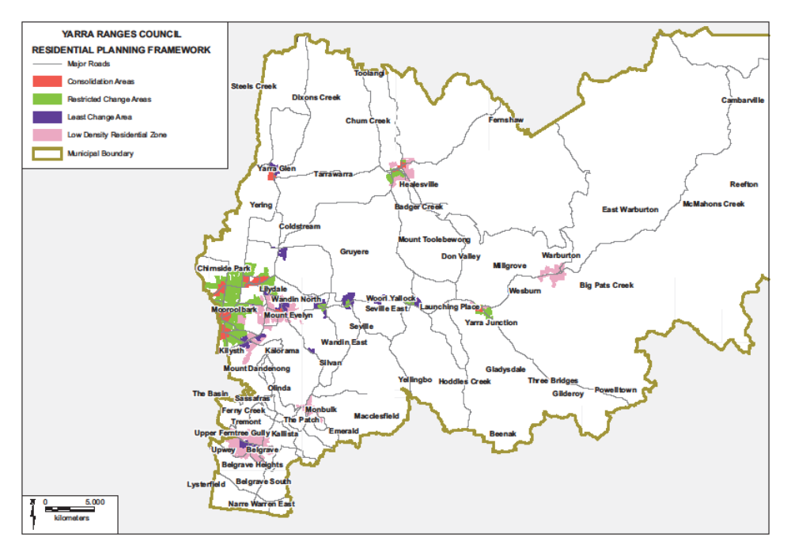
Figure 2. Residential Planning Framework
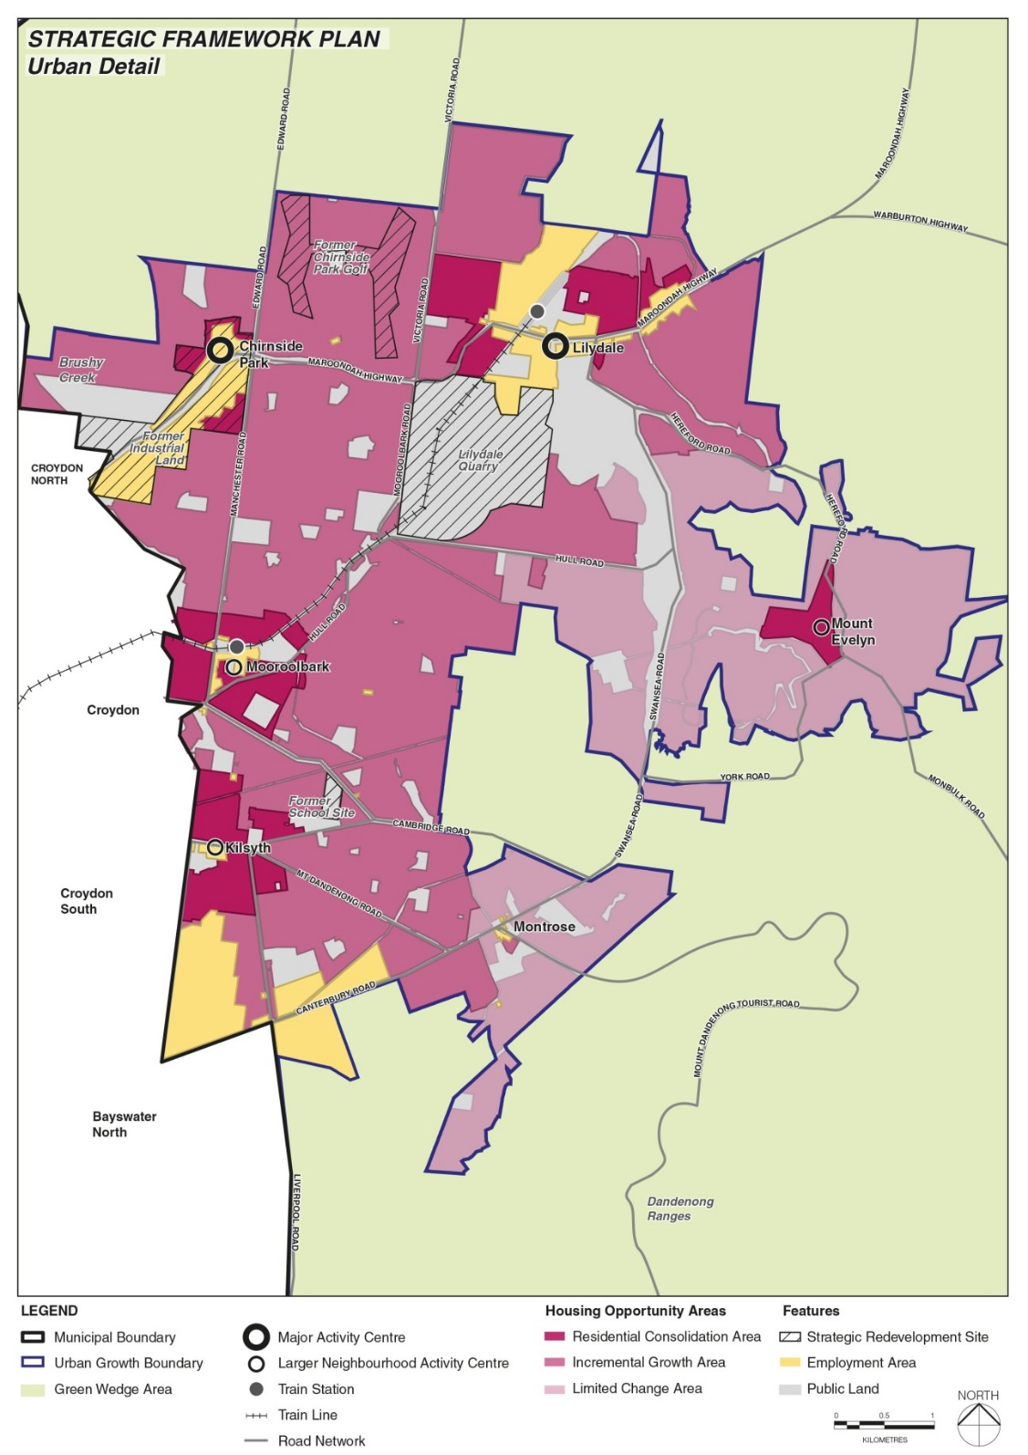
Figure 3 Urban Detail Residential Planning Framework

Existing Planning Scheme Policies

The Yarra Ranges Planning Scheme contains the following relevant policy clauses and statements:

State Planning Policy
11 (Settlement): “Planning is to anticipate and respond to the needs of existing and future communities through provision of zoned and serviced land for housing, employment, recreation and open space, commercial and community facilities and infrastructure.”
11.01-1R (Green wedges): “Metropolitan Melbourne: To protect the green wedges of Metropolitan Melbourne from inappropriate development.”
11.03-1S (Activity Centres): “To encourage the concentration of major retail, residential, commercial, administrative, entertainment and cultural developments into activity centres that are highly accessible to the community.”
11.03-5S (Distinctive Areas and Landscapes): “To recognize the importance of distinctive areas and landscapes to the people of Victoria and protect and enhance the valued attributes of identified or declared distinctive areas and landscapes.”
13 (Environmental Risks and Amenity): “Planning should strengthen the resilience and safety of communities by adopting a best practice environmental management and risk management approach.”
15 (Built Environment and Heritage): “Planning is to recognize the role of urban design, building design, heritage and energy and resource liveable and sustainable cities, towns and neighbourhoods.”
16 (Housing): “Planning should provide for housing diversity, and ensure the efficient provision of supporting infrastructure; ensure the long term sustainability of new housing, including access to services, walkability to activity centres, public transport, schools and open space; include the provision of land for affordable housing.”
16.01-2S (Housing Affordability): “To deliver more affordable housing close to jobs, transport and services.”
16.01-5S (Residential Aged Care Facilities): “To facilitate the development of well-designed and appropriately located residential aged care facilities.”
19.03-1S (Development and Infrastructure Contributions Plans): “To facilitate the timely provision of planned infrastructure to communities through the preparation and implementation of development contributions plans and infrastructure contributions plans.”

Municipal Planning Strategy
02.02 Vision: “The efficient use of urban land will avoid the need for urban encroachment in the Green Wedge.”
02.03-1 (Settlement): “There are opportunities for more intensive development within and adjoining activity centres to provide additional housing and employment generating land uses.”
02.02-3 (Environmental Risks and Amenity): “Discourage additional dwellings, subdivision and other sensitive land uses in bushfire prone areas and where the required defendable space would necessitate significant removal of high-quality indigenous vegetation; locate and design development to minimize the potential risk from flooding; locate and design development within areas of landslip risk to minimize the potential risk to life and property.”
02.03-1 (Activity Centres): This Clause contains Yarra Ranges’ Activity Centre Hierarchy
02.03-5 (Built Environment and Heritage): “Protect and respect sensitive environments, significant landscapes and cultural and natural heritage.”
02.03-6 (Housing): “Council’s strategic directions for housing area to:
- Support residential growth, increased densities and housing diversity in the consolidation areas of the major activity centres,
- Support diverse housing on key redevelopment sites and combined lots that are close to community services, local employment and public transport,
- Support affordable housing in new developments in consolidation areas and other locations with access to town centres, commercial and community facilities,
- Contain residential subdivision within the existing Urban Growth Boundary,
- Discourage housing in locations that would increase the potential for land use conflicts and adverse impacts on landscape amenity or the environment,
- Support aged care accommodation in locations that meet the needs of an ageing population.”
02-03-9 (Infrastructure): “Consolidate future development in fully serviced areas within the Urban Growth Boundary.”

Local Planning Policy
11.01-1L-01 (Settlement): “Support residential infill development in the consolidation areas of large neighbourhood activity centres or where appropriate to the role or the town or suburb consistent with Table 2 to Clause 2.03-1.”
11.03-1L-01 (Activity Centres)
16.01-1L (Housing): Yarra Ranges’ current Residential Framework is found in this Clause.

These towns were the subject of planning scheme amendment C159, which applied the current residential controls. This amendment was approved by the Minister for Planning 20 November 2020. There is no strategic support for any further changes to these towns at this time.

