
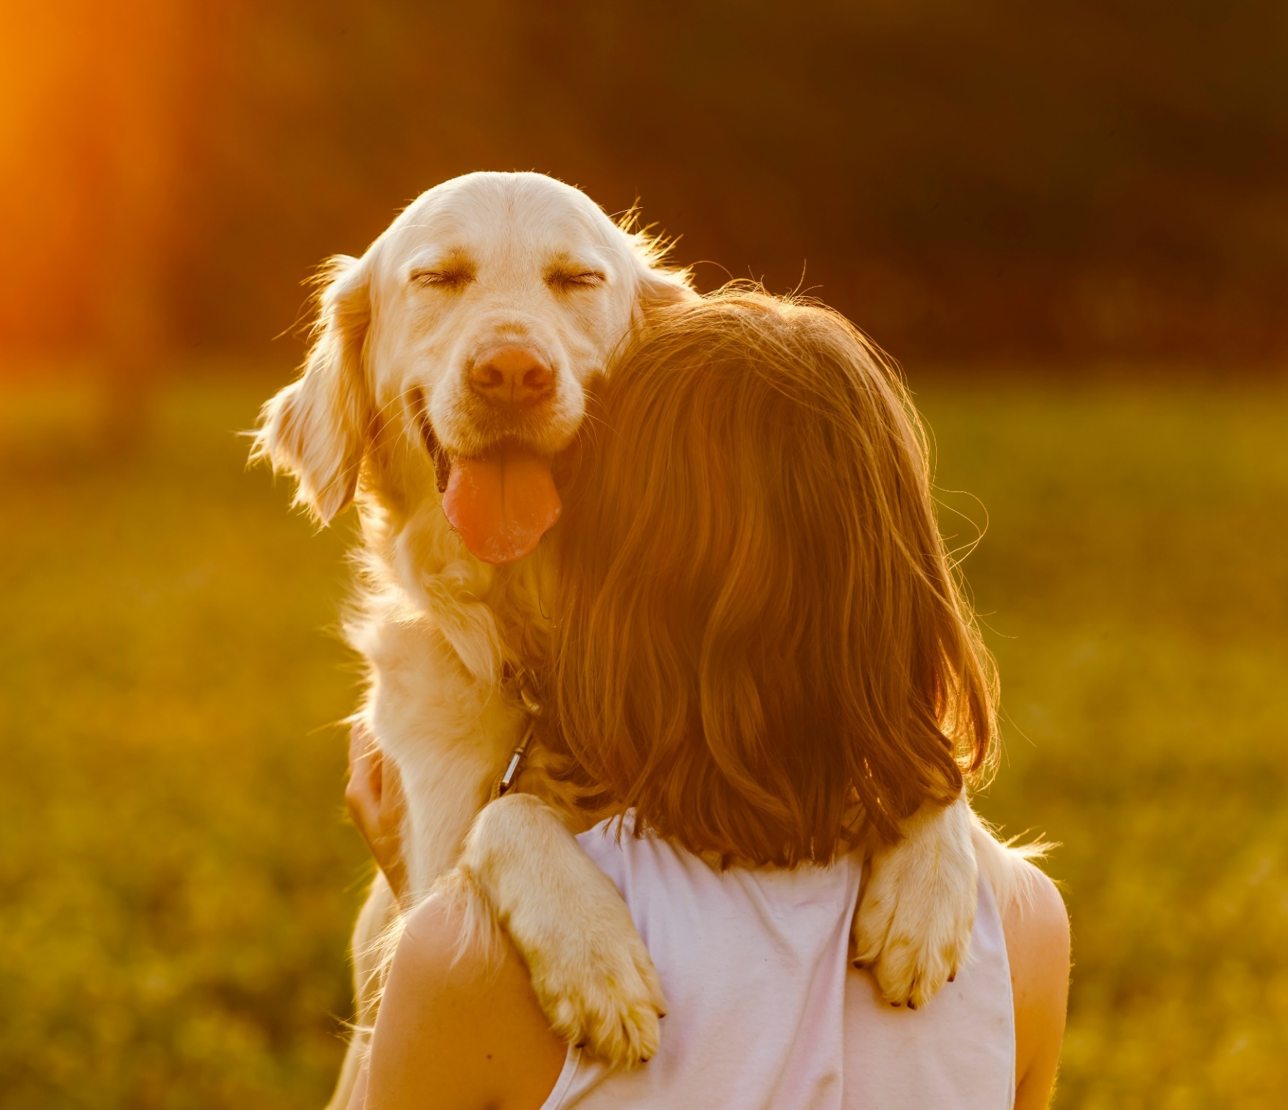
Yarra Ranges

DRAFT Domestic
Animal Management Plan 2022-26



Acknowledgement of Country
Yarra Ranges Council respectfully acknowledges the traditional owners, the Wurundjeri people, as the custodians of this land. We pay respect to all Aboriginal community Elders, past and present, who have resided in the area and have been an integral part of the history of the region.

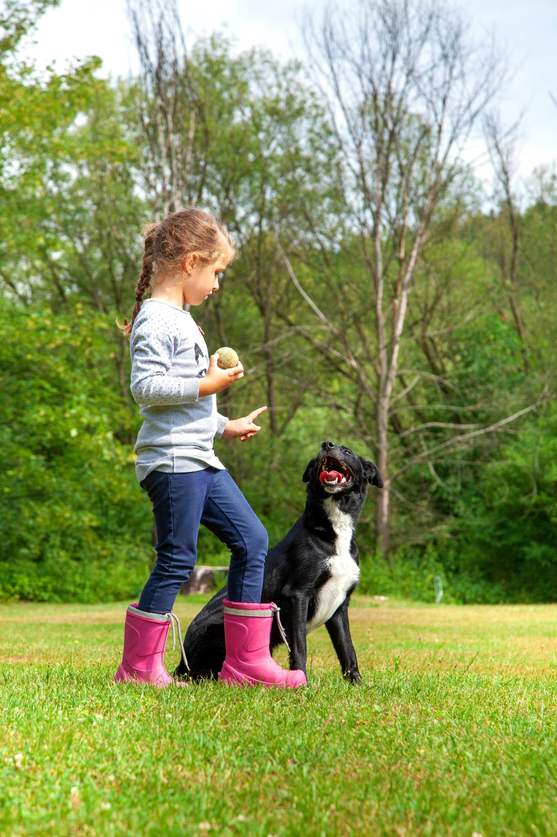

Our Vision

Whether you live here or visit, you will see how much we care for Country, how in inclusive and connected our communities are, and how balanced growth makes this the best place in the world.

Principles that guide our services

We aim for a community where pets are valued and treated humanely, living in harmony with people, other animals, and the environment.

To achieve this we:
- support and value the role of pets in our community
- recognise pets are considered ‘members’ of most families and include species of animals other than cats and dogs
- need pet owners to responsibly care for and protect their pets and ensure they do not adversely affect other pets, people, wildlife, or the environment
- are proactive in addressing service issues and priorities, recognising the need for community and Council to work closely together
- share responsibilities with community to ensure compliance with State and Council policy and legislation
- need the community to work with us to address issues that might arise, particularly in relation to pets in crisis situations
- acknowledge some issues we need to address are complex and their solutions may stir opposing points of view
- believe the way we treat our animals reflects us as a community.

Focussing on objectives of:
- Ensuring Council staff have access to professional development opportunities relating to animal management
- Proactively promoting and managing Councils pet registration program
- Promoting delivery of community education regarding responsible pet ownership
- Ensuring the safety and wellbeing of our community, infrastructure, tourism, wildlife, and the natural environment
- Working with our community, businesses, and networks to help our local Domestic Animal Businesses to manage and grow responsibly
- Advocating for the safety, health and wellbeing of domestic animal registered within the municipality
- Using data to inform our service delivery and decision making

Table of Contents
A message from our CEO 6
Executive Summary 7
Glossary 7
Introduction 9
Councils Planning Context 9
Preparing the Plan 11
Our Story and Understanding Our Services 12
Key Achievements and Focus Moving Forward 12
Our Core Services 12
Local Laws and Orders 13
Evaluating our Service 14
Addressing Legislated Requirements 15
Why we have a Domestic Animal Management Plan 15
Training of Authorised Officers 15
Promoting and Encouraging Responsible Ownership 17
Minimising Risk of Attacks 18
Over-population, Euthanasia, and Abandoned Pets 20
Registration and Identification 21
Dealing with Nuisances 23
Managing Dangerous, Menacing, and Restricted Breeds 25
Other Matters 27
People and Dogs in Parks 27
Domestic Animals and the Environment 27
Domestic Animal Business (DAB) 28
Animal Welfare and Domestic Violence 28
Pets in Emergencies 29
Child Safety 29
Gender Impact 29
Appendix A: Consolidated Action Plan 30
Appendix B: Key Service Data 36
Appendix C: Neighbourhood Amenity Local Law - Animal Keeping 37


Foreword

A message from our CEO
Welcome to our Domestic Animal Management Plan 2022-26.
For community members, there are few Council services that are as close-to-home than those about our pets.
Our pets are, quite simply, members of the family. They enrich our lives which is why we feel devastated at the thought of them getting lost, encouraging us to keep them safely both in and outside of the home. We have a responsibility to provide shelter, care, and comfort for them and allow them to enjoy their world safely while respecting the rights of others when out and about.
No time has outlined the importance of pets more than the last two years of the pandemic, where our pets became our everyday companions and, for many of us, part of our working lives.
This Domestic Animal Management Plan lays out responsible pet ownership and the need for pet owners to keep their pets registered, safe, happy, and healthy. It also outlines in detail, Council responsibilities in setting and enforcing rules around pets and creating ways for pets and their owners to have fulfilling lives here in the Yarra Ranges. This covers the things we have to do as Local Government – such as pet registration, the training of authorised officers, and our work with Animal Aid to connect owners with their lost pets. There are also areas we will be focusing on through our upcoming People and Dogs in Parks Plan including: using data to inform our services, educating the community about responsible pet ownership, and providing off-leash and recreation areas.
Of course, how we manage pets is an ongoing partnership with the community which is why this plan has been shaped with community feedback, helping us outline key areas to work in, such as maintaining community safety, managing wandering cats and reducing the number of strays, and reducing animal related nuisances. This ensures peace and comfort for everyone, community members and pets alike.
This plan details how we will achieve this and lists what we will do with clear goals, when we will get there, and how we will improve our work while educating the community.
I hope you find this plan comprehensive yet clearly stating a community approach to responsible pet ownership. Should you wish to explore this topic further, including details of your local off-lead parks, we would welcome you to visit yarraranges.vic.gov.au/pets.
Tammi Rose,
CEO, Yarra Ranges Council

Executive Summary
Animal management is now a diverse industry, where Council plays an integral role in protecting and promoting responsible animal ownership in the community.
The Yarra Ranges Domestic Animal Management Plan (DAMP) provides Council and community with a framework for identifying and addressing matters associated with the management and wellbeing of cats and dogs. It identifies animal management compliance and education initiatives carried out by Council, and new initiatives identified to address emerging issues. It also identifies opportunities for community and Council partnerships to tackle challenges associated with pets (predominately dogs and cats per legislative requirements) in the community.
The DAMP has been developed in line with Victorian State Government requirements for all Councils to develop a DAMP every four years.

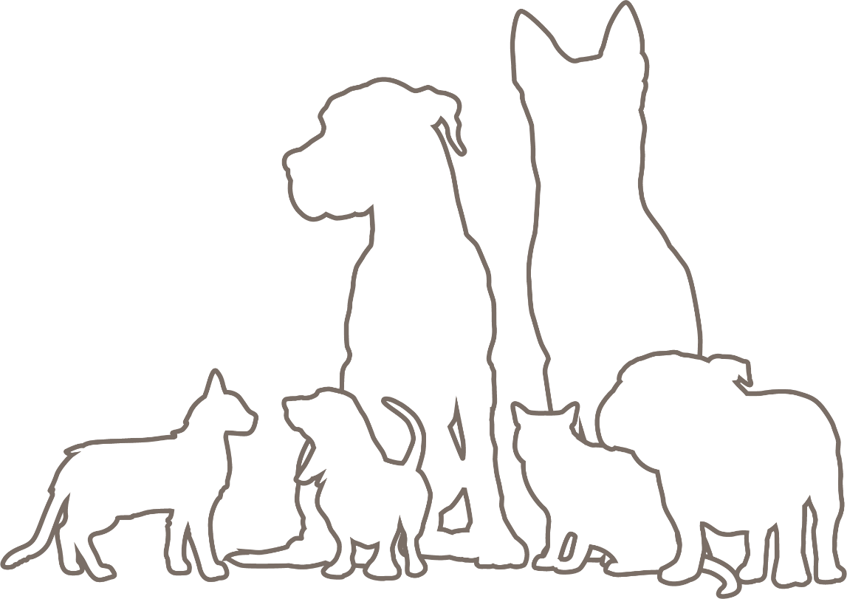

Glossary
Term | Definition for the purpose of this document
AMA | Animal Medicines Australia
Authorised Officer | Person Authorised by Council under section 224 of the Local Government Act 2020 to administer or enforce legislation
AVA | Australian Veterinary Association
CSOs | Community Safety Officers
DAA | Domestic Animals Act 1994 (the Act)
Dog Rush | A dog that has approached a person to a distance less than 3 metres, displaying aggressive tendencies that may include snarling, growling or raised hackles.
Feral Cat | Cats which do not obtain any food or shelter from humans. Estimated to represent only 10% of cats entering pounds.
LGA | Local Government Area
Local Laws/Order | Ordinances put in place by Council under various Acts of State Government
Owned Cat | Cats that receive full care by owners
Pets | Within this document Pets refers to cats and dogs
Pet Survey | Yarra Ranges Pet Survey 2022
POCTA legislation | Prevention of Cruelty to Animals Legislation
RSPCA | Royal Society for the Prevention of Cruelty to Animals
YRC (or Council) | Yarra Ranges Council
Restricted Breed | Dogs that are identified in the Approved Standard of Restricted Breed Dogs in Victoria. These breeds include American Pit Bull Terrier, Perro de Presa Canario, Dogo Argentino, Japanese Tosa, and Fila Brasileiro
Semi-owned cats | Cats that have been given some form of long-term care (generally food) by humans.
Stray Cat | Typically, are lost or wandering owned cats, abandoned cats, or semi-owned cats receiving some care (e.g., food) from humans.

Introduction

Councils Planning Context
Yarra Ranges is home to a population of 157,419 which is expected to increase to 175,326 by 2032 (id, 2021). The increase in residential population will also result in an increase in cat and dog ownership which will place further pressure on community safety and animal management services provided by Council.
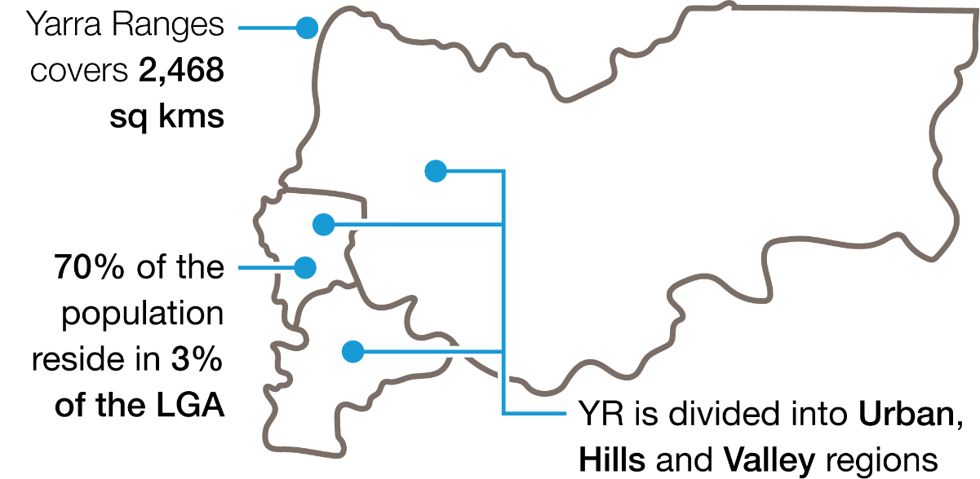

Due to its geography, Council must address complex issues associated with pets residing in different urban and agricultural landscapes, and in areas adjacent to protected and endangered flora and fauna environments.
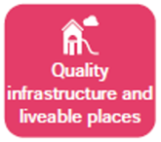
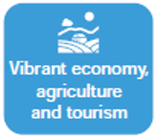
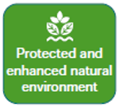
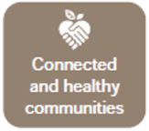
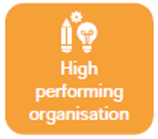
An integrated approach to planning for pets in the community enables Council to understand and address pet related matters with implications for other Council services. These include considerations relating to pets in situations of domestic violence, pet related tourism, and planning for dogs in public spaces. It also enables Council to identify new and innovative ways to achieve opportunities associated with pets with relevance to the Council Plans key strategic objectives.

Our Community Values and Municipal Vision Statement guide us in design and delivery of services within these objectives. These views, including those below, help us navigate our challenges and keep our aspiration that community is at the heart of everything we do alive.

Community Values

“We value the way we help each other in times of need and how we work together to make our communities safe and friendly places to settle into and raise our families”

“We value the diverse and unique environment we live in.. we value our active spaces and our healthy lifestyle”

“We value our close connection to place… and our role in respecting these places”

“We value our “best of both worlds” location… and that no one need feel isolated or unable to be part of our divers and inclusive community”

“We value that we live somewhere special that others come to visit”

Municipal Vision

“Through a local planning approach, the strength of local communities and their sense of place is enhanced, recognising they are diverse and have different needs to support their health, safety, and wellbeing”

“At the heart of our vision is an authentic desire for Council to engage and listen to all members of our community”

“Yarra ranges is known to prioritise the protection of biodiversity and habitat”

“Council resources are managed responsibly, and principles of fairness and consistency are applied”

Preparing the Plan


Research and consultation for the DAMP will be carried out in two stages:

Stage 1 – undertaken in April and May 2022 involving:
- a review of Council documents and policy having implications for the DAMP, including Council Plan, the Health and Wellbeing Plan, and the Recreation and Open Space Strategy, and the Draft People and Dogs in Parks Plan
- a workshop with staff from relevant council service areas
- a community survey that attracted 460 respondents
- submissions from residents and community organisations
- opportunities to be involved in the preparation of the DAMP were promoted via:
  - A newsletter distributed to 11,300 people
  - Facebook posts and Council website
  - Direct email to 1,300 people who registered for updates on Council’s ‘Shaping Yarra Ranges’ webpage
Consultation results from Stage 1 of the project are available on the Yarra Ranges Council website at: https://shaping.yarraranges.vic.gov.au/domestic-animal-management-plan.

Stage 2 – Community Consultation on the Draft DAMP (Conducted September-October 2022).

Our Story and Understanding Our Services

Key Achievements and Focus Moving Forward
Council aimed to deliver an ambitious program of initiatives through its previous DAMP and despite being affected by the COVID-19 pandemic, still achieved the core of its planned outcomes (per Our Core Services) to improve safety and liveability relative to domestic animals and their place in society.
The COVID pandemic interrupted the normal course of service delivery due to implementation of lockdown regulations and requirements for social distancing. This required flexibility in the delivery of community support services coupled with the diversion of resources to assist with storm recovery, which resulted in some initiatives proposed in the previous DAMP being deferred. Councils’ intent is to ensure these key initiatives, such as developing trial programs to address dog and cat containment issues, and investigating industry initiatives to minimise over-population of cats, are addressed in our ongoing service provision.
Together with finalising Yarra Ranges approach to off-leash and recreation areas through its People and Dogs in Parks Plan, Councils focus moving forward will be to strengthen community safety and knowledge through targeted education and initiatives including:
- protecting environmentally sensitive areas, through education and enforcement action
- safe management of domestic animals in times of emergency
- initiatives to raise awareness on causes and consequences of dog attacks and rushes
- focusing on minimising the number of semi-owned cats
- undertaking targeted feral and stray cat trapping programs

For a detailed list of actions refer to the Consolidated Action Plan at Appendix A.

Our Core Services
Community Safety Officers are committed to working within legislated regulations and obligations while providing the following services to Yarra Ranges community:

Animal Management Service
Collecting stray animals, containment for collection, and lost pets
Reuniting registered lost pets with their owners
Administration of pet registrations – Including running an annual renewal campaign
Reviewing and issuing permits (excess animals, domestic animal businesses and voluntarily enrolled foster carers)
Enforcing animal related provisions under the Neighbourhood Amenity Local Law and other State Government Acts.
Conducting patrols of public spaces and parks where animals are found to be causing a nuisance
Nuisance animal property inspections
Providing advice and education to pet owners
Responding to customer requests and complaints about domestic animals
Overseeing Councils contact for the provision of pound services and related programs
Respond to attack reports that are an immediate safety risk
Investigation, enforcement and prosecution of dog attacks, dog rushes and dogs at large

Local Laws and Orders
The Act allows Council to make specific directions or orders to protect public amenity and provide pet owners with a clear understanding of responsibilities.
The Neighbourhood Amenity Local Law (2020) and Council Orders have been established by Council in relation to the keeping and management of animals:
- A permit is required to keep more than two dogs, and/or two cats on any property less than 2000m2 in size.

The following Orders apply in relation to dogs in public places:
- Dogs must be kept on a leash in all public places other than in areas that are specifically designated as areas where dogs are permitted off the leash
Effective control means dog owners
- have the dog on a leash or under voice command,
- can see what the dog is doing, and
- can demonstrate that the dog will return promptly on command.
- Owners must ensure their dogs do not worry, threaten, rush, or attack another person or animal
- Dog owners must carry a device suitable for immediately picking up dog litter and responsibly disposing of it
- When in a designated off-leash area, dogs may be exercised off the leash if the owner:
  - carries a leash and immediately leashes their dog if circumstances require
  - remains in ‘effective control’ of the dog
  - does not allow the dog to worry, threaten, rush, or attack another person or animal
  - obeys all rules displayed on signs to do with an off-leash area
- Dogs are always prohibited:
  - on ovals and sports fields except for dog training activities approved by Council and relevant Committees of Management
  - within 20 metres of fixed playground equipment
  - within 20 metres of fixed fitness equipment
  - within 20 metres of permanent BBQ or picnic area
  - on designated beach areas
- The following Orders have been established by Council in relation to cats:
  - Cats are required to be confined to their owner’s property 24 hours a day (cat curfew)

Evaluating our Service
In line with the Act, Council has established criteria for monitoring implementation of Actions provided for in this DAMP. The tasks set out in the Action Plan respond to service priorities identified following consultation and research undertaken for its development.
In addition, council will:

conduct regular short community pulse surveys to test if community sentiment changes over the term of the DAMP | monitor relevant evidence-based research and as a result review service delivery where practical | focus on opportunities to improve service responsiveness, efficiencies, and extend partnerships in animal management.

Council will conduct annual reviews to identify opportunities that address emerging issues and will undertake a full review of all activities, outcomes, successes, and learnings from this DAMP in the 2025/26 financial year.

Addressing Legislated Requirements

Why we have a Domestic Animal Management Plan
Under Section 68A of the Domestic Animals Act 1994 (the Act) every Victorian Council must prepare a DAMP every four years to:
- demonstrate Council provides and evaluates services to ensure it implements all the requirements of the Act and other relevant State Government legislation
- outline programs for the training of authorised officers to ensure that they can properly administer and enforce the requirements of State Government legislation
- outline programs, services and strategies relating to pets that will:
  - promote and encourage responsible ownership
  - ensure people comply with the Act, any regulations, and other relevant legislation
  - minimise the risk of attacks by dogs on people and other animals
  - address any over-population and high euthanasia rates
  - encourage registration and identification of dogs and cats
  - minimise the potential for dogs and cats to create a nuisance
  - identify ‘dangerous’, ‘menacing’ and ‘restricted’ breed dogs and ensure they are kept appropriately.
- ensure existing orders and local laws are current and appropriate for management of dogs and cats
- ensure all matters relating to the management of dogs and cats are identified and considered
- evaluate the DAMP’s programs, services, and strategies.

Training of Authorised Officers

Aim:
To ensure staff have appropriate knowledge and skills to deliver services in line with current and emerging service requirements. Addressing this means staff have the expertise to respond to service demands professionally and proactively.

Background
The Community Safety Team includes 13 full-time equivalents comprising both full and part-time Authorised Officers. As part of its charter, the team provides administrative, operational and customer service support across the organisation and to the community.

Table 1: Training outline and frequency requirements for our Community Safety Officers.
TRAINING | SCHEDULE
Animal Management Induction Program | All new staff upon commencement
Certificate IV – Government  Certificate IV – Animal Control and Regulation  Certificate IV – Government Investigations | Upon appointment or as required  “  “
Industry Training:  - Animal handling & animal assessment  - Statement taking & brief preparation | As required  “  “
Situational Awareness and Conflict Resolution | Annually
Baton Training | Annually
Restricted Breed Identification Accreditation | Annually
Aggressive Dog Handling | Annually
Mental Health First Aid | Renewed every 3 years
Animal management training (State & Others) | As required
Child Safety Standards session | Every 6 months
Existing training schedules (above) will be continued for the duration of this DAMP.

Reflecting Yarra Ranges ongoing commitment to training, research involving over 4,000 respondents demonstrates a high level of satisfaction among respondents having interacted with the Community Safety Team:
- 85% of respondents agreed that council staff care about the welfare of pets
- 79% of respondents agreed that council recognises the importance of pets
- 87% of respondents agreed that council officers are helpful and courteous

Our Key Initiatives and Actions
Action # | Action | Timeframe

GOAL: Staff will be supported to pursue professional development, networking, and knowledge sharing opportunities within the animal management sector
1.1.1 | Council staff are supported to complete compliance modules and maintain professional standards. | Ongoing
1.1.2 | Attendance at industry workshops, seminars or conferences relating to animal management is promoted and encouraged | Ongoing

GOAL: Ensuring that our Community Safety Team have appropriate expertise, knowledge, and skills to carry out their work
1.2.1 | Undertake a review and improvement program of our animal management processes | 2022-23
1.2.4 | Introduce bi-annual child safety training including enforcement of responsibilities (such as disclosure) under the Child Wellbeing and Safety Act 2005 | 2022-23

Promoting and Encouraging Responsible Ownership

Aim:
To encourage a pet owning community that understands their responsibilities. Addressing this means people and pets live in harmony with each other, the community, and the environment.

Background
Council recognises ‘responsible pet ownership’ can be interpreted very differently by individuals, communities, and groups with different opinions on management and control of pets including taking responsibility for their welfare and behaviour.
Through service delivery guided by the DAMP, Council will ensure effective communication across multiple facets of pet ownership including objectives listed in the Consolidated Action Plan. The DAMP and its actions will promote and encourage not only responsible pet ownership, but also community safety, our pet’s welfare, and protection of our natural environment.
Council is committed to clear and specific messaging and action about pet owner responsibilities, particularly as they relate to compliance with relevant state and local government legislation.

Our Key Initiatives and Actions
Action # | Action | Timeframe

GOAL: Engage with our community regarding responsible pet ownership
3.1.1 | Deliver contemporary information to community through face-to-face, online sessions or online channels | Ongoing
3.1.2 | Have members of the Community Safety Team attending both on-leash and off-leash dog areas and engaging with dog owners | Ongoing
3.1.3 | Develop a program identifying and addressing location specific issues (such as nuisance animals) based on community feedback | 2023-24

GOAL: Educate and promote responsible pet ownership in both on leash and off leash areas, including the impacts on environmentally sensitive areas
3.5.1 | Community Safety Team members will ensure a presence of Authorised Officers at on leash and off leash areas including areas where dogs are prohibited | Ongoing

GOAL: Raise awareness for responsible pet ownership and animal welfare concerns within the community
3.6.1 | Campaign for increased community awareness concerning the safe transport of domestic animals within cars and utility vehicles | Ongoing
3.6.2 | Ensure Council employees and the community are aware of, and action, reporting of animal welfare concerns to appropriate authorities | Ongoing

Minimising Risk of Attacks

Aim:
To minimise risk of dog attacks and rushes through education and community support. Addressing this creates safe public environments and dog owner awareness of their responsibilities.

Background
Dog attacks and dog aggression presents a substantial risk to community and Community Safety Officers attending these events. Research demonstrates most dog attacks generally occur in the home, or where the dog is known to the victim. Most bites occurring in the home are a result of lack of adult supervision and children are at least three times more likely to need medical attention for a dog bite than any other age group.
‘Menacing Dog’ - A dog can be declared as a ‘menacing dog’ if it has ‘rushed’ at a person or animal or inflicted a non-serious bite injury to a person or animal.
‘Dangerous Dog’ – A dog can be declared ‘dangerous’ if it has incurred two ‘menacing dog’ violations or caused death or serious injury to a person or animal.
‘Dog Rush’ – A dog that has approached a person to a distance less than 3 metres, displaying aggressive tendencies that may include snarling, growling or raised hackles.
Dogs are automatically declared dangerous if they are trained to attack or used as guard dogs.
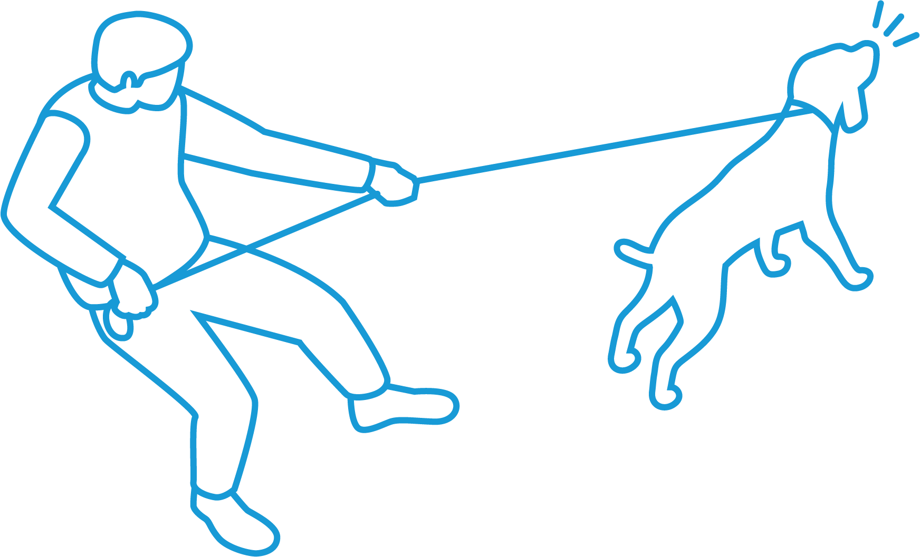
Council also recognises numerous factors can influence a dog’s tendency to behave either aggressively or inappropriately. These factors can include:
- Lack of training or socialisation
- Experiences in a dog’s younger life
- The gender or age of a dog
- A dog’s heredity (e.g., genes, breed)
- The behaviour of victims whether another dog or a person
- Overcrowding or congestion in a public environment (e.g., in a fenced off-leash area or retail footpath environment)
- Owners failing to read environmental indicators potentially triggering aggressive dog behaviour

Since 2018, Council overall has seen reductions in reported dog attacks and dogs reported to be wandering at large, with only a slight increase in the number of dog rushes reported.

Table 2: Dog attack, rush, and ‘at large’ trends 2018-22
INCIDENT | 2018/19 | 2019/20 | 2020/21 | 2021/22
Dog Rush | 109 | 91 | 99 | 101
Dog Attack | 162 | 186 | 180 | 157
Dog Wandering | 383 | 263 | 312 | 297

Council has a thorough investigation process relative to dog attacks causing serious injury. Prosecution of dog owners for dogs involved in attacks is based on:
- Injury seriousness
- Nature of the attack
- Provided or available evidence
- A dog’s behaviour and owner actions
- Community risk
Dog attacks causing non-serious injuries can be enforced by either prosecution, or an infringement notice under the Act noting that restrictive control and accommodation measures are placed on a dog that is declared as menacing or dangerous.

Our Key Initiatives and Actions
Action # | Action | Timeframe

GOAL: Educate and promote responsible pet ownership by advocating State Government programs in primary schools and kindergartens
3.4.1 | Actively promote programs including those such as ‘Responsible Pet Ownership Program’ and ‘Dog Bite Prevention Program’ delivered through Agriculture Victoria | Ongoing
3.4.2 | Advocate for the benefits of a state-wide campaign aimed at reducing instances of dog attacks, wandering dogs, and dog rushes | Ongoing

GOAL: Promote and raise awareness within the community regarding the risk and seriousness of dog attacks
4.1.1 | Encourage more registered dog training businesses through reducing the cost of application fees and encouraging trainers to focus on behaviours that prevent dogs attacking | 2022-23
4.1.2 | Undertake annual review of Councils dog attack investigation process ensuring timely and effective responses while referring matters to court as required | Ongoing
4.1.3 | Refine and improve Councils enforcement guidelines, policies, and processes to assist Council in successful court action in events of serious dog attacks | 2023-24

GOAL: Ensure that all declared dangerous and/or menacing dogs within Yarra Ranges are effectively registered and managed
4.2.2 | Review processes regarding the declaration of a dangerous and/or menacing dog to support responsible pet ownership and community safety | 2023-24

Over-population, Euthanasia, and Abandoned Pets

Aim:
To minimise numbers of stray, abandoned, and unwanted pets. Addressing this improves welfare outcomes for pets and for people working in the animal welfare sector.

Background
There was an 18% decrease in the number of dogs impounded between 2018 and 2021, 483 compared to 396 respectively, a decrease of 87 dogs. This was also the case for cats, with 320 impounded in 2021 compared to 457 in 2018, a decrease of 137.
Council understands the COVID pandemic will likely have affected the number of pets impounded and surmises the decrease in impoundments is related to an increase in residents working from home, with pets less likely to wander during this period.
Council also recognises a need to address the high euthanasia rate for dogs and in particular, cats. In 2021 only 83 of the 320 (26%) of cats impounded were reunited with owners, in contrast to 321of the 396 (81%) dogs impounded.
Animals that are not reclaimed are offered for rehoming if they meet temperament and health requirements. Animals may be euthanised if they have an untreatable disease or if they have temperament issues that pose a risk to the community.
Of the 237 of unclaimed/unowned cats:
- 151 (63%) were rehomed by adoption, an increase of 24 from 2020 figures
- 80 (34%) were euthanised, approximate to 82 euthanised in 2020
- Six (3%) remain available for adoption

Of the 65 unclaimed/unowned dogs:
- 34 (53%) were rehomed by adoption programs
- 25 (38%) were euthanised, approximate to 14 euthanised in 2020
- 6 (9%) remain available for adoption
Council attempts to return registered dogs and cats found outside their property to owners rather than impound them. Reuniting cats with their owners is more difficult to achieve because of high numbers not being microchipped and owners unable to be identified.
Increasing microchipping of cats is a priority for our community. To successfully reduce euthanasia rates, there needs to be an increase in reuniting animals with their owners, and an increased adoption rate.
A focus of this DAMP is building partnerships with relevant organisations and residents to secure the best health and wellbeing outcomes for animals with a concentration on semi-owned cats, protecting wildlife environments, and neighbourhood amenity. Semi-owned cats can negatively affect the community in several ways while contributing to issues of over population. These cats are predominantly unowned however are being supported and looked after by someone in the community who is providing them with their basic needs.

Definitions of different cat populations

Owned cat | Cats receiving full care by owners. | 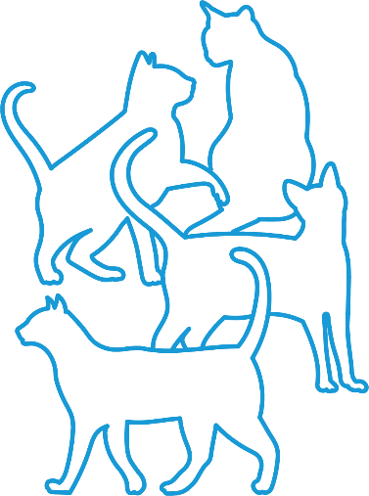
Stray cats | Typically, are lost or wandering owned cats, abandoned cats, or semi-owned cats receiving some care (e.g., food) from humans.
Semi-owned cat | Cats that have been given some form of long-term care (generally food) by humans.
Feral | Cats which do not obtain any food or shelter from humans. Estimated to represent only 10% of cats entering pounds.
Ref: Managing Cats Humanely and Scientifically to Reduce Cats, Wildlife Predation and Costs, J. Rand

Our Key Initiatives and Actions
Action # | Action | Timeframe

GOAL: Educate and inform the community concerning the management of dogs
3.2.4 | Ensure advocacy and funding opportunities regarding dog desexing to help subsidise registration costs for owners participating such schemes | Ongoing

GOAL: Work with community, businesses, and organisations to increase the rehoming rate of abandoned or surrendered animals
6.1.1 | Partner with Animal Aid to promote and assist in improving rehoming rates of dogs and cats from pound facilities | Ongoing

Registration and Identification

Aim:
To increase cat and dog registrations in line with industry estimations and projected populations. Addressing this ensures Council has the necessary information and resources to appropriately meet service demand.

Background
As of 2021 there are 25,185 dogs, and 8,483 cats on Council’s registration database, a total of 33,668 animals. This is a decrease of 4,438 (-12%) between 2018 and 2021.
According to Animal Medicines Australia (AMA) the ‘owned’ dog and cat populations in Australia are likely to be notably higher than are reflected on local government data bases.
AMA suggests there are likely to be 30,087 dogs and 21,871 cats residing in Yarra Ranges. This is 4,902 more dogs and 13,388 more cats than registered. If estimations are applied to future household numbers, then in 2032 there will be near 36,000 dogs and 26,000 cats residing in the community.
Compared to other LGA’s, Yarra Ranges has a relatively high registration rate of dogs and cats which is expected to be from its concerted initiatives and community awareness campaigns. Accurate registration numbers assist Council to plan for service delivery and to put in place local and targeted initiatives to address demand. Of note, 86% of respondents to the 2022 Pet Survey stated they had registered their pets, the remaining 14% stated their pet was not registered, or were unsure of their current registration status.
Registration of cats and dogs provides benefits to owners and community alike and as well as enabling Council to fulfill State Government requirements, they enable Council to subsidise additional services including:
- Reuniting registered pets (with no prior incidence of escaping from their property), with their owner
- Provision, monitoring, and management of off-leash areas.
- Expanded cat trapping programs
- Community awareness and education initiatives
- Discounted registration fees for Foster Carers
- Introduction of discounted registration fee incentives.

Our Key Initiatives and Actions
Action # | Action | Timeframe

GOAL: Encourage registration (and registration renewal) of dogs and cats in Yarra Ranges
2.1.1 | Investigate discounted registration fees for eligible new animal purchases from a Yarra Ranges registered Domestic Animal Business Breeder | 2024-25
2.1.2 | Investigate discounted registration fees to any eligible puppy completing a dog training course with a Yarra Ranges registered Domestic Animal Business Trainer | 2024-25
2.1.4 | Proactively investigate and action unregistered pets and/or unpaid registrations within Yarra Ranges | Ongoing

GOAL: Ensure Councils pet registration program delivers benefit to our community
2.2.3 | Provide community updates about the management of pet registration including how fees are used to support delivery of animal management services | Ongoing

Dealing with Nuisances

Aim:
To minimise occurrence of incidents giving rise to animal related complaints. Addressing this protects and enhances neighbourhood amenity and the health and wellbeing of pets and native animals.

Background
Over the two years prior to COVID there was a decrease in cat and dog collections (-22%, and -12% respectively), dogs wandering at large (-9%) and an increase (15%) in the hire of cat traps.
During the first year of COVID there was a notable decrease across all customer request categories, particularly in relation to the allocation of cat traps (-60%), cat pickups (-31%) and dogs wandering (-31%). Largely due to the impact of COVID pandemic restrictions, this data therefore cannot be interpreted as representing any ongoing trend.
Between 2020 and 2021:
- Cat pickups remained the same but 30% (94) lower than pre-COVID
- Cat trap hire increased by 44% (74) but 42% (177) lower than pre COVID
- Dogs wandering at large increased by 18% (49) but 19% (71) lower than pre COVID
- Dog pickups decreased by 29% (165) and remain 43% (309) lower than pre COVID

Table 4. Nuisance Complaints
 | 2018 | 2019 | 2020 | 2021
Cat pick-up | 395 | 310 | 214 | 216
Dog barking | 228 | 230 | 207 | 194
Dog pick-up | 810 | 712 | 569 | 404
Dog wandering at large | 420 | 383 | 263 | 312
Cat trap hire | 364 | 418 | 167 | 241
Total | 2217 | 2053 | 1437 | 1383
Definitions
Cat or dog pick-ups = An animal is contained and ready for collection.
Dog wandering = Dog is not contained and at the time of reporting is wandering at large.

Council will carefully monitor customer requests and complaints and put in location specific programs to minimise the escalation of complaint related matters.

Stray Cats
Feedback from the 2022 Pet Survey demonstrates 37% (170) of respondents are concerned about cats wandering outside their property. In 2013, Council created an Order which requires cats to always be contained to their property. Cats are permitted outside, however need to be contained within the boundaries of their property. Of note, the survey indicated a lack of regard for this Order by some cat owners. To assist in addressing the issue, Council will expand cat trapping services by providing more traps to assist in reducing wait times for the community.
A focus for the DAMP is on reviewing and strengthening initiatives that ensure compliance with cat confinement regulations. Council will also advocate to State Government for consistency in penalties for all animals found outside their property.

 Dog Litter
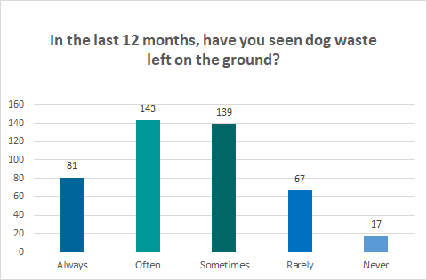
A significant issue to emerge from the Pet Survey relates to increased prevalence of dog litter in public places. 50% (224) of survey respondents state they ‘always’ or ‘often’ see dog litter on the ground and only 4% (17) state they ‘never’ see dog litter left on the ground. A perceived increase in use of parks and trails for dog walking over COVID may indicate the prevalence of dog litter in public places including parks, trails, and footpaths.
Response to the Pet Survey demonstrates the community expects greater enforcement of dog litter disposal regulations noting it is a requirement under the Neighbourhood Amenity Local Law 2020 that an owner remove their dog’s litter.

Barking Dogs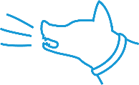
Barking is a natural behaviour for dogs, and it is their way of communicating. However, excessive nuisance barking can cause stress and anxiety amongst the community.
Barking dogs, and dogs wandering outside their property were significant issues for 24% and 23% respectively of survey respondents. This suggests these matters may be impacting on residents more than otherwise indicated from complaints received by Council. Barking dog investigations can also be resource intensive, taking significant time to resolve.
The data on barking dog complaints over the past four years has shown a reduction in initial complaints. This can be attributed to Council providing education to dog owners on how to minimise barking nuisances, and some residents willing to resolve these matters directly with barking dog owners.
This DAMP will explore options to assist residents in starting discussions with their neighbour in the first instance so they can take reasonable steps to resolving the issue before Council investigation and enforcement.

Our Key Initiatives and Actions
Action # | Action | Timeframe

GOAL: Educate and inform the community relating to the management of dogs
3.2.1 | Investigate benefits of litter bag and rubbish bin locations in high traffic areas | 2022-23
3.2.3 | Enhance processes to reduce response timeframes and simplify reporting of barking dogs | Ongoing

GOAL: Educate and inform the community relating to the management of cats
3.3.1 | As well as promoting effective containment options, implement a strategic communication plan targeting area specific environmental and wildlife impacts and distribute to all registered cat owners regarding responsibility in adhering to Councils 24/7 cat curfew, | Ongoing
3.3.2 | Raise community awareness on environmentally sensitive areas, and provide detailed information outlining the negative impacts cats can have on the community, wildlife, and environment | 2022-23
3.3.4 | Implement process efficiencies and increase capacity of the current cat trap service to assist in reducing the impacts of stray and wandering cat | 2023-24
3.3.8 | Liaise with other LGA’s and key stakeholders to advocate to State Government on the importance of a consistent approach to enforcement and penalties of cats found at large | 2024-25

Managing Dangerous, Menacing, and Restricted Breeds

Aim:
To minimise the prevalence of, and ensure the correct management and control of dangerous, menacing, and restricted breed dogs. Addressing this minimises community risk and ensures these dogs are kept in accordance with regulations.

Background
There are six declared menacing or dangerous dogs on Council’s registration database, which is a reduction of four since 2018.
Menacing Dog - A dog can be declared as a ‘menacing dog’ if it has ‘rushed’ at a person or animal or inflicted a non-serious bite injury to a person or animal.
Dangerous Dog – A dog can be declared dangerous if it has incurred two menacing dog violations or caused death or serious injury to a person or animal.
Dogs are automatically declared dangerous if they are trained to attack or used as guard dogs.
There are two Restricted Breed dogs on Council’s registration database. Restricted Breed dogs have not necessarily attacked a person or animal or even displayed signs of aggression. However, they are considered a higher risk to community safety than other breeds of dogs. Restricted dog breeds are Pit Bull Terriers, Presa Canario, Dogo Argentino, Japanese Tosa and Fila Brasileiro.
There are strict requirements for Dangerous Dogs and Restricted Breed Dogs relating to signage, housing requirements, and identification.
Council officers conduct annual inspections to ensure dogs declared as dangerous, menacing or of a restricted breed to ensure they are housed in compliance with regulations.

Our Key Initiatives and Actions
Action # | Action | Timeframe

GOAL: Ensure that all declared dangerous and menacing dogs within Yarra Ranges are effectively registered and managed
4.2.1 | Communicate any relevant updates or changes in legislation to owners of declared dangerous and/or menacing dogs and ensure continued compliance with these requirements | Ongoing
4.2.2 | Review processes regarding the declaration of a dangerous and/or menacing dog to support responsible pet ownership and community safety | 2024
4.2.4 | Ensure Council effectively maintains its own register of declared dangerous and/or menacing dogs and that it matches the Victorian Declared Dog Registry | Ongoing

Other Matters

People and Dogs in Parks
There is a need to recognise dog owners and their dogs as legitimate users of open space and promote an expectation of responsibility and consideration of others while enjoying facilities, parks, paths, and trails provided for their enjoyment.
Local Government Authorities’ face significant challenges in terms of dog owner non-compliance with on and off- leash regulations, as well as in areas where dogs are prohibited. This results in community frustration particularly in terms of dog litter and being confronted by dogs off the lead or not under effective control where people should be able to enjoy open space.
Planning for off leash areas needs to be consistent with space allocated on a defined catchment or demand. For this reason, Council is developing a People and Dogs in Parks Plan regarding management of dog off leash areas, reviewing these spaces, and making recommendations that will make them more appealing. The progress of this plan forms a key part of this DAMP with objectives designed to improve community services, education, and overall experiences.

Domestic Animals and the Environment
Together with the impacts of climate stressors on our domestic animals, and the health, nutrition, housing, and management methods necessary to relieve things such as heat stress, Council recognises that irresponsible domestic animal ownership also has a significant impact on our environment, sometimes with devastating consequence. This is especially true in the case of abandoned and semi-owned animals and their impact to our natural flora and fauna, but also extends to uncontrolled animals in terms of public amenity and disturbance to our native wildlife. Irresponsible domestic animal ownership impacts our environment, threatening native species, biodiversity, and public amenity, while growing urbanisation and climate change impacts our approach to managing domestic animal health and wellbeing. It is an animals owners’ responsibility to ensure domestic animals are appropriately cared for and do not adversely affect our fragile environment while respecting public amenity and the rights of others to utilise public space.
Council’s role in minimising domestic animal impact on our environment is both an education and compliance one. Council plays a key part in animal control and our Community Safety Officers are tasked daily with responding to concerns of dog litter, dogs not under effective control, and cats wandering. Domestic animal registration (including micro-chipping) provides substantial benefit towards effectively managing the challenges faced and is a legislated requirement.
Our intervention strategies included in the Neighbourhood Amenity Local Law 2020 limit the number of dogs and cats allowed on any property in accordance with the size of the land, include general provisions for the housing and keeping of animals on private land, directs owners to collect and remove their pet litter from any road or public place, prevents the owner allowing the animal to cause nuisance, and discourages people to feed pests and wild animals. Penalties may apply for failing to comply, and enforcement action may be taken.
As part of the DAMP, council will proactively respond to issues raised by the community, and enforcement may apply in instances of non-compliance. Community Safety will continue to advocate to State Government to increase the penalty unit for wandering cats, so it aligns with the current penalty for dogs.
Regarding the impact of climate change and urbanisation on our domestic animals, Council has a responsibility to ensure the community is proactively educated as urbanisation dramatically alters the composition of wildlife communities, leading to biodiversity loss, abundance of species and ability for species to thrive in urban areas. Domestic animals are part of the threat to the collective impact of urbanisation and effective animal ownership is part of the solution.

Domestic Animal Business (DAB)
There are 27 DABs in Yarra Ranges, 17 of which are boarding facilities. Thirty-one percent of DABs are in the two townships of Dixons Creek and Macclesfield.

Table 5 - Domestic Animal Businesses in Yarra Ranges (2022)
Training Establishments | Boarding Establishments | Pounds and Shelters | Pet Shops | Breeding Establishments
4 | 17 | 2 | 2 | 2

The Act requires DABs be registered with Council as the authority responsible for inspecting and auditing DABs. Council is committed to identifying and strengthening relationships with DABs to ensure they understand and adhere to their obligations.
In implementation of the DAMP, Council will consider strategies that:
- highlight the benefits of using registered DABs
- promote registered DABs
- encourage people to use the services of registered DABs only, including those that sell or rehome pets such as from registered breeders, pounds, and rehoming groups
- Proactively monitor and engage with unregistered service providers who meet the criteria of DABs.

Animal Welfare and Domestic Violence
In the Yarra Ranges Health and Wellbeing Plan, residents identify family violence as a top health related priority. The plan proposes this matter be addressed through universal and targeted services and education for young families.
The Community Safety Team will work closely with relevant Council departments, community support agencies, and Victoria Police to ensure pet owners in situations of domestic violence are aware of the support and networks and services available.

Pets in Emergencies
Council recognises pet owners have specific needs during times of personal and community crisis. Pets are a significant part of most households, many of which rely on their pets for emotional and mental health support during challenging times. The recent COVID pandemic particularly highlighted the important role of pets. Pet ownership in Australia increased by nearly 10% over COVID with demand exceeding supply.
Mental and emotional anguish is amplified for many pet owners in times of crisis because they are fearful of being separated from their pets, the safety of their pets and/or not being able to care for them. To assist, Council staff work closely with not-for-profit, volunteer, and business sectors to secure appropriate support for pet owners ensuring their pets can be catered for in times of emergency, particularly at Emergency Relief Centres.

Child Safety
Council is committed to promoting and adhering to the Child Safe Standards which aim to protect children and young people, through our endorsed Child Safety and Wellbeing Policy. This aims to make keeping children and young people safe.
The Child Safe Standards help to:
- Promote the safety of children
- Prevent child abuse
- Ensure effective processes are in place to respond to and report allegations of child abuse
- Encourage children to ‘have a say’, especially on issues that are important to them or about decisions that affect their lives.
To ensure the Community Safety (CS) team feel confident, empowered, and supported to disclose child safety concerns, Council have scheduled Child Safety Standards sessions to run every six months.

Gender Impact
To further explore the impacts on gender diversity (including intersectionality) in implementing this plan, Council will undertake Gender Impact Assessments (GIA) on appropriate actions, programs and services outlined within the DAMP.
In line with Victorian Government guidelines, the process of undertaking GIA’s will allow Council to address areas where its policy and approach to domestic animal management may have potential to influence social norms and gender roles in the broader society. This process will establish if Councils services and actions adequately consider the differing needs of all stakeholders, regardless of gender, cultural identity, age, sexual identity or preference, disability levels, religion, or intersectionality. It will also consider if all people are able to access and use council services or if there are hidden barriers limiting access for some people thereby creating inequality in services, resources, or decision making.

Appendix A: Consolidated Action Plan

Objective 1 – Ensuring Council staff have access to professional development opportunities relating to animal management
Action # | Action | Timeframe

GOAL: Staff will be supported to pursue professional development, networking, and knowledge sharing opportunities within the animal management sector
1.1.1 | Council staff are supported to complete compliance modules and maintain professional standards. | Ongoing
1.1.2 | Attendance at industry workshops, seminars or conferences relating to animal management is promoted and encouraged | Ongoing

GOAL: Ensuring that our Community Safety Team have appropriate expertise, knowledge, and skills to carry out their work
1.2.1 | Undertake a review and improvement program of our animal management processes | 2022-23
1.2.2 | Ensure all Community Safety Team members are familiar with relevant processes, policies, and standards | Ongoing
1.2.3 | Promote the skills of our Community Safety Team to ensure a safe and effective service for both community and all animals they interact with | Ongoing
1.2.4 | Introduce bi-annual child safety training including enforcement of responsibilities (such as disclosure) under the Child Wellbeing and Safety Act 2005 | 2022-23

Objective 2 – Proactively promote and manage Councils pet registration program
Action # | Action | Timeframe

GOAL: Encourage registration (and registration renewal) of dogs and cats in Yarra Ranges
2.1.1 | Investigate discounted registration fees for eligible residents of newly purchased or adopted animals from a Council approved pound or shelter | 2024-25
2.1.2 | Investigate discounted registration fees for eligible new animal purchases from a Yarra Ranges registered Domestic Animal Business Breeder | 2024-25
2.1.3 | Investigate discounted registration fees to any eligible puppy completing a dog training course with a Yarra Ranges registered Domestic Animal Business Trainer | Ongoing
2.1.4 | Proactively investigate and action unregistered pets and/or unpaid registrations within Yarra Ranges | Ongoing

GOAL: Ensure Councils pet registration program delivers benefit to our community
2.2.1 | Build and enhance positive relationships with our local registered Domestic Animal Businesses and Veterinary Clinics | Ongoing
2.2.2 | Apply warnings to owners of registered animals found wandering in the first instance rather than infringements | Ongoing
2.2.3 | Provide community updates about the management of pet registration including how fees are used to support delivery of animal management services | Ongoing

Objective 3 – Promote delivery of community education regarding responsible pet ownership
Action # | Action | Timeframe

GOAL: Engage with our community regarding responsible pet ownership
3.1.1 | Deliver community information through face-to-face and online sessions or channels | Ongoing
3.1.2 | Have members of the Community Safety Team attending both on-leash and off-leash dog areas and engaging with dog owners | Ongoing
3.1.3 | Develop a program identifying and addressing location specific issues (such as nuisance animals) based on community feedback | 2023-24

GOAL: Educate and inform the community concerning the management of dogs
3.2.1 | Investigate benefits of litter bag and rubbish bin locations in high traffic areas | 2022-23
3.2.2 | Work with community to minimise the impacts of animal excrement | Ongoing
3.2.3 | Enhance processes to reduce response timeframes and simplify reporting of barking dogs | Ongoing
3.2.4 | Ensure advocacy and funding opportunities regarding dog desexing to help subsidise registration costs for owners participating such schemes | Ongoing

GOAL: Educate and inform the community relating to the management of cats
3.3.1 | Implement a strategic communications plan targeting area specific environmental and wildlife impacts and distribute to all registered cat owners regarding responsibility in adhering to Councils 24/7 cat curfew, as well as promoting effective containment options | Ongoing
3.3.2 | Raise community awareness on environmentally sensitive areas, and provide detailed information outlining the negative impacts cats can have on the community, wildlife, and environment | 2022-23
3.3.3 | Review and improve processes concerning enforcement of cat trespassing orders and local laws including the advertisement of penalties for non-compliance | 2022-23
3.3.4 | Implement process efficiencies and increase capacity of the current cat trap service to assist in reducing the impacts of stray and wandering cat | 2023-24
3.3.5 | Ensure advocacy and funding opportunities regarding cat desexing to help subsidise registration costs for owners participating such schemes | Ongoing
3.3.6 | Ensure Council orders published regarding wandering cats and desexing of cats are appropriately published | Ongoing
3.3.7 | Explore options that may assist the Community Safety Team to identify and reunite wandering cats with their owners | 2023-24
3.3.8 | Liaise with other LGA’s and key stakeholders to advocate to State Government on the importance of a consistent approach to enforcement and penalties of cats found at large | 2023-25

GOAL: Educate and promote responsible pet ownership by advocating for State Government programs in Primary Schools and Kindergartens
3.4.1 | Actively promote programs including those such as ‘Responsible Pet Ownership Program’ and ‘Dog Bite Prevention Program’ delivered through Agriculture Victoria | Ongoing
3.4.2 | Advocate for the benefits of a state-wide campaign aimed at reducing instances of dog attacks, wandering dogs, and dog rushes | Ongoing

GOAL: Educate and promote responsible pet ownership in both on leash and off leash areas, including the impacts on environmentally sensitive areas
3.5.1 | Community Safety Team members will ensure a presence of Authorised Officers at on leash and off leash areas including areas where dogs are prohibited | Ongoing
3.5.2 | Promote off leash areas and any restrictions or changes associated with these open spaces through accessible publication channels | Ongoing

GOAL: Raise community awareness for responsible pet ownership and animal welfare concerns
3.6.1 | Campaign for increased community awareness concerning the safe transport of domestic animals within cars and utility vehicles | Ongoing
3.6.2 | Ensure Council employees and the community are aware of, and action, reporting of animal welfare concerns to appropriate authorities | Ongoing

Objective 4 – Ensure the safety and wellbeing of our community, infrastructure, tourism, wildlife, and the natural environment
Action # | Action | Timeframe

GOAL: Promote and raise community awareness regarding the risk and seriousness of dog attacks
4.1.1 | Encourage more registered dog training businesses through reducing the cost of application fees and encouraging trainers to focus on behaviours that prevent dogs attacking | 2022-23
4.1.2 | Undertake annual review of Councils dog attack investigation process ensuring timely and effective responses while referring matters to court as required | Ongoing
4.1.3 | Refine and improve Councils enforcement guidelines, policies, and processes to assist Council in successful court action in events of serious dog attacks | 2023-24
4.1.4 | Deliver key community messages regarding dog attacks, including the role of Council, potential outcomes, and support services available to victims of these events | Ongoing

GOAL: Ensure that all declared dangerous and/or menacing dogs within Yarra Ranges are effectively registered and managed
4.2.1 | Communicate any relevant updates or changes in legislation to owners of declared dangerous and/or menacing dogs and ensure continued compliance with these requirements | Ongoing
4.2.2 | Review processes regarding the declaration of a dangerous and/or menacing dog to support responsible pet ownership and community safety | 2023-24
4.2.3 | Maintain annual inspection of premises with a registered declared dangerous and/or menacing dog | Ongoing
4.2.4 | Ensure Council effectively maintains its own register of declared dangerous and/or menacing dogs and that it matches the Victorian Declared Dog Registry | Ongoing
4.2.5 | In the event of a dog being reported missing or impounded, Community Safety Team members will ensure relevant registers are checked to provide theirs and others safety | Ongoing

GOAL: Engage and work with others to protect our built and natural environment and wildlife
4.3.1 | Identify opportunities to proactively engage with our Indigenous community regarding domestic animals and related services particularly impacts to the environment | 2023-24
4.3.2 | Provide input to Council and State Government plans, services, and activities that may impact domestic animal services | Ongoing

Objective 5 – Work with our community, businesses, and networks to help our local Domestic Animal Businesses to manage and grow responsibly
Action # | Action | Timeframe

GOAL: Ensure all registered Domestic Animal Businesses comply with relevant Acts, Regulations and Codes of Practice
5.1.1 | Commit to inspecting all registered Domestic Animal Businesses within Yarra Ranges at least annually to ensure the health and wellbeing of their animals and all requirements of operating are being met | Ongoing
5.1.2 | Where a Domestic Animal Business is not meeting their requirements, Council will work with proprietors to ensure their compliance | Ongoing
5.1.3 | Communicate any relevant updates or changes in legislation to Domestic Animal Management Businesses to ensure continued compliance | Ongoing

GOAL: Engage with and promote registered Domestic Animal Businesses
5.2.1 | Investigate opportunities for Council to promote responsible pet ownership through accessing registered Domestic Animal Businesses | Ongoing
5.2.2 | Our Community Safety Team will work with Domestic Animal Businesses to increase community connection | Ongoing

Objective 6 – Advocate for the safety, health and wellbeing of domestic animal registered within the municipality
Action # | Action | Timeframe

GOAL: Work with community, businesses, and organisations to increase the rehoming rate of abandoned or surrendered animals
6.1.1 | Partner with Animal Aid to promote and assist in improving rehoming rates of dogs and cats from pound facilities | Ongoing
6.1.2 | Investigate online applications and/or other channels aimed at reuniting missing or impounded animals quickly with their rightful owner | 2024-25
6.1.3 | Encourage adoption of animals from pound facilities through discounted registration fees for adopted animals through approved pound service providers | 2024-25

GOAL: Promote initiatives to enhance community experience while using dog off leash areas
6.2.1 | Conduct inspections of all dogs off-leash and prohibited areas to ensure signage is correctly installed, visible, and maintained | Ongoing
6.2.2 | Identify opportunities to update Yarra Ranges Neighbourhood Amenity Local Law when dealing with managing dogs within off-leash areas | 2023-24
6.2.3 | Progress Councils People and Dogs in Parks Plan to ensure appropriate open space and associated services are made available | 2023-24

GOAL: Raise awareness for victims of, and animals exposed to, domestic violence
6.3.1 | Identify opportunities to promote and support victims of domestic violence through responsible pet ownership and/or other appropriate domestic animal services | Ongoing
6.3.2 | Engage with our community regarding impacts of domestic violence on pets | Ongoing

GOAL: Ensure safe management of all domestic animals in an emergency
6.4.1 | Work with Councils Emergency Management team to support the development and review of Regional Emergency Animal Welfare Plans | 2023-24
6.4.2 | Explore ways Council can provide temporary animal shelter for registered domestic animals in fire, flood, and other emergency situations | 2024-25

Objective 7 – Using data to inform our service delivery and decision making
Action # | Action | Timeframe

GOAL: Collect and use our data with purpose
7.1.1 | Collect, analyse, and report on domestic animal registrations to predict changing trends, undertake advocacy activities, and support community needs | Ongoing
7.1.2 | Use available data to improve and direct animal management services provided by our Community Safety Team | Ongoing
7.1.3 | Access both internally and externally available data to ensure the health, safety and wellbeing of our community, domestic animals, natural environment, and wildlife | Ongoing
7.1.4 | Advocate and apply for State Government grants using collected and/or accessible data to support our application | Ongoing
7.1.5 | Develop a methodology to gather data informing more detailed assessments of gender associated impacts with this and following Domestic Animal Management Plans | 2024-25

GOAL: Create opportunities for responsible data sharing and transparency
7.2.1 | Investigate opportunities to share data and/or reporting regarding domestic animal services | 2024-25
7.2.2 | Make data and/or summaries of collected data, available to the community, state government agencies, organisations, and others where appropriate | 2024-25

Appendix B: Key Service Data
 |  |  | Variance 2018 - 2021
Measure | 2018 | 2021 | Count | %
Estimated Resident Population * | 152,246 | 157,419 | -277 | -0.2
Population Density (persons/km²) | 63.9 | 63.8 | -0.1 | -0.2
DOGS
Estimated total dog population (registered and unregistered) | 30,449 | 30,087 | -362 | -1.2
Number of registered dogs | 29,805 | 25,185 | -4,620 | -15.5
Per 100 people | 18.90 | 16.00 | -2.90 | -15.4
Number of registered ‘declared’ dogs | 21 | 6 | -15 | -71.4
As a % of registered dogs | 0.1% | 0.0% |  | -0.1%
Number of impounded dogs | 483 | 396 | -87 | -18.0
As a % of registered dogs | 1.6% | 1.6% |  | -0.1%
Number of impounded dogs returned to owner | 407 | 321 | -86 | -21.1
As a % of impounded dogs | 84.0% | 81% |  | -3.0%
Number of dogs rehoused | 35 | 34 | -1 | -2.9
As a % of impounded dogs | 7.25% | 8.6% |  | 1.35%
Number of dogs euthanised | 31 | 25 | -6 | -19.4
As a % of impounded dogs | 6.4% | 6.3% |  | -0.1%
CATS
Estimated total cat population (registered and unregistered) | 24,359 | 21,871 | -2,488 | -10.2
Number of registered cats | 8,301 | 8,483 | 182 | 2.2
Per 100 people | 5.26 | 5.39 | 0.12 | 2.4
Number of impounded cats | 457 | 320 | -137 | -30.0
As a % of registered cats | 5.5% | 3.8% |  | -1.7%
Number of impounded cats returned to owner | 143 | 83 | -60 | -42.0
As a % of impounded cats | 31.0% | 26.0% |  | 6.0%
Number of cats rehoused | 145 | 151 | 6 | 4.1
As a % of impounded cats | 32.0% | 47.2% |  | 15.2%
Number of cats euthanised | 143 | 80 | -63 | -44.1
As a % of impounded cats | 31.0% | 25.0% |  | -6.0%
CUSTOMER SERVICE REQUESTS/COMPLAINTS
Total (Customer service requests/complaints) | 1333 | 1001 | -332 | -24.9
(Customer service requests/complaints/per 1,000 residents | 8.45 | 6.36 | -2 | -24.8
Dog attack | 192 | 180 | -12 | -6.3
Dog rush | 97 | 99 | 2 | 2.1
Dog – barking | 228 | 194 | -34 | -14.9
Dog – wandering | 420 | 312 | -108 | -25.7
Cat nuisance | 395 | 216 | -179 | -45.3
INFRINGEMENT NOTICES
Total (Infringement notices) | 1241 | 237 | -1004 | -80.9
(Infringement notices/per 1,000 residents) | 7.87 | 1.51 | -6 | -80.9
Dog – wandering at large | 715 | 101 | -614 | -85.9
Dog and cat - failure to register | 526 | 136 | -390 | -74.1
* Source Australian Bureau of Statistics (Population estimates by LGA and electoral division (ASGS2021), 2001 to 2021)

Appendix C: Neighbourhood Amenity Local Law - Animal Keeping
Animal type | Land Area
 | Up to 2000 sqm | Over 2000 to 4000 sqm | Over 4000 sqm
Cats | 2 | 2 | 2
Dogs | 2 | 3 | 4
Roosters | Permit required | Permit required | Permit not required
Poultry | Permit not required | Permit not required | Permit not required
Sheep and goats | Permit required | Permit not required | Permit not required
Llamas, donkeys, alpacas, pigs, cattle, ponies, horses and mules | Permit required | Permit required | Permit not required

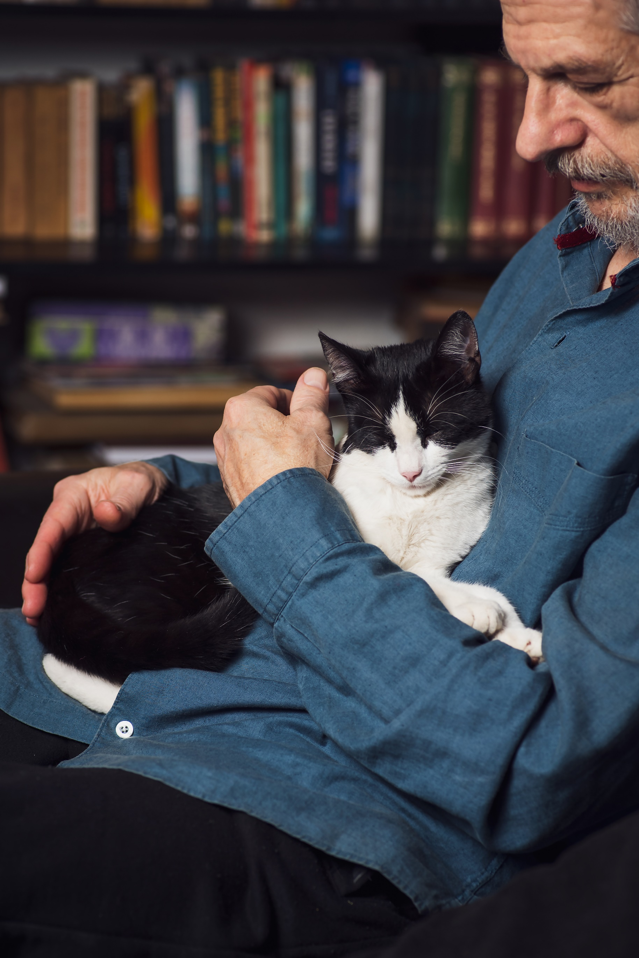
  - Back Cover

