Stormwater Management Plan
2024 to 2034

Contents
1 Executive Summary 4
2 Glossary 6
3 Introduction 6
3.1 Stormwater and Flooding 7
4 Background to this Plan 8
4.1 Responsibilities 8
4.2 Setting 8
4.3 Stormwater Policy 9
5 Challenges and Opportunities 10
5.1 Municipal Size, Geography and High Value Waterways 10
5.2 Water in the Landscape 11
5.3 Ageing Infrastructure 11
5.4 Constrained Funding 11
5.5 Growth and Development 11
5.6 Flooding, Climate Change and Resilience 11
5.7 Landslips and the Environmental Management Overlay 12
6 Stormwater Management Plan 2024-2034 13
6.1 Mission 13
6.2 Objectives, Targets and Measures 14
6.3 Managing Drainage and Flood Requests 17
6.4 Updates to Development Engineering Guidelines and Planning Permit Processes 17
6.5 Investigation of Stormwater Offsets 18
6.6 Establishing Strategic Partnerships 18
6.7 Exploring Funding Mechanisms 18
6.8 Waterway Prioritisation Framework: Where to Focus WSUD and IWM Initiatives 19
6.9 10-year Flood Mapping Strategy 24
6.9.1 Flood Mapping Prioritisation Framework 24
6.9.2 Catchment Area Maps and Tables 26
6.10 Implementation Plan and Timeline 29
7 References 33
Appendix A. Background to the SWMP 34
0.0 Key Policies and Legislation 34
0.0.1 Victorian Planning Provisions (VPP) 34
0.0.1 Yarra Ranges Planning Scheme 34
0.0.2 Urban Stormwater Best Practice Environmental Management Guidelines (CSIRO, 1999) 36
0.0.3 Urban Stormwater Management Guidance (EPA, 2021) 36
0.0.4 Healthy Waterways Strategy Stormwater Targets: Practitioner’s Note 39
0.0.5 DELWP Guidelines for Development in Flood Affected Areas 39
0.1 Key Strategies, Plans and Frameworks 40
0.1.1 Plan Melbourne– 2017-2050 Strategy 40
0.1.2 Victoria’s Climate Change Strategy 40
0.1.3 Built Environment Climate Change Adaptation Action Plan 2022–2026 41
0.1.4 Flood Management Strategy for Port Phillip and Western Port (2021-2031) 41
0.1.5 Water for Victoria and IWM Framework for Victoria 41
0.1.6 Yarra Catchment IWM Plan and Dandenong Catchment IWM Plan 41
0.1.7 The Healthy Waterways Strategy 41
0.1.8 Yarra River Action Plan 42
0.1.9 Yarra Strategic Plan 42
0.2 Council Plans and Strategies 42
0.2.1 Council Plan 2021-2025 and Community Vision for 2036 42
0.2.2 Housing Strategy 43
0.2.3 Flood Management Plan 43
0.2.4 Yarra Ranges IWM Plan 44
0.2.5 Environment Strategy 2015-2025 44
0.2.6 Recreation and Open Space Strategy – Policy, Implementation and Strategic Framework 44
0.2.7 Tree Canopy Strategy 44
0.2.8 Health and Well-being Plan 45
Appendix B. Flood Mapping Catchment Area Prioritisation Process 46
Appendix C. Flood Mapping Catchment Area Prioritisation Results 49
Appendix D. Flood Mapping Program: Catchment Area Maps 50
Appendix E. Flood Mapping Program: Catchment Area Information Tables 51

Tables
Table 4-1 Summary of key relevant policies, legislation, strategies, plans and frameworks 8
Table 6-1 Example catchment area information table 28
Table A-1 Quantitative performance objectives for urban stormwater (EPA Victoria, 2021) 38
Table A-2 Typical IWM Interventions at each scale (HWS, 2021) 39
Figures
Figure 4-1 Private property showing private drainage (landowner’s responsibility) versus Council drainage (Council’s responsibility) 8
Figure 6-1 Current waterway DCI 21
Figure 6-2 Predicted change in DCI of waterways (to 2060 under a BAU scenario) 22
Figure 6-3 Waterway prioritisation 23
Figure 6-4 Flood mapping catchment area prioritisation (where ID is the catchment ID and P is the priority score, with a higher P number being higher priority) 25
Figure 6-5 Example catchment area map 27
Figure A-1 Objectives for environmental management of stormwater (CSIRO, 1999) 36
Figure A-2 Steps in controlling hazards and risks associated with stormwater (EPA Victoria, 2021). 37
Figure A-3 Hierarchy of controlling hazards and risks (EPA, 2021) 37
Figure A-4 Scenario 8 example stormwater management scenario (EPA Victoria, 2021) 38
Figure A-5 Scales at which infiltration and harvesting targets need to be achieved per catchment (HWS, 2021) 39
Figure A-6 Council Plan – strategic objectives 43
Figure A-7 Environment Strategy goals 44

Executive Summary
The Yarra Ranges Stormwater Management Plan (SWMP) supports the objectives within the Yarra Ranges Stormwater Policy, which implements requirements and guidelines pertaining to stormwater management.
The Yarra Ranges region is characterised by its extensive size of 2450 square kilometres in total area and unique landscape, named as the largest local government area in land size. The Council's drainage network, spanning over 790 km, interacts with Melbourne Water's managed waterways and presents intricate challenges in maintaining and renewing infrastructure. With constrained funding, growth and development plans, ageing infrastructure, existing flood risk, climate change considerations, and number of waterways highly valued by the community, there are many challenges relating to stormwater and flooding in the municipality, and opportunities for improvement. There is a need, highlighted in both the Council Plan 2021-2025 and Community Vision for 2036, to better understand flood risk so that drainage requirements can be better understood and prioritised to support more sustainable development. Community collaboration, including education and engagement, is key in building a resilient stormwater network.
Urban development can also put increased pressure on water resources through increased runoff and pollution and needs to be carefully managed. The Yarra Ranges SWMP emphasises the need to balance flood protection with the preservation of downstream receiving waterways and aims to address the actions necessary for a resilient stormwater management system that can sufficiently cater for future expected demands. Initiatives such as multi-scale WSUD measures and stormwater harvesting contribute to building resilience and mitigating the impacts of climate change.
The SWMP is aligned with the key policies, guidelines, frameworks, and legislation at the federal, state and local levels, reflective of their key objectives and including:
- Urban Stormwater Best Practice Environmental Management Guidelines
- Urban Stormwater Management Guidance
- Healthy Waterways Strategy
- Healthy Waterways Strategy Stormwater Targets: Practitioner’s Note
- DELWP Guidelines for Development in Flood Affected Areas
- Victorian Floodplain Management Strategy
- Planning and Environment Act
- Plan Melbourne 2017-2050 Strategy
- Victoria’s Climate Change Strategy
- Flood Management Strategy for Port Phillip and Western Port (2021-2031)
- Water for Victoria
- IWM Framework for Victoria
- Yarra Catchment IWM plan
- Dandenong Catchment IWM Plan
- Yarra River Action Plan
- Yarra Strategic Plan
- Built Environment Climate Change Adaptation Action Plan 2022-2026
- Victorian Planning Provisions
- Greater Melbourne Urban Water & System Strategy: Water for Life
The SWMP is heavily informed by the following Yarra Ranges Council-specific Plans and Strategies:
- Council Plan 2021-2025
- Community Vision for 2036
- Housing Strategy
- Flood Management Plan 2016
- Yarra Ranges Integrated Water Management Plan
- Environment Strategy 2015-2025
- Recreation and Open Space Strategy
- Tree Canopy Strategy
- Health and Well-being Plan
- Yarra Ranges Planning Scheme
The SWMPs measures and targets to meet the objective include:
- Municipal-wide flood modelling to assist with reducing hazardous flooding and Annual Average Damage (AAD)
- Lower urban runoff volume through use of WSUD including increased use of rainwater or stormwater use for the appropriate end use (residential, commercial, industrial, irrigation)
- Increased percentage of new developments to meet best practice water quality standards
- Identification of natural flow paths through catchment prioritisation frameworks for municipal wide flood mapping
- Inclusion of community engagement and participation through all mapping and mitigation studies
- Inclusion of climate change factors in all public and private drainage and stormwater designs
Key actions of the SWMP include:
- The Infrastructure Services Department will manage a program of works to better understand the asset base and flood risk within relevant catchments throughout the municipality. The program of works will be completed catchment area by catchment area per a prioritised program. Each catchment area will have drainage assets surveyed where required and flood modelling and mapping produced for both existing conditions and anticipated future conditions (including development and climate change). Mitigation modelling can then occur which will assist Council in drainage upgrades in critical areas via the Asset Management Plan which can be supported by Annual Average Damages assessments to assist in cost-benefit analysis.
- To support achieving harvesting and infiltration targets, a waterways prioritisation framework within this SWMP assists in identifying key locations in which to focus efforts for better IWM and WSUD initiatives, and stronger development stormwater management. Since most of the municipality is identified as having high priority waterways by the Healthy Waterways Strategy, and therefore has ambitious targets relating to management of stormwater due to development, this more granular prioritisation enables more targeted effort that is more effective in achieving desired outcomes.
- Council will develop several Fact Sheets to clearly outline Council’s approach prioritise catchments for future flood mapping and drainage issues, detail how Council manages new developments with respect to flooding and outline authority and private responsibilities including responsibilities for private-to-private property flooding with no infrastructure and property access.
- Council will determine a clear prioritisation for and approach to addressing flood and drainage complaints.
- The Development Engineering Guidelines will be updated to include the following details:
  - A requirement for all applicable development classes (as identifies in the Stormwater Management Plan) to comply with the performance requirements set out in the BPEMG.
  - Reference to all relevant provisions and requirements in the Yarra Ranges Planning Scheme that are available to support sustainable stormwater management.
  - Specific design specifications and requirements for the design of stormwater management systems.
  - Examples of acceptable on-lot and street-scale water sensitive urban design options to facilitate stormwater retention, infiltration, reuse, water quality targets and other ecosystem services, as supported by the Yarra Ranges IWM Plan.
  - Incorporate the use of climate change factors in Permissible Site Discharge and Onsite Detention requirements.
- Council will consider the establishment of a stormwater offsets program as an alternative to the existing Melbourne Water stormwater offset program. This will aid applicable developers within the Council to meet their stormwater management obligations by making a payment to a voluntary stormwater offset contribution.
- Council have formed existing partnerships to date, including with DEECA and other authorities through the IWM Forums, and the Yarra Ranges Council and Melbourne Water Waterway Protection Partnership Project, which is a 3-year joint program to deliver stormwater harvesting and infiltration projects in high priority catchments. Continuing to foster and build upon these strong strategic partnerships is an important aspect in achieving sustainable stormwater management.
There are multiple funding mechanisms available for drainage and stormwater management. This SWMP will further explore funding options as part of the implementation plan.

Glossary
Directly Connected Imperviousness (DCI) | This is an umbrella measure that combines all aspects of waterway condition that are known to be impacted by development and urbanisation, into a factor that can determine if significant stormwater changes may occur to a specific area. These aspects considered include changes in stormwater flows, volumes, quality, gross litter, etc.
Drainage network | The network of pits, pipes, swales and channels that collects stormwater runoff and conveys it away from the built environment.
Erosion Management Overlay (EMO) | Identifies areas that are at risk of landslip.
Fluvial or riverine flooding | This type of flooding is what happens when a river, creek or other waterway overtops its banks and floods the land around it.
Hotspot | A known flood problem area which has a history of repeat flooding of a road, crossing or property, often highlighted through anecdotal information and customer complaints. It is a localised issue which will  vary from council to council.
Pluvial, overland or flash flooding | In large rainfall events, when the drainage network is overwhelmed, some of the stormwater flows over the ground instead and can cause this type of flooding.
Runoff | The amount of rainfall that enters the stormwater drainage system, (underground pipes, overland flow paths, floodway and waterways) after losses such as infiltration has been taken into account.
Stormwater | Flows produced when rain falls onto and runs off from all surfaces within a catchment, including roads, roofs, driveways, footpaths and vegetated areas
Water Sensitive Urban Design (WSUD) | Water Sensitive Urban Design is an approach to minimise harmful effects to the environment when designing drainage systems

Introduction
Stormwater is produced when rain falls onto and runs off from all surfaces within a catchment, including roads, roofs, driveways, footpaths and vegetated areas. Stormwater needs to be considered and managed in a way that protects local waterways and improves our flood resilience. Council’s drainage network, including pits, pipes, swales and channels, collects stormwater runoff and conveys it away from the built environment to the waterways. Current approaches to stormwater management consider not only flood hazard, but also the impact it has on the receiving waterways, and how it can be best managed to achieve multiple community and ecosystem benefits. Council’s stormwater services include:
- Planning and controlling land use and development
- Understanding flood risk
- Protecting receiving waterways and the environment from harmful impacts from stormwater
- Improving climate resilience through stormwater management
- Design, construction and maintenance of drainage assets and stormwater quality treatment systems
- Increasing fit for purpose stormwater reuse
- Improving landscape resilience, urban greening and cooling stormwater irrigation and passive irrigation
- Preparing for and recovering from flood events
- Fostering partnerships with other water authorities to improve stormwater management
- Designing capacity and flexibility in the drainage network to allow for climate change and population growth
The Yarra Ranges municipal area covers an area of 2450 square kilometres and is highly valued by its community. The Yarra Ranges is 2% is owned by Council, 30% is private ownership and the remaining 68% is Crown land. The land is a mix of farming, residential, commercial, industrial, and townships, with state forest and drinking water catchments.
The Yarra Ranges contains some of the most pristine and highly valued waterways in Victoria, including the headwaters of the iconic Yarra River. These headwaters are highly valued by the community and have great ecological importance. Rain that falls in the catchments eventually makes its way to these waterways. When development happens, areas that were once forest, farm or more natural surfaces end up becoming covered with concrete and other ‘hard’ surfaces. The hard surfaces cause rainwater to flow over the landscape rather than naturally soaking into the soil, which causes unnaturally high flows of water to enter streams and creeks, potentially causing erosion and damaging fish and platypus habitat. The stormwater runoff can also carry pollution to the waterways. Additional stormwater from developed areas and our road network needs to be managed in a way that protects our waterways from these impacts through keeping some of the stormwater within catchment while maintaining flood protection.
Development in Yarra Ranges occurs broadly accordance with the Housing Strategy (YRC, 2009).
Water and flooding form a part of our natural environment and landscape. While we aim to control and improve conditions in some rainfall events, not all storm events can be managed and there is not always an engineering solution for every stormwater issue. The municipality faces several local flood management and drainage challenges. There are over 4,900 properties known to be at risk of flooding from waterways or underground drains according to the Flood Management Plan (YRC and Melbourne Water, 2016). Adding to these challenges are long-term future pressures on the existing drainage system associated with urban consolidation and an increase in rainfall intensity due to climate change.
Sustainable stormwater management is needed to strategically manage both the flood risk associated with development, and to protect and maintain the natural water cycle and health of waterways from the impacts of urban development. This Stormwater Management Plan enables Council to plan appropriately for future growth and to consider the impact of increased development (including infill development) across the municipality, per the Council Plan (YRC, 2021).
This SWMP supports the five strategic objectives within the Council Plan, along with supporting the objectives and goals of other Council strategies and plans, and state-level strategies, plans and frameworks as detailed throughout this document.

Stormwater and Flooding
Stormwater is the water that runs off surfaces such as rooftops, roads, carparks, and other ‘hard surfaces’ during rain events. It can also come from hard grassed surfaces such as lawns and ovals. The drainage network of pits, pipes and channels throughout Yarra Ranges helps to capture and move this stormwater away from people and buildings and allowing it to eventually flow to the waterways.
Sometimes, when there is a large amount of rain or rain that occurs in a short amount of time, the water can’t get into the drains quickly enough, the drains may not have been designed to take the amount of rain, or there may not be drainage structures present to take the stormwater away. When this happens, some of the stormwater flows over the ground instead and can cause flooding. This can happen quickly and without warning. This is known as ‘pluvial’, ‘overland’ or ‘flash’ flooding.
Another type of flooding that occurs in Yarra Ranges is ‘fluvial’ or ‘riverine’ flooding. Fluvial flooding is what happens when a river, creek or other waterway overtops its banks and floods the land around it. This flooding can also cause the drainage network to back up and surcharge (come out) in the catchment itself, making the flooding even worse.
Each type of flooding is different and can affect the environment and people in different ways.

Background to this Plan

Responsibilities
In accordance with various legislative requirements, Council has important responsibilities related to drainage within the community. These responsibilities are outlined below, reflecting the Council's commitment to effective water management, environmental protection, and ensuring the overall well-being of residents.
As the local drainage authority under the Water Act 1989, Council has the important job of managing some of the drainage within the Yarra Ranges municipal area. This includes the planning, construction, and maintenance of drainage infrastructure to help prevent flooding, manage stormwater runoff, and maintain water quality standards.
Between two private properties however, the landowners, developers, and body corporates are responsible for the drainage up to the Legal Point of Discharge, except if the drainage structure is within a drainage easement. The image below helps to show this.
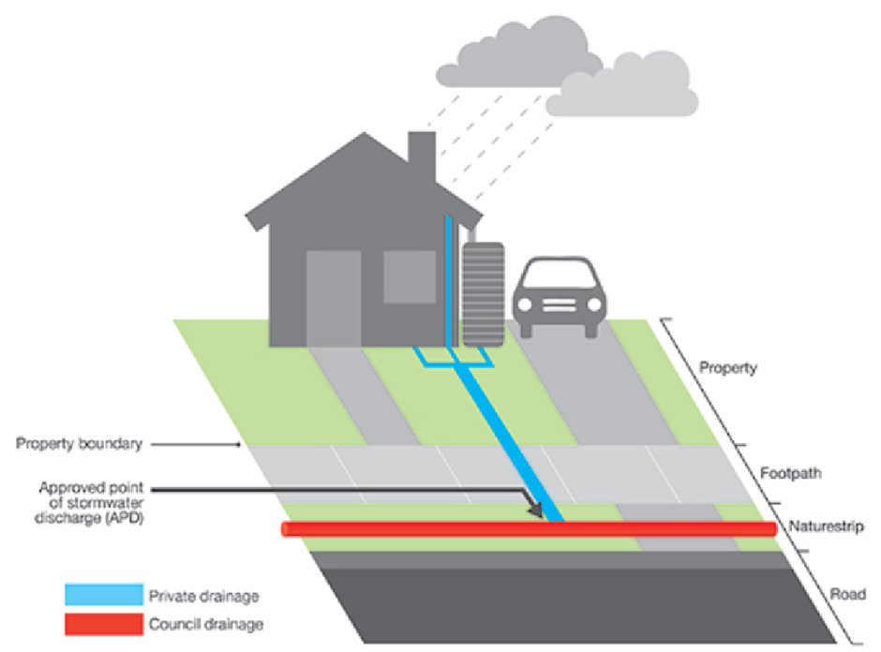
Figure 4-1 Private property showing private drainage (landowner’s responsibility) versus Council drainage (Council’s responsibility)

Council is also responsible for:
- Nominating stormwater discharge points under the Building Regulations 2018. This ensures that stormwater is channelled in a way that reduces the risk of flooding and harm to the environment.
- Making sure stormwater quality targets are met for different types of development, via the Yarra Ranges Planning Scheme and under the Planning and Environment Act 1987. This promotes sustainable development practices and safeguards the local environment.
- Actively works to reduce the risk of activities that might harm the environment, under the Environmental Protection Act 2017

Setting
A comprehensive review of relevant policies, legislation, strategies, plans and frameworks at both the state and local level was undertaken, with key influencing aspects of those documents summarised in Appendix A. These key documents heavily inform the objectives, measures, targets and actions of this SWMP.
Table 4-1 Summary of key relevant policies, legislation, strategies, plans and frameworks
Category | State / Regional | Local
Land Use & Planning | Victorian Planning Provisions (VPP) | Yarra Ranges Planning Scheme  Community Vision for 2036  Housing Strategy
Climate Adaptation | Victoria’s Climate Change Strategy  Built Environment Climate Change Adaptation Action Plan 2022–2026 | Council Plan 2021-2025  Community Vision for 2036  Environment Strategy 2015-2025  Health and Well-being Plan
Stormwater Specifications & Management | Victorian Planning Provisions (VPP)  Water for Victoria and IWM Framework for Victoria  Stormwater Best Practice Environmental Management Guidelines (CSIRO, 1999)  Urban Stormwater Management Guidance (EPA, 2021) | Yarra Catchment IWM Plan and Dandenong Catchment IWM Plan  Yarra Ranges IWM Plan  Environment Strategy 2015-2025  Recreation and Open Space Strategy – Policy, Implementation and Strategic Framework  Tree Canopy Strategy
Flood Management & Mitigation | DELWP Guidelines for Development in Flood Affected Areas  Plan Melbourne– 2017-2050 Strategy  Flood Management Strategy for Port Phillip and Western Port (2021-2031) | Flood Management Plan  Recreation and Open Space Strategy – Policy, Implementation and Strategic Framework
Riverine & Waterway Management | The Healthy Waterways Strategy  HWS Stormwater Targets: Practitioner’s Note  Greater Melbourne Urban Water & System Strategy: Water for Life | Yarra River Action Plan  Yarra Strategic Plan  Environment Strategy 2015-2025
General Environment | General Environmental Duty  Environmental Protection Act | Environment Strategy 2015-2025  Tree Canopy Strategy  Health and Well-being Plan
Collaboration & Partnerships |  | Council Plan 2021-2025  Community Vision for 2036

Stormwater Policy
The Stormwater Policy outlines how stormwater will be managed in the Shire of Yarra Ranges. The Policy seeks to implement and give effect to:
- Council’s legislative requirements
- Existing Council policies, strategies and plans
- State-led strategies, plans and guidelines
The purpose of the Stormwater Policy is to:
- Summarise Council’s current position and priorities towards stormwater management within the municipality.
- Define Council’s responsibility and scope of control as it relates to stormwater management.
- Outline Yarra Ranges Council objectives for stormwater management pertaining to the facilitation of sustainable development within the municipality.
- Provide an internal framework and action plan for how the policy objectives will be addressed.
- Guide Council’s use and implementation of internal documents such as the Stormwater Management Plan, the Engineering Development Design Guidelines, the flood mapping program, the IWM Plan and the Stormwater Asset Management Plan.

The objectives of the Stormwater Policy are shown below, along with their links to the SWMP objectives (discussed further in section 6.2).
Policy Objective | Links to SWMP Objectives
Encourage all eligible new stormwater assets and developments within Yarra Ranges Council to be water sensitive, allowing them to be attractive, thrive and perform well now and into the future. | Utilising Stormwater as a resource.  Healthy and valued waterways.  Healthy and valued urban and rural landscapes.  Strategic Partnerships.
Continue Council and Melbourne Water’s efforts to rehabilitate, protect and enhance all waterways within the municipality. | Healthy and valued waterways.  Strategic Partnerships.
Ensure all new eligible developments achieve full compliance with relevant best practice standards in BPEMG and encourage developments to follow the Urban Stormwater Management Guidance. | Healthy and valued waterways.
Ensure that all new eligible development on public and private land does not adversely impact on the performance of the existing local stormwater drainage network. | Existing and future flood risks are managed to maximise outcomes for the community.
Ensure that all new eligible development on public and private land does not cause detrimental increases in flows to neighbouring properties. | Existing and future flood risks are managed to maximise outcomes for the community.
Ensure that all new capital stormwater works are fit for purpose. | Existing and future flood risks are managed to maximise outcomes for the community.  Community values are reflected in stormwater planning.  Healthy and valued waterways.  Healthy and valued urban and rural landscapes.
Increase Council’s knowledge of the current stormwater asset base and the existing and future flood risk across the municipality. | Existing and future flood risks are managed to maximise outcomes for the community.
Enhance communications with residents, landowners and developers who live and work within the municipality to clearly articulate issues, solutions, and responsibilities related to stormwater management and flooding. | Community values are reflected in stormwater planning.  Utilising Stormwater as a resource.  Healthy and valued waterways.  Healthy and valued urban and rural landscapes.  Strategic Partnerships.

Challenges and Opportunities
There are many challenges and opportunities in sustainable stormwater management with development in Yarra Ranges, including the size of the municipality and constrained funding, growth and development plans, ageing infrastructure and existing flood risk, climate change and resilience and the abundance of high value waterways throughout. These aspects need to be considered together to determine the best, most efficient and sustainable approach to stormwater management.

Municipal Size, Geography and High Value Waterways
The Yarra Ranges municipality is the largest in area of all the local government areas in Melbourne. It covers an area of 2450 square kilometres. The majority of the upper catchment is protected forest, while development occurs across the municipality through forest, farmland and urbanised area. The Council managed drainage network is over 790 km in total, contains over 29,000 pit structures and over 20 km of minor culverts (YRC, 2016). There are over 1,962 km of Melbourne Water managed waterways within Council, 64 km of open channels and 42 km of underground drainage, much of which interfaces with Council’s stormwater drainage network.
The large geographic size of Yarra Ranges means it is more costly to deliver services, and there are greater distances for residents to access services (Council Plan, 2021). Likewise, ensuring that the networks of roads, footpaths, bridges and drainage are maintained and renewed into the future and the particular challenges associated with the geographic spread and topography of the area is important (Council Plan, 2021).
The Yarra Ranges contains some of the most pristine and highly valued waterways in Victoria, including the headwaters of the iconic Yarra River. Most of the Yarra Ranges falls within designated stormwater priority catchments – areas with high ecological values, where protection from the impacts of urban development is required to maintain the natural water cycle and protect the health of waterways (MW, 2018).

Water in the Landscape
Water and flooding forms a part of our natural environment and landscape. While we aim to control and improve conditions in some rainfall events, not all storm events can be managed and there is not always an engineering solution for every stormwater issue. We strive to integrate traditional knowledge into innovative approaches in managing stormwater, to improve and pay our respects to the land, water, and biodiversity within our municipality whilst minimising the hazards that can occur in our community during extreme events. By fostering collaboration, education and community engagement, we aim to empower individuals to embrace responsible stormwater management, cultivating a culture of stewardship to transform stormwater management into a catalyst for sustainable development and resilience. Through continuous monitoring, research, and adaptive management, we aim to build a resilient future and ensure sustainable stormwater resource management within the Yarra Ranges municipality area.

Ageing Infrastructure
Many older areas within the municipality contain drainage infrastructure developed according to the standards of their time. Much of Council’s original drainage network was designed to cater for a lower-density residential development with significant pervious area by comparison to today’s standards. Drainage assets, once constructed, are not guaranteed to be able to meet their designed capacity in perpetuity given further development that may occur in future and given climate change increases in rainfall intensity and infrastructure lifespan.

Constrained Funding
The maintenance and construction of the asset base across such a large area requires considerable budget. The Council Plan identifies that there are reduced options to raise revenue due the introduction of rate capping by the State Government while at the same time needing to ensure essential community services are accessible. The Council Plan further identifies that there is a need for significant investment in our ageing infrastructure to meet the expectations of the community.

Growth and Development
Yarra Ranges is home to a population of 163,298, and this is expected to grow to 186,000 residents by 2041, representing an average annual growth rate of 0.7% (YRC, 2016). This future growth will not occur evenly across Yarra Ranges. Recent trends have shown the highest rates of growth are concentrated in the western, urbanised part of Yarra Ranges comprising Lilydale, Chirnside Park, Mooroolbark and Kilysth, where the majority of Yarra Ranges’ development opportunities and infrastructure are located. The Council Plan hence identifies the need to appropriately plan for future growth and consider the impact of increased infill development across the municipality (Council Plan).
Urban development also presents specific threats to our water resources. The hard surfaces cause rainwater to flow over the landscape rather than naturally sinking into the soil, which causes unnaturally high flows of water to enter streams and creeks, causing erosion and damaging fish and platypus habitat. The stormwater runoff also carries pollution to the waterways. There is an abundance of pristine waterways throughout Yarra Ranges. Since the provision of drainage assets as they have been traditionally constructed for flood protection can have detrimental impacts on the function, form, quality and values of downstream receiving waterways, sustainable stormwater management measures need to consider the protection of these receiving waterways though retention of stormwater within the catchment alongside flood protection. Sustainable resource management as part of growing development can also consider strategic initiatives such as the storage of water within open spaces, buildings, and roadways for reuse. This can create opportunities for more sustainable water usage and providing more drought resilient Council assets.

Flooding, Climate Change and Resilience
From the available flood modelling at the time of the Flood Management Plan (2016), many properties within Yarra Ranges are identified as potentially being flood prone. Major contributors to this are increased housing density, developments within floodplains and overland flow paths and no formal overland flow paths (FMP, 2016). Council’s Flood Management Plan identifies a number of known flood hotspots throughout the municipality (as of 2016), and Council fields many flood and drainage requests each year across the municipality.
While some of this stormwater runoff is the rain taking its natural path to the receiving creeks and rivers, the quantity of runoff can be exacerbated by development and climate change.
The Council Plan recognises that there will be an increased frequency and severity of extreme weather events such as floods and storms. Stormwater management and planning conditions in Yarra Ranges will seek to consider climate change impacts on rainfall intensity using industry standard approaches, and as supported by numerous state and local strategies, plans and frameworks.
Further, Council recognises in its Plan the need to adapt to the challenges posed by a changing climate. This takes the form of both better drainage and flood management, which considers the impacts of flooding on development and of development on flooding, and which further considers the opportunity to incorporate IWM and water sensitive urban design elements throughout the municipality to improve stormwater management and support many additional ecosystem services.
Creating resilience in a changing climate also necessitates searching for and implementing fit for purpose water supply where possible. Harvesting stormwater and reusing it to irrigate open spaces is one way to retain water in the landscape, protect downstream waterways from excessive stormwater and support a greener, cooler environment. Larger systems can also provide flood mitigation benefits.
Council’s Tree Canopy Strategy has a particular focus on increasing tree canopy on public land in built up areas including Lilydale and surrounds, Yarra Glen, Healesville and towns in the Dandenong Ranges and Yarra Valley. This SWMP supports WSUD initiatives to incorporate passively irrigated street trees where the need for canopy is identified within the Tree Canopy Strategy. Passive irrigation of street trees via stormwater runoff redirected to the root zone of the tree can help to support a healthy canopy cover, while also potentially taking stormwater volume out of the network and providing stormwater quality treatment.

Landslips and the Environmental Management Overlay
Council’s Erosion Management Overlay (EMO) identifies areas that are at risk of landslip. The likelihood of slip is a factor of slope, soil type, what structures are on the ground, and rainfall. Long periods of consistent rainfall can cause saturation of the soil which may lead to landslips. Similarly, large volumes of water introduced to a landslip area can lead to landslips.

Stormwater Management Plan 2024-2034
Key actions relating to the entire Stormwater Management Plan include SWMP20, SWMP22, SWMP23, SWMP26, and SWMP27

Mission
At Yarra Ranges Council, our mission is to proactively manage stormwater to safeguard our community, preserve natural ecosystems, and promote sustainable development practices.
Guided by a commitment to resilience and environmental stewardship, we strive to minimise flood risk while protecting the integrity of our waterways and the health of our communities amidst the increasing frequency and severity of severe weather events.
Through innovative strategies, continuous monitoring, and collaborative partnerships, we aim to adapt to evolving environmental challenges and build a future where stormwater management serves as a foundation for thriving, resilient communities within the Yarra Ranges municipality.

Objectives, Targets and Measures
This will be delivered via the actions in this SWMP (refer section 6.10)
The Objectives are adapted from the Yarra Catchment IWM Plan and Dandenong Catchment IWM Plan which are well understood and accepted across the Victorian stormwater industry. Speaking to common Objectives will enable better outcomes through increased partnership and funding opportunities. There are strong links between Council’s IWM Plan (2017), particularly with respect to WSUD practices and stormwater harvesting opportunities. This SWMP therefore seeks to also support the objectives and targets of the IWMP.
The targets below also contribute to Yarra Catchment IWM Plan and Dandenong Catchment IWM Plan targets of AAD reduction, cross-consideration of IWM and flood mitigation opportunities for all projects, and 21 and 11 GL/year respectively of mean annual runoff volume reduction by 2030. Links to the Monitoring, Evaluation, Reporting and Improvement Plan (2022) indicators are also provided for ease of future reporting. It also supports targets within those plans pertaining to water for the environment, passive irrigation of street trees and active and passive public open spaces with alternative water, improvements in community literacy around the water cycle, supply of alternative water for agriculture, increasing skills and organisational capacity and leadership and visioning amongst others.
There are further links to the Yarra Strategic Plan (which is a requirement of the Yarra River Protection Act 2017) performance objectives of ‘A healthy river and lands’.
Objective | Indicator | Measure | Target
Utilising Stormwater as a resource | Increase fit-for-purpose use of stormwater and rainwater | Percentage of new buildings and new development areas with opportunities for water reuse that have storage and reuse installed (%)N.B. Council’s IWMP will also focus on storage and reuse options for open spaces, parks and Council buildings  Links to MERI indicator 1.2. | 90-100% of new buildings and new development areas with opportunities for water reuse that require a planning permit to have storage and reuse installed by 2025. All other buildings and areas encouraged.
Existing and future flood risks are managed to maximise outcomes for the community. | Reduce the impacts of dangerous flooding now and into the future with development and climate change. | Area of the municipality which has been flood mapped and has in place a catchment-wide stormwater strategy including identification of mitigation projects. | 50% of the municipal catchments considered in the prioritisation framework to have their mapping completed by 2029.
 |  | Reduction in community exposure to hazardous flooding delivered by flood management initiatives. | Investment decisions use an appropriate cost/benefit assessment. Capital works programs are informed by asset management plans and are included in the long-term financial plan.
 |  | Annual Average Damage (AAD) reduction delivered by flood management initiatives ($ millions addition to baseline).  Links to MERI indicator 3.1  N.B. Council’s IWMP will contain targets relating to TN , TP and TSS reductions | Reduction in Annual Average Damage (AAD) delivered by flood management initiatives. Capital works programs are informed by asset management plans and are included in the long-term financial plan.
 | Increase cross-consideration of flood mitigation and integrated water management | Number of projects that include IWM opportunities.  Links to MERI indicator 3.3. | Increase the number of projects cross-consider IWM and flood mitigation opportunities as part of their design by 2030 and maintained by 2050 in line with the Yarra and Dandenong Catchment IWM Plans. This includes consideration of opportunities to achieve stormwater, open space and/or amenity outcomes on all existing and future flood infrastructure projects.
 | Improve community education around the flood management function of roadways. | Community survey. | Improvement in knowledge base.
Healthy and valued waterways | Reduce the total urban stormwater runoff volume discharged to receiving waters. | Mean annual urban runoff volume reduction:  - Urban runoff volume reduction achieved by WSUD assets (infiltrated in ML/y)  - Rainwater use for residential, commercial and industrial development (ML/y)  - Stormwater use for public open space and infiltration (ML/year)  Links to MERI indicator 4.1. | - Decrease urban runoff volume via WSUD.  - Increase rainwater use for residential, commercial and industrial development via increase in new buildings with rainwater tanks.  - Increase stormwater use for public open space and irrigation.
 | Decrease pollutants discharged to receiving waters. | Percentage of new developments that require a planning permit that meet best practice water quality guidance within the same catchment (i.e. via on-lot WSUD, street-scale WSUD or downstream IWM/WSUD) (%). | Increase in percentage of new developments that meet best practice water quality guidance within that catchment.
 |  | Percentage of new developments that require a planning permit that pay a stormwater offset to Melbourne Water. | Year on year reduction in percentage of new developments that require a planning permit that contribute a stormwater offset contribution to Melbourne Water.
 | Protect high value waterways | % Directly Connected Imperviousness (DCI) in priority catchments.  Links to HWS target. | Achieve minimal net increase in DCI in priority catchments.
Healthy and valued urban and rural landscapes. | To minimise increases in stormwater due to development and protect the environmental values and physical characteristics of the landscape from degradation by stormwater. | Target established for road sealing program. | Baseline and target for stormwater management associated with road sealing programs determined.
 | To ensure integrated stormwater management that maximises ecosystem services, such as cooling and local habitat improvement, and provides attractive and enjoyable spaces.  N.B. this indicator, measure and target can also sit in the below objective. | Area (m²) of blue-green infrastructure created or enhanced by WSUD or IWM.  Links to MERI indicator 6.2. | Year on year increase in area of blue-green infrastructure created or enhanced by WSUD or IWM.
Community values are reflected in stormwater planning. | Increase organisational capacity to partner with Traditional Owners to be able to respectfully acknowledge the connection of Traditional Owners to the land and waterways and include indigenous knowledge in stormwater management. | Partner with the Traditional Owners and engage other community groups during flood mapping and catchment management projects so that natural flow paths are understood and protected. | Identify natural flow paths through flood mapping programs and engagement in flood mapping programs for 100% of all high-priority catchments identified in the catchment prioritisation framework.
 | Engage with the community during flood mapping and stormwater management projects and studies to support and enhance community connection with and understanding of the water cycle. | Extent of engagement with community on the delivery of stormwater services and participation with a community reference group. | All flood mapping and mitigation studies include community engagement and participation with community reference group.
 | To enable better asset management with improved efficiencies and overall cost reductions for Council via strategic planning. | Area of the municipality which has been flood mapped with pipe/pit/channel blockage scenarios included. | 50% of the municipal catchments considered in the prioritisation framework to have their mapping completed by 2029, including pipe/pit/channel blockage modelling where those assets exist.
 | Respond to climate and climate change related events through resilience planning. | Number of public and private drainage and stormwater designs which include climate change factors. | 100% of public and private drainage and stormwater designs which include climate change factors.
Strategic Partnerships | Increased collaboration with other organisations to support strategic stormwater management | Number of partnerships for flood or stormwater projects undertaken.  Links to MERI indicator E3. | Partnerships pursued for all flood mapping/mitigation or stormwater infrastructure projects.

Managing Drainage and Flood Requests
This will be delivered via actions SWMP15, SWMP16, SWMP17, SWMP18, SWMP19, SWMP24, and SWMP26
Local knowledge collected via drainage complaints and post flood event data collation plays an important role. This knowledge will be used to supplement information gathered via flood modelling and asset surveys to provide important “pulse-checks” of the stormwater drainage network.
Each piece of information collated by the Infrastructure Services Department will be categorised based on the severity of the issue. This will allow Council to communicate with the community regarding the priority of addressing the issue compared to other stormwater management issues within the municipality. This strategic approach to drainage management will assist Council in ensuring that capital expenditure outlined within the Asset Management Plan is appropriately prioritised, addressing the greatest known severities first.
Council will use the collated drainage and flood requests to:
- Gather information on areas which may require new projects to add to the Asset Management Plan or projects that need to be reprioritised that are already within the Asset Management Plan.
- Respond to residents around the prioritisation program, linked to Council budgets.
- Effectively, efficiently and equitably manage Council’s capital expenditure on drainage asset renewals and improvements.
As part of the implementation plan for this SWMP, the following information will be developed and made available to the community:
- Develop a Fact Sheet to clearly outline Council’s approach prioritise catchments for future flood mapping and drainage issues.
- Determine a clear prioritisation for and approach to addressing flood and drainage complaints and an associated Fact Sheet.
  - Council is producing a classification system for all flooding issues experienced by residence classified by severity, to help more efficiently and effectively manage issues and enquiries.
- Develop a Fact Sheet to clearly detail how Council manages new developments with respect to flooding, per the Stormwater Policy.
- Develop a Fact Sheet to clearly outline authority and private responsibilities including responsibilities for private-to-private property flooding with no infrastructure and property access.

Updates to Development Engineering Guidelines and Planning Permit Processes
This will be delivered via actions SWMP2, SWMP3, SWMP10, SWMP11, SWMP12, SWMP13, SWMP18, SWMP19, and SWMP25
The Development Engineering Guidelines will be updated to include the following details:
- A requirement for all applicable development classes (as identifies in the Stormwater Management Plan) to comply with the performance requirements set out in the BPEMG.
- Reference to all relevant provisions and requirements in the Yarra Ranges Planning Scheme that are available to support sustainable stormwater management.
- Specific design specifications and requirements for the design of stormwater management systems.
- Examples of acceptable on-lot and street-scale water sensitive urban design options to facilitate stormwater retention, infiltration, reuse, water quality targets and other ecosystem services, as supported by the Yarra Ranges IWM Plan.
- Incorporate the use of climate change factors in Permissible Site Discharge and Onsite Detention requirements.
The Yarra Ranges Council Engineering Development Design Guidelines 2024 (the Engineering Guidelines) will facilitate the conveyance of Council’s technical requirements for stormwater and associated works, with improvements to allowing them to be more clearly understood up front by land developers and engineering consultants so that the plans can be prepared to the necessary standard, endorsed efficiently with minimum delay, and constructed to an acceptable sustainable standard.
Council will use the Engineering Guidelines in the following circumstances:
- To communicate Council’s position on stormwater management and linkages with other policies, plans, and requirements.
- To clearly communicate to the community the expected standards and requirements for stormwater management in new developments of any size within the municipality.
- To provide up-to-date technical guidance and direction to land developers and engineering consultants to allow for a consistent approach to the preparation of site-specific stormwater management plans to satisfy Council requirements.
- To clarify the differences in responsibility between private developers and Council with the implementation and management of stormwater assets.
- To outline the approval process required for new developments and appropriate communication points between Council and developers to facilitate efficient, equitable and appropriate designs and approvals.
In line with the Built Environment Climate Adaptation Action Plan 2022-2026, it is pertinent to begin planning for the impacts of climate change on the drainage network. One way to adapt to the expected changes is to incorporate climate change factors into drainage design calculations. Australian Rainfall and Runoff provides estimates of interim climate change factors which can be used in design across a range of RCP (Representative Concentration Pathway) scenarios from 4.5 – 8.5. Australian Rainfall and Runoff recommends the use of RCP4.5 and RCP8.5 values, with the more conservative RCP8.5 value generally selected in design.
Based on RCP8.5, by the year 2100 we can expect to see an increase in rainfall intensity of 18.5% and a temperature increase of 3.48 C within Yarra Ranges. These effects, in combination with higher urbanisation and hard surfaces is likely to result in an increased flood risk and pressures on our drainage network. The Development Engineering Guidelines will be updated to require all new developments to incorporate an 18.5% increase in rainfall intensity in all designs for the planning horizon of 2100.

Investigation of Stormwater Offsets
This will be delivered via actions SWMP9
Stormwater offsets are allowed under the Victorian Planning Scheme and the Planning and Environment Act 1987 (DELWP, date unknown). Council are undertaking a concurrent project looking to establish a stormwater offsets program managed by Council as an alternative to the program being managed by Melbourne Water.
The stormwater offsets would allow Council to offer offsets to developers to meet their stormwater management obligations by making a payment to a voluntary stormwater offset contribution for some development types including residential subdivisions, apartments, commercial and industrial and public use developments, with exemptions listed in VPP 53.18-1. If pursued, the directives of the stormwater offsets will form an addendum to the Stormwater Policy. Given the amount of high priority waterways in the municipal area, Council may consider using offsets to achieve better outcomes in higher value catchments rather than in lower value catchments (DELWP, date unknown).

Establishing Strategic Partnerships
This will be delivered via actions SWMP26, SWMP28, and SWMP30
Yarra Ranges Council have formed existing partnerships to date, including with DEECA and other authorities through the IWM Forums, and the Yarra Ranges Council and Melbourne Water Waterway Protection Partnership Project, which is a 3-year joint program to deliver stormwater harvesting and infiltration projects in high priority catchments. Continuing to foster and build upon these strong strategic partnerships is an important aspect in achieving sustainable stormwater management. A sound governance structure would be one that supports the commissioning and development of the catchment flood mapping and stormwater management strategies, and that supports the implementation of actions identified in the strategies.
Partnerships with the following groups is also important in delivering sustainable stormwater management:dci
- State and federal government departments
- Neighbouring councils
- Community groups, developers, industry bodies

Exploring Funding Mechanisms
This will be delivered via actions SWMP9, SWMP14, SWMP29, and SWMP31
There are multiple funding mechanisms available for drainage and stormwater management. This SWMP will further explore funding options as part of the implementation plan. Funding mechanisms include (but are not limited to) the following:
- Stormwater offsets collected by Melbourne Water
- Drainage scheme contributions
- Melbourne Water quality and quantity infrastructure – sometimes handed over to Council (not as a rule though)
- Victorian urban stormwater offsets
- Developer Contribution Plans
- Special rates and charges
- General rates
- Grants
- Leveraging from other capital plans – e.g. road upgrades/infrastructure
- Melbourne Water partnership on flood modelling, mapping and planning scheme amendments
- Melbourne Water redevelopment schemes
- Partnerships with major projects – e.g. LXRA, major road projects.
- Federal/state funding – e.g.

Waterway Prioritisation Framework: Where to Focus WSUD and IWM Initiatives
This will be delivered via actions SWMP1, SWMP10, SWMP11, SWMP12, and SWMP13
There are many pristine creeks and rivers in the Yarra Ranges municipal area, including the headwaters of the Yarra River, Birrarung. These headwaters are highly valued by the community and have great ecological importance. Rain that falls in the catchments eventually makes its way to these waterways. When development happens, areas that were once forest, farm or more natural surfaces end up becoming covered with concrete and other ‘hard’ surfaces. The hard surfaces cause rainwater to flow over the landscape rather than naturally soaking into the soil, which causes unnaturally high flows of water to enter streams and creeks, potentially causing erosion and damaging fish and platypus habitat. The stormwater runoff can also carry pollution to the waterways. Additional stormwater from developed areas and our road network needs to be managed in a way that protects our waterways from these impacts through keeping some of the stormwater within catchment while maintaining flood protection.
Yarra Ranges are committed to updating their Development Engineering Guidelines to encourage meeting the additional harvesting and infiltration targets per current best practice. In some cases, offsets may be allowed to manage the stormwater quality impacts of a development off-site, instead of meeting these on-site. As stated within the Healthy Waterways Strategy, the stormwater condition of a catchment is measured by 'directly connected imperviousness' (DCI) (Victorian State Government, 2018). This is an umbrella measure that integrates all aspects of waterway condition that are known to be impacted by development and urbanisation, including increases in flows due to more hardstand surface area (ie. From more road pavement post-development) and reductions in water quality (ie. Increases in gross litter and silt entering the waterways). To support achieving the harvesting and infiltration targets, the Directly Connected Imperviousness (DCI) waterways prioritisation framework assists in identifying key locations in which to focus efforts for better IWM and WSUD initiatives, and stronger development stormwater management. Since most of the municipality is identified as having high priority waterways by the Healthy Waterways Strategy, and therefore has ambitious targets relating to management of stormwater due to development, this more granular prioritisation enables more targeted effort that is more effective in achieving desired outcomes.
Datasets used in the prioritisation process include:
- Healthy Waterways Strategy Priority Areas (Melbourne Water)
- Current waterway DCI and future waterway DCI under a Business As Usual (BAU) scenario (Melbourne Water)
Figure 6-1 highlights current waterway DCI, while Figure 6-2 shows the expected change in DCI from current to 2060 under a BAU scenario. The final waterway prioritisation is shown in Figure 6-3, which is based on the following prioritisation framework:
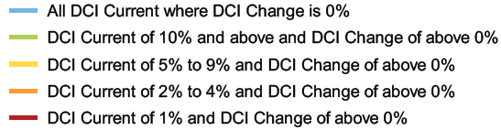
Where:
- Red waterways are of a high to very high condition currently and are projected to have a DCI change in future under BAU development
- Orange waterways are of a moderate condition currently and are projected to have a DCI change in future under BAU development
- Yellow catchments waterways are of a low condition currently and are projected to have a DCI change in future under BAU development
- Green catchments waterways are of a very low condition currently and are projected to have a DCI change in future under BAU development
- Blue waterways do not have an increase in DCI projected in this dataset
  - Catchments containing blue waterways may still have rural road sealing programs being undertaken.
This prioritisation highlights catchments requiring the most effort and attention to maintain DCI at more desirable levels, given projected increase in DCI, with red being the highest priority. Research has concluded that waterway health declines significantly when DCI exceeds 2% of catchment area.
2009 Housing Strategy areas of Least, Restricted and Consolidation change precincts are shown in the maps, indicating where additional focus will be required in managing any potential increases in DCI as development occurs.

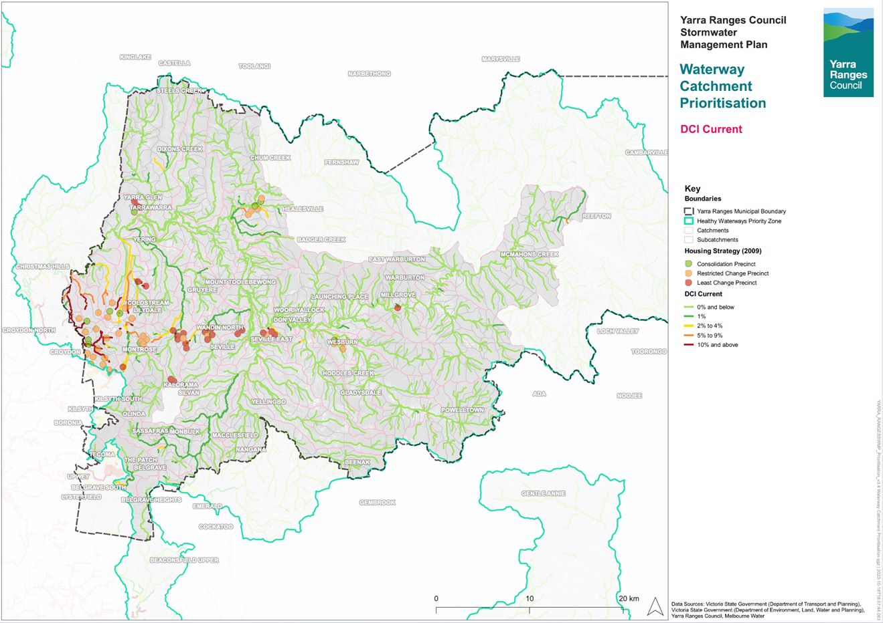
Figure 6-1 Current waterway DCI
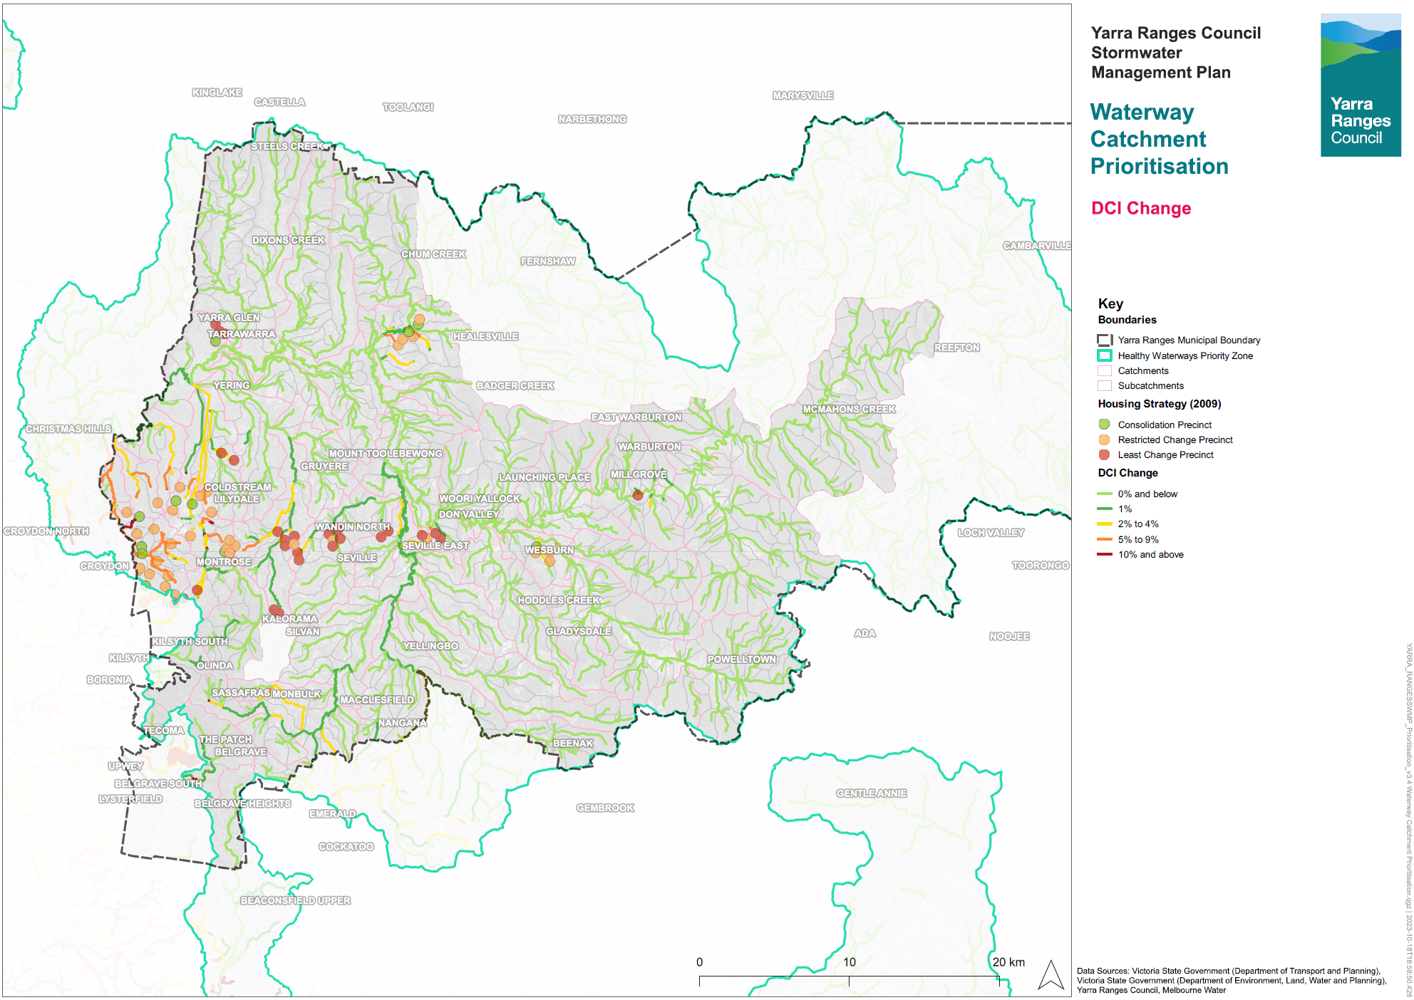
Figure 6-2 Predicted change in DCI of waterways (to 2060 under a BAU scenario)
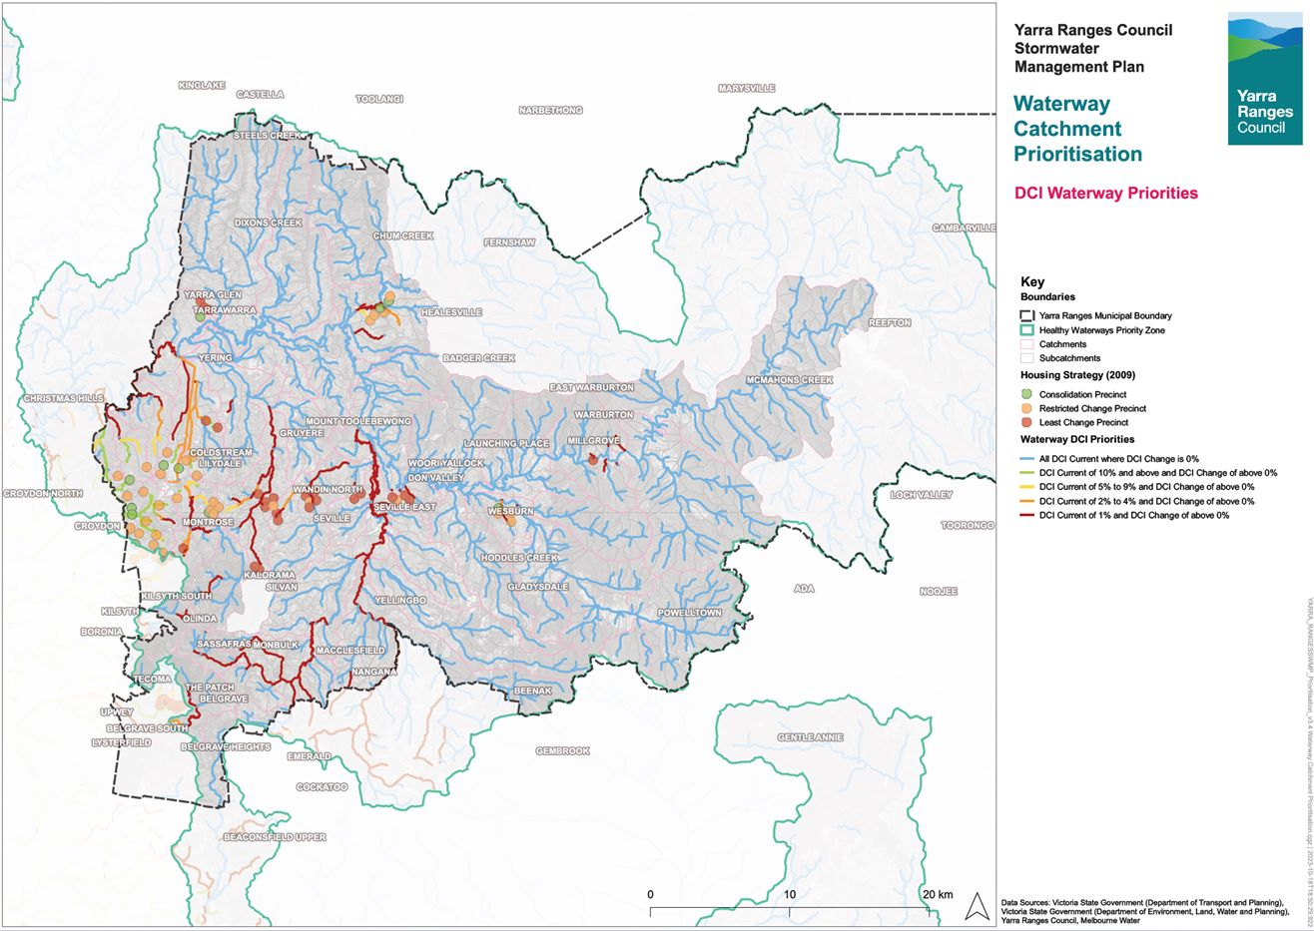
Figure 6-3 Waterway prioritisation

10-year Flood Mapping Strategy
This will be delivered via actions SWMP4, SWMP5, SWMP21, SWMP28 and will help deliver SWMP6, SWMP7, SWMP8, SWMP22, SWMP23
There are different types of flooding that occur in Yarra Ranges. Each type of flooding is different and can affect the environment and people in different ways. We know there are some areas that are more prone to flooding than others. As well as addressing flooding through, drainage maintenance, responding to drainage requests and mitigation projects, we need to undertake modelling of key areas across the municipality, for better planning and flood risk reduction.
The Infrastructure Services Department will manage a program of works to better understand the asset base and flood risk within relevant catchments throughout the municipality. Rural areas are included in this program as we subjectively assess flooding across all areas. The program of works will be completed catchment area by catchment area and prioritised per section 6.9.1 of this Plan. Each catchment area will have drainage assets surveyed where required and flood modelling and mapping produced for both existing conditions and anticipated future conditions (including development and climate change). Mitigation modelling can then occur which will assist Council in drainage upgrades in critical areas via the Asset Management Plan which can be supported by Annual Average Damages assessments to assist in cost-benefit analysis. The EMO (land slip risk) can also be considered in prioritisation of drainage works and mitigation options.
Given the close interaction of the Council stormwater network with Melbourne Water’s drainage assets, Council will strive to work with Melbourne Water where possible. Council and Melbourne Water are pursuing an agreement to work together for more effective drainage management, and approaches to modelling and the sharing of outcomes will be detailed in that agreement.
Through the mitigation modelling, outcomes and objectives of the IWM Plan will be incorporated. Precinct scale opportunities such as large stormwater harvesting and reuse projects or street scale WSUD could provide additional flood mitigation benefits across some storm events and may provide alternate sources of funding for multi-benefit projects that include flood risk reduction.
The updated asset survey and flood information will become a new GIS asset for Council which will be managed, maintained and updated overtime. Information on asset capacity, condition and service level will assist Council in managing the network as well as delivering objectives from the Development Engineering Guidelines when new developments occur. Flood modelling information can also be provided to developers to be updated to incorporate proposed development works to assisting in meeting Council’s position of no downstream detrimental impacts due to development are achieved and that models are kept up to date.
Resultant flood mapping can also be used in the planning and approvals area through the designation of flood impacted areas or planning scheme overlays via an amendment process, better allowing Council to manage flood risk throughout the municipality.
Council will use the flood mapping program to:
- Gather detailed information on the existing drainage network and keep this updated overtime as new assets are introduced.
- Gain an understanding of the likely flood extents, depths, velocities and hazards across the municipality in current and future conditions, including natural flow paths.
- Prepare flood mitigation projects for inclusion in Council’s Asset Management Plan.
- Provide advice around appropriate development in flood affected areas.
Dams in the area are generally not flood protection structures.

Flood Mapping Prioritisation Framework
We have used lots of information to work out which areas need to be modelled most urgently. The information used to prioritise the catchment ‘areas’ for flood mapping included:
- Whether or not there were flood hotspots
- What type of development (if any) is expected
- Whether there are any facilities that are considered ‘vulnerable’
- How much ‘hard surface’ drains directly to waterways now, and how much this is expected to change in the future
There are 49 identified catchment areas that have been prioritised.
Furter detail regarding the prioritisation process is outlined in Appendix A.
The results of the prioritisation process are mapped in Figure 6-4.

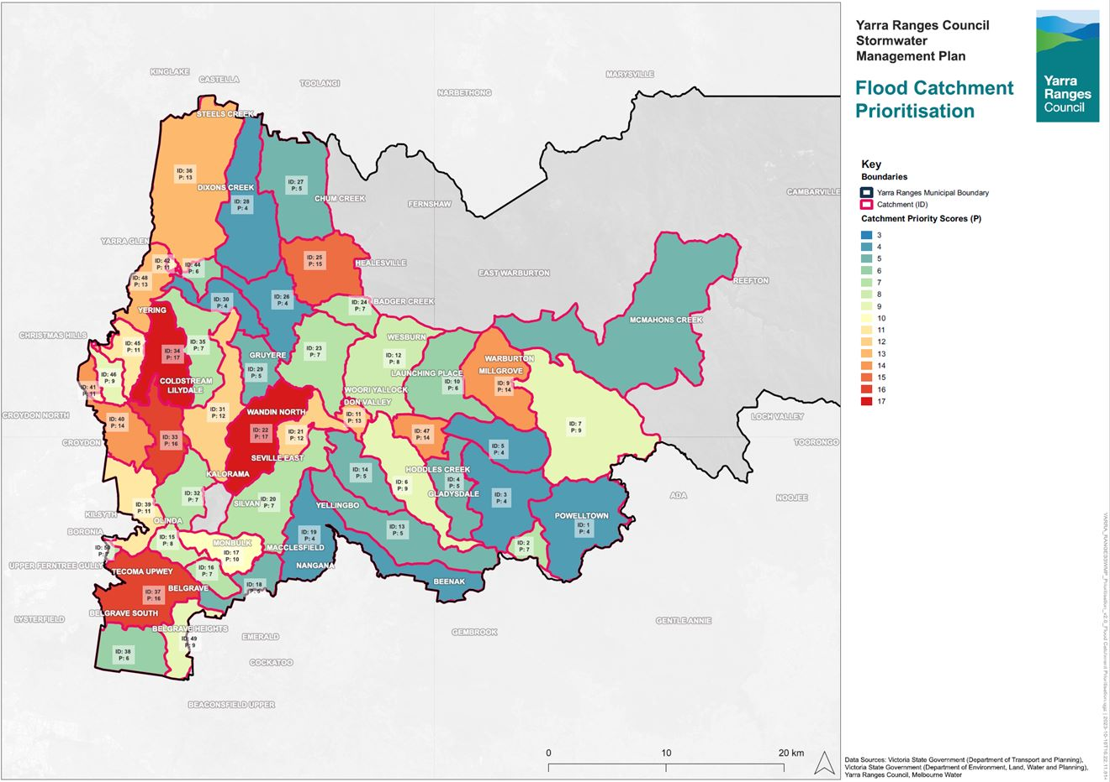
Figure 6-4 Flood mapping catchment area prioritisation (where ID is the catchment ID and P is the priority score, with a higher P number being higher priority)

Catchment Area Maps and Tables
To help with future planning of the catchment area flood mapping and stormwater strategy program, a map was created for each catchment area, along with a table of important information and potential opportunities.
Figure 6-5 provides an example of one of the maps for an area covering Lilydale, Mt Evelyn and Montrose, while the remaining maps are in Appendix D. Table 6-1 provides an example of one of the catchment area information tables, while the remaining tables are in Appendix E.
Key information shown on the maps includes:
- Approximate locations of Consolidation, Restricted Change and Least Change Precincts (2009 Housing Strategy)
- High, medium and low priority flood hotspots (per 2016 FMP)
- Current DCI of waterways in the catchment area
- Approximate locations of stormwater harvesting, and stormwater infiltration opportunities identified by Council
- Locations of vulnerable facilities
- Land Subject to Inundation Overlay extents
- Known flood extents (from either Melbourne Water or Council flood mapping)
- Locations of Melbourne Water stormwater channels and pipes
- Locations of Council stormwater pipes

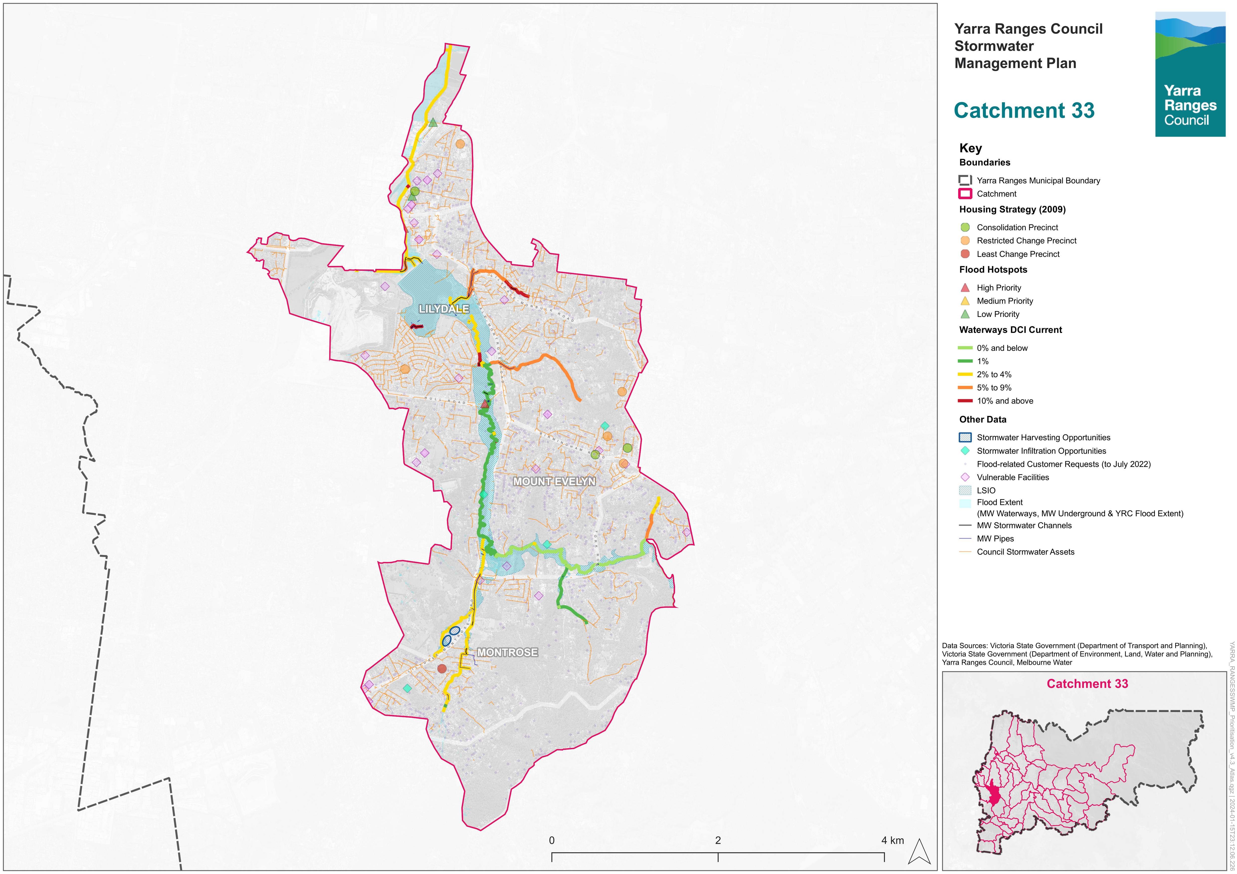
Figure 6-5 Example catchment area map
Table 6-1 Example catchment area information table
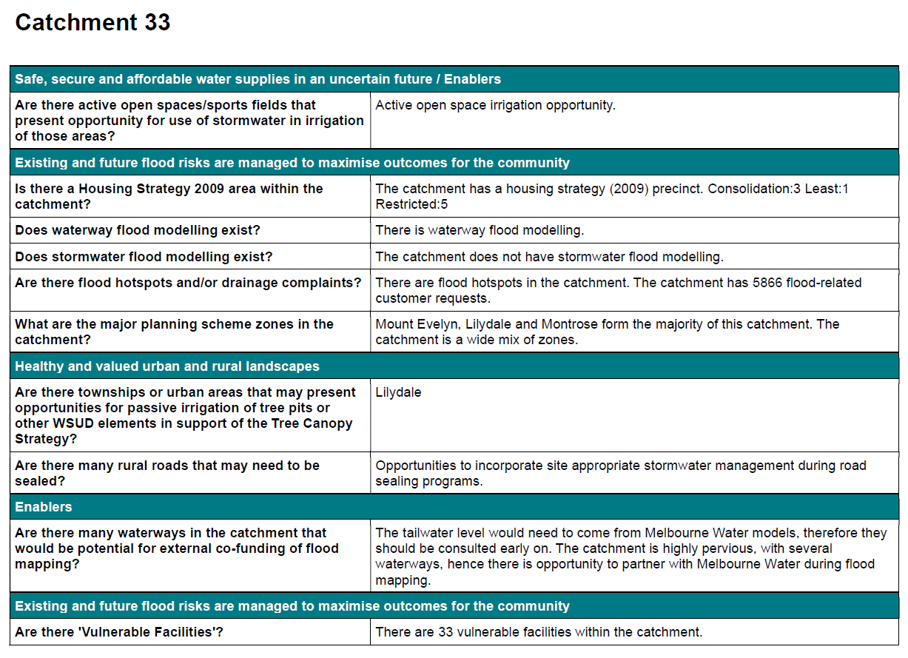

Implementation Plan and Timeline
The Implementation Plan will be completed over a span of 10 years, from 2024 to 2034.
Action ID | Description | Timeline (target completion date) | Key External Stakeholders | Estimated Cost | Funding Source | Key SWMP Indicator Link
Utilising Stormwater as a resource
SWMP1 | Finalise the Integrated Water Management plan which will help inform the catchment stormwater management strategies. | TBC | MW, DEECA | No Cost | Existing | Increase fit-for-purpose use of stormwater and rainwater.  Protect high value waterways.  Reduce the total urban stormwater runoff volume discharged to receiving waters.  Decrease pollutants discharged to receiving waters.  To minimise increases in stormwater due to development and protect the environmental values and physical characteristics of the landscape from degradation by stormwater.  Respond to climate and climate change related events through resilience planning.  Increased collaboration with other organisations to support strategic stormwater management.
Existing and future flood risks are managed to maximise outcomes for the community
SWMP2 | Update the Development Engineering Guidelines to better support the Stormwater Policy and this SWMP. | 2025 | MW, DEECA, Developers | No Cost | Existing | Reduce the total urban stormwater runoff volume discharged to receiving waters.  Decrease pollutants discharged to receiving waters.  Reduce the impacts of dangerous flooding now and into the future with development and climate change.  Respond to climate and climate change related events through resilience planning.
SWMP3 | Review and improve the development application and approvals process to better support the Stormwater Policy and the SWMP | 2025 | MW, DEECA, Developers | No Cost | Existing | Reduce the total urban stormwater runoff volume discharged to receiving waters.  Decrease pollutants discharged to receiving waters.  Reduce the impacts of dangerous flooding now and into the future with development and climate change.  Respond to climate and climate change related events through resilience planning.
SWMP4 | Undertake flood mapping and prepare stormwater management strategies for priority catchment areas. These are the highest priority, and the approach will be refined after each iteration. | 2028 | MW, Wider local community within Yarra Ranges Council | $2.1M | TBC – Grant assistance from MW | Reduce the impacts of dangerous flooding now and into the future with development and climate change.  To enable better asset management with improved efficiencies and overall cost reductions for council via strategic planning.  Respond to climate and climate change related events through resilience planning.  To minimise increases in stormwater due to development and protect the environmental values and physical characteristics of the landscape from degradation by stormwater.  Increase cross-consideration of flood mitigation and integrated water management.  Increase organisational capacity to partner with Traditional Owners to be able to respectfully acknowledge the connection of Traditional Owners to the land and waterways and include indigenous knowledge in stormwater management.
SWMP5 | Complete development of flood mapping and Stormwater Management Strategies for all remaining catchments. Provide implementation status update and prepare next version of the Stormwater Policy and SWMP. | 2034 | MW | TBC | Other strategies | Reduce the impacts of dangerous flooding now and into the future with development and climate change.  To enable better asset management with improved efficiencies and overall cost reductions for council via strategic planning.  Respond to climate and climate change related events through resilience planning.  To minimise increases in stormwater due to development and protect the environmental values and physical characteristics of the landscape from degradation by stormwater.  Increase cross-consideration of flood mitigation and integrated water management.  Increase organisational capacity to partner with Traditional Owners to be able to respectfully acknowledge the connection of Traditional Owners to the land and waterways and include indigenous knowledge in stormwater management.
SWMP6 | Develop and prioritise a program of works (for design & delivery) for our most critical outfall drains as part of the rolling completion of action SWMP4. These outfall drains coincide with where the downstream drainage network meets the natural waterways. | Ongoing | Nil | $30,000 | TBC | Reduce the impacts of dangerous flooding now and into the future with development and climate change.
SWMP7 | Develop and prioritise a program of works focused on mitigation and adaptation of our existing drainage network. The critical areas of our existing drainage network will be determined via a combination of flood modelling (SWMP4) and hazard categorisation assessment. | Ongoing | Nil | $60,000 | TBC | Reduce the impacts of dangerous flooding now and into the future with development and climate change.
SWMP8 | Consider drainage infrastructure for new unsealed road upgrade programs. | TBC | Nil | $30,000 | TBC | To minimise increases in stormwater due to development and protect the environmental values and physical characteristics of the landscape from degradation by stormwater.  Reduce the impacts of dangerous flooding now and into the future with development and climate change.  Convey to the community that roadways are intended to perform a flood management function in large rainfall events, allowing the stormwater runoff to make its way to the waterways.
Healthy and valued waterways
SWMP9 | Investigate Victorian urban stormwater offsets which can be managed by Council. | 2024 | MW, DEECA | $120,000 | TBC | To minimise increases in stormwater due to development and protect the environmental values and physical characteristics of the landscape from degradation by stormwater.  Protect high value waterways.
SWMP10 | Improve workable options for on lot WSUD via research and pilot testing and develop WSUD Guidelines with preferred solutions. | 2025 | MW, DEECA | No Cost | Existing | Protect high value waterways.  Reduce the total urban stormwater runoff volume discharged to receiving waters.  Decrease pollutants discharged to receiving waters.
SWMP11 | Establish WSUD criteria for public and private realms – either in standalone guidelines or as part of updates to existing guidelines. | 2025 | MW, DEECA | $60,000 | TBC | Protect high value waterways.  Reduce the total urban stormwater runoff volume discharged to receiving waters.  Decrease pollutants discharged to receiving waters.  To ensure integrated stormwater management that maximises ecosystem services, such as cooling and local habitat improvement, and provides attractive and enjoyable spaces.  Increase fit-for-purpose use of stormwater and rainwater.
SWMP12 | Review outcomes of the Little Stringy Bark Creek stormwater management | 2025 | MW, DEECA | No Cost | Existing | Increased collaboration with other organisations to support strategic stormwater management.  Protect high value waterways.
Healthy and valued urban and rural Landscapes
SWMP13 | Following the completion of SWMP10, assess the Tree Canopy Strategy (e.g. along key pedestrian routes and throughout activity centres) for overlaps with new or redevelopment areas, or with road upgrade plans to determine where passively irrigated street trees could best be placed. | 2025 | MW, DEECA | $20,000 | Existing | To enable better asset management with improved efficiencies and overall cost reductions for council via strategic planning.  Respond to climate and climate change related events through resilience planning.  Increase fit-for-purpose use of stormwater and rainwater.  Reduce the total urban stormwater runoff volume discharged to receiving waters.  Decrease pollutants discharged to receiving waters.  Protect high value waterways.  To minimise increases in stormwater due to development and protect the environmental values and physical characteristics of the landscape from degradation by stormwater.
Community values are reflected in stormwater planning
SWMP14 | Determine where road capital works program locations overlap with drainage works and align timelines where appropriate. | 2024 | DOT, MW | No Cost | Existing | To enable better asset management with improved efficiencies and overall cost reductions for Council via strategic planning.
SWMP15 | Develop framework for data collection to inform assessment against SWMP objectives. | 2024 | Nil | $25,000 | TBC | To enable better asset management with improved efficiencies and overall cost reductions for council via strategic planning.
SWMP16 | Develop a Fact Sheet to clearly outline Council’s approach to prioritising catchments for future flood mapping and drainage issues, and the roles that infrastructure, including roadways, play in flood management. | 2025 | Wider local community within Yarra Ranges Council | No cost | Existing | Engage with the community during flood mapping and stormwater management projects and studies to support and enhance community connection with and understanding of the water cycle.  Convey to the community that roadways are intended to perform a flood management function in large rainfall events, allowing the stormwater runoff to make its way to the waterways.
SWMP17 | Determine a clear prioritisation for and approach to addressing flood and drainage complaints and an associated Fact Sheet. | 2025 | Wider local community within Yarra Ranges Council | $10,000 | Existing | Engage with the community during flood mapping and stormwater management projects and studies to support and enhance community connection with and understanding of the water cycle.
SWMP18 | Develop a Fact Sheet to clearly detail how Council manages new developments with respect to flooding, per the Stormwater Policy. | 2025 | Wider local community within Yarra Ranges Council | $5,500 | Existing | Engage with the community during flood mapping and stormwater management projects and studies to support and enhance community connection with and understanding of the water cycle.
SWMP19 | Develop a Fact Sheet to clearly outline authority and private responsibilities including responsibilities for private to private property flooding with no infrastructure and property access (e.g. water running down driveway). | 2025 | Wider local community within Yarra Ranges Council | $5,500 | Existing | Engage with the community during flood mapping and stormwater management projects and studies to support and enhance community connection with and understanding of the water cycle.
SWMP20 | Provide SWMP implementation status update to Council. | 2029 | Nil | No cost | Existing | All
SWMP21 | Following completion of flood mapping and Stormwater Management Strategies for priority catchments, undertake community consultation and investigate Planning scheme amendment. | 2029 | MW | $200,000 | TBC | Reduce the impacts of dangerous flooding now and into the future with development and climate change.  To enable better asset management with improved efficiencies and overall cost reductions for council via strategic planning.  Respond to climate and climate change related events through resilience planning.  To minimise increases in stormwater due to development and protect the environmental values and physical characteristics of the landscape from degradation by stormwater.  Increase cross-consideration of flood mitigation and integrated water management.  Increase organisational capacity to partner with Traditional Owners to be able to respectfully acknowledge the connection of Traditional Owners to the land and waterways and include indigenous knowledge in stormwater management.
SWMP22 | Update asset management plans (including 10-year capital plan) using information from completed stormwater management strategies. | Ongoing | Nil | $25,000 | TBC | To enable better asset management with improved efficiencies and overall cost reductions for council via strategic planning.
SWMP23 | Incorporate key findings from the catchment flood mapping projects into the Municipal Flood Management Plan. | Ongoing | Wider local community within Yarra Ranges Council | $20,000 | TBC | Engage with the community during flood mapping and stormwater management projects and studies to support and enhance community connection with and understanding of the water cycle.
SWMP24 | Investigate ways of further improving community flood resilience, such as retrofits and overlays. | 2024 | Wider local community within Yarra Ranges Council, MW | No cost | Existing | Reduce the impacts of dangerous flooding now and into the future with development and climate change.  Respond to climate and climate change related events through resilience planning.
SWMP25 | Undertake a process review and gap analysis of the permit application process from start to statement of compliance. Involve planners, developers, engineering, consultants in the review. This will help with overall process improvement. | 2024 | Developers | No cost | Existing | Increase fit-for-purpose use of stormwater and rainwater.  Protect high value waterways.  Reduce the total urban stormwater runoff volume discharged to receiving waters.  Decrease pollutants discharged to receiving waters.  To minimise increases in stormwater due to development and protect the environmental values and physical characteristics of the landscape from degradation by stormwater.  Respond to climate and climate change related events through resilience planning.  Increased collaboration with other organisations to support strategic stormwater management.
SWMP26 | Implement a Community Reference Panel (CRP) for Stormwater Management. | Ongoing | Wider local community within Yarra Ranges Council | $30,000 | Existing | Engage with the community during flood mapping and stormwater management projects and studies to support and enhance community connection with and understanding of the water cycle.
SWMP27 | Biennial review of the SWMP. | 2026, 2028, 2030, 2032, 2034 | All | No cost | Existing | All
Strategic Partnerships
SWMP28 | Establish a partnership between the Yarra Ranges water managers, including Yarra Valley Water, South East Water and Melbourne Water to enable a governance structure that supports the commissioning and development of the catchment flood mapping and stormwater management strategies, and that supports the implementation of actions identified in the strategies. | 2024 | MW, DEECA | No cost | Existing | Increased collaboration with other organisations to support strategic stormwater management.
SWMP29 | Investigate alternative funding opportunities. | 2026 | MW | No cost | Existing | To enable better asset management with improved efficiencies and overall cost reductions for council via strategic planning.  Increased collaboration with other organisations to support strategic stormwater management.
SWMP30 | Commence advocacy for any special or flagship projects pertaining to waterway protection, stormwater and flood management as identified in stormwater management strategies. | 2026 | MW, DEECA | No cost | Existing | Increased collaboration with other organisations to support strategic stormwater management.  Reduce the total urban stormwater runoff volume discharged to receiving waters.  Protect high value waterways.  Reduce the impacts of dangerous flooding now and into the future with development and climate change.
SWMP31 | Test alternative funding opportunities. | 2027 | MW, DEECA, State Government | No cost | Existing | To enable better asset management with improved efficiencies and overall cost reductions for council via strategic planning.

References
Yarra Ranges Planning Scheme. Planning scheme last updated by VC231 on 06/04/2023.
Urban Stormwater Best Practice Environmental Management Guidelines. CSIRO, 1999.
Urban stormwater offsets: Guidance for councils developing urban stormwater offsets in Victoria. DELWP, date unknown.
Plan Melbourne 2017-2050. DELWP, 2017a.
Yarra River Action Plan. DELWP, 2017b.
Victoria’s Climate Change Strategy. DELWP, 2021.
Dandenong Catchment IWM Plan Summary. DELWP, 2022a.
Yarra Catchment IWM Plan Summary. DELWP, 2022b.
Built Environment Climate Change Adaptation Action Plan. (DELWP, 2022c)
Urban Stormwater Management Guidance. EPA Victoria, 2021.
Flood Management Strategy for Port Phillip and Westernport. Melbourne Water, 2021.
Greater Melbourne Urban Water & System Strategy: Water for Life. Melbourne Water, 2022.
Shire of Yarra Ranges Housing Strategy. Shire of Yarra Ranges, 2009.
Healthy Waterways Strategy. Victorian State Government, 2018.
Burndap Birrarung Burndap Umarkoo: Yarra Strategic Plan. A 10-year plan for the Yarra River corridor 2022-2032. Victorian State Government, 2022a.
Yarra Strategic Plan Implementation Plan. Victorian State Government, 2022b.
Development Engineering Guidelines v1.2. YRC, date unknown.
Recreation and Open Space Plan Strategic Framework 2013-2023. YRC, 2013.
Environment Strategy 2015-2025. YRC, 2016.
IWM Plan 2017. YRC, 2017.
Council Plan 2021-2025. YRC, 2021.
Health and Wellbeing Plan 2021-2025. YRC, 2021a.
Tree Canopy Strategy 2022-2042. YRC, 2022a.
Yarra Ranges Council Asset Plan 2022-2032. YRC, 2022b.
Flood Management Plan. YRC & MW, 2016.

- Background to the SWMP
This section expands upon Section 0 which details the key policies, legislation, strategies, plans and frameworks at both the state and local level that form the basis for this SWMP.

Key Policies and Legislation

Victorian Planning Provisions (VPP)
Clause 56 of the Victorian Planning Provisions requires that stormwater run-off from residential subdivisions in an urban area comply with the Urban Stormwater – Best Practice Environmental Management Guideline (BPEMG)(CSIRO,1999). In particular, the urban run-off management objectives outlined in Clause 56.07‒4 and Standard C25 address urban stormwater and will contribute to improved stormwater water quality and assist in achieving the objectives of the State Environment Protection Policy (Waters of Victoria). The standards to be met include performance objectives as described in BPEMG. These standards can be met by incorporating water sensitive urban design (WSUD) elements as part of the drainage system. Council supports the principles of WSUD and requires the drainage design to incorporate these principles.
Clause 56.07 Integrated Water Management (IWM) also includes objectives and discretionary standards for stormwater management for residential subdivisions that are in addition to meeting BPEMG performance objectives (including considerations for flooding and stormwater reuse).
Objectives and standards within Clauses 55.03 (Standard B9), 55.07 (Standard B39), and 58.03 (Standard D13) also require that stormwater management systems be designed to comply with the BPEM Guidelines. These standards enable use of alternative water (such as rainwater from tanks) and contain other inclusions that assist in reduction of the impacts of stormwater run-off. These standards apply to residential developments comprising apartments or multiple dwellings.
Clause 53.18 was introduced via Amendment VC154 to extend stormwater management requirements and generally applies to non-residential subdivisions and developments, or residential developments in non-residential zones.

Yarra Ranges Planning Scheme
The planning scheme’s strategic directions for housing include to:
- Contain residential subdivision within the existing Urban Growth Boundary.
- Discourage housing in locations that would increase the potential for land use conflicts and adverse impacts on landscape amenity or the environment.
With regards to community and development infrastructure, there is a strategic direction to:
- Support the upgrade of stormwater drainage and other reticulated infrastructure in established urban areas that have been identified for more intensive development.
With regards to stormwater management, portions of Clauses 53, 55, 56 and 58 can apply within Yarra Ranges depending on the type of works and the zoning. 53.18 and 56.07 are most commonly applied.
Clause 53.18 (Stormwater Management in Urban Development) applies to most non-residential development activity (some exceptions are listed within the planning scheme) and residential development in non-residential zones. Under Clause 53.18:
Applications to subdivide land must meet all objectives of 53.18-4 and 53.18-6 and should meet all the standards of clauses 53.18-4 and 53.18-6. Exemptions – YR Planning scheme 53.18-1.
Applications to construct a building or construct or carry out works must meet all objectives of 53.18-5 and 53.18-6 and should meet all the standards of clauses 53.18-5 and 53.18-6.
The objectives of each are shown below, with the standards available within the planning scheme.
53.18-4 – Stormwater management objectives for subdivision
- To minimise damage to properties and inconvenience to the public from stormwater.
- To ensure that the street operates adequately during major storm events and provides for public safety.
- To minimise increases in stormwater and protect the environmental values and physical characteristics of receiving waters from degradation by stormwater.
- To encourage stormwater management that maximises the retention and reuse of stormwater.
- To encourage stormwater management that contributes to cooling, local habitat improvements and provision of attractive and enjoyable spaces.
53.18-5 – Stormwater management objectives for buildings and works
- To encourage stormwater management that maximises the retention and reuse of stormwater.
- To encourage development that reduces the impact of stormwater on the drainage system and filters sediment and waste from stormwater prior to discharge from the site.
- To encourage stormwater management that contributes to cooling, local habitat improvements and provision of attractive and enjoyable spaces.
- To ensure that industrial and commercial chemical pollutants and other toxicants do not enter the stormwater system.
53.18-6 – Site management objectives
- To protect drainage infrastructure and receiving waters from sedimentation and contamination.
- To protect the site and surrounding area from environmental degradation prior to and during construction of subdivision works.
Clause 56.07 – IWM is applied via the Yarra Ranges planning scheme for residential subdivision only. 56.07-4 Stormwater Management Objectives is specifically relevant to stormwater management. The objectives of 56.08-4 are very similar to 53.18-4:
- To minimise damage to properties and inconvenience to residents from stormwater.
- To ensure that the street operates adequately during major storm events and provides for public safety.
- To minimise increases in stormwater and protect the environmental values and physical characteristics of receiving waters from degradation by stormwater.
- To encourage stormwater management that maximises the retention and reuse of stormwater.
- To encourage stormwater management that contributes to cooling, local habitat improvements and provision of attractive and enjoyable spaces.
All subdivision and development captured under these Clauses must meet the above objectives and should meet all the standards of Standard C25.
With regards to the flow and quantity requirements on developments, Standards within the Clauses listed above outline how works should manage the quantity of stormwater. Some specific examples from Clause 56.07-4 C25 are:
The stormwater management system must be:
- Designed and managed in accordance with the requirements and to the satisfaction of the relevant drainage authority.
- Designed to ensure that flows downstream of the subdivision site are restricted to pre-development levels unless increased flows are approved by the relevant drainage authority and there are no detrimental downstream impacts.
- For all storm events up to and including the 20% Average Exceedance Probability (AEP) standard:
  - Stormwater flows should be contained within the drainage system to the requirements of the relevant authority.
  - Ponding on roads should not occur for longer than 1 hour after the cessation of rainfall.
- For storm events greater than 20% AEP and up to and including 1% AEP standard:
  - Provision must be made for the safe and effective passage of stormwater flows.
  - All new lots should be free from inundation or to a lesser standard of flood protection where agreed by the relevant floodplain management authority.
  - Ensure that streets, footpaths and cycle paths that are subject to flooding meet the safety criteria d_{a}V_{ave} < 0.35 m²/s (where, d_{a} = average depth in metres and V_{ave} = average velocity in metres per second).
- The design of the local drainage network should:
  - Ensure stormwater is retarded to a standard required by the responsible drainage authority.
  - Ensure every lot is provided with drainage to a standard acceptable to the relevant drainage authority. Wherever possible, stormwater should be directed to the front of the lot and discharged into the street drainage system or legal point of discharge.
  - Ensure that inlet and outlet structures take into account the effects of obstructions and debris build up. Any surcharge drainage pit should discharge into an overland flow in a safe and predetermined manner.
- Any flood mitigation works must be designed and constructed in accordance with the requirements of the relevant floodplain management authority.
Standard W1 within Clause 53.18 applies very similar standards with relation to quantity management as Clause 56.07-4 C25.

Urban Stormwater Best Practice Environmental Management Guidelines (CSIRO, 1999)
Yarra Ranges are committed to updating their Development Engineering Guidelines to ensure BPEMG are being met across all development types where supported by the Yarra Ranges Planning Scheme (and hence the Victorian Planning Provisions).
Urban Stormwater Best Practice Environmental Management Guidelines (CSIRO, 1999) (‘BPEMG’) were produced to assist urban catchment managers protect stormwater quality. They include guidance to meet or comply with the State Environment Protection Policies (SEPP) and are included within Victorian Planning Schemes within with the Victorian Planning Provisions. BPEMG’s best practice post-construction performance objectives included:
- 80% retention of typical urban load for suspended solids;
- 45% retention of the typical urban annual load for phosphorous;
- 45% retention of the typical urban annual load for nitrogen;
- 70% reduction of typical urban annual load for Litter; and
- Flows: maintain discharges for 1.5-year Average Recurrence Interval (ARI) at pre-development levels.
The BPEMG note the following regarding Local government responsibilities:
- “Local government planners can help protect stormwater quality by ensuring the land is capable of sustaining urban development, minimising the extent of impervious surfaces and providing adequate space for stormwater detention and treatment. New drainage infrastructure should be designed to ensure the impact of urban stormwater on receiving environments is minimal”.
- “Local government is responsible for the management of various parts of the urban environment that discharge directly into the stormwater system. These include roads, reserves, parks and car parks. Adopting a best practice environmental management approach in regard to the operation and maintenance of these resources is an essential element for improved stormwater quality”.
The stormwater management objectives (Figure A-1) within the BPEMG are reflected throughout the Victorian Planning Provisions and apply to both construction and post-construction development conditions.
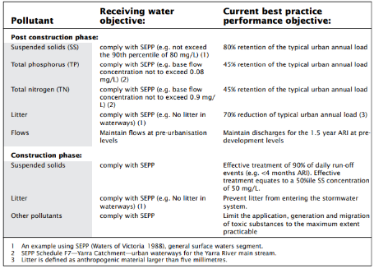
Figure A-1 Objectives for environmental management of stormwater (CSIRO, 1999)

Urban Stormwater Management Guidance (EPA, 2021)
To better meet the Guidelines, we need to investigate WSUD and IWM solutions at a range of scales to suit the conditions specific to the municipality. We will work with the community, developers and other water managers to find solutions suitable for on-lot (such as rainwater tanks), street-scale (such as rain gardens) and precinct scale (such as stormwater harvesting and infiltration) WSUD and IWM applications.
The intent of the Urban Stormwater Management Guidance (EPA Victoria, 2021) is to “help improve the management of urban stormwater in Victoria by recognising current science and the risk of harm from urban stormwater flows”. They support those who inform infrastructure planning and design, including technical consultants and developers, in minimising the risks to human health and the environment from their design, planning and development activities, as General Environmental Duty (GED) requires.
The Guidance sets out the steps in controlling hazards and risks associated with stormwater (Figure A-2), as well as a hierarchy of hazard reduction (Figure A-3), which highlights that eliminating the hazard is the most effective approach. Eliminating hazard associated with stormwater runoff can be achieved by measures such as reducing impervious surfaces, harvesting and infiltrating stormwater and preventing pollutants from entering the waterways. The most effective hazard elimination associated with development comes from ensuring planning permits contain the adequate conditions.
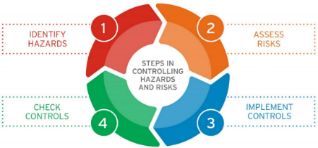
Figure A-2 Steps in controlling hazards and risks associated with stormwater (EPA Victoria, 2021).
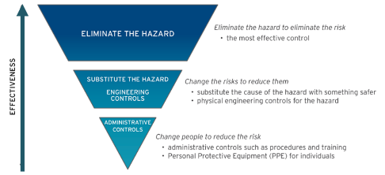
Figure A-3 Hierarchy of controlling hazards and risks (EPA, 2021)
Table A-1 (from the Guidelines) assists in evaluating the risks of stormwater-related harm from development, whereby performance against the objectives can be used as a guide as to the level of risk of waterway values being lost or impacted. The priority areas referred to in Table A-1 are identified in the Melbourne Water Healthy Waterways Strategy. These priority areas have significant infiltration and/or harvesting/reuse targets. The Healthy Waterways Strategy has a target of 'no increase in DCI' in high priority catchments, and this forms the basis of the stormwater harvesting and infiltration targets for these catchments. The Urban Stormwater Management Guidance endorse this 'no increase in DCI' target by stating that achieving these targets is consistent with protecting waterways under General Environmental Duty.
The municipality generally sits within 850 – 2,100 mm average annual rainfall band as highlighted in Table A-1.
The Guidelines include stormwater management scenarios for different types of development to demonstrate how the performance objectives shown in Table A-1 may be met. An example of one of these scenarios is shown in Figure A-4 for management of stormwater from a residential townhouse infill multi-dwelling development.
Table A-1 Quantitative performance objectives for urban stormwater (EPA Victoria, 2021)
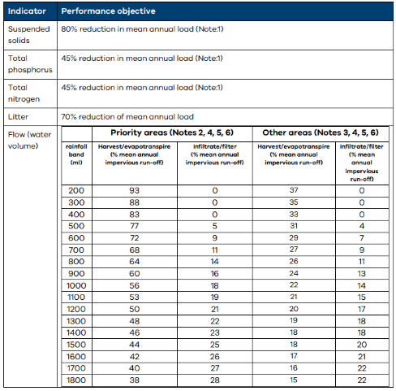
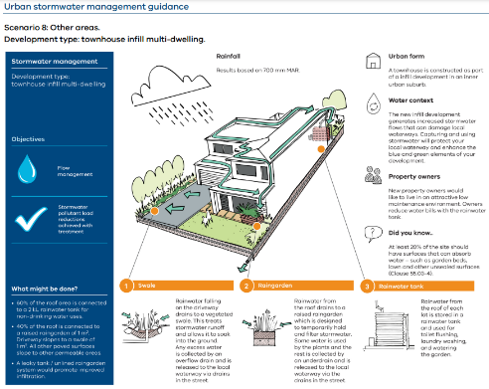
Figure A-4 Scenario 8 example stormwater management scenario (EPA Victoria, 2021)

Healthy Waterways Strategy Stormwater Targets: Practitioner’s Note
Yarra Ranges are committed to updating their Development Engineering Guidelines to encourage meeting these additional harvesting and infiltration targets per current best practice. In some cases, offsets may be allowed to manage the stormwater quality impacts of a development off-site, instead of meeting these on-site.
The Practitioner’s Note assists with the application of the EPA (2021) Guidelines
The Practitioner’s Note outlines that the targets need to be achieved at a range of scales: allotment/street scale, precinct scale and regional or catchment scale (Figure A-5), with typical intervention examples provided for each scale (Table A-2).
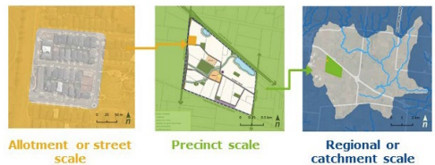
Figure A-5 Scales at which infiltration and harvesting targets need to be achieved per catchment (HWS, 2021)
Table A-2 Typical IWM Interventions at each scale (HWS, 2021)
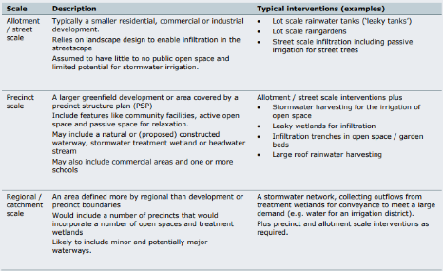

DELWP Guidelines for Development in Flood Affected Areas
The DELWP Guidelines for Development in Flood Affected Areas (DELWP, 2018)
“Provide an assessment framework and method to assist decisions on development in flood affected areas. In principle, development should not intensify the harmful impacts of flooding”
The guidelines are extensively used across Victoria in development applications where the works sit within any of the flood overlays as defined in the planning scheme. Development is defined by the guidelines as “the construction, alteration or demolition of a building or works and subdivision or consolidation of land” as per Clause 44.04 and Clause 44.05.
The guidelines are supported by state government drivers such as the Victorian Floodplain Management Strategy and the Planning and Environment Act.
Works within the boundaries of Clause 44.04 and Clause 44.05 have a mandatory referral to the applicable floodplain management authority, which is Melbourne Water. For works outside of this mapped area, such is the case where the referral is directed to Clause 66 of the Planning Scheme, or Council is not the referral authority, no requirement to apply the guidelines may exist. However , where Council believe there may be a flood risk, Council officers may be required to make their own assessments of development proposals and can utilise the guidelines for this purpose.

Key Strategies, Plans and Frameworks

Plan Melbourne– 2017-2050 Strategy
This SWMP facilitates strategic planning in relation to flood management and mitigation, and IWM initiatives and objectives in support of Plan Melbourne’s Principles 4 and 8.
Plan Melbourne (DELWP, 2017a) will “guide the growth of our city for the next 35 years. It sets the strategy for supporting jobs, housing and transport, while building on Melbourne's legacy of distinctiveness, liveability and sustainability”. Plan Melbourne is guided by nine principles, two of which have direct relevance to the SWMP:
- Principle 4: Environmental resilience and sustainability: Protecting Melbourne’s biodiversity and natural assets is essential for remaining a productive and healthy city. There is an urgent need for Melbourne to adapt to climate change and make the transition to a low carbon city.
- Principle 8: Infrastructure investment that supports balanced city growth: Smart infrastructure investment and better utilisation of existing infrastructure is the key to creating new jobs and driving population growth in the right places. It is also vital for the social, economic and environmental wellbeing of the city. That’s why there needs to be a pipeline of projects and initiatives that make Melbourne more sustainable, accessible and prosperous.
The principles are supported in Plan Melbourne by 7 outcomes. The following are of direct relevance to stormwater management in Yarra Ranges:
- 6.2 Reduce the likelihood and consequences of natural hazard events and adapt to climate change.
- 6.3 Integrate urban development and water cycle management to support a resilient and liveable city.
- 6.4 Make Melbourne cooler and greener.
- 6.5 Protect and restore natural habitats.
The following policies within Plan Melbourne are of direct relevance to stormwater management in Yarra Ranges:
- Policy 6.3.2 Improve alignment between urban water management and planning by adopting an IWM approach.
- Policy 6.4.1 Support a cooler Melbourne by greening urban areas, buildings, transport corridors and open spaces to create an urban forest.
- Policy 6.5.2 Protect and enhance the health of urban waterways.
  - “Retaining stormwater in the landscape through water sensitive urban design and stormwater harvesting is necessary to secure the health of the city’s waterways and bays. It will also reduce flood risks, improve landscapes and amenity, and create a greener city. Objectives and performance standards within planning schemes must be strengthened to minimise the impacts of stormwater”.

Victoria’s Climate Change Strategy
Victoria’s Climate Change Strategy (DELWP, 2021) supports building infrastructure that has more ability to withstand climate change impacts, transparent communication around climate change, climate change adaptation and active management of ecosystems to provide for their function and resilience in the face of climate change. With regards to stormwater management, this has particular relevance to setting of floor levels in flood affected areas and in setting drainage capacity, PSD, OSD and IWM or WSUD requirements. Yarra Ranges are committed to updating their Development Engineering Guidelines to better plan for climate change impacts.
Victoria’s Climate Change Strategy (DELWP, 2021) sets the state’s plan for further reducing emissions, while at the same time creating new opportunities and new jobs.
Two of the 2030 objectives specifically relevant to stormwater management in the Yarra Ranges are:
- Our built environment and infrastructure will have an improved ability to avoid, withstand and recover from climate change impacts, while continuing to provide essential services and support community wellbeing.
- Victoria’s biodiverse ecosystems will be functional and resilient in the face of climate change. They will be actively managed and enjoyed, balancing sometimes competing values and uses.
The adaptation priorities to 2025 include:
- Transparently communicate to all Victorians the challenges, opportunities and trade-offs required under climate change.
- Integrate climate change risk management into investment decisions, particularly for large and long-lived investments.
- Demonstrate the benefits and business case for climate change adaptation action.

Built Environment Climate Change Adaptation Action Plan 2022–2026
This SWMP supports the consideration of climate change in drainage design.
The Built Environment Climate Change Adaptation Action Plan is designed to support communities in how to address and respond to climate and climate change related events through resilience planning. The plan is currently being developed (with a timeline of 2022 – 2026) and will then be updated every 5 years until 2050.
As part of the action plan, a number of governance and regulation actions are being developed, including updating planning provisions to respond to climate change and updating the building standards relevant to flooding and storm exposure. The Action Plan will support councils in managing climate change adaptation and risk reduction and will review legal mechanisms to support climate-resilient urban development.
With regards to stormwater management, climate change is expected to impact rainfall intensities and overall volumes. Rainfall intensities are predicted to increase, particularly in the summer month. There will be a decline in rainfall across the cooler seasons, as well as an overall decrease in average annual rainfall. With these changes, temperature is also expected to increase, placing a greater importance on urban heat island reducing mechanisms of which stormwater plays an important role.

Flood Management Strategy for Port Phillip and Western Port (2021-2031)
The Flood Management Strategy Port Phillip and Westernport is a 10-year strategy that aims to enhance the flood resilience of the region. The Strategy identifies key directions that provide a greater emphasis on managing climate change, empowering diverse communities, and managing flooding to achieve multiple benefits for water security, liveability and sustainability. The strategy recognises the roles and responsibilities of partner organisations in managing flood risks and the need for effective collaboration.
The Strategy recognises that although an extensive network of flood infrastructure has been built over many years to reduce the impacts of flooding, it is not feasible to completely remove flood risk from the region, and also that climate change and urban development are increasing flood risk in the Port Phillip and Westernport region.
The vision of the Strategy is that “Together we are aware, responsive and resilient. Communities, business and government understand flooding, plan collaboratively for challenges and take action to manage risks and optimise opportunities, for now and the future”.

Water for Victoria and IWM Framework for Victoria
There are several key strategies and frameworks related to IWM that influence the direction of this SWMP.
Water for Victoria (Victorian State Government, 2016) provides the framework to guide smart water management, bolster the water grid and support more liveable Victorian communities. From the framework came the IWM Framework for Victoria (DEECA, 2017). This provided guidance to assist government, water authorities and the communities in determining water management solutions.

Yarra Catchment IWM Plan and Dandenong Catchment IWM Plan
The IWM framework led to the establishment of the IWM Forums, and from there IWM strategies for each of the major catchments across Greater Melbourne were developed. Relevant to Yarra Ranges are the Yarra Catchment IWM Plan (DELWP, 2022a) and the Dandenong Catchment IWM Plan (DELWP, 2022b). The Plans include the following targets:
- $10m reduction (Yarra catchment) and $9-64m reduction in AAD (Dandenong catchment) delivered by flood management initiatives by 2030
- 100% of projects cross-consider IWM and flood mitigation opportunities as part of their design by 2030 and maintained by 2050
- 21 GL/year (Yarra catchment) and 11 GL/year (Dandenong catchment) mean annual urban runoff volume reduction by 2030
There are also targets around water for the environment, passive irrigation of street trees and active and passive public open spaces with alternative water, improvements in community literacy around the water cycle, supply of alternative water for agriculture, increasing skills and organisational capacity and leadership and visioning amongst others.

The Healthy Waterways Strategy
The Healthy Waterways Strategy 2018-28 sets a long-term vision for managing the health of rivers, wetlands and estuaries in the Port Phillip and Westernport region, in order to protect and improve their value to the community. The strategy is supported by co-designed programs for each of the region’s five catchments which provide a flexible framework for managing waterways. A Healthy Waterways Strategy Practitioners note was developed by Melbourne Water and the EPA in 2021. The Practitioner’s Note assists with the application of the EPA (2021) Guidelines and clarifies stormwater harvesting and infiltration targets that apply to the different regions.

Yarra River Action Plan
The Yarra River Action Plan (DELWP, 2017b) outlines the Government’s response to the Yarra River Protection Ministerial Advisory Committee (Yarra MAC) Discussion Paper, Protecting the Yarra River (Birrarung).
It is guided by five objectives, the first being “A healthy river”, which has the following aims:
- Wilip-gin Birrarung murron (keep the Birrarung alive)
- Protect and improve the health of the river and its riparian ecology
- Increase the resilience of the river to the impacts of climate change and population growth
- Protect the health of Port Phillip Bay
The second objective is “The Great Yarra Parklands”, with the following aims:
- Recognise the network of parklands along the Yarra as part of the one integrated living whole natural asset
- Improve community access to, movement along and on the river
- Increase opportunities to enjoy the river parklands for people of all ages and abilities
- Create more destinations and improve visitor experiences
The fifth objective, “Modern Governance”, includes partnering with the Traditional Owners in the management of natural resources as an aim.

Yarra Strategic Plan
The Yarra Strategic Plan (Victorian State Government, 2022a) is a requirement of the Yarra River Protection Act 2017 and is the first plan to protect and enhance the Yarra River and its land as one living and integrated natural entity. The Plan sets out 10-year performance objectives, one of which is ‘A healthy river and lands’. This performance objective is stated to have been successful if the following are met:
- Terrestrial and aquatic habitats are improved, connected and maintained resulting in improved biodiversity, increased resilience and net gain in their overall extent and condition.
- Waterway condition/water quality is improved in accordance with targets set in the Healthy Waterways Strategy.
- Populations of native fish including threatened species are improved.
- Participation in land management activities by landowners, recognised Traditional Owners, managers and wider community increases, resulting in improved native vegetation, water quality and biodiversity.

Council Plans and Strategies

Council Plan 2021-2025 and Community Vision for 2036
The Community Vision supports the protection of biodiversity and habitat. The protection of highly valued, high priority waterways throughout the municipal area is dependent on sound stormwater management practices. This SWMP contains actions to include WSUD approaches in development to best practice and beyond, supported by updates to the Development Engineering Guidelines and further supported by a program of determining WSUD and IWM options suited to the unique environment of Yarra Ranges.
The Community Vision also supports taking steps to actively mitigate against Climate Change and be prepared for natural disasters. This directly relates to management of drainage, stormwater and development with respect to the impacts of climate change on flood risk. This SWMP sets out a strategic approach to understanding flood risk across the relevant areas of the municipality so that drainage requirements can be better understood to support more sustainable development.
The Council Plan articulates the Community Values Statement, including the following components that are particularly relevant to stormwater management in the municipality:
We value fresh air, clean rivers and streams, valley views and mountain vistas. We value the diverse and unique natural environment we live in, the many native plants and animals that inhabit it and the opportunities we have to ‘go bush’ in our backyard. We value our active spaces and our healthy lifestyle and how it sustains us in both mind and body.
We value our close connection to place. We value the spiritual connection the traditional custodians of our land have to place in Yarra Ranges, and our role in respecting these places, learning about them and preserving them for future generations.
The Community Vision (for 2036) includes:
- The municipality’s natural beauty, stunning landscapes and reputation for exceptional local produce is enhanced and have a significant influence on decisions made regarding sustainable growth and development in the region.
- The look and feel of our commercial and industrial areas, and their environmental characteristics, has improved. Our roads, paths and other infrastructure are well maintained.
- Yarra Ranges is known to prioritise sustainability and the protection of biodiversity and habitat.
- The community has taken steps to actively mitigate against Climate Change and be prepared for natural disasters including bushfire planning
The five strategic objectives of the Council Plan are shown in Figure A-6.
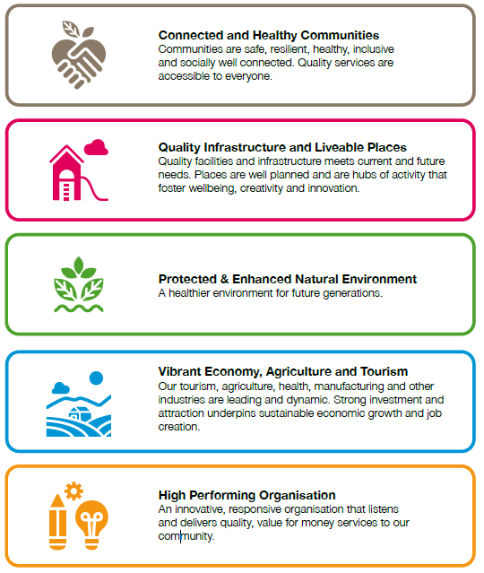
Figure A-6 Council Plan – strategic objectives

Housing Strategy
Urban consolidation and development is an important consideration in understanding flood risk. The housing densities and locations have been considered in this SWMP for the prioritisation of the catchments for flood mapping and stormwater strategy development. This enables better planning for drainage, flood risk and waterway protection.
The work in this SWMP incorporates the 2009 Housing Strategy levels and locations of development.

Flood Management Plan
This SWMP considers the flood hotspots and areas not yet flood mapped within Council’s Flood Management Plan to help identify the priority areas for flood mapping.
The Flood Management Plan was developed by Melbourne Water and Council in 2016. It highlights known flood hotspots of particular concern at the time. It also outlined the areas that had not yet been flood mapped across the municipality. The FMP outlines Local Government roles and responsibilities regarding flood management to be:
- Administer and enforce planning provisions and building regulations in relation to building and development on flood affected land.
- Provide for and support the conservation of natural resources and areas of environmental significance through land use planning and asset management.
- Contribute to development of local flood management plans and flood emergency management plans.
- Participate in flood risk reduction activities and project prioritisation.
- Support public awareness and access to flood risk information.
- Support delivery of flood warning messages.
- Participate in flood risk reduction activities and project prioritisation.
- Coordinate flood relief, recovery, and clean-up at the local level.
- Lead local adaptation processes to prepare for climate change induced flood risks, such as extreme weather events.

Yarra Ranges IWM Plan
This SWMP supports the objectives and targets of the IWMP, as it is recognised that sustainable stormwater management is required for developments and the success or failure of this plays a huge role in the protection of Yarra Ranges’ highly valued catchments and waterways.
There are strong links between Council’s IWM Plan (2017) and the SWMP and stormwater policy, particularly with respect to WSUD practices and stormwater harvesting opportunities. The development of the SWMP is a direct action from the IWMP. The IWMP is currently being reviewed.

Environment Strategy 2015-2025
This SWMP supports meeting the Environment Strategy goals through the sustainable management of stormwater with development.
The Environment Strategy goals are per Figure A-7.
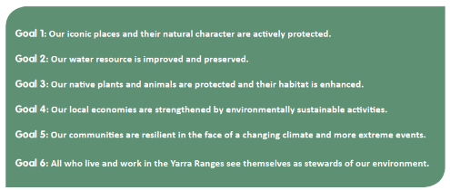
Figure A-7 Environment Strategy goals

Recreation and Open Space Strategy – Policy, Implementation and Strategic Framework
The catchment stormwater strategies supported by this SWMP will consider the opportunity for stormwater harvesting and irrigation of playing fields as part of flood management solutions.
This document identifies that Council needs to explore climate change adaptation in addition to mitigation measures when planning open spaces. There are 65 playing fields across 47 reserves throughout the municipality. There is opportunity to harvest stormwater for irrigation of these open spaces and reserves. This will assist Council in meeting their infiltration and harvesting targets per the HWS Practitioner’s note, to protect and enhance downstream waterways. It would also take pressure of the potable network, and support greening, cooling, and other ecosystem services.

Tree Canopy Strategy
Urban development increases hard surface which can exacerbate urban heating, a key consideration with climate change and development. This SWMP contains an action to identify opportunities for incorporation of WSUD initiatives with development, to support passive irrigation of trees in key areas and hence promote cooling greening through supported tree canopy.
Council’s Tree Canopy Strategy has a particular focus on increasing tree canopy on public land in built up areas including Lilydale and surrounds, Yarra Glen, Healesville and towns in the Dandenong Ranges and Yarra Valley.

Health and Well-being Plan
Understanding flood risk with development and climate change is needed to support community resilience and adaptability. The flood mapping program of this SWMP directly supports this goal.
The Health and Well-being Plan (YRC, 2021a) identifies 7 key priorities, including a priority to ‘Tackle climate change and its impact on health’, with a goal of ‘People and businesses in Yarra Ranges are resilient, prepared, and able to adapt and protect against the potential health impacts of climate change’.

- Flood Mapping Catchment Area Prioritisation Process
Multiple variables provide data into the weighted decision priority matrix to result in the final prioritisation (bottom layer in figure below).
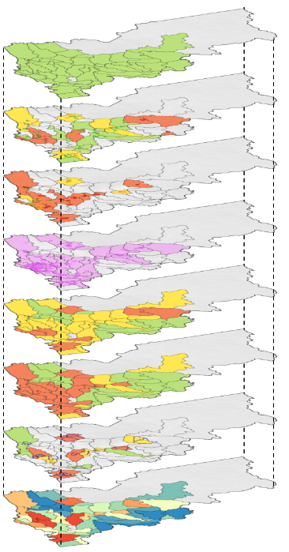

 | Catchments to Include |  | (P_CI)
 | KEY |  | PRIORITY SCORE
 |  | Catchment to include | 1
 |  | Catchment to exclude | 0
 | DESCRIPTION
 |  | This variable acts as a placeholder for any future inclusion variables; it provides each catchment with a priority score of at least 1 so that no catchment has a null value. Catchments outside of this area are allocated a value of 0.

 | Flood Hotspots |  | (P_FH)
 | KEY |  | PRIORITY SCORE
 |  | Catchment only has, at-most, low priority flood hotspot/s | 1
 |  | Catchment has, at-most, medium priority flood hotspot/s | 2
 |  | Catchment has at least one high priority flood hotspot/s | 3
 | DESCRIPTION
 |  | The highest priority Council Flood Hotspot type within the catchment determines the priority value for the catchment. Catchments intersect with a 50 m buffer around each Flood Hotspot node to provide a fair margin of accuracy. Hotspots are as identified in the 2016 Flood Management Plan.

 | Housing Strategy Precincts |  | (P_HS)
 | KEY |  | PRIORITY VALUE
 |  | Catchment has, at-most, Consolidation precinct/s | 1
 |  | Catchment has, at-most, Restricted Change precinct/s | 2
 |  | Catchment has, at least, one Least Change precinct/s | 3
 | DESCRIPTION
 |  | The highest priority Housing Strategy (2009) precinct type within the catchment determines the priority. Catchments intersect with a 50 m buffer around each Housing Strategy Precinct node to provide a fair margin of accuracy.

 | Vulnerable Facilities |  | (P_VF)
 | KEY |  | PRIORITY SCORE
 |  | Catchment has at least one Vulnerable Facility | 1
 | DESCRIPTION
 |  | A catchment with at least one Vulnerable Facility within it is allocated a priority score of 1. Catchments intersect with a 50 m buffer around each Vulnerable Facility node to provide a fair margin of accuracy. Quantification of the number of vulnerable facilities within each catchment can over-prioritise catchments with facilities of lower vulnerability due to the varying nature of the facility types. Catchments are therefore determined to be of equal priority whether than have one vulnerable facility, or several.

 | DCI Change |  | (P_DCICH)
 | KEY |  | PRIORITY SCORE
 |  | Catchments with DCI Change of less than 0% | 1
 |  | Catchments with DCI Change areas of between 0% and 9% only | 2
 |  | Catchments with DCI Change areas of 10% or more | 3
 | DESCRIPTION
 |  | Directly Connected Imperviousness (DCI) percentage change values were calculated for each area. The maximum DCI Change value within a catchment determines the priority score.

 | DCI Current |  | (P_DCICU)
 | KEY |  | PRIORITY SCORE
 |  | Catchments with DCI Current areas of 3% or less | 1
 |  | Catchments with DCI Current areas of between 4% and 9% only | 2
 |  | Catchments with DCI Current areas of 10% or more | 3
 | DESCRIPTION
 |  | Current Directly Connected Imperviousness (DCI) percentage values for each drain were used to determine the maximum DCI Current value within a catchment. The maximum DCI Current value within each catchment was used to determine the priority score.

 | Flood Hazard Analysis (Select Areas) |  | (P_FHA)
 | KEY |  | PRIORITY SCORE
 |  | Catchment with low flood hazard in developed area. | 1
 |  | Catchment with moderate flood hazard in developed area. | 2
 |  | Catchment with higher flood hazard in developed area. | 3
 |  | Flood Hazard Analysis Area
 | DESCRIPTION
 |  | Coarse Flood Hazard Analysis was performed within key areas (indicated by navy borders). Priority scores were ranked based on assessment of the extent of high flood hazard present in developed areas. A high flood hazard was determined to be H3 to H6 inclusive.
- Flood Mapping Catchment Area Prioritisation Results
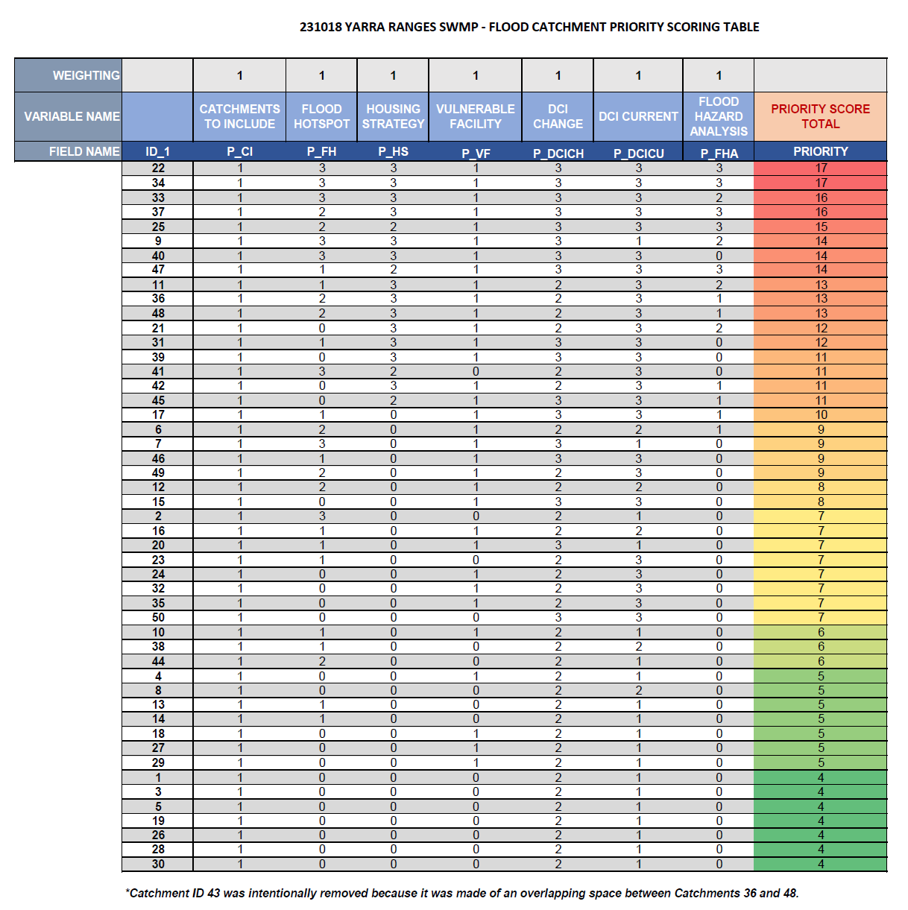

- Flood Mapping Program: Catchment Area Maps
- Flood Mapping Program: Catchment Area Information Tables

