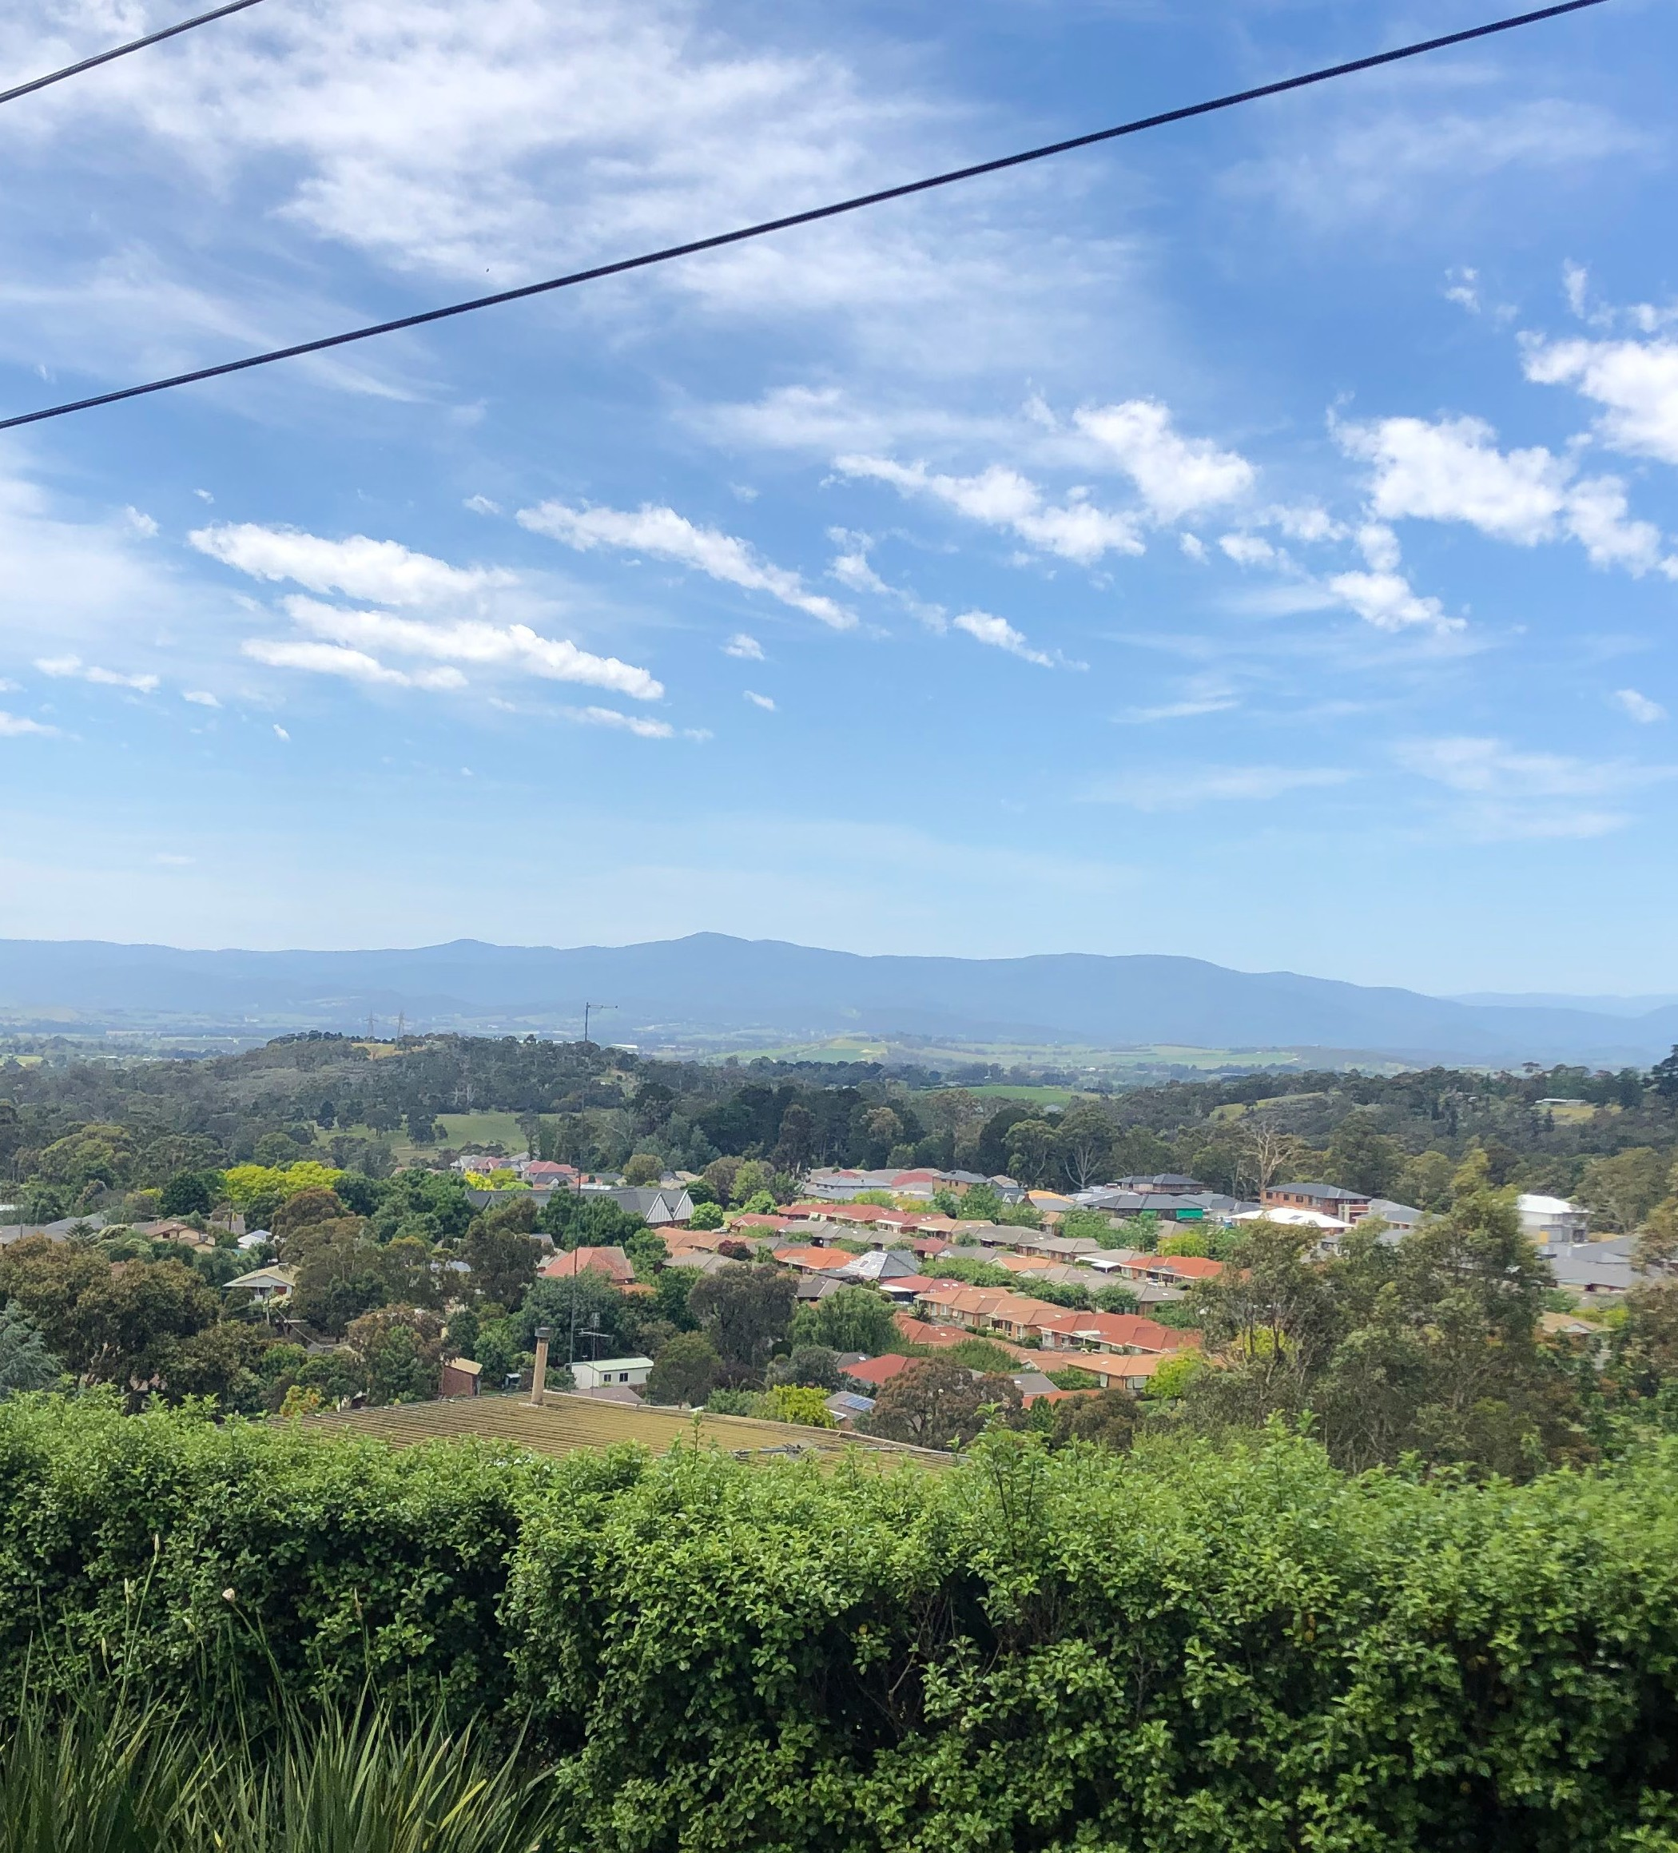



Yarra Ranges Council

Draft Housing Strategy 2023

Summary Brochure

Housing provides us with shelter, protection and helps with our wellbeing. Homes are more than where the heart is – they promote social stability, contribute to the economy, and are a basic human right.

The draft Housing Strategy is a plan for managing housing growth and change across Yarra Ranges for the next 15 years. In this time there will be an increase of roughly 10,700 homes in Yarra Ranges. Key developments like the Kinley Estate will provide for some of this, but our suburbs and townships also play a critical role in providing for different housing choices.

Council has a vital role when it comes to housing, by ensuring that our policies and planning provide for the diverse housing needs of our community now and into the future. Councils can encourage housing supply and guide new development into sustainable locations with access to services, transport and facilities balanced with the community’s changing housing needs for liveability, environmental sustainability and neighbourhood character.

That’s why we’re asking for your feedback on our draft Housing Strategy.

Who Lives in Yarra Ranges?
To plan effectively for housing, there is a need to understand the
population and demographic changes occurring in Yarra Ranges.

Yarra Ranges also has an aging population and in the future there will be an increasing proportion of smaller households.

These trends will create more demand for smaller, more diverse housing options in well located areas near commercial centres, shops, public transport options, employment and services, such as units, townhouses, apartments, and options for elderly residents. Providing more housing choice will lead to more affordable, accessible, and inclusive housing for everyone.

Current population 163,298 | Current dwellings 61,480 | 3  No. of bedrooms in most dwellings | 2.67  Ave. household size
Projected population 2041 185,902 | New dwellings est. over 15yrs 10,700 | 35.2%  Most dominant household = couples with children | 93%  Live in separate houses
Growth rate 0.7% | New dwellings est. over 15yrs 10,700 | 35.2%  Most dominant household = couples with children | 93%  Live in separate houses

What have we heard so far?
Consultation on the Housing Strategy Discussion Paper, took place in 2022, and a number of key themes were identified which have helped to understand the community’s views on housing needs in Yarra Ranges, including:

- New housing that respects neighbourhood character
- Increased housing affordability
- Housing with better environmental performance
- Housing diversity to fit varying resident needs
- New housing directed to suitable locations

The strategy considers housing under the following themes:

- Neighbourhood Character  To encourage housing that fits with the preferred neighbourhood character of Yarra Ranges’ suburban areas. | - Housing Diversity  To encourage the right sizes, types, and mix of housing to meet the population’s changing needs.
- Affordable and Social Housing  To increase the supply of social and affordable housing, including how Council can work with other levels of government in pursuit of these goals. | - Sustainability  To increase the energy efficiency of homes and promote sustainable living.

The final Strategy adopted by Council will be used to update the Yarra Ranges Planning Scheme to achieve desired outcomes. It will also identify issues Council can advocate to other levels of government or agencies for.

Yarra Ranges Housing Framework Plan
The draft Housing Strategy identifies land for the following levels of change:

Substantial Change | Increased Change
These areas are well serviced with physical and community infrastructure, with good walking access to transport, shops and services. These areas will provide for a mix of apartments and townhouses, and are areas where housing affordability, sustainability and diversity will be prioritised. | These areas allow for smaller and more diverse housing options in the large neighbourhood centres of Mount Evelyn, Yarra Junction, Yarra Glen and Healesville, on land which has good access to the town centre. These areas will provide for townhouses and units, allowing for changing housing needs, not only for residents of these towns but also their hinterland areas.
Incremental Change | Minimal Change
These areas will allow for moderate levels of change in parts of Yarra Ranges’ main urban areas of Lilydale, Chirnside Park, Mooroolbark and Kilsyth that do not have easy walking access to the town centre. These areas will continue to provide for units and townhouses, and suburban family homes. | These areas are applied to rural and large townships, where there are limited transport options, or access to shops and services. Some areas have environmental risks or sensitivity. These areas will continue to provide for large semi-rural dwellings .

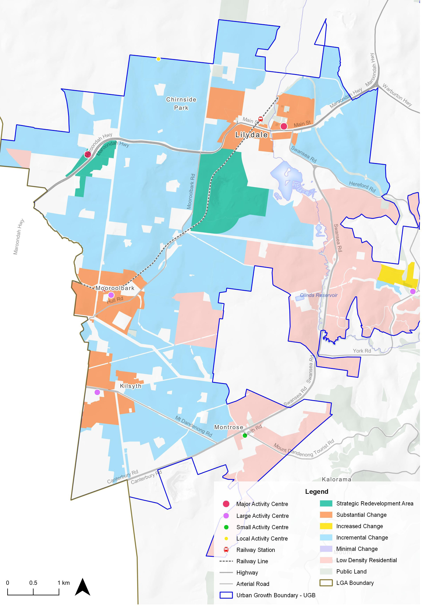

Neighbourhood Character
While planning for growth and different housing types are important to address changing needs, it is also important that new developments respond to Yarra Ranges’ distinctive neighbourhoods, in terms of the scale of new buildings, the type and amount of landscaping, and how private land relates to the street. A key consideration of the draft Strategy is how new housing will contribute to an areas preferred neighbouhood character. The draft Housing Strategy identifies character areas, including:

Urban consolidation  Urban areas for substantial change where it is important to reduce building bulk, encourage landscaping opportunities and protection of views. | Urban township  The historic part of Lilydale where new development should complement the heritage streets, trees and features.
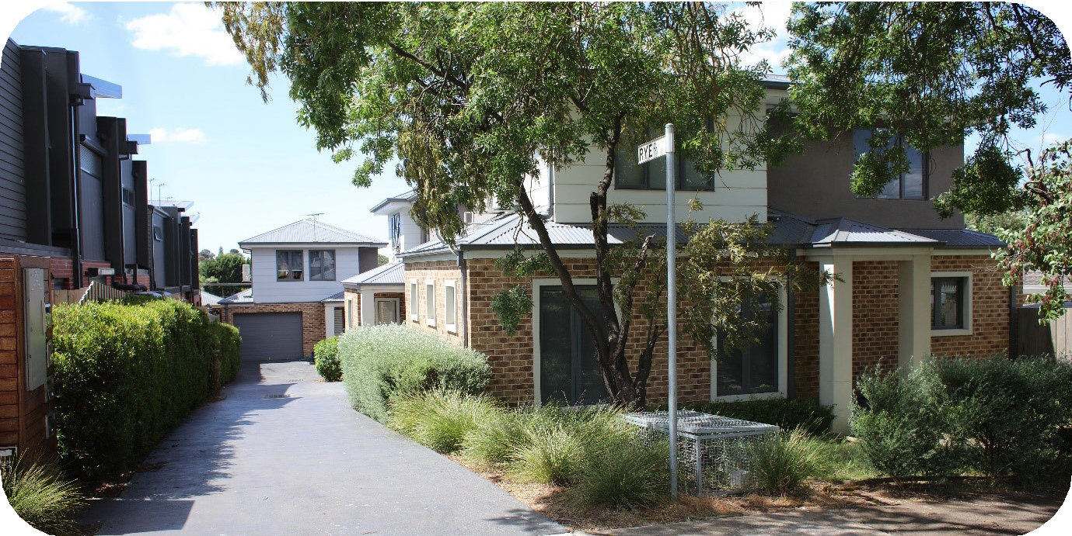 | 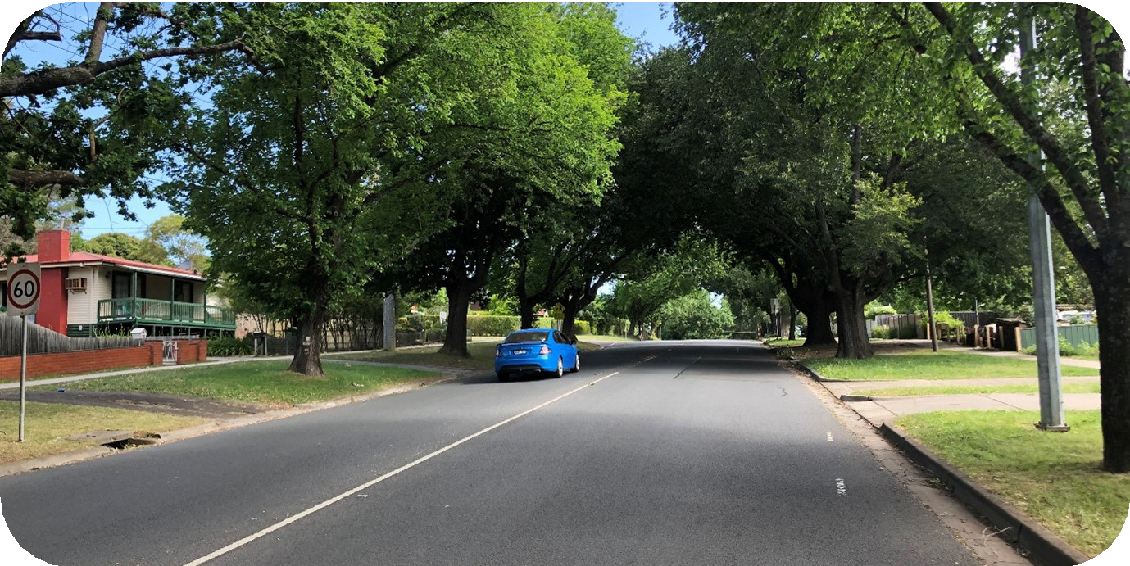
Foothills consolidation  Well located parts of Mt Evelyn, where new development should respond to the highly treed, bushy character. | Garden suburban  Urban areas with moderate change that will see some units and infill development. It is important to manage the appearance of new buildings from the street, and encourage ample separations of buildings from property boundaries.
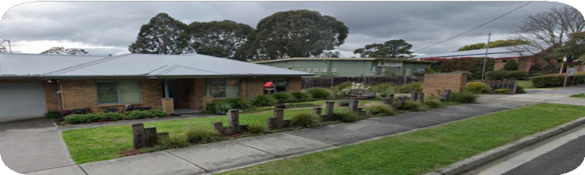 | 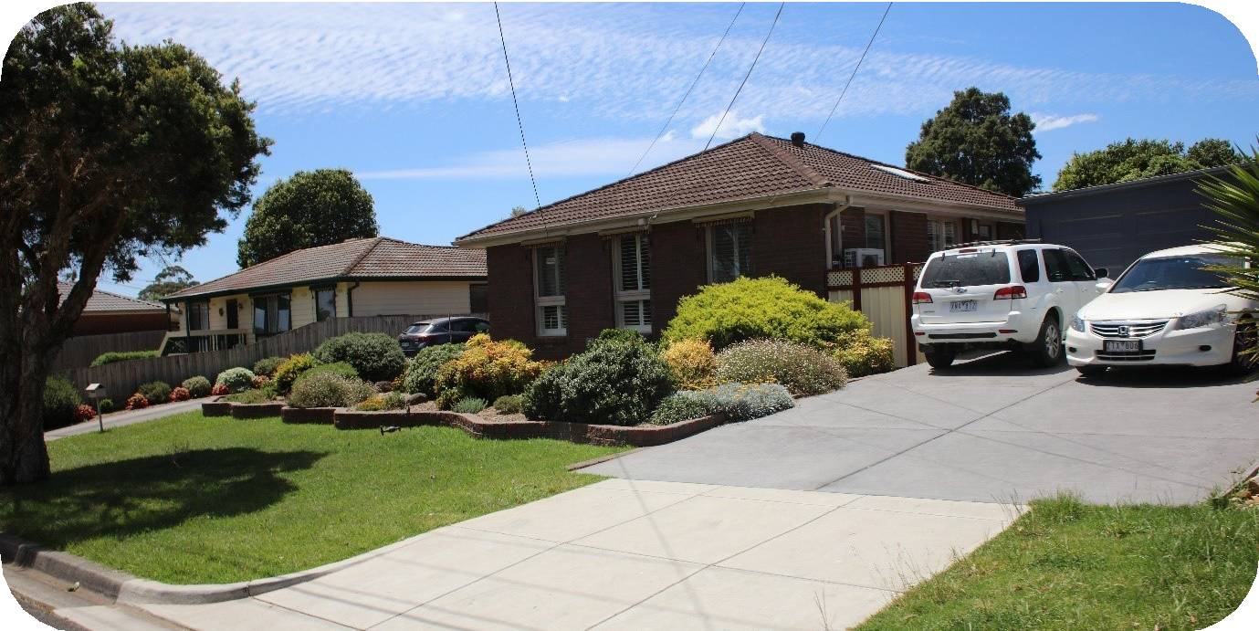

Township consolidation  Well located parts of Healesville, Yarra Glen and Yarra Junction, that will see some unit and townhouse development, where new buildings should respond to the spacious, township feel and views. | Foothills suburban  Hilly, bushy areas around the foothills of the Dandenongs, where it is important to preserve the spacious, leafy environment.
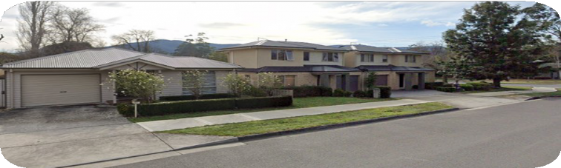 | 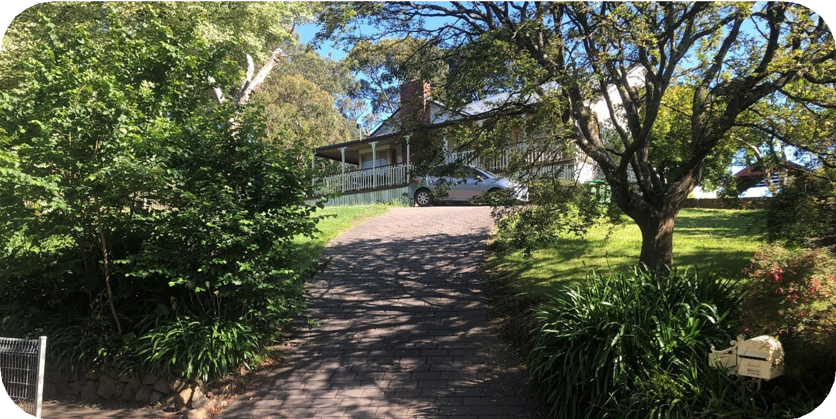
Township suburban  Spacious, large blocks throughout township areas, dominated by detached dwellings, views and the landscape, where this character should be preserved. | Township rural-residential  Areas of townships far from commercial centres where the landscape dominates, roads are sometimes unsealed, and there is a sense of informality that should be preserved.
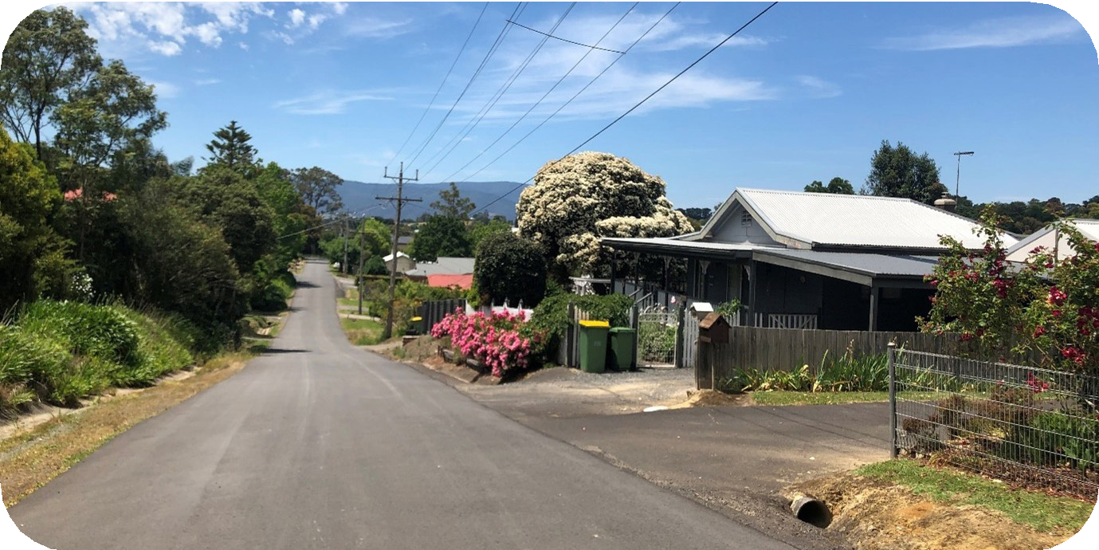 | 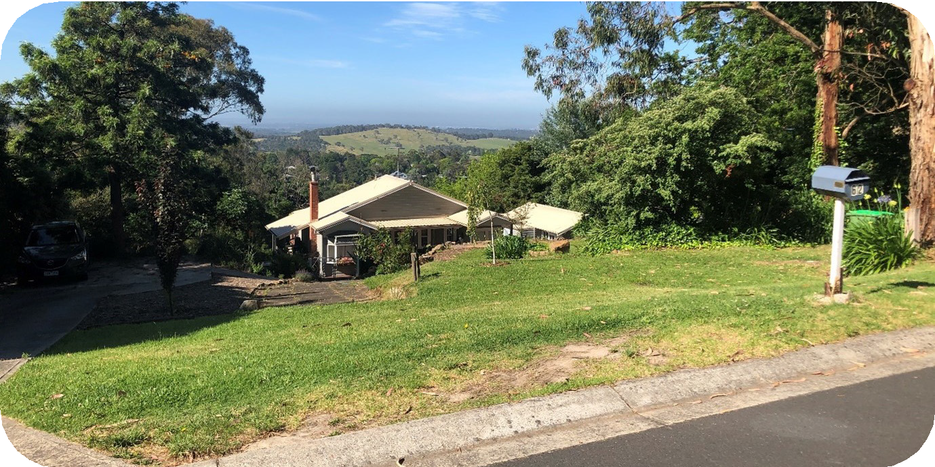

Neighbourhood character
- is essentially the combination of the public and private realms. Every property, public place or piece of infrastructure makes a contribution, whether great or small. It is the cumulative impact of all these contributions that establishes neighbourhood character. (DTP)

Housing Diversity
Demographic information indicates Yarra Ranges’ population is becoming more diverse in terms of age, household size, household structure, ethnicity, and other characteristics. This will need more diverse housing options, including:

- Housing for older people
- Housing for people with a disability, or limited mobility
- Non-standard housing models, such as tiny houses
- Seasonal worker accommodation

Chapter 9 of the Housing Strategy explores housing diversity issues in depth.

Affordability of housing
At a Federal and State Government level, housing and rental affordability are among Australia’s largest contemporary challenges. Council’s Housing Strategy can provide direction at a local level by:

- Identifying actions to help achieve more housing and targeted to emerging housing needs, within available legal and policy frameworks such as the Yarra Ranges Planning Scheme
- Identifying housing challenges for Yarra Ranges that require advocacy to the State and Federal Governments for progress on issues which are beyond its direct remit.

Chapter 10 of the Housing Strategy explores the many facets of housing affordability, and what role Council can play.

Environmental Sustainability
The Housing Strategy presents an important opportunity to consider how Yarra Ranges can transition to a more environmentally sustainable future. At a site level, this includes issues of how buildings are oriented for better environmental performance, and how water and waste can be better managed. At a neighbourhood level, it includes focusing density opportunities near shops and services to encourage walking and cycling, and avoiding urban growth in areas of environmental risk.

How to Get Involved
We want to know what is important to you about housing in Yarra Ranges, and about your neighbourhood. You can find out about the draft Housing Strategy by:

- FAQs
- A full copy of the draft Strategy
- A short video explaining the draft Strategy
- Information on upcoming pop-up information stalls
- Invitation to register to attend an information webinar
- Invitation to register to be part of a focus group, for a deep dive discussion on one of four specific themes
- An interactive map where you can find more details on what is proposed for your property

Get in touch with Council by phone or email at designandplace@yarraranges.vic.gov.au or 9294 6165. You can also write to ‘Draft Housing Strategy 2023, Yarra Ranges Council, 15 Anderson Street, Lilydale VIC 3140’

