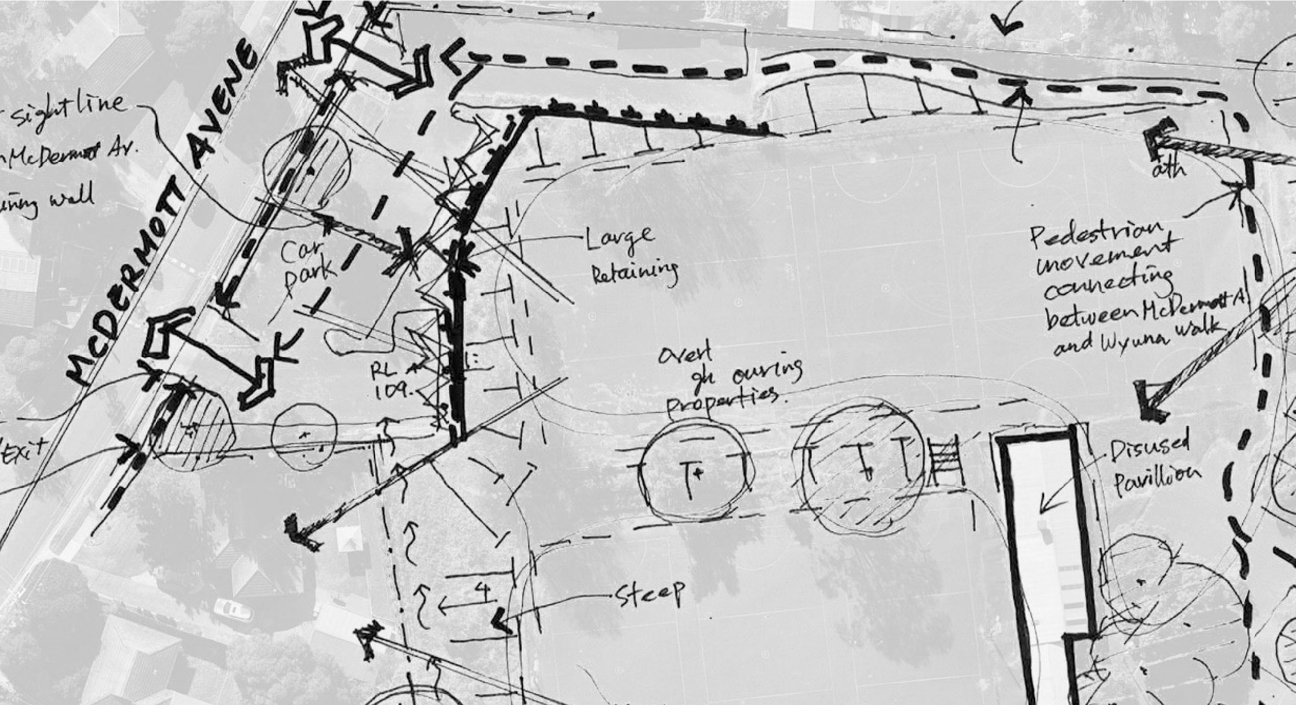
December 2020 Summary Report
M
c
D
ermott Avenue Reserve
Background Research
Initial Community Engagement


Initial research including community and stakeholder engagement, was conducted in the second half of 2020, with a commnuity survey in December 2020. The community engagement sought to understand how the community had used the reserve area at 52 McDermott Avenue since the netball competition moved to new premises at Pinks Reserve, Kilsyth and understand their vision for the future.
Due to Covid restrictions at the time, only online engagement was possible. Since then officers have engaged with community members informally on site, taken phone calls and responded to written enquiries. Issues and ideas have remained consistent.
This Engagement Report provides a summary of the feedback provided by the community during the consultation in 2020. It offers a snapshot of the ideas being considered alongside site constraints and broader provision in the area.

Community engagement
Who we spoke to
Over a 5 week engagement period (3 November - 13 December 2020) we received feedback from approximately 340 people.
600 letters were dropped into local resident mailboxes to inform the community about the engagement, provide a link to details about the project and the survey for feedback.
Project information including a link to the survey, was circulated to local schools and pre-schools for distribution to their members.
We also sought feedback from Council’s Advisory Groups, including
Indigenous, Disability, Health & Wellbeing, Youth and the Youth Ambassadors.
406 survey views of the 52 McDermott Avenue, Mooroolbark - Master Plan Development page.
Survey responders came from: Mooroolbark (71%); Croydon (9%); Other suburbs (<6% each)

What the community told us
Most popular improvement recommendations by age group
Skate / BMX area
0
%
10
%
%
20
30
%
40
%
50
%
60
%
70
%
80
%
%
0
10
%
%
20
30
%
40
%
50
%
%
60
%
70
%
80
Adults
Youth (12 - 18 years)
Children (0 - 12 years)
Circuit walking path / running track / ride a bike
Grassed area for social ball games
Grassed area for community picnics,
gatherings, events etc.
Community garden / sensory garden
Picnic shelters / BBQ area
Exercise equipment
Shade and seating
Basketball half-court
Netball half-court
Climbing wall / Parkour / Ninja
Multi-purpose sports court
Playspace
Nature play area
The feedback from the community and stakeholders has
been reviewed and assessed to ensure that proposed
improvements to McDermott Avenue reserve are
appropriate and have broad support. The key themes
and recommendations for consideration to emerge from
consultation have been captured and summarised on
the following page.
Key themes
Paths and path connectivity
•
Support for a path network for
walking, running and connections
to nearby schools and surrounding
residential areas
•
Path suitable for learning to ride a bike
Security
•
Lighting of paths
•
Activation to deter
unsociable behaviour.
Grassed open space
•
for social ball games such
as soccer
•
for community picnics,
gatherings and events
Activity spaces
•
Half-court area
•
Climbing activities
•
Exercise equipment
•
Gardening experiences
Park furniture
•
Call for more shade (shelters
and/or trees), seating, picnic
and BBQ facilities
Playspace
•
Range of play activities that include
both formal and nature play for a
wide range of ages and abilities
•
Access to toilet facilities

