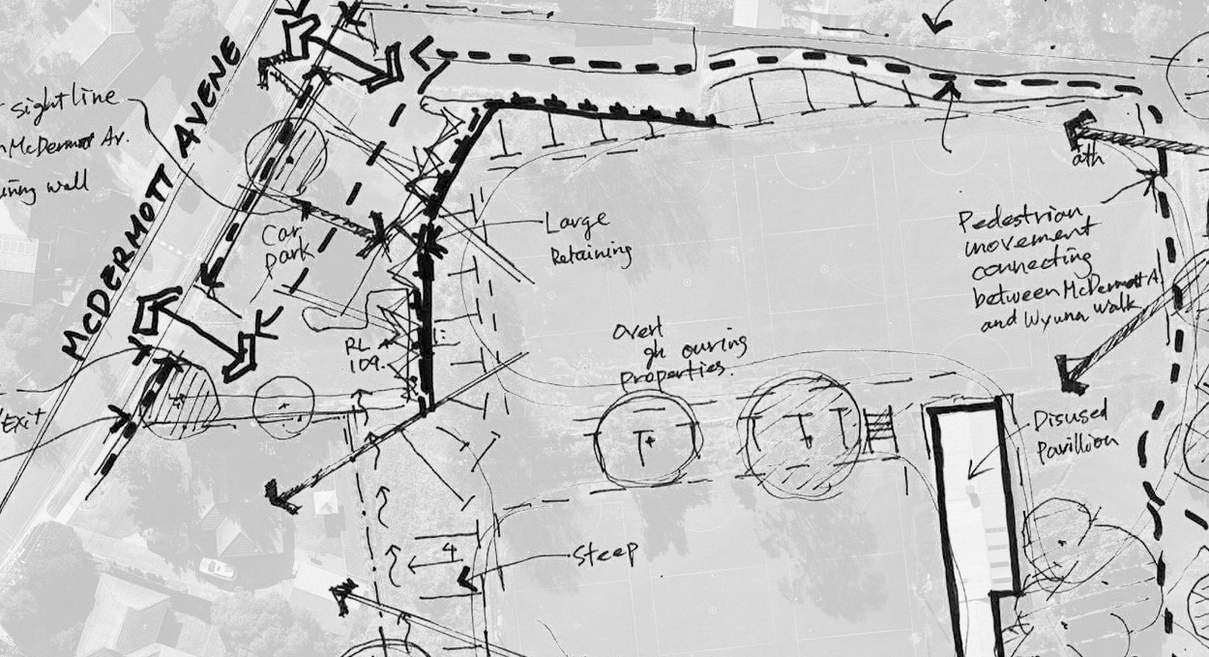
McDermott Avenue Reserve, Mooroolbark

Master Plan

Community Engagement Report
Community feedback to Draft Master Plan November – December 2025






Historically, McDermott Avenue Reserve was the home of local netball clubs, however in 2015 they were relocated into a new Netball Centre at Pinks Reserve. At this time, Council resolved to prepare the entire property at 52 McDermott Avenue Reserve, Mooroolbark for rezoning with the intention to sell the land for housing.

Project Background
Since then, recent research has shown that there is a lack of open space in the area, and a Neighbourhood Level open space (approx. 1.4 hectares) is needed to meet community needs.
On 28 October 2025 Council supported the recommendation to proceed with a new resolution to retain the land for open space, with a small portion of the site preserved for further investigation of housing opportunities (approx. 0.3 hectares).
A draft Master Plan has been prepared based on site analysis and community feedback and was exhibited to the public for feedback from 11 November until 14 December 2025. This report presents the results of
community engagement with the draft McDermott Avenue Reserve Master Plan.

2

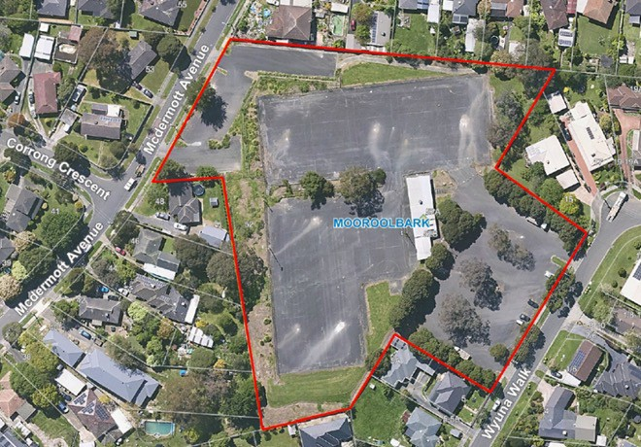


- 4.5 week engagement period for McDermott Avenue Reserve Master Plan was undertaken (11 November – 14 December 2025)

How we engaged

- 650 letters were delivered to residents in the immediate area of McDermott Avenue Reserve to advertise the community
engagement period and direct the community to the Shaping Yarra Ranges website.

- 7 Pop-Up engagement sessions were held with exposure to over 250 people and 136 contributions. (18 November – McDermott Avenue Reserve, 23 November – Kilsyth Festival, 24 November – Mooroolbark Library, 25 November – Burmese Playgroup, 3 December – Shop 16 Market Day, 4
December – Mooroolbark Community Centre (Gymbaroo), 10 December – McDermott Avenue Reserve).
- 2326 views of the McDermott Avenue Reserve Shaping Yarra Ranges website with 70 individual contributors.


- Social media campaign notifying about the engagement period and directing people to the Shaping Yarra Ranges website. (5514
views on Facebook, 571 views on Instagram).
- Promotion through the Yarra Ranges e-newsletter in addition to poster
advertisements in the local community.
- Email distribution to Council Advisory Groups and local schools (Mooroolbark College, Bimbadeen Primary, Mooroolbark Pre School) directing people to the Shaping Yarra Ranges website.

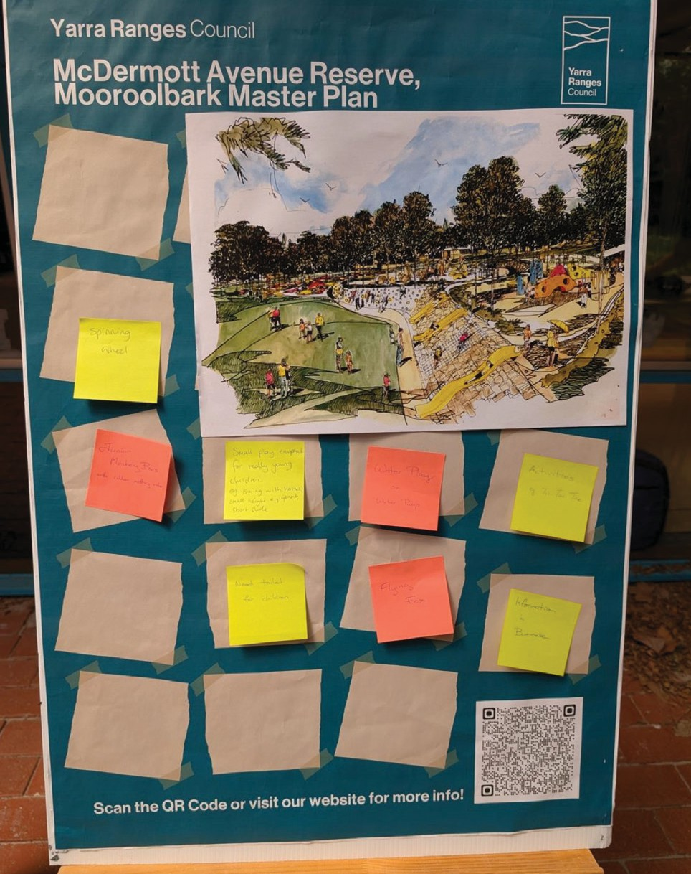
3

4

During the community engagement period we received responses from a diverse representation of the community that primarily live locally to 52 McDermott Avenue.
What we heard

Snapshot of Survey Participants

Survey participants included people from a range of backgrounds and perspectives
which included people who identify as an unpaid carer, as a migrant or refugee, as
culturally and linguistically diverse, as a member of the LGBTQIA+ community and as Aboriginal or Torres Strait Islander.

Survey participants ranged in age from under 16 to over 85 years of age.

73% of survey participants live in Mooroolbark.

Gender of Survey Participants
10%
57%
33%
Male Female
Prefer not to say

What we heard ?

“Seniors activity park”
41%
Park Activities
Theme 1
“Love walking. A circuit would help – I’d walk there”
16%
Paths
Theme 2
15%
“Equipment for disabled children
to use the playground”
Playspace
Theme 3
can BYO”
15%
Park Infrastructure
“BBQ not required for maintenance reasons people
Theme 4
“Lighting for security”
6%
Park Safety
Theme 5
7%
“Area for housing is a
terrible idea”
Other Feedback
“Houses are fine in the corner”
Theme 6





Theme 1 Park Activities

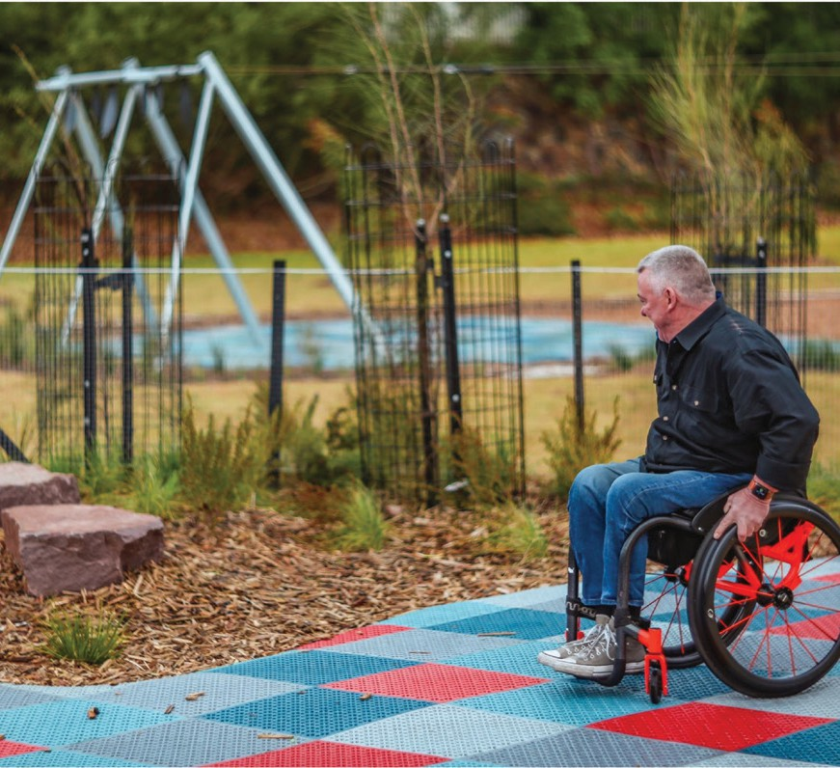
Survey participants were asked how well the Master Plan provides interactive elements such as a sensory garden.
Here’s what they said:
9%
11%
23%
0%
57%
Completely Well Slightly
Not at all
Unsure
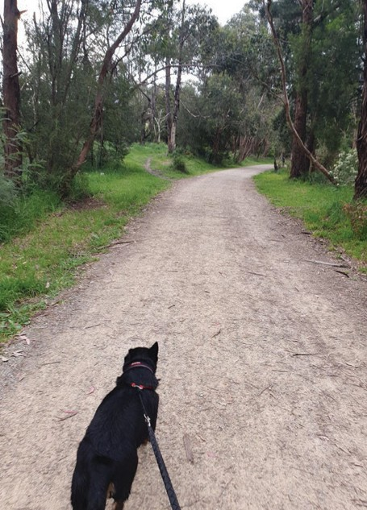
41% of comments related to park activities that people would like to see.
“Bikes and scooters – like Bayswater
Train Park”
26%
15%
23%
36%
Open space area (soccer, cricket, football, events, picnics)
Multipurpose court (volleyball, basketball, netball, pickle ball, tennis, handball and raquet ball)
Wheel sports (pump track, traic school, bikes, scooters, skate boards)
Other activities (exercise equipment, table tennis, ninja, parkour, toboggan, go kart, pool, mini golf, sensory garden, nature play, community garden and dog off leash)
Survey participants were asked how well the Master Plan provides somewhere to picnic with friends and
family. Here’s what they said:
4%
15%
0%
27%
“In open space
grass – football and soccer goals”
54%
Completely Well Slightly
Not at all
Unsure

Survey participants were asked how well the Master Plan provides places to walk and ride. Here’s what they said:

Theme 2 Paths
16% of all comments related to paths within the
reserve. There was strong support for a perimeter walking track and spaces for kids to learn to ride.

Completely Well Slightly
1%
10%
24%
29%
36%
Not at all Unsure
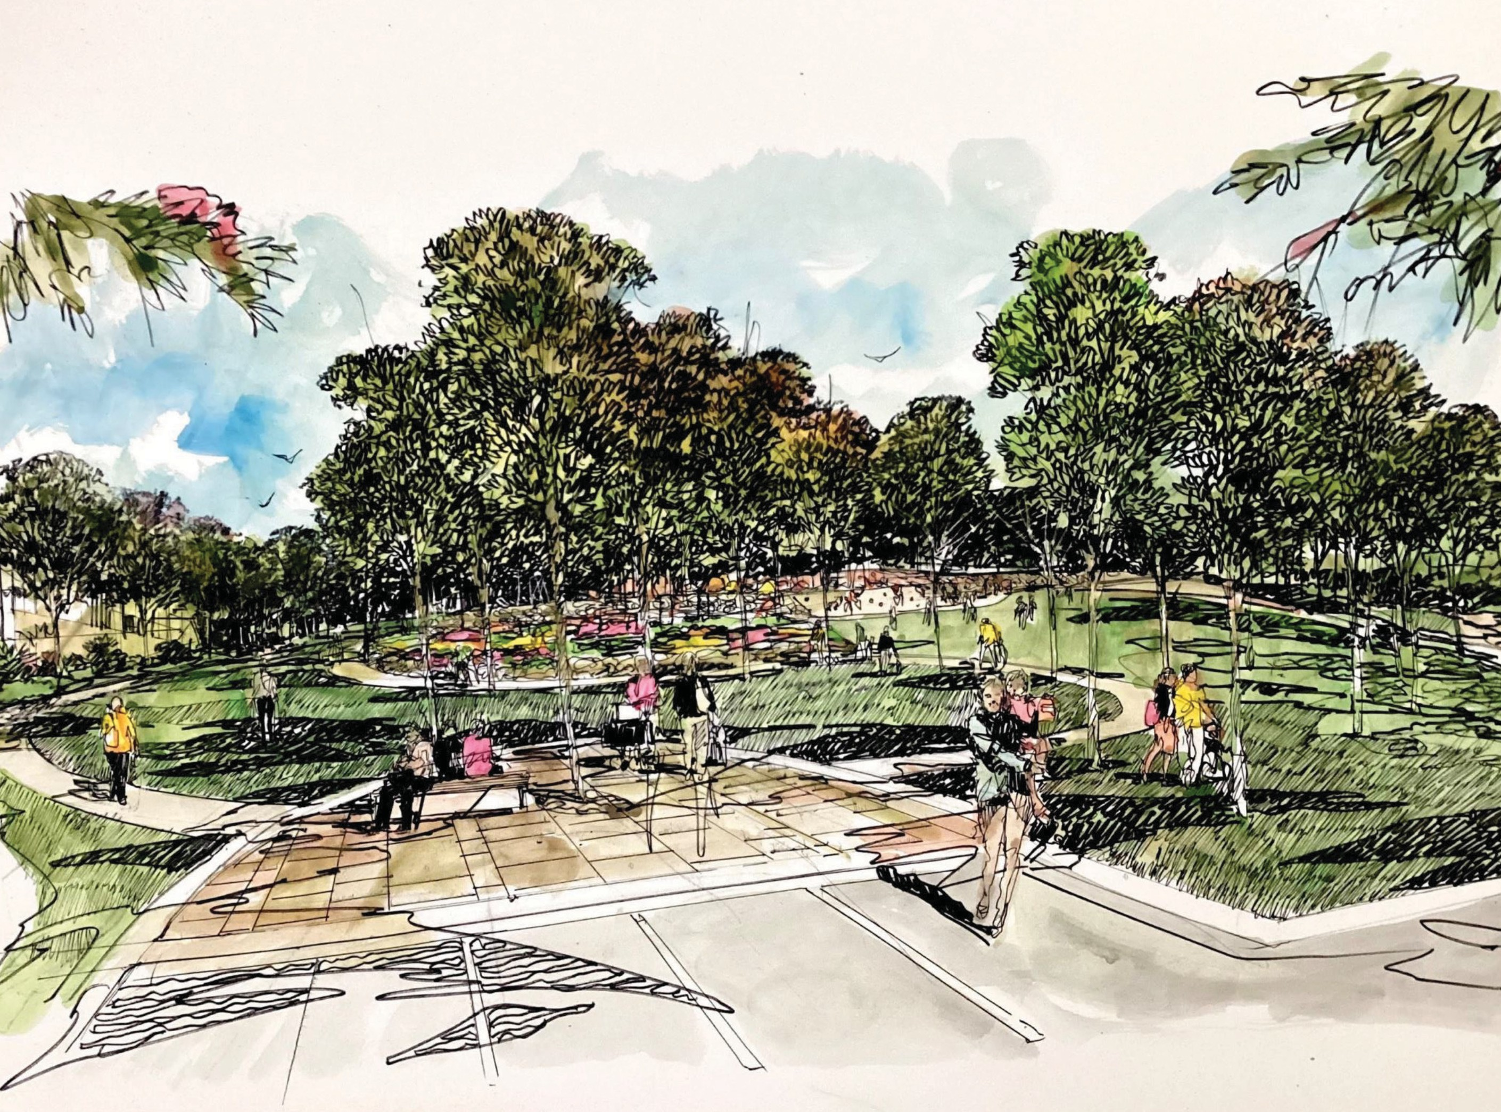
“Bike path for kids”
“Is it pram and wheelchair
friendly?”
“Perimeter walking track”

Theme 3 Playspace

15% of all comments were in relation to the
playspace. The community presented strong
themes for water play, climbing equipment and accessible play equipment for all ages and
abilities. Community enthusiasm for water play is acknowledged and valued. This feedback will
be assessed to ensure alignment with Council’s strategic priorities.
Survey participants were asked how well the Master Plan addresses climbing elements.
Here’s what they said:

4%
7%
0%

32%
Completely
Well
57%
Slightly
Not at all Unsure

“Climbing area is great”

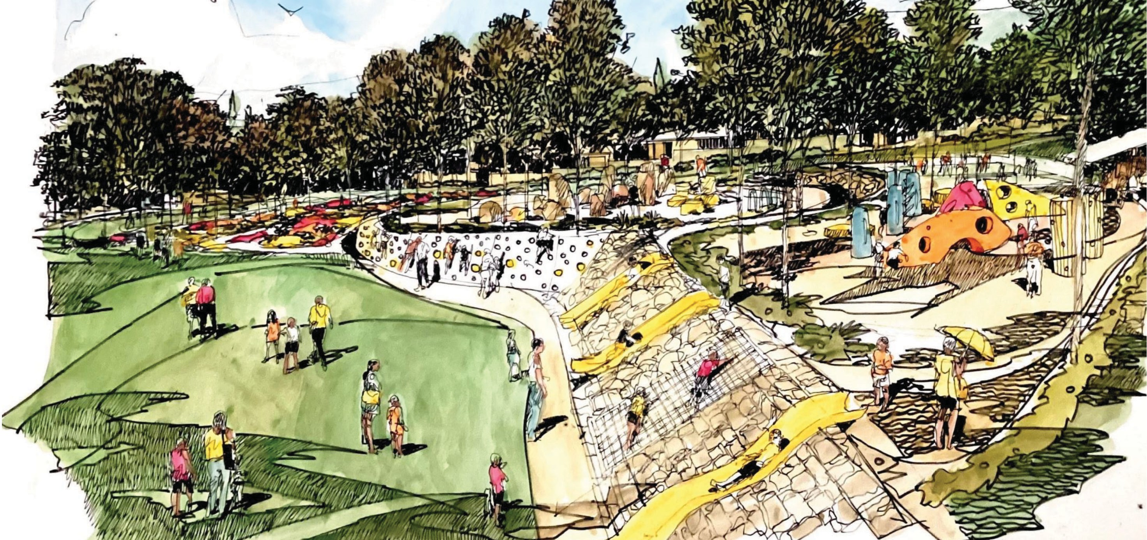
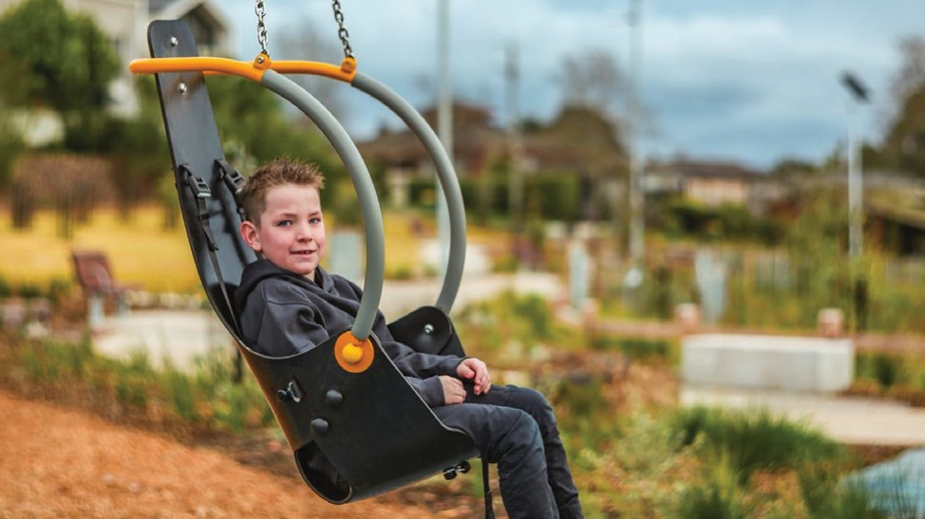
Survey participants were asked how well the
Master Plan addresses places for multipurpose play. Here’s what they said:
1%
6%
16%
27%
50%
Completely Well Slightly
Not at all
Unsure
“Swing suitable for very young”
“Include a big swing for grandparent
and child”

Survey participants were asked how well the Master Plan provides social spaces for users

Theme 4 Park Infrastructure
e.g. barbecues, seating etc. Here’s what they said:
15% of all comments received were related to Park Infrastructure. A strong theme was a request for
more seating. There were conflicting views on the need for toilets and barbecues within the reserve.

Completely Well Slightly
7%
0%
23%
19%
51%
Not at all Unsure
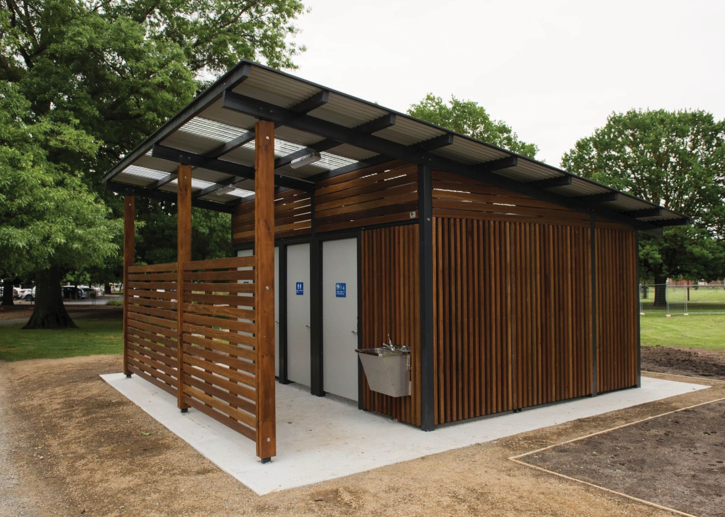
“More seating”
“More tables for people to get
together”
“No BBQ, locals can bring their own”



Theme 5 Park Safety

Survey participants were asked how well the
Master Plan caters for visibility through the space. Here’s what they said:
20%
21%
6% 0%
53%
Completely Well Slightly
Not at all
Unsure
Survey participants were asked how well the
Master Plan creates a welcoming, lively and safe space. Here’s what they said:
6%
9%
0%
24%
Completely
Well
61%
Slightly Not at all
Unsure
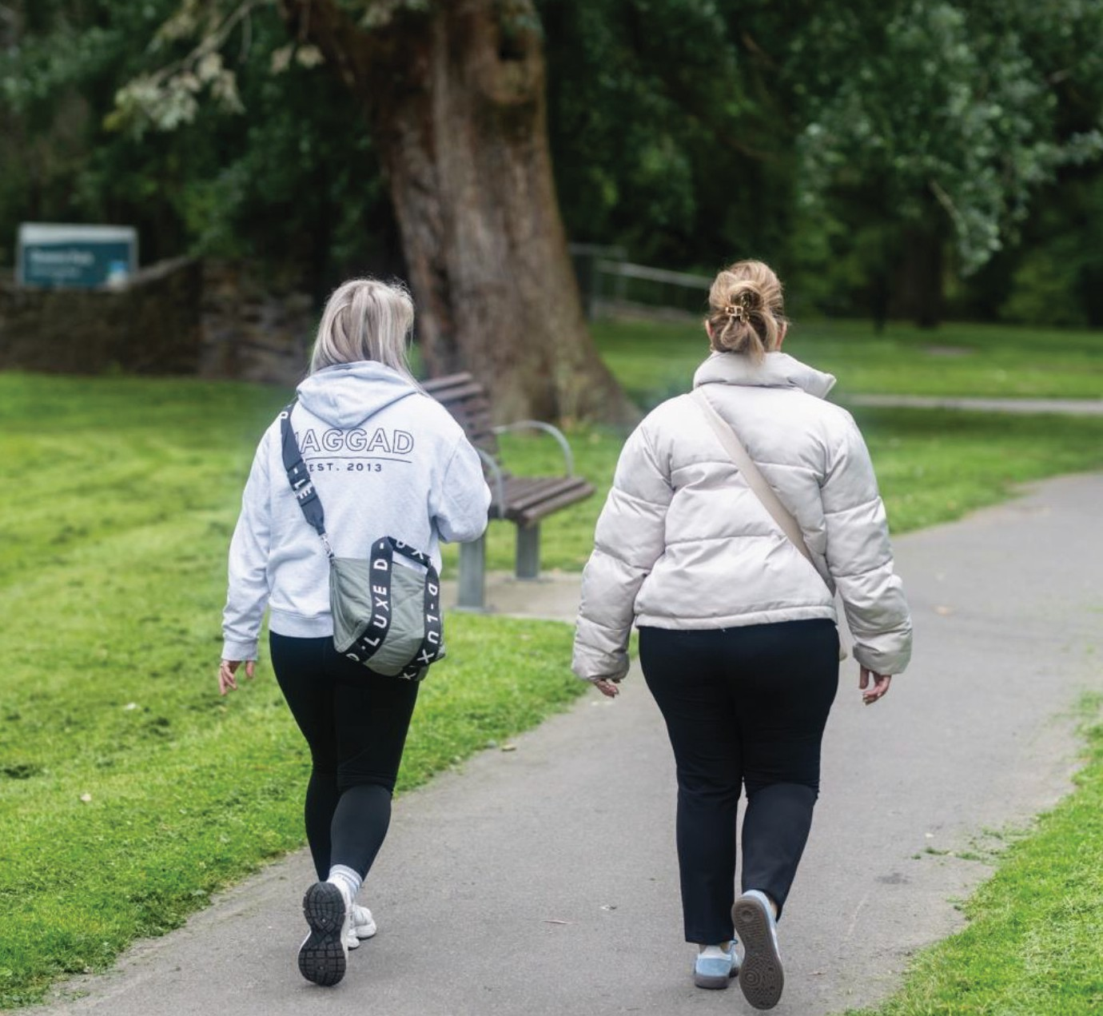
6% of survey participant comments related to safety within
the park. The themes raised by community included lighting, safe playspaces, anti-social deterrents.
“Consider security options to minimise
antisocial behaviour for surrounding houses”
“Targeted lighting”
“Surveillance”

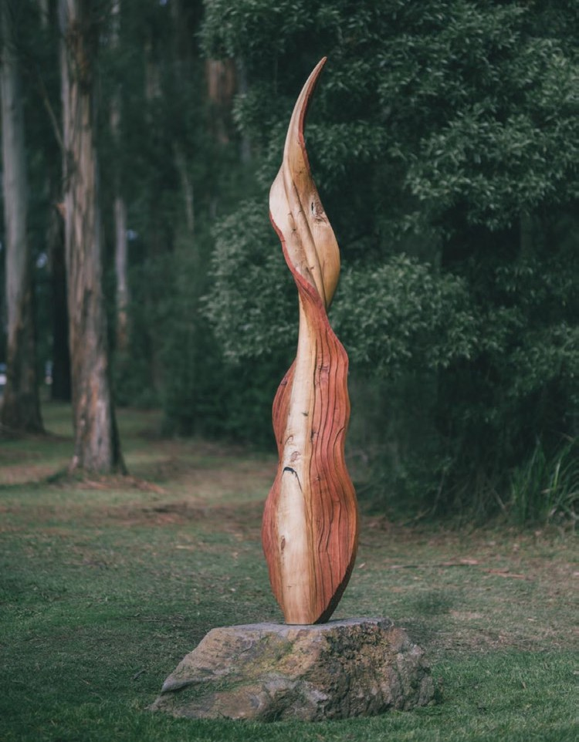
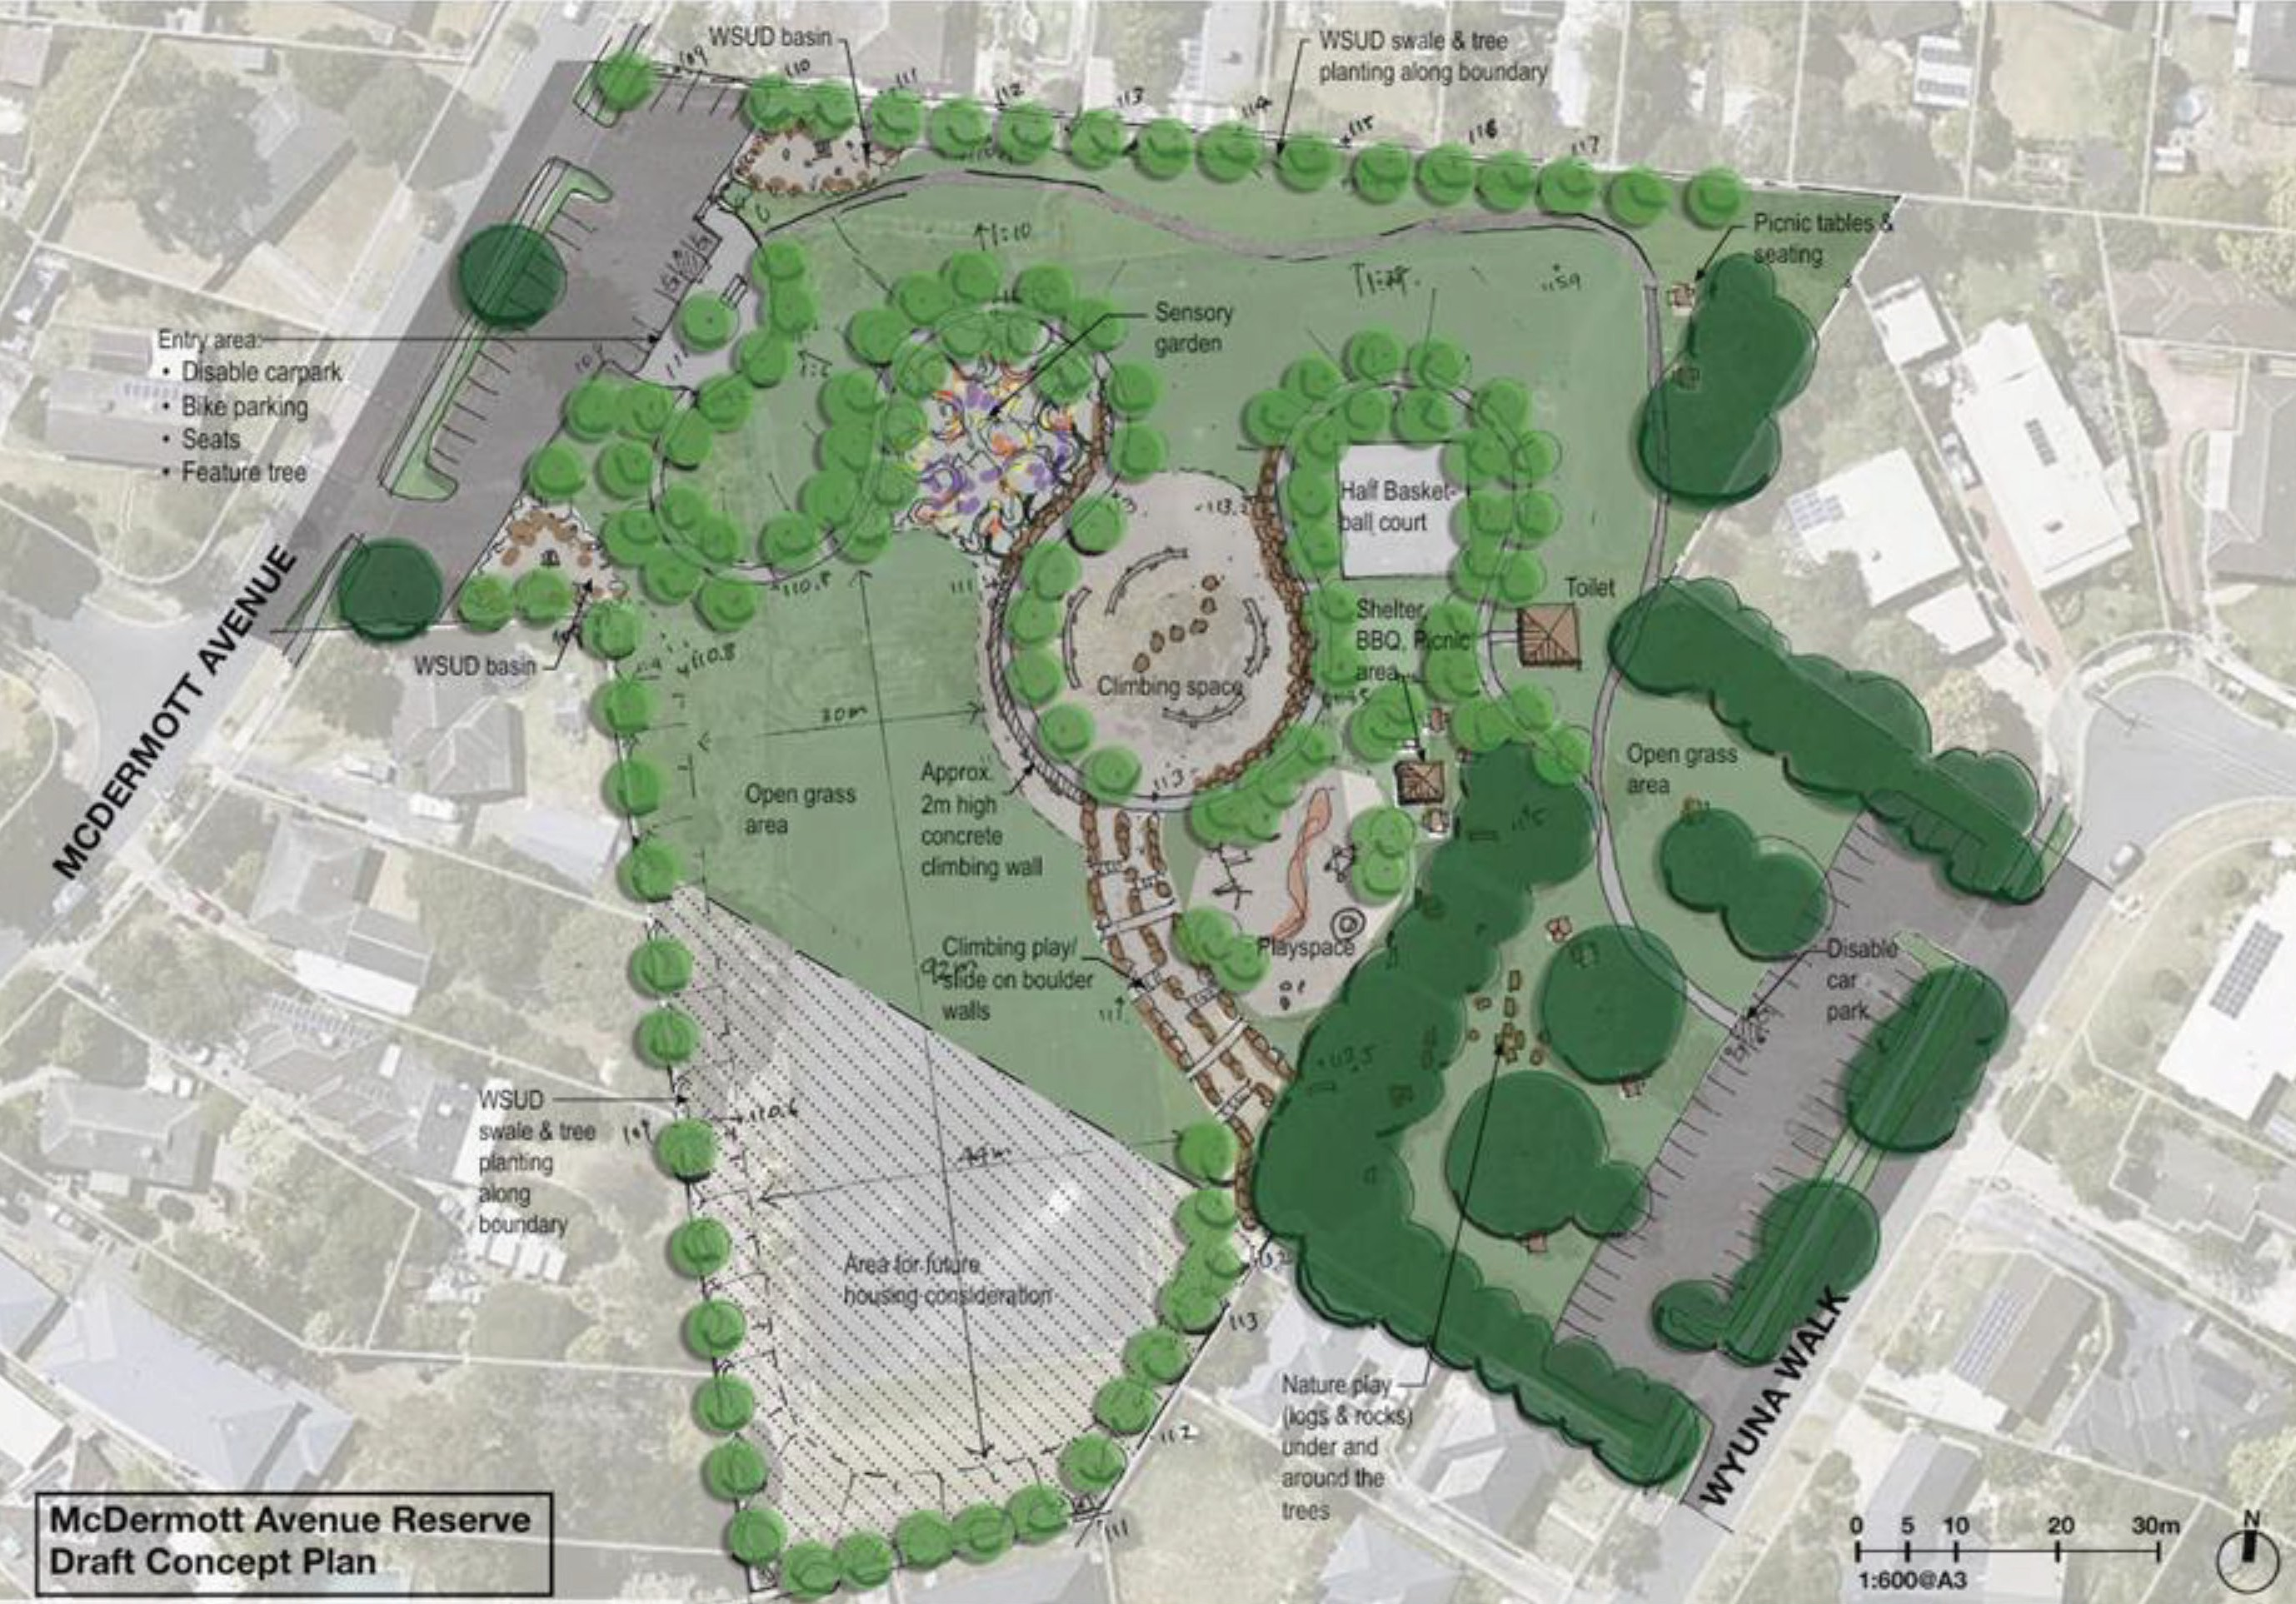
Theme 6 Other Feedback

The remaining 7% of feedback related to a range of topics in relation to the reserve including the area for housing, naming of the reserve and public art.

“I would like to see public art in this reserve”

“No Housing”

“Support houses (the area could be
weird without houses)”

The feedback from the exhibition of McDermott Avenue Reserve Master Plan is being assessed to ensure

Next steps
the Master Plan captures the aspirations of the local community and the reserve objectives can be sustainably achieved in the long term.
Master Plan updates will reflect feedback and proposed changes made through this round of community engagement (Nov – Dec 2025).
Following these updates, the Master Plan will be presented to Council for consideration.

Initial engagement with community

Background study for the site

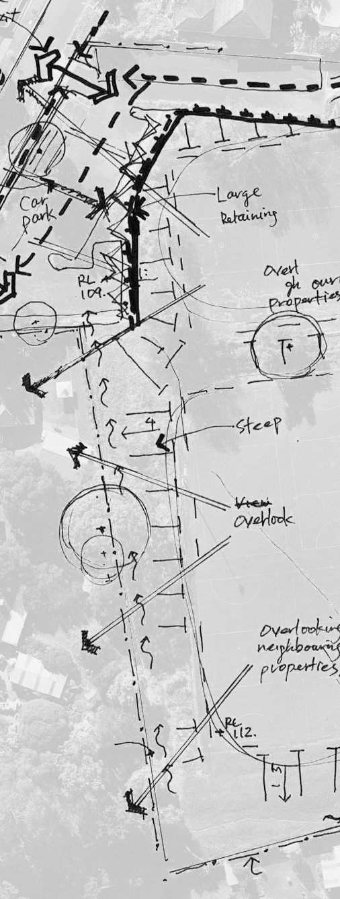

Development of a draft Master Plan

Draft Master
Plan open for community feedback

Finalise McDermott Avenue Reserve Master Plan

Master Plan presented to Council for consideration

Seek funding for Master Plan actions

12

