

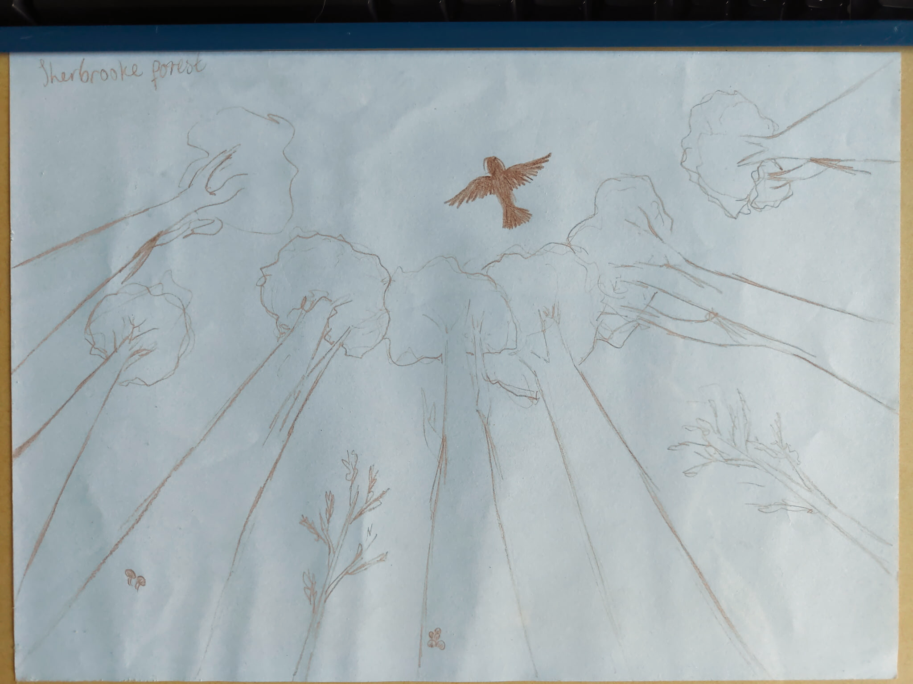
Picture 1. My Special Place drawing 'Sherbrooke Forest' from 2026 Youth Summit
Yarra Ranges Council
Draft Climate and Environment Strategy 2026-2036
Community Engagement Summary
Phase 1
Acknowledgement of Country
Yarra Ranges Council acknowledges the Wurundjeri and other Kulin Nation peoples as the Traditional Owners and Custodians of these lands and waterways. We pay our respects to all Elders, past, present, and emerging, who have been, and always will be, integral to the story of our region. We proudly share custodianship to care for Country together.

Table of contents
Table of contents 3
Introduction 4
How we engaged 4
Who we heard from 5
Key findings 7
What’s next 16
More information 17
Contact information 18

Introduction
The Climate and Environment Strategy will set a long-term, shared direction for how Council and the community will care for Country, tackle climate change and protect the environment together to 2036.
Phase One engagement drew on scientific evidence, recent community insights, and evaluation findings from the 2015 Environment Strategy to test seven areas of focus. These focus areas were presented as a framework to guide direction and gather input, alongside a visioning activity to understand community priorities for the next 10 years.
From Thursday 19 March to Sunday 31 May 2026, the consultation approach combined digital, face-to-face and targeted stakeholder sessions to reach a broad cross-section of the Yarra Ranges community.
Consultation objectives:
- Reflect on community values, ensuring the strategy aligns with the community’s climate and environment priorities and aspirations.
- Create a unified vision, establishing a shared vision that connects all stakeholders around common goals.
- Honours and embeds cultural knowledge supporting Country and community through shared stewardship.
- Amplify children and youth voice to ensure the Strategy reflects their priorities and perspectives, given it shapes the future they will inherit.
How we engaged
Approach
Engagement was delivered through:
- Online participation via the Shaping Page (survey and visioning board)
- Targeted workshops and summits, including a Youth Summit and a Next Gen forum
- Community presence through pop-ups and events across 11 locations
- Drop-in sessions at Community Hubs
- Advisory and stakeholder engagement across seven Council committees and key groups
- Traditional Owner engagement directly with Wurundjeri
- Broad promotion through newsletters, posters, and social media.
This blended approach ensured opportunities for both broad participation and deeper, deliberative input.

Who we heard from
Our engagement targets
Engagement Metric |  | Minimum target | Phase 1 Engagement
Promotional Reach | Online engagements (shaping page visits) | 1000 | 1,133 Visitors
Promotional Reach | Printed Media | Direct mail, YRLocal, 2 newspaper stories | Posters in all Links and Libraries. Other print media planned for P2 Engagement.
Promotional Reach | Social media reach  Including under 25-year-olds | 15,000 - 20,000  1000+ | 61,514 reach including 804 interactions  919 under 25’s
Feedback and Contributions | Face to face contacts | 300-500 | 508
Feedback and Contributions | Event locations (geographic and accessibility focus) | 8 to 12 | 11
Feedback and Contributions | Children and youth engagement  (under 25yo's) | 50+ responses | 289 responses
Feedback and Contributions | Stakeholder groups engaged  Including Council Advisory Committees | 8 to 10  7 committees | 10  7: DAC, IAC, HWAC, PARG, RAC, SEAC, YAG
Feedback and Contributions | Traditional owner (TO) engagement | direct engagement with all TO Groups | Wurundjeri Policy and Partnerships Committee Session.  Continuing conversations in P2.
Participation Total | Total Participants | ~1000 | 2,445 participants  229 Workshops  279 Events  1,133 Shaping Page  804 Social Media
Contribution Total | Total Contributions | 500 | 712 Contributions  182 Shaping Page  125 Social Media  204 Workshop  201 Events/Pop-ups
Reach and participation
Engagement substantially exceeded all targets. Youth participation was strong through targeted activities, with over 200 young people engaged in person, supported by youth-specific forums. Online reach to this cohort represented two percent of all online views.
Stakeholder consultation included engagement to all Council advisory committees as well as engaging with representatives from government, emergency services, environmental organisations and agriculture and industry, including the Municipal Fire Management Planning Committee.
Key background documents were downloaded over 300 times from the Shaping Page, including 125 downloads of the State of the Climate and Environment Report, indicating strong use of detailed information to inform community feedback.
Gender representation in the survey was broadly balanced (53% women, 36% men, 11% self-described or preferred not to say), with a similar distribution observed at in-person events. Participation was also well distributed across the municipality for both events and survey responses.
Five written submissions were received and acknowledged, with contributors directed to follow the Shaping Page for updates. Feedback has been included in the thematic analysis, where individual submissions are not tracked.
Things to keep
- A place-based and inclusive approach was effective and important to understand variation in perspectives across geographic areas and communities
- Face-to-face engagement delivered depth, while digital channels delivered scale
- Structured and specific sessions was the best approach for engaging with younger audiences.
- Be deliberate in selecting locations and events to reach a broad cross-section of the community.
- Monitor participation throughout the consultation period to identify gaps early and allow time to adjust.
Sample size, Interpretation and Limitations
The dataset resulting from the engagement is large enough to provide a sound basis for identifying broad trends. Subgroup analysis was undertaken with consideration of sample size, with groups of approximately 30 or more responses treated as reliable, and smaller groups interpreted as indicative. As with all consultation-based datasets, findings reflect a range of community perspectives and differing views.

Key findings
Part 1: What was the level of agreement on the seven focus areas?
Focus Area: Quantitative data analysis
The community rated their agreement with each focus area in contributing to a healthy, thriving environment by 2036 (Table 1).
Table 1. Results of Focus Area Question 'To what extent do you think each of these focus areas will help create a healthy, thriving environment by 2036?'
 |  | 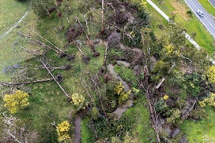 | 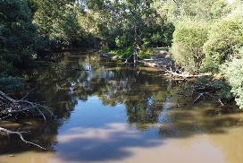 | 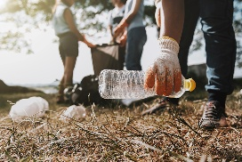 | 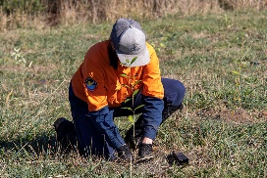 | 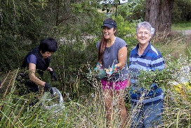 | 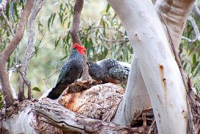
 | Protecting and Strengthening Nature | Resilient Communities and Places | Using Water Wisely and Caring for Waterways | Reducing Waste and Environmental Impacts | Caring for Country | Multi-Generational Stewardship | Tracking and Reporting Progress
Agree | 91% | 87% | 95% | 90% | 82% | 79% | 86%
Neither | 3% | 7% | 2% | 5% | 10% | 12% | 10%
Disagree | 6% | 6% | 3% | 5% | 8% | 9% | 4%
Findings
- Three focus areas, Protecting and Strengthening Nature, Using Water Wisely and Caring for Waterways and Reducing Waste and Environmental Impacts, received the highest agreement, indicating strong understanding and alignment.
- Resilient Communities and Places received strong support, however the slightly higher ‘neither’ and ‘disagree’ responses compared with the top-performing focus areas suggests further refinement is required.
- Three focus areas, Caring for Country, Multi-Generational Stewardship and Tracking and Reporting Progress, had higher ‘neither’ (and in two cases, ‘disagree’) responses, indicating less clarity and a need for refinement.
Overall, results show strong and consistent agreement (>75%) across all focus areas supporting a healthy, thriving environment by 2036. Variations in consensus for some areas identifies opportunities for further exploration through qualitative analysis.
Focus Area: Qualitative data analysis
Community feedback from the shaping page and workshops was analysed to better understand community perspectives (Table 2).
Table 2. Summary of key themes, insights and interpretation of feedback.
 | What we heard | Interpretation of Feedback (including Quantitative)
Protected and Enhanced Natural Environment | Strong support for biodiversity protection, habitat restoration and urban nature, with concern about tree loss, development pressure and invasive species. Participants frequently referenced the need to protect existing environmental values alongside opportunities for restoration and enhancement. | Environmental protection and restoration emerged as a clear priority area, with strong expectations for the protection of biodiversity, vegetation and habitat values and broad support for improving ecological condition across the municipality.
Resilient Communities and Places | Support for resilience, preparedness and connected communities, with strong emphasis on transport access, infrastructure, local self-sufficiency and community connection. Concerns were raised regarding fire risk, inequity in outer areas and limitations of existing infrastructure. | Resilience was generally supported but was interpreted broadly, extending beyond emergency preparedness to include social, economic and infrastructure considerations. Feedback reflected varied expectations regarding infrastructure, equity, preparedness and Council's role. While support was strong, the breadth of the topic may have contributed to lower agreement than other focus areas.
Using Water Wisely and Caring for Waterways | Strong support for clean waterways and efficient water use, with concerns about runoff, septic systems and pollution. Feedback also identified emerging issues such as increasing water demand from technology and expectations for broader system-level approaches. | Water is viewed as both an environmental and community issue. Feedback supports continued focus on waterway health and water efficiency while recognising broader catchment influences, water quality pressures and long-term water security considerations.
Reducing Waste and Environmental Impacts | Strong support for circular economy approaches, with practical suggestions including FOGO, repair, reuse and textile recycling. Participants expressed frustration with plastics, convenience-driven consumption and perceived limitations of current waste systems. | Feedback demonstrated support for waste reduction and resource recovery, alongside increased focus on the role of waste systems, services, industry and supply chains in influencing environmental outcomes.
Caring for Country | Support was expressed for First Nations leadership and knowledge, including land stewardship and cultural burning, with emphasis on education and recognising Country as a living system. Some concerns were raised regarding tokenism and current system limitations. | Feedback indicates support for First Nations knowledge, leadership and custodianship within environmental management. Participants viewed Caring for Country as a connected approach to environmental health and resilience, aligning strongly with the 2036 Community Vision to care for Country. Higher neutral and disagree responses suggest some uncertainty regarding how these concepts translate into practical application and outcomes.
Multi-Generational Stewardship | Participants highlighted the importance of education, youth voice and intergenerational learning, including opportunities for meaningful participation, school programs and ongoing engagement. Limited structured pathways for participation were also identified. | While concepts of education, participation and connection were generally supported, lower agreement suggests the focus area may be less clearly understood than others and interpreted in different ways by participants.
Tracking and Reporting Progress | Support for clear and transparent reporting, with strong demand for accessible formats, visible outcomes and improved baseline information. Concerns were raised that reporting can be overly complex, difficult to understand or disconnected from tangible outcomes. | Community confidence is influenced by the visibility and accessibility of information about environmental outcomes and progress. Higher neutral responses suggest reporting is viewed as important but may be less tangible or immediately relevant to participants than other environment and climate outcomes.
.
Findings
Overall, the qualitative feedback reinforces strong community support across all focus areas, consistent with the high levels of agreement observed in the survey results. It also provides important context for areas of lower agreement, indicating these responses reflect ambiguity or gaps in how some concepts are defined or expected to be delivered, rather than opposition.
Across all focus areas, participants expressed clear expectations for Council to demonstrate leadership, enable system-level change and provide greater transparency in implementation. Key tensions include balancing growth with environmental protection, the limits of Council influence, and the need to translate intent into practical action.
Demographic analysis was undertaken for gender and age to test whether responses differed across these groups. No significant differences were identified, so detailed demographic breakdowns have not been included in this summary.
Emerging themes, particularly from younger participants, highlight growing concern around system-level impacts (e.g. technology-related resource use), equity in access to infrastructure, and the need for more visible outcomes. These gaps, tensions and emerging issues are explored further in Part Four, with implications for strategic priorities and next steps outlined under ‘What’s Next’.
Part 2: What key themes and aspirations emerged from the visioning activities?
The vision activity asked, ‘What do you hope Yarra Ranges looks like in 2036?’ and received 265 contributions with a significant number of young people participating in this activity.
Aspirations
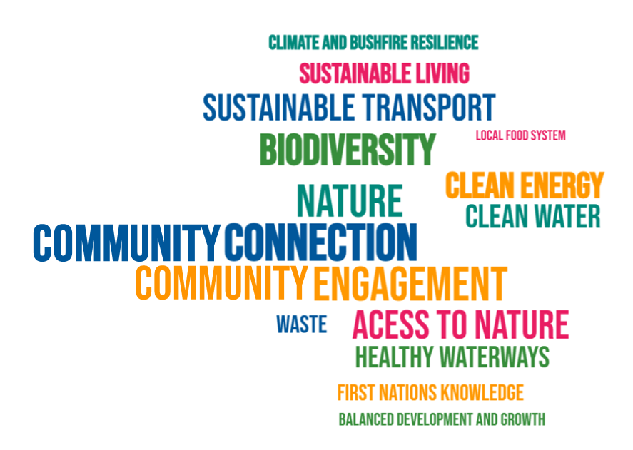
Visioning activities highlighted a strong and consistent community hope for a future that is greener, more connected and more sustainable. Nature and biodiversity emerged as the dominant priority, supported by strong themes around access to nature, sustainable transport, clean energy and community connection. Alongside these, participants emphasised the importance of practical, everyday action, such as reducing waste, improving water quality and strengthening local food systems.
Importantly, feedback showed these ideas were interconnected, reflecting a desire for outcomes that consider environmental protection, liveability, climate responsiveness and community wellbeing together.
Managing growth and development pressures and ensuring they occur in balance with the natural environment, was also identified as a key underlying concern shaping aspirations.
Themes
Table 3. Recurrent themes from Vision Activities ordered based on frequency shown in brackets.
Theme | Community voice | Interpretation of this Aspiration
Nature and biodiversity (101) | “Thriving wildlife”, “more trees”, “native plants everywhere” | A greener, thriving environment with healthy ecosystems, abundant wildlife and protected habitats, including conservation action and restoration of degraded areas.
Access to green space and sustainable transport (82) | “Walking trails”, “bike paths”, “better public transport”, “access to green space” | Better walking and cycling connections, improved public transport and access to green space, supporting both environmental outcomes and quality of life.
Clean energy transition (63) | “Solar on every roof”, “100% renewable”,  “EV chargers” | A shift to renewable energy, with widespread solar, electrification and reduced emissions across homes, businesses and Council operations.
Community connection and engagement (60) | “Working together”, “sense of belonging”, “community hubs” | Stronger community connection, with opportunities for education, participation and collective action in caring for the environment.
Clean water and healthy waterways (35) | “Clean rivers”, “drinkable creeks”, “platypus flourishing” | Clean, healthy rivers and creeks that support biodiversity and provide spaces for community connection.
Waste and circular economy (33) | “Repair hubs”, “recycling that works”, “less landfill” | Practical, everyday sustainability with reduced waste, improved recycling and reuse systems, and accessible community solutions.
Growth, development and place (30) | “Protect bushland from development”, “balance development and nature” | Growth and development that works in balance with nature, protecting local character, biodiversity and access to green space.
Food security and local production (27) | “Community gardens”, “local food”, “grow your own” | Increased local food production, community gardens and stronger food resilience.
Climate and bushfire resilience (22) | “Prepared for heat and storms”, “resilient” | A climate-ready community with stronger infrastructure, preparedness and support for adapting to heat, storms and fire risk.
First nations knowledge (20) | “Cultural burning”, “embedded in our practices” | Greater recognition and integration of First Nations knowledge and practices, particularly in land management.
Findings
- Nature is the most regularly mentioned idea, underpinning how the community defines a “healthy and thriving” future.
- Liveability and environment are interconnected, particularly through access to nature, transport and community connection.
- There is a strong preference for practical action, not just vision, particularly in waste, water and energy.
- Managing growth is a defining concern, with clear expectations that development should not come at the expense of the natural environment.
Part 3: What insights did our target groups contribute?
The insights from the target groups have emphasised that successful implementation will depend not only on what is delivered, but how, particularly in relation to trust, inclusion, cultural integration and responsiveness to local context. These perspectives will help ensure the strategy is grounded, equitable and aligned with the diverse needs of the community.
Advisory committees and other stakeholders
Advisory Committees and stakeholders broadly supported the focus areas, while emphasising different priorities. Some called for stronger Council leadership, advocacy and system-level change on emissions, energy transition, environmental health and waste; others focused on practical, locally achievable outcomes and implementation. Feedback also highlighted tensions around planning and land use, in balancing housing, rural change and environmental protection. A small number of submissions recommended separating climate and environment into distinct strategies. This reflects differing views on how these issues are best addressed. However, the strategy has been developed as a single, integrated framework in recognition of the significant connections and interdependencies between climate and environmental outcomes.
There was a shared emphasis on Council improving communication, building trust and ensuring clear, evidence-based messaging, identifying the need to balance ambition with clarity, credibility and responsiveness to real-world constraints.
Traditional Owners
Traditional Owners engagement highlighted that Wurundjeri knowledge and perspectives should underpin the strategy through a Whole-of-Country approach, recognising Country as an interconnected system of land, water, sky, plants, animals, ancestors and spirit, and as the foundation of identity, culture, language and community. This perspective emphasises a relational understanding of the environment, where ecological, cultural and community wellbeing are inseparable.
Further feedback emphasised embedding cultural practices such as cultural burning, alongside strengthening community understanding through education, storytelling and language. There was also a clear need for appropriate cultural protocols and ongoing engagement, ensuring this is a sustained partnership rather than a one-off input. Overall, Elders expressed a clear expectation that this connected, Whole-of-Country perspective is meaningfully embedded across the strategy, shaping both decision-making, delivery and knowledge sharing.
Young people
Young people contributed a clear and future focused perspective, with a strong emphasis on action, accessibility and meaningful involvement. Key themes included:
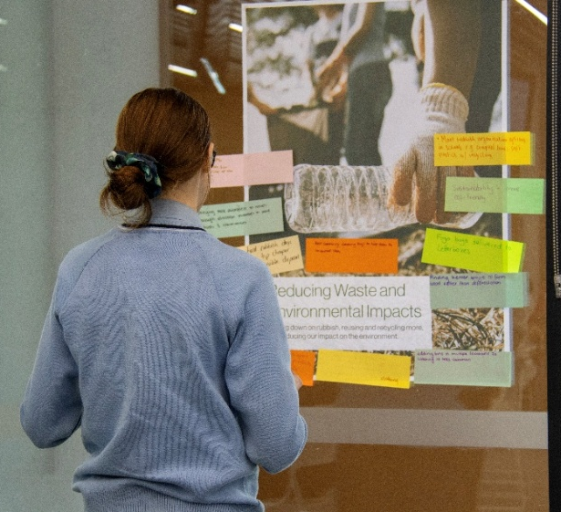
- A preference for clear, transparent communication, with simple and engaging ways to understand progress and outcomes.
- Strong interest in active involvement in decision-making and environmental action, including through education, volunteering and structured participation opportunities.
- Emerging concerns relating to the environmental impacts of technology, as well as access to transport and services in outer areas.
- The importance of affordable and accessible actions that reflect both environmental priorities and broader liveability considerations.
- A clear expectation that responsibility for change is shared, with government and industry playing a key role alongside individuals.
Overall, young people want to see visible action and meaningful opportunities to be involved, with the strategy reflecting their priorities and enabling ongoing participation in shaping outcomes.
Regional insights
Targeted and place-based feedback also highlighted some regional variation:
- Urban communities: Broadly supportive, with strong focus on liveability, services and localised issues (e.g. quarry impacts).
- Hills communities: Highly engaged, with strong environmental stewardship and emphasis on biodiversity and community-led action.
- Upper Yarra communities: Strong support for practical, on-ground outcomes, with less confidence in systems, reporting and governance language.
- Valley communities: Greater focus on immediate needs with an emphasis on practical delivery.
Part 4: What gaps, tensions or emerging issues were identified?
Across the engagement, several consistent gaps, tensions and emerging issues were identified, building on both the focus area feedback and visioning outcomes. Some of these issues extend beyond the scope of the strategy and will be referred, where appropriate, for consideration but are included here for completeness.
While there is strong alignment on the overall direction, community feedback has highlighted a need to resolve how competing priorities are balanced, how outcomes are delivered in practice, and how broader system-level challenges are addressed.
Gaps and tensions
Table 4. Gaps and Tensions identified through the consultation process grouped by theme
Theme | Description | Implications
Infrastructure, services and environmental outcomes | Infrastructure (roads, drainage, transport) emerged as a major concern, with strong links made between service delivery and environmental outcomes. Gaps in public transport, road maintenance and access, particularly in outer areas, were also consistently raised. | Whilst some elements are out of scope, the strategy should clearly link outcomes with existing strategies, along with infrastructure and service planning, recognising that liveability and sustainability are interconnected.
Growth, development and environmental protection | Strong concern about development pressure, tree clearing and loss of rural character. Growth is expected to “work in harmony with nature,” not at its expense. | Including planning for balanced growth alongside environmental protection, including clear principles and boundaries that manage this tension.
System responsibility versus individual action | Across waste, water and emissions, there is expectation that responsibility sits with Council, government and industry, not just individuals. Frustration exists with current systems and lack of accountability. | The strategy should emphasise system-level change, regulation, advocacy and leadership, rather than relying primarily on behaviour change.
From vision to visible action | While aspirations are strong, there is scepticism about delivery, particularly around reporting, transparency and “greenwashing.” Community want to see tangible outcomes (e.g. improved biodiversity, climate response). | Clear metrics, measurable outcomes and visible reporting will be critical to building trust and demonstrating progress.
Participation, equity and access | Strong desire for ongoing input, particularly from young people, alongside concerns about access and equity (e.g. transport, cost, regional differences). Some groups feel underrepresented or unheard. | The strategy should define clear, inclusive and ongoing pathways for participation, ensuring equitable access across communities and regions.
Tangible climate action and emissions reduction | Feedback highlights the importance of clearly articulating how climate action and emissions reduction will be delivered in practice, including visible metrics, pathways and leadership from Council. | Strengthen the approach to climate action, including defined roles and pathways for emissions reduction and energy transition to build confidence and demonstrate leadership.
Education, awareness and community connection | Education and community connection were identified as important enablers of environmental outcomes, including access to information, learning opportunities and collective action. While reflected across several areas, they are not yet clearly integrated. | The strategy should better articulate how education, communication and community connection will support behaviour change, participation and shared stewardship across all outcomes.
Emerging pressures and future risks
New and growing concerns include technology-related impacts, such as AI and data centre water use, climate anxiety, and cumulative pressures from tourism and industry.
The strategy should remain adaptive and forward-looking, acknowledging emerging risks and areas of uncertainty.
Findings
- Strong support is accompanied by a need for clearer guidance on balancing growth, infrastructure and environmental protection.
- There is a clear expectation for system-level change and Council leadership beyond individual action.
- Confidence will depend on visible delivery, including clear metrics, outcomes and transparent reporting.
- Participation and equity remain key, with growing demand for inclusive, place-based approaches.
- Climate action is expected to be more explicit, with defined pathways for emissions reduction and energy transition.
- Emerging pressures highlight the need for a more adaptive, integrated and forward-looking strategy.
These gaps, tensions and emerging issues highlight the key areas where the strategy will need to provide greater clarity, direction and responsiveness. Importantly, they reflect not a lack of support, but areas where stronger integration, clearer articulation and more practical application are required. The final section outlines how these insights have informed strategic priorities and next steps.
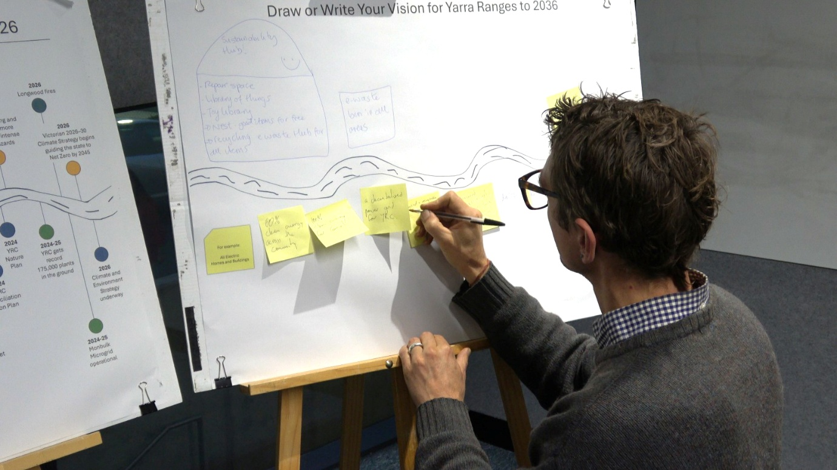
What’s next
Across the engagement, there was strong support for the overall direction of the focus areas. Feedback highlights the need to strengthen clarity, integration and delivery, particularly in how the Strategy collectively addresses climate change, environmental protection and community connection.
Considerations for the Strategy
- Clarify the scope of focus areas and how they will fit in the strategy: Focus areas with lower agreement, Resilient Communities and Places, Caring for Country, Multi-Generational Stewardship and Tracking and Reporting Progress, should have intent, scope and practical application within the strategy refined.
- Articulate how climate action is delivered: While climate change is currently embedded across the focus areas, there is a clear expectation for more explicit and measurable commitments, including defined pathways for emissions reduction and energy transition.
- Embed system-level change and leadership: Across all areas, there is strong expectation that Council will lead through advocacy, partnerships, own activities and system change, rather than relying primarily on individual behaviour.
- Strengthen the link between environment, climate and liveability: Feedback consistently highlights the interrelationship between environmental outcomes, infrastructure, health and community connection. The strategy should clearly articulate how these are integrated.
- Clarify Council’s role and sphere of influence: There is a need for the Strategy to define where Council leads directly, partners, or advocates, particularly in areas influenced by broader systems.
- Prioritise visible and practical delivery: Confidence in the strategy will depend on clear actions, measurable metrics and tangible outcomes that can be seen and experienced by the community.
Conclusion
Across all activities in Phase one engagement, there was strong and consistent support for the overall direction of the Climate and Environment Strategy. Based on the thematic data, protecting nature and biodiversity was the strongest priority, along with creating a future that is more connected, sustainable and resilient. These aspirations are closely linked to everyday liveability, including access to nature, transport, community connection and local infrastructure.
The feedback demonstrates a clear preference for practical, visible action. There is a clear expectation that Council will lead, work towards system-level change and be open and transparent about progress. While the focus areas were broadly supported, some areas of lower agreement need clearer explanation of what they mean and how they will work in practice.
The engagement highlighted some important challenges for the strategy to address. These include balancing growth with environmental protection; aligning local action with broader system constraint; ensuring fair and accessible actions, and being clear about climate action, infrastructure, technology impacts and regional differences.
Overall, the findings provide a strong foundation for Council to progress the strategy, with a clear opportunity to strengthen how priorities are articulated, connected and reflected in the strategy.
The next step is to translate this feedback and accompanying evidence into a clear, integrated and practical strategy that will be released for further community feedback prior to being consider by Council for adoption.
Considerations for Phase two engagement
The next phase of engagement should build on the strong foundation established, maintaining a place-based and inclusive approach, reflecting the variation across communities and regions. Continue emphasis on targeted, structured engagement to effectively involve younger audiences and other underrepresented groups.
Clear, accessible and transparent communication will be critical to build trust and demonstrate how community feedback has helped shape the strategy. Overall, the focus should shift from broad engagement to more targeted, iterative and responsive approaches that support refinement, clarity and confidence in the final strategy.
Strategy development timeline
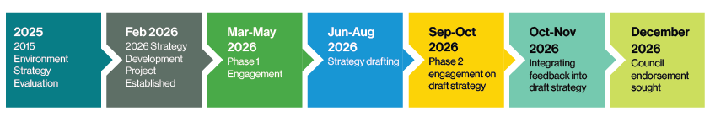
Complete
Current
Upcoming
More information
For more information, please visit the Shaping page https://shaping.yarraranges.vic.gov.au/climate-and-environment-strategy-2026-2036

Contact information
Community Links  Lilydale  15 Anderson Street  Healesville  110 River Street  Monbulk  21 Main Road  Yarra Junction  2442-2444 Warburton Highway  Upwey  40 Main Street | National Relay Service  133 677 – for callers who have a hearing, speech or communication impairment and for Text Telephone or modem callers  1300 555 727 – for callers using Speech to Speech relay  9658 9461 – TTY  Translation and Interpreting Service  131 450 – Translating and Interpreting Services (TIS) National. An interpreting service is available if required.
Yarra Ranges Council  PO Box 105  Lilydale VIC 3140  1300 368 333  mail@yarraranges.vic.gov.au  yarraranges.vic.gov.au | 

