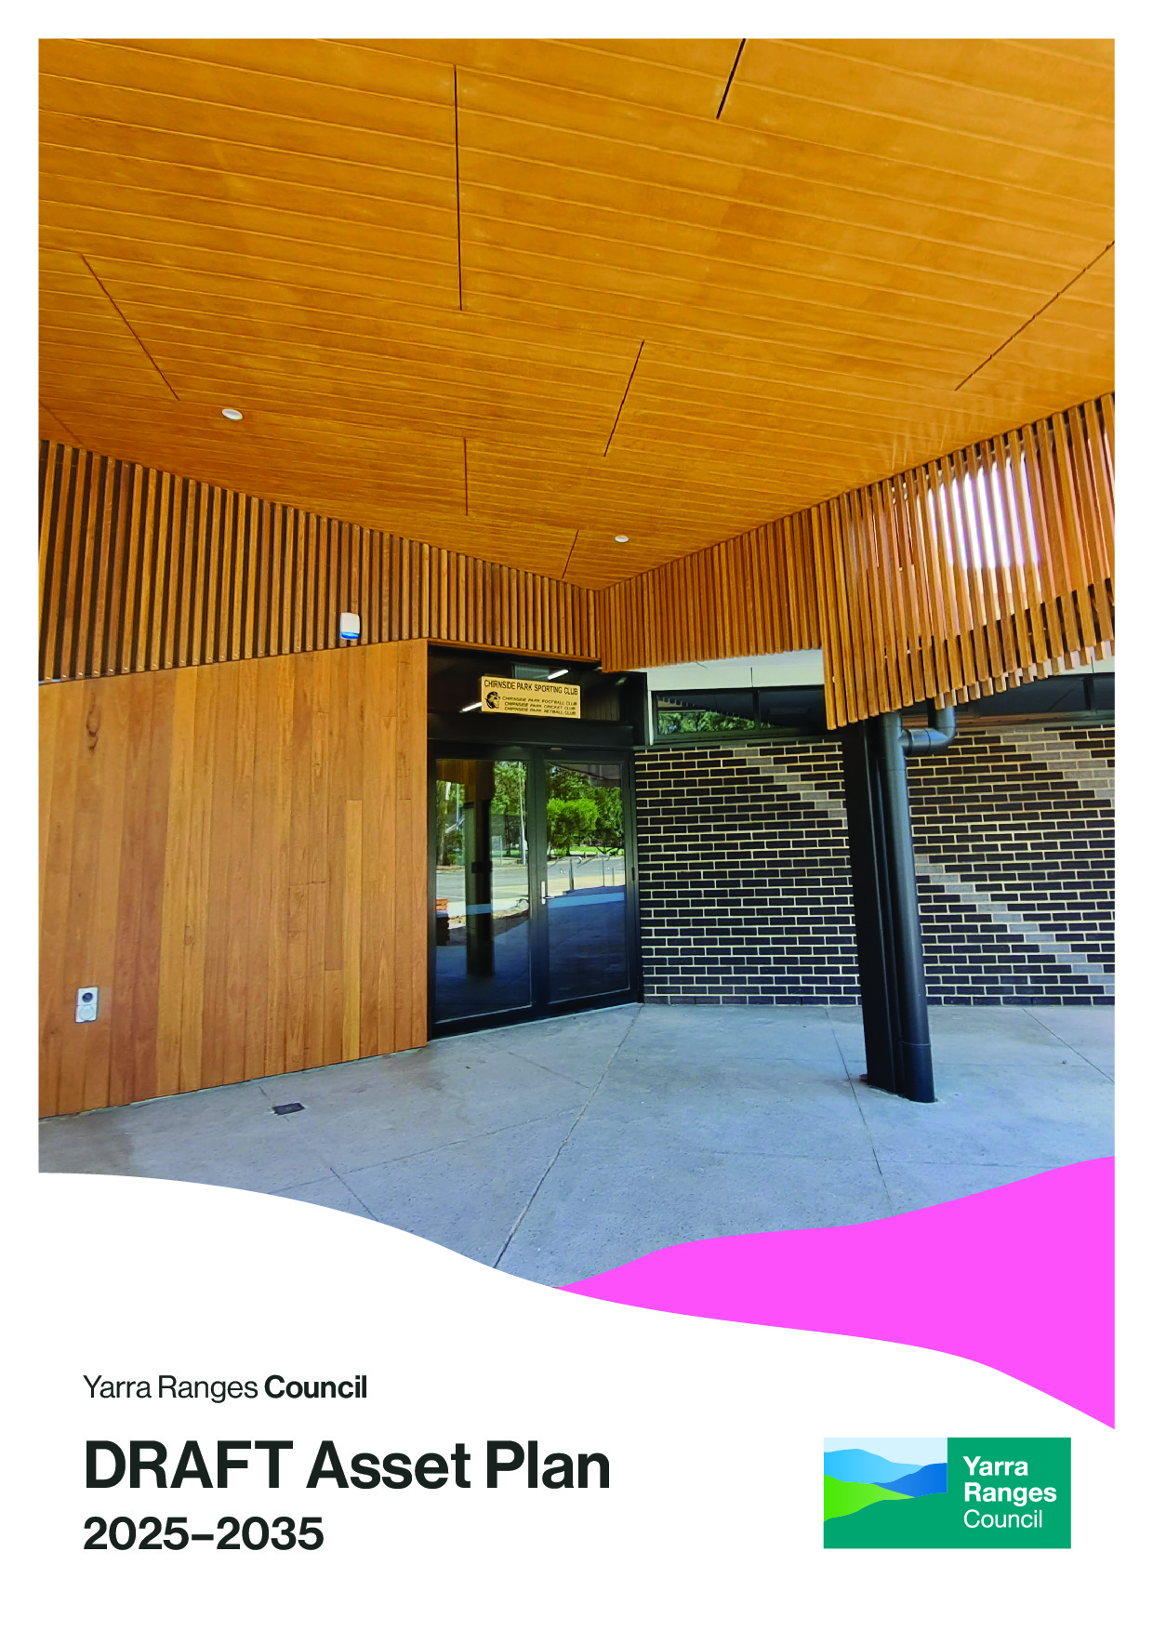

Acknowledgement of Country

Yarra Ranges Council acknowledges the Wurundjeri and other Kulin Nations as the Traditional Owners and Custodians of these lands and waterways.

We pay our respects to all Elders, past, present, and emerging, who have been, and always will be, integral to the story of our region. We proudly share custodianship to care for Country together.



Table of contents
Introduction 5
Integrated planning 5
The purpose of this Asset Plan 5
What is an asset? 6
Why do we have assets? 7
How does Council measure assets? 7
Assets in our Region 11
How this plan was developed 18
Challenges for assets in the region 20
Asset Investment Strategy 21
Type of Asset Investment 21
Asset Investment Decision 21
How much money will Council be spending? 24
Performance, Reporting and Success Measurement 28

Introduction
Providing effective and efficient assets for the community is an integral part of Council’s operations. As the steward of these assets, Council is committed to managing them in the most cost-effective and responsible way. From planning, design and creation to maintenance, renewal, repair and operation, and ultimately to replacement or disposal, Council undertakes all these activities with the goal of providing safe, reliable, and efficient services for both the current community and future generations.

Integrated planning
This Asset Plan has been prepared in accordance with the requirements of the Local Government Act 2020. It provides an overview of Yarra Ranges Council's approach to maintain, renew, acquire, expand, upgrade, dispose and/or decommission its infrastructure assets. This Asset Plan is not a stand-alone document; it is integrated with other key documents. The following diagram shows how Council's different plans and strategies fit together. Informed by evidence, state and federal legislation and policy, community engagement and continuous improvement, these plans guide the delivery of all Council services to help achieve our Community Vision.
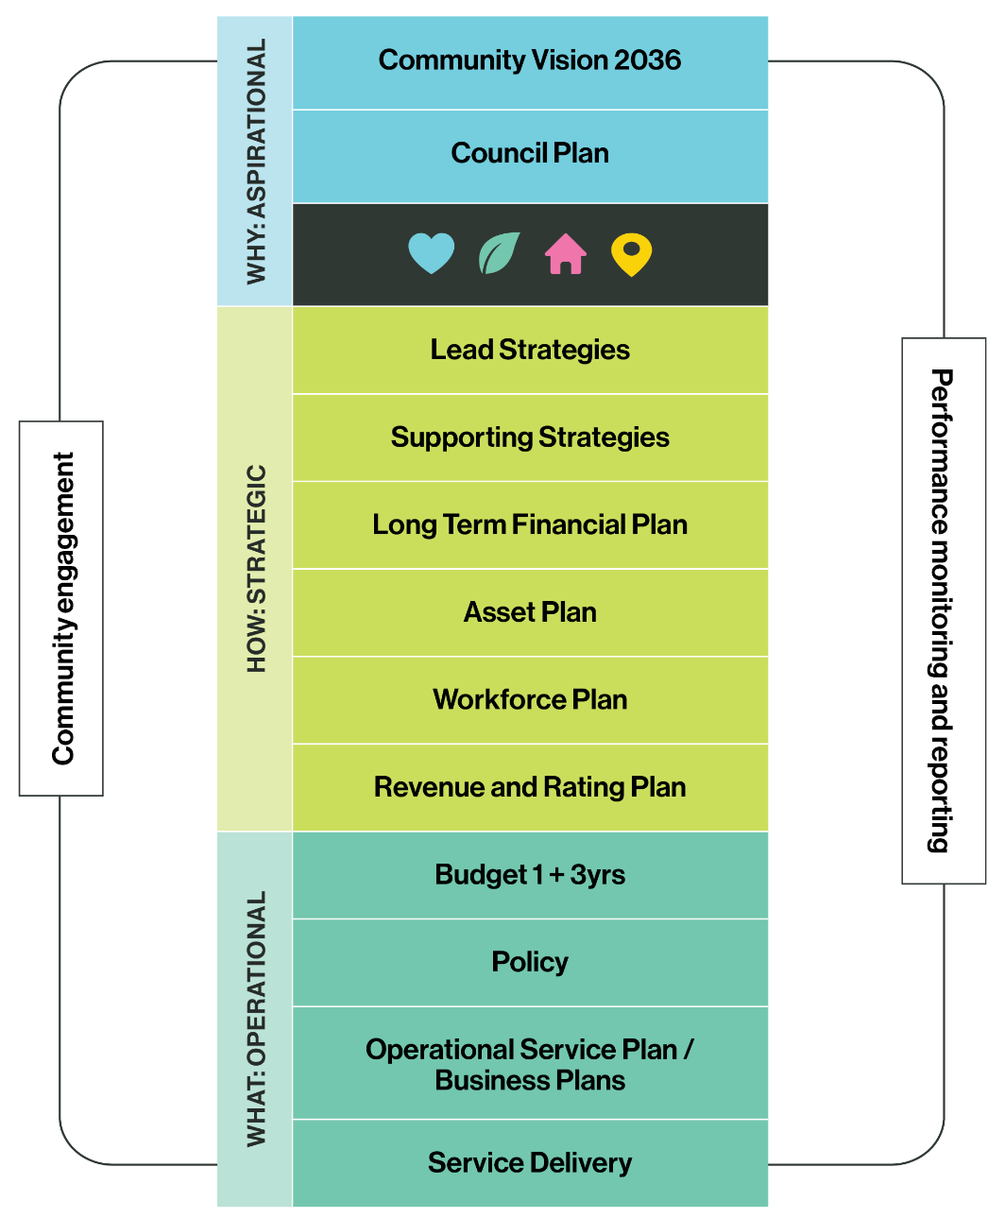

The purpose of this Asset Plan
This Asset Plan provides an overview of all the assets Council owns and outlines how Council will manage these assets efficiently and responsibly. By minimising risks, maximising benefits and managing investments, Council aim to provide quality, well-maintained and reliable assets for the community to enjoy now and into the future.
Council works to address the diverse needs of our community, including gender, intersectionality and accessibility. This Asset Plan:
- lists the assets Council owns, including how many there are and total replacement cost.
- outlines the money needed to operate and invest in these assets.
- explains how Council calculates risks related to infrastructure.
- details how Council decides on the amount of money to invest and which assets to focus on. Ensures that decisions about managing assets align with Council’s overall vision and strategic objectives.
- ensures there is alignment between asset management planning and the Long-Term Financial Plan.
- incorporates community feedback and considers the changing needs of the local community.

Council prepares Asset Management Plans for each major asset category including buildings, drainage, roads infrastructure, pathways, and open space. These technical plans are reviewed regularly and cover a 10-20-year planning period and ensure legislative compliance.
The development of this version of the Asset Plan is based on Council’s understanding of the performance and condition of Council’s assets, feedback from community and other key assumptions included in strategies, implementation plans and urban design frameworks, amongst others, at its time of preparation.
Council acquires, renews, expands, upgrades and disposes of assets based on community needs and required service levels. Changes in technology, political and financial environments can affect the original assumptions and forecasts in the Asset Plan, therefore it is essential to actively monitor, review and update this document to reflect significant changes.

What is an asset?
The most basic definition is - something that is of value.
Assets are all the things that enable Council to deliver services for our community, and help residents to stay connected, healthy and active.
Many of the things our community see as they step outside their home are assets that Council manages: the footpaths leading to shops, schools or sports centres; most of the roads (75%); buildings for community activities such as halls and libraries; parks and open spaces that keep community healthy and active, and playgrounds that provide endless fun for children. This Asset Plan focuses on these tangible assets that community can touch and feel.

Why do we have assets?
Council’s infrastructure assets help support many service outcomes and benefits:
Service outcome | Description and examples
Social Connection | Strongly affiliated with volunteer-run organisations, i.e. Friends of groups. Any activities that support groups coming together and building social capital.
Preparedness for emergencies and severe weather events | Strengthens community resilience in the emergencies through its community emergency networks and community planning groups.
Active Living | Promotes recreation, sport, movement for all ages, genders and ability
Food Security | Includes community gardens and food systems such as community supported agriculture, food relief support
Health and Wellbeing | Enhances physical and mental health and wellbeing, providing access to a range of health services.
Education and Training | Facilitates skills development and supports to access education or training opportunities.
Employment | Assisting people in job seeking and job readiness.
Culture | Celebrates arts, heritage, indigenous history, creativity, performance, and our collective history.
Community Participation | Encourages community involvement in decision making (place-based or issue based) and self-determination for all communities.
Transport | Connects people to essential services and amenities, supporting a range of transport available for the needs of our community.
Social inclusion and non-discrimination | Supports gender equity and programs to reduce gender-based violence against women and children. Also addresses the needs of the aging population, culturally and linguistically diverse considerations and accessibility.

How does Council measure assets?
The characteristics or specifications that underpin these service outcomes are defined as Levels of Service characteristics. This is the way of measuring how those assets support the different services Council delivers for the community. To provide these services, Council needs different infrastructure assets. Sometimes infrastructure like buildings and car parks support many different services. Others, like pipes, pits and roads, support a smaller number of them. All, however, are important for the local community. Therefore, to ensure assets are helping to provide the best service they can, Council measures:
- Condition: How does the asset look, feel and sound? Are there cracks, damage or wear and tear? Is it safe and durable?
- Utilisation: How many people are using the infrastructure? How many people are visiting this building?
- Capacity: How much can it carry, move or support? How much water can flow through this pipe in a storm?
- Function: Is it fit for purpose? Is it accessible and available to everyone in our community?
The graphic below demonstrates the complexity and link between:

Levels of Service Characteristics - the outcomes of all the benefits the Yarra Ranges region offers.

The Service Types – all the different services and actions Council delivers with, and for, the community.

The Assets – all the physical things Council must have to provide these services.

The Measures – how Council measures and improves services and outcomes.

Levels of Service Characteristics  What are the service outcomes | Social Connection | Preparedness and resilience to emergency and weather events | Active Living | Food Security | Health and Wellbeing
Services Types  What we deliver to help achieve this | Community Strengthening  Arts, Culture and Heritage  Early and Middle Years  Maternal and Child Health  Youth Development  Healthy Active Ageing  Pavilion and Club Houses  Cultural Venues Community Halls  Libraries | Animal Management  Emergency Management.  Public and Environmental Health  Building Service  Strategic Projects  Tree Management  Land Management  Climate Adaptation  Energy Transition and Emission Management | Public Health and Wellbeing  Local Roads, Bridges, Footpaths, and Carparks  Sports Fields  Trails  Aquatics  Pavilions and Club Houses  Recreation Facilities  Play Spaces  Parks  Open Spaces | Community Strengthening | Maternal and Child Health  Healthy Active Ageing  Immunisation  Public Health and Wellbeing  Employee Relations
Assets  What infrastructure we need to provide these objectives | Buildings  Car Parks  Playspaces  Footpaths  Land  Art | Buildings  Land  Car Parks  Plant, Fleet and Equipment  Pipes  Pits  Kerb and Channel | Buildings  Car Parks  Playspaces  Trails  Parks  Land  Pools  Roads  Sportsfields  Sports Courts | Buildings  Land | Buildings  Car Parks  Plant, Fleet and Equipment  Playspaces  Land
Strategic Service Indicators Measuring change in what matters, over the long term | Feeling secure  Sense of community | Prepared for weather events  Council Carbon Emissions  Water Diversion | Access to Open Space | Biodiversity protection | Mental Health
Levels of Service Characteristics  What are the service outcomes | Education and Training | Employment | Culture | Civic Participation | Transport | Social inclusion and non-discrimination
Services Types  What we deliver to help achieve this | Local Laws and Regulatory Compliance  Community Strengthening  Early and Middle Years  Economy, Tourism and Investment Support | Economy, Tourism and Investment Support | Arts, Culture and Heritage  Cultural Venues and Community Halls  Libraries | Emergency Management  Community Strengthening  Indigenous Development  Youth Development  Economy, Tourism and Investment Support  Community Engagement  Executive Governance | Local Roads, Bridges, Footpaths, and Carparks  Traffic Management | Community Strengthening  Indigenous Development  Youth Development  Healthy Active Ageing  Public Health and Wellbeing  Libraries  Communications
Assets  What infrastructure we need to provide these objectives | Buildings  Car Parks  Plant, Fleet and Equipment  Playspaces  Land | Buildings  Car Parks  Land | Buildings  Car Parks  Art  Land | Buildings  Land | Bridges  Car Parks  Roads  Footpaths and Trails  Signs | Buildings  Land
Strategic Service Indicators Measuring change in what matters, over the long term | Local employment | Diversity of local economy  Overnight stay tourism | Access to services and facilities | Community facilities usage and demand | Transport options | Diversity of housing supply

Assets in our Region
Council manages a vast network of assets that support the delivery of services for the Yarra Ranges community. These assets, combined, have a total replacement value of over $2 billion.
The management of Council's assets is strongly supported by community in many ways. The need for improvement and maintenance of assets is often raised through engagement with the community and by receiving customer requests.
Council also works in partnership with the community in managing assets. Community groups such as Township Groups, Environmental Volunteers, Committees of Management, Sporting Clubs, users of facilities who have lease, licence, tenancy or hire agreements and committees such as Preschool Committees, play an active role in shaping and maintaining these assets. The ongoing support of local community and community groups is essential to managing the wide range of facilities across the municipality.

The asset quantities and values for all Yarra Ranges Council are outlined in the table below.
Asset Class | Asset Quantities | Asset Descriptions | Current Replacement Cost  ($ million)
Buildings, Aquatics and Minor Structures | 53 | Halls, Community Hub/Link and Scout/Guide Halls | $ 821.2
Buildings, Aquatics and Minor Structures | 35 | Community Centre’s (Neighbourhood House and Senior Citizens) | $ 821.2
Buildings, Aquatics and Minor Structures | 44 | Community Sports Pavilions | $ 821.2
Buildings, Aquatics and Minor Structures | 74 | Toilet Blocks | $ 821.2
Buildings, Aquatics and Minor Structures | 9 | Aquatic Facility and Water Play Parks | $ 821.2
Buildings, Aquatics and Minor Structures | 159 | Recreational and utility shelter structures larger than 10 m² | $ 821.2
Drainage | 844 km | of Pipes | $ 217.7
Drainage | 33,321 | Pits | $ 217.7
Drainage | 44 | Stormwater related assets | $ 217.7
Parks, Bushland and Recreation | 197 | Sports Courts and Fields | $ 70.5
Parks, Bushland and Recreation | 14 | BMX/Skate Parks | $ 70.5
Parks, Bushland and Recreation | 126 | Playspaces | $ 70.5
Parks, Bushland and Recreation | 211 | Reserves and Parks | $ 70.5
Pathways | 766 km | Footpaths | $ 85.9
Pathways | 145 km | Trails | $ 85.9
Roads, Kerbs, Car parks and Bridges | 1,050 km | Sealed Roads | $ 550
Roads, Kerbs, Car parks and Bridges | 700 km | Unsealed Roads | $ 550
Roads, Kerbs, Car parks and Bridges | 1000 km | Kerb and channel | $ 550
Roads, Kerbs, Car parks and Bridges | 301 | Bridges, major culverts and associated structures (including boardwalks) | $ 550
Roads, Kerbs, Car parks and Bridges | 392 | Off-Street Car Parks | $ 550
Land | 599 | Council owned land sites | $ 454.7
TOTAL |  |  | $ 2,200

Yarra Ranges is quite different from other municipalities. Covering approximately 2,500 square kilometres, it is 22 times larger than Manningham (114 km2), five times larger than Nillumbik (432 km2) and 40 times larger than Banyule (63 km2).
Yarra Ranges Council uses the .id Community Profile to provide a comprehensive socio-demographic analysis of the area, including suburbs and localities. This profile is updated regularly with data from the Australian Bureau of Statistics. Council have categorised infrastructure based on the Profile. Id planning regions to provide a detailed insight into where Council’s assets are located. This vast area has been split into four separate regions: Urban, Hills, Healesville-Yarra Glen and Yarra Valley.
By utilising demographic data at a regional level, Council can move beyond a 'one-size-fits-all' approach to provide more efficient resource allocation, better-targeted services and more liveable and sustainable assets for the community, ensuring e the right infrastructure is built in the right place at the right time. 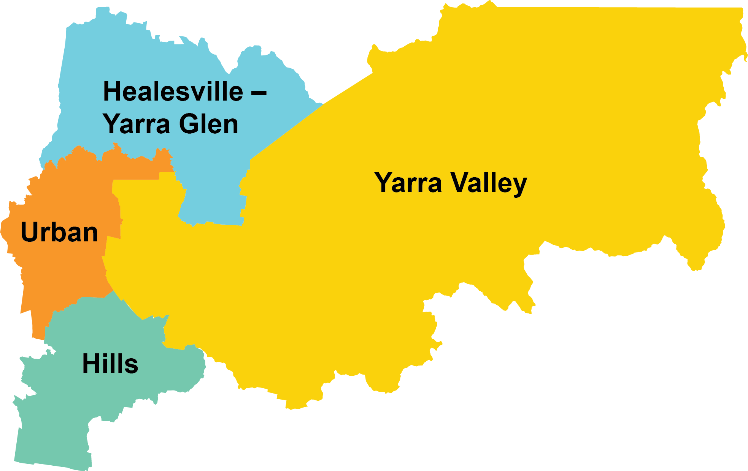

The following table shows the population, land area and density of population (person/km2) of each region.

 | Urban Area | Hills | Healesville-Yarra Glen | Yarra Valley
Population (ABS ERP 2024) | 85,013 | 35,465 | 14,051 | 25,309
Land Area (square km) | 181.6 | 219.0 | 369.3 | 1,697
Population Density (persons per square km) | 468 | 161.9 | 38.05 | 14.92

Estimated replacement cost of Council assets for Healesville-Yarra Glen region
Asset Class | Asset Quantities | Asset Descriptions | Current Replacement Cost  ($ million)
Buildings, Aquatics and Minor Structures | 5 | Halls, Community Hub/Link and Scout/Guide Halls | $ 99.4
Buildings, Aquatics and Minor Structures | 15 | Community Centre’s (Neighbourhood House and Senior Citizens) | $ 99.4
Buildings, Aquatics and Minor Structures | 5 | Community Sports Pavilions | $ 99.4
Buildings, Aquatics and Minor Structures | 10 | Toilet Blocks | $ 99.4
Buildings, Aquatics and Minor Structures | 1 | Outdoor Pool | $ 99.4
Buildings, Aquatics and Minor Structures | 28 | Recreational and utility shelter structures larger than 10 m² | $ 99.4
Drainage | 76 km | of Pipes | $ 21.8
Drainage | 2,753 | Pits | $ 21.8
Drainage | 4 | Stormwater related assets | $ 21.8
Parks, Bushland and Recreation | 24 | Sports Courts and Fields | $ 9.8
Parks, Bushland and Recreation | 3 | BMX/Skate Parks | $ 9.8
Parks, Bushland and Recreation | 11 | Playspaces | $ 9.8
Parks, Bushland and Recreation | 18 | Reserves and Parks | $ 9.8
Pathways | 60 km | Footpaths | $ 6.6
Pathways | 10 km | Trails | $ 6.6
Roads, Kerbs, Car parks and Bridges | 123 km | Sealed Roads | $ 67.5
Roads, Kerbs, Car parks and Bridges | 142 km | Unsealed Roads | $ 67.5
Roads, Kerbs, Car parks and Bridges | 57 km | Kerb and channel | $ 67.5
Roads, Kerbs, Car parks and Bridges | 51 | Bridges, major culverts and associated structures (including boardwalks) | $ 67.5
Roads, Kerbs, Car parks and Bridges | 48 | Off-Street Car Parks | $ 67.5
Land | 56 | Council owned land sites | $ 32.2
TOTAL |  |  | $ 237.3

Estimated replacement cost for Council assets in the Yarra Valley region
Asset Class | Asset Quantities | Asset Descriptions | Current Replacement Cost  ($ million)
Buildings, Aquatics and Minor Structures | 12 | Halls, Community Centres, Senior Citizens and Scout Halls | $ 177.7
Buildings, Aquatics and Minor Structures | 4 | Community Houses | $ 177.7
Buildings, Aquatics and Minor Structures | 13 | Community Sports Pavilions | $ 177.7
Buildings, Aquatics and Minor Structures | 27 | Toilet Blocks | $ 177.7
Buildings, Aquatics and Minor Structures | 1  2 | Indoor Aquatic Facility  Water Play Parks | $ 177.7
Buildings, Aquatics and Minor Structures | 45 | Recreational and utility shelter structures larger than 10 m² | $ 177.7
Drainage | 86 km | of Pipes | $ 24.2
Drainage | 3,460 | pits | $ 24.2
Drainage | 3 | Stormwater related assets | $ 24.2
Parks, Bushland and Recreation | 46 | Sports Courts and Fields | $ 17.1
Parks, Bushland and Recreation | 3 | BMX/Skate Parks | $ 17.1
Parks, Bushland and Recreation | 25 | Playspaces | $ 17.1
Parks, Bushland and Recreation | 42 | Reserves and Parks | $ 17.1
Pathways | 56 km | Footpaths | $ 9.2
Pathways | 37 km | Trails | $ 9.2
Roads, Kerbs, Car parks and Bridges | 235 km | Sealed Roads | $ 143.5
Roads, Kerbs, Car parks and Bridges | 263 km | Unsealed Roads | $ 143.5
Roads, Kerbs, Car parks and Bridges | 86 km | Kerb and channel | $ 143.5
Roads, Kerbs, Car parks and Bridges | 119 | Bridges, major culverts and associated structures (including boardwalks) | $ 143.5
Roads, Kerbs, Car parks and Bridges | 72 | Off-Street Car Parks | $ 143.5
Land | 121 | Council owned land sites | $ 44.9
TOTAL |  |  | $ 416.6

Estimated replacement cost for Council assets in the Urban Area region
Asset Class | Asset Quantities | Asset Descriptions | Current Replacement Cost  ($ million)
Buildings, Aquatics and Minor Structures | 17 | Halls, Community Centres, Senior Citizens and Scout Halls | $ 316.1
Buildings, Aquatics and Minor Structures | 9 | Community Houses | $ 316.1
Buildings, Aquatics and Minor Structures | 17 | Community Sports Pavilions | $ 316.1
Buildings, Aquatics and Minor Structures | 16 | Toilets Blocks | $ 316.1
Buildings, Aquatics and Minor Structures | 1  1 | Outdoor Pool  Water Play Park | $ 316.1
Buildings, Aquatics and Minor Structures | 65 | Recreational and utility shelter structures larger than 10 m² | $ 316.1
Drainage | 528 km | of Pipes | $ 131.2
Drainage | 20,040 | pits | $ 131.2
Drainage | 27 | Stormwater related assets | $ 131.2
Parks, Bushland and Recreation | 81 | Sports Courts and Fields | $ 33.6
Parks, Bushland and Recreation | 5 | BMX/Skate Parks | $ 33.6
Parks, Bushland and Recreation | 69 | Playspaces | $ 33.6
Parks, Bushland and Recreation | 105 | Reserves and Parks | $ 33.6
Pathways | 532 km | Footpaths | $ 52.5
Pathways | 85 km | Trails | $ 52.5
Roads, Kerbs, Car parks and Bridges | 446 km | Sealed Roads | $ 231.5
Roads, Kerbs, Car parks and Bridges | 55 km | Unsealed Roads | $ 231.5
Roads, Kerbs, Car parks and Bridges | 653 km | Kerb and channel | $ 231.5
Roads, Kerbs, Car parks and Bridges | 91 | Bridges, major culverts and associated structures (including boardwalks) | $ 231.5
Roads, Kerbs, Car parks and Bridges | 172 | Off-Street Car Parks | $ 231.5
Land | 274 | Council owned land sites | $ 307.8
TOTAL |  |  | $ 1,072.7

Estimated replacement cost for Council assets in the Hills region
Asset Class | Asset Quantities | Asset Descriptions | Current Replacement Cost  ($ million)
Buildings, Aquatics and Minor Structures | 19 | Halls, Community Centre’s, Senior Citizens and Scout Halls | $ 228.0
Buildings, Aquatics and Minor Structures | 7 | Community Houses | $ 228.0
Buildings, Aquatics and Minor Structures | 9 | Community Sports Pavilions | $ 228.0
Buildings, Aquatics and Minor Structures | 21 | Public Toilets | $ 228.0
Buildings, Aquatics and Minor Structures | 1  2 | Indoor Aquatic Facility  Outdoor Aquatic Facilities | $ 228.0
Buildings, Aquatics and Minor Structures | 21 | Recreational and utility shelter structures larger than 10 m² | $ 228.0
Drainage | 154 km | of Pipes | $ 40.5
Drainage | 7,068 | pits | $ 40.5
Drainage | 10 | Stormwater related assets | $ 40.5
Parks, Bushland and Recreation | 46 | Sports Courts and Fields | $ 10.0
Parks, Bushland and Recreation | 3 | BMX/Skate Parks | $ 10.0
Parks, Bushland and Recreation | 21 | Playspaces | $ 10.0
Parks, Bushland and Recreation | 46 | Reserves and Parks | $ 10.0
Pathways | 118 km | Footpaths | $ 17.6
Pathways | 13 km | Trails | $ 17.6
Roads, Kerbs, Car parks and Bridges | 246 km | Sealed Roads | $ 107.5
Roads, Kerbs, Car parks and Bridges | 243 km | Unsealed Roads | $ 107.5
Roads, Kerbs, Car parks and Bridges | 203 km | Kerb and channel | $ 107.5
Roads, Kerbs, Car parks and Bridges | 40 | Bridges, major culverts and associated structures (including boardwalks) | $ 107.5
Roads, Kerbs, Car parks and Bridges | 100 | Off-Street Car Parks | $ 107.5
Land | 148 | Council owned land sites | $ 69.8
TOTAL |  |  | $ 473.4

How this plan was developed
Since March 2024 Council have received direct feedback from over 1,250 people and informed over 6,000 community members in the development of the Council Plan, Long Term Financial Plan and Asset Plan. This included:
- 700+ survey responses
- 213 postcards completed
- Nine pop-up events, connecting with 800+ community members
- 135 attendees at three community and stakeholder summits
- Over 400 expressions of interest for Deliberative Community Panel
- 40 panel members representative of the diverse community, selected by an independent consultant
- Three workshops to discuss and debate Council priorities and challenges
- 10+ Focus Groups with key population groups

For further information read the full Community Engagement Reports available via Council’s website. In these conversations the community spoke strongly about the following priorities, which have formed the strategic intent for Asset Management at Council, and thus the development of this Asset Plan.

 | Planning to provide services to current and future generations within the community
 | Encouraging and supporting the economic, environmental, social and cultural development of the municipality
 | Providing quality community infrastructure as an integral factor in providing liveable places that support community connection
 | Developing assets that are responsive to the changing environment in which community live

The strategic intent is supported by the guiding principles outlined below. These principles were developed by the community in 2022 and re-tested by a community panel in 2024. These principles guide asset-related decision-making at Council.

Evidence Based
- Informed decision making
- Asset planning will incorporate population projection and demand forecasts for Council services
- The reliability of asset data will be regularly reviewed, and any necessary improvements identified and documented
Sustainability
- The impact on environmental, financial, social and cultural sustainability will be considered when evaluating asset projects and processes
- Asset planning and service levels are developed in consideration of available resources identified in Council's Long Term Financial Plan
Appropriate Quality
- Assets are planned and managed in a structured and coordinated way to be functional, efficient and sustainable for current and future generations
Community Vision
- Asset management objectives align and are consistent with our community vision and key strategic objectives noted in the Council Plan
- The views of the community are valued and play an important role in determining appropriate levels of services for assets through engagement activities that are consistent with the Council’s Engagement Policy
Fairness
- Asset provisions will consider fairness in population distribution and geographic location
Health and Wellbeing
- Council plans for, and manages, infrastructure that supports active living, mental wellbeing and social connections
- Council optimises the utilisation of public spaces and facilities to meet service demands and support community connections
Safety and Resilience
- Asset related risks are identified and managed
- Critical assets are identified and managed to maximise their availability, including times of emergency response and recovery
Continuous Improvement
- Adequate resources are provided to ensure Council realises its asset management objectives
- The implementation and performance of the Asset Management System will be overseen by an internal steering committee that has cross organisational representation

Challenges for assets in the region
As the community changes over time, so do their needs and wishes. As a result, Council needs to provide new, different or bigger assets to meet changing needs for the future. This also involves replacing those assets that are no longer useful, fit for purpose or offer poor value for money in supporting services to the community.
There are several complex issues facing local communities and Council. These have been identified by community and Councillors as ongoing challenges. Some of the key issues that Council is facing in the Asset Management space are:
Challenge | Impact
Growth and development | - Yarra Ranges’ population is expected to grow by 13,000 over the next 10 years. This will carry with it an associated growth in demand for Council services. The changes in population across Council is used to help understand the changing needs of the community and what impact this might have on investment.  - Regions within Yarra Ranges are popular tourist destinations with visitation projected to double to nine million. This increase of visitors contributes to wear and tear on infrastructure.
Staying healthy and safe | - Over the next 10 to 20 years the region is forecast to experience significant growth in the number of residents that are of retirement age or older. This will impact the way Council provides and delivers services which can influence the type of infrastructure community needs.  - Closing the gender gap by applying a gender lens to asset planning and considering the needs and priorities of different gender groups when making decisions about community assets.
Extreme weather | - Council faces significant challenges in the construction of climate resilient assets including rising costs, replacement of ageing assets and navigating the unique topography of Yarra Ranges.

Asset Investment Strategy

Type of Asset Investment
The money that Council invests on assets can be broken down into capital investment and operational investment.
Investment Type | Activity | Description | Buildings Example
Operational  Investment | Maintenance | Ongoing work required to keep an asset performing at the required level of service | Gutter cleaning
Operational  Investment | Operations | Recurrent investment that is required to provide a service | Utility costs
Capital Investment | Renewal | Extending the life of an existing asset | Replacing the Roof
Capital Investment | Upgrade, Expansion and New | Delivery of new services or increasing existing service levels | Building extension or new building

The funds that drive this investment at Council come from several sources such as rates, borrowings, grants and proceeds from asset disposal. Renewal, Maintenance and Operations investment is primarily supported by rates and borrowings. This type of investment is prioritised over Upgrade, Expansion and New. Upgrade, Expansion and New investment is often leveraged from grants and proceeds from asset disposals. The decision-making process related to this investment is outlined below.

Asset Investment Decision
Assets cost money to maintain and operate and, as assets age and deteriorate, Council must decide whether to renew, upgrade or dispose them. Decisions regarding when, where, and how much to invest in specific assets are primarily driven by risk considerations.
Council has an approach to consider risk associated with both new and existing infrastructure.
Risks associated with investment on new infrastructure considers Social, Environmental, Economic, and Cultural factors, and incorporates governance considerations like Risk, Strategic Alignment and Financial Implications.
Risk factors considered in assessing investment in existing infrastructure are Consequence of Failure (COF), Likelihood of Failure (LOF) and Criticality.
This approach ensures that assets with high consequences, high likelihoods and high criticality are prioritised for investment. It's not just about if something bad will happen, but also how bad it could be.
For example:
- Likelihood: How likely is it that something bad will occur? Is it probably going to happen, maybe, or is it very unlikely?
- Consequence: If something bad does happen, how bad will it be? Will it be a little problem, a medium problem, or a big problem?
- Criticality: Is the impact to the community easily fixed? Or is this the only asset around that can do this thing?

When investing based on risk, Council considers lowering the likelihood of something bad happening. Often the Consequence is fixed and unlikely to change. For example, a brand-new building that is in excellent condition and provides maternal and child health services, may be risker than a small car park that is in poor condition. Council has defined the criteria for consequence, likelihood and criticality in the tables below.
During the life of this Asset Plan, Council will continue to collect and collate data, test assumptions and refine this approach to risk-based investment.
Consequence of Asset Failure | Description | Example
Asset Consequence | If this asset fails, how impactful is it to the service that it provides or supports? | A major bridge collapse severely disrupts road transport, impacting commuters, emergency services, and commerce.
Business Interruption | How valuable are the outcomes of this service? | The closure of a maternal and child health centre leads to significant disruptions in essential healthcare services for vulnerable populations.
Natural Environment | How much damage to the natural environment could this asset cause? | A leaking septic tank contaminates a waterway with serious environmental consequences compared to sports light collapse which can have a minimal impact on the environment.
Health and Safety | What are the risks to people when this asset fails? | A poorly maintained playground structure poses a risk for injury to children.
Reputation and Stakeholder Relationship | How will stakeholders view the organisation if this asset or facility is not managed properly? What would be the impact on Council’s reputation? | The closure of a community library leads to public outcry and damages trust in local government.
Financials | How much does this asset cost to replace? | Replacing a sporting pavilion requires significant capital investment due to its size, complexity and varied use.
Regulation and Compliance | Is there legislation that relates specifically to this type of asset? | A bridge must comply with strict regulations, making its failure legally complex.

Likelihood of Asset Failure | Description | Example
Condition | What is the physical state of the asset? Does it have damage that might cause failure? | A bridge with visible cracks and corrosion is at a high risk of structural failure.
Age | How old is this asset? | A drainage pipe network built in the 1970s has deteriorated over time.
Climate | Is this asset prepared for future climate events? What impact will fire, wind, rain and temperature have on it? | A road located in a flood-prone area is vulnerable to damage from increased rainfall and flooding.
Utilisation | How many people use this asset? Is this causing it to deteriorate quicker than usual? | A popular urban park trail experiences heavy foot traffic, leading to accelerated wear and tear.
Capacity | How much demand can this asset manage before it fails? | A stormwater pipe (part of the network) struggles to manage peak load during heavy rainfall events.
Function | Is it designed in a way that makes it fit for purpose? | A community hall with poor accessibility features is not fully functional for all members of the community.

Criticality | Description | Example
Criticality | Can you get a similar asset or service in nearby proximity and how does it compare in terms of cost and access to those similar assets? | A remote rural bridge has no easily accessible alternatives, making its failure critical for local access.

Council manages these risks by increasing preventative maintenance, investing capital and/or decommissioning an asset. Often Council uses a mix of these three options to obtain acceptable levels of risk, maintain quality services whilst achieving financial sustainability.

How much money will Council be spending?
Over the next ten years, Council has forecast it will spend a total of $520 million in capital expenditure (renewal, upgrading and creating new assets) and $621 million in operational expenditure (maintenance and operations of existing and new assets). This investment is aligned with Council’s Long-Term Financial Plan. The below table summarises the capital and operational funding planned for our assets over the next ten years.
Financial Year | Renewal Funding ($'000) | Upgrade, Expansion and New Funding ($'000) | Maintenance and Operations Funding ($'000)
2025/26 | 26,044 | 32,254 | 59,397
2026/27 | 25,490 | 24,572 | 59,991
2027/28 | 22,813 | 20,116 | 60,591
2028/29 | 24,354 | 19,980 | 61,197
2029/30 | 27,589 | 16,507 | 61,809
2030/31 | 29,274 | 18,713 | 62,427
2031/32 | 27,918 | 22,586 | 63,051
2032/33 | 31,633 | 26,533 | 63,682
2033/34 | 32,370 | 26,707 | 64,318
2034/35 | 32,746 | 32,697 | 64,962

Note: The figures in the table above exclude any Project Management allocation. It also only includes operational investment related directly to managing and operating assets.
While the Asset Plan covers a ten-year horizon, the life of this plan is only four years. This Plan is due to be published again in 2029. Below is a detailed breakdown of the asset investment allocation by asset class over the life of this Asset Plan (four years):
Asset Class | Renewal Funding ($'000) | Upgrade, Expansion and New Funding ($'000) | Total Funding ($'000)
Roads | 41,611 | 14,497 | 56,108
Buildings | 12,774 | 18,840 | 31,614
Footpaths and Trails | 7,367 | 17,159 | 24,527
IT, Plant and Equipment | 13,200 | - | 13,200
Drainage | 1,450 | 10,819 | 12,269
Aquatics | 6,174 | - | 6,174
Playspaces | 3,165 | - | 3,165
Carparks | 1,400 | - | 1,400
Bridges | 1,124 | - | 1,124

Note: The figures in the table above exclude $9.8 million allocated to the Asset Improvement Fund, and $20 million allocated to Project Management. These amounts are yet to be allocated to specific projects and will depend on the priorities of our community at the time.
Council engages with community in the development of strategic and planning documents. This information is collated and considered to inform Council and support decision making on investment priorities. Council then allocates the capital budgets for each asset classes with the intention of prioritising assets that present the highest risk to Council. This allocation of funding aligns with the risk management approach outlined above.
The graph below shows the distribution of asset risk within each asset class. The colour gradient (minimal to extreme) provides a clear visual hierarchy of risk severity, allowing for quick identification of assets that hold the most risk to Council. The blue diamonds on the graph indicate the ten-year capital funding allocation for each asset class.
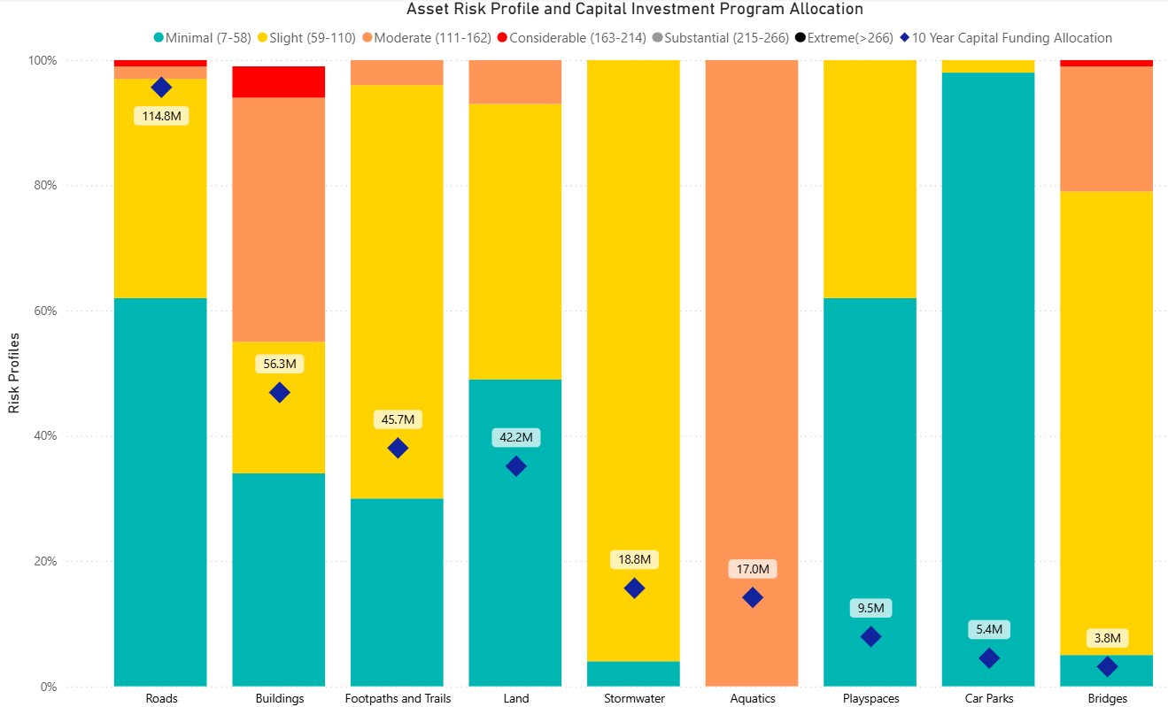
 | Percentage of Current Replacement Cost by Risk
Asset Class | Minimal  (7-58) | Slight  (59-110) | Moderate (111-162) | Considerable (163-214) | Substantial (215-266) | Extreme  (>266) | 10 Year Capital Funding Allocation**  ($ million) |  | Total Current Replacement Cost**  ($ million)
Buildings | 34% | 21% | 40% | 5% | 0% | 0% |  | 56 | 815
Roads | 62% | 35% | 2% | 1% | 0% | 0% |  | 115 | 420
Footpaths and Trails | 30% | 66% | 4% | 0% | 0% | 0% |  | 46 | 57
Bridges | 5% | 74% | 20% | 1% | 0% | 0% |  | 4 | 106
Aquatics | 0% | 0% | 100% | 0% | 0% | 0% |  | 17 | 25
Stormwater | 4% | 96% | 0% | 0% | 0% | 0% |  | 19 | 216
Car Parks | 98% | 2% | 0% | 0% | 0% | 0% |  | 5 | 25
Land* | 49% | 44% | 7% | 0% | 0% | 0% |  | 42 | 452
Playspaces | 62% | 38% | 0% | 0% | 0% | 0% |  | 10 | 60
*10 Year asset funding allocation for Land includes Open Space, Townships and Sports field investment.
** Figures rounded
***Aquatics only includes pools, pumps and filtration and does not include the building

Council's investment strategy focuses on prioritising assets with moderate and considerable risk to prevent them from deteriorating into higher-risk categories. This approach doesn't aim to eliminate all risk but rather to maintain a comfortable level of residual risk for the organisation. It is important to note that many assets that have a minimal to slight risk profile will deteriorate over the next ten years, and thus their likelihood of failure will increase. Council has factored this risk transition into the prioritisation process.
Investment decisions are communicated through internal processes where the strategic intent of asset management is balanced against organisational strategic direction to provide the best outcome for the community.

Performance, Reporting and Success Measurement
The Draft Council Plan 2025-2029 contains key initiatives and/or projects that Council will commit to deliver over the next four years.
The actions listed within the Draft Council Plan 2025-2029 will be reported to Council over the four-year period and this Asset Plan will be measured against the performance of four initiatives that support Quality Infrastructure and Liveable Places.
# | Initiative
10 | Manage storm water and drainage  Proactively manage stormwater to safeguard our community, promote sustainable development practices and preserve natural ecosystems
11 | Activate Ridges and Rivers  Deliver funded stages and operating models of ngurrak-barring-RidgeWalk, Yarra Valley Trail and Warburton Bike Park, while continuing to advocate for future funding.
12 | Facilitate diverse housing options  Work with partners and industry to increase opportunities for diverse housing around transport hubs, employment centres and key services
13 | Continue to address the safety and maintenance of local roads  Advocate, plan and deliver road maintenance in accordance with local priorities

While the Asset Plan covers a ten-year horizon, it is reviewed every four years by 31 October in the year following a Council Election as required by the Local Government Act 2020.
This Asset Plan supersedes any previous versions and is due to be published again in 2029.

Asset Plan Copies

Copies of the Asset Plan are available as hard copies or online.

All strategic documents to support the delivery of the strategic objectives are available in hard copy and in electronic format on Council’s website at www.yarraranges.vic.gov.au or by contacting 1300 368 333.

Contact Information

Community Links  Lilydale  15 Anderson Street  Healesville  110 River Street  Monbulk  21 Main Road  Yarra Junction  2442-2444 Warburton Highway  Upwey  40 Main Street | National Relay Service  133 677 - for callers who have a hearing, speech or communication impairment and for Text Telephone or modem callers  1300 555 727 - for callers using Speech to Speech relay  9658 9461 – TTY  Translation and Interpreting Service  131 450 Translating and Interpreting Services (TIS) National. An interpreting service is available if required.

