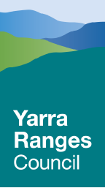
Yarra Ranges Council Tree Policy 2024 - 2028

Version: | 1.0
Approved by Council/ELT: | <MONTH YEAR>
Review Date: | December 2028
Policy Owner: | Manager Recreation Parks & Facilities
Applicable to: | Tree Management Team

Acknowledgement of Country
Yarra Ranges Council acknowledges the Wurundjeri and other Kulin Nation peoples as the Traditional Owners and Custodians of these lands and waterways. We pay our respects to all Elders, past, present, and emerging, who have been, and always will be, integral to the story of our region. We proudly share custodianship to care for Country together.

Yarra Ranges Community Vision 2036
The Yarra Ranges Community Vision 2036 has been developed to describe the communities and Council’s aspirations for the future of the municipality. It’s based on input from over 1,000 community members and reflects the local communities’ aspirations for the municipality.
Whether you live here or visit, you will see how much we care for Country, how inclusive and connected our communities are, and how balanced growth makes this the best place in the world.

What We Want to Achieve
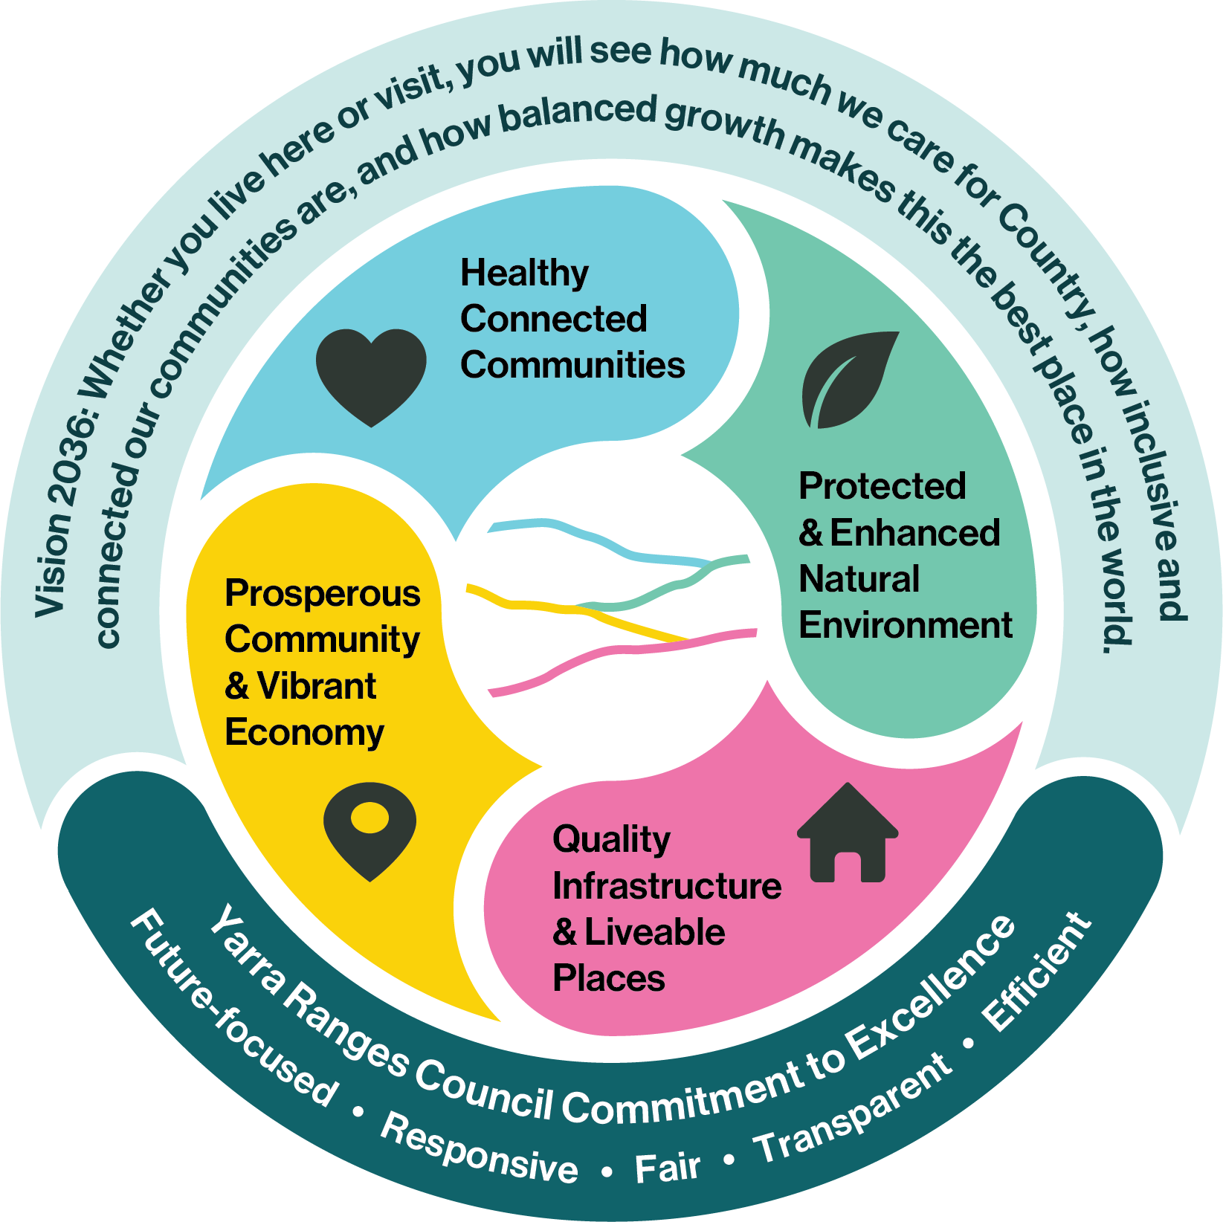
Council has four objectives to describe what we are working towards and how we want Yarra Ranges to be in the future. These objectives have been developed in response to our communities’ priorities and the big issues facing Yarra Ranges. All policies and activities completed by the organisation contribute to one or more of these objectives

- Introduction
Yarra Ranges is home to some of the most significant vegetation in the state, providing substantial ecological value within the natural catchments surrounding metropolitan Melbourne. Council’s Environment Strategy, Nature Plan and Tree Canopy Strategy, highlight that trees are one of the most important assets in Yarra Ranges.

There are approximately 1,250 ha of Council controlled parks and reserves, 1,757 kilometres of road corridors, and a further 600 km of roadsides on main roads, which contain a large tree population. In a report on Australian local government tree canopy cover, Where are all the trees?, Yarra Ranges had the highest number of trees in Victoria and the second highest in Australia.
- Purpose
The purpose of this Policy is to provide Council’s strategic direction and assessment framework for a consistent approach to managing trees on Council controlled land and roadsides, while meeting the goals of Healthy Connected Communities and Protected and Enhanced Natural Environment.

The importance of trees is reinforced through key Council strategies and plans, including the Environment Strategy 2015–2025, Nature Plan 2024–2034, Liveable Climate Plan 2020–2030, and Tree Canopy Strategy 2024–2044, which collectively establish a foundation for sustainable tree management.

The policy maintains a balance between retaining and protecting trees and managing tree related risk to people and property. It also recognises the importance of meeting our electrical line clearance requirements in the “declared areas”.

Scope

This policy applies to trees on Council managed land, including:
- Council managed parks
- Gardens around Council owned and managed buildings
- Council managed road reserves

The policy provides tree related information and guidance for:
- Council employees
- Councillors
- Residents
- General public
It is essential to note that the Tree Policy is only applicable to land that council directly controls and does not apply to other reserves or private property. In the case of roads managed by the Department of Transport Council has limited responsibility for the control or management of the roadside vegetation (including trees) adjacent to these roads.

The Tree Policy takes into consideration the management of risks, and available resources, and defines the levels of service for tree maintenance considering Yarra Ranges’ position as an interface Council with both urban and semi-rural road and a significant volume of trees.
- Definitions
Table 1. Definitions
XXXX | XXXX
- Policy Statement
Yarra Ranges Council is committed to retaining trees where possible while ensuring public tree risk is kept to a minimum.

The Tree Policy has two main components: the strategic principles for managing trees, and an assessment framework. These are designed to retain, maintain and enhance the tree resource within Yarra Ranges.
- Principles
The following principles establish Council’s strategic direction and hierarchy for managing trees and our tree assessment framework
- Avoid Tree Removal
- Minimise Tree Removal
- Proactive tree planting

A risk-based approach is applied to all decisions, which considers the health of the tree, risk to the local environment from the removal of the tree, as well as to the risk impacts on life and property.

The three broad principles for the Tree Policy relate directly to the Environment Strategy 2015–2025 and Nature Plan 2024–2034, which provides the rationale for tree management in the context of the total environment.

Avoid Tree Removal
Objective:
- All available alternatives will be explored to retain trees and avoid and minimise unnecessary tree removal.
Council will avoid the removal of trees from Council land and roadsides where risks from the tree can be managed. When considering any options for the maintenance, management or development of Council controlled land, alternatives will be identified to retain vegetation where possible to avoid unnecessary tree removal.

Minimise Tree Removal
Objective:
- Using best arboriculture practices vegetation will be maintained in healthy condition.
Council, in minimising the need for vegetation removal, will use best arboriculture practices such as tree pruning, root management, tree support systems and the control of weeds, animals and diseases as a means by which the health of trees and their longevity can be enhanced.

Proactive Tree Planting
Objective:
- Council will replant trees or carry out offset planting where tree removal cannot be avoided.
Council will implement a planned approach to tree planting, based on the Tree Canopy Strategy, and taking into consideration available funding, landscape requirements, seasonal conditions, availability of stock and community expectations.
- Tree Assessment Framework
Introduction
Trees provide a significant benefit for the community; however, trees can also be a liability. In some cases, it is necessary to determine the risks posed by trees and whether any action is required to mitigate or avoid that risk.

A key issue confronting Yarra Ranges is how to manage our extensive tree resource, from both an ecological and a public safety perspective, ensuring that reasonable care is taken to assess and manage the risks associated with hazardous trees and avoid unnecessary tree removal.

The tree assessment framework approach provides a systematic process for the allocation of resources for assessment and management of trees on Council controlled land and roadsides. Due to the vast tree resource located within the municipality, it is cost prohibitive to assess and perform maintenance works on all trees. Rather, a system is presented that prioritises tree assessment and maintenance works based on levels of risk.

Council’s tree programs are broken down into two parts, reactive and proactive. There are different levels of assessments for our programs.

Reactive tree inspections
Reactive tree inspections and works are in response to staff, residents and members of the public or other organisations advising Council of a potentially hazardous tree.

Qualified arborists assess the health and structure of the inspected tree and determine any required works using different levels of assessment, as detailed below.

Proactive tree inspections
The proactive program has three components:
- Electric Line Clearance in Declared Areas
Council conducts proactive tree inspections and works to maintain clearance space around electric lines in declared areas, as required by the Electricity Safety (Electric Line Clearance) Interim Regulations 2025. Under Section 81 of the Electricity Safety Act 1988, land can be made a “declared area”. In a declared area, the local council is responsible for tree clearing around power lines on public land. The electric line clearance work is also bundled up with road clearance, which is a program to allow for the safe passage of trucks and high vehicles, within the declared area. Level 1 assessments are undertaken in this program.

Council prepares an Electrical Line Clearance Management Plan each year, which can be found here.
- Road Clearance
The aim of the proactive Road Clearance program is to provide adequate clearance for vehicle and other road users in the non-declared areas. Maintaining road clearance is a responsibility Council has through the Road Management Act 2004.

As well as providing road clearance, the tree crews also remove large dead or damaged branches overhanging roads.

Under this program, roads are selected using local knowledge and monitoring roads that have a large amount of reactive customer requests. Level 1 assessments are undertaken in this program.

- Council owned Parks and Buildings inspections and works.
Proactive (Council owned) Parks and Buildings tree inspections and works are programmed. The program gave a risk rating to each park and facility, based on the type of tree stock and density, which determined the inspection frequency. Initially a level 1 assessment is undertaken, and a level 2 where required.

Levels of assessments
There are three levels of assessments undertaken, as recommended by the International Society of Arboriculture:

- Level 1: Limited Visual Assessment
Level 1 inspections are undertaken when a large number of trees have to be inspected and are usually done from a car or walking. Information is not recorded about each tree. If a fault is noticed, then a level 2 inspection is completed.
- Level 2: Basic Assessment
This is Council’s standard assessment. A tree or group of trees in inspected from the ground, often using binoculars. A full report is written on each tree.
- Level 3: Advanced Assessment
If required from a level 2 assessment, more detailed assessments are undertaken. Methods may include using a climbing arborist or an elevated work platform to access the crown of a tree, or tomography to assess extent of wood decay. Testing for tree diseases is also included under level 3. Information from a level 3 assessment is either added to the level 2 report or contained in a new report.

Tree Risk Classification
In line with normal risk management principles, the level of risk for all tree assessments is determined by probability level of the risk and its consequences and is based on the tree risk assessment methodology provided by the International Society of Arboriculture.

Further information about the International Society of Arboriculture tree risk framework, risk classification and the methodology can be found here. More detailed information can be found in Council’s Tree Risk Framework.

Tree Roots and Infrastructure

A qualified arborist will investigate claims of property damage that are alleged to be a result from public trees. Council will consider measures such as tree root pruning or tree root barriers when there is clear proof that public trees are damaging private infrastructure.

Tree removal will only be considered if no practical arboricultural or engineering solution can be determined to mitigate proven damage to private infrastructure. In some cases, Council will consider replacing stands of trees that are causing damage, dependent on available budget and community consultation.

- Decision Review Process

If a resident disagrees with a decision made by the tree management team to retain a tree, it will be escalated following a four tiered process set out in the Customer Complaint Policy.

Tier 1: First-contact complain resolution
The aim of Tier 1 is to resolve most complaints at initial contact. These complaints are resolved by identifying quick and mutually acceptable solutions. It is important that we understand the complaint and any specific needs of the complainant, then identify the ability and approach to find a workable solution. If a solution cannot be immediately found, then the Council officer will explain what will happen next and why.

Tier 2: Investigation
If a complaint needs further consideration, it moves to Tier 2. An investigation is usually carried out by a Council officer with specialist expertise. Under Tier 2, additional information is gathered, and an evidence-based decision is made. These specialist Council officers will communicate with you throughout the investigation and provide a written outcome that explains our decision.

Tier 3: Internal Review
If you believe Council officers have made the wrong decision in a complaint investigation, you can request an internal review. This review moves the complaint to Tier 3 and will be initially referred to the
team. The team will review the request and seek further information if required. The complaint is then referred to a member of an independent panel for review. The panel member will investigate to consider whether the complaint should have been dealt with differently. The panel member must not have had any prior involvement with the complaint and will make an evidence-based decision to uphold or overturn the original decision.

Tier 4: External Review
If you remain dissatisfied with a decision made or processes followed via Tier 3 complaint, we will provide you with information on how to seek an external review. Tier 4 complaints are escalated to an oversight body such as the Victorian Ombudsman or the Local Government Inspectorate, or to a tribunal or court. Council will contribute to Tier 4 complaints by participating in, and cooperating with, the external review process.

See the Customer Complaint Policy here for more information.
- Roles and Responsibilities
Table 2. Roles and Responsibilities
Manager Recreation Parks & Facilities | Responsible for ensuring budgets and resources are available to fulfil the policy’s requirements.
Executive Officer Parks, Trees and Trails | Supervises the Coordinator and liaises with the manager to ensure the policy is met.
Trees Coordinator | Everyday implementation of the policy.
- Related Documents
- Environment Strategy 2015-2025
- Nature Plan 2024-2034
- Yarra Ranges Liveable Climate Plan
- Tree Canopy Strategy
- Electric Line Clearance Management Plan
- Electricity Safety (Electric Line Clearance) Interim Regulations 2025
- Road Management Plan
- Customer Policy Complaint
- Planning and Environment Act 1987
- Monitoring and Evaluation
The monitoring and evaluation of this Policy will be overseen by Manager Recreation Parks & Facilities. The Trees Coordinator will conduct annual reviews, reporting the findings to the Executive Officer Parks, Trees and Trails. These reviews will assess the effectiveness of the policy, measured by customer feedback and appropriateness to relevant legislation.
- Policy Review
This Policy will be reviewed every four years following the Council election. From time to time, circumstances may require minor administrative amendments to be made to this document. Where such an amendment does not materially alter the intent of the document, this may be made administratively with the approval of the Director- Built Environment and Infrastructure without the need to be approved by ELT or Council.
- Revision History
Version | Date | Summary of revisions

