

Yarra Ranges Council
Draft Climate and Environment Strategy 2026 - 2036
Acknowledgement of Country
Yarra Ranges Council acknowledges the Wurundjeri and other Kulin Nation peoples as the Traditional Owners and Custodians of these lands and waterways. We pay our respects to all Elders, past, present, and emerging, who have been, and always will be, integral to the story of our region. We proudly share custodianship to care for Country together.


Version:
Approved by:
Review Date:
Document Owner:
Applicable to:

Table of contents
Executive summary 4
Message from the Mayor 6
Message from Wurundjeri 6
Introduction 7
Strategic context 13
Goals 18
Climate Ready | Woi-Wurrung Name 19
Water futures | Woi-Wurrung Name 20
Nature positive | Woi-Wurrung Name 22
Resilient places | Woi-Wurrung Name 24
Resource wise | Woi-Wurrung Name 26
Implementation 27
Monitoring and evaluation 28
Appendix - Supporting Information 30
Contact information 31

Executive summary
Purpose of this strategy
Humanity is facing a defining moment: the systems that sustain life are under pressure, and the decisions made now will echo for generations. Local Governments are closest to the places people love and the impacts communities already feel.
The Climate and Environment Strategy 2036 sets a shared direction for Yarra Ranges Council, partners and the community to care for Country and respond to the interconnected challenges of climate change, biodiversity loss and environmental degradation. It outlines the priorities and outcomes needed to achieve a climate-ready, nature-positive and resilient Yarra Ranges. It supports the Yarra Ranges Council Community Vision 2036 and is the lead strategy for Council’s strategic objective Protected and Enhanced Natural Environment.
The future of Yarra Ranges will be shaped by what we choose to protect, restore and change today. In the face of more frequent extreme weather, including increasing bushfire and storm risks, as well as urban heat, rising living costs and growing pressure on resources. Council has a responsibility to act with courage and care. Adapting and preparing for the future has never been more important.
Informed by science, community priorities and an ongoing partnership with Wurundjeri Woi-Wurrung people, this strategy responds to these challenges through five aspirational goals:
Goals
- Yarra Ranges is a climate-ready, net zero emissions community
People are empowered with the knowledge, resources and systems, to lead climate action, mitigate emissions, adapt to changing climate and be prepared in extreme weather events.
- Yarra Ranges has protected, healthy water systems
Water shared fairly and managed to restore and improve ecosystems; sustain culture and communities, with waterways are respected as living entities.
- Yarra Ranges has a thriving natural environment
Ecosystems and biodiversity are regenerating, guided by Indigenous Knowledge Systems. Our natural environment is protected and strengthened by shared responsibility and connection.
- Yarra Ranges has resilient, connected and inspiring places
Places to live and visit are thoughtfully designed, built and adapted, supporting liveability, adapting to climate change and celebrating distinctive landscapes.
- Yarra Ranges is leading circular economy action
Products and materials are designed for a circular lifecycle and are kept in use for as long as possible, with communities and businesses reducing their impact on the environment.

Glossary of terms
Term | Definition
Adaptation | Actions taken to prepare for, respond to or adjust to the impacts of climate change and reduce harm from future climate risks.
Biodiversity | The variety of plants, animals, fungi and microorganisms, the ecosystems they form, and the genetic diversity within species.
Circular economy | An economic system that designs out waste and pollution, keeps products and materials in use for as long as possible, and regenerates natural systems.
Climate change | Long-term changes in climate patterns caused largely by human activities that increase greenhouse gases in the atmosphere. Climate change contributes to rising temperatures, sea level rise, and more frequent and intense extreme weather events. Records show the planet is warming, with global temperatures already about 1.1°C higher than in pre-industrial times.
Country | Country is the interconnected system of land, water, sky, plants, animals, ancestors, spirit, culture, language, lore, and community. For First Peoples, Country is living and relational; and central to identity, wellbeing and belonging. Caring for Country refers to the First Peoples’ practices of land, waterway and sea management that draws on knowledge based on many thousands of years.
Extreme weather | A weather event that is rare at a particular place and time of year. Examples of extreme weather events are heatwaves, bushfires, storms, floods and droughts.
Greenhouse gas emissions | Gases released into the atmosphere that trap heat and contribute to climate change. Common greenhouse gases include carbon dioxide, methane and nitrous oxide. Overall balance between greenhouse gas emissions produced and greenhouse gas emissions taken out of the atmosphere.
Habitat connectivity | The extent to which landscapes enable plants and animals to move between habitats and maintain healthy populations.
Indigenous Knowledge Systems | These encompass traditional knowledge, perspectives, and practices. Knowing is how First Peoples perceive and understand the world, encompassing their beliefs, stories, accumulated bodies of knowledge, and wisdom.
Integrated Water Management (IWM) | A collaborative approach to managing all parts of the water cycle, including drinking water, stormwater, wastewater, waterways and groundwater, to deliver social, environmental, cultural and economic benefits.
Mitigation | Actions that reduce or prevent greenhouse gas emissions.
Nature positive | An approach that stops decline of nature and reverses nature loss so that biodiversity, ecosystem health and natural systems are restored and measurably improved over time.
Net zero | Overall balance between greenhouse gas emissions produced and greenhouse gas emissions taken out of the atmosphere
Resilience | The ability of people, communities, infrastructure, businesses and ecosystems to anticipate, prepare for, respond to and recover from climate-related impacts and shocks.
Regenerative agriculture | Practices that improve soil health, biodiversity, water cycles and ecosystem function

Message from the Mayor

Est. Pages [0.5]
Purpose: Leadership endorsement of strategy and to reinforce Council’s commitment. Recommended for lead strategies. The message from the Mayor for external strategy and the CEO for internal strategy.

Message from Wurundjeri

Est. Pages [0.5]
Holding space – Mirroring similar statement to 2015 Strategy
Inclusion of statement is consistent with approach taken in Council’s 2015 Environment Strategy and recognises the enduring cultural connection of Traditional Owners to Country.

Introduction
A healthy natural environment is essential for community wellbeing.
Yarra Ranges is a place of great natural and cultural significance. It is Melbourne's largest municipality by area. It is home to a wide range of communities and environments, from urban centres and neighbourhoods to townships and peri-urban areas. These settled areas are closely connected to productive rural land, extensive forests, national parks, and valued Green Wedge landscapes.
These landscapes provide clean air, cooling, habitat for wildlife and more than half of Melbourne's drinking water. They also support agriculture, tourism, biodiversity and community wellbeing. Importantly they shape the identity of Yarra Ranges and the lives of the people who live, work and visit here.
This Strategy sets a shared direction for the next 10 years. It brings together:
- scientific evidence about climate and environmental change
- Wurundjeri partnership and Caring for Country
- community priorities and lived experiences.
The key environmental and climate challenges facing Yarra Ranges include:
- Climate change is increasing temperatures and the frequency and intensity of extreme weather events
- Declining ecosystem health, biodiversity loss and habitat fragmentation
- Increasing pressure on water systems from climate variability, population growth and competing demands.
- Growing exposure of communities and infrastructure to climate risks.
- Population growth, land use change, pollution and consumption patterns that place additional pressure on natural systems.
The Strategy responds to these challenges by focusing on five key areas:
- healthy water systems
- thriving biodiversity
- resilient places
- low-emissions living
- a circular economy.
Together, these priorities guide how we care for Country; and how we work towards a climate-ready, nature-positive and resilient Yarra Ranges.
Caring for Country
For tens of thousands of years, the Wurundjeri Woi‑Wurrung and other Kulin Nation peoples have lived on and cared for Country.
Their knowledge comes from thousands of generations watching and following the seven seasons; understanding how plants and animals behave; and knowing how fire, water, soil, air and people all depend on each other. This knowledge recognises that environment, culture and community are inseparable; and that caring for Country is a shared responsibility.
This Strategy recognises that Country is alive, holding its own stories, knowledge, and authority. Country is shaped by both nature and culture. By the ecosystems, waterways and animals; and by the stories, languages and practices that belong to this place.
Today, as we face climate change, extreme weather and the loss of species and habitats, the knowledge that has guided this place for thousands of generations remains critically important. Wurundjeri knowledge provides a deep understanding of connection, balance, and long-term stewardship. This includes cultural fire practices, reading the seven seasons through plants and animals, and treating species and places like family.
This Strategy adopts a Country-centred approach that connects climate action, biodiversity, waterways, land management and community resilience. Working in partnership with Wurundjeri Woi-Wurrung people, we commit to supporting the long-term healing of Country and the wellbeing of everyone who lives on Country.
The Wurundjeri Seven Seasons
The Wurundjeri Woi-Wurrung people recognise seven seasons. These are marked by changes in plants, animals, waterways, weather and the night sky. These observations of flowering plants, animal movements, water levels, insect activity and weather patterns provide valuable local insights into ecosystem health, water cycles, biodiversity and fire conditions. This builds a deeper understanding of local environmental change and resilience.
For more information: Seven Seasons of the Kulin Nation, Wurundjeri Woi-Wurrung Cultural Heritage Aboriginal Corporation, Whole of Country Plan Wurundjeri-Woi-Wurrung-Whole-of-Country-Plan-2025-2035.pdf.

Contemporary Custodianship
Caring for Country is not only a responsibility of Traditional Owners. Today, it is a shared commitment. Wurundjeri Woi-Wurrung people, Council, communities, landholders, agribusinesses, businesses and partner organisations all have a role to play.
Many people have strong connections to the landscapes they live and work. They contribute practical knowledge and care through local food production, soil and water management, habitat restoration and land management. Contemporary custodianship recognises that everyone can contribute to the wellbeing of Country through their everyday choices and actions.
A Changing Climate and Environment
This Strategy draws on climate science, environmental monitoring, Indigenous Knowledge and local evidence. These show that Yarra Ranges is experiencing increasing climate and environmental pressures. These pressures affect people, communities, infrastructure, water, biodiversity and the natural systems that support life in the region.
Yarra Ranges is particularly significant because it:
- contains significant protected catchments, including the Upper Yarra, which form part of Melbourne’s drinking water supply.
- contains extensive native forests and globally significant Mountain Ash forests of the Central Highlands.
- supports almost 100 threatened species including critically endangered Helmeted Honeyeater, Leadbeater’s possum, and Wine-lipped Spider-Orchids.
- includes important waterways, wetlands and habitat corridors, including the Birrarung (Yarra River).
- faces high risk from bushfire, storm and flood risks.
Globally, the Intergovernmental Panel on Climate Change (IPCC) has identified that greenhouse gas emissions need to fall quickly to limit global warming and reduce the worst impacts of climate change. The IPCC advises that emissions must be cut significantly this decade to keep warming as close as possible to 1.5°C above pre-industrial levels.
Climate change does not affect everyone in the same way. People may experience climate risks differently depending on their age, disability, culture, location, income and life circumstances. Climate and environmental challenges also vary across urban areas, townships and rural communities.

Looking Ahead to 2036
Yarra Ranges is already experiencing the impacts of a changing climate and environment. The municipality is experiencing hotter temperatures and more frequent heatwaves. Rainfall patterns are changing, while severe storms, flooding, landslides and longer fire seasons are becoming more common. These changes affect urban and rural communities. They impact services, systems, infrastructure and the natural environment, negatively affecting quality of life. These events are already more frequent and are expected to intensify over coming decades.
The scale of these changes can be seen in recent disaster events (shown below). Since 2006, Yarra Ranges has recorded 42 federal disasters recovery activations, making it one of Australia's most disaster affected local government areas.
Year | Disaster Event |  | Area
1891 | Flood | Lilydale
1891 | Landslide | Montrose
1904 | Flood | Healesville, Yarra Glen
1905 | Fire | Healesville
1913 | Fire | Sassafras, Monbulk
1923 | Fire | Belgrave, Upwey, Ferny Creek
1923 | Flood | Healesville, Yarra Valley
1926 | Fire | Dandenong’s, Upper Yarra, Healesville
1932 | Fire | Upper Yarra (Matlock)
1934 | Fire | The Basin, Ferntree Gully
1934 | Flood | Warburton and Yarra Valley
1939 | Fire | Dandenong’s, Upper Yarra, Healesville (Black Friday)
1944 | Fire | The Basin, Ferntree Gully, Monbulk
1954 | Fire | Upper Ferntree Gully, One Tree Hill
1962 | Fire | Dandenong’s, Upper Yarra, Healesville
1968 | Fire | The Basin, Sassafras, Ferny Creek, Upwey
1972 | Fire | The Basin, Sassafras, Upper Ferntree Gully
1973 | Fire | Lysterfield
1980 | Fire | Upwey, Mt Dandenong
1983 | Fire | Dandenong’s, Upper Yarra (Ash Wednesday)
1991 | Fire | Yarra State Forest, Mt Little Joe
1992 | Landslide | Warburton
1995 | Landslide | Lilydale
1996 | Landslide | Belgrave, Mt Dandenong Tourist Road
1997 | Fire | The Basin, Dandenong Ranges, Montrose
2005 | Landslide | Kalorama, Tremont, Kallista, Olinda
2009 | Fire | Steels Creek, Chum Creek, Dixons Creek, Yarra Glen, Coldstream, Yering, Gruyere, Upwey, Belgrave, Belgrave South, Healesville, Tarrawarra, Toolangi (Black Saturday)
2015 | Fire | Wandin North
2016 | Storm | Dandenong Ranges
2019 | Fire | Upper Yarra Catchment
2021 | Storm | Yarra Ranges
2022 | Flood | Lilydale, Belgrave, Kallista, Kilsyth, Monbulk, Upwey, Tecoma, Yarra Junction
2022 | Landslide | Upper Yarra, Dandenong Ranges
2024 | Flood | Yarra Valley, Lilydale
2025 | Fire | Montrose
Table 1. Timeline of Disasters in Yarra Ranges.

Events such as the 2019-2020 bushfires and the June 2021 storms show how disruptive these impacts can be. Beyond damage to homes and infrastructure, they can cause prolonged power and communications outages, reduced access to essential services, disruption to businesses and significant effects on health and wellbeing of our community.
The natural environment including forests, water systems, biodiversity and places of cultural significance, is under increasing pressure from a changing climate. More frequent heatwaves, droughts, storms and changing fire patterns are affecting the health of natural systems. At the same time land use, development, population and tourism growth, resource consumption and biodiversity loss place additional strain on the ecosystems that sustain the region.
Healthy natural environments provide many benefits to communities across Yarra Ranges. Benefits include cooling urban areas, clean water, supporting wildlife, strengthening cultural connections and provide important benefits for physical and mental health through contact with nature.
As ecosystem health declines, these benefits are increasingly at risk. Protecting and restoring these natural assets is critical to maintaining the resilience, liveability, character and health and wellbeing of people in urban and rural areas of Yarra Ranges as climate impacts become more frequent and severe.
The next decade is a critical time for action. Decisions made today will shape community resilience, ecosystem health, and the ability of future generations to adapt to a changing climate.

Beyond 2036
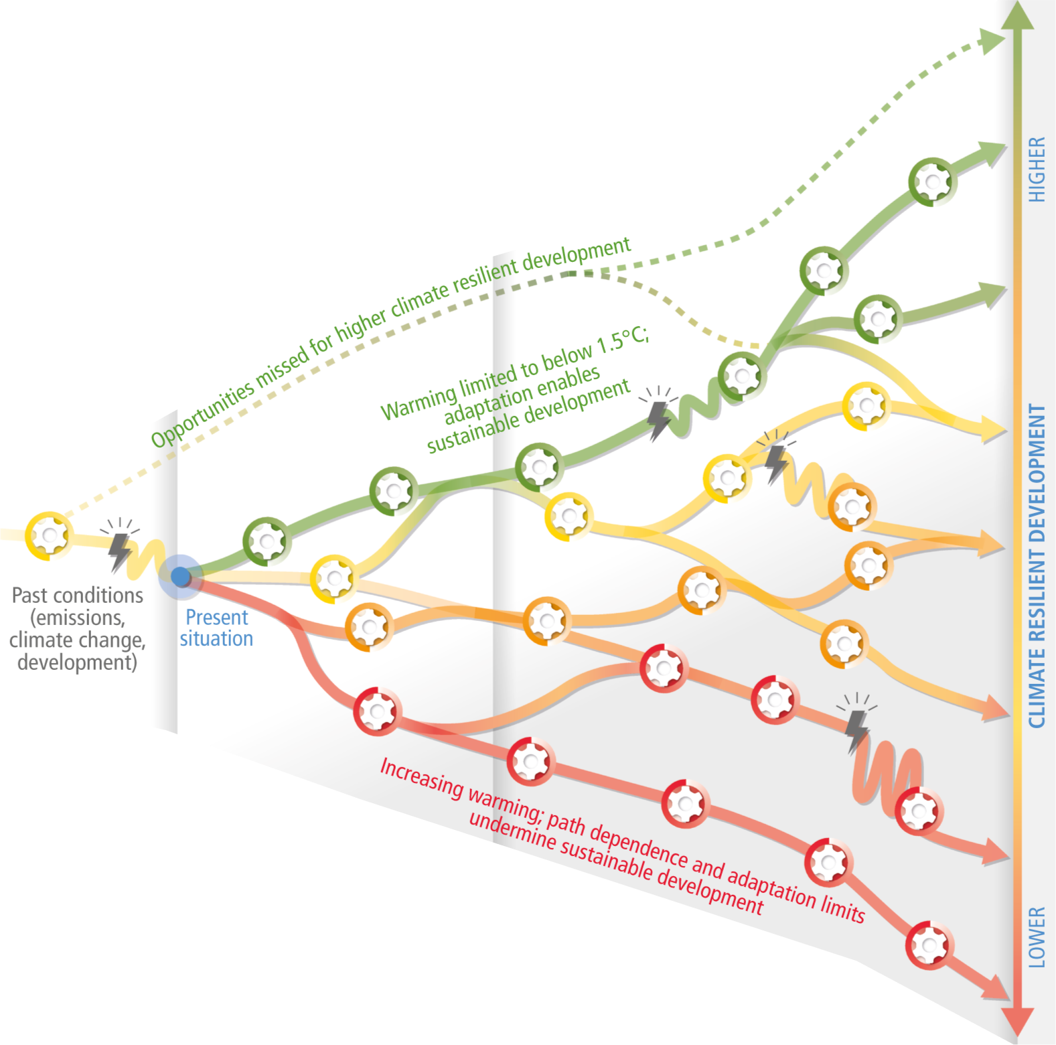
Figure 1. Climate-resilient development pathways illustrating how decisions made today shape future resilience, sustainability and vulnerability to climate change. Adapted from Schipper et al. (2022), IPCC Sixth Assessment Report.
By 2050, many people living in Yarra Ranges today will be experiencing the impacts of the decisions we make now.
Some climate change impacts can no longer be avoided. However, the severity of future impacts will depend on how quickly emissions are reduced and how effectively communities, infrastructure and natural systems adapt.
The longer we wait to act, the greater the risks, costs and challenges for current and future generations. By acting now and maintaining momentum, Yarra Ranges can better adapt, recover and protect what people value.
For more information about climate projections, biodiversity and environmental indicators is available in Council's State of the Climate and Environment Report.
Strategic context
The Strategy is Yarra Ranges Council's overarching framework for climate and environmental action. It sets the long term, direction to guide Council, partners and the community in caring for Country and achieving a climate-ready, nature-positive and resilient Yarra Ranges by 2036.

It is the lead strategy supporting the Council Plan objective of:


Protected and Enhanced Natural Environment
Caring for Country together and ensuring the environment is healthier for future generations

It contributes to delivery of the Yarra Ranges Community Vision 2036, which was developed with the Yarra Ranges community to describe Council’s shared aspirations for the future of the municipality.
Whether you live here or visit, you will see how much we care for Country, how inclusive and connected our communities are, and how balanced growth makes this the best place in the world.
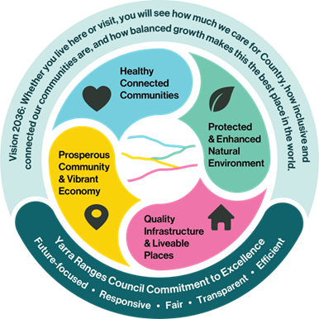
Figure 2. Council Plan roadmap

The list below shows the Council plans and strategies that support delivery of this Strategy. These translate the long-term direction of this strategy into actions, investments and targets that will support progress towards achieving each goal.
- Economic Development Strategy 2022-2032
- Community Waste and Resource Recovery Plan 2023-2030
- Housing Strategy 2024-2039
- Integrated Transport Strategy 2020-2040
- Key Life Stages Plan 2025-2029
- Liveable Climate Plan 2020-2030
- Health and Wellbeing Strategy2025-2029
- Reconciliation Action Plan
- Stormwater Management Plan 2024-2034
- Integrated Water Management Plan
- Yarra Strategic Plan 2022-2032
- Tree Canopy Strategy 2024-2044
- Nature Plan 2024-2034
- Green Wedge Management Plan
- Open Space Strategy
Through the Victorian Local Government Act 2020, Council has a legislated responsibility to promote environmental sustainability, respond to climate change risks, and help create a resilient future for current and future generations. This Strategy supports Council to meet these responsibilities and aligns with relevant state, national and international legislation and strategic frameworks.
This includes:
State
- Victorias Climate Change Strategy 2026-30
- Statewide Treaty (Gellung Warl) Act 2025
- Melbourne Water Healthy Waterways Strategy 2018-28
- Burndap Birrarung Burndap Umarkoo (Yarra Strategic Plan) 2022–32
- Recycling Victoria: A new Economy Policy (2020-2030)
- Protecting Victoria’s Environment – Biodiversity 2037 (2017-2037)
- Plan for Victoria

Federal
- Australia’s Net Zero Plan 2025
- Australia’s National Adaptation Plan 2025
- Australia’s Strategy for Nature 2019-2030
- Australia’s Circular Economy Framework 2024
- Australia’s National Water Agreement 2025
- Australia’s First Nations Strategy 2025-2030
Global
- United Nations Convention on Biodiversity
- Global Biodiversity Framework
- State of the Global Climate 2022
- Intergovernmental Panel on Climate Change (IPCC) Reports
- United Nations Declaration of Rights of Indigenous People
- The United Nations Sustainable Development Goals include 17 goals.
  - This strategy has particular alignment with: Clean Water and Sanitation; Affordable and Clean Energy; Industry, Innovation and Infrastructure; Sustainable Cities and Communities; Responsible Consumption and Production; Climate Action; Life on Land and Life Below Water (SDG 6,7,9, 11,12,13,15,14 respectively).
- The 2015 Paris Climate Agreement legally binds Australia to reduce emissions to keep climate change to below 2°C.

Community Consultation
This Strategy has been shaped by the Yarra Ranges community that cares deeply about the future of Yarra Ranges. People spoke of:
- thriving forests and waterways
- abundant wildlife
- stronger communities
- renewable energy
- local food; and
- a landscape where people live in harmony with nature and have respect for Country.
Underpinning these aspirations was a powerful message: protect what makes Yarra Ranges special, while preparing together for the challenges and opportunities ahead.
Participants of all ages expressed a shared desire for visible action, meaningful involvement and a future that balances environmental protection, climate resilience and community wellbeing. This Strategy reflects those aspirations and provides a pathway towards the future the community has envisioned together.
A total of 2,445 participants, preschoolers to seniors 80+ were reached through community and stakeholder engagement activities, including:
- the Youth Summit and Next Gen Forum
- 11 community pop-up events
- seven Advisory Committees and stakeholder groups
- engagement with Wurundjeri Woi-Wurrung as Traditional Owners and Custodians of Country.
Through this process, 712 contributions were received, providing input into the development of the Strategy.
Community feedback directly influenced the development of the Strategy, including strengthening priorities relating to climate adaptation, waterway health, biodiversity protection, local food systems, renewable energy, emergency preparedness and community participation.
To find out more about this engagement visit: https://shaping.yarraranges.vic.gov.au/climate-and-environment-strategy-2026-2036/

Shared Future
Youth participation was a strong feature of the engagement process, ensuring the Strategy reflects both current needs and the aspirations of future generations. More than 200 young people contributed their ideas and aspirations for the future of Yarra Ranges. Through targeted workshops and activities young people consistently called for visible action, greater accessibility and meaningful involvement in decisions that affect their future.
The following statement, prepared by the Yarra Ranges Council’s Youth Ambassadors reflects the aspirations and priorities identified by young people throughout the engagement process and captures their shared hope for Yarra Ranges in 2036:

The young people of Yarra Ranges hope that:
“In 2036, we strive to make Yarra Ranges a place where native habitats and animals thrive alongside people, homes, and streets: protected and cared for through Indigenous Knowledge Systems.
Our community is climate-ready, with landscapes and neighbourhoods designed to stay safe and liveable through heat, fire and flood. This means more cool, green spaces that are powered by renewable energy.
We are living sustainably with thriving community gardens, electrified transport and clean waterways. There’s easy access to low-impact environmental choices and everyone feels they belong. We connect, have opportunities to learn and are able to help shape a sustainable future.”
Goals

The following pages detail the five goals of this Strategy. Each goal has a:
- distinct focus identified in both English and Woi-Wurrung
- goal statement that describes the long-term future this Strategy is working towards.
To support progress towards each goal, the Strategy also identifies:
Approach – ways of working
Outcomes – changes we want to see over time
Measures – how progress will be measured.
While each goal has a distinct focus, they are interconnected and work together as part of a broader system. Progress in one area often supports progress in another.
All goals and approaches recognise the diversity of people and places across Yarra Ranges and are guided by a commitment to leadership, participation, connection, systems thinking, accountability, inclusion and accessibility.
The figure below illustrates how the Strategy’s five goals work together.
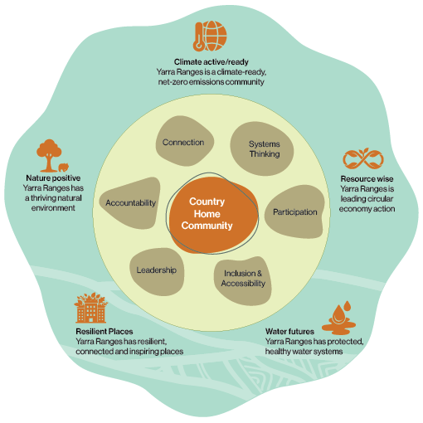
Figure 3. Interconnection between goals, approaches and foundation of Country.
Climate Ready | Woi-Wurrung Name Placeholder
Goal 1: Yarra Ranges is a climate-ready, net-zero emissions community.
People are empowered with the knowledge, resources and systems to lead climate action, mitigate emissions, adapt to change, and respond confidently to extreme weather events.
Approach
- Work with communities, households and businesses to prepare for climate change and extreme weather through practical information, tools and place-based planning.
- Work with communities to understand local climate risks and support local climate action through place-based engagement and community development.
- Embed climate considerations into Council operations, procurement and service delivery.
- Support communities transition to renewable energy, electrification and other low-carbon, climate ready solutions through advocacy, partnership, education, grants and incentives.
- Facilitate and promote local and home food production, community gardens and farmers markets that supports a low-emission food system.
Outcomes
- People, particularly those most at risk or facing barriers, have equitable access to knowledge, resources and social networks needed to prepare, adapt and recover.
- Essential infrastructure and services (including energy systems and critical Council services) are low-emission, climate-resilient, accessible and prepared for disruption.
- More people grow, buy and eat locally produced, low-emission food.
- Community and Council emissions are reduced.
Measures
- Number of towns with an active climate or emergency preparedness group.
- Community understanding about climate risks and what they can do to prepare.
- Amount of low-emission goods and services purchased by Council.
- Reduction in Council greenhouse gas emissions and progress towards Council’s 2040 net-zero target.
Water futures | Woi-Wurrung Name Placeholder
Goal 2: Yarra Ranges has protected, healthy water systems.
Water is shared fairly and managed regeneratively to sustain thriving ecosystems, culture and communities, with waterways respected as living entities.
Approach
- Support community understanding of flood risk, flood behaviour, stormwater systems, and climate-driven changes to rainfall patterns.
- Partner with traditional owners, agribusinesses, recreation user groups, landholders, community and water authorities to strengthen understanding of water systems, shared responsibilities and local water security challenges.
- Support restoration of vegetation growing alongside rivers, billabongs, wetlands and floodplain habitat within the municipality, that help protect water quality, reduce erosion and provide habitat for wildlife.
- Incorporate integrated water management principles, water-sensitive design, water reuse opportunities and Indigenous Knowledge into council planning, decision-making, infrastructure and operations.
- Manage stormwater to mitigate flood risk and protect the health of waterways.
- Identify risks and oversee the management of onsite wastewater systems (e.g. Septic systems) to protect human health and the environment.

Outcomes
- Community understands water systems, values waterways and actively contributes to protection and stewardship.
- Increased quality and quantity of riparian and aquatic habitat.
- Agribusinesses, landholders, recreation users and community members actively support sustainable water management and waterway health.
- Stormwater and recycled wastewater are widely captured, treated, and reused as valuable resources.
- Water is used efficiently, sustainably, equitably and prioritised for the environment and climate adaptation.
- Water quality is protected and improved through effective prevention of pollutants entering waterways.
- Landholders understand their responsibilities for wastewater system maintenance and connect to sewer infrastructure when available.

Measures
- Community attitudes, understanding and practices around water management.
- Health of vegetation and aquatic biodiversity at monitored sites.
- Water quality at monitored sites.
- Reduction in volume of urban stormwater run-off.
- Volume of stormwater and recycled water that substitutes potable water use.
- Area of water-sensitive and nature-based infrastructure (e.g. raingardens and wetlands) created or maintained.

Nature positive | Woi-Wurrung Name Placeholder
Goal 3: Yarra Ranges has a thriving natural environment.
Ecosystems and biodiversity are regenerating, guided by Indigenous Knowledge Systems. Our natural environment is protected and strengthened by shared responsibility and connection.
Approach
- Promote awareness and knowledge of indigenous plants, fungi, animals, biodiversity, weeds, pest species and the actions people can take to care for the natural environment.
- Support environmental groups and stewardship networks to build community capacity, leadership and participation across all ages, abilities and backgrounds.
- Design and deliver places, programs and experiences that strengthen connection to nature, encourage intergenerational learning and provide equitable access to nature across generations.
- Embed nature-positive principles and Indigenous Knowledge into Council decision-making, land management planning, operations and service delivery.
- Partner with agribusinesses, Traditional Owners, landholders, environmental organisations and community groups to improve environmental outcomes and landscape connectivity.
- Support the adoption of regenerative agriculture and sustainable land management practices through partnerships, incentives, education and knowledge sharing.
- Support compliance with planning controls, environmental regulations and local laws to protect biodiversity, habitats and landscape values.
Outcomes
- Communities, businesses and landholders value nature, actively participate in stewardship activities and share responsibility for environmental outcomes.
- Indigenous Knowledge Systems are recognised, and in partnership with Traditional Owners actively incorporated into Council decision-making and land management practices where appropriate and possible.
- Regenerative agriculture and sustainable land management practices are widely adopted.
- Land use decisions encourage long-term environmental health, with trade-off’s transparently assessed and communicated.
- Habitat connectivity is strengthened, with private and public landowners reducing fragmentation across landscapes.
- Ecosystem health, biodiversity, habitat quality are improved, including the health of plant, fungi and animal populations.
- Soil health improves, reliance on/use of fertilisers and other inputs decreases, and productive land becomes more resilient to environmental change.

Measures
- Community participation in Council-supported activities to care for nature.
- Area of private land restored with native vegetation.
- Number and area of vegetation removal incidents.
- Amount of weeds and pest animals removed or treated.
- Conservation value of Council bushland reserves.

Resilient places | Woi-Wurrung Name Placeholder
Goal 4: Yarra Ranges has resilient, connected and inspiring places.
Places to live and visit are thoughtfully designed, built and adapted, supporting liveability, adapting to climate change and celebrating distinctive landscapes.

Approach
- Integrate climate resilience, regenerative design, cultural knowledge, environmental protection and emergency preparedness into place planning, infrastructure design, asset management and renewal programs.
- Advocate for stronger sustainability and climate resilience requirements within building and construction standards.
- Engage communities in inclusive and collaborative place planning and design processes that reflect local needs, strengths and aspirations using Asset Based Community Development (ABCD) practices.
- Work with landholders and agricultural businesses to adapt to changing environmental, economic and climate conditions and opportunities.
- Recognise and promoting local examples of sustainable design, innovation and best practice.
- Promote use of climate-responsive design that improves resilience, sustainability and long-term liveability. This includes considering through planning processes, measures such as passive solar orientation, energy efficiency, water-sensitive urban design, urban cooling, permeable surfaces and sustainable building materials where appropriate.
- Recognise and protect environmental values through vegetation retention, biodiversity conservation, stormwater management and landscape outcomes.

Outcomes
- Places are liveable and climate-resilient, supporting community connection and wellbeing.
- Public infrastructure and assets are planned, designed, maintained and renewed using sustainable and resilient practices that respond to future conditions.
- Infrastructure, services and systems support community safety, emergency preparedness, response and recovery, including during periods of increased demand.
- Place planning and design are inclusive, accessible and responsive to the diverse needs of the community.

Measures
- Amount of open space available for the community.
- Access to public open space within walking distance.
- Number of community hubs with backup power and connectivity that function effectively during an extreme weather event.
- Area of farmland continuing to be used for agriculture Tree canopy cover in townships and progress towards Council’s tree canopy targets.
- Use of sustainable design criteria in Council’s purchasing decisions.

Resource wise | Woi-Wurrung Name Placeholder
Goal 5: Yarra Ranges is leading circular economy action.
Products and materials are designed for a circular lifecycle and are kept in use for as long as possible, with communities and businesses reducing their impact on the environment.
Approach
- Support and advocating for coordinated systems that reduce waste; and encourage reuse, repair, resource recovery, recycling and sustainable product design.
- Facilitate community access to services, infrastructure and programs that help people participate in reuse, repair and recycling.
- Embed circular economy principles into Council purchasing, policies, contracts, decision making and day to day operations.
- Work with community and businesses through education, leadership, partnerships, data sharing initiatives that encourage circular economy practices.
Outcomes
- Circular economy and waste minimisation principles are part of/embedded across Council operations, procurement, businesses and the wider community activities.
- People have access to services and facilities that support reuse, repair, recycling and resource recovery.
- Communities and businesses actively reduce waste, reuse materials, repair products and maximise resource recovery as part of everyday practice.
- More resources are recovered and less material goes to landfill.
- Food and organic waste are turned into useful products such as compost for regenerative land management and agriculture.
Measures
- Amount of waste diverted from landfill
- Tonnes of materials recovered for reuse and recycling
- Tonnes of food and garden organics (FOGO) recovered
- Use of circular economy principles in Council’s purchasing decisions

Implementation
The Climate and Environment Strategy (Strategy) sets the long-term direction for climate and environmental action in Yarra Ranges. It provides the overarching framework for the delivery plans and supporting strategies that guide Council’s work (see page 14). These supporting documents set priorities, targets, actions and investment decisions.
Many Council teams, services and partner organisations contribute to delivering this work. The Strategy helps connect these activities, so efforts are coordinated and consistent across Council. It also helps ensure climate and environment considerations are included in planning, operations and everyday decisions.
To keep the Strategy current, Council will review midway through its 10-year life. Updates may be needed to reflect new Council plans or respond to legislation or policy changes.

Working with Traditional Owners
Council acknowledges the continuing cultural authority of Wurundjeri Woi-Wurrung people as Traditional Owners and Custodians of Country and is committed to strengthening partnerships that support the long-term health and healing of Country. This approach reflects Victoria’s evolving Treaty context, including the Statewide Treaty (Gellung Warl) Act 2025. It also reflects Council’s responsibility to support self-determination, respectful partnership and Traditional Owner leadership in decisions affecting Country.
Under this Strategy, partnerships may include:
- involving Traditional Owners early in planning, co-design and decision-making.
- incorporating Indigenous Knowledge Systems into projects, planning and land management.
- identifying opportunities for self-determined cultural land management and Caring for Country practices.
- supporting cultural safety and learning within Council and the broader community.
- working together on shared environmental, cultural and community outcomes.
Partnerships will continue to evolve through ongoing dialogue, trust, mutual respect and shared learning.

Monitoring and evaluation
Monitoring and evaluation of this Strategy will support transparency, accountability, continuous improvement and informed decision-making throughout the life of the Strategy.
Monitoring
The measures within the Strategy will be reported through Council’s annual Climate and Environment Report. This report will also provide a consolidated overview of achievements, trends and challenges across the Strategy's five goals and delivery plans. The Report will enable Council and the community to track progress over time and identify areas requiring further attention, investment or collaboration.
Evaluation
Evaluation will focus on Key Evaluation Questions to help inform continuous improvement throughout the life of the strategy. This will pay particular attention to:
- learnings from relevant Council Plan initiatives and priority projects.
- key approaches, such as partnership, leadership, community participation and Caring for Country.
- governance, decision-making and legislative compliance.
The following Strategy Outcomes provides the overarching framework for monitoring and evaluation. It outlines how the strategic approach is expected to lead to intended outcomes.

Strategy Outcomes
Council Plan: Protected and Enhanced Natural Environment
Climate and Environment Strategy Goals
Caring for Country sits across the following goals. (Woi-Wurrung text on this page is a placeholder for the equivalent language)
- Climate Ready | Woi-Wurrung
  - Long-term outcome
- Low emissions and climate resilient community
  - Medium-term outcome
- Resilient, low-emission infrastructure and services
- Empowered community to prepare and adapt
  - Short-term outcome
- Climate action embedded across Council
- Prepared and ready services
- Water Futures | Woi-Wurrung
  - Long-term outcome
- Water health, quality and availability
  - Medium-term outcome
- Sustainable water use
- Stormwater reuse
- Community value and protection of water systems
  - Short-term outcome
- Integrated Water Management practices embedded across Council
- Nature Positive | Woi-Wurrung
  - Long-term outcome
- Healthy, connected, resilient ecosystems
  - Medium-term outcome
- Community, landholders and Council actively care for and protect the natural environment
  - Short-term outcome
- Land management decisions embrace regenerative practices and Wurundjeri knowledge
- Resilient Places | Woi-Wurrung
  - Long-term outcome
- Liveable, resilient places supporting community connection and wellbeing
  - Medium-term outcome
- Infrastructure, services and systems can withstand future climate impacts
- Capacity to mitigate, respond and recover in emergencies
  - Short-term outcome
- Resilience and sustainability embedded in planning, design, construction and asset maintenance
- Resource Wise | Woi-Wurrung
  - Long-term outcome
- High resource, food and organic waste recovery
- Materials diverted from landfill
  - Medium-term outcome
- Accessible systems for community and business to actively participate in a circular economy
  - Short-term outcome
- Circular economy and waste minimisation embedded across Council
Approach
- Leadership, advocacy and partnerships
- Council operations, services and procurement
- Community development, engagement, education and communication
- Partnering with Wurundjeri Woi-wurrung and Traditional Owners
- Design and planning
Challenges and opportunities
- Climate change and extreme weather risks and impacts
- Wurundjeri Woi-wurrung knowledge systems and Caring for Country together
- Yarra Ranges has a highly valued and significant natural environment
- Climate and environment are central to how we live, our wellbeing, and support local agriculture and tourism
- Council has a key role in local community adaptation and preparedness

Appendix - Supporting Information
Relevant law
Statewide Treaty (Gellung Warl) Act 2025
Country Fire Authority Act 1958
Land Act 1958
Land Conservation Act 1970
Wildlife Act 1975
Planning and Environment Act 1987
Conservation, Forests and Lands Act 1987
Flora and Fauna Guarantee Act 1988
Water Act 1989
Heritage Rivers Act 1992
Advancing the Treaty Process with Aboriginal Victorians Act 2018
Catchment and Land Protection Act 1994
Environment Protection and Biodiversity Conservation Act 1999 (Federal)
Aboriginal Heritage Act 2006
Public Health and Wellbeing Act 2008
Treaty Authority and Other Treaty Elements Act 2022
Climate Change Act 2017
Environment Protection Act 2017
Yarra River Protection (Wilip-gin Birrarung murron) Act 2017
Heritage Act 2017
Flora and Fauna Guarantee Amendment Act 2019
Local Government Act 2020
Circular Economy (Waste Reduction and Recycling) Act 2021

References
IPCC (2022), Climate Change 2022: Impacts, Adaptation and Vulnerability.

Contact information

Community Links  Lilydale  15 Anderson Street  Healesville  110 River Street  Monbulk  21 Main Road  Yarra Junction  2442-2444 Warburton Highway  Upwey  40 Main Street | National Relay Service  133 677 – for callers who have a hearing, speech or communication impairment and for Text Telephone or modem callers  1300 555 727 – for callers using Speech to Speech relay  9658 9461 – TTY  Translation and Interpreting Service  131 450 – Translating and Interpreting Services (TIS) National. An interpreting service is available if required.
Yarra Ranges Council  PO Box 105  Lilydale VIC 3140  1300 368 333  mail@yarraranges.vic.gov.au  yarraranges.vic.gov.au | 

