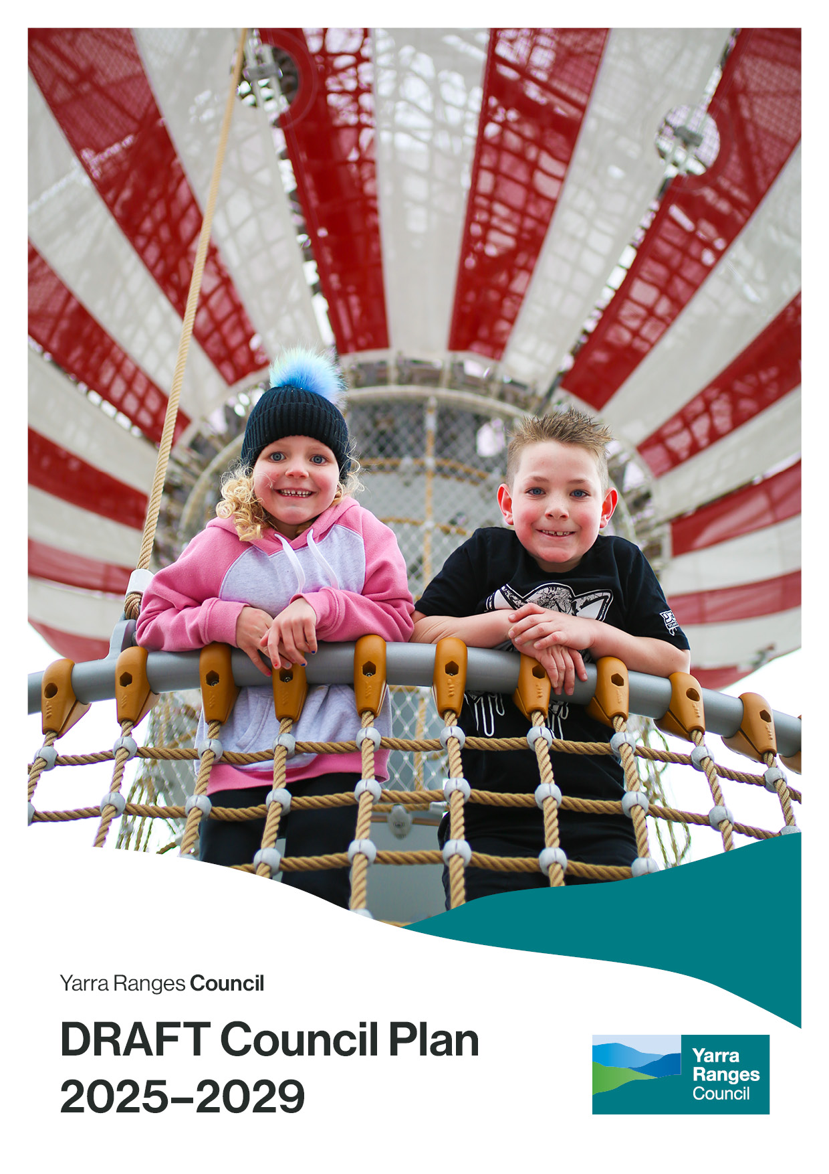
stra`

 | Acknowledgement of Country  Yarra Ranges Council acknowledges the Wurundjeri and other Kulin Nations as the Traditional Owners and Custodians of these lands and waterways.  We pay our respects to all Elders, past, present, and emerging, who have been, and always will be, integral to the story of our region. We proudly share custodianship to care for Country together.

Value of History
We acknowledge that history shapes our identities, engages us as citizens, creates inclusive communities, is part of our economic well-being, teaches us to think critically and creatively, inspires leaders and is the foundation of our future generations.

Table of Contents

Table of Contents 3
Introduction 4
Purpose 5
Message from the Mayor 6
Message from our CEO 7
Your Councillors 8
The role of Council 9
Our commitment 10
About our region 11
Snapshot of Yarra Ranges 12
Our unique places 13
Council Plan 14
Overview of Council Plan 15
Our Strategic Direction 16
Yarra Ranges Community Vision 2036 17
Our challenges 19
Our community told us 20
The next four years 22
Strategic Objective: Healthy Connected Communities 24
Strategic Objective: Protected and Enhanced Natural Environment 27
Strategic Objective: Quality Infrastructure and Liveable Places 30
Strategic Objective: Prosperous Community and Vibrant Economy 33
Measuring success 35
Planning Framework 38
Developing this plan 39
How this plan was developed 40
Community Engagement 41
Action Plan 43
Contact Information 53

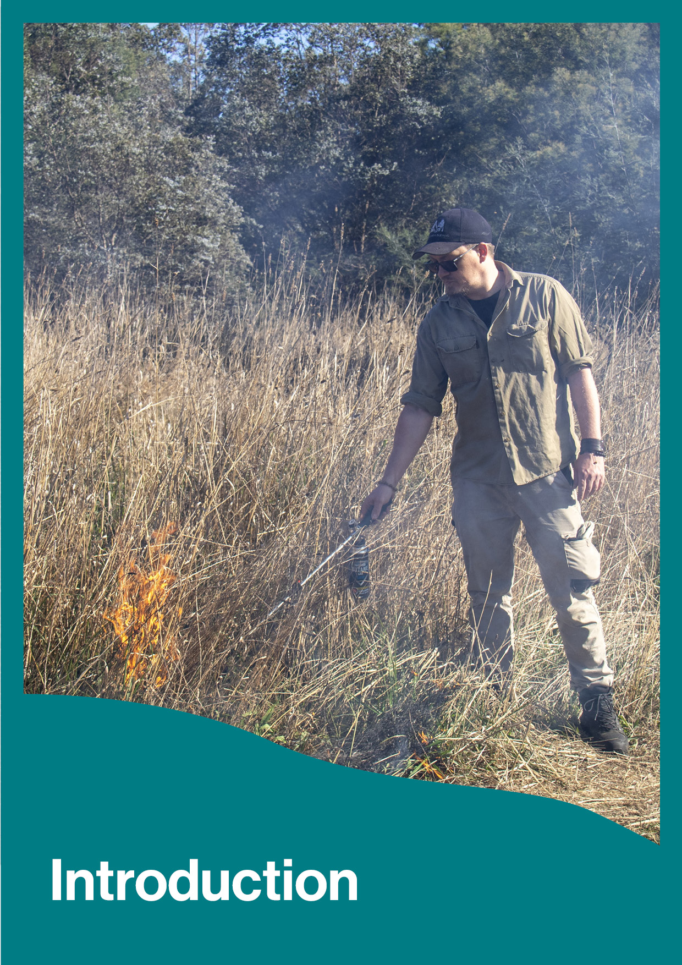
Introduction

Purpose
The Council Plan 2025-29 (the Plan) is Council’s overarching strategic plan and outlines what Council will achieve over the next four years. It identifies where efforts will be focused and how the progress of priorities and projects will be measured. It has been developed through work of Councillors, as well as broad and deliberative engagement with a cross-section of the community.
The Plan responds directly to the Yarra Ranges Community Vision 2036. It considers the needs and aspirations of communities who live in the townships and suburbs of Yarra Ranges and our interactions with those who visit.

The Plan is presented in five main sections:

- Introduction
- About our region
- Council Plan & The next four years
- Developing this plan
- Action Plan

A summary and accessible version are also available on the website.

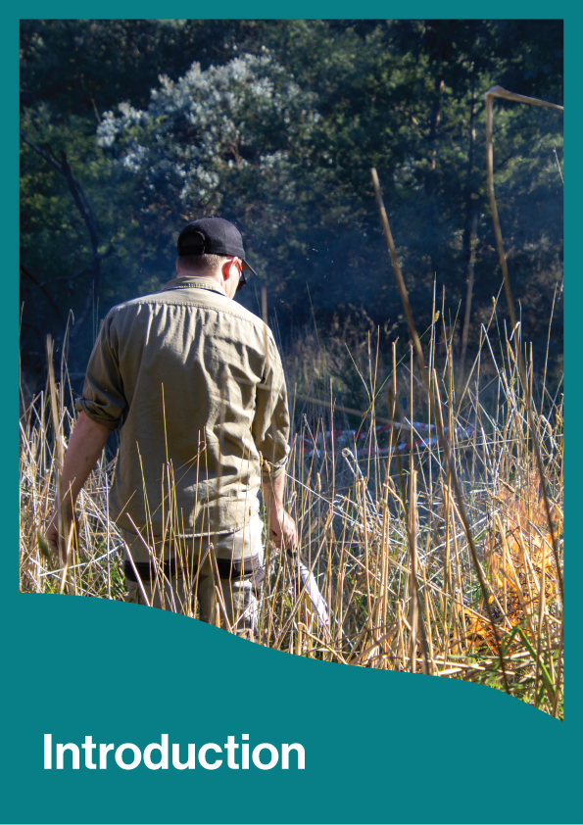
Message from the Mayor
Welcome to the Yarra Ranges Council Plan 2025-2029.
We are delighted to present this plan and its positive vision for the future of Yarra Ranges. As we embark on an exciting new chapter for our community, this Plan details how we can best support our community in excess of 165,000 people over the next four years and build on the strong foundations of the previous Council Plan.
Feedback from our community is clear - you want us to demonstrate leadership and focus on getting the basics right. And when you say basics, you mean clear communication and decision making, improving drainage and waste management, being equipped to respond to emergencies, taking care of our unique environment and ensuring townships are well maintained in collaboration with local communities.
Our communities are also looking to Council to ensure we get the balance right between protecting local liveability and our natural environment with welcoming visitation to the region. We know tourism will continue to play a significant role in our future with visitor numbers projected to double to over nine million in the coming decade, bringing with it the potential for over 500 local jobs and an estimated $80 million boost the local economy annually. Whilst these are promising opportunities for Yarra Ranges, we understand the need to ensure tourism is balanced, sustainable and of benefit to all in our local communities.
The impacts of cost-of-living pressures affecting many households across Yarra Ranges has also been a key consideration in the development of this Council Plan. That's why this Plan has been carefully designed to balance community needs with responsible financial management. We remain focused on ensuring we deliver our services efficiently and are taking a practical approach to managing our infrastructure and community assets, continuing to advocate strongly to State and Federal governments, and working with local communities to make informed decisions.
We look forward to delivering the commitments outlined in this Plan so that together, we can fulfill our community’s vision of “whether you live here or visit, you will see how much we care for Country, how inclusive and connected our communities are, and how balanced growth makes this the best place in the world”.

Cr Jim Child
Mayor,
Yarra Ranges Council

Message from our CEO
As we embark on an exciting new chapter for our community, I am delighted to share the new Yarra Ranges Council Plan 2025-2029.
This Plan is more than just a roadmap for today - it outlines the vision and commitments to fostering a vibrant, healthy and sustainable Yarra Ranges now and into the future. The Plan is centred around four key objectives:
- Building healthy and connected communities where everyone is safe, resilient, feels included and connected to others.
- Protecting and enhancing our extraordinary natural environment, ensuring that Country is healthy and can be enjoyed by future generations.
- Designing liveable places and delivering quality infrastructure that support our townships and suburbs to be hubs of activity.
- Fostering a vibrant local economy which creates jobs, attracts sustainable investment and promotes community wellbeing.
Our commitment to excellence drives us to be an organisation dedicated to achieving our community vision. We strive to be future-focused, responsible, fair, transparent, and efficient. Council will track and report on progress each year to ensure accountability.
All local government areas face their own challenges, however for Yarra Ranges, ours are especially unique. As the largest local government area in metropolitan Melbourne, from thriving urban centres and character villages, through to forested ranges and vast agricultural regions, our communities’ needs are as diverse as Yarra Ranges itself. Ensuring equitable distribution of our services and support across our municipality has been core to the development of this Council Plan, as has anticipating some of the opportunities and challenges for our communities in the future.
Despite the current challenging financial environment, we are confident this Council Plan will deliver what is most important to our community in an efficient and effective manner. We will continue to engage closely with our community and respond to their needs. By working together, we can preserve the unique qualities that make Yarra Ranges special, while also laying the foundations for a vibrant and healthy future.

Tammi Rose
Chief Executive Officer,
Yarra Ranges

Your Councillors
The municipality is divided into nine wards, and one Councillor is elected to represent each ward. The nine Councillors, including the Mayor and Deputy Mayor of Yarra Ranges Council will work together to achieve the best outcomes for the whole municipality, including future generations.
O’Shannassy Ward  Mayor  Cr Jim Child | Chirnside Ward  Deputy Mayor  Cr Richard Higgins | Walling Ward  Cr Len Cox OAM
Billanook Ward  Cr Tim Heenan | Streeton Ward  Cr Jeff Marriott | Melba Ward  Cr Mitch Mazzarella
Ryrie Ward  Cr Fiona McAllister | Lyster Ward  Cr Peter Mcilwain | Chandler Ward  Cr Gareth Ward
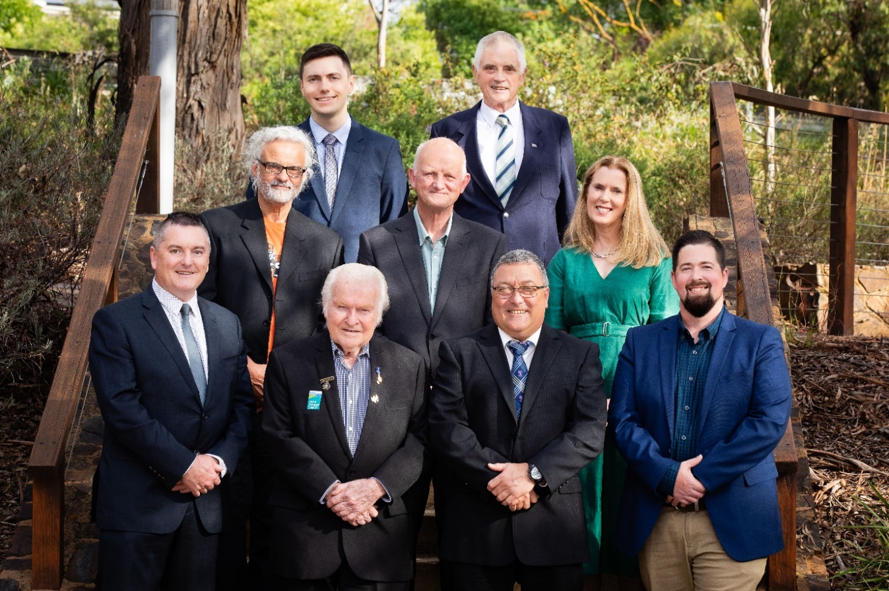
Front row, Cr Jeff Marriott, Cr Len Cox OAM, Deputy Mayor Richard Higgins, Cr Gareth Ward, Second row: Cr Peter Mcilwain, Cr Tim Heenan, Cr Fiona McAllister, Back row: Cr Mitch Mazzarella, Mayor Jim Child
Councillor contact details are available at: https://www.yarraranges.vic.gov.au

The role of Council
The role of Council is to provide good governance for the benefit of current and future communities. Council provides a range of services and manages community assets that people use every day.
Council undertakes a range of roles and functions to serve local communities. It is important for Council to work together with other levels of government, industry partners and communities to achieve the best outcomes.
The roles Council performs are listed below. These definitions are used within this Plan and other Council documents.

 |  | 
PROVIDER | EDUCATOR | PARTNER
Responsible for delivery of services, programs, infrastructure and support to individuals and groups. | Share information, raise awareness, develop knowledge and skills to empower individuals and groups. | Build relationships and partner with others to enable things to happen and work towards common goals.
 |  | 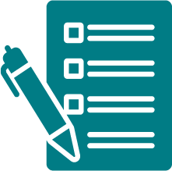
ADVOCATE | PLANNER | REGULATOR
Raise awareness and show leadership for the interests of local communities, to other decision makers e.g. State and Federal Government. | Use evidence, including community views to plan for current and future community needs and priorities. | Prioritise safety and regulate compliance of activities through local laws and legislation

Our commitment
To achieve our Community Vision and best serve our communities, Council is committed to being:

- Future-focused – anticipating challenges and opportunities, demonstrating continued leadership to build resilience, climate adaptation and make decisions that benefit us now and generations in the future.
- Responsive – meaningfully engaging, listening and addressing community needs in a timely and appropriate manner.
- Fair – ensuring equitable access to services, resources and opportunities across our diverse communities.
- Transparent – being open, inclusive and accountable in our decision-making processes.
- Efficient – making the most impact with our resources, minimising waste and delivering quality cost-effective services.
Our commitment to excellence drives us to be an organisation dedicated to achieving our community vision and serving our communities in the best way possible.
We are focused on ensuring every action and decision we take is responsible, transparent and efficient - maximising impact while delivering strong value for money. With a future-focused mindset, we continuously seek smarter, fairer and more sustainable ways to serve our community, ensuring our resources are positioned to meet both current and future needs.
Council will track and report on progress against these principles each year, using the indicators on page 35 to ensure we remain accountable to our residents.

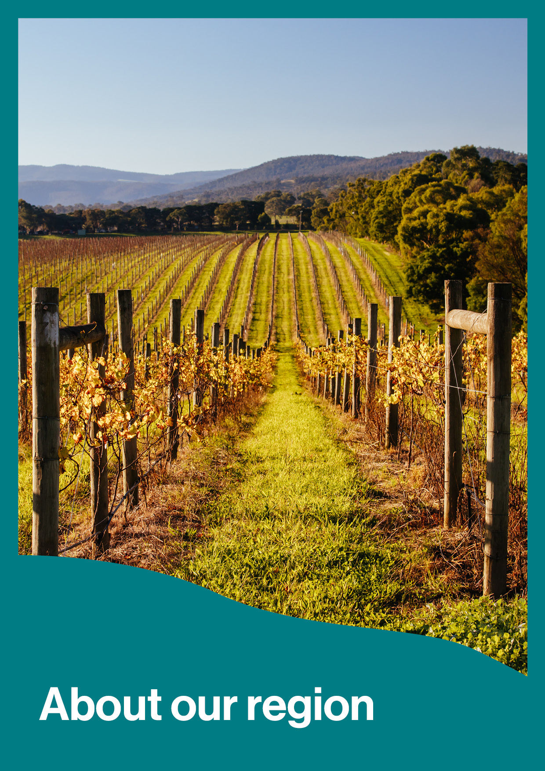
About our region

Snapshot of Yarra Ranges
Region  Located in Melbourne’s outer eastern suburbs, our region is a prized place to live and visit. It features urban areas, 55 townships, productive agricultural land and some of the most environmentally important areas in Victoria. | Community  The residents of Yarra Ranges are highly involved in community life, volunteering and carer roles, enjoy low crime rates and experience good health among mothers, infants, and older residents.
- Land area approx. 2,500 km2  - Largest local government area in Melbourne  - Two percent is Council land, 30 percent is in private ownership, and 68 percent is Crown land  - Yarra Ranges Council encompasses over 51 percent of the Birrarung (Yarra River) catchment area  - Second highest tree canopy in Australia  Emerging trends  - Visitors to the region are expected to double to over 9 million per year in the next decade. | - Over 165,000 residents  - 1,713 Indigenous residents  - 16.8 percent born overseas  - 17.2 percent of the population are aged over 65  Emerging trends  - Over 185,000 residents by 2041  - 19.8 percent of the population aged over 65 by 2034
Housing  Households in Yarra Ranges live in a mix of low – medium density housing that is dispersed across the area’s rural and urban areas, and townships. | Economy  Yarra Ranges has a diverse economy, with manufacturing as the leading sector. Other important sectors include tourism, construction, property and business services, retail trade, and agriculture.
- 70 percent of the population live in the urban areas of Yarra Ranges  - $840,000 median house price (Dec 2023)  - 61,480 dwellings  Emerging trends  - 10,700 new dwellings and greater housing diversity needed by 2040 | - 13,991 local businesses  - 55,544 local jobs  - $7.58 billion Gross Regional Profit (Est)  - $1.2 billion visitor expenditure  Emerging trends  - 9.1 billion Gross Regional Profit estimated by 2032  - 57, 323 local jobs estimated by 2032

Our unique places
As the largest local government area in metropolitan Melbourne, Yarra Ranges is unique. Our region features diverse landscapes and communities, spanning from urban areas and commercial centres, townships, agricultural areas, forested valleys, hills and waterways, including the Yarra/Birrarung River.
Ensuring equitable distribution of our services and support across our municipality has been core to the development of this Council Plan, as has anticipating some of the opportunities and challenges for our communities in the future.
The map of Yarra Ranges below (Figure 1) shows four regions that highlight the different characteristics of our large and diverse municipality.

Figure 1. Map of Yarra Ranges
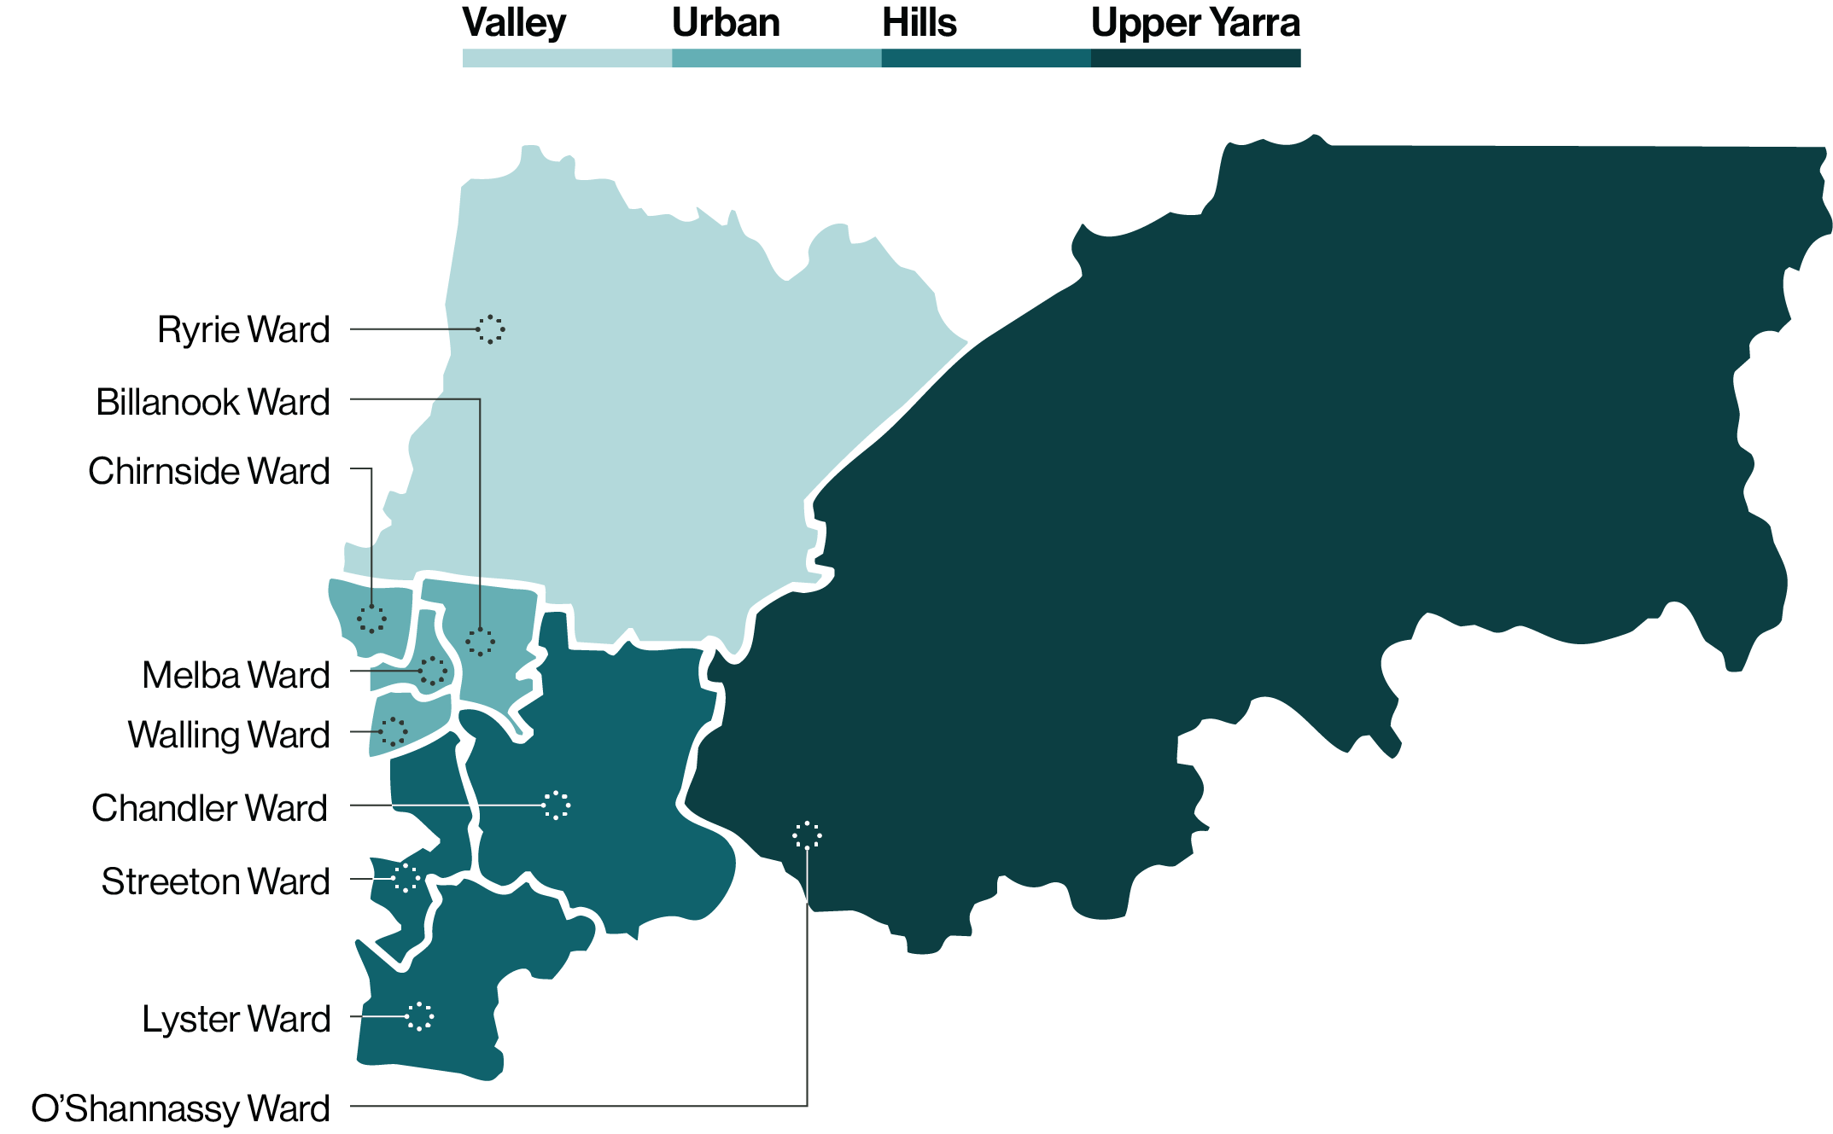

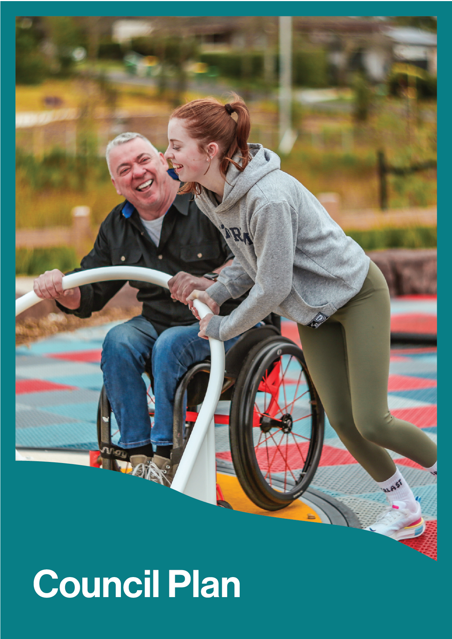
Council Plan

Overview of Council Plan
The Council Plan 2025-29 (the Plan) is Council’s overarching strategic plan and outlines what Council will achieve over the next four years. It identifies where efforts will be focused and how progress will be measured as we work towards our community vision.
The Plan contains the following features:
Community Vision 2036 |  | The Community Vision describes the aspirations for the long-term future of our municipality. It shapes the strategic direction and priorities of this plan. Through this plan, and all strategies, initiatives, and services, Council works diligently to deliver the Community Vision.
Strategic Objectives |  | The four strategic objectives are aligned to the Community Vision and describe the future Council is working towards.  All the activities completed by Council, including those in this Plan, contribute to one or more of these strategic objectives.  The Plan and Action Plan are presented under these four Strategic Objectives and detail the priorities, strategies, services and initiatives that Council will deliver to achieve these outcomes.  Each strategic objective has the following:
 | Healthy Connected Communities
 | Protected and Enhanced Natural Environment
 | Quality Infrastructure and Liveable Places
 | Prosperous Community and Vibrant Economy
Priority Areas |  | Topics that we will focus on over the next four years
Council Strategies |  | Lead and Supporting Strategies Council will deliver
Council Services |  | Services Council will deliver
Initiatives |  | The high priority projects Council will deliver over the next four years
Indicators |  | The indicators provide clear targets across the four strategic objectives and our commitment
Action Plan |  | The annual Action Plan details what Council will do to deliver the 16 initiatives each year. Presented under each of the four Strategic Objectives it provides greater detail on each initiative, including key milestones

Our Strategic Direction
To support achievement of the Community Vision, this Council Plan is centred on four strategic objectives. These objectives have been developed in response to our communities’ priorities and the challenges facing Council. These objectives provide the strategic direction for all Council services, strategies and workplans.

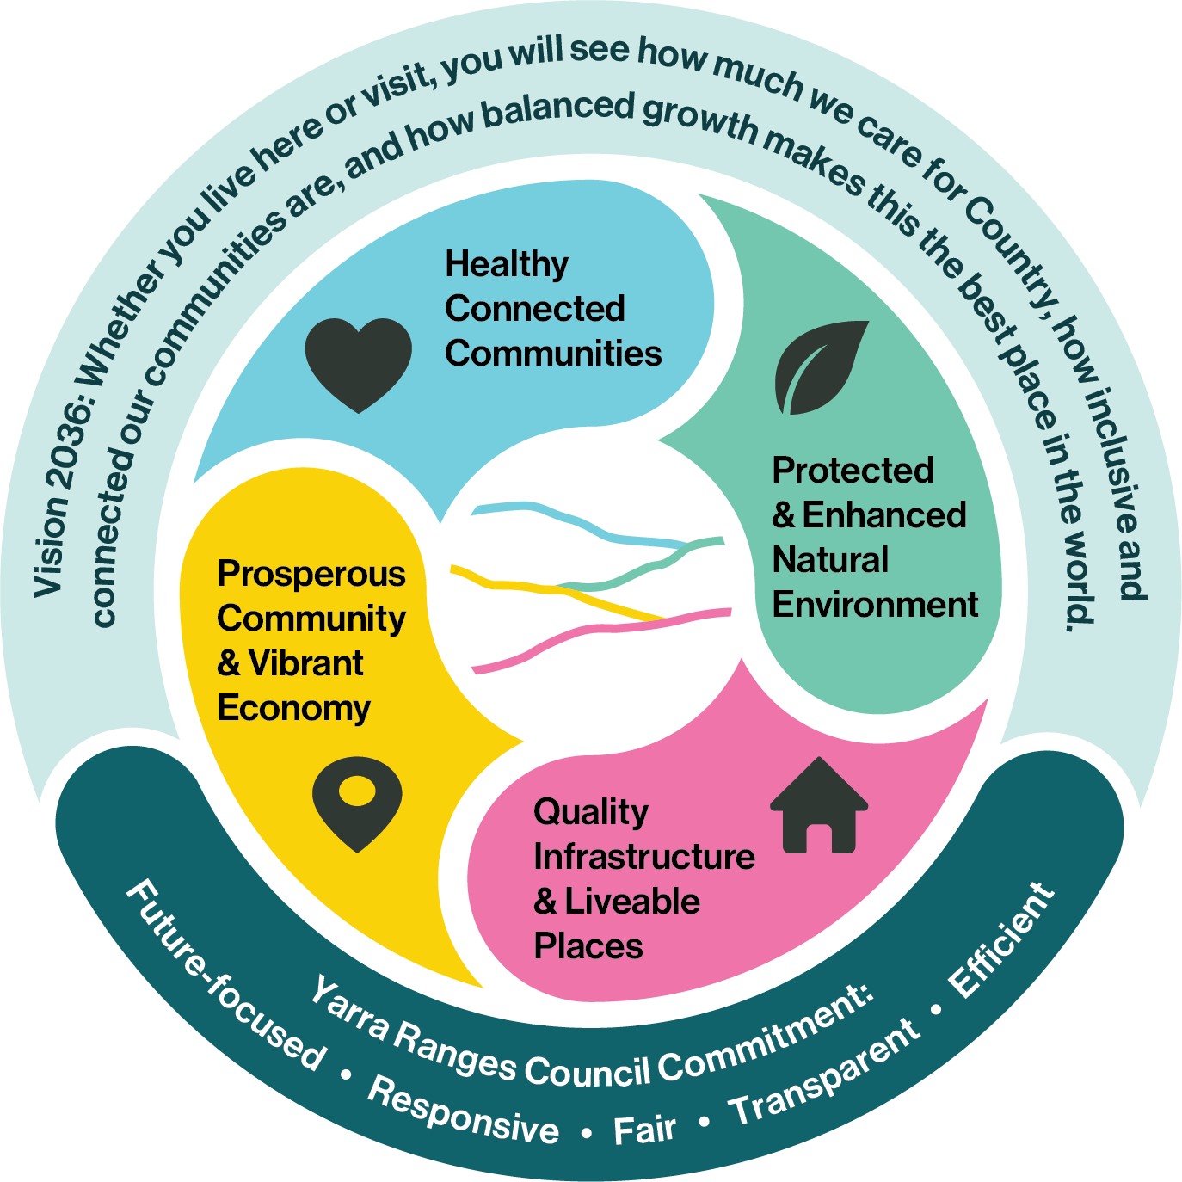
Figure 2: Council Plan roadmap

Our commitment to excellence drives us to be an organisation dedicated to achieving our community vision. We are focused on ensuring every action and decision is informed by this commitment and serves our communities in the best way possible.
This plan, delivered over 4 years, will move us toward the Community Vision for Yarra Ranges.

Yarra Ranges Community Vision 2036
Whether you live here or visit, you will see how much we care for Country, how inclusive and connected our communities are, and how balanced growth makes this the best place in the world.
In 2036 Yarra Ranges is a wonderful place to live, and a world-class destination for visitors and investors who make a significant contribution to prosperity within the region.
Community members are proud of where they live. Our values are respected, we feel connected, and our health and wellbeing is a priority.
The municipality’s natural beauty, stunning landscapes and reputation for exceptional local produce is enhanced and have a significant influence on decisions made regarding sustainable growth, and development in the region. A focus on responsible eco-tourism projects, access to digital services, networks and infrastructure and balanced economic development has enhanced the region’s reputation and improved quality of life for all.
The look and feel of our residential, commercial and industrial areas, and their environmental characteristics, has improved. Our roads, paths, facilities and other infrastructure are well maintained. Our townships are welcoming and designed to improve liveability and support health and wellbeing through improved footpaths, trails, lighting and infrastructure.
Advocacy for innovative and state of the art transport solutions has improved access to important community services, new and upgraded facilities, infrastructure and jobs.
‘Gateways’ into Yarra Ranges and other areas throughout the municipality now strengthen the identity of our First Nations people, their culture, stories, history and progress towards Reconciliation. This connection strengthens our collective identity, our culture and heritage and creates a sense of belonging for our diverse community.
Educational facilities build the skills of our people and develop our leaders to strengthen all communities and support local employment. Community is passionate about where we live. We contribute our time, volunteering to support people in need and use our voices to provide feedback to Council on issues that affect us.
A local planning approach enhances the strength and sense of place of local communities, recognising their diversity and different needs to support our health, safety and wellbeing while also embracing the commonalities we share in calling Yarra Ranges home.
Yarra Ranges is known for prioritising sustainability, careful land management and the protection of biodiversity and habitat. Regenerative farming practices are used to protect precious agricultural land that offers our community access to healthy, locally grown food. Our community has taken steps to actively mitigate against climate change and to be prepared for natural disasters, including bushfire planning.
Services are accessible, gender equitable and inclusive, catering to all ages, genders cultures, and abilities. Our community is healthy and active, with easy access to recreational facilities and cultural activities and are available to everyone. Residents experiencing disadvantage are well supported through partnerships between government, business and community organisations.
At the heart of the Community Vision is an authentic desire for Council to engage and listen to all members of our community, including our young people, and respond to their needs and aspirations. Our Council are visible, transparent, accountable and communicate clearly and honestly.
Council resources are managed responsibly, and principles of fairness and consistency are applied to avoid unnecessary burdens for rate payers. Through expertise, insight, technology and creativity, Council is a leader in striving for excellence and delivering best practice services for the community
We work together to create a better future.

This Community Vision was developed with the Yarra Ranges community and describes their aspirations for the future of our municipality in 2036. Originally created in 2016, it is based on the priorities of more than 1000 members of our community. It was checked with community in 2021 and again in 2024. It continues to reflect the community’s future aspirations for the municipality.

Our challenges
This Plan has been shaped by several complex challenges identified by our local communities and Council. Some of the key issues include:
Growth and development
Both residential population and visitor numbers are predicted to significantly increase. This brings both opportunities and increased pressure on workforce, jobs, housing, infrastructure, resources and services. Balancing growth with township character, liveability, biodiversity and sustainability will be an ongoing challenge.
Extreme weather and changing climate
Extreme weather events, including floods, storms, heatwaves and bushfires, are increasingly impacting our communities. These climate related challenges require Council to continue providing leadership in mitigating climate change and adapting to its effect. Council recognises its role in achieving net zero emissions across the region.
Staying healthy and safe
It is important for Council to proactively plan for different life stages including those of seniors, young people and children. This involves developing inclusive, safe, age friendly places and providing accessible services and support that enable residents to be active, connected, and supported.
Political context
Council will continue to be impacted by the changes in the political and policy context of State and Federal Government. Council must adapt to changes in relevant budgets, legislation and regulations. We will continue to provide opportunities for local civic participation and strive to provide greater transparency, information and meaningful engagement in decision making.
Efficient and effective services
Council recognises our community is facing increasing need to provide maximum value for residents. State government cost shifting, escalated material costs and reduced grants puts pressure on the sustainability of Council services. We continue to explore ways to increase efficiencies through cost reduction and raise revenue. This includes collaboration for share services with the Eastern Regional Group of Councils (ERG).

Our community told us
This Council Plan was developed through extensive community engagement, Councillor and staff workshops over fifteen months. Our communities’ priorities have informed this plan. For detailed information on the community engagement process, please visit: https://shaping.yarraranges.vic.gov.au

Key priorities include
Keeping community informed and engaged | Transparency and good governance were emphasised, with the community feedback indicating a need for better communication (including non-digital) about Council activities and decisions, and meaningful community engagement.  The findings show that information should be easily accessible and indicate a need for stronger relationships between Council and the community.
Looking after the natural environment | Environmental stewardship emerged as another crucial priority, with the community feedback supporting climate action initiatives, energy-efficient facilities, and sustainable tourism practices.  The community feedback highlights strong interest in the value and preservation of local bushland and green spaces, as well as embracing sustainable technologies like micro-grids and solar power.
Looking after our roads, local area & townships | The community feedback indicates a desire for clean, well-maintained local areas. Roads, drains, housing, and transport accessibility were emphasised as key to improving daily life now and into the future.  There is significant support for preserving local character while addressing development pressures.
Impact of extreme weather | The community feedback shows a desire to feel prepared for extreme weather events. Building community resilience against extreme weather, changing climate, and emergencies was emphasised.  This included planning, maintaining, and advocating for infrastructure that strengthens the community's ability to handle and recover from severe weather conditions.
Supporting the local economy | The community feedback highlighted the benefits of local tourism, as well as the challenges of being a popular tourist destination.  The findings show that tourism should benefit the local economy and create job opportunities without straining infrastructure and the environment. Residents are keen to support local traders and access goods from local food producers.
Include everyone in community life | Community inclusion was identified as vital, with calls for support and inclusion across all life stages.  Key community priorities included housing affordability and homelessness, and improving access to safe spaces, health, education, and childcare services.
Planning for the future | Financial responsibility was also highlighted, with calls for prudent spending, strategic asset management, and exploring alternative revenue sources.  There is strong interest in Council planning beyond electoral cycles to address challenges and the long-term sustainability of the region.

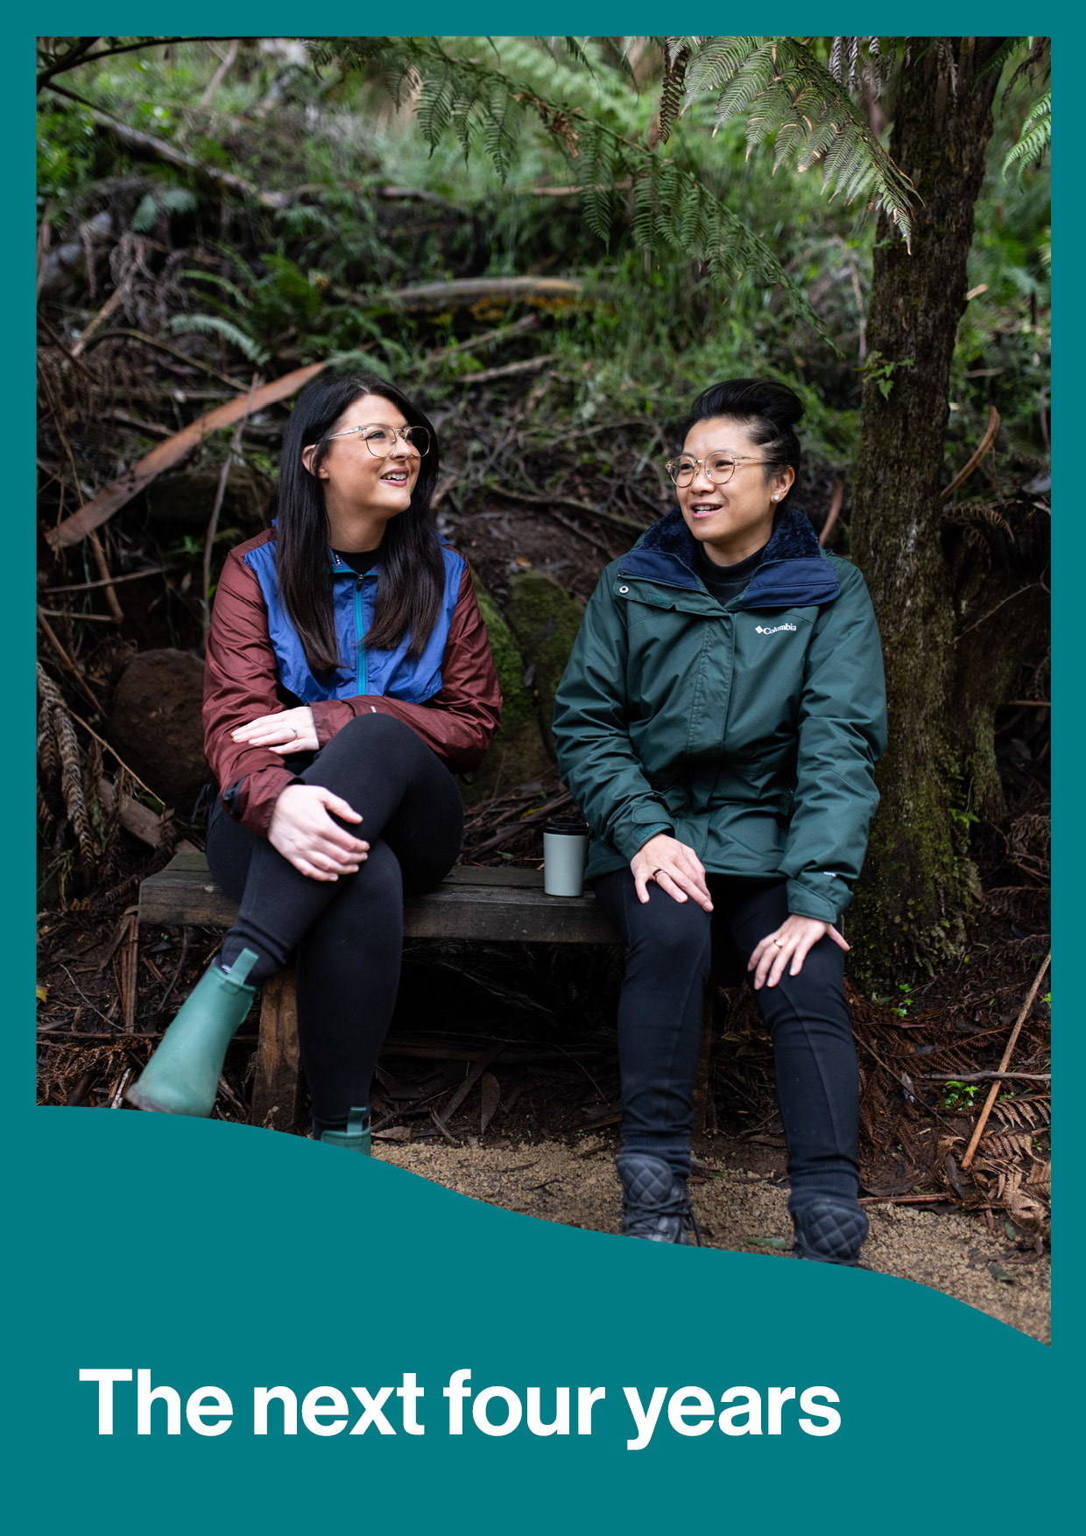

supported by priority areas, council strategies, services, and high-priority initiatives. that address key challenges and opportunities identified through community consultation. The annual Action Plan provides detailed steps and milestones to ensure we achieve these outcomes,

The next four years

This Plan and Action Plan take into account the unique features of our municipality, the people that live here, the challenges we face and what our community have told us.

This section (page 24-34) details how Council is responding under each strategic objective. It details the priorities, initiatives, strategies and services that Council will deliver to respond to these local challenges and opportunities.

The annual Action Plan (page 43) provides detail on each initiative, including key milestones to ensure we achieve the desired outcome.

The indicators (page 35) provide clear targets across the four strategic objectives and our commitment in this Plan and are used to measure progress.

Strategic Objective:
Healthy Connected Communities
This objective focuses on fostering communities that are safe, resilient, healthy, inclusive and socially connected with quality services accessible to everyone.
To achieve this, the following four priority areas have been identified: connected and resilient; inclusive and safe; healthy through life stages and access to local services. Council will regularly share how Yarra Ranges is progressing in these priority areas, using the indicators on page 35 to monitor change in our communities over the long term.

Initiatives
Over the next four years Council will deliver the following big initiatives to support healthy and connected communities. For more detail on each initiative please see the action plan on page 43.
Initiative |  | Council’s role
1 | Place-based approach to achieve local priorities  Work with local communities to identify and coordinate place planning to create town centre plans for services and infrastructure that address local priorities. | Partner
2 | Work with partners to advocate for local priorities  Collaborate with partners, including the Eastern Region Council Group, to advocate for and advance shared priorities. | Advocate
3 | Deliver and enhance multi-use Community Pavilions across the municipality  Deliver the Don Rd Healesville and Seville Community Pavilions and program of upgrades for existing pavilions to be fit-for-purpose, future proof, and designed to meet the needs of people of all genders, ages, abilities, and diverse backgrounds. | Provider
4 | Planning for an urban aquatic and leisure facility  Progress planning for an aquatic and leisure facility within the urban area. | Planner

Council Strategies
Over the next four years, Council will implement, lead and support strategies that will support our healthy and connected communities. This includes:

Lead strategy
Health and Wellbeing Strategy 2025-2029
that will:
- Create inclusive and accessible local opportunities for children, young people and families to have a say and get involved in shaping their community and Council services.
- Design and maintain parks, play spaces, and outdoor exercise equipment that encourage all ages and abilities to participate.
- Facilitate learn to ride programs to encourage the uptake of cycling as an accessible physical activity.
- Embed equity, safety and accessibility into Council spaces, services and culture.

Support strategies
- Innovate Reconciliation Action Plan 2024-2026
- Disability Action Plan 2025-2029
- Creative Communities Strategy
- Municipal Emergency Management Plan
- Aquatic and Leisure Strategy 2022-2033
- Domestic Animal Management Plan
- Key Life Stages Plan (in development)

Council Services
Council delivers a range of services to the community that contribute to healthy and connected communities. This includes:

Community safety
- Emergency Management
- Local Laws and Regulatory Compliance
- Animal Management
- School Crossings

Community wellbeing
- Social Infrastructure Planning
- Community Strengthening
- Arts, Culture and Heritage
- Indigenous Development

Community services
- Early and Middle Years Services
- Maternal and Child Health
- Youth Development
- Healthy Active Ageing

Health services
- Public and Environmental Health
- Immunisation
- Public Health and Wellbeing

Strategic Objective:
Protected and Enhanced Natural Environment
This objective focuses on caring for Country together and ensuring the environment is healthier for future generations.
To achieve this, the following four priority areas have been identified: local biodiversity; energy, climate, disaster and resilience; water management and circular economy. Council will regularly share how Yarra Ranges is progressing in these priority areas using the indicators on page 35 to monitor change in our communities over the long term.

Initiatives
Over the next four years Council will deliver the following exciting initiatives that will protect and enhance natural environments. For more detail on each initiative please see the action plan on page 43.
Initiative |  | Council’s role
5 | Enhance energy and infrastructure resilience for Council and communities before, during and after extreme weather events  Enabling Council and community to achieve sustainable infrastructure design by enhancing infrastructure resilience and energy efficiency, thereby reducing climate and weather-related impacts. | Partner
6 | Increase and protect biodiversity links and canopy connections  Increase and protect connected natural landscapes and healthy waterways for local biodiversity, and cooling affect. | Provider
7 | Use nature-based solutions to increase resilience of natural landscape in a changing climate  Partner with Traditional Owners and utilise solutions for the changing climate that work with nature, reducing impact of natural hazards (e.g. storms, flooding and fire). | Partner
8 | Provide leadership in achieving net zero emissions and developing a resilient local energy supply  Deliver climate programs that strengthen community’s climate adaptation and resilience to climate impacts. Support the transition to a net zero future, by increasing the use of renewable energy, improving energy efficiency, and promoting sustainable practices in local businesses and homes. | Deliver

Council Strategies
Over the next four years, Council will implement, lead and support strategies that will protect and enhance natural environments. This includes:

Lead strategy
Environment Strategy will ensure:
- Our water resource is improved and preserved.
- Our native plants and animals are protected, and their habitat is enhanced.
- Our communities are resilient in the face of a changing climate and more extreme events.
- All who live and work in the Yarra Ranges see themselves as stewards of our environment.
- Our local communities are strengthened by environmentally sustainable activities and circular economy.
- Reduce Council’s energy consumption in line with Council’s Liveable Climate Plan and support the community to reduce theirs.

Support strategies
- Nature Plan 2024-2034
- Liveable Climate Plan 2030
- Community Waste and Resource Recovery Plan 2023-2030
- Integrated Water Management Plan
- Energy Transition Plan
- Tree Canopy Strategy 2024-2044
- Burndap Birrarung Burndap Umarkoo (Yarra Strategic Plan) 2022-2032

Council Services
Council delivers a range of services to the community that ensure we protect and enhance natural environments. This includes:

Nature enhancement
- Land management
- Planting Programs
- Biodiversity

Liveable climate
- Climate adaptation
- Energy and emission management
- Resource recovery
- Landfill management

Healthy resilient waterways
- Stormwater Management
- Water management
- Waterway biodiversity

Strategic Objective:
Quality Infrastructure and Liveable Places
This objective focuses on facilities and infrastructure that meet current and future needs, and places that are well planned hubs of activity that foster wellbeing and innovation.
To achieve this, the following four priority areas have been identified: roads and drainage; paths, trails and green open space; clean and well-planned townships and urban areas and fit-for-purpose assets and facilities. Council will regularly share how Yarra Ranges is progressing in these priority areas using the indicators on page 35 to monitor change in our communities over the long term.

Initiatives
Over the next four years Council will deliver the following exciting initiatives to ensure quality infrastructure and liveable places. For more detail on each initiative please see the action plan on page 43.
Initiative |  | Council’s role
9 | Reduce stormwater and flood risks  Proactively manage stormwater to safeguard our community, promote sustainable development practices and preserve natural ecosystems. | Provider
10 | Activate Ridges and Rivers  Deliver funded stages and operating models of ngurrak-barring/Ridge Walk, Yarra Valley Trail and Warburton Mountain Bike Park while continuing to advocate for future funding. | Provider
11 | Facilitate diverse housing options  Work with partners and industry to increase opportunities for diverse housing around transport hubs, employment centres and key services. | Partner
12 | Improve safety and maintenance of local roads  Plan and deliver road maintenance in accordance with local priorities and advocate for further funding opportunities. | Provider

Council Strategies
Over the next four years, Council will implement, lead and support strategies that ensure quality infrastructure and liveable places. This includes:

Lead strategy
Yarra Ranges Planning Scheme will be amended and updated with the introduction of the following actions:
- Place Plans, Structure Plans, Township Design Frameworks and Masterplans will all result in changes to the Planning Scheme - Initiative 1: Place-based approach to achieve local priorities
- Implementation of the Stormwater Management Plan will result in changes to the planning scheme through new flood mapping (see Initiative 10 Reduce storm water and flooding risk)
- Introducing the Housing Strategy into the Planning Scheme (see Initiative 12 Facilitate diverse housing options)
- New Green Wedge Management Plan – will result in changes to the planning scheme (see Initiative 17)

Support strategies
- Strategic Asset Plan
- Housing Strategy
- Aquatics Strategy
- Integrated Transport Strategy
- Open Space Strategy
- Stormwater Management Plan
- Paths and Trails Plan
- Play Space Plan
- Structure Plans
- Township Design Frameworks

Council Services
Council delivers a range of services to the community that contribute to quality infrastructure and liveable places. This includes:

Placemaking
- Building services
- Place planning and design
- Statutory Planning
- Strategic Projects

Roads and transport
- Local roads
- Footpaths
- Carparks
- Public Lighting
- Traffic Management

Recreation and sporting
- Sports fields
- Aquatics
- Trails
- Pavilions and Club Houses
- Recreation facilities

Community facilities
- Cultural venues and Community halls
- Libraries
- Property and leasing

Parks and open space
- Townships
- Play spaces
- Parks
- Buildings
- Open spaces
- Tree management

Strategic Objective:
Prosperous Community and Vibrant Economy
This objective focuses on fostering an economy, tourism sector and industries that actively support our communities, and investment attraction that underpins sustainable economic wellbeing and local job creation.
To achieve this, the following four priority areas have been identified; local industry and producers; local business; balanced tourism and local jobs. Council will regularly share how Yarra Ranges is progressing in these priority areas using the indicators on page 35 to monitor change in our communities over the long term.

Initiatives
Over the next four years Council will deliver the following exciting initiatives to ensure a prosperous community and vibrant economy. For more detail on each initiative please see the action plan on page 43.
Initiative |  | Council’s role
13 | Enhance local amenity and walkability  Continue improving and maintaining the look, feel and walkability of townships and local areas in collaboration with communities. | Provider
14 | Strengthen tourism destination management across the region  Collaborate across the new Visitor Economy Partnership and local communities to cohesively manage the impact of new and existing tourism assets on established communities and infrastructure. | Partner
15 | Support local Agri-Food Futures Centre of Excellence and Innovation  Work with industry, education, Traditional Owners, community and government partners to establish an industry hub and centre of excellence. | Planner
16 | Develop a new Green Wedge Management Plan  Develop a new, contemporary Green Wedge Management Plan that addresses emerging agricultural practices and industry needs related to land use. | Planner

Council Strategies
Over the next four years, Council will implement, lead and support strategies, that will ensure a prosperous community and vibrant economy. This includes:

Lead strategy
Economic Development Strategy 2022-2032 will deliver
- Support more local employment opportunities
- Support business development, innovation and resilience
- Attraction and facilitation of appropriate investment into the region
- Tourism destination management

Support strategies
- Destination Management Plan
- Investment Attraction Plan
- Green Wedge Management Plan

Council Services
Council delivers a range of services to the community that contribute to a prosperous community and vibrant economy. This includes:

Economic development
- Business and Industry support
- Investment attraction
- Tourism destination management

Measuring success
The following table outlines the twenty indicators that Yarra Ranges Council uses to measure progress towards our Community Vision. These indicators provide clear targets across the four strategic objectives and our commitment in this Plan. All of Council’s services, strategies and initiatives collectively work towards the community vision and deliver on the strategic objectives, which are monitored through these indicators.
Table 1: Council Plan Indicators
Strategic Objective | Indicators |  | Target
Healthy Connected Communities | a. | Access to services and facilities |  | Residents rate their experience of local high-quality health services at 6.5 or above out of 10.
Healthy Connected Communities | b. | Sense of community |  | Maintain the level of residents who volunteer at 15.5 percent or above.  Residents rate their experience of a strong sense of community in their local area at 6.5 or above out of 10.
Healthy Connected Communities | c. | Feeling secure |  | Residents rate their personal financial circumstances at 6 or above out of 10.  Residents rate their experience of feeling safe in their local area at 7 or above out of 10.
Healthy Connected Communities | d. | Mental health & wellbeing |  | Reduced level of residents (all ages) with at least one long-term health condition.  Residents rate their physical wellbeing, mental wellbeing and social wellbeing at 7 or above out of 10.
Protected and Enhanced Natural Environment | e. | Biodiversity protection & enhancement |  | Restoration and revegetation work achieves a 50% increase by 2028.  At least 200 land stewards improve the biodiversity on their land each year.
Protected and Enhanced Natural Environment | f. | Council greenhouse gas emissions |  | Reduce greenhouse gas emissions by 60% on 2005 levels by 2025 (6,400 tCO2e or lower).  Net zero emissions by 2040.
Protected and Enhanced Natural Environment | g. | Prepared for weather events |  | Increased confidence of residents in their local area’s ability to adapt to the effects of climate change.  Maintain or increase community satisfaction with Council’s emergency preparedness.
Protected and Enhanced Natural Environment | h. | Waste diversion |  | Divert 90% of waste from landfill by 2030.  Cut the volume of organic material going to landfill by 60% by 2030.
Quality Infrastructure  and Liveable Places | i. | Roads and drainage |  | Reduced levels of Stormwater discharge and gross pollutants.  Maintain average rating of 43.5 or above, for condition of local roads and footpaths.
Quality Infrastructure  and Liveable Places | j. | Diversity of housing supply |  | Meet the Victorian housing target of an additional 25,000 new homes in Yarra Ranges by 2051.  Increased proportion of medium density and 1–2-bedroom housing as part of the total housing mix.
Quality Infrastructure  and Liveable Places | k. | Community facilities usage and demand |  | Increase in occupancy rates of facilities by local community.
Quality Infrastructure  and Liveable Places | l. | Access to open space and walkability |  | One- and five-kilometre walking circuits in all 55 townships, by 2036.  Increased walkability score of townships.
Prosperous Communities  and Vibrant Economy | m. | Local employment |  | Number of local jobs increased to 57,323, and 50 percent of local jobs filled by local people, by 2032.
Prosperous Communities  and Vibrant Economy | n. | Diversity of local economy |  | Employment in local industries with comparative competitive advantage increased by 2032.
Prosperous Communities  and Vibrant Economy | o. | Overnight stay tourism |  | Percentage of overnight stays increased in line with the regional target of 18 percent, by 2032.
Prosperous Communities  and Vibrant Economy | p | Business Friendly Council |  | Increased satisfaction with Council's business concierge program among small businesses by 2029.
Council’s Commitment | q. | Community decisions |  | Community satisfaction with Council decision making increased to 50 or above, by 2029.
Council’s Commitment | r. | Value for money |  | Community perception of value for money increased to 45 or above, by 2029.
Council’s Commitment | s. | Customer satisfaction |  | Increase percentage of customer interactions that customers rate positively in timeliness and helpfulness.
Council’s Commitment | t. | Consultation and engagement |  | Increase community satisfaction with Council's consultation and engagement to at least 50 by 2029.

Tracking community outcomes and regularly reporting on these indicators, contributes to responsive, effective and transparent governance. This approach ensures Council’s actions actively contribute to our community’s long-term vision for the future.
We recognise that Council’s work generates positive outcomes beyond these twenty indicators, that also all contribute to the Community Vision.
Changes in the indicators are influenced by the actions of the Council, other stakeholders, and environmental factors. While we cannot always attribute specific changes to the individual efforts of a single stakeholder, monitoring and sharing these outcomes
- keeps stakeholders informed about community progress
- guides future planning with evidence-based insights and
- strengthens collaborative efforts to achieve the Community Vision.
In addition to annual indicator reporting, Council publishes a detailed annual report which includes:
- progress updates on the 16 initiatives in this Plan, measured against the action plan milestones
- performance of essential Council services using the Local Government Performance Reporting Framework
Plus, dedicated annual progress reports for each lead strategy are prepared for Council review. and Gender Impact Assessments will be undertaken for all initiatives with direct and significant community impact to support inclusive and equitable outcomes.

Planning Framework
The figure below illustrates how Council’s various plans and strategies are integrated.
All of Council’s planning and decision-making are guided by the community’s aspirations for the future. Council’s annual, medium, and long-term plans advance the Community Vision and deliver on the strategic directions and indicators outlined in this plan.
They are all informed by evidence, State and Federal legislation and policy, community engagement, and a commitment to continuous improvement. Collectively, they provide clear direction and accountability, reflecting Council’s financial and resource capacity.

Figure 1: Planning Framework
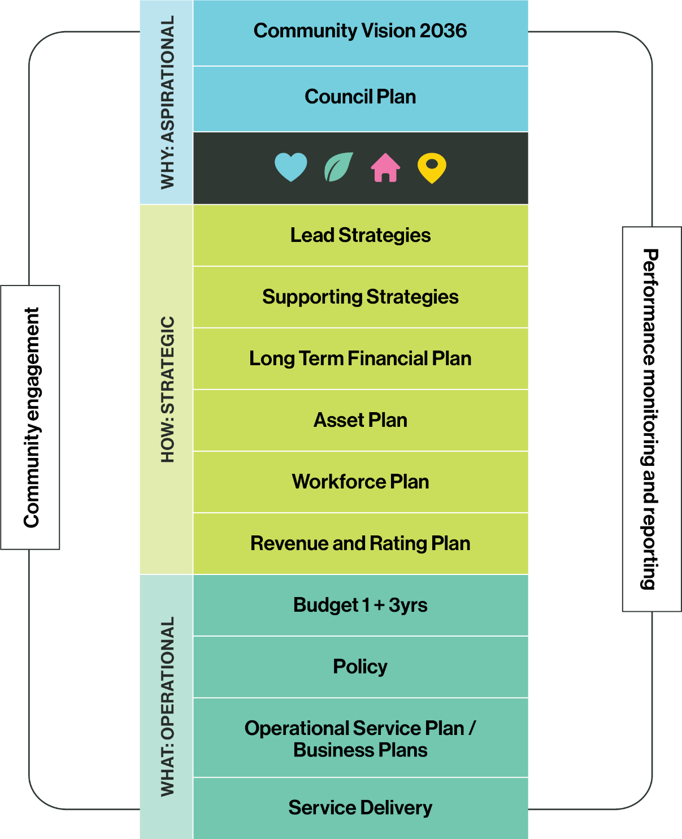

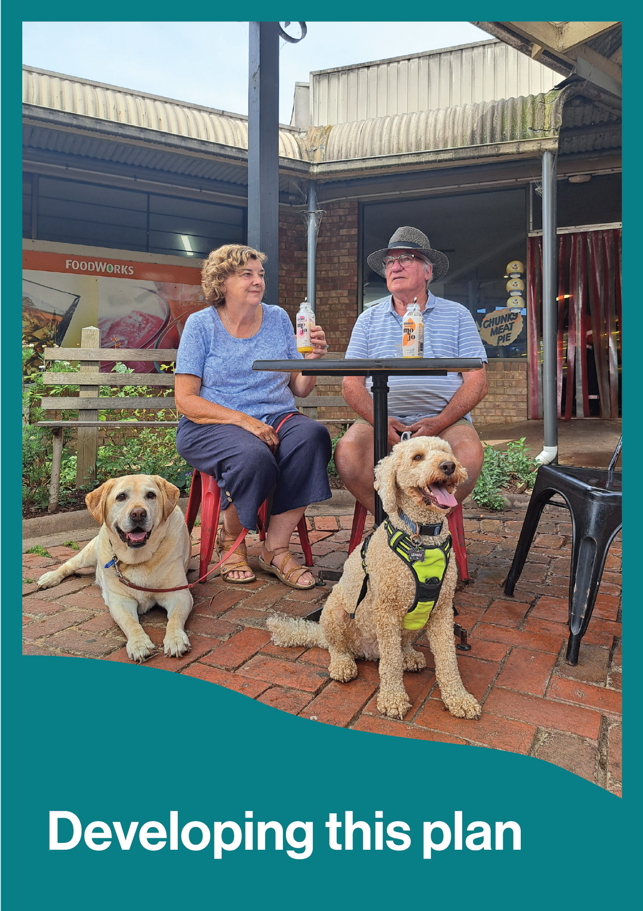
Developing this plan

How this plan was developed

This Council Plan has been developed through a range of data collection techniques and methodologies including broad and deliberative community engagement, input from Councillors, a review of current evidence and grey literature, subject matter insights and learnings from other councils over a 15-month period.

Community engagement data  A range of community engagement activities gathered diverse perspectives and priorities, including:  - Broad community surveys  - Community summits  - Targeted focus groups  - Deliberative workshops  Eastern Region Councils and other Councils  - Peer review and collaboration for best practice and regional perspective.  Evidence and grey literature  A review of current evidence, grey literature, subject matter insights including:  - Yarra Ranges Health Profile  - Profile id  - Voice of customer data  - Local Government Community Satisfaction Survey  - Human Services Needs Analysis  - Background papers, reports and strategies •  - Gender Impact Assessment in line with Gender Equality Act 2020 | Councillor insights and feedback  Councillor involvement throughout the development of the plan ensured alignment with community views and expectations.  - Three interactive Councillor workshops  - (Pending: Council meeting for consideration to adopt Council Plan 2025-2029)

Community Engagement

The Plan was created by actively involving a wide range of community members in thoughtful discussions and consultations. The goal was to gather diverse perspectives and ensure that the plan reflects the community's needs and priorities. Since March 2024 we have received direct feedback from over 1,250 people and reached over 6000 community members in the development of the plan.
This has included:
- 700+ survey responses
- 213 postcards completed
- 9,582 visits to the project’s Shaping Page by 4,435 people
- Nine pop-up events, connecting with 800+ community members
- 135 attendees at three Community and Stakeholder Summits
- Over 400 expressions of interest for the Deliberative Community Panel
- 40 panel members representative of the diverse community, selected by an independent consultant, for the Deliberative Community Panel
- Three workshops to discuss and debate Council priorities and challenges
- 10+ Focus Groups with 20 key population groups
- 50 young people from 6 local secondary schools

For more information on the community engagement that has helped shaped this plan and to view the full Community Engagement Reports please visit: https://shaping.yarraranges.vic.gov.au

Stage 1  March – May 2024 | Broad community engagement  - Survey and postcards  - Pop-up events  - Community and stakeholder summits
Stage 2  July – August 2024 | Deliberative Community Panel  - Open expressions of interest for community panel  - Panel members selected by an independent consultant  - Workshops discussed and debated Council priorities and challenges  - Panel report presented to Councillors
Stage 3  November – March 2025 | Checking in on what we heard  - Reported back findings and key themes  - Focus Groups – Youth groups, Townships groups, members of the Disability Advisory Group, Health and Wellbeing Advisory Committee, Indigenous Advisory Committee, Positive Ageing Reference Group, Rural Advisory Committee, Sustainable Environment Advisory Committee and Youth Advisory Group  - Dedicated Youth Summit  - Focused survey on Place and Priorities for budget
Stage 4  July 2025 | Draft released for community feedback  - Pop up events  - Shaping page  - Community group feedback

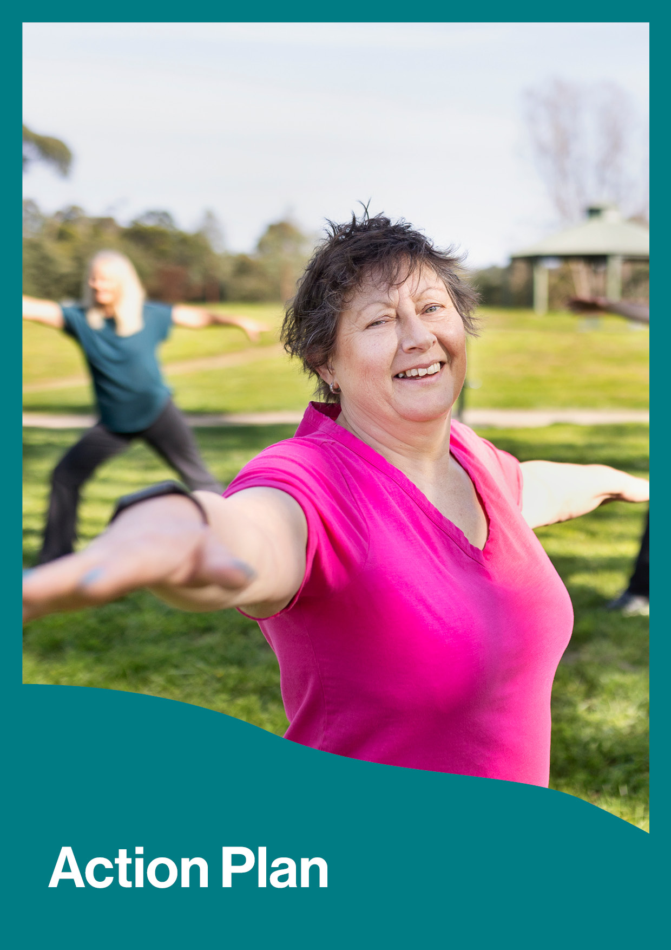
Action Plan

 | Strategic Objective:  Healthy Connected Communities
Initiative  Title and short description |  | Priority Areas | Thinking ahead 10 years’ – what benefits for community and future generations will this bring? | Milestones
 |  | Priority Areas |  | Year 1  (End 30 June 2026) | Year 2  (End 30 June 2027) | Year 3  (End 30 June 2028) | Year 4  (End 30 June 2029)
1 | Place-based approach to achieve local priorities  Work with local communities to identify and coordinate place planning to create town centre plans for services and infrastructure that address local priorities (such as Place Plans, Masterplans, Township Design Frameworks and Structure Plans) | Connection and Resilience | Increased connected communities where local priorities are addressed through tailored solutions. This coordinated and customised design approach recognises each area and community’s (Urban, Upper Yarra, Hills, and Valley) unique character and needs, resulting in more effective services, stronger community ownership, and better use of resources. | Q2: Preparation of three scheduled town centre plans  Q4: Living Places Framework finalised to guide all planning for place | Preparation of up to three scheduled town centre plans | Preparation of up to three scheduled town centre plans | Preparation of up to three scheduled town centre plans
2 | Work with partners to advocate for local priorities  Work with community and council partners to advocate for and progress shared community advocacy priorities. | Connection and Resilience | A stronger collective voice that achieves tangible results for local communities. By working together with partners and key stakeholders, we will secure greater federal and state funding, better infrastructure, services, and quality of life improvements for future generations. | Q2: Prepare Budget submissions and advocacy plans for the following state and federal government Budget cycles, and for the 2026 Victorian election.  Q4: Delivery of a network action plan for collaborative work with Eastern Region Group of Councils, MAV, and other partners. | Advocacy priorities in 2026-27 target the November 2026 Victorian election and its outcomes. | Review and update advocacy, partnerships, and government relations priorities. | Review and update advocacy, partnerships, and government relations priorities.
3 | Deliver and enhance multi-use Community Pavilions across the municipality  Deliver the Don Rd Healesville and Seville Community Pavilions and program of upgrades for existing pavilions to be fit-for-purpose, future proof, and designed to meet the needs of people of all genders, ages, abilities, and diverse backgrounds. | Healthy through Life | Inclusive and accessible spaces that bring people together through sport and community activities and groups. These multipurpose facilities will support increased participation, create volunteer opportunities, deliver environmental sustainability as a key design element, and strengthen community connections for generations. | Q2: Don Rd, Healesville -Schematic Design Complete | Construction Commenced & Building Permit Issued | Construction Completed, (Certificate of practical completion and occupancy permit issued). | Contract Finalised (defects liability complete and final certificate issued)
 |  |  |  | Q4: Permits and Approvals Issued Contract Awarded | Construction Commenced & Building Permit Issued
 |  |  |  | Q2: Seville - Detailed Design Complete & Project Tendered | Construction Progress Update | Construction Completed, (Certificate of practical completion and occupancy permit issued). | Contract Finalised (defects liability complete and final certificate issued)
 |  |  |  | Q4: Construction Commenced & Building Permit Issued | Construction Progress Update
4 | Planning for an urban aquatic and leisure facility  Progress planning for an aquatic and leisure facility within the urban area | Healthy through Life | An aquatic and leisure facility will offer year-round access to swimming, fitness programs, and water safety education, promoting community wellbeing and active lifestyles.  The centre will be a valuable community gathering space that can serve multiple generations, while boosting local economic activity and employment opportunities. | Q2: Shortlist of site locations and facility components established.  Pursue funding models including private sector investment. | Complete business case to confirm best facility mix and complete final investment decision. | Pursue preferred funding arrangements and partnerships | Initiate project delivery - Pending secured funding
 |  |  |  | Q4: Test sites with architectural concepts completed. Finalise preferred locations.  Develop and implement a targeted advocacy campaign to gain funding for development of aquatics and leisure facility. |  | Pursue preferred funding arrangements and partnerships

 | Strategic Objective:  Protected and Enhanced Natural Environment
Initiative  Title and short description |  | Priority Areas | Thinking ahead 10 years’ – what benefits for community and future generations will this bring? | Milestones
 |  | Priority Areas |  | Year 1  (End 30 June 2026) | Year 2  (End 30 June 2027) | Year 3  (End 30 June 2028) | Year 4  (End 30 June 2029)
5 | Enhance energy and infrastructure resilience for Council and communities before, during and after extreme weather events  Enable Council and community to achieve sustainable infrastructure design, increasing infrastructure resilience and energy efficiency to reduce the impact of climate change. | Energy, disaster, and climate resilience | Council and community can access energy and climate resilient infrastructure, which is energy efficient, minimises service disruption, protects vulnerable residents and reduces the overall impact of power outages, heatwaves, storms, floods, and other weather-related events on Council and communities. | Q2: Develop a place-based action plan that informs Council’s capital works pipeline with recommended energy and resilient building, and improvement works. | Implementation of action plan through capital works pipeline. | Implementation of action plan through capital works pipeline. | Implementation of action plan through capital works pipeline.
 |  |  |  | Q4: Environmentally Sustainable Design Policy finalised.
6 | Increase and protect biodiversity links and canopy connections  Through the development of a Biolinks Plan and the implementation of the Tree Strategy we will restore important corridors for biodiversity protection and enhancement across the municipality in partnership with community and agencies, achieving priority actions within the Nature Plan. | Local Biodiversity | A connected natural landscape where native wildlife can thrive and move safely. Expanded tree canopy and healthy waterways will support local biodiversity, cooler neighbourhoods, and ecosystem health. | Q2: Establish Project Governance and commence data and stakeholder mapping. | Draft Biolinks Plan developed. | Biolinks Plan presented to Council. | Biolinks on-ground project delivered.
 |  |  |  | Q4: Natural assets baseline data from Council and multiple agencies collected and collated. | Draft Biolinks Plan developed. | Biolinks Plan presented to Council. | Biolinks on-ground project delivered.
7 | Use nature-based solutions to increase resilience of natural landscape in a changing climate  Utilise solutions for the changing climate, which work with nature, reducing the impact of natural hazards and improve restoration and resilience of natural landscapes including the Birrarung (Yarra River). Solutions include strategic wetland restoration for flood mitigation, strategic vegetation management for fire control, utilising fire as a land management tool and riparian buffers for erosion prevention. | Energy, disaster, and climate resilience | Sustainable nature-based solutions that provide lasting protection from natural hazards, such as floods, fires, drought and erosion while improving biodiversity and water quality including strategic wetland restoration for flood mitigation, strategic vegetation management for fire control, fire as a land management tool and riparian buffers for erosion prevention, helping to achieve key outcomes of Councils Nature Plan and the Yarra Strategic Plan. | Q2: Establishment of cross-organisational working group that will lead a review of current natural assets and identification of new nature-based solution (NBS) opportunities. | Establish a referral pathway through capital pipeline for future NBS. Commence planning of pilot projects to trial NBS approaches, investigating nature repair investment opportunities.  Begin assessing natural asset value such as through ecosystem accounting. | Deliver trial of new NBS and continue to monitor existing.  NBS in place. Investigate future funding, and resourcing needs for expanded NBS initiatives. | Embed use of NBS across Council functions, promoting best practice and highlighting successful examples to the community and industry.
Q4: Funding and investment opportunities explored and NBS and Nature Fund profile raised.
Provide baseline NBS report.
8 | Provide leadership in pursuit of net zero emissions and developing a resilient local energy supply  Deliver programs that strengthen community’s climate adaptation and resilience to climate impacts and support the transition to a low carbon future, by increasing the use of renewable energy, improving energy efficiency, and fostering sustainable practices in local businesses and homes. | Energy, disaster, and climate resilience | Our region is at the forefront of the challenges imposed by climate change, with the social, environmental, and economic impacts already being felt throughout our communities. Local government has an important role to influence change, build community capacity, and demonstrate leadership.  By partnering with communities and empowering residents to actively participate in climate solutions, we can develop practical and sustainable adaptation and net zero strategies tailored to unique community needs. This approach also brings co-benefits, such as better prepared and connected communities, improved climate literacy and more climate conscious behaviours. | Q2: Undertake a gap analysis of climate adaptation and net zero initiatives, including development of Energy Transition Plan, continue roll out of ‘The Adaptation Game’ (TAG), to embed best practice implementation across communities.  Q4: Select pilot community to develop a localised climate adaptation and resilience plan. Build capacity of community led facilitation of engagement and education tools. | Deliver pilot Local Climate Adaptation and Resilience Plan. Evaluate and use learnings to inform further implementation.  Continue implementation of TAG and other engagement and education tools, alongside monitoring of effectiveness. | Implementation in line with Liveable Climate Plan actions, and key actions identified in the Energy Transition Plan.  Continue roll out of programs to support community including the use of TAG and other engagement and education tools. | Implementation in line with Liveable Climate Plan actions, and key actions identified in the Energy Transition Plan.  Continue roll out of programs to support community including the use of TAG and other engagement and education tools.

 | Strategic Objective:  Quality Infrastructure and Liveable Places
Initiative  Title and short description |  | Priority Areas | Thinking ahead 10 years’ – what benefits for community and future generations will this bring? | Milestones
 |  | Priority Areas |  | Year 1  (End 30 June 2026) | Year 2  (End 30 June 2027) | Year 3  (End 30 June 2028) | Year 4  (End 30 June 2029)
9 | Reduce storm water and flooding risk  Proactively manage stormwater to safeguard our community, promote sustainable development practices and preserve natural ecosystems. | Roads and drainage | Protecting public assets and natural waterways from damage while improving water quality through pollutant filtration.  Well-designed stormwater systems can capture water for reuse, helping communities adapt to changing climate conditions, support healthy ecosystems, and maintain essential infrastructure functionality.  Developing and prioritizing infrastructure upgrades will improve flood protection and the reliability of the stormwater management system.  Ensure the long-term sustainability and resilience of the stormwater management system, supporting healthy ecosystems and adapting to changing climate conditions. | Q2: Flood mapping in partnership with Melbourne Water and stakeholders commenced | Deliver program of drainage upgrade works focused on reducing risk to properties.  Development of water sensitive urban guidelines  Investigate alternative funding opportunities | Implement developer & engineering technical guidelines.  Complete flood mapping across the municipality in partnership with Melbourne Water | Completion of flood mapping.  Community consultation and investigate Planning scheme amendment.  Review Stormwater Management Plan
 |  |  |  | Q4: Disseminate community fact sheets in collaboration with the Stormwater Community Reference panel. Review Integrated Water management strategy
10 | Activate Ridges and Rivers  Deliver funded stages and operating models of ngurrak barring | RidgeWalk, Yarra Valley Trail and Warburton Mountain Bike Park, while continuing to advocate for future funding. | Paths, trails, and green open space | Connected trail networks that showcase our beautiful natural landscapes. These trails will encourage active lifestyles, improve physical and mental wellbeing, boost tourism, strengthen environmental connections, and preserve significant landscapes for future generations. | ngurrak barring | ngurrak barring  Operating model and activations. | ngurrak barring  Operating model and activations | ngurrak barring  Operating model and activations
 |  |  |  | Q2: Website, operating model, and activations development | ngurrak barring  Operating model and activations. | ngurrak barring  Operating model and activations | ngurrak barring  Operating model and activations
 |  |  |  | Q4: Advocacy for additional art, installations, activations, and events | ngurrak barring  Operating model and activations. | ngurrak barring  Operating model and activations | ngurrak barring  Operating model and activations
 |  |  |  | Warburton Mountain Bike | Warburton Mountain Bike  Stage 1C 30km’s and Stage 1D completion  Full operating model in function  Stage 2 funding advocacy, approvals development and design progression | Warburton Mountain Bike  Full operating model in function  Stage 2 funding advocacy, approvals development and design progression | Warburton Mountain Bike  Full operating model in function  Stage 2 funding advocacy, approvals development and design progression
 |  |  |  | Q2: Stage 1A works completion.
 |  |  |  | Q4: Stage 1B works completion and Business and operating model commenced.
 |  |  |  | Yarra Valley Trail | Yarra Valley Trail  Stage 2A (Yarra Glen to Tarrawarra) construction completion  Stage 1C (Yarra River to Yarra Glen), 2B (Tarrawarra to Healesville) and Stage 3 (Healesville to Woori Yallock) planning and funding advocacy | Yarra Valley Trail  Stage 1C (Yarra River to Yarra Glen), 2B (Tarrawarra to Healesville) and Stage 3 (Healesville to Woori Yallock) planning and funding advocacy | Yarra Valley Trail  Stage 1C (Yarra River to Yarra Glen), 2B (Tarrawarra to Healesville) and Stage 3 (Healesville to Woori Yallock) planning and funding advocacy
 |  |  |  | Q2: Stage 1B.1 (Yering to Melba bend) opened.
 |  |  |  | Q4: Stage 1B.2 (Melba bend to Yarra River and Yarra Glen Northern Tourist Loop construction completion.
11 | Facilitate diverse housing options  Work with partners and industry to increase opportunities for diverse housing around transport hubs, employment centres and key services. | Clean and well-planned townships and urban areas | Increased housing diversity and a community where people of all ages, genders, abilities and income levels can find suitable housing near transport and services. This will reduce housing insecurity, support workforce retention, help families stay connected to their community, and create a more inclusive society. | Q2: Required Planning Scheme Amendment prepared, and implementation of Housing Strategy key actions commenced | Implementation of key actions from the Housing Strategy  Implementation of key actions arising from Social and Affordable Housing Policy | Continue implementation of actions arising from the adopted Housing Strategy | Continue implementation of actions arising from the adopted Housing Strategy
 |  |  |  | Q4: Social and Affordable Housing Policy completed
12 | Improve safety and maintenance of local roads  Plan and deliver maintenance of sealed and unsealed local roads, in accordance with local priorities and advocate for further funding opportunities. | Roads and drainage | Safe, well-maintained roads that connect people to essential services, jobs, and each other. Strategic road maintenance will improve safety, support business activity, and ensure accessibility for everyone, especially vulnerable community members. | Q2: Road management Plan review completed | Advocacy for road infrastructure funding  Local Area Traffic Management Concept Design | Road Condition Audit  Local Area Traffic Management Engagement | Local Area Traffic Management Program Delivery
 |  |  |  | Q4: Community engagement program on road maintenance services commenced. |  |  | Local Area Traffic Management Program Delivery

 | Strategic Objective:  Prosperous Communities and Vibrant Economy
Initiative  Title and short description |  | Priority Areas | Thinking ahead 10 years’ – what benefits for community and future generations will this bring? | Milestones –what do we promise to achieve and report on?
 |  | Priority Areas |  | Year 1  (End 30 June 2026) | Year 2  (End 30 June 2027) | Year 3  (End 30 June 2028) | Year 4  (End 30 June 2029)
13 | Enhance local amenity and walkability  Continue improving and maintaining the look, feel and walkability of townships and local areas in collaboration with communities. | Balanced Tourism  Local Business  Clean and well-planned townships | Clean, attractive, and functional public spaces that reflect community pride. Well-maintained townships will improve quality of life, increase safety and property values, attract visitors, and create accessible and inclusive spaces where people can gather, strengthening community bonds. | Q2: Deliver two park and township blitz.  Deliver footpath and trail rehabilitation and upgrade program | Implement annual audit and develop Park Blitz schedule.  Develop and implement a Township Minor Works Program | Implement annual audit and develop Park Blitz schedule.  Develop and implement a Township Minor Works Program | Implement annual audit and develop Park Blitz schedule.  Develop and implement a Township Minor Works Program
Q4: Deliver two park and township blitz.
Deliver footpath and trail rehabilitation and upgrade program.

14 | Strengthen tourism destination  management across the region  Collaborate across the new Visitor Economy Partnership and local communities to manage the impact of new and existing tourism assets on established communities and infrastructure. | Local Business | Balanced tourism that benefits locals while welcoming visitors. This approach will prevent over-tourism problems, distribute economic benefits throughout the community, create sustainable jobs, and protect the natural and cultural assets that make our region special. | Q2: Key priorities from the Destination Management Plan updated.  Designated Area Migration Agreement (DAMA) to support seasonal workforce needs in hospitality and tourism established.  Complete feasibility study of RV/Caravan facilities to encourage stops and overnight stays. | Implement key Council actions from the Destination Management Plan | Implement key Council actions from the Destination Management Plan | Implement key Council actions from the Destination Management Plan
Q4: Develop an action plan to mitigate the impacts of tourism on townships, while providing a quality tourism experience.
Establish partnerships to support implementation of EV chargers across the Shire.
15 | Support local Agri-Food Futures Centre of Excellence and Innovation  Work with industry, education, Traditional Owners, community and government partners to establish an industry hub and centre of excellence. | Local Industry and Producers  Local jobs | A thriving innovation hub that creates local jobs and economic growth. By connecting businesses, education providers and government, we will develop new skills, attract talent, support business growth, and establish our region as a recognised leader in agriculture and food technology. | Q2: Establish an Agri/Food Sector cross-functional Taskforce with representatives from across industry, education, community, and government. | Implement key Council actions from the Economic Development Strategy.  Complete feasibility study for a Centre of Excellence.  Develop new Agri-Food Futures Plan | Implement key Council actions from the Economic Development Strategy.  Centre of Excellence Business Case developed.  Deliver and evaluate pilot program to support local producers through micro-leasing spaces | Implement key Council actions from the Economic Development Strategy.  Continue the process from Year 3.
 |  |  |  | Q4: Commence Centre of Excellence feasibility study.
16 | Develop new Green Wedge Management Plan  Develop new contemporary Green Wedge Management Plan that responds to (land use) emerging agricultural practice and industry needs | Local industry and Producers | Protected green spaces and productive agricultural land for future generations. This plan will prevent land use conflicts, protect biodiversity, support local economic opportunities, and maintain the distinctive character that makes our region unique. | Q2: Engage with industry partners and develop draft green wedge management plan. | Update Green Wedge Management plan finalises | Commence implementation of action plan | Implementation of action plan
 |  |  |  | Q4: Draft plan for community and industry consultation | Update Green Wedge Management plan finalises | Commence implementation of action plan | Implementation of action plan

Council Plan Copies
Copies of the Council Plan are available as hard copies or online.
All strategic documents to support the delivery of the strategic objectives are available in hard copy and in electronic format on Council’s website at www.yarraranges.vic.gov.au or by contacting 1300 368 333.

Contact Information
Community Links  Lilydale  15 Anderson Street  Healesville  110 River Street  Monbulk  21 Main Road  Yarra Junction  2442-2444 Warburton Highway  Upwey  40 Main Street  National Relay Service  133 677 - for callers who have a hearing, speech or communication impairment and for Text Telephone or modem callers  1300 555 727 - for callers using Speech to Speech relay  9658 9461 – TTY | Translation and Interpreting Service  131 450 Translating and Interpreting Services (TIS) National. An interpreting service is available if required.
Yarra Ranges Council

PO Box 105
Lilydale VIC 3140

1300 368 333 | mail@yarraranges.vic.gov.au
yarraranges.vic.gov.au

References

This commitment is supported by our obligations under the Gender Equality Act 2020, Child Safe Standards, Climate Change 2017, and the Local Government Act 2020.
Australian Bureau of Statistics, 2021. Censuses of Population and Housing- [Online] Available at: https://profile.id.com.au/yarra-ranges [Accessed June 2025].
Yarra Ranges Council (2024) Asset Register. Unpublished report. Yarra Ranges Council, Victoria
Melbourne Water and the Yarra Collaboration Committee (2025) Yarra Strategic Plan (Burndap Birrarung burndap umarkoo) [Online] Available at: https://www.melbournewater.com.au/about/what-we-do/publications/burndap-birrarung-burndap-umarkoo-yarra-strategic-plan [Accessed June 2025].
RMIT University, Greener Spaces Better Places (2021) National Benchmarking Study - [Online] Available at: https://www.greenerspacesbetterplaces.com.au/media/163445/wwattb_phase2.pdf [Accessed June 2025].
Yarra Valley and Dandenong Ranges Destination Management Plan (DMP) - [Online] Available at: https://www.visityarravalley.com.au/yarrarangestourism/about-1/destination-management-plan [Accessed June 2025].
Australian Bureau of Statistics, 2021. Censuses of Population and Housing- [Online] Available at: https://profile.id.com.au/yarra-ranges [Accessed June 2025].
Australian Bureau of Statistics, 2021. Censuses of Population and Housing- [Online] Available at: https://profile.id.com.au/yarra-ranges [Accessed June 2025].)
Australian Bureau of Statistics, 2021. Censuses of Population and Housing- [Online] Available at: https://profile.id.com.au/yarra-ranges [Accessed June 2025].
Australian Bureau of Statistics, 2021. Censuses of Population and Housing- [Online] Available at: https://profile.id.com.au/yarra-ranges [Accessed June 2025].
.id consulting pty ltd , Population forecast – [Online] Available at: https://forecast.id.com.au/yarra-ranges [Accessed June 2025]. Australian Bureau of Statistics, 2021. Censuses of Population and Housing- [Online] Available at: https://profile.id.com.au/yarra-ranges [Accessed June 2025].
.id consulting pty ltd , Population forecast – [Online] Available at: https://forecast.id.com.au/yarra-ranges [Accessed June 2025].
Australian Bureau of Statistics, 2021. Censuses of Population and Housing- [Online] Available at: https://profile.id.com.au/yarra-ranges [Accessed June 2025].
.id consulting pty ltd, Housing Monitor, (Dec 2024) [Online] Available at: https://housing.id.com.au/yarra-ranges/ [Accessed June 2025].
Australian Bureau of Statistics, 2021. Censuses of Population and Housing- [Online] Available at: https://profile.id.com.au/yarra-ranges [Accessed June 2025].
Yarra Ranges Housing Strategy and populations forecasts based on ABS census and forecast by Id (Informed decisions)
Australian Bureau of Statistics, 2021. Censuses of Population and Housing- [Online] Available at: https://profile.id.com.au/yarra-ranges [Accessed June 2025].
National Institute of Economic and Industry Research (NIEIR) 2023/2024 [Online] Available at: https://economy.id.com.au/yarra-ranges/industry-sector-analysis [Accessed June 2025].
National Institute of Economic and Industry Research (NIEIR) 2023/2024 [Online] Available at: https://economy.id.com.au/yarra-ranges/industry-sector-analysis [Accessed June 2025].
Australian Bureau of Statistics Tourism Satellite Account 2023/2024 [Online] Available at: https://economy.id.com.au/yarra-ranges/tourism-value [Accessed June 2025].
Yarra Ranges Council (2022-32) Economic Development Strategy [Online] Available at: https://shaping.yarraranges.vic.gov.au/economic-development-strategy [Accessed June 2025].
Yarra Ranges Council (2022-32) Economic Development Strategy [Online] Available at: https://shaping.yarraranges.vic.gov.au/economic-development-strategy [Accessed June 2025].
Australian Government, Measuring What Matters Framework, https://www.abs.gov.au/statistics/measuring-what-matters [Accessed June 2025] and State Government of Victoria (2024) Victorian Public Health and Wellbeing Outcomes Framework. [Accessed June 2025]
Department of Government Services Victoria, Local Government Community Satisfaction Survey [Online] Available at: https://www.localgovernment.vic.gov.au/strengthening-councils/performance-reporting [Accessed June 2025]
Yarra Ranges Council (2024) Health and Wellbeing Data Profile of Yarra Ranges: Summary Report. - [Online] Available at: https://www.yarraranges.vic.gov.au/Our-services/Health-and-wellbeing/Health-and-demographic-data-for-Yarra-Ranges/Health-and-wellbeing-profile
Australian Bureau of Statistics, 2021. Censuses of Population and Housing- [Online] Available at: https://profile.id.com.au/yarra-ranges [Accessed June 2025].
JWS Research, Community Satisfaction Survey 2024, Yarra Ranges Shire Council, Victoria
Yarra Ranges Council (2023) Access to Human Services in the Yarra Ranges, online: Human Services Needs Analysis Yarra Ranges Council

