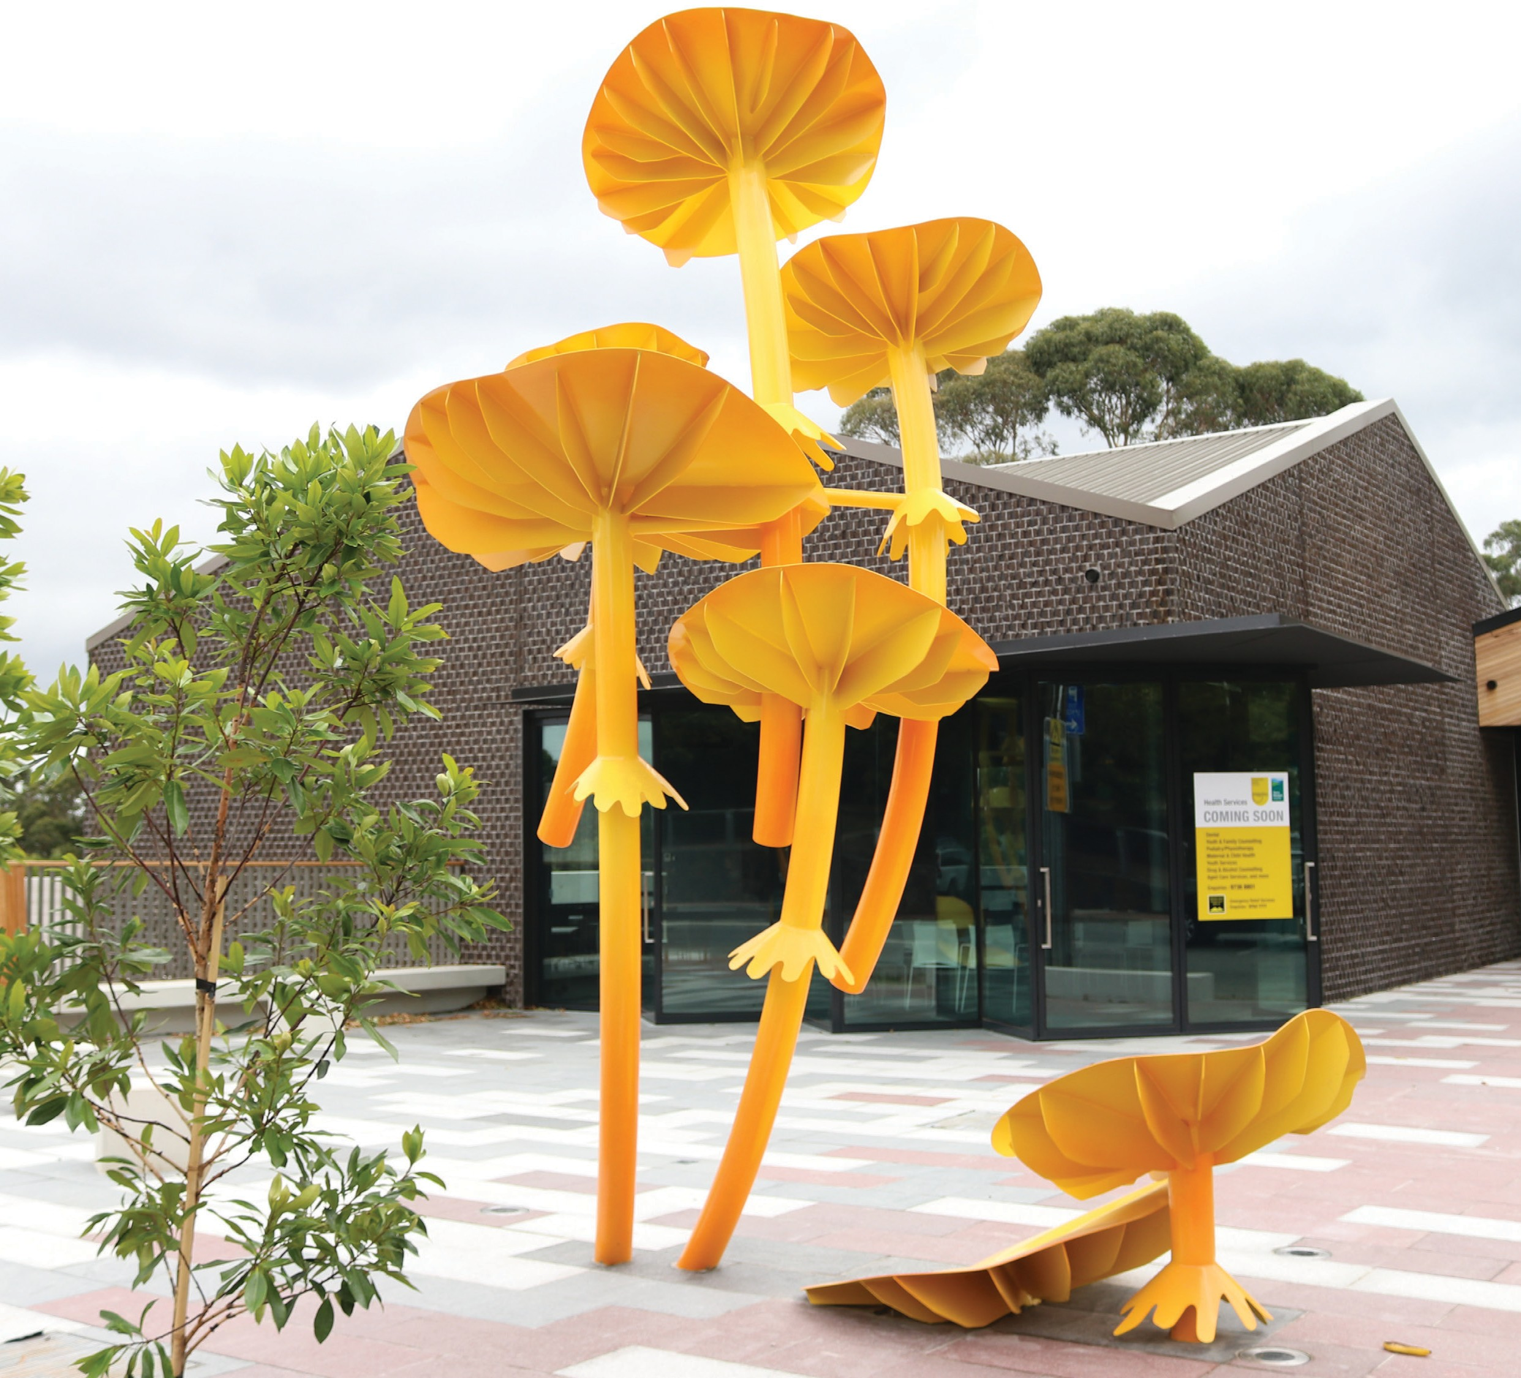


Yarra Ranges Council

Belgrave Hub
Consultation Summary

Project Background
The Belgrave Community Hub (aka Belgrave Hub or ‘the Hub’) was built and is owned by Yarra Ranges Council (Council), in partnership with Inspiro, who are the lead tenants of the facility. Inspiro has a tenancy agreement in place with Council to manage the facility. Council’s Maternal Child and Health services run out of the building, and Council staff have access to a space in the building under a hot desk arrangement.
Dandenong Ranges Emergency Relief Service (DRERS) also operates out of the Hub, and the Orange Door is joining the space later in 2023. Inspiro manages these partnerships.
Opened in 2018 after extensive community consultation, the Hub has been operating primarily to provide community health and emergency relief services to the Hills communities. A wide range of community groups have also hired the meeting and conference spaces over the years, some as regular hirers, some as one-off hires.
The site the Hub is located on also hosts the Belgrave Community Garden, a small public playground and has an outdoor plaza space that connects to the large meeting space via glass doors and is available for public access.
Over the years, and with the added impacts of COVID, several questions have continued to arise from community, including:
- why does the Hub exist?
- who is the Hub for?
- what happens at the Hub?
The Partnership and Community Building team at YRC identified the need to take a focused approach at working with the current stakeholders of the Hub (the groups that call the Hub ‘home’) and the broader community, to ensure the Hub has a clear purpose and vision to best serve the hills community.
This resulted in the Belgrave Hub Visioning project with Hatrick & Co consultants who lead the conversations to hear feedback.

Who we spoke to
- Website visitation – 1,112 page views and 118 contributions
- Engagement Period – 1 March 2023 – 22 March 2023
- Identity workshop with Hub partners and tenants (internal)
  - Yarra Ranges Council, Inspiro, DRERS
- Interviews with key stakeholders of the Hub (internal and external)
  - 10 community representatives, 2 Councillors, Yarra Ranges officers and Inspiro
- A community survey seeking feedback on community perceptions and experiences of the Hub (external)
  - 125 responses; 118 online, 6 paper surveys
- Mini workshop with community to explore the purpose, vision and mission for the Hub (external)
2 - 17 attendees

What we heard
- 54% of survey respondents didn’t know that many of the services at the Hub are free or low cost.
- 69% of survey respondents didn’t know that community members could hire spaces at the Hub
- Information available about services available at the Hub, including the signage outside the building, were RATED LOWEST
- 48 respondents answered the question “If you visited the Hub, how would you rate the general atmosphere?” Over half of the respondents rated the atmosphere as below average.
“The name, Hub, to me means interconnecting space where community can connect, play, enliven, enhance community capacity, place of discovery, where groups might come together and forge bonds, a place of outreach for those doing it tough – a sanctuary (Belgrave Hub does do that, has done that in storm time).” – survey respondent

Next Steps
Recommendation 1: Agree and adopt a new identity Statement & explore a change to the name
of the Hub to better reflect the purpose and identity of the Hub.
Recommendation 2: Develop a simple plan to identify and activate opportunities to share the story of the Hub with more people, more often, in more places.
Recommendation 3: Improve governance structures by strengthening collaboration with key stakeholders and tenants, establishing greater clarity of roles around policy and community engagement.
Recommendation 4: Identify and enable programs, events and partnerships that connect to and support the vision and purpose of the Hub.
Recommendation 5: Identify and pursue opportunities to enhance the internal spaces for an improved experience; small changes to humanise the space.


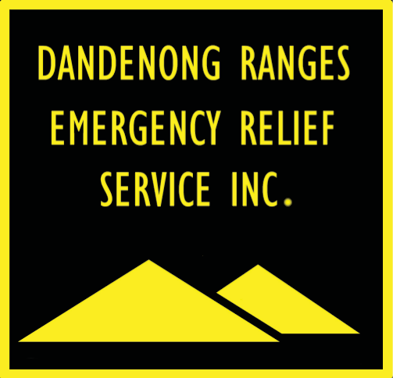

3


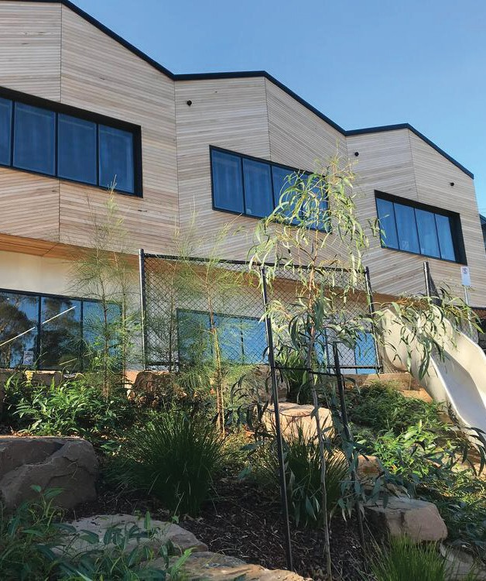

Yarra Ranges Council PO Box 105
Lilydale VIC 3140

1300 368 333 | mail@yarraranges.vic.gov.au yarraranges.vic.gov.au
4

