Yarra Ranges Council
Draft Aquatic and Leisure Strategy
2023 to 2033


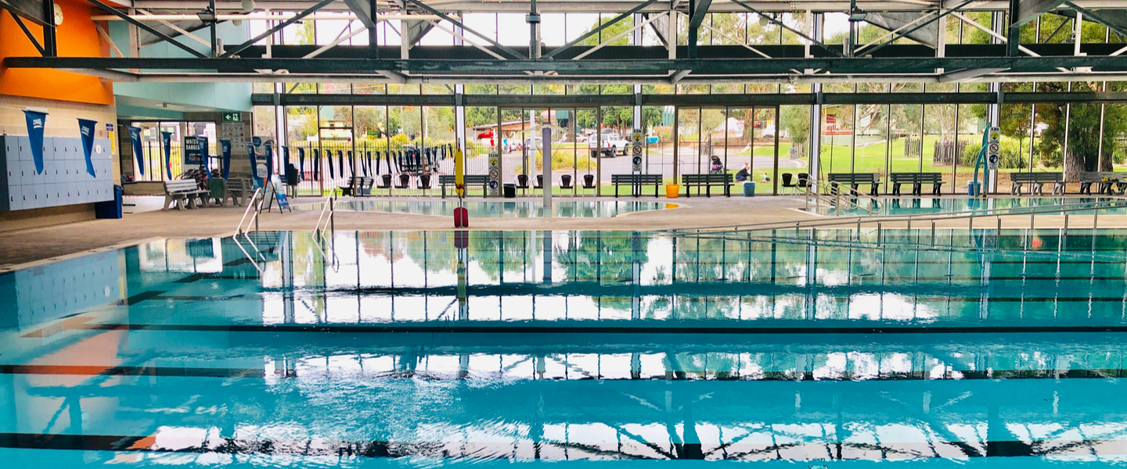
PART A
September
2023

Yarra Ranges Council acknowledges the Wurundjeri and other Kulin Nations as the Traditional Owners and Custodians of these lands. We pay our respects to all Elders, past, present, and emerging, who have been, and always will be, integral to the story of our region. We proudly share custodianship to care for Country together.

 | 

Contents

Part A
Introduction 1
Why do we need a Strategy? 1
Our planning Districts 3
Strategic Context 4
Vision and Objectives 19
Vision 19
Objectives 19
How do we achieve our vision and objectives? 20
Strategic Direction 23
Urban District 23
Hills District 24
Yarra Valley District 24
Water Play Areas 24
Future Aquatic and leisure Facility Catchments 6
Recommendation and Actions 7
Strategy Review 31

Part B
Supporting Information 11
Aquatic Service Hierarchy 13
Our Current Facilities 14
How our facilities have performed? 14
Attendance 15
Community Benefits of Aquatic and Leisure Centres 15
The future of outdoor pools 16
Vision and Objectives 19
Vision 19
Operatiional Performance 19
Council Cost 20
Indoor Pools 24
Outdoor Pools 24
Water Parks 24
Who is our community? 21
Population 23
Age 24
Diversity 24
Disadvantage and Social Capital 24
Community Consultation 21
How we engaged 23
What we hear 24
What Industry trends and challenges do we need to consider? 21
History of Swimming Pools 24
The Future of Outdoor Pools 25
What is our current aquatic centre catchment 31
Closure of Kilsyth Centenary Pool 24

Introduction

The Yarra Ranges Aquatic and Wellness Strategy 2023 to 2033 (Strategy) provides a 10-year road map towards a diverse network of aquatic and leisure facilities. Our facilities will deliver adventure and leisure, education, health and fitness and therapy-based programs and participation opportunities for our community.

The Strategy is a summary of market research, facility operating information and community consultation. It considers the upgrade and renewal requirements of the existing facilities, the current and future needs of residents, population growth and demographic influences, emerging participation, usage and facility trends and the financial impact on Council. The Strategy defines the role aquatic facilities play in providing aquatic and leisure services across the Yarra Ranges.

Why do we need a Strategy?

Yarra Ranges Council is committed to supporting involvement in active and healthy lifestyles and improving the health and well-being of residents. Council recognises that the programs and services provided at aquatic and leisure centres play an important role in promoting holistic health, including physical, mental and emotional wellbeing. The programs create safe and accessible spaces for community members to come together to build social networks and connections and develop core life skills.

Council has invested significant funds into the development and operation of aquatic and leisure facilities over many years. Some of these facilities are nearing the end of their useful life and many do not meet the identified needs for contemporary facilities to support health and wellness outcomes, such as warm water pools. The current aquatic and leisure facilities also have a significant impact on the environment through the use of gas for heating and high water use. Significant investment is therefore required to update the facilities to ensure they remain relevant and address the environmental impact to achieve Council’s climate targets.

The development of the Yarra Ranges Aquatic and Wellness Strategy 2023 to 2033 focuses on the physical health, mental wellbeing and community engagement of residents while also addressing ageing infrastructure, and environmental and financial sustainability. The comprehensive Strategy will enable Council to continue to have a positive impact on the health and wellbeing of residents.

What facilities do we have?

Council currently supports aquatic services through the provision of two indoor aquatic and leisure facilities, five aquatic facilities and three water play facilities, offering the community diverse water experiences across the municipality.

Council is also currently managing the Jack Hort Memorial Pool located on Department of Education and Training (DET) land at Healesville High School for a trial period.

Aquatics and Leisure Facilities
- Monbulk Aquatic Centre
- Yarra Centre

Aquatics Facilities
- Kilsyth Centenary Pool
- Jack Hort Pool
- Belgrave Outdoor Pool
- Olinda Outdoor Pool
- Lilydale Outdoor Pool
- Healesville Outdoor Pool

Water Play Facilities
- Lilydale Lake Water Play
- Seville Water Play
- Warburton Water World

Aquatics & Leisure Facilities
- Monbulk Aquatic Centre
- Yarra Centre

Water Play Facilities
- Lilydale Lake Water Play
- Seville Water Play
- Warburton Water World
Aquatics Facilities
- Kilsyth Centenary Pool
- Jack Hort Pool
- Belgrave Outdoor Pool
- Olinda Outdoor Pool
- Lilydale Outdoor Pool
- Healesville Outdoor Pool

Our Planning Districts

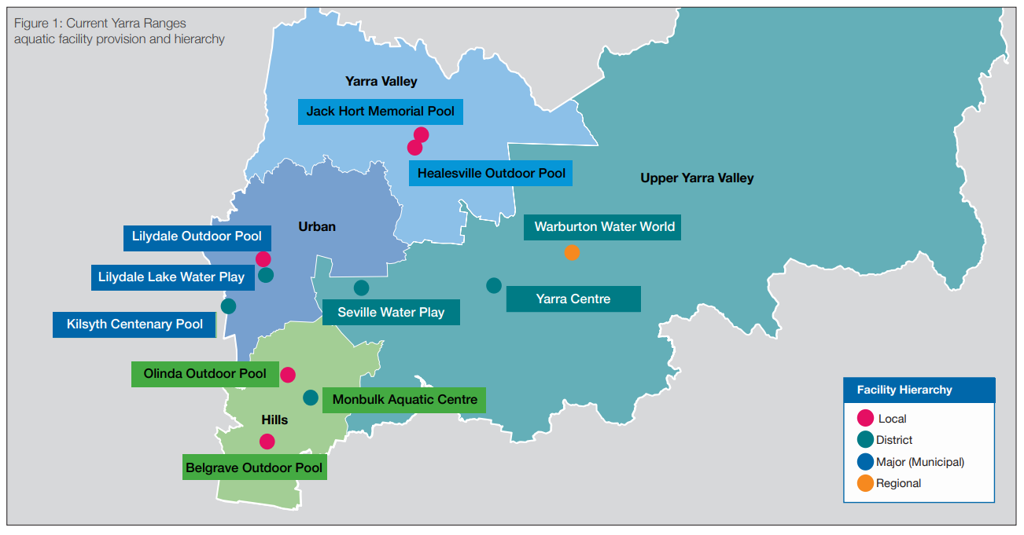
This map shows the Yarra Ranges planning districts - Urban, Hills, Yarra Valley and Upper Yarra Valley - and the aquatic facility locations within each district.
Figure 1 Current Yarra Ranges aquatic facility provision and hierarchy

Strategic Context

Yarra Ranges Council is proud of its integrated planning framework. A continuous review of the framework ensures Council’s plans, strategies, and resources are more closely aligned and increase the connection between what the community values, their priorities, and the Council’s planning processes. One of the priorities of the Yarra Ranges Council Plan 2021-2025 is ‘Quality Infrastructure and Liveable Places’, ensuring the facilities and infrastructure meet the current and future needs of the community. It states that ‘Places should be well-planned hubs of activity that foster wellbeing, creativity and innovation’ and that community assets will be welcoming, will respond to the needs of the community, and will be well-maintained for future generations. The Aquatics and Leisure Strategy will guide Council on the best provision of aquatics facilities for the community in order to achieve this priority. The diagram below shows the strategic relationship between Yarra Ranges Council’s strategic landscape and the Yarra Ranges Aquatic and Leisure Strategy 2023 to 2033

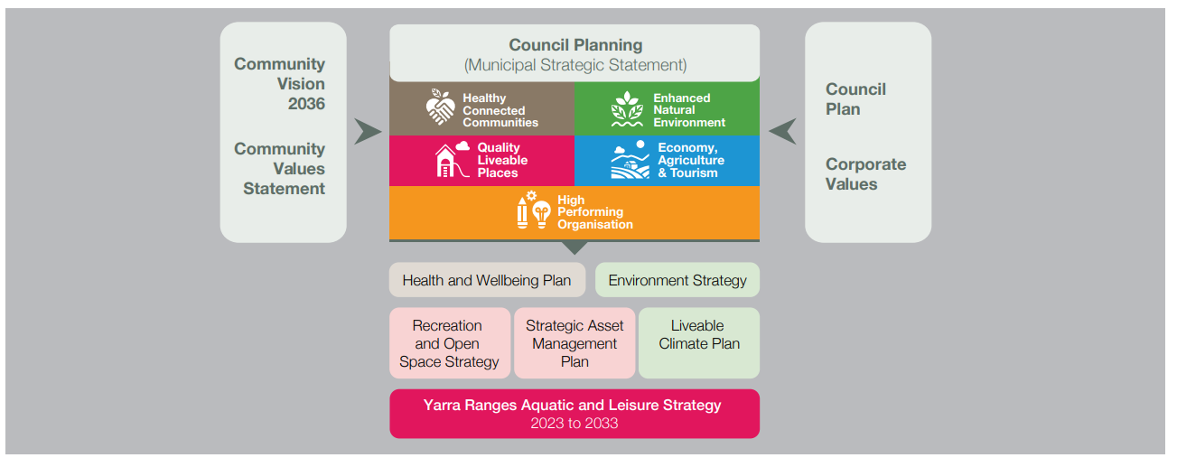

Vision

To provide a diverse and sustainable network of aquatic and leisure facilities, bringing Yarra Ranges residents together to access and enjoy health and wellbeing, education, fitness, leisure and play experiences

The pivotal role aquatic and leisure centres play in enhancing holistic health, including physical, mental, and emotional wellbeing is the primary reason for Councils commitment to the provision and advancement of these facilities. The priority is to maximise the benefits the programs and services offer while concurrently creating safe and inclusive spaces where community members can convene, forge social connections, and nurture core life skills. Furthermore, Council is dedicated to environmental sustainability and understands the substantial energy footprint associated with aquatic and leisure facilities, making them one of the highest energy consumers. Addressing these environmental concerns and attaining Council’s established sustainability targets is another key focus. Considering the substantial investments required to operate and maintain these facilities, it is imperative to ensure future investments align with key business objectives, prioritising increased participation and financial returns. Additionally, future investments must also underpin broader economic, health, and social impacts for the Yarra Ranges community, including creation of employment opportunities.

Objectives

Participation, Inclusion and Wellbeing
Provide accessible, affordable, and inclusive aquatic and leisure facilities that support diverse participation opportunities and key programming needs.

Environmental Sustainability
Provide environmentally sustainable and universally designed aquatic and leisure facilities including adapting to climate change.

Financial Sustainability
Deliver well-managed, maintained and financially sustainable facilities that are provided for the capacity of the Yarra Ranges recurrent and long-term financial plan.

Economic Benefits
Deliver a diverse network of complementary aquatic and leisure facilities across the Yarra Ranges that support economic and employment opportunities.

How do we achieve our vision and objectives?

Participation, Inclusion and Wellbeing will be achieved by providing most residents with:
• Access to an aquatic and leisure facility within a reasonable drive of their home.
• Access to purpose-built warm water pools and programs pools at key indoor facility locations to support therapy, rehabilitation and learn to swim activities.
• Development of a business case to further investigate an integrated health and leisure facility in the urban area to support the anticipated population growth.

How we measure our success:
• 15% increase in participation.
• Access to Aquatic facility within a 20min drive time.
• Construction of warm water pools within Yarra Ranges.
• Completion of business case for Integrated Aquatic Facility in Lilydale

Environmental sustainability will be achieved by:
• Discontinuing gas use within aquatic facilities in line with the targets of Council’s Livable Climate Plan.
• Reduction over time of facilities that do meet the environmental objectives of council.
• Future design for development or redevelopment will include best practice in environmentally sustainable design. For example:
º Rainwater harvesting system.
º Energy efficient boiler.
º Thermal insulation around the pool shell.
º High levels of air tightness to improve the efficiency of the heating and cooling systems.
º Building Management System that allows for monitoring and control of all major systems.
º Energy-efficient lighting, which uses less energy and needs replacing less often.
º Double and clear glazing windows let heat into the building during winter

How we measure our success:
• Removal of gas and replacement with renewable energy source.
• Achievement of Council’s livable climate plan targets.
• Deletion of single use plastic.
• 20% of capital investment attributable to Environmentally Sustainable Design (ESD) initiative

Financial Sustainability will be achieved by:
• Significantly reducing Council’s subsidy for the operation of aquatic and leisure portfolio.
• Recommending upgrades or new developments that are supported by an evidence-based business case and support financially sustainable targets. • Providing a range of services and programs, including some high-yield programs that have the capacity to cross-subsidise high-cost components.
• Reducing programs and services and facility components that do not achieve financial targets.

How we measure our success:
• 50% reduction in Council financial subsidy to manage and operate network of Aquatic and Leisure facilities.
• Completion of Business case for Lilydale, MAC and Yarra Centre.

Economic Benefits will be achieved by:
• Providing a range of services and programs to improve productivity and assist in reducing preventative health costs.
• Providing employment opportunities for residents.
• Where appropriate, optimising facilities may provide a wider regional economic impact through both the construction and operational phases

How we measure our success:
• 20% increase in EFT within the Aquatic network.
• Increase of construction employment during the development of redevelopment of Aquatic Facilities.
• Increase to wider economic benefit to the Yarra Ranges region

Strategic Direction

Given operational and financial performance of existing facilities, along with catchment analysis, industry trends, and extensive community engagement, indicates there is significant demand and interest from key stakeholders across the Yarra Ranges. The feedback gathered indicates pools are highly valued. However, many are ageing and are not fit for the purpose of addressing community sector needs. There is strong support for facilities that deliver inclusive and accessible services and programs that focus on maximising health and wellbeing outcomes and are environmentally and financially sustainable. The recommended strategic direction for aquatic facilities and services in the four Council planning districts is as follows:

Urban District

Investigate Opportunities for an Integrated Aquatic and Leisure Centre in Lilydale
Develop a business case to support planning for a major (municipal level) integrated indoor aquatic and leisure facility in Lilydale that services the widest population growth and catchment needs of the Yarra Ranges. The facility is to be situated on a visible and accessible site within proximity to public transport and other key activity nodes.

The key components of the facility may include:
Aquatics
• Indoor lap pool
• Program pool (learn to swim)
• Warm water pool – including spa
• Interactive leisure water
• Steam and sauna
Dry health and leisure
• Group fitness rooms
• Gym
• Social space
• Café
• Community meeting spaces

Permanent closure of the Kilsyth Centenary Pool
The age and condition of the Kilsyth Centenary Pool resulted in the need to close the facility for the safety of both facility users and staff. The location of the facility on the border of the Yarra Ranges results in significant overlapping and competing population catchments with Aquahub Croydon. The facility had a declining usage and lacks a number of essential components now seen in contemporary aquatic and leisure centres to meet identified needs.

Retention of Lilydale Outdoor Pool
Retention of the existing outdoor pool in Lilydale until the proposed indoor integrated facility is built in the Urban area or the pool fails. Funds will be provided for maintenance and minor renewals to support the pool’s function.

Hills

Upgrade of the Monbulk Aquatic Centre (MAC)
Upgrade the MAC to improve disability and inclusion access and to support the diverse needs of the community. Subject to a detailed business case the upgrade may include the following key components:
• Additional program pool
• Upgrade to leisure water
• Extension of the gym
• New program room.

Retain the Belgrave Outdoor Pool and Olinda Community
Pool Retain and monitor the ongoing usage of the facilities and provide funding for maintenance. The future of the pools will be reviewed once the upgrades to the MAC are completed

Yarra Valley District

Continue management and operations of Jack Hort Memorial Pool in the short term and investigate the opportunity for a district facility in the long term.
The facility components at Jack Hort Memorial Pool are limited and do not meet the aquatic service level of a district facility. In the short-term Council will investigate possible alternate operating models and monitor ongoing usage and maintenance requirements. In the longer-term Council will investigate opportunities to provide access to a district-level facility to service the Yarra Valley District.

Master plan for the Healesville Outdoor Pool
The 50m pool is highly valued by the community it serves and provides a 50m pool for schools in the Yarra Ranges to hold carnivals and events. The infrastructure is ageing and needs to be upgraded to meet identified future needs. A master plan will be developed that investigates:
• Condition and life of the 50M pool shell
• Heating of the pool
• Upgrade to the changerooms
• Opportunities for the inclusion of a small interactive water play feature.

Upper Yarra Valley District

Upgrade of the Yarra Centre
Upgrade the Yarra Centre to support the diverse needs of the community. Subject to a detailed business case the upgrade may include the following key components:
• New entry and café
• Extension of the pool hall to incorporate a new warm water pool, spa and accessible change facilities
• Redevelopment and expansion of gym and program rooms
• Development of an external fitness zone.

Water Play Areas

The Seville Water Play area, Warburton Water World and Lilydale Lake Water Play have proved to be extremely successful, attracting high visitation per annum. The current provision of water play in Yarra Ranges is sufficient when considered as part of the broader aquatics portfolio. Use, and access will continue to be monitored over the life of the strategy. Funding will be provided for ongoing operation and maintenance.

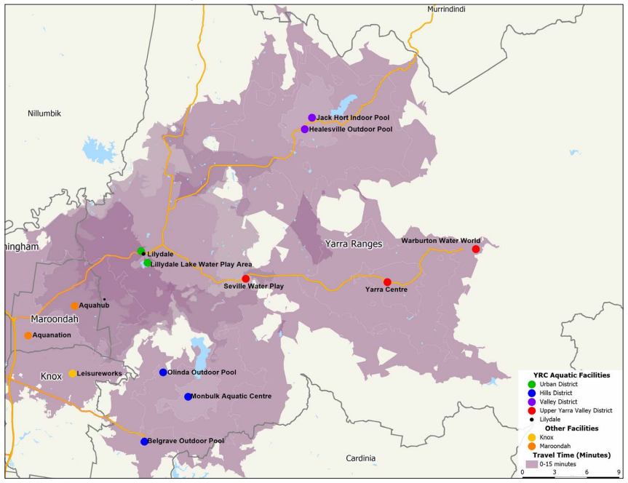
Future Aquatic and Leisure Facility Catchments
Figure 2 Areas of Yarra Ranges Council within a 15 minute drive of an Aquatic and Leisure Facility

Recommendations and Actions

The following table provides recommendations and actions for the four planning districts - Urban, Hills, Yarra Valley and Upper Yarra Valley to implement the strategic directions. The priority column is presented as short term, medium term and long term based on the following timeframe: Short Term - 1 to 2 years, Medium Term - 3 to 4 years, Long Term- 5+ years

Recommendation | Objective | Action | Priority | Estimate Resource
Urban District
1. Development of a Major integrated indoor aquatic and leisure hub in Lilydale that services the key aquatic and well-being needs of the Shire, subject to a detailed business case | Participation, Inclusion & Wellbeing, Environmental Sustainability, Financial Sustainability, Economic Benefits | That Council prepares a business case for the development of the integrated aquatic and leisure centre to understand site options, capital cost operational costs, usage and economic and health impacts. | Short | $250K - $300K
 |  | That Council develops a funding strategy that considers the potential internal and external (state and federal governments, private partnerships) to support the development of an integrated aquatic and wellbeing centre | Medium | Internal resources
2. Permanent Closure of Kilsyth Centenary Pool | Environmental Sustainability, Financial Sustainability | That Kilsyth Centenary Pool remains permanently closed, and Council investigates opportunities to assist displaced members access alternate facilities i.e., Aquanation, Aquahub and Knox Leisureworks. | Short | Internal resources
2. Permanent Closure of Kilsyth Centenary Pool | Environmental Sustainability, Financial Sustainability | That Kilsyth Centenary Pool is decommissioned, and the site restored for general use while a Master Plan is completed to determine the future use of the land. The Master Plan will investigate opportuities for a water play area. | Short | $1M
2. Permanent Closure of Kilsyth Centenary Pool | Environmental Sustainability, Financial Sustainability | That Council investigates opportunities with the private sector to establish dedicated learn-to-swim facilities within the urban area. | Short | Internal resources
3. Retention of Lilydale Pool until a new urban pool constructed or pool failure | Participation, Inclusion & Wellbeing | That Council provides funding to enable the Lilydale Pool to remain open until the proposed new facility is developed, or the pool plant and pool shell equipment fails. | Ongoing | 150k per year approx.

Recommendation | Objective | Action | Priority | Estimate Resource
Hills District
4. Expand Monbulk Aquatic Centre | Participation, Inclusion & Wellbeing, Environmental Sustainability, Financial Sustainability, Economic Benefits | That Council prepares a business case and Master Plan for the redevelopment of the Monbulk Aquatic Centre to understand the capital costs, operational costs, usage and Council subsidy. | Short | $150K
4. Expand Monbulk Aquatic Centre |  | That Council develops a funding strategy that considers the potential internal and external (state and federal governments, private partnerships) to support the development of the Monbulk Aquatic Centre. | Short | Internal resources
4. Expand Monbulk Aquatic Centre |  | MAC is upgraded in line with the Master Plan and business case. | Long | $47M
5. Electrification of Plant | Environmental Sustainability | That the cost and feasibility of removing the use of gas and replacing with a renewable energy source is undertaken for Monbulk Aquatic Centre. | Short | 50K
5. Electrification of Plant | Environmental Sustainability | MAC transferred to electricity and renewable energy sources. | Long | $2M
6. Maintain provision at Belgrave Outdoor | Participation, Inclusion & Wellbeing | That Council identifies minor renewal costs and implements works associated with the operation and maintenance of the Belgrave Outdoor Pool. | Medium | Ongoing 200k per year approx.
7. Maintain provision at Olinda Outdoor Community Pool | Participation, Inclusion & Wellbeing | That Council identifies minor renewal costs and implements works associated with the operation and maintenance of Olinda Outdoor Community Pool. Council continues to monitor the use and management arrangements of the Olinda Community Pool. | Medium | Ongoing 150k per year approx

Recommendation | Objective | Action | Priority | Estimate Resource
Yarra Valley District
8. Investigate operational management in the short term of Jack Hort Memorial Pool | Participation, Inclusion & Wellbeing, Financial Sustainability | That Council works with the Department of Education and Training to determine the management and maintenance responsibilities of the facility in the short and long term. | Short | Internal resources
9. Investigate opportunities to develop a District Level facility to support the Yarra Valley District in the long term. | Participation, Inclusion & Wellbeing, Environmental Sustainability, Financial Sustainability, Economic Benefits | That Council further investigates the feasibility of developing a district level facility at Healesville. | Medium | $60K - $80K
10. Upgrade of the Healesville Outdoor pool | Participation, Inclusion & Wellbeing, Financial Sustainability | Development of a business case and Master Plan for the redevelopment of the Healesville Outdoor Pool. | Short | $60K - $80K
10. Upgrade of the Healesville Outdoor pool |  | Upgrades to Healesville Outdoor Pool are completed in line with the Master Plan. | Short | $5M

Recommendation | Objective | Action | Priority | Estimate Resource
Upper Yarra Valley District
11. Expand Yarra Centre | Participation, Inclusion & Wellbeing, Environmental Sustainability, Financial Sustainability, Economic Benefits | That Council prepares a business case and Master Plan for the upgrade of the Yarra Centre to understand the capital costs, operational costs, usage, and Council subsidy. | Medium | $150K
11. Expand Yarra Centre |  | That Council develops a funding strategy that considers the potential internal and external (state and federal governments, private partnerships) to support the redevelopment of the Yarra Centre. | Medium | Internal resources
11. Expand Yarra Centre |  | Yarra Centre is upgraded in line with the master plan and business case | Long | $30M
12. Electrification of Plant | Environmental Sustainability | That the cost and feasibility of removing the use of gas and replacing with a renewable energy source is undertaken for the Yarra Centre. | Short | 50K
12. Electrification of Plant | Environmental Sustainability | Yarra Centre transferred to electricity and renewable energy sources | Long | $2M

Recommendation | Objective | Action | Priority | Estimate Resource
Water Play
13. Maintain provision of water play at Warburton, Seville and Lilydale | Participation, Inclusion & Wellbeing, Environmental Sustainability, Financial Sustainability, Economic Benefits | That Council continues to monitor the usage of water play to align with community needs. | Short | Internal resources
 |  | Review water play provision in line with community need (ongoing) | Short | Internal resources

Recommendation | Objective | Action | Priority | Estimate Resource
Aquatic Facilities
14. Develop asset management plan for aquatic facilities | Participation, Inclusion & Wellbeing, Environmental Sustainability, Financial Sustainability, Economic Benefits | Council captures current asset data, assesses asset condition and monitors performance to assign an appropriate renewal value to maintain assets. | Short | Internal resources

Strategy Review

The network of Yarra Ranges aquatic and leisure facilities requires regular review to assess usage and performance against the Strategy vision, progress against Strategy objectives, and the ongoing alignment of actions to the Council’s objectives.

This strategy represents the most appropriate provision of aquatic and leisure facilities to service our community at this time. Council acknowledges the social benefits of outdoor pools however also recognises the ageing infrastructure, rising costs, declining attendance, and environmental impacts of these assets. Prority for investment will be directed to year round indoor facilities.

Monitoring, reporting and evaluation are required to understand effectiveness, identify areas for improvement and enhance the evidence base for current and future work in this space. The implementation of the strategy depends on investment from State and Federal Governments and should consider the potential for private investment.

A mid-term review of the strategy at year five will be undertaken and a review of the implementation plan will occur annually to allow Council to respond to changing circumstances. This approach will ensure the strategic direction for aquatic services remains relevant to the needs of the community

Yarra Ranges Council
Draft Aquatic and Leisure Strategy
2023 to 2033

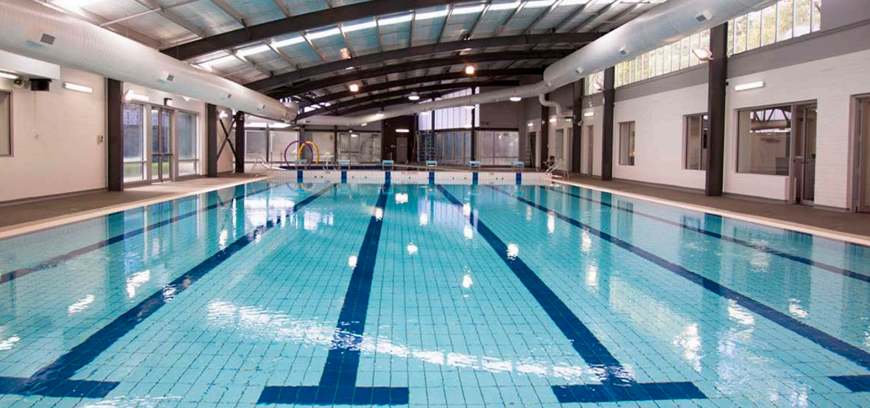

PART B
September
2023

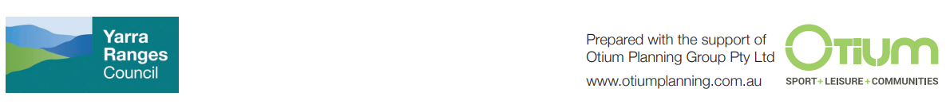

Supporting Information

The Yarra Ranges Aquatic and Leisure Strategy 2023 to 2033 (Strategy) provides a 10-year road map towards a diverse network of aquatic and leisure facilities. Our facilities will deliver adventure and leisure, education, health and fitness and therapy-based programs and participation opportunities for our community.

Yarra Ranges Council is committed to supporting active and healthy lifestyles and improving the health and well-being of residents. Council recognises that the programs and services provided at aquatic and leisure centres play an important role in promoting holistic health, including physical, mental and emotional well being. The programs create safe and accessible spaces for community members to come together to build social networks and connections and develop core life skills.

The supporting document provides evidenced based research and data helping guide the key strategic directions and recommendations detailed within the Strategy and includes:
• Aquatic service hierarchy
• Current facilities operating performance trends
• Demographic profile
• Community engagement feedback and findings
• Industry trends
• Value of the Aquatic Industry
• The future of outdoor pools
• Aquatic centre catchments.

Aquatic Service Hierarchy

Access to aquatic facilities will be provided through a combination of:
- Council-owned aquatic and leisure facilities and water play parks.
- Community-managed aquatic and leisure facilities.
- Facilities/services available from the private sector (e.g., swim school, fitness centres and personal training studios).
- Regional aquatic facilities offered by adjoining municipalities in Maroondah (Croydon Aquahub and Ringwood Aquanation) and Knox City Council (Knox Leisureworks).

The Yarra Ranges Aquatic and Wellness Strategy 2023 to 2033 seeks to provide a full range of harmonious, diverse and unique water experiences in Yarra Ranges.

The following table shows the service hierarchy for Yarra Ranges and other neighbouring major aquatic and leisure facilities that relate to the ‘industry’ standards for catchment sizes. The postcode analysis of casual visits at all Yarra Ranges aquatic facilities and memberships for learn to swim and health and fitness at the indoor pools align with the industry catchments for each facility within the service hierarchy.

Service Hierarchy | Service Level Objective | Yarra Ranges Pools | Other Local and Regional Facilities
Local  10,000 – 40,000 Catchment Population | - Ability to provide limited program water combined with leisure water.  - Limited dry/gym facilities. | - Belgrave Outdoor Pool  - Olinda Outdoor Pool  - Lilydale Outdoor Pool  - Healesville Outdoor Pool  - Jack Hort Indoor Pool (Healesville) (Department of Education and Training) | - King Swim (Chirnside Park)  - Moores Swim School (Kilsyth)  - Vicki Field Swim School (Kilsyth)  - Boronia Swim School (Boronia)  - Paul Sadler Swim Land (Narre Warren and Rowville)  - Kingswim St Joseph’s College (Ferntree Gully)  - Casey ARC (Narre Warren)  - RACV Club (Healesville)  - Croydon Outdoor Memorial Pool (Croydon)
District  40,000 – 70,000 Catchment Population | - Ability to separate program and leisure water.  - Larger dry/gym facilities.  - Additional limited facilities. | - Monbulk Aquatic Centre  - Kilsyth Centenary Pool (currently closed)  - Yarra Centre  - Seville Water Play  - Lillydale Lake Water Play | - Aquahub (Croydon)
Major (Municipal)  70,000 – 100,000 Catchment Population | - More extensive program and leisure water.  - Consideration of indoor 50m pool and complementary warm water pool.  - Increased gym and program space.  - Additional complimentary amenities, food and beverage. |  | - Knox Leisureworks (Boronia)
Regional  100,000 – 150,000 Catchment Population | - Extensive and varied program leisure water and attractions  - Inclusion of indoor 50m pool and separate warm water pools.  - Wellness/health club and extensive program room inclusions.  - Complementary services and amenities, crèche, food and beverage. | - Warburton Water World | - Aquanation (Ringwood)  - Casey RACE

Our Current Facilities

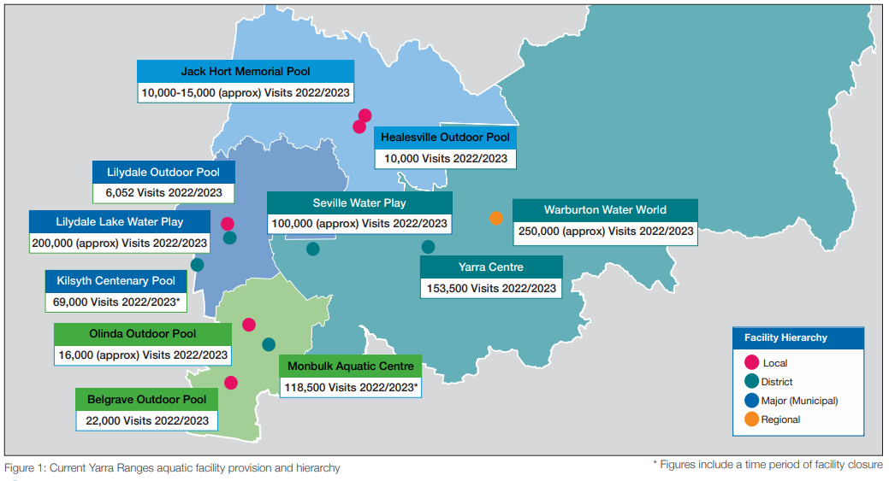
This map shows the Yarra Ranges planning districts - Urban, Hills, Yarra Valley and Upper Yarra Valley - and the aquatic facility locations within each district.
Figure 3 Current Yarra Ranges aquatic facility provision and hierarchy

How our facilities have performed

This section summarises the operational performance of the aquatic facilities, including attendances, operational income and operational expenditure, and the cost to Council for providing the aquatic facilities.

Notably, Covid-19 restrictions impacted the operational performance across all facilities in 2019/20 and 2020/21. The Monbulk Aquatics Hall was also closed for eight months from June 2021– February 2022, following damage caused by storms. Kilsyth Centenary Pool was closed from March 2023 due to safety concerns.

The figures have been presented as aquatic facilities (indoor and outdoor pools) and excludes the three water play areas (Lilydale, Seville and Warburton).

Attendance

The following table details the annual visitation to the Yarra Ranges aquatic facilities, excluding the three water park areas (Lilydale, Seville and Warburton).

Table 1: Attendances at Yarra Ranges Aquatic Facilities 2018/19 to 2022/23
2018/19 | 2019/20 | 2020/21 | 2021/22 | 2022/23
482,077 | 344,937 | 164,837 | 219,556 | 367,787

Figure 4: Attendances at Yarra Ranges Aquatic Facilities 2018/19 to 2022/23

Total attendances over the review period were significantly impacted by the closure of the facilities as a result of Covid 19, closure of Monbulk Aquatics Hall due to storm damage is 2021 and the closure of Kilsyth Centenary Pool in 2023 due to safety concerns.

Total attendances have decreased from a high of 482,077 in 2018/19 (pre Covid-19) to 367,787 in 2022/2023 (post Covid-19) a decrease of approximately 114,290 visits (23.7%).
However due to significant interruptions to business continuity over the last 4 years, no trend in data can be identified.

Operational Performance

The following table details the operational performance of the Yarra Ranges aquatic facilities (excluding the three water play areas). Operating income includes admission fees, memberships, kiosk and merchandise sales. Operation expenditure includes all costs associated with day-to-day operations. This data excludes the Council subsidy, asset renewal/maintenance, and the staff costs to oversee the current management contract.

Table 2: Yarra Ranges Aquatic Centres Operating Performance 2018/19 to 2022/23
Centre Operating Costs | 2018/19 | 2019/20 | 2020/21 | 2021/22 | 2022/23
Operating Income | $4,968,944 | $4,714,170 | $3,784,918 | $1,603,918 | $3,800,514
Operational Expenditure | $6,379,553 | $6,575,700 | $3,846,132 | $5,244,104 | $6,051,189
Operating Performance | -$1,410,609 | -$1,861,530 | -$61,214 | -$3,640,186 | -$2,250,675

Figure 5: Yarra Ranges Aquatic Centres Operating Performance 2018/19 to 2022/23

In line with a decrease in attendance, the total operating income has decreased from a high of $4,968,944 in 2018/19 to $1,603,918 in 2022/23, a decrease of approximately $3,365,026 (47%). Over the last five years attendances have been impacted by the Covid-19 interruptions, closure of Monbulk Aquatics Hall due to storm damage and closure of Kilsyth Centenary Pool due to safety concerns therefore making it difficult to provide an accurate trend line.

The operational income for the 2019/20 and 2020/21 years includes Job keeper payments received by the facility operator, which enabled the retention of staff.

The total operating expenditure over the period has decreased from a high of $6,379,553 in 2018/19 to a low of $3,846,132 in 2022/23, a decrease of approximately $2,533,421 (60%).

Council Costs

The following table details the cost to Council to provide the Yarra Ranges aquatic facilities (excluding the splash parks) and includes the Council contract management subsidy, asset renewal and maintenance, and the Council staff costs to oversee the management contract.

Table 3: Yarra Ranges Aquatic Facilities Costs to Council 2018/19 to 2022/23
Council Costs | 2018/19 | 2019/20 | 2020/21 | 2021/22 | 2022/23
Council management and subsidy costs | $1,611,426 | $1,593,544 | $1,724,295 | $2,601,757 | $1,964,465
Asset renewal | $54,476 | $142,322 | $785,289 | $671,144 | $662,000
Maintenance | $270,049 | $557,298 | $451,666 | $279,502 | $195,000
Total Cost to Council | $1,935,951 | $2,293,164 | $2,961,250 | $3,552,403 | $2,821,465
Subsidy Per Visit | $4.02 | $6.65 | $17.96 | $16.18 | $7.67

Figure 6: Yarra Ranges Aquatic Facilities Costs to Council 2018/19 to 2022/23

A review of the costs to Council indicates:
- The cost of providing the aquatic facilities, including Kilsyth Centenary Pool, Monbulk Aquatic Centre, Yarra Centre and the outdoor pools in Lilydale, Belgrave, Olinda and Healesville, has increased over the five-year review period.
- The cost to Council has increased from a low of $1,593,544 in 2018/19 to $2,601,757 in 2020/21, an increase of $1,088,213 (42%).
- The Council subsidy in 2020/21 was slightly impacted by Covid 19 closures however the full impact was offset by Job keeper subsidy.
- The Council subsidy in 2021/22 increased significantly as a result of Covid-19 and the storm damage at the Monbulk Aquatic Centre.
- Given the age of the facilities, asset renewal has increased from $54,476 in 2018/19 to a high of $785,289 in 2020/21. It should be noted that Council took the opportunity to undertake necessary maintenance work while the centres were closed during Covid-19.

The following section provides a breakdown of operational performance comparing indoor pools and outdoor pools.

Indoor Pools

The operating performance and attendances for the three Yarra Ranges indoor pools (Kilsyth, Yarra Junction, Monbulk) between 2018/19 to 2022/23 are detailed in the table and graph below.

Table 4: Yarra Ranges Indoor Pools Operating Performance 2018/19 to 2022/23
Centre Operating Costs | 2018/19 | 2019/20 | 2020/21 | 2021/22 | 2022/23
Operating Income | $4,750,102 | $4,548,010 | $3,237,351 | $1,525,217 | $3,689,948
Operational Expenditure | $5,765,091 | $5,887,022 | $3,137,907 | $4,499,644 | $5,297,009
Operating Performance | -$1,014,989 | -$1,339,012 | $99,444 | -$2,974,427 | -$1,607,061

Council provides an annual subsidy for the operations of the Jack Hort Memorial Pool, located at Healesville High School, which has been included in this data.

Figure 5: Yarra Ranges Indoor Pools Operating Performance 2018/19 to 2022/23

The following table details the cost to Council to provide the indoor pools and includes the Council contract management subsidy, asset renewal and maintenance, and the Council staff costs to oversee the management contract.

Table 5: Yarra Ranges Indoor Pools Costs to Council 2018/19 to 2022/23
Council Costs | 2018/19 | 2019/20 | 2020/21 | 2021/22 | 2022/23
Council management and subsidy costs | $1,209,792 | $1,201,921 | $1,166,605 | $2,057,421 | $1,514,134
Asset renewal | $28,592 | $72,806 | $592,938 | $548,187 | $283,714
Maintenance | $203,973 | $403,111 | $305,580 | $236,492 | $83,571
Total Cost to Council | $1,442,357 | $1,677,838 | $2,065,123 | $2,842,100 | $1,881,420
Subsidy Per Visit | $3.28 | $5.25 | $15.46 | $15.60 | $5.71
Note: CERM industry benchmark (Group 7 - Indoor Pools) subsidy is $1.78.

Outdoor Pools

The operating performance and attendances for the three Yarra Ranges seasonal outdoor pools from 2018/19 to 2022/23 are shown in the following figure. The outdoor pools operate for a five-month period between November and the end of March each year.

Table 6: Yarra Ranges Outdoor Pools Operating Performance 2018/19 to 2022/23
Centre Operating Costs | 2018/19 | 2019/20 | 2020/21 | 2021/22 | 2022/23
Operating Income | $218,842 | $166,161 | $547,567 | $78,701 | $110,566
Operational Expenditure | $614,462 | $688,678 | $708,405 | $744,460 | $754,180
Operating Performance | -$395,620 | -$522,517 | -$160,838 | -$665,759 | -$643,614

It should be noted that the Olinda Outdoor Pool is operated by a Committee of Management that is supported by an annual Council subsidy, which has been included in this data.

Figure 7: Yarra Ranges Outdoor Pools Operating Performance 2018/19 to 2022/23

The following table details the cost to Council to provide the outdoor pools and includes the Council contract management subsidy, asset renewal and maintenance, and the Council staff costs to oversee the management contract.

Table 7: Yarra Ranges Outdoor Pools Costs to Council 2018/19 to 2022/23
Council Costs | 2018/19 | 2019/20 | 2020/21 | 2021/22 | 2022/23
Council management and subsidy costs | $401,634 | $391,622 | $557,691 | $544,336 | $450,331
Asset renewal | $25,884 | $60,858 | $180,676 | $122,241 | $283,714
Maintenance | $55,592 | $127,054 | $117,147 | $26,035 | $83,571
Total Cost to Council | $483,110 | $579,534 | $855,514 | $692,612 | $817,617
Subsidy Per Visit | $11.44 | $22.79 | $27.37 | $18.53 | $21.44
Note: CERM industry benchmark (Group 5 - Outdoor Pools) subsidy is $4.90, dramatically lower than Yarra Ranges Council subsidy per visit.

A comparison of Yarra Ranges aquatic facilities against industry benchmarks (CERM) indicates that the facilities are performing below the benchmarks for both expense recovery and attendance when compared to similar facilities across Australia. Lilydale Outdoor Pool in particular is operating well below the benchmark in terms of expense recovery and attendance levels and prior to its closure, the Kilsyth Centenary Pool was operating lower than Council’s other two indoor facilities. This is resulting in Council contributing a high subsidy to maintain underperforming aquatic facilities.

Water Parks

The three water parks located within the Yarra Ranges Shire include Seville Water Play Park, Lilydale Lake Water Park and Warburton Water World. All facilities are free for public use between the months of September and the end of March each year.

The total cost for operating the parks in 2022/23 is $147,000, which includes maintenance and water testing.

The estimated annual usage across the three water parks is approximately 550,000 visits.

Who is our community?

Population
- Yarra Ranges population estimate for 2023 is 163,298.
- It is expected to grow by 13.84% to 185,902 by 2041.
- The population growth will fuel the continued demand for aquatic and leisure services in Yarra Ranges.
- Urban District has the highest population growth areas, led by Lilydale (61.8%), Chirnside Park (25.8%) and Mooroolbark (19.5%).

Travel
- Car is the main mode of Travel (limited public transport in rural areas).
- 65% of households with access to two or more vehicles (Greater Melbourne at 51%.)
- There are improved pedestrian and bike trails between townships and from where people live to township centres.
These improvements may also influence the travel behaviour of aquatic and leisure centre users if connected to these public and active transport options.
Age
- Higher proportion of person aged 35 to 59 parents and House builder Groups (35-49) and Older Workers and Pre-Retirees Group (50-59)
- 18.7% of the population was aged between 0 and 15 (Greater Melbourne 22.2%).
- 24.5% of people were aged 60 years and over (Greater Melbourne 24.5%).
- The age profile of Yarra Ranges supports a mix of aquatic and leisure and health and wellness services. The younger age groups seek access to learn-to-swim programs and leisure water experiences. Our older age groups are more active today than in the past and seek social and therapy-based programs.

Diversity
- Cultural diversity is generally low within Yarra Ranges.
- However, there is a high proportion of people that identify as Aboriginal and Torres Strait Islander (1.1%) compared to 0.5% in Greater Melbourne.
- There is a high proportion of Aboriginal and Torres Strait Islander people residing within the Yarra Valley District.
Any future development should connect and celebrate the cultural significance of these areas.

Health and Wellbeing
Across the Yarra Ranges there are high levels of disabilities, obesity and mental health issues, with low levels of physical activity and long commuting times increasing times of sedentary behaviours.
- Violence against women and gender inequality – increases in number of family violence incidents 12% (Victoria 7%).
- Risk Factors – two or more chronic diseases (high bloody pressure, diabetes etc) 29% (Victoria 25%)
- Mental Health – sought help for mental health related problem in the last 12 months 25% (Victoria 18%)
- Healthy Eating – experienced food in security. Consumed sugar sweetened drinks daily 25% (Victoria 18%)
A diverse mix of aquatic and leisure experiences covering adventure and leisure, fitness, education and therapy will be important to address these health issues in Yarra Ranges.

Disadvantage and Social Capital
- Yarra Ranges has a moderate level of disadvantage.
- There is a lower proportion of people earning a high income (those earning $1,750 per week or more), however also a lower proportion of low-income people (those earning less than $500 per week). Overall, 15.5% of the population earned a high income, and 31.4% earned a low income, compared with 11.9% and 37.8% respectively for Greater Melbourne.
- The areas with the highest disadvantage in Yarra Ranges were within the Upper Yarra Valley and Yarra Valley Districts (Yarra Junction/Milgrove/Wesburn – 940.3, Warburton and Surrounds – 940.7 and Healesville and Surrounds – 991.3). The areas with the lowest disadvantage were within the Hills District (Belgrave Heights and Surrounds – 1083.4, Kallista and Surrounds – 1082.0 and Hilltop Towns – 1078.8). The areas with the highest disadvantage are most reliant on Council provision of aquatic and leisure facilities.

Community Consultation

How we engaged

A detailed community engagement plan was developed to ensure Yarra Ranges residents had the opportunity to provide input into the development of the Strategy. The extensive consultation and engagement included:
- Councilor workshop
- Stakeholder interviews and focus groups – 6 sessions
- Resident community survey – 2,040 responses
- 10 Pop-up sessions – 523 residents attended.
- School survey -12 school responses
- Social media: 7 Facebook posts, 4 digital newsletter inclusions, 4 Instagram posts - 81,287 impressions, 135 Facebook comments received, 1,226 newsletter link clicks

What we heard

Community feedback key themes:
- Aquatic facilities and services are highly valued.
- Ongoing demand for access to learn-to-swim programs for local schools and the community.
- Need for a contemporary warm water program pool for rehabilitation and therapy activities.
- Improvements required to outdoor pools – warmer water, greater opening hours, accessibility upgrades.
- Residents value having facilities that remain open throughout the year.
- Opportunity for increased access to 50-metre pools to support lap swimming and competitive swimming and events.
- Residents appreciate the importance of creating a welcoming, accessible, and inclusive atmosphere, ensuring that individuals of all abilities and backgrounds feel comfortable and encouraged to participate.
- Importance of regular upkeep and cleanliness of facilities.
- Dedicated changing room facility for school students.
- An integrated indoor aquatic and wellness centre that includes multiple pools and service opportunities.

What Industry trends and challenges do we need to consider?

There has been a much greater emphasis on the development and provision of a variety of water spaces within public aquatic centres including:
• Program pools designed for Learn to Swim and a variety of aquatics programs.
• Warm water pools which are used for rehabilitation and therapy, are one of the highest use spaces within public aquatic and leisure centres.
• Water play including large, enclosed slides, water jets and other leisure play opportunities.

Health and fitness programming have advanced with a greater emphasis on programs for older adults as well as a much broader range of opportunities including Pilates, Yoga and Boot Camp.

In recognition of the significant capital investment required for aquatic and leisure facilities, a variety of funding models have been utilised. These include funding from State and Federal Government and Public Private Partnerships.

Components that contribute to successful contemporary aquatic and leisure facilities are summarised in the figure below.

Figure 7: Successful aquatic and leisure facility mode
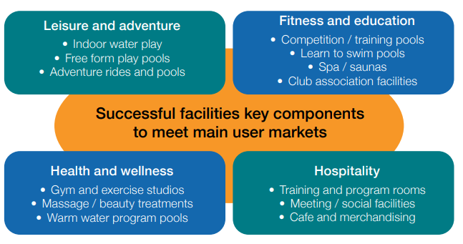

What makes a successful aquatic and leisure centre?

Successful future facility trends indicated a number of common success factors:
- One-stop shop: Large range of activity areas at the one site to maximise use/help share the costs.
- Reduce operating losses: Need a mix of community and commercial activities at the one site. However, the location needs to be right to make this viable.
- Programmable spaces: Need to offer programs and memberships to keep users coming back.
- Cater for all ages and interests: Need to develop facilities for a broad range of people.
- Community/social hub: Needed to offer quality food, beverage, social and entertainment spaces. This could also provide a range of other services like community and cultural services, health and allied services and/or commercial precincts.

Business Drivers

Industry trends demonstrate there are two key business drivers that contribute to the bottom-line operating performance of aquatic and leisure centres. These business drivers, not surprisingly, match services provided by the commercial market, primarily because there is an operating surplus (profit) to be made. The two key business drivers are:

- Health and Fitness memberships
- Learn to Swim enrolments.

It is therefore critical to ensure that facility developments, particularly the gym, group exercise rooms, Learn to Swim pools, warm water pools and supporting amenities, are correctly planned and sized to maximise the performance of these areas, which can offset operating deficits incurred by other activity areas.

The Value of the Aquatic Industry

In 2021, Royal Life Saving Australia engaged Price Waterhouse Coopers (PWC) to investigate the value of the aquatic industry. The Social, Health and Economic Value of the Australian National Aquatic Industry report (July 2021) found the industry’s total benefit to be $9.1 billion annually in economic, health and social benefits.

The following graphic provides a summary of the key economic, health and social benefits. The report provides a range of aquatic specific indicators, including a $4.87 social return on investment in capital cities.
Social
- The aquatic industry is a key driver of social benefit for Australians
- $3.8bn
Annually in benefits from increased individual and community surplus
Health
- The aquatic industry benefits the Health and Wellbeing of Australians
- $2.5bn
Annually in reduced burden of disease in Australia
Economic
- The aquatic industry supports $2.8 billion of economic activity
- $2.8bn
Annually to gross domestic product

Figure: 8 Summary of the royal Life Saving Australia report into aquatic industry value

History of Swimming Pools

Swimming and swimming areas are embedded in our history with Aboriginal and Torres Strait Islander communities having deep connections to water, using rivers, oceans, and lakes for swimming and aquatic recreation. One of the first known aquatic facilities built was the Natatorium Baths built in Sydney in the 1888. Over the years, pools have evolved from single purpose facilities’ to integrated health and wellness hubs. The following diagram illustrates the evolution of aquatic and leisure facilities over the last ninety years

Figure 9: Evolution of Aquatic and Leisure Facilities over the past 90 years

The Future of Outdoor Pools

Like many Local Government areas Yarra Ranges has a number of ageing outdoor pools that are nearing the end of their useful life. In 2022, Royal Life Saving Society Australia released The State of Aquatic Facility Infrastructure in Australia report which highlighted the following issues.

• Ageing Infrastructure: Many outdoor pools built during the 1950s, 1960s, and 1970s have reached the end of their operational life and need replacement. The life expectancy of a public swimming pool is typically 50 years, and many of these pools have surpassed that lifespan.

• High Replacement Costs: Replacing these aging pools is expensive, with an outdoor public pool costing at least $10 million. Local governments, primarily responsible for funding and maintaining aquatic facilities, face significant financial strain due to the high replacement costs.

• Limited Funding: While some state and federal government funding schemes are available, many local councils cannot secure sufficient funding to cover pool replacements’ substantial upfront capital costs. This places a heavy burden on local governments to generate the necessary funds.

• Rising Operational Costs: The operational expenditure on swimming facilities continues to rise, further straining the resources of local governments. Maintaining aging pools becomes increasingly costly due to the need for repairs, upgrades, and compliance with modern health and safety standards.

• Environmental Concerns: Ageing pools often have issues such as leaking chlorinated water into groundwater, posing environmental concerns. The cost of addressing these issues compounds the challenges faced by governments.

Yarra Ranges has experienced the same challenges with ageing infrastructure, rising costs, declining attendances and environmental concerns at its outdoor pools. As a result the future of the Yarra Ranges outdoor pools should be continually monitored and assessed to ensure they meet the key vision and four key objectives set for aquatic service provision in this Strategy.

Priority for investment in aquatic facilities will be in year-round indoor facilities that provide greater health and wellbeing benefits to the community, are more financially viable, and provide opportunities for permanent employment for the community.

What is our current aquatic centre catchment?

Leisure and sporting facility trends and benchmarking generally indicates that local or municipal indoor, year-round facilities have a primary catchment radius of approximately 5 km and a secondary catchment radius of 10 km. In terms of travel distance, this equates to between 5 minutes and 15 minutes.

In general, approximately 75% to 85% of users will reside within a 0 km to 5 km radius of a facility with the remaining 15% to 25% coming from areas within the 5 km to 10 km radius of the facility. Regional facilities, providing unique and varied facility components and a larger number of services will draw users from a much wider catchment than a local/municipal facility.

The size and shape of the catchment area will be influenced by a number of factors including the range and quality of facilities and services offered, natural and built barriers i.e. freeways, travel times and the availability of competing facilities. In metropolitan Melbourne, it is not uncommon for facilities to share catchment areas, particularly the secondary catchment areas. The population facility catchment analysis indicates that the local pools are fulfilling their respective industry catchment areas. The analysis further shows that prior to its closure, there was significant overlap between the Kilsyth Centenary Pool and the Croydon Aquahub (City of Maroondah) catchments. The map on the following page details the catchments for the current facilities. Due to the proximity of the Aquahub Croydon to the Kilsyth Centenary Pool (currently closed), this facility and catchment have also been included on the map.

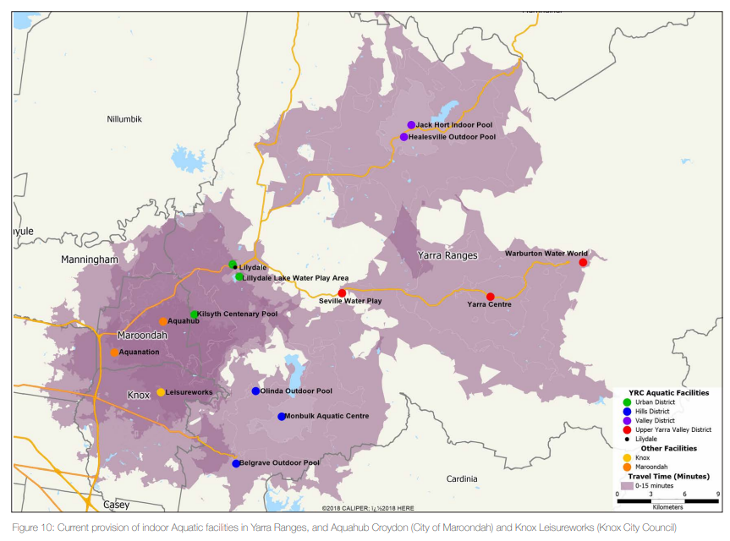
Figure 10: Current Provision of indoor Aquatic facilities in Yarra Ranges, and Aquahub Croydon (City of Maroondah and Knox Leisure works (Knox City Council)

Closure of Kilsyth Centenary Pool

The strategic directions recommend that Kilsyth Centenary Pool remain closed, and a contemporary aquatic and leisure facility be planned for the Lilydale area to serve the urban catchment and future population growth.

The facility was closed in March following structural assessments that identified significant defects to the dome and supporting fixtures. Following closure defects in pool plant and pool shell that impact operation have become apparent.

The current state of infrastructure has been estimated to require at least $2M for the pool to potentially reopen. In addition, given the current age and condition, this investment does not guarantee the structural integrity of the dome and may only provide a limited number of years of operation before additional investment is needed.

This investment provides very poor return for Council and does not meet minimum thresholds for consideration, specifically of concern:
• The significant overlap in catchment population between the Kilsyth Centenary Pool and Aquahub Croydon (193,439 people) (Figure 11).
• The limited facility components that no longer address identified community need, i.e.:
º Dry health and wellness facilities and programs
º Range of pools different with water depths and temperatures
º Leisure water.
• Low and declining attendance levels (Figure 12).
• High ongoing operational subsidy due to the lack of high-yield programs and services to support high-cost aquatic areas.
• High cost per user of approximately $12.00 per visit in 2022/23, which is significantly higher than other Council indoor facilities and industry benchmarks.
• High environmental impact due to permeable dome structure.
• Highest user of utilities representing 42.3% of aquatic total costs ($449,991).
• High competition with key business drivers within the Urban District, with a significant increase in private health and fitness and learn-to-swim businesses

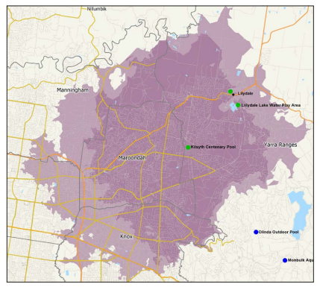
Figure 11: Kilsyth Centenary Pool overlapping facility catchment

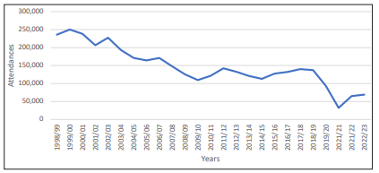
Figure 12: Kilsyth Centenary Pool Attendance 1998/1999 to 2022/2023



