PATHS AND TRAILS
COMMUNITY
ENGAGEMENT
July-August 2024
Paths and Trails Strategy

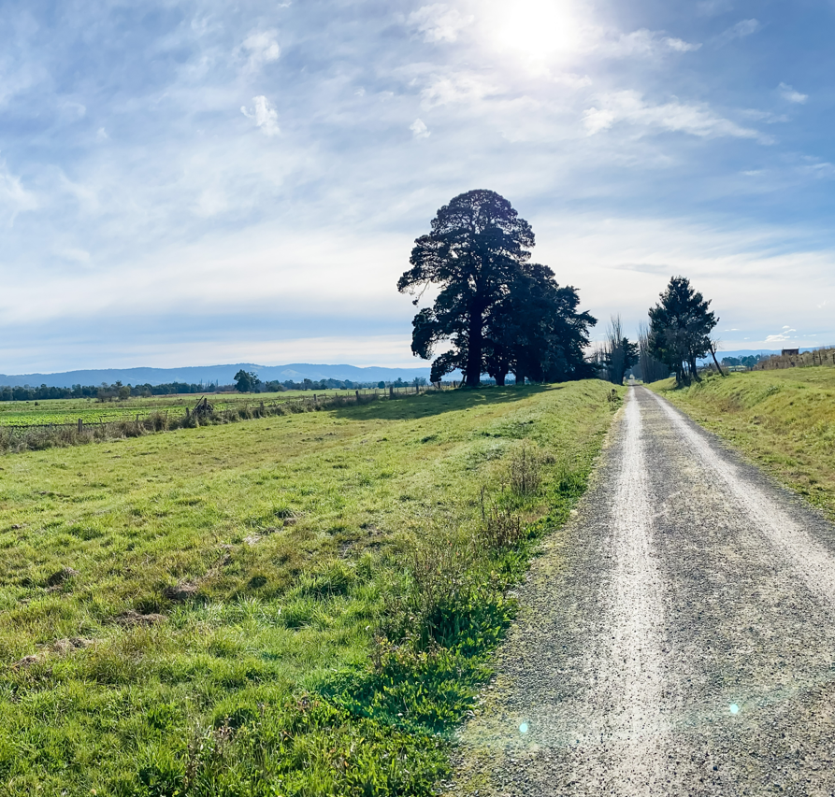

Acknowledgment of Country

Yarra Ranges Council acknowledges the Wurundjeri and other Kulin Nations as the Traditional Owners and Custodians of these lands and waterways. We pay our respects to all Elders, past, present, and emerging, who have been, and always will be, integral to the story of our region. We proudly share custodianship to care for Country together.

Contents

What did we ask? – Page 4
How did people get involved? – Page 5
What were we told? – Page 6
Who told us? – Page 7
What’s next? – Page 8

What did we ask?

To further assist in the development of the Draft Paths and Trails Plan we sought feedback from the community on if there any trails or missing connections within our network that they would like us to consider.

The following section summarises how we engaged, who we engaged with and the outcomes of the engagement.

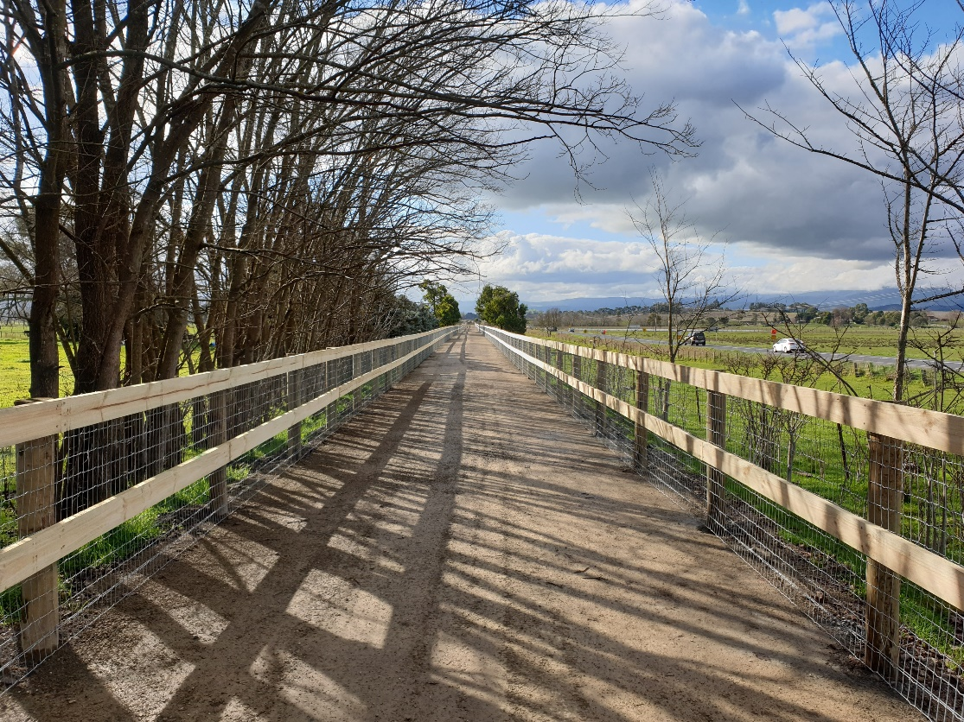

How did people get involved?
Between 5 July 2024 and 2 August 2024, Council used a range of different communications and engagement methods to make sure that the entire community had the means, and notice, to provide feedback if they wished.
Council communicated and promoted the engagement via the following methods:
- Social Media (Facebook and Instagram)
  - 11,300+ post reach
  - 34 comments
  - 140+ link clicks through to engagement page
- E-Newsletters and newspaper ads
  - Engagement was promoted in Council’s fortnightly e-newsletter twice
  - 580+ link clicks from newsletter to engagement page
- Shaping Yarra Ranges
  - The main platform where people provided their feedback
  - 145 people completed the online survey via the Shaping Yarra Ranges platform
What were we told?
The common themes that emerged across the engagement were:
- New Trails/Pathways (38%) – A significant portion of respondents expressed a desire for new walking and cycling trails to be developed.
- Trail Connections (26%) – Many participants highlighted the need to connect existing trail sections, enhancing overall accessibility and network continuity.
- Safety Concerns (17%) – Safety was a recurring theme, with issues raised about pedestrian crossings, pedestrian lights, narrow pathways, and visibility (sightlines) along trails and roads.
- Surface and Maintenance (17%) – Feedback included concerns regarding the condition of pathways, trail surfaces (sealed vs. unsealed), drainage, vegetation management, and the need for regular cleaning and repairs to damaged sections.
- Lighting (2%) – A small portion of responses mentioned the need for improved lighting along trails for better visibility and safety.

Who told us?
Analysing the distribution of all community suggestions, new trails or trail improvement requests were submitted for the following areas:
Suburb | % of trail requests
BELGRAVE, BELGRAVE HEIGHTS, BELGRAVE SOUTH, TECOMA (3160) | 12
BIG PATS CREEK, EAST WARBURTON, MCMAHONS CREEK, MILLGROVE, WARBURTON, WESBURN (3799) | 12
THE PATCH (3792) | 9
BADGER CREEK, HEALESVILLE (3777) | 8
LILYDALE (3140) | 8
HODDLES CREEK, LAUNCHING PLACE, SEVILLE, WANDIN, WOORI YALLOCK (3139) | 5
OLINDA (3788) | 5
POWELLTOWN, YARRA JUNCTION (3160) | 5
Other (single requests across multiple locations) | 19

What’s next?

