
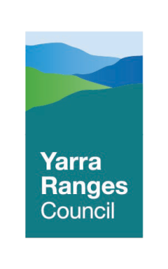

Draft Wastewater Management Plan
2021 - 2026

May 2020

TABLE OF CONTENTS

Executive Summary
- Introduction 1
  - OVERVIEW OF ONSITE WASTEWATER MANAGEMENT 1
  - THE REGION 1
  - COUNCIL RESPONSIBILITIES 4
  - WASTEWATER MANAGEMENT PLAN 7
  - RISKS ASSOCIATED WITH WASTEWATER MANAGEMENT 7
    - RISKS ASSOCIATED WITH WASTEWATER TREATMENT SYSTEMS 7
  - CONCEPTUAL FRAMEWORK 8
- Yarra Ranges Context 10
  - POLICIES AND PROCEDURES 10
  - WATERWAYS AND CATCHMENTS 12
    - CATCHMENT MANAGEMENT AUTHORITIES 15
  - LAND CAPABILITY ASSESSMENTS 16
  - PLANNING SCHEME 16
  - EMERGING HAZARDS 17
    - CLIMATE CHANGE 17
    - LAND SUBJECT TO INUNDATION OVERLAY (LSIO) 18
    - PROTECTION OF TREES ON DEVELOPMENT SITES 19
- Risk Assessment 20
  - RISK FRAMEWORK 20
  - CURRENT RISK LEVEL 23
- VAGO 26
  - INTRODUCTION 26
    - CONSULT WITH RELEVANT AUTHORITIES 26
    - ROLLING INSPECTIONS 28
    - DATA MANAGEMENT 28
    - COMMUNITY EDUCATION 29

- Risk 30
  - INTRODUCTION 30
  - MINIMUM LOT SIZES FOR SUB-DIVISIONS 30
  - EROSION MANAGEMENT OVERLAY (EMO) 31
  - LANDSLIP 31
  - RAINFALL 32
  - PROXIMITY TO WATERWAYS 32
  - PROXIMITY TO GROUNDWATER SUPPLIES 34
  - SLOPE OF THE LAND 35
  - VEGETATION 35

Sewage Infrastructure in the Municipality 37
  - INTRODUCTION 37
  - WATER CORPORATIONS 37

Monitoring and Evaluation 41
  - INTRODUCTIONS 41

Appendix 1: Spatial Risk Assessment Maps 42

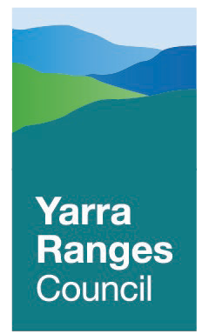

Y ARRA RANGES COUNCIL
III

DRAFT W ASTEW ATER MANAGEMENT PLAN 2021 - 2026

EXECUTIVE SUMMARY
The Wastewater Management Plan has been developed in accordance with the requirements for Council under the State Environment Protection Policy (Waters) and the Environment Protection Act 1970. The Plan has been designed to assist in the critical assessment of parcels of land to determine whether wastewater can be treated and retained within the boundaries with minimal risk to public health and the environment.

The Plan has recognised the risks for existing wastewater treatment systems including the age of the system, lack of maintenance and point of discharge for effluent. Effective management of existing systems will help to protect public health and the environment.

The Plan has been developed to recognise and support existing Council policies. These policies recognise Council’s obligation to fulfill their legal responsibilities and have a strong emphasis on the protection of the unique natural environment within the Yarra Ranges. This includes the declared special water catchment areas that need protection due to providing potable and non- potable water supplies for human consumption, industry and agricultural purposes.

An important component of the Plan is the identification of risk that can impact the ability of a property to treat and contain wastewater. The spatial risk assessment has identified the soil type, dwelling density, possibility of landslip and the proximity to watercourses as the main risk factors and provides the platform for conducting rolling inspections of existing systems and the assessment of new applications.

The Victorian Auditor General’s Office (VAGO) 2018 audit entitled ‘Managing the Environmental Impacts of Domestic Wastewater‘, has identified the practices that Council should adopt to ensure effective management of wastewater both collectively with other agencies and individually within the Shire. Council will use this Plan at the platform to meet and exceed the recommendations of the VAGO audit.

The plan outlines the recognised risks associated with development planning and the considerations for the treatment and retention of wastewater onsite. These risks are coupled with how Council employs constraints or controls to ensure effective wastewater management that controls public health and environmental concerns as well as meeting Council’s legal requirement outlined in AS/NZS Standard 1547 – On-site wastewater management to control risk.

It is important to recognise the relationship between Council and the water corporations that oversee sewerage infrastructure and manage protected waterways. The provision of reticulated sewer needs to be in an area where there are issues with existing wastewater treatment systems or for increased urban development.

INTRODUCTION

This Wastewater Management Plan (WMP) has been developed to assist in the critical assessment of parcels of land within Yarra Ranges Council (‘Council’) that will generate wastewater without the availability of reticulated sewer for disposal. This Plan provides a detailed overview of wastewater management within the municipality including:

- The constraints to effectively retain wastewater onsite in a manner that protects public health, the environment and local amenities;
- The recognition of legislative controls that govern onsite wastewater management, and
- Recognition of how this Plan compliments existing Council policies and plans.

  - OVERVIEW OF ONSITE WASTEWATER MANAGEMENT
An onsite wastewater treatment system is required for the collection, holding, treatment and disposal of wastewater where reticulated sewer is not available. The system is designed for bacterial, biological, chemical and / or physical treatment of wastewater prior to disposal so as to minimise the impact on public health, the environment and local amenities.

Under the Environment Protection Act 1970, Council has been delegated as the regulatory authority that has the responsibility to manage individual onsite wastewater treatment systems within their municipality. Section 53J(2) of the Act confirms that Council is responsible for overseeing systems that have been designed to discharge less than 5,000 Litres of wastewater per day.

The State Environment Protection Policy (Waters) requires a Council that manages onsite wastewater treatment systems to develop and implement a Wastewater Management Plan. This requirement is outlined in Clause 29, which states that the Plan must:

- Identify public health and environmental risks associated with onsite wastewater treatment, and
- Outline strategies to minimise the identified risks.

The Plan is a document that outlines wastewater policies that are developed, implemented and reviewed to maintain and improve public health, the environment and local amenities.

  - THE REGION
The Yarra Ranges Council area is located on the eastern fringe of metropolitan Melbourne, between 30 and 110 kilometres east of the CBD. The region stretches from the densely populated outer suburbs of Mooroolbark and Lilydale into the foothills, agricultural valleys and forested areas of the Great Dividing Ranges. The municipality shares boundaries with nine other Councils including Murrindindi Shire in the north, Mansfield Shire in the east, Baw Baw Shire in the south, and the City of Knox in the west.

The Council covers an area of roughly 2,500 square kilometres and has a population of over 158,000, which equates to an average population density of 0.64 people per hectare. The Shire balances a mix of urban and rural communities, with the majority of the population living in urban areas.

Y ARRA RANGES COUNCIL 1

DRAFT W ASTEW ATER MANAGEMENT PLAN 2021 - 2026

Yarra Ranges Council has approximately 22,000 active onsite wastewater treatment systems, which is the second most for any municipal Council within Victoria. The Shire also contains large areas of public forested land that provide important water catchments for Melbourne and significant areas of remnant native vegetation.

The rural areas of the Shire contain visually attractive landscapes comprising an intricate mix of open valleys, rolling foothills, steep forested land and majestic mountain ranges. The scenic features of the non-urban areas are an integral component of the image and identity of the Shire.
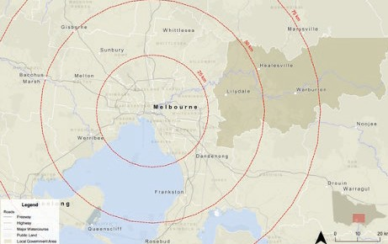

The Yarra Ranges Council contains three distinct and unique areas commonly referred to as the urban, valley and hills area. Each area has distinct characteristics that impact on domestic wastewater management.

Urban
Located toward the western end of the municipality comprising the suburbs of Lilydale, Kilsyth, Mooroolbark, Mount Evelyn and Chirnside Park. Referred to internally by Council as the urban triangle, the area contains a high density of residential properties accounting for approximately 70 per cent of the population that has been condensed into around 3 per cent of the land area within the municipality. The common soil types to the urban area include brown chromosol (Lilydale) and black vetosol (Chirnside Park).

Brown chromosol soil usually has a silty surface that is dispersive when in contact with moisture. The silty surface soil becomes unsettled when it comes into contact with water, which then hardens when the soil dries. This results in a reduction in the percolation rate of the soil as dispersion takes longer to occur when the soil again comes into contact with water. Black vetosol soils contain a high concentration of clay particles that shrink and expand when water is introduced and removed during wet and dry seasons, which results in a lower percolation rate. Both soil types demonstrate slow drainage properties.

A low percolation soil rating may require additional controls by Council for effective wastewater management. This may include:

- Increasing the size of the Land Application Area to prevent inundation;
- A higher level of treatment for effluent prior to disposal;
- Reducing wastewater generation through recycling and reuse of treated effluent, and
- Lowering wastewater calculations at the planning stage, which may require a reduction in the number of bedrooms for a residential dwelling or changes to activities at a commercial property.

Valley
The Valley is an interal term used to reference the upper regions surrounding the Yarra River. The major towns include Coldstream, Yarra Glen, Healesville and Warburton that are home to many primary produce food businesses (such as manufacturing and wineries) making it a popular tourist destination. The common soil types in the region include brown chromosol (Yarra Glen) and red dermosol (Don Valley).

Red dermosol soil is common to areas that are located within or close proximity to water catchment areas that usually have the additional characteristics of high average rainfall levels and higher groundwater tables. Red dermosol soil has been classified as a diverse, well structured soil type that displays good drainage properties and is well suited to primary food production.
Wastewater generated from commercial activities may require controls such as:

- Large or specially designed treatment systems to effectively treat and contain higher levels or surge loads of effluent;
- Secondary or advanced secondary treatment systems capable of effectively treating effluent with high organic loading;
- The use of holding / buffer tanks to store effluent that can either be periodically discharged through the wastewater treatment system or transported offsite to help prevent system overloading;
- A Land Application Area that has clear separation from primary food production, grain livestock and vehicle use, and
- A Land Application Area that is located in an area that minimises the risk of contamination to; o Water catchments;
  - Waterways that connect to water catchments;
  - Waterways that harness potable water in food production or for livestock, and
  - High groundwater supplies – including seasonal fluctuations.

Hills
The Hills are a component of the Dandenong Ranges and is a popular spot for tourists and visitors due to the forests and walking tracks. The major towns include Monbulk, Olinda and Sassafras that are home to popular cafés and restaurants. Red dermosol soil is common to the hills area. Wastewater controls that may be required in the Hills area may include:

- Large or specially designed treatment systems;
- Secondary or advanced secondary treatment systems;
- The use of buffer / holding tanks;
- Installation of food and oil interceptors to separate waste prior to treatment from the wastewater system, and
- The requirement for upgrades to existing systems for higher treatment of effluent where wastewater cannot be retained within property boundaries.

Y ARRA RANGES COUNCIL 3

Y ARRA RANGES COMMUNITY P ANEL

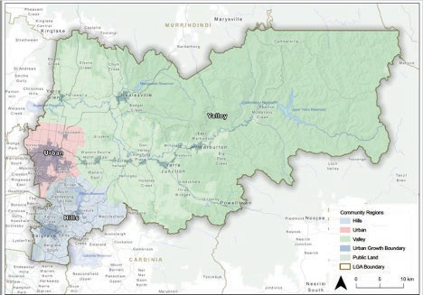

COUNCIL RESPONSIBILITIES
The roles and responsibilities of Council are clearly outlined in the various laws, codes and policies that govern onsite wastewater management. In addition, standards are available to guide decision-making by Council for effective wastewater management.

The Code of Practice – onsite wastewater management (EPA Publication 891.4 – 2016)
The Code of Practice – onsite wastewater management outlines statutory responsibilities for municipal Councils regarding onsite domestic wastewater management. This includes:

- Developing a wastewater management plan in accordance with the requirements of the State Environment Protection Policy (Waters);
- Issuing planning permits with a requirement for the provision of reticulated sewerage to be provided when wastewater cannot be retained within the property boundaries, and
- Assessment of land development applications to determine the suitability of a site for onsite wastewater treatment where reticulated sewerage is not available.

Under the Environment Protection Act 1970, Council is responsible for managing onsite wastewater treatment systems that generate wastewater loads less than 5,000 Litres per day. This responsibility includes overseeing the installation, operation, management and servicing of systems in accordance with the requirements of the Code of Practice – onsite wastewater management (EPA Publication 891.4 – 2016), which includes:
- Assessing permit applications to ensure onsite wastewater treatment systems are designed in accordance with legislative requirements and Australian / New Zealand Standards;
- Refusing to issue permits for a proposed development where wastewater cannot be contained within the boundaries of the property or an identified risk cannot be suitably managed;
- Providing a permit granting approval to install a new or alter an existing system;

- Monitoring the installation of systems for compliance with legislative requirements and permit conditions;
- Issuing a certificate approving use of a system;
- Monitoring active systems for compliance with maintenance / servicing requirements and permit conditions, and
- Investigating issues with onsite wastewater systems that may impact public health, the environment and / or local amenities.

Environment Protection Act 1970
The Environment Protection Act is the main regulatory tool used by Council to oversee the correct installation and responsible use of onsite wastewater treatment systems. The Act defines an onsite wastewater treatment system as ‘a system for the bacterial, biological, chemical or physical treatment of sewage, and includes all tanks, beds, sewers, drains, pipes, fittings, appliances and land used in connection with the system.’

The Act outlines the controls for the installation and use of an onsite wastewater treatment system, including:

- The requirement for a permit to be issued by Council to construct, install or alter any part of a system;
- That the conditions outlined in the permit must be complied with;
- A system cannot be used until Council has inspected the system and issued a permit approving its use, and
- The system must be maintained in accordance with the requirements outlined in the permit.

The application process is guided by the principles outlined in Section 1B to 1L of the Act, with particular consideration given (but not limited) to:
  - Decision making should be guided by a careful evaluation to avoid serious or irreversible damage to the environment wherever practicable – outlined in the precautionary principle;
  - Protection of the environment is a responsibility shared by all levels of Government and industry, business, communities and the people of Victoria – outlined in the principle of shared responsibility, and
  - The measures adopted should be cost-effective and in proportion to the significance of the environmental problems being addressed – outlined in the principle of integration of economic, social and environmental considerations.

These requirements are applied by Council to all approved wastewater and recycling systems that treat, compost or hold wastewater and organic matter prior to disposal. For approval to be provided the systems must be:

- Compliant with the Act and the Code of Practice, and
- Have a certificate of conformity issued under relevant Australian Standards by an accredited JAS-ANZ (Joint Accredited System of Australia and New Zealand) Conformity Assessment Body (CAB).

The current Environment Protection Act is under review and will be replaced with the Environment Protection Amendment Act 2018 that will become law on 1 July 2021. The aim of the new Act is to update the waste management framework with a strong focus on reducing the environmental impact of waste materials while advocating for waste material reuse, recovery and resource efficiency.
Y ARRA RANGES COUNCIL 5

DRAFT W ASTEW ATER MANAGEMENT PLAN 2021 - 2026

State Environment Protection Policy (Waters)
State Environment Protection Policies (SEPPs) are developed under controls outlined in the Environment Protection Act as an additional legal framework to protect and improve the natural environment. The current State Environment Protection Policy (Waters) has been developed to:

- Help provide a smooth transition from the existing Environment Protection Act to the new
Environment Protection Amendment Act, and
- Provide regulatory authorities with the controls to be employed to protect and manage waters within Victoria.

The success of these measures will be determined by the ability to:
- Achieve the level of environmental quality required to protect the beneficial uses of waters;
- Ensure that pollution to waters from both diffuse and point sources is managed in an integrated way to deliver the best outcome for the community as a whole, and
- Protect and improve environmental quality through consistent, equitable and proportionate regulatory decisions that focus on outcomes and use the best available information.

Yarra River Protection (Wilip-Gin Birrarung Murron) Act 2017
The Act is the first piece of co-titled legislation in Australia as it contains Traditional Owner language. ‘Wilip-Gin Birrarung Murron’ originates from the Wurundjeri Woi-wurrung people and translates as ‘keep the Birrarung alive’ in recognition of the Traditional Owners’ custodianship and connection to the river and surrounding land. The main objectives include:

- Recognition of the need to protect the Yarra River and surrounding public land as a single living and integrated natural entity;
- Outlining principles that responsible public entities must employ while undertaking duties or exercising powers regarding Yarra River land, and
- To establish a Council to provide advice to the relevant Minister regarding land use and development that may impact Yarra River land.

Public Health and Wellbeing Act 2008
The purpose of the Act is to promote and protect public health and wellbeing within Victoria. The Act outlines that water or emissions may constitutes a nuisance if they are, or liable to be, dangerous to health or offensive, which is further defined as being noxious or injurious to personal comfort. It also states that it is an offence by a person to cause a nuisance, or knowingly allow or suffer a nuisance to exist on, or emanate from any land owned or occupied by that person.
Section 60 of the Act outlines that Council is duty bound to remedy as far as reasonably possible all nuisances that exist in its municipal district. This includes nuisances relating to wastewater management and onsite wastewater treatment systems.
These provisions are guided by the principles outlined in Sections 5 to 11A with particular consideration given (but not limited) to:

- The prevention of illness and disease is preferable to remedial measures – outlined in the principle of primacy of prevention;
- Decisions made and actions taken in the administration of this Act should be proportionate to the public health risk sought to be prevented, minimised or controlled – outlined in the principle of proportionality, and
- Public health and wellbeing, in Victoria and at a national and international level, can be enhanced through collaboration between all levels of Government and industry, business, communities and individuals – outlined in the principle of collaboration.

WASTEWATER MANAGEMENT PLAN
This plan includes an overview of the risks wastewater poses to Yarra Ranges Council and the proposed actions designed to successfully manage onsite wastewater systems within the municipality. The objectives of this plan include:

- Recognising the current state of onsite wastewater management within the municipality and the risks involved;
- Developing a proactive approach to evaluate and improve active onsite wastewater systems;
- Achieve ongoing compliance with current legislative controls and quickly adapt to changes from new legislation;
- Promotion of sustainable wastewater practices, and
- Guidance for planning and investigation of community sewerage programs and alternative services for wastewater management.

RISKS ASSOCIATED WITH WASTEWATER MANAGEMENT
Yarra Ranges Council has the second highest number of active onsite wastewater systems of all Victorian municipalities, with approximately 22,000 properties currently managing wastewater onsite. This equates to more than one in three of all rateable properties within the Yarra Ranges managing wastewater onsite.

Many aspects of onsite wastewater management are embedded within the Planning Scheme and are well managed by Yarra Ranges Shire. This is particularly the case in relation to ensuring new development is undertaken sustainably.
However, at present there is limited information about existing onsite wastewater treatment systems. It is expected that:

- A high percentage of systems have most likely exceeded their life expectancy;
- Many systems are not being serviced in accordance with manufacturer instructions;
- Older properties still discharge to the roadside or an easement, which was the legal point of discharge at the time of installation – prior to 1988 untreated grey water could be discharged, and prior to 1996 treated wastewater could be discharged;
- There are potentially illegally installed systems, given the size and rural nature of the Shire, and
- Owners and occupiers of properties with wastewater treatment systems may be unaware of their system type, location, capacity and legal point of discharge.

In addition, older permits were issued in perpetuity, and Yarra Ranges Council has limited capacity to force compliance with current standards.

RISKS ASSOCIATED WITH WASTEWATER TREATMENT SYSTEMS
Onsite wastewater treatment systems have been designed to provide temporary storage for wastewater prior to disposal. Temporary storage of wastewater allows time for treatment through processes such as filtration, sedimentation, flocculation and floatation. These processes are designed to remove organic and inorganic matter from the wastewater with further reduction of matter through microbiological digestion from anaerobic bacteria.

Y ARRA RANGES COUNCIL 7

DRAFT W ASTEW ATER MANAGEMENT PLAN 2021 - 2026

Onsite wastewater treatment systems that are not provided with regular servicing / maintenance or have foreign materials deposited in the system are unable to function properly. This can include the inability of the system to remove a sufficient amount organic and inorganic matter prior to the wastewater being discharged to the effluent field or legal point of discharge. Wastewater that is not properly treated may discharge effluent that contains the following pollutants into the environment:

- Human waste;
- Food solids as well as fats, oils and grease;
- Chemicals from non-biodegradable cleaning products or products high in sodium or phosphorus;
- Highly concentrated bleaches, whiteners and disinfectants, and
- Paints and thinners.

Effluent discharged from onsite wastewater treatment systems can have a significant impact on the natural environment. The goal of wastewater management is to protect the natural environment, community health, social wellbeing and economic stability against the risks posed by wastewater. The potential risks associated with wastewater systems include:

- Public health – through contamination of drinking water and recreational water bodies with human pathogens;
- The environment – via pollution of surface waters and groundwater, with nutrients, pathogens and other pollutants, which can cause harm to aquatic fauna and indigenous vegetation, and
- Amenity – including offensive odours and unsightly discharges leading to reduced amenity and potentially impact on property values.

These impacts can occur when onsite wastewater systems have deteriorated, are poorly maintained, are not fit for purpose (e.g. inadequately sized), and/or are not properly located.

CONCEPTUAL FRAMEWORK
The following table outlines the conceptual framework for this wastewater management plan. All relevant components of wastewater management fall within one of four categories. The top two categories highlight the importance of a proactive approach to managing existing systems while the remaining two categories recognise the need for forward planning to prevent potential future issues.

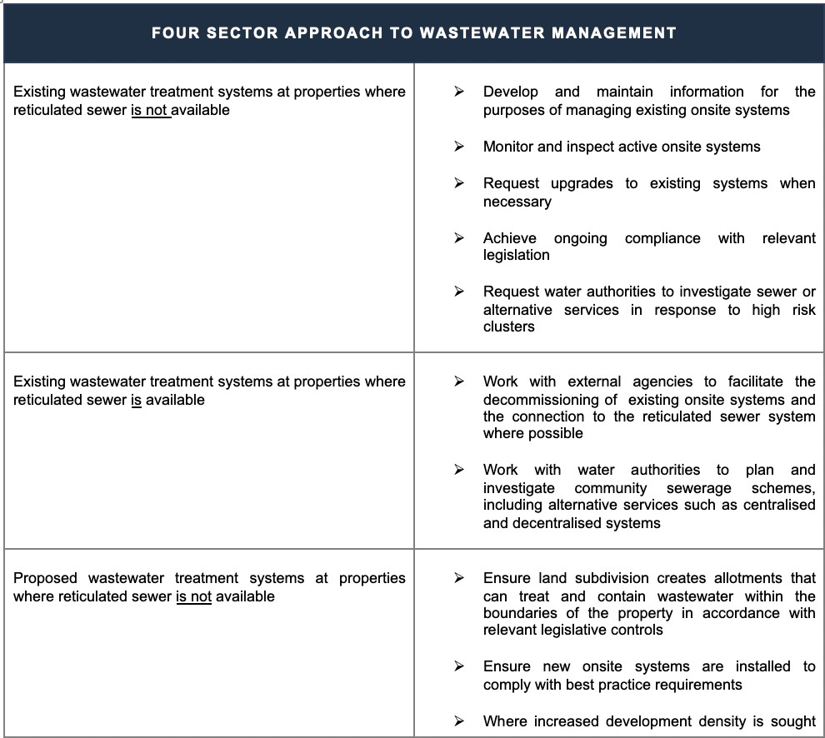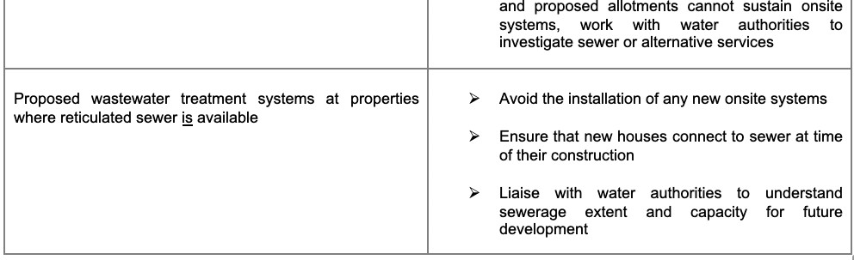

Y ARRA RANGES COUNCIL 9

DRAFT W ASTEW ATER MANAGEMENT PLAN 2021 - 2026

YARRA RANGES CONTEXT

POLICIES AND PROCEDURES
The Wastewater Management Plan has been designed to recognise and complement existing Council policies. The Policies and Plans listed below recognise the importance of the natural environment and the threats and challenges faced for sustainability and improvement.

Council Plan 2017-2021
The vision statement developed by Yarra Ranges Council provides a clear view of the aspirations for the future of the municipality. The vision statement was formulated in 2016 and was based on the submissions from more than 1,000 members of the community. The vision of the Yarra Ranges Council is:

‘Whether you live here or visit, you will see how much we value our natural beauty, how connected our communities are, and how balanced growth makes this the best place in the world.’

This vision is further enhanced by the recognised Yarra Ranges Community Values Statement outlining the high value placed on clean rivers and streams, fresh air as well as the many native plants and animals that inhabit the local environment.

Five strategic objectives have been identified by Council to help achieve the overall vision by the year 2036. The strategic objectives are:

- Connected and healthy communities;
  - Recognition that active spaces are needed for sustaining mind and body.
- Quality infrastructure and liveable places;
  - The community values its role in preserving the land for future generations.
- Protected and enhanced natural environment;
  - Importance is placed on providing fresh air, clean rivers and streams as well as protecting native plants and animals.
- Vibrant economy, agriculture and tourism;
  - Residents and visitors value local attractions and produce.
- High performing organisation.
  - Council will continue to recognise community needs and expectations.

Environment Strategy 2015-2025
The vision for the Environment Strategy is consistent with the objective of the Council Plan. The vision of the Environment Strategy is that:

‘We are dedicated to making Yarra Ranges a place of thriving communities, at home in healthy landscapes.’

The vision statement contains three clear elements:

- Our place, our healthy landscapes;
  - Including landscape diversity, waterways, animals and plants.
- Thriving communities;
  - Recognising how local communities and economies work with the natural environment.
- My home.
  - How individual live with, belong to and respond to the environment.

These three main elements have been further translated into six goals that provide the framework for environmental program planning and decision making for the duration of the Environmental Strategy. The six goals are:
Goal 1 – Our iconic places and their natural character are actively protected;
Goal 2 – Our water resource is improved and preserved;
Goal 3 – Our native plants and animals are protected and their habitat enhanced;
Goal 4 – Our local economies are strengthened by environmentally sustainable activities;
Goal 5 – Our communities are resilient to the face of a changing climate and more extreme events, and
Goal 6 – All who live and work in the Yarra Ranges see themselves as stewards of our environment.

Flora and Fauna Plan 2012
The Flora and Fauna Plan is an integral step by Council toward the long-term protection, preservation, management and enhancement of the natural environment including the provision of fresh air and clean water. The plan recognises the need to educate land owners and residents to better understand how various domestic and commercial activities can disturb or change the ecology of the natural environment.

Green Wedge Management Plan 2010
The green wedge zone within the municipality covers around 237,000 hectares (or 2,370 square kilometres) of land that stretches through the Yarra Valley, the Yarra Ranges and the Dandenong Ranges (approximately 95 per cent of the total land area within the Shire). The green wedge zone is the largest in Victoria and is predominantly located within Yarra Ranges Council with small components extending into the neighbouring Councils of Cardinia, Casey, Maroondah and Knox. The aim of the Green Wedge Management Plan has been to establish a vision and set of objectives for the sustainable management of the green wedge area that reflects the vision and values of existing stakeholders including government organisations, land owners, land managers and community groups.

The Plan highlights the need for sustainable practices such as harvesting treated wastewater from onsite wastewater treatment systems for reuse within the environment such as sporting ovals and golf courses. It also recognises the risk to groundwater supplies and catchment areas given the number of active systems (approximately 17,000) within the green wedge zone acknowledging that a high number present a significant risk to the natural environment due to the age of the system, low level of treatment prior to effluent disposal, lack of servicing and allowance for a legal point of discharge of wastewater outside the boundary of the property.

Health and Wellbeing Strategy 2017-2021
The Health and Wellbeing Strategy recognises the direct relationship between the health of the natural environment and the physical and mental wellbeing of residents and visitors. The Strategy has identified a need to prioritise resilient and liveable communities with the long-term goal being to enable people to enjoy safe and sustainable natural and built environments.
A priority of the Strategy is to undertake statutory, building and health planning in a manner that guides future land use and development for the protection of the natural environment.

Y ARRA RANGES COUNCIL 11

DRAFT W ASTEW ATER MANAGEMENT PLAN 2021 - 2026

Integrated Water Management Plan 2017
The Integrated Water Management Plan (IWMP) has been implemented to protect the waterways within Yarra Ranges Council. This is reflected in a component of the vision statement, which states:
‘As custodians of the upper Yarra River and Dandenong Creek catchments, the Yarra Ranges ensures water passing through the municipality
is of high quality for downstream users and the environment.’

The plan recognises that conventional approaches to stormwater management that were implemented for quick drainage of water have caused issues including declining waterway health
– due to pollution and changes to the natural flow of the waterways. The plan has identified the following components to implement to improve the health of the natural waterways, which are to:

- Minimise the use of potable water supplies;
- Increase the use of alternative water supplies generated from rainwater, stormwater and treated wastewater reserves;
- Implement best practice policies to optimise stormwater as a resource;
- Reduce discharges to the natural environment from reticulated sewer and onsite wastewater treatment systems, and
- Promote sustainable use of groundwater and surface water supplies.

The implementation of these components has been based on the guiding principles of resource efficiency, multiple benefits to the community, ensuring the recycled water is appropriate for the intended use and employing flexible practices with regard to centralised and decentralised for harvesting the alternative water supplies.

WATERWAYS AND CATCHMENTS
Council’s Environment Strategy (2015-2025) identified the environmental assets located within the municipality that have a significant impact on the air quality, water quality, condition of the soil for growing primary produce and the habitat that is provided for indigenous wildlife. The Strategy recognised the importance of the local waterways for potable water supplies not only to the municipality and the surrounding areas but the wider community.

‘The upper half of the Yarra River and its tributaries support a diverse range
of plants and animals including significant populations of platypus, frogs and fish. These waterways and key dams and reservoirs such as O’Shannassy, Upper Yarra, Maroondah and Silvan provide about 70% of Melbourne’s drinking water’.

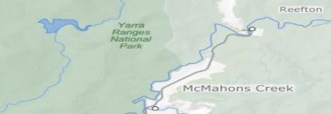
O’Shannassy Reservoir REREREReReReservoir

Located near McMahon’s Creek (approximately 80 kilometres east of Melbourne), the reservoir is a man-made structure with around a 3.1 gigalitre capacity. The reservoir forms part of the water supply chain for Melbourne and gravity feeds water through to the Silvan Dam. It is the smallest reservoir managed by Melbourne Water but is considered productive due to the high flow rate to downstream catchments.

Upper Yarra Reservoir
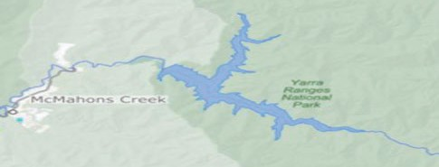

The reservoir provides valuable water supplies to the Yarra Valley townships. The reservoir is situated in the township of Reefton, which is approximately 20 kilometres past Warburton and about 100 kilometres east of Melbourne. The reservoir has a capacity of around 200,000 megalitres that feeds into the Silvan Dam.

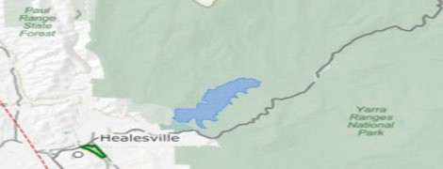
Maroondah Reservoir
The reservoir is located between Healesville and Chum Creek (about 70 kilometres east of Melbourne). Water is retained from the Watts River and the reservoir has a capacity of 22,000 megalitres, which is a source of potable water for the Melbourne metropolitan area.

Y ARRA RANGES COUNCIL 13

DRAFT W ASTEW ATER MANAGEMENT PLAN 2021 - 2026

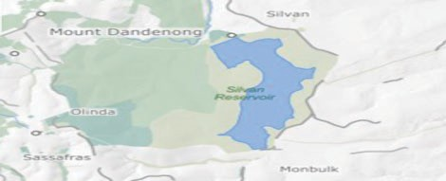
Silvan Reservoir
Silvan Reservoir is located in Silvan (approximately 40 kilometres east of Melbourne). Silvan is considered an off-stream storage reservoir as the main supply of water is provided by other catchments and reservoirs. The reservoir has a storage capacity of 40,000 megalitres and provides potable water supplies direct to townships as well as other storage reservoirs including Greenvale and Cardinia.

Declared Special Water Catchment Areas
A catchment can be a source of potable water for domestic, industrial and farming purposes as well as helping to maintain native flora and fauna. If the catchment is considered to have significant value it can be protected under the controls outlined in the Catchment and Land Protection Act 1994. The Act, previously known as the Soil Conservation and Land Utilisation Act 1958, provides a framework for the integrated management and protection of catchments within Victoria. This includes allowing water supplies to be classified as declared special water catchment areas for protection purposes given their recognised importance to community groups, planners and land managers.

The protection of water catchments in Victoria is a component of integrated catchment management (ICM), which aims to provide sustainable management of land and water resources while supporting biodiversity. The Victorian Catchment Management Council is the main advisory body on catchment management and is responsible for recommending water bodies for declared special water catchment area status to the relevant State Government Minister.
There are currently 134 declared special water supply catchment areas located within the nine Victorian Catchment Management regions. Yarra Ranges Council is part of the Port Phillip Catchment Region that includes 26 catchment areas. There are five catchments within the municipality, which are:

Healesville
Recognised as special water catchment area in 1966, Healesville contains the Coranderrk Aqueduct that transports water directly to the local township and downstream to the Silvan Reservoir. The area is also home to Coranderrk Creek, which has significant value to the Coranderrk Aboriginal Mission and Badger Creek located near Healesville Wildlife Sanctuary

McCrae Creek
McCrae Creek was declared a special water catchment area in 1965 for the Gembrook-Cockatoo- Emerald Waterworks Trust. The Creek is approximately 21km in length and runs from Gembrook through Kurth Kiln Regional Park to Yellingbo with a catchment area of approximately 1,280 acres. The catchment area includes around 800 acres of freehold land and 400 acres of reserved forest. The remaining land consists of a Quarry Reserve and Crown Land located along the creek frontage that provides water to the townships of Gembrook, Cockatoo and Emerald.

Mick Creek
Mick Creek is located approximately 10 kilometres north of the township of Healesville near the Toolangi State Forest. The Creek was recognised as a special water catchment area in 1972 for the Healesville Waterworks Trust with the main catchment area located in Tarrawarra North. Mick Creek is considered a tributary as it flows directly into the Yarra River.

Britannia Creek
The Creek obtained special water catchment supply status in 1980. Managed by the Yarra Junction Waterworks Trust the catchment provides water to the townships of Yarra Junction and Wesburn through an outlet in the western part of the catchment in a reserved forest area approximately 18 square kilometres in size.

Tomahawk Creek
The Creek is located on the south boundary of the Yarra River catchment between Gembrook and Powelltown and has a catchment area of approximately 337 hectares. Tomahawk Creek is recognised as a special water catchment supply area in 1984 due to supplying water to the Gembrook-Cockatoo-Emerald Waterworks Trust.

CATCHMENT MANAGEMENT AUTHORITIES
A catchment management authority is responsible for the integrated planning and co-ordination of land, water and biodiversity management in a catchment and land protection region. The authority consists of board members whose primary responsibility is to develop a catchment management strategy, which outlines the planning framework for managing the land, water and biodiversity resources.
The aim of the strategy is to identify community expectations and incorporate regional requirements in relevant laws and policies where possible. This can include:

- The land, water and biodiversity resources and their current uses;
- The nature, cause, extent and severity of degradation to catchments;
- A long-term vision for the region, and
- A program of management measures for the duration of the strategy.

The strategy is prepared by the catchment management authority in partnership with relevant organisations (including local governments) and local communities. The catchment management authority for the Port Phillip Catchment region developed the Yarra4Life Strategic Plan in conjunction with relevant parties, which included representatives from Yarra Ranges Council.

Yarra4Life Strategic Plan 2017-2022
The strategic plan has been designed to develop and support biodiversity and environmental improvement projects across the catchment region of the Yarra Valley, which is around 82,000 hectares in size. The Port Phillip catchment management authority co-ordinates the strategy on behalf of the Victorian National Parks Association, Parks Victoria, DELWP (the Department of Environment, Land, Water and Planning), Melbourne Water and local Councils (Yarra Ranges and Cardinia Shire).

Y ARRA RANGES COUNCIL 15

DRAFT W ASTEW ATER MANAGEMENT PLAN 2021 - 2026

The vision of Yarra4Life states that:
‘Ecosystems across the Yarra4Life landscape are protected, connected and resilient, and supported by a community that values the natural environment’.
The strategy aims to protect the environment (including catchment areas) through educating local community to better understand the local environment and providing a platform for individuals and organisations to work together to improve the environment.

LAND CAPABILITY ASSESSMENTS
Council can request a Land Capability Assessment (LCA) report to determine whether a parcel of land has the ability to treat and contain wastewater within its boundaries. The independent report must be prepared by a suitably qualified and experienced soil scientist, hydro-geologist or geotechnical engineer. Discretion can be used by Council when requesting LCA reports if sufficient information is already available and the land is considered to be low-risk to human health and the environment. However, under the requirements of the Code of Practice – onsite wastewater management it is mandatory for Council to request that a LCA report be provided for a development in a declared special water catchment area due to the recognised high risk and potential consequences of onsite wastewater treatment.

A Land Capability Assessment (LCA) can be provided on any of the three following levels, which generally provide mapping and land system studies in context to the size of the development. The three levels are:

- Broad scale – used for regional or strategy planning;
- Intermediate scale – for planning in a municipal area, or
- Detailed scale – individual properties or sub-divisions.

The Land Capability Assessment (LCA) report should follow the guidelines outlined in the Municipal Association of Victoria (MAV) document entitled the Victorian Land Capability Assessment Framework (2014) to ensure information provided is consistent and objective. The report should therefore include:

- An outline of the established land use objectives and how they will be adhered to regarding the proposed development and the impact it potentially creates from onsite wastewater management;
- Identifying land characteristics that can impact onsite wastewater treatment such as slope, rainfall, soil texture, proximity to waterways and depth of bedrock;
- Recognising the hazards created by the land characteristics individually or collectively and the degree of impact on public health or the environment, and
- The actions or controls designed to manage, reduce or eliminate the identified risks.

  - COUNCIL PLANNING SCHEME
The Victorian planning system allows local government organisations to develop individual planning schemes to suit the individual needs of their own municipality. The purpose of the Victorian planning scheme is:

- To provide a clear and consistent framework within which decisions about the use and development of land can be made;
- To express state, regional, local and community expectations for areas and land uses, and
- To provide for the implementation of State, regional and local policies affecting land use and development.

A municipal planning scheme is generally developed in accordance with the vision and strategic direction of the Council and is designed to complement any existing planning policies. A main aim of the Yarra Ranges Council planning scheme is to protect public health and well-being;

- Preventing pollution of the natural environment including land, water and air;
- The protection, restoration and enhancement of environmentally sensitive areas;
- Sustainable management of existing waterways;
- Balancing the demand for development while minimising the impact on the natural environment,
- Recognising emerging hazards and their potential future impact.

EMERGING HAZARDS

CLIMATE CHANGE
The average global temperature has been increasing in recent years and has had a significant impact on the natural environment. Higher temperatures can result in a change to the evaporation rate in the atmosphere, which can result in an increase in the number and intensity of extreme weather events such as rainfall and storms.

Yarra Ranges Council has recognised the validity of scientific information published regarding the impact of climate change and the importance of reducing its carbon footprint. Council has developed a climate policy entitled ‘Adapting to a changing climate and energy future’ to outline practices to mitigate and adapt to changes in the climate. The policy includes the following objectives:

- To build and maintain community infrastructure that is resilient to withstand extreme climatic events;
- To incorporate land management approaches that assist the environment to adapt to climate changes;
- Sustainable resource use to protect the environment, and
- The development of risk management strategies to reduce or mitigate the impact of short- term emergency situations including extreme weather events.

An increase in the number and / or intensity of extreme weather events including rainfall and storms can have a significant impact on the controls employed by Council for effective onsite wastewater treatment. This can include:

- A greater requirement for Land Capability Assessments to be provided to demonstrate that the subject land is capable of effectively treating and containing wastewater within the boundaries;
- Requiring a minimum of secondary treatment for wastewater discharged to the environment;
- Changing the approved location of the Land Application Area (LAA), and
- The need for additional requirements to protect the LAA such as increasing the size of the area required to treat and contain wastewater or requesting the installation of cut-off drains to protect against surface water run-off.

Y ARRA RANGES COUNCIL 17

DRAFT W ASTEW ATER MANAGEMENT PLAN 2021 - 2026

LAND SUBJECT TO INUNDATION OVERLAY (LSIO)
Sensible planning controls for land use in urban and rural areas can help to protect human life, property and community infrastructure from the impact of flooding and the damage that it can cause. Flooding is caused by prolonged or heavy rainfall and is classified as either:

- Mainstream flooding - where extreme levels of rainfall cause high levels of surface water to discharge into rivers, creeks, streams and dams, or
- Stormwater flooding – where land in inundated due to drainage systems not having the capacity to cope with rainfall runoff.

Given the difficulty to predict the true extent of a flood, a Design Flood Event (DFE) standard is generally applied by Council when planning for future land use. The potential area identified in the DFE is referred to as land subject to inundation overlay (LSIO) and is used for planning purposes within Victoria. The current LSIO applies a 1 in 100 year average recurrence interval (ARI), which indicates that flooding is likely to occur on average only once in every 100 years. This ARI is used to determine flood levels and flood prone areas under the Water Act 1989.

The DFE can provide Council with the most accurate representation of the potential for flooding within the municipality and can then be applied to planning controls. The flooding information is used by Council to assist with onsite wastewater management in determining whether additional controls may be required to ensure wastewater is treated and retained onsite with minimal impact on public health and the environment.

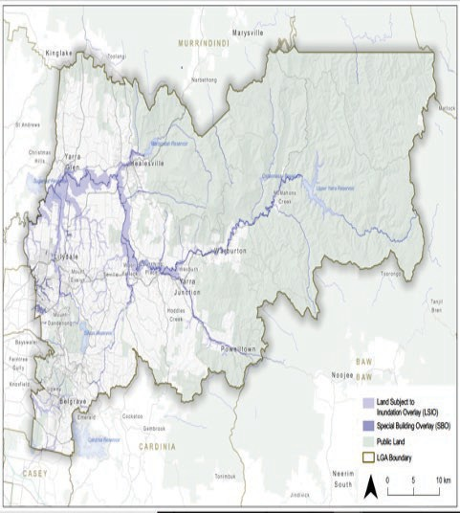

PROTECTION OF TREES ON DEVELOPMENT SITES
Australian Standard 4970 – 2009 Protection of trees on development sites states:

‘A living tree is a dynamic organism that needs specific environmental conditions to continue healthy, stable growth. It is rarely possible to
repair stressed and injured trees, so substantial injury needs to be avoided during all stages of development and construction’.

The Standard outlines that tree retention is important as it can provide:

- Aesthetic qualities;
- Heritage value;
- Benefits to the ecosystem – including the management of stormwater, and
- Social and psychological value.

The protection of trees must be considered when assessing a site for development where wastewater is required to be maintained onsite and may include vegetation both on the subject property as well as adjoining properties. In order to protect existing trees, consideration may need to be given to:

- Obtaining a report from a suitably qualified and experienced arborist that outlines the location of each Tree Protection Zone (TPZ), which is defined as the exclusive area around a tree set aside for the protection of the tree roots and crown;
- Establishing the potential sizes of Land Application Areas when dealing with potential sub- divisions and boundary realignments where future development is likely;
- Reducing the size of the required Land Application Area through wastewater recycling, reuse or reduction, and
- The installation of wastewater disposal systems that can be installed on top of existing ground or just below the surface - such as irrigation and Low Pressure Effluent Distribution (LPED) – that minimise the impact on recognised TPZ.

Y ARRA RANGES COUNCIL 19

DRAFT W ASTEW ATER MANAGEMENT PLAN 2021 - 2026

RISK ASSESSMENT

RISK FRAMEWORK
Australian Standard ISO 31000 : 2018 Risk management – Guidelines defines risk as the ‘effect of uncertainty on objectives’. Risk can arise where there is uncertainty about achieving an objective, which requires an organisation such as Council to co-ordinate activities to manage potential or identified risks.

Risk is normally expressed in terms of:

- The nature of the event, which can include information both at the time of and leading up to the event;
- The outcome or consequence of the event;
- The likelihood of the event occurring, and
- The measures to control the risk.

With regard to wastewater, the risk frame may relate to:
- The nature of the event such as:
  - The generation, collection, storage, treatment or disposal of wastewater;
  - The installation or use of a wastewater treatment system, or
  - Compliance with permit or legislative requirements by the owner or operator of a wastewater treatment system.
- The outcome or consequence of the event may relate to:
  - The potential negative outcomes of effluent disposal through a wastewater treatment system such as;
- Bacterial or chemical contamination of potable or recreational water supplies that may result in gastroenteritis in humans;
- Contamination of the natural environment that impacts flora and fauna, and
- Offensive odours or unsightly discharges that impact local amenities

The likelihood of the event occurring may be determined by the components of a wastewater treatment system including:
- The level of treatment the system provides;
- The point of discharge;
- The age of the system and frequency of servicing and maintenance, and
- The use by the owner or operator in accordance with permit conditions and manufacturers’ requirements.

Measure to control the risk can include:
  - Ensuring compliance with the requirements for installing new or altering existing wastewater treatment systems;
  - Conducting rolling inspections of existing legacy systems, and
  - Investigating potential issues notified to Council regarding existing wastewater treatment systems.

The potential negative impact from wastewater can be reduced by employing risk management practices in accordance with the principles outlined in ISO 31000:2018. Council will employ the six key principles of risk management to wastewater practices to assist in identifying, controlling and minimising potential issues generated by wastewater within the municipality. The six key principles are:

- An integrated organisational approach to wastewater;
- A structured approach to risk management regarding wastewater;
- A customised approach to wastewater that best suits the unique municipality of Yarra Ranges Council;
- The inclusion of relevant stakeholders where necessary;
- A dynamic approach to events, and
- The use of relevant, reliable and timely information where applicable.

There remains uncertainty as to the extent of the impact occurring, particularly when considering the cumulative impact across Yarra Ranges Shire. As such, there is a need to take a risk management approach in determining the actions Council should take to improve wastewater management.

Determining the level of risk requires assessment of both likelihood (the chance of an event occurring) and consequence (the severity of impact from the event). These are rated and then combined to determine risk level using the following matrices.

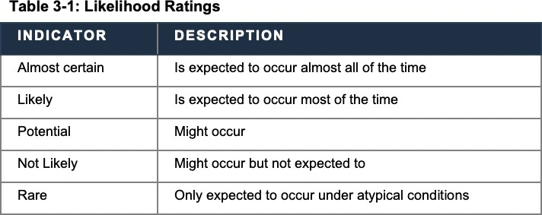

Y ARRA RANGES COUNCIL 21

DRAFT W ASTEW ATER MANAGEMENT PLAN 2021 - 2026

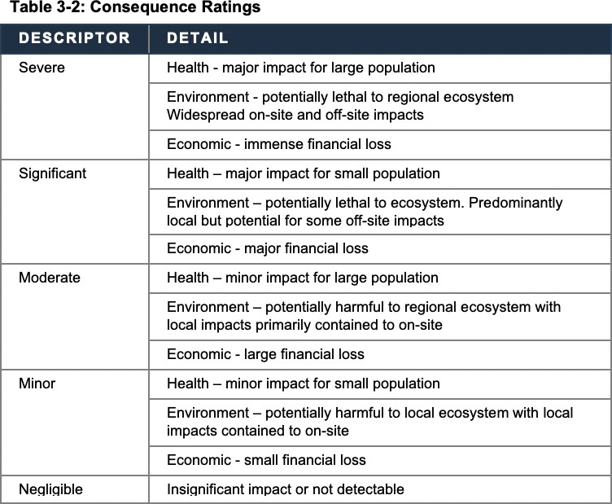

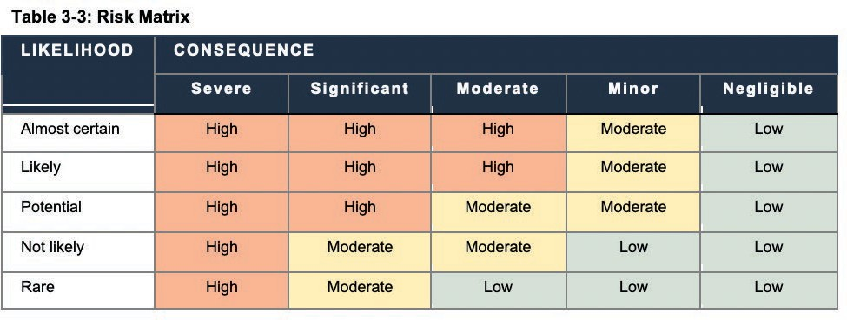
Once the level of risk has been determined, priority risks should be dealt with first. That is, the higher the risk the higher the priority. Also, risk is dynamic and therefore managing risk is iterative. This risk assessment and the selected risk treatments (actions) will need to be monitored and reviewed on a regular basis.
The risk assessment takes into account established practices at Yarra Ranges Council. As such, the assessment is of residual risk.

CURRENT RISK LEVEL
OVERVIEW
This WMP uses a four-sector approach to capture all aspects of onsite wastewater management. An overview of risk is provided below based on this matrix.
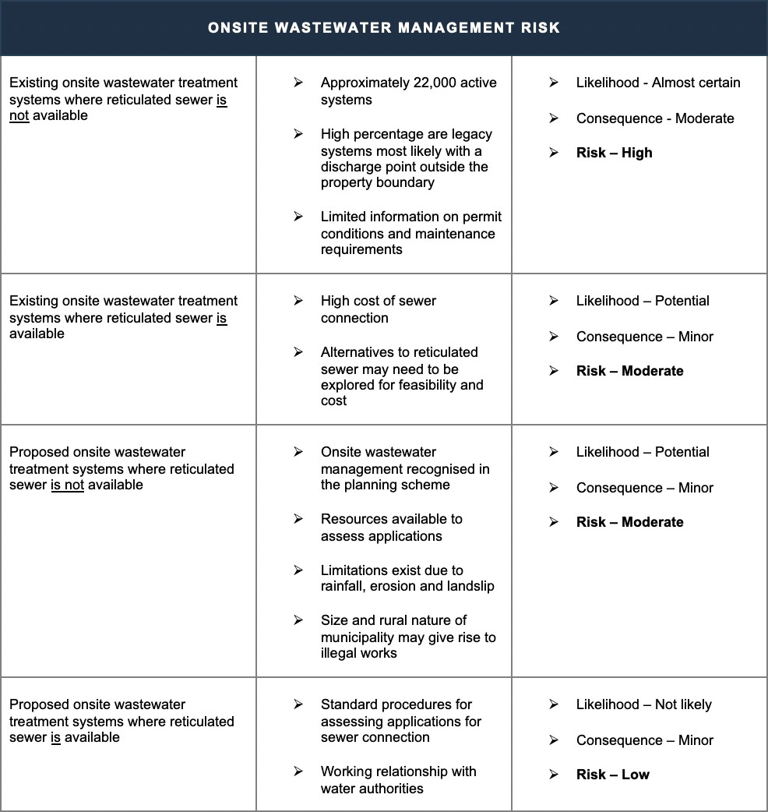

Y ARRA RANGES COUNCIL 23

DRAFT W ASTEW ATER MANAGEMENT PLAN 2021 - 2026

SPATIAL RISK ASSESSMENT
Many of the risks associated with onsite wastewater management vary spatially. This is of particular relevance when investigating the cumulative risk associated with onsite systems. Therefore, spatial risk assessment has been undertaken. This is a mapping exercise that combines various types of geographic information. The main risk factors that have been identified are;

- The density of onsite systems;
  - Above 40 houses per square kilometre (high risk); 20 to 40 houses per square kilometre (medium risk), and below 20 houses per square kilometre (low risk).
- The slope of the land;
  - Above 20 per cent and within the EMO (high risk), 10-20 per cent slope outside the EMO (medium risk), and below 10 per cent and outside the EMO (low risk).
- The soil type, and
- The erosion risk and the proximity to sensitive water systems and the natural environment o 5m depth and <1000 mg/L TDS OR < 30m of a watercourse OR <2km from
active potable water off-take – high risk
  - 5 - 10m depth and <1000 mg/L TDS, OR <5m depth and 1000 - 3500 mg/L TDS OR 30 to 60m from a watercourse OR 2 to 15km from active potable water off- take – medium risk, and
  - >10 m depth and >1000 mg/L TDS OR >5 m and >3500 mg/L TDS AND > 60m from a watercourse OR >15km from active potable water off-take – low risk.

The spatial risk assessment was tailored to suit the Yarra Ranges. It draws on recent approaches used by other councils in Victoria, and particularly the Edis Method that was developed for Mansfield Shire in 2014.

The risk assessment combines multiple risk factors to form an overall risk rating as shown in the maps in Appendix 1. This mapping can be used for the purposes of:

- Prioritising sites to be audited/monitored under an inspection program;
- Understanding key issues for or constraints on future development and the level of assessment required to ensure sustainable onsite wastewater systems are installed, and
- Understanding the need for and potential benefit of future sewerage connections or alternative services.

Conclusions drawn from the spatial risk assessment include:
- Many of the highest risk areas are currently under investigation for backlog sewerage by the urban Water Corporations. While this is promising, until sewerage actually becomes a reality for these areas, they remain highest risk from an onsite wastewater management point of view and need to be managed as such.

- The key locations of high-risk identified are:
  - Montrose, Kalorama, Mount Dandenong, Olinda, Sassafras, Sherbrooke,
Monbulk, Beagley Bridge, The Patch, Tecoma, Selby and Belgrave
  - Around the fringes of the sewerage investigation areas there are some areas of high risk that warrant consideration in the water corporation’s backlog schemes
  - In built up parts of Healesville, Healesville West, Warburton, East Warburton and Launching Place.

- Extensive area of medium risk land have been identified:
- Along the Upper Yarra River
- Along the streams in the Woori Yallock Catchment
- North of Mt Evelyn
- Gruyere and Yerringberg
- Steele’s Creek and the escarpment west of Yarra Glen

Full details of the spatial risk assessment are contained in a separate report (RMCG 2019, Spatial Risk Assessment – Yarra Ranges Council WMP)

Y ARRA RANGES COUNCIL 25

DRAFT W ASTEW ATER MANAGEMENT PLAN 2021 - 2026

VAGO

INTRODUCTION
Effective wastewater management is vitally important within the Yarra Ranges to maintain human health and protect the sensitive natural environment. The effective management of wastewater is undertaken by Council in conjunction with other regulatory authorities.
Victorian Auditor General’s Office (VAGO)

In 2006, the Victorian Auditor General’s Office (VAGO) released a report entitled ‘Protecting our environment and community from failing septic tanks’, which outlined the current state of wastewater treatment systems within Victoria and the recommendations for improvements. A follow-up audit report in 2018 entitled ‘Managing the Environmental Impacts of Domestic Wastewater‘, made the following observations, in that:

- An overly complex, onerous and duplicative framework exists for wastewater management;
- A lack of clarity exists for roles and responsibilities;
- Current regulatory tools do not ensure owner / operator compliance with permit conditions and legislative requirements, and
- Municipal Councils’ are not being held accountable for their role in wastewater management.
- The 2018 report provided recommendations specifically for Yarra Ranges Council. The five recommendations were:
  - Consult with relevant authorities in relation to integrated water cycle management planning so that the management of wastewater, stormwater, floods, alternative water supplies and drinking water supplies is not undertaken in isolation;
  - Implement a rolling annual program of inspections of wastewater treatment systems in identified high-risk areas for compliance with permit conditions;
  - Develop and implement a data management plan for the number, location and performance of active wastewater treatment systems;
  - Develop an education plan to inform owners and operators of wastewater treatment systems regarding their responsibilities for system maintenance, and
  - Finalise a wastewater management plan.

This Wastewater Management Plan developed by Council seeks to address the recommendations of the 2018 VAGO report.

CONSULT WITH RELEVANT AUTHORITIES
Municipal Association of Victoria (MAV)
The MAV has developed a framework to assist local government with Land Capability Assessment (LCA) reports. The framework entitled Model Land Capability Assessment Report was developed in 2006 to assist with understanding, critique and assessment of LCA reports.

Environment Protection Authority (EPA) Victoria
The EPA has developed numerous policies that Council applies to regulate onsite wastewater management so as to provide a uniform approach to treating and containing wastewater onsite. These policies assist in providing technical information for system designs to ensure calculated daily wastewater and Biological Oxygen Demand (BOD) levels can be effectively treated. The policies also provide clear guidance for correct system installation. The policies include:

- EPA Publication 891.4 – Code of Practice – onsite wastewater management (2016);
- EPA Publication 500 – Code of Practice for Small Wastewater Treatment Plants (1997)

In addition, EPA Victoria provides a list of certified wastewater treatment systems that Council can approve for installation. The system types that can be approved are consistent with the requirements outlined in the following Australian / New Zealand Standards:

- AS/NZS 1546.1: 2008 – On-site domestic wastewater treatment units – Septic tanks;
- AS/NZS 1546.2: 2008 – On-site domestic wastewater treatment units - Waterless composting toilets;
- AS/NZS 1546.3: 2017 – On-site domestic wastewater treatment unites – Secondary treatment systems, and
- AS/NZS 1546.4: 2016 – On-site wastewater treatment units – Domestic wastewater treatment systems.

EPA Victoria oversees the design, installation and maintenance of onsite wastewater treatment systems that generate a minimum of 5,000 Litres of wastewater per day. The operator of a system generating more than 5,000 Litres a day may be required obtain a works approval from the EPA to operate the system. If the system generates more than 100,000 Litres of wastewater a day an EPA licence may be required to operate the system.

EPA Victoria may also receive complaints from members of the public regarding concerns about discharge or odour from wastewater treatment systems. These complaints may be referred to Council for investigation if it is determined that the likely point source of the concern is in relation to an active treatment system that generates under 5,000L of wastewater a day.

Yarra Ranges Council has made submissions to the EPA regarding the new Environment Protection Amendment Act 2018, which will become law on 1 July 2021. Council has strongly advocated for increased controls to assist with the assessment of legacy wastewater treatment systems and greater powers to enforce alterations to existing or the installation of new systems where required to reduce the impact on public health and the environment.

Department of Environment, Land, Water and Planning (DELWP)
The Department of Environment, Land, Water and Planning (DELWP) manages climate change, energy, environment, water, forests and emergency management. The aim of the Department is to provide a connection between the environment, community, industry and the economy.
Council may seek the assistance of DELWP as the control agency for emergency responses to:

- Incidents involving blue-green algae;
- Non-hazardous pollution of inland waters, or
- Disruptions to wastewater services.

Planning Department (Internal)
The requirement for a new wastewater treatment system may be the result of a new development where reticulated sewer is not available or where the existing system is not appropriately sized or in a state of repair to treat potential increases to daily wastewater flows.
Wastewater flow rates can increase for a variety of reasons including:

- An extension of a domestic property that includes additional bedrooms;
- An increase in water fixtures and fittings at domestic property that may cause surge loads of wastewater to the onsite wastewater treatment system – such as a spa bath, or
- A change of activities at a commercial property resulting in an increase to the wastewater loading from higher levels of waste products or increased patronage.
Y ARRA RANGES COUNCIL 27

DRAFT W ASTEW ATER MANAGEMENT PLAN 2021 - 2026

In addition, an upgrade to the existing wastewater treatment system may be required where a change in activities increases the daily amount of organic matter (referred to as Biological Oxygen Demand – BOD) discharged at a higher level than the system is designed to deal with. Calculations for both daily wastewater loading and BOD levels will be based on the levels outlined in Table 4: Minimum daily wastewater flow rates and organic loading rates outlined in the Code of Practice – onsite wastewater management.

ROLLING INSPECTIONS
The rolling inspections program will focus on the areas identified in the spatial risk assessment outlined in Section 3 of the Wastewater Management Plan. The inspections will prioritise properties where:

- Council has no records of the existing wastewater management system;
- The size and / or slope of the property indicates off-site discharge to a roadside drain or easement or is likely;
- Testing of waterways including drains, creeks, streams and rivers in the immediate area determines a high level of bacterial content consistent with effluent discharge from one or more poorly performing wastewater treatment systems;
- The system is likely to have exceeded its’ life expectancy (normally a minimum of 15 years in accordance with relevant Australian Standards), and
- No recent service or maintenance records have been received by Council in accordance with permit conditions or manufacturers’ instructions for use.

DATA MANAGEMENT
Council currently uses Pathways to record information on applications for new installations or alteration to existing wastewater treatment systems. All information regarding the application, inspections, permits and documents received is stored electronically against the property file. At present, information does not exist for all active wastewater treatment systems as a result of:

- Legacy systems installed prior to the requirement for permits from local Council;
- Limited record keeping prior to amalgamation into Yarra Ranges Council;
- Records lost or destroyed over time, and
- Difficulty in matching existing records to subject properties due to changes of ownership, the lack of information on permit applications (full street address or legal description) and minimal information on the overhead plan (location of dwelling or other points of reference).

COMMUNITY EDUCATION
Education on wastewater management can be provided in various formats including direct contact with customers and information provided in written form including:

- Website content that also has links to relevant agencies such as government department and water authorities;
- Planning conditions that accurately outline wastewater requirements for property development, and
- Permit conditions that clearly define the requirements for the installation, use and maintenance of wastewater treatment systems.

Information for land owners, system installers and systems operators should highlight the importance of:
- Water conservation through the use of water saving fixtures and fittings as well as encouraging the recycling of wastewater where it is safe and suitable to do;
- Suitable cleaning products for use where an active wastewater treatment system exists;
- Minimising food waste entering the wastewater treatment systems including grease, fats and oils;
- Encouraging system maintenance in accordance with permit conditions and manufacturers’ instructions, and
- Ways to protect the system from damage including isolation from vehicle and grazing animal access, separation from property development and stormwater diversion.

Education should also be provided to planners, surveyors and land developers in accordance with the requirements outlined in AS/NZS 1547: 2012 – On-site domestic wastewater management, in that it is their responsibility to:

- Provide design reports to local authorities, property owners and potential property purchasers to help determine the ability of a block of land to effectively treat and contain wastewater from a potential development;
- Ensure on-site systems install meet the performance requirements of recognised Standards and relevant Council documents (including this Plan);
- Provide a suitable Land Application Area (LAA) that meet location and size requirements for onsite wastewater disposal;
- Evaluate the cumulative impact on public health and the environment from long-term use of an onsite wastewater treatment system, and
- Assess the validity of sustainable wastewater management practices at the initial planning stage of development.

Y ARRA RANGES COUNCIL 29

DRAFT W ASTEW ATER MANAGEMENT PLAN 2021 - 2026

RISKS

  - INTRODUCTION
The principles of risk management are applied to the planning, design and development stages for the sub-division of land into individual lots where reticulated sewer is not available. The principles applied are consistent with the requirements outlined in AS/NZS 1547: 2012 – On-site wastewater management, which includes:

- An initial assessment to determine whether onsite wastewater management is feasible;
- Determining the sustainability and environmental implications of long-term onsite wastewater retention;
- Adhering the recommendations outlined in soil reports when considering the size and shape of individual lots, and
- Evaluating the potential individual and cumulative impact of onsite wastewater retention on public health and the environment.

  - MINIMUM LOT SIZE FOR SUB-DIVISIONS
Restrictions for sub-division and dwelling development are already in place to support sustainable onsite wastewater management. Proposed sub-divisions in areas classified as Low Density Residential Zones under the Planning Scheme must be a minimum of 0.4 hectares (approximately one acre) in size if reticulated sewer is unable to be provided at the time of development. This requirement is outlined in Clause 32.03-3 of the Yarra Ranges Council Planning Scheme.

A proposal to sub-divide or develop a parcel of land may require a LCA report to confirm that the proposed individual lots are capable of treating and retaining all wastewater onsite. The disposal of wastewater into a designated Land Application Area must meet the design requirements outlined in Section 5.5.1 of AS/NZS 1547: 2012 On-site domestic wastewater management, which states that the designated wastewater envelope must have sufficient capacity to:

- Receive, treat and absorb all treated wastewater;
- Complete the uptake and absorption of all wastewater within the boundaries of the property,
- Avoid the creation of unpleasant odours and the accumulation of offensive matter.

The LCA report must outline the identified risks of the block and how they could potentially impact onsite wastewater management. The report may need to discuss the following items:

- Erosion Management Overlay (EMO);
- Whether the soil is dispersive and creates a potential land-slip risk;
- Rainfall;
- The proximity to waterways and whether they are considered to be potable or non-potable water supplies;
- The proximity to groundwater supplies factoring in seasonal fluctuations;
- The slope of the land and the potential for wastewater leaching;
- The presence of existing vegetation.

Australian Standard ISO 31000: 2018 Risk management – Guidelines outlines that a risk assessment should be conducted in a systematic and collaborative manner with due consideration given to all relevant stakeholders. The Standard recognises that risks must be identified as they may help or hinder an organisation to achieve its objectives, which can be applied to wastewater management.

Existing Small Lots
The development of existing small lots (defined as <4,000 m2) where reticulated sewer is not available can be approved if consideration is given to:

- Onsite soil analysis provides confirms a high permeability rate;
- The risk of land instability or landslip is minimal or non-existent;
- The feasibility of wastewater reuse is examined;
- Daily wastewater levels are minimised, and
- Wastewater is treated to a secondary level as a minimum requirement.

  - EROSION MANAGEMENT OVERLAY (EMO)
Erosion can occur when surface processes such as water flow or wind transport soil, rock or natural material from one location to another. Erosion occurs due to natural phenomena but may be accelerated when a parcel of land is developed using any of the following processes:

- Disturbance to the soil through the use of earth moving equipment;
- Increasing the level of water retained onsite including the installation of a wastewater treatment system;
- The removal of existing vegetation, or
- Changes to run-off or site drainage points.

The Victorian Planning Provisions outline that an area that is susceptible to land degradation, erosion or landslip may need to be protected from inappropriate development that can cause disturbance to the land. This control is reiterated in Section 13.04-2S Erosion and Landslip of the Yarra Ranges Council Planning Provisions, which outlines the following strategies to protect land from erosion:

- Identify land that is subject to land erosion or instability when assessing potential development or use;
- Reject or request amendments to applications that may facilitate land erosion or instability,
- Promote the vegetation retention, planting and rehabilitation in areas where land erosion or instability is likely to occur.

  - LANDSLIP
Yarra Ranges Council contains numerous areas of land which are susceptible to landslip, including properties identified in the Dandenong Ranges, Silvan, the Don River Valley and Warburton. All land included in the Erosion Management Overlay has been identified as having a sufficiently high risk of potential instability to warrant specific review of these risks prior to the issue of a planning permit.

To control landslip in identified high-risk areas within the municipality, with regard to onsite wastewater management, consideration is given to:

- Geotechnical and LCA reports provided regarding site risks and the proposed development;
- Historical data regarding landslip or erosion that has previously occurred in the area;
- The type of soil present and the risk of dispersal;
- The proposed daily wastewater calculations from the development;
- The level of wastewater treatment required and the best method of effluent disposal, and
- The slope of the land for the proposed Land Application Area (LAA).

Y ARRA RANGES COUNCIL 31

DRAFT W ASTEW ATER MANAGEMENT PLAN 2021 - 2026

Wastewater retention at a site that has been identified as having unstable land or highly susceptible to landslip requires additional controls to negate the risk. The need to control risk with regard to wastewater disposal is outlined in Section 3.1 of AS/NZS 1547: 2012 On-site wastewater management, which states that Council (as the regulatory authority) must ‘identify all risks in the on-site system and the mechanisms to address these’.

To help control the risk, wastewater generated should be dispersed over a large Land Application Area (LAA) at a lower application rate. Council currently controls wastewater dispersal in these identified high-risk areas by requiring a minimum of secondary treatment with at least one square metre of sub-surface irrigation for each Litre of wastewater calculated per day – based on the information outlined in Table 4: Minimum daily wastewater flow rates and organic loading rates outlined in the Code of Practice – onsite wastewater management.

Council can liaise with the customer at the planning stage to help reduce the daily calculated wastewater loading for a proposed dwelling. This can be achieved by making design changes such as decreasing the number of bedrooms, installing water saving fittings as well as avoiding fixtures that generate high wastewater loads such as baths or spas.

  - RAINFALL
High rainfall (>750 mm annual average), combined with relatively cool climate conditions for much of the year, impacts on management of wastewater in that evapotranspiration (uptake of wastewater by plants and through evaporation from the soil) is reduced. It also means there is significant natural runoff and accessions to groundwater, which should not be contaminated by the nutrients, salt or pathogens in wastewater.

The entire Yarra Ranges Council is subject to high rainfall conditions, which has meant Council applies the following controls (where applicable) to mitigate the risk:

- Using a Land Application Area (LAA) that is shaped to shed rainfall;
- Installing cut-off drains to divert stormwater away from the disposal area;
- Selecting a LAA that takes advantage of available sunlight and wind to maximise evaporation and evapotranspiration to the disposal area, and
- Planting native vegetation with high transpiration uptake and nutrient use species that have shallow root systems that do not impact the trenches or irrigation lines.

  - PROXIMITY TO WATERWAYS
Permit conditions that govern an onsite wastewater treatment system must include provisions to protect public health and the natural environment. The conditions must clearly outline how the design, installation, maintenance and use of the system will be undertaken to prevent effluent contaminating potable and non-potable water supplies. A potable water supply may be used by people for consumption, food preparation or cleaning purposes. A non-potable water supply may also create a contamination risk for humans if it is used as a secondary water source for swimming, fishing or boating activities.

The design of the system must be able to accommodate both the daily wastewater loading and the organic matter loading both at the treatment and disposal stages. A system that is overloaded may be unable to adequately treat or retain wastewater, which may leach into surrounding waterways causing issues for public health as well as natural fauna and flora. The operator of the system must also be educated as to the load limitations of systems and the frequency with which servicing is required.

The system must be installed in a location that meets the recognised setback distances but also provides favourable conditions for wastewater disposal. This may include locating the Land Application Area (LAA) in prominent area to allow the sun and wind to provide natural evaporation or the planting of suitable vegetation for evapotranspiration.
The controls listed above can help to prevent system failure and the risk of effluent discharging into a local waterway. Section 3 of the Water Act 1989 defines a waterway as:

- A river, creek, stream or watercourse;
- A natural channel in which water regularly flows, whether or not the flow is continuous;
- A channel formed wholly or partly by the alteration or relocation of a waterway;
- A lake, lagoon, swamp or marsh, being-
  - A natural collection of water (other than water collected and contained in a private dam or a natural depression on private land) into or through or out of which a current that forms the whole or part of the flow of a river, creek, stream or watercourse passes, whether or not the flow is continuous;
  - A collection of water (other than water collected and contained in a private dam or a natural depression on private land) that the Governor in Council declares to be a lake, lagoon, swamp or marsh;

- Land on which, as a result of works constructed on a waterway (as listed above in points 1-3), water collects regularly, whether or not the collection is continuous;
- Land which is regularly covered by water from a waterway (as listed above in points 1-4) but does not include any artificial channel or works which diverts water away from such a waterway, and
- If any land described (in the previous point) forms part of a slope rising from the waterway to a definite lip – the land up to that lip.

The location of the Land Application Area (LAA) is submitted to Council during the application stage of the proposed development. The proposed location is assessed against the required setback distances outlined in Table 5: Setback distances for primary and secondary treatment plants and effluent / irrigation areas in sewered and unsewered areas outlined in the Code of Practice – onsite wastewater management. The Table outlines larger setback distances reserved for potable water supplies, which is applied to onsite wastewater management systems installed in the recognised declared special water supply catchments within the municipality.

Waterways can be further protected from wastewater discharge through:
- The installation of a secondary treatment or advanced secondary treatment system;
- Positioning the LAA (where feasible) at a lower point on the subject land than the waterway, and
- Planting suitable vegetation to assist with evapotranspiration and to prevent erosion.

Y ARRA RANGES COUNCIL 33

DRAFT W ASTEW ATER MANAGEMENT PLAN 2021 - 2026

  - PROXIMITY TO GROUNDWATER SUPPLIES
Groundwater is defined as water that is located in the spacing caused by soil pores and the cracks within rock formations, which are commonly referred to as aquifers. It is considered an important resource for both primary and secondary water use with the quality and aquifer yield a determining factor in whether it can be extracted for human consumption (water bores), stock watering or irrigation.

Groundwater supplies can also feed into waterways within catchment areas, which provide additional resourcing to potable water storage facilities. These supplies can be protected in several ways:

- Capping the level of water that can be extracted in order to maintain the water supply and quality, or
- Making an application to have a groundwater or surface water supply declared a Water Supply Protection Area (WSPA) under S27 of the Water Act 1989 for preservation purposes.

Yarra Ranges Council has two rivers within the municipality that have been declared as Water Supply Protection Areas (WSPA) under the Act. The rivers have both received endorsement as a WSPA for their supply of surface water.

Little Yarra River
The Little Yarra River has a catchment area of approximately 150km², which flows through the townships of Powelltown, Three Bridges, Gladysdale and Yarra Junction. The Little Yarra River joins up with the Yarra River in Launching Place.

Don River
The Don River catchment is approximately 20km² in size and flows from Mount Toolebewong to Launching Place where it connects with the Yarra River.
Groundwater supplies used for potable and non-potable applications must be protected from wastewater discharged to Land Application Areas (LAA). Council can help to protect by recognising areas where the groundwater table is high and may be at greater risk of contamination from wastewater discharge. The Department of Environment, Land, Water and Planning has developed a groundwater resources map, which can be used to determine approximate groundwater levels. The following areas within Council have recognised average high water tables:

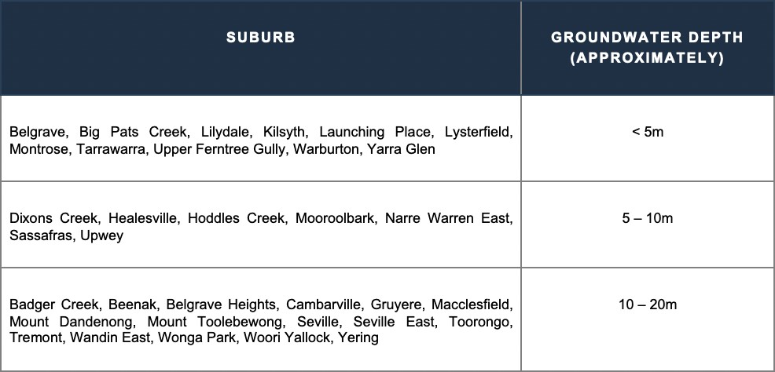

Groundwater tables can be protected by:
- Requiring a minimum of secondary treatment and sub-surface irrigation for areas where the groundwater table is high;
- Locating the Land Application Area (LAA) in a suitable area that increases the buffer distance between the bottom of the trench or irrigation lines and the groundwater table;
- Adhering to the buffer distances outlined in Table 5 of the Code of Practice – onsite wastewater management for groundwater bores (a minimum of 20m for Class 2b to 6 soils as per the classification outlined in Table 9 Soil Categories and Recommended Maximum Design Loading / Irrigation Rates for Land Application Systems outlined in AS/NZS 1547:2012 – On-site domestic wastewater management and the watertable (a minimum vertical depth of 1.5m from base of trench or irrigation line to the highest seasonal watertable point).

  - SLOPE OF THE LAND
The slope of the land can be a determining factor in the type of onsite wastewater system that can be installed and the location of the Land Application Area (LAA). A steep slope can cause significant issues for systems both during installation and use, including:

- Difficulty in getting equipment in to install trenches or irrigation lines;
- Increased soil disturbance or erosion during installation;
- Increased run-off during periods of heavy rainfall, and
- An increased risk of leaching where trenches or irrigation lines – especially when installation occurs in soil that has minimum natural drainage.

Council adheres to the recommendations outlined in Table K1 Land Application Systems – Limitations Due to Site, Soil, and Climatic Factors from AS/NZS 1547: 2012 – Onsite domestic wastewater management.

  - VEGETATION
When determining the location of the Land Application Area (LAA), consideration should be given to the existing vegetation. Under AS 4970: 2009 – Protection of trees on development sites, a tree may need to be retained due to its aesthetic qualities, heritage value or benefit to the ecosystem. The Standard states:

‘A living tree is a dynamic organism that needs specific environmental conditions to continue healthy, stable growth. It is rarely possible to repair stressed and injured trees, so substantial injury needs to be avoided during all stages of development and construction. For trees to be retained and their requirements met, procedures must be in place to protect trees at every stage of the development process. This should be taken into account at the earliest planning stage of any outdoor event or design of a development project where trees are involved’.

The Standard outlines the following protection zones for trees:

- Tree Protection Zone (TPZ) – A specified area above and below ground and at a given distance from the trunk set aside for the protection of a tree’s roots and crown to provide for the viability and the stability of a tree to be retained where it is potentially subject to damage by development, and
- Structural Root Zone (SRZ) – The area around the base of the tree required for the tree’s stability in the ground, which is necessary to hold the tree upright.

Y ARRA RANGES COUNCIL 35

DRAFT W ASTEW ATER MANAGEMENT PLAN 2021 - 2026

Council must determine at the planning stage as to whether the existing vegetation will impact on the required size or location of the LAA. This may be achieved by requesting a report from a suitably qualified and experienced arborist that should outline the exclusions within the TPZ and the SRZ, which may include:

- Machine excavation (including trenching);
- Storage;
- The dumping of waste, and
- Soil level changes.

Adherence to the requirements of the TPZ and the SRZ may limit the available land for the LAA. A reduction to the LAA may require Council to request the applicant to amend the proposed plan to reduce the daily wastewater calculations in order to ensure effluent can be treated and retained onsite.

- SEWERAGE INFRASTRUCTURE IN THE MUNICIPALITY
  - INTRODUCTION
The provision of sewerage is an important tool in the management of wastewater in areas where the existing population density is high, new housing developments are planned or high levels of wastewater is generated – including areas popular with tourists. Connection to the sewer helps to eliminate the risks to public health and the environment that exist with a wastewater treatment system that disposes of effluent onsite or offsite to a legal point of discharge.

The provision of sewer is generally dependent on a combination of factors including the level of identified risk, the feasibility of installation and cost effectiveness. For example, townships in the Hills area including Olinda and Sassafras have both housing density and commercial entities in a recognised tourism area where effluent is currently treated by wastewater treatment systems, which creates a higher priority for sewer connection. Common wastewater issues in these areas include:

- The continued use of existing wastewater treatment systems that have exceeded their life expectancy;
- A high number of systems discharge all wastewater offsite to the natural environment and local waterways;
- Systems are not being serviced or maintained to adequate treat wastewater;
- Legacy systems are insufficient in size to deal wastewater levels from increased commercial activities – this includes centralised systems servicing multiple commercial activities, and
- Many properties have insufficient land available for onsite wastewater retention should an upgrade to the current wastewater treatment system be required.

However, the topography of the area combined with the presence of sheet rock and the remote location of the townships makes the provision of sewer difficult and costly.

Council can work with local water corporations to help identify areas where sewer connection is most needed to help negate the potential risk created by wastewater treatment systems. This may include:

- Properties recognised in existing sewerage backlog programs where new issues have been identified that increase the risk or consequences created by wastewater;
- Providing historical data to water corporations regarding existing wastewater treatment systems, and
- Working with the water corporations regarding alternatives solutions to wastewater disposal where the feasibility of sewer connection is low.

Council is committed to working with relevant stakeholders to explore (where possible) innovative and cost effective solutions to wastewater disposal in recognition of potential concerns regarding maintaining public heath, the preservation of the natural environmental and the protection of local amenities.

Y ARRA RANGES COUNCIL 37

DRAFT W ASTEW ATER MANAGEMENT PLAN 2021 - 2026

  - WATER CORPORATIONS
The effective management and use of onsite wastewater treatment systems can impact on the activities undertaken by water corporations. The Code of Practice – onsite wastewater management states that the key areas of concern for water corporations from poorly maintained or failing systems are:

- The impact on water quality in reservoirs and declared special water catchment areas, and
- The need to provide reticulated sewer services and requirement for properties to connect.

Water corporations have legislative powers that assist with planning and enforcement controls with regard to domestic wastewater management. This includes:

- The Planning and Environment Act 1987
  - S52 – provides a water corporation with the option to provide comment on planning developments;
- The Water Act 1989
  - S147 – provides a rural water authority with the power to enforce connection to the reticulated sewer;
- The Water Industry Act 1994
  - S65 – provides a metropolitan water authority with the power to enforce connection to the reticulated sewer;
- The Catchment and Land Protection Act 1994.
Reticulated sewer services within Yarra Ranges Council are provided by Yarra Valley Water and South East Water. The water corporations have developed community sewerage programs to provide sewer to properties and help protect public health and environmental interests. Council and water corporation work toward the collective goals of:

- Improving the health of local waterways;
- Protection public health;
- Reducing the number of poorly performing wastewater treatment systems;
- Reducing odours and discharge from wastewater treatment systems;
- Improving local amenities for residents and visitors.

The priority to provide sewerage infrastructure to protect human health, the environment and local amenities needs to be balanced with other community needs and expectations. The provision of reticulated sewer to an area should recognise the changing needs and expectations regarding housing provisions.

Housing Strategy 2009
The Yarra Ranges Council Housing Strategy was developed to manage the future housing growth in line with community needs. The Strategy recognised that current and emerging issues regarding the provision housing within the municipality related to:

- Housing affordability;
- An aging population;
- Social change;
- Housing projections.

The issues identified in the Strategy indicate that economic and social factors are contributing to public expectations for increasing the number of smaller property developments that are cheaper to buy and have lower maintenance requirements. The provision of smaller properties for housing development will require the provision of reticulated sewer services to prevent public health and environmental issues.

The Yarra Valley Water Community Sewerage Program has been designed to provide sewerage infrastructure to the outer northern and eastern suburbs of Victoria. The Program will provide infrastructure to the Yarra Ranges Council in the following areas:
- Kallista (Stage 1)
  - The project will provide services to Kallista, The Patch and Menzies Creek as these areas have been identified by the water corporation as having a high number of properties with wastewater treatment systems that are unable to treat and retain effluent on-site;
- Kallista (Stage 2)
  - Sewerage infrastructure will be provided to Sherbrooke, The Patch and Kallista to help protect human health, preserve local waterways as well as improve liveability in the area. In conjunction with Stage 1, the water corporation will provide reticulated sewer service to approximately 1,000 properties;
- Launching Place
  - The project aims to provide services to Launching Place, Don Valley, Yarra Junction and Wesburn to maintain waterways, preserve public health as well as negate odours observed from poorly performing wastewater treatment systems;
- Lilydale
  - Sewerage infrastructure services will be provided to areas of Lilydale to protect human health and preserve local waterways;
- Monbulk
  - The aim of the project is to provide reticulated sewer services to properties in Monbulk that are unable to treat and retain wastewater on-site.

South East Water
The South East Water sewerage scheme will provide sewerage infrastructure to approximately 700 properties within the Belgrave and Selby areas.

Melbourne Water
Melbourne Water manages water supply protection areas for the Little Yarra River and Don River. The authority developed the Little Yarra and Don Rivers Water Supply Protection Area Stream Flow Management Plan in 2012 to implement measures to improve the management of the surface water catchments. Section 32A (1) of the Water Act 1989 outlines that the objective of the management plan must be to manage resources in an equitable manner to ensure long-term sustainability.

The authority is currently developing the Yarra Strategic Plan which aims to:
- Identify immediate actions that need to be implemented to maintain the health of the River;
- Guide local planning;
- Facilitate long-term collaboration between relevant agencies and the Traditional Owners of the land.

The draft Yarra Strategic Plan has outlined four performance objectives that have been designed to meet the objectives of the plan:
- A healthy river and lands;
- A culturally diverse river corridor;
- Quality parklands for a growing population, and
- Protecting the natural beauty of the Yarra River Corridor.

Yarra Ranges Council has been working with Melbourne Water and other authorities on several projects to achieve the objectives of the Yarra Strategic Plan.
Y ARRA RANGES COUNCIL 39

DRAFT W ASTEW ATER MANAGEMENT PLAN 2021 - 2026

Microbial Tracking in Waterways
Council has been working with Melbourne Water, EPA Victoria and Monash University to investigate the potential risks and impacts to beneficial uses of waterways created by discharges from onsite wastewater systems. It is recognised that pathogen and nutrient loads from poorly performing onsite wastewater systems could be transported through stormwater networks into waterways and Water Sensitive Urban Design (WSUD) assets, which poses a risk to ecological and recreational values of the waterways.

The initial testing involved the periodic collection of water samples from identified high-risk sites in the Warburton, Launching Place and Yarra Junction areas. The testing of the water samples has not indicated a direct link between the pathogens identified in the samples and discharge from wastewater treatment systems.

It was observed that collection sites with larger stormwater influence had increased pathogen levels after a heavy rainfall event and during holiday periods, and septic tank discharge may represent a significant input source.

This study has enabled an expanded program of microbial monitoring in the Dandenong Ranges. This will provide a deeper understanding of the interactions between stormwater and septic systems and aim to assist in the prioritisation of future sewerage connections.

The Warburton MTB Destination and the Yarra Valley Trail
Work is currently underway to design, develop and link world class mountain bikes trails within the Yarra Ranges. Council is working with agencies including Parks Victoria, DELMWP and Melbourne Water to ensure that the risks to the environment from the construction of the trails are effectively managed. This includes:

- Organising a panel of experts to advise on methods to minimise the impact on ecologically sensitive areas;
- Strict guidelines for the removal of vegetation, and
- Supervision during construction by experts to ensure preservation of the environment.

- MONITORING AND EVALUATION

7.1 INTRODUCTION
Council recognises the importance of monitoring and evaluating this Wastewater Management Plan (WMP) for continuous improvement.

Periodic review and improvement of this Plan will be undertaken including:
- Annual review and adaptation of the action plan with reporting to Council and stakeholders on progress, including results of inspection and monitoring program;
- Based on annual review, determine priorities for implementation and recommend to Council for consideration via the regular budget process;
- Refine the spatial risk assessment as necessary if better resolution datasets become available or other risk factors come to light, and
- A full review of the Plan five years after its adoption by Council.

Council will report back to the community on the implementation of the Plan with respect to the focus areas and the progress towards to the following goals:
- Improve the compliance of existing onsite wastewater systems through an integrated program of education, monitoring and compliance;
- Ensure any new development requiring onsite wastewater systems occurs in a sustainable manner;
- Work with water corporations to facilitate connection to sewerage where it is available, and
- Work with water corporations to expand the sewerage network or provide alternative services if required in response to risks identified.

Y ARRA RANGES COUNCIL 41

DRAFT W ASTEW ATER MANAGEMENT PLAN 2021 - 2026

APPENDIX 1: SPATIAL RISK ASSESSMENT MAPS
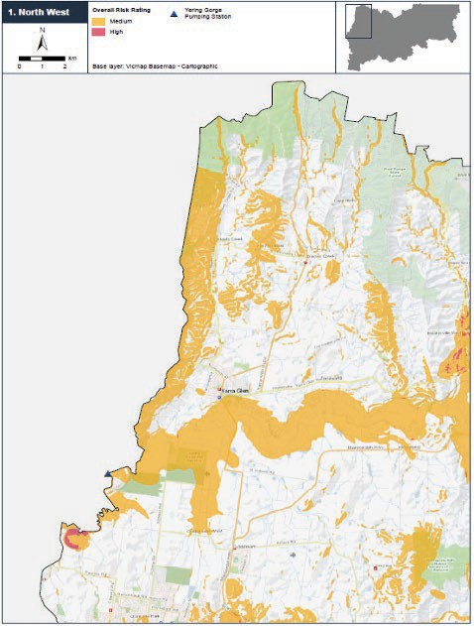

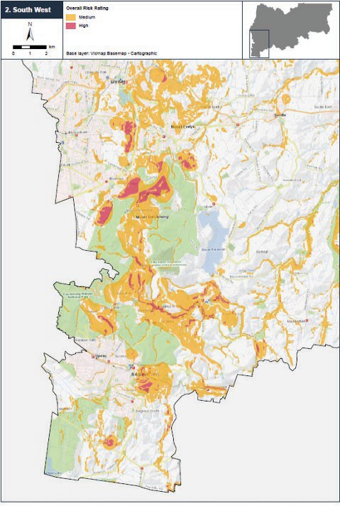

Y ARRA RANGES COUNCIL 43

DRAFT W ASTEW ATER MANAGEMENT PLAN 2021 - 2026

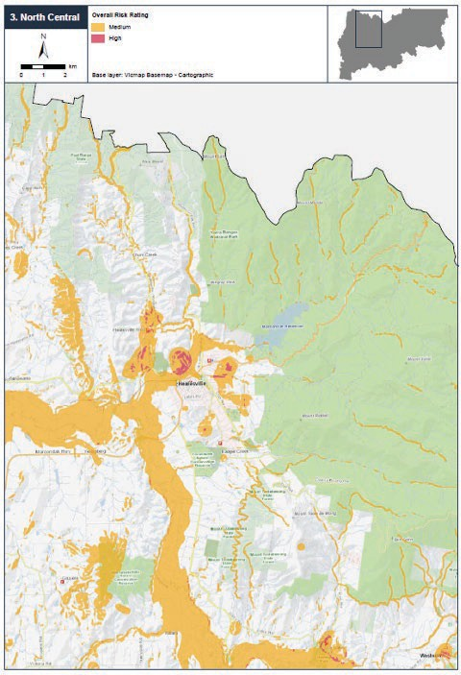

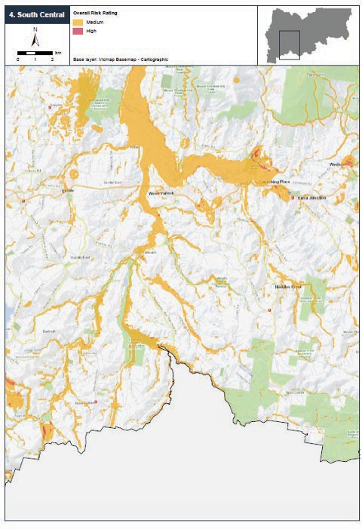

Y ARRA RANGES COUNCIL 45

DRAFT W ASTEW ATER MANAGEMENT PLAN 2021 - 2026

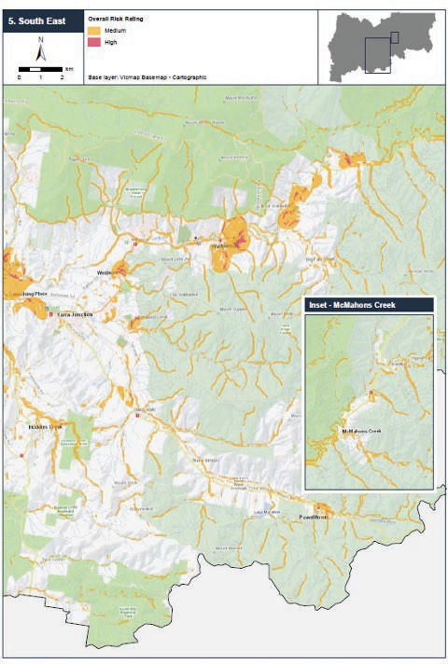

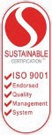
This report has been prepared by:

RM Consulting Group Pty Ltd trading as RMCG
135 Mollison Street, Bendigo Victoria 3550
(03) 5441 4821 — rmcg.com.au — ABN 73 613 135 247

Offices in Bendigo, Melbourne, Torquay and Warragul (Victoria) and Penguin and Hobart (Tasmania)


Key Project Contact Anna Kelliher
0427 859 129 — annak@rmcg.com.au

Document review and authorisation Job Number: #410

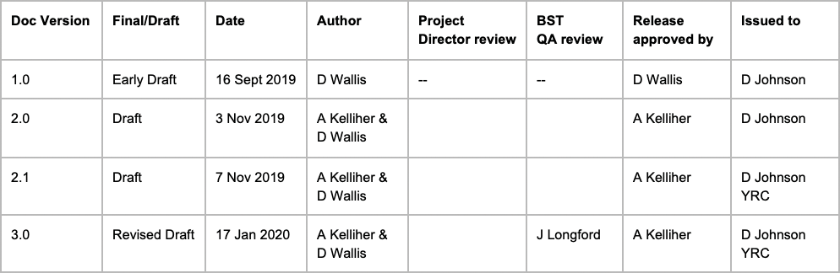

Y ARRA RANGES COUNCIL 47

