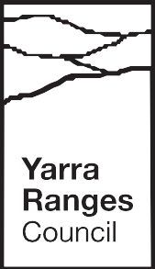
Yarra Ranges Council
Draft Active Recreation Plan 2023
Summary Report

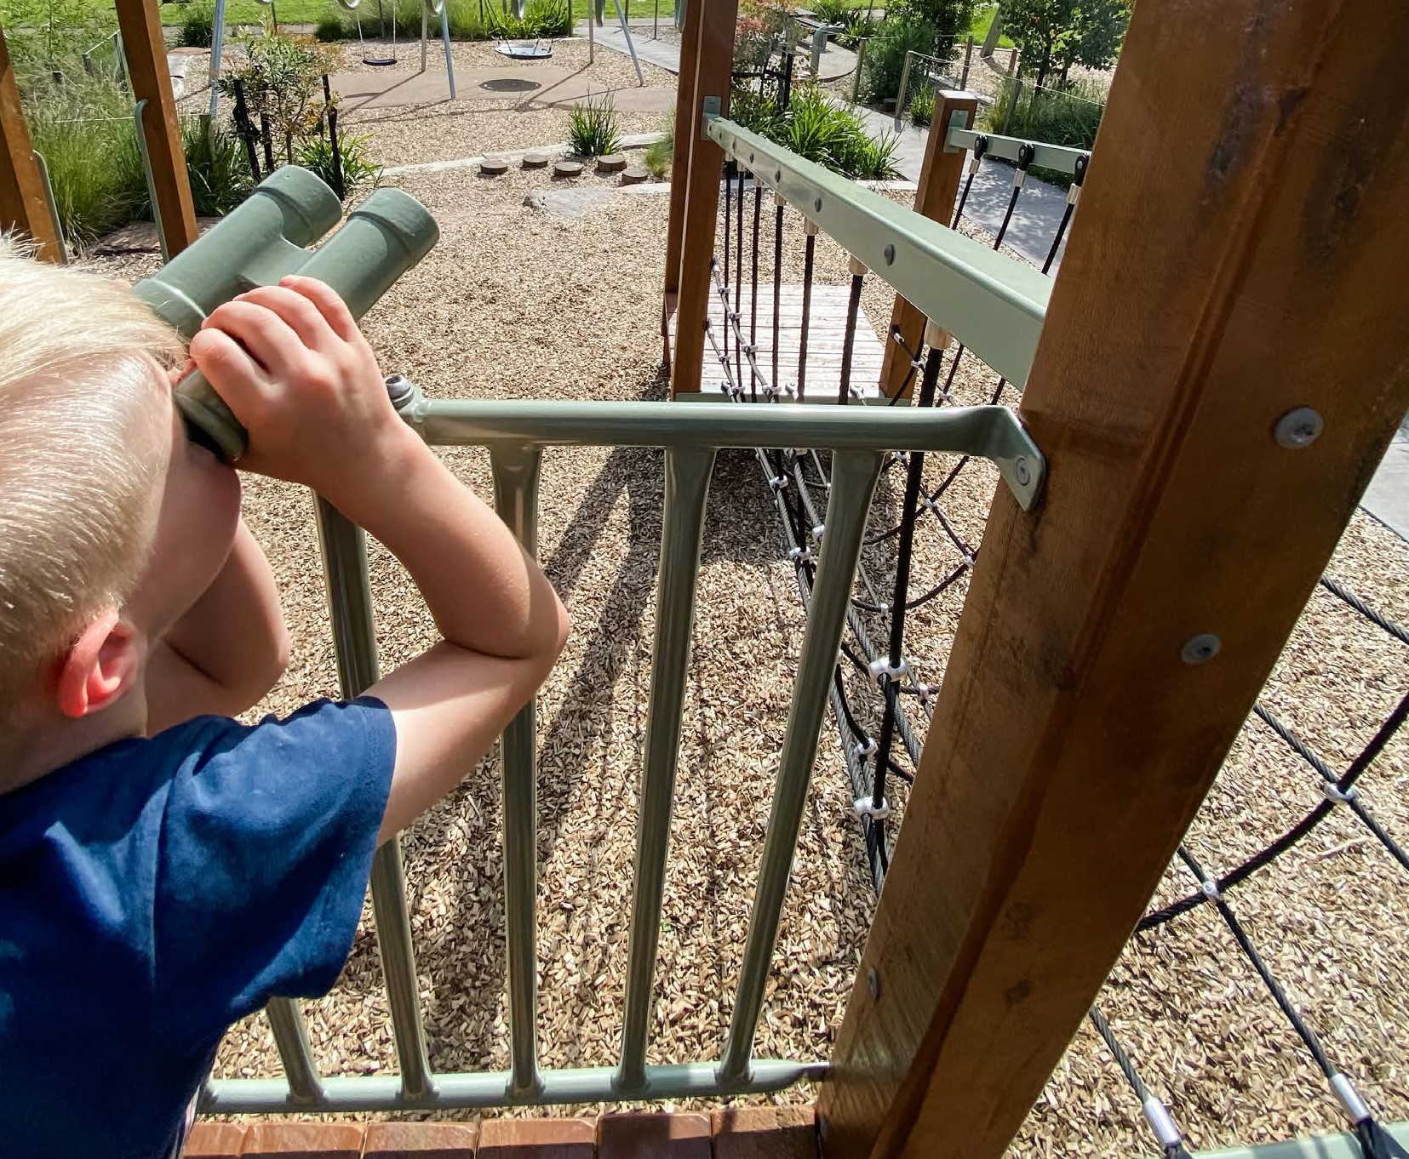

Vision:
Yarra Ranges is a place where everyone has the opportunity to participate in a diverse range of active recreation facilities programs and events that contribute to a healthy life.
1
Target: increase physical activity by 15% over 10 years

Development of the Plan
The Plan has four action areas with a set of measurable actions. The development of the actions within the plan were guided by our key principles and will help us achieve our vision and overall target. These actions reflect the collective aspirations received from community engagement regarding active recreation. Industry research and review as well as targeted community consultation informed the plans content, key principles, action areas and actions.

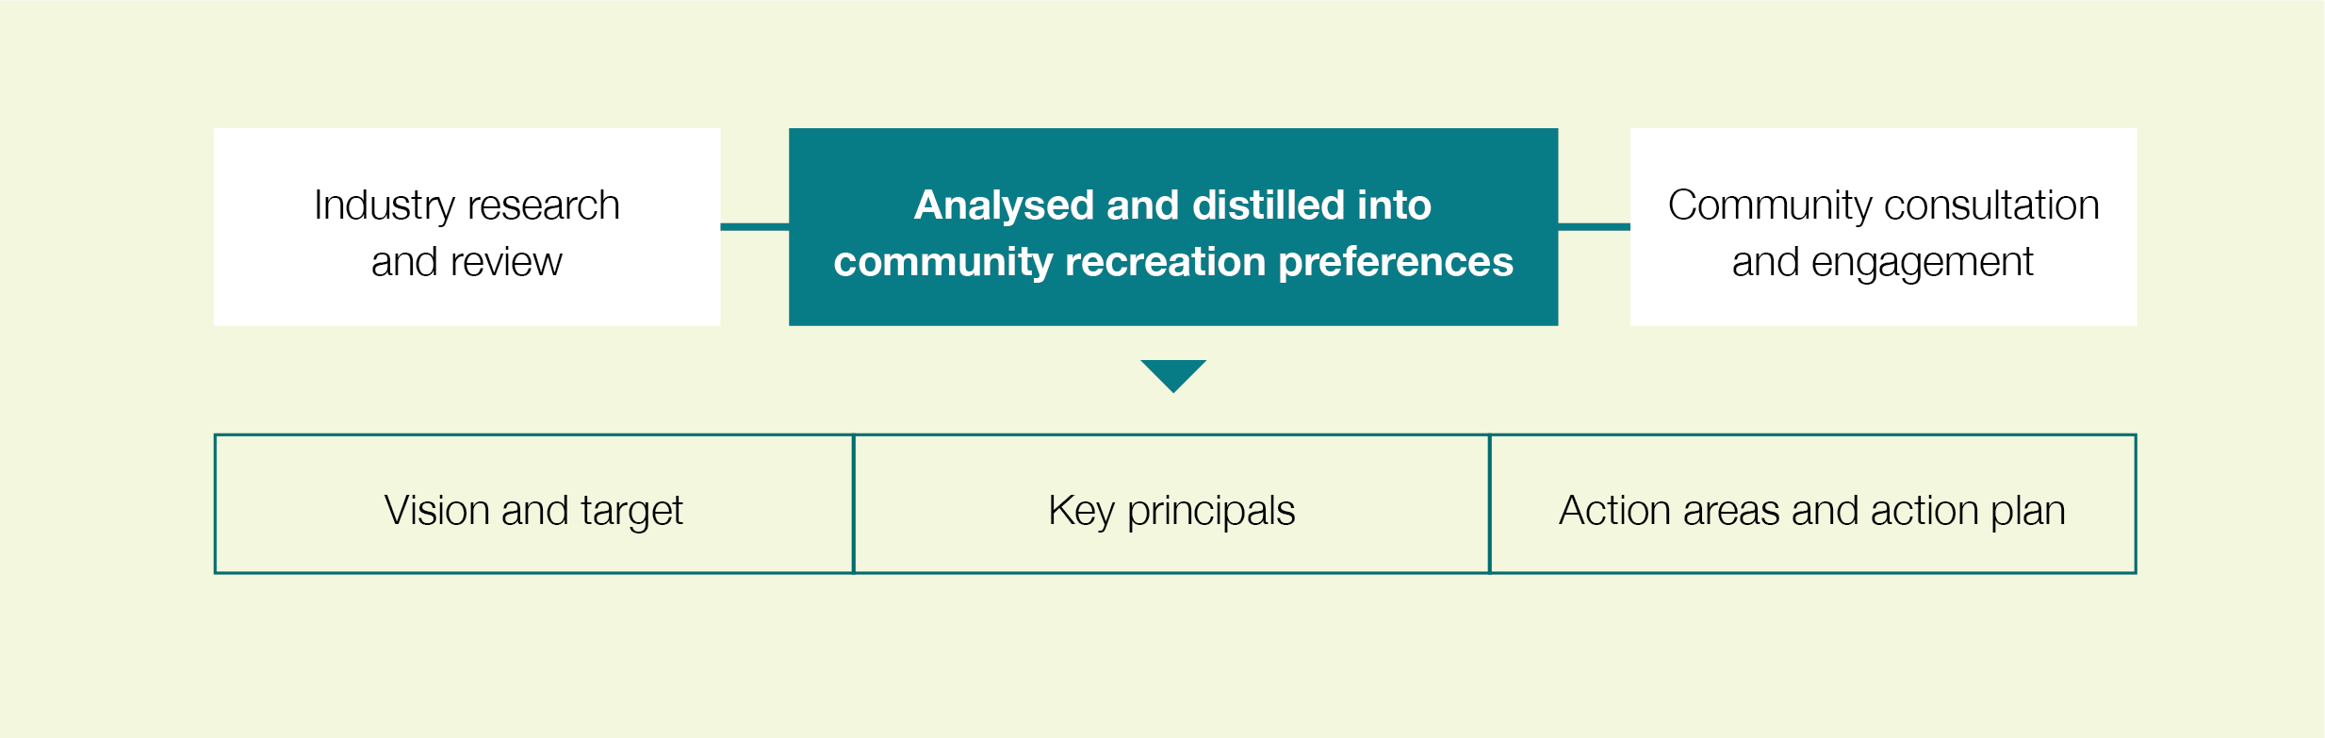

What is active recreation?
Active recreation can be defined as ‘leisure time physical activity undertaken outside of structured, competition sport’ (https://sport.vic.gov.au/our-work/participation/active-recreation). It provides participants a wide range of benefits related to physical health, mental health and social interaction. While all activity types can provide these benefits, active recreation plays an important role because it allows people to participate in a way of their choosing at a time that suits them. This flexibility can help to overcome barriers to participation that exist for more structured activity types.

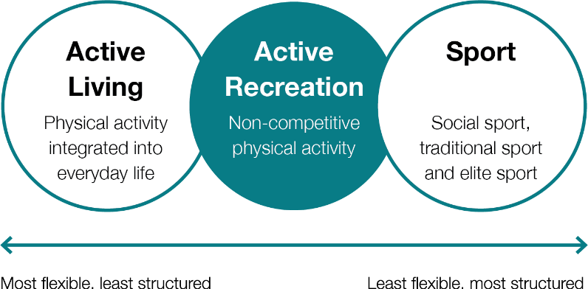

Figure 1: Physical activity spectrum Source: Adapted from Physical Activity Spectrum adapted from the Vichealth ‘Doing Sport Differently’ resource accessed via www.vichealth.vic.gov.au//media/ResourceCentre

Why do we need this Plan?
The Active Recreation Plan will guide Council’s effort to encourage people to be healthy and active through the design of active recreation infrastructure and programs that remove barriers and respond to people’s participation preferences over the next ten years. Over 42% of women and over 36% of men in YRC residents are sedentary or insufficiently active. 89% of residents said they would be more active if there was something interesting, appealing, accessible and convenient for them.

What the community told us
“We need to strip back the traditional thinking about profit versus non-profit activities and look at the overall community benefit the activity provides. We need to work with clubs and educate them about what they aren’t doing that private providers are.”
“If you activate places of cultural and environmental significance, you build a connection and pride, and instil a sense of conservation and protectionism in the next generation.”
“The water playspace (in Seville) has been a huge success. The community are really proud of it”

Key principals
 | Access | Active recreation opportunities that encourage participation and have a positive influence on physical health are provided in accessible and convenient places for residents within Yarra Ranges.
 | Diversity | A diversity of active recreation opportunities are provided reflecting the diversity of our community and places across the municipality, the diversity of needs and preferences of the community, and different financial capacities.
 | Activation | Programming and events are delivered through internal and external partnerships to optimise utilisation of recreational assets, maximise health and wellbeing outcomes for the community, and contribute to sustainable tourism and economic prosperity across the municipality.
 | Inclusion | Facilities are designed with inclusion, accessibility, and safety of all people in mind, enabling individuals to make choices based on their needs and interests. There is a particular focus on women and girls, gender diverse people, disability, and Indigenous ways of knowing, being and doing.
 | Social  Connection | Where possible, active recreation facilities are provided in proximity to other compatible uses where they facilitate social interaction and encourage intergenerational use of reserves and spaces.

Action Areas: We will achieve our target through

Improving safety and accessibility |  | 
providing active recreation infrastructure and programs that are appealing and accessible to all community members, where participation is encouraged and people feel safe.
Refer to actions 1.1–1.4

Activating existing facilities |  |  |  |  | 
identifying ways to increase the use of existing active recreation facilities (eg. through events, programming or promotion).
Refer to actions 2.1–2.10

Increasing existing facility provision |  | 
relating to active recreation opportunities that currently exist within Yarra Ranges but are few in number, and where providing additional faciilities, where gaps in provision have been identified, would increase the opportunity for participation.
Refer to actions 3.1–3.3

New facility provision |  |  |  | 
identifying new active recreation opportunities that do not currently exist within Yarra Ranges.
Refer to actions 4.1–4.6

For more information, please see our detailed action plan from page 51 of the Active Recreation Plan.

Yarra Ranges Council
PO Box 105
Lilydale VIC 3140
1300 368 333 | mail@yarraranges.vic.gov.au
yarraranges.vic.gov.au

