Engagement and Directions Paper

Yarra Junction Place Plan Project

December 2023

Acknowledgement of country
Yarra Ranges Council acknowledges the Wurundjeri and other Kulin Nations as the Traditional Owners and Custodians of these lands and waterways. We pay our respects to all Elders, past, present, and emerging, who have been, and always will be, integral to the story of our region. We proudly share custodianship to care for Country together.

What is place planning?

Place planning is a collaborative, long-term approach to building thriving communities delivered in a defined geographic location. This approach is characterised by developing a shared vision, stewardship, and accountability for outcomes and impacts. Place-based approaches are often used to respond to complex, interrelated, or challenging issues.
While place-based approaches in planning have been used by local governments in Australia to address urban renewal or town centre revitalisation, they have not been widely used as a whole-of-Council approach to planning for communities. For local governments, place planning shifts the focus from outputs of various departments to outcomes delivering on quality-of-life improvements for communities. As such, community is central to the development and delivery of a place plan so that issues can be pursued in a more collaborative way to identify economic, social and environmental priorities.
Council will then work with the community to identify an action plan to address the issues and opportunities, providing a road map for future project development and enabling advocacy for future investment and funding.

Principles

Place Planning at Yarra Ranges is driven by six key principles:
A Culture, Community & Service Needs
B Economic Prosperity
C Transport, Movement, Public Space & Infrastructure
D Future Land Use & Development
E Leadership & Governance

Project plan

Extensive community engagement will inform the Yarra Junction Place Plan. This includes interviews, community pop ups, involvement in community events, workshops with community representatives, and online feedback opportunities.
Phase 1: Community Engagement – Understanding Issues and Opportunities
Phase 2: Community Engagement Report – Share community feedback with community
Phase 3: Community Representative Workshops – Prioritise themes, develop actions & establish community vision
Phase 3: Draft Place Plan– Consolidate feedback, outcomes of workshops and present Draft Place Plan for community feedback
Phase 4: Community Engagement Report – What we heard, how will we respond to it and why
Phase 5: Final Yarra Junction Place Plan

Yarra Junction Place Plan

The Yarra Junction Place Plan Project set out with the intention to hear from the local community, what they love about Yarra Junction, where are the opportunities for improvement and what the future vision should strive for. This will allow community to guide the strategic direction and establish the opportunity for Council to work with community and various stakeholders in delivering improvements to Yarra Junction with a shared vision, guiding the delivery of infrastructure, programs and services.
Yarra Junction is a township that services the broader community of the Upper Yarra, as such the feedback received by community members is not only focused on the centre of the township, but also reflective of the lived experience of residents in the surrounding areas in the Upper Yarra that may rely on the township for services, employment, education, or sport and recreation.
The feedback received through the initial round of community engagement will be considered, along with data and background reports to identify priorities and develop Council actions in the Place Plan.
These actions will be developed in collaboration with a Community Reference Group, who will work through the key themes that have appeared in community consultation in a series of community representative workshops. It is intended that the resources, strengths, and values of community are considered during these workshops to help develop a shared vision that provides direction for both Council and community.

What we heard
When people were asked what they love about living in Yarra Junction. Overwhelmingly the responses focused on the people, the environment, and the Yarra Centre.
The key themes that came through community consultation when discussing opportunities and future vision include:

Principle A
- Emergency Services
- Young People
- Mental Health & Substance Abuse
- Community Groups & Activities
- Support Services & Accessibility

Principle B
- Shopping Centre
- Town Aesthetic
- Diversity of Business
- Development of Industry
- Development of Tourism

Principle C
- Roads
- Community Infrastructure
- Pedestrian Movement & Trails
- Accessibility
- Parking
- Transport

Principle D
- Planning & Development
- Tourism
- Housing

Principle E
- Business
- Council
- Community

Further discussion on what we’ve heard from the community is on pages 20-24.

What does the data tell us?
Statistical data compiled from the 2021 Census

Population
- In 2021, Yarra Junction had 2,875 residents.
- 1.8 average number of children in families.
- 31% of the population live in loan person households
- Yarra Junction has a high level of residents aged 60 plus, and a low level of residents aged 15-49.

Household type & income
- A high level of one parent families and people living alone; and a low level of married or de facto couples.
- A high level of level of people living in medium to high density dwellings; and in marginal housing such as caravans or improvised homes
- A high level of dwellings being rented, or homes being lived in under alternative tenure types (e.g., rent free); and a low level of households with mortgages.
- An extremely high level of rental stress and a very high level of mortgage stress, in terms of households spending more than 30% of their income on rent or mortgage payments.
- Very low incomes, with 25% of households with incomes of less than $650 per week

Public space and Council facilities
- The town is fragmented with the highway creating a pedestrian barrier
- Facilities are ageing and not meeting acceptable levels of service
- Accessibility and people movement are very poor
- Some facilities are under utilised and others working beyond capacity

Cultural expression
- 1.3% of the population is made up of Indigenous residents
- 79% of residents are Australian born
- 89.5% of households only speak English
- 53.1% residents with no religion

Jobs, business sectors & training
- A very low level of residents attending or have attended tertiary education – 10.5%
- 24.7% of residents have a household income of less than $650- per week.

Top three professions:
21.1% working as Technicians and Trades Workers
13.6% working as Community and Personal Service Workers
12.8% working as Clerical and Administrative Workers

Community services & health
- An above average level of residents with a mental health condition – 11.3%
- 32.6% of residents report one or more long-term health conditions

Transport networks & car use
- The Warburton Highway runs through the centre of the activity centre creating a barrier for pedestrians
- The bus service is the only public transport option in the area
- There are gaps in the local pathway network limiting pedestrian access to town

About Yarra Junction
Yarra Junction is located approximately 57 kilometres to the east of the centre of Melbourne, with a driving distance of approximately 65 kilometres. The primary access is from the Warburton Highway which connects the town to Lilydale and the metropolitan area to the west and Warburton to the east. There is a road connection to Powelltown to the south-east, which in turn leads on to Noojee, Mt Baw Baw and Warragul.
Geographically, the town is set in flat and undulating land near the junction of the Yarra and Little Yarra Rivers, flowing from sources beyond Warburton and Powelltown respectively. The wider area is valley geography, dominated by high hills/low mountains with extensive forest cover.
The main area of the town as defined by the Urban Growth Boundary is approximately 204 hectares. The town has a well-developed recreation reserve precinct encompassing a range of recreation facilities plus the former railway station environs and senior citizens’ centre which totals approximately 11 hectares, plus a further 20 hectares of residential area east of the Little Yarra River which, while physically is part of the Wesburn town area, is within the Yarra Junction postcode.
Yarra Junction became the administrative centre of Upper Yarra Shire until the creation of the Shire of Yarra Ranges in 1994. It became a civic and recreation hub for the Warburton Highway corridor. In particular, the recreation reserve has an extensive range of facilities including sports ground, netball and tennis courts, basketball stadium, indoor aquatic centre, children’s playground, and general-purpose hall. The town is also a commercial hub, with the Woolworths supermarket which was the sole full-line supermarket beyond Lilydale up until the opening of the Seville Woolworths supermarket in 2014.

Yarra Junction is one of the destinations along the well-known cycle and walking tracks, The Lilydale to Warburton Trail and the O’Shannassy Aqueduct Delight Trail loop. These trails offer tourist and locals the opportunity to actively engage with Yarra Ranges environment along with giving townships such as Yarra Junction a place on the map for tourism and possible economic gain.

Forecasts for Yarra Junction include population data for Milgrove and Wesburn. The population in 2023 is 5,720 people, with 13.2% forecast growth which could lead to an expected population of 6,475 by 2046. This forecast predicts a peak in residential developments in the area over the coming 10 years. (Source Forecast.id.com.au)
2021 Census data indicates a 15% increase in the Yarra Junction population reaching retirement age by 2031, and a 6.3% increase in population reaching working age.

Yarra Junction’s natural environment
The Wurundjeri peoples occupied the lands of the Yarra River catchment for tens of thousands of years prior to the arrival of Europeans. In the 1840’s surveyor William Hoddle led an expedition to locate the Yarra River’s source, completing a detailed survey of the river from present day Woori Yallock to the headwaters in the east, establishing a camp in the now Yarra Junction recreation reserve during this period.
Yarra Ranges is recognised for its natural beauty and diverse habitats, the natural environment is dominated by hills and trees, and these features will continue to be its most defining characteristics. The combination of national parks, state forests, private gardens, and its proximity to Melbourne combine to make the area unique. Some of Victoria's most environmentally important areas are located in the Yarra Ranges.

The mountainous landscapes make up a part of the Yarra Junction geography and are a spectacular backdrop to this environmentally diverse township. This area, known for its timber, contains significant native vegetation providing vibrant ecosystems for native flora and fauna. The Little Yarra River that runs through the town is a vital part of the Yarra Ranges ecosystem. These natural features are highly valued by the local community, who acknowledge the natural environment as an important part of their lifestyle and the character of the area.

Emergency Management role
The people of Yarra Junction have historically taken on the role of supporting Upper Yarra townships in times of emergency. The Upper Yarra Valley Historical Society have records of residents of Yarra Junction assisting Launching Place residents to fight bushfires as early as 1900. With the first town Fire Brigade being formed in 1927, assisting surrounding townships. Including protecting Powelltown which was surrounded by fire during the Black Friday bushfires of 1939.
Yarra Junction continues to play a role in emergency management today, with this service centre identified as an emergency relief hub, recreation reserve a place of last resort and hosts the Yarra Junction Country Fire Authority (CFA).

Yarra Junction’s history & cultural heritage
Yarra Junction sits within the lands of the Wurundjeri people of the Kulin Nations who have had a continuous presence in the area for over 40,000 years. Although Wurundjeri peoples occupied the lands of the Yarra River catchment, early surveys suggested the Wurundjeri people were never present in large numbers in the Upper Yarra area, evidently finding the Yarra Glen, Yering, Mooroolbark, and Lilydale areas more suitable.
Following the first pastoral settlement in the area by the Ryrie brothers in the 1830s, pastoral settlement of the Upper Yarra expanded in the 1840’s, with the Home Hotel in Launching Place established shortly after.
By the 1860’s gold was discovered in Little Yarra River and Britannia Creek, which led to the small settlement known as Britannia. The exploration for gold continued for two decades with underground mining bringing more people to the area. As gold mining declined new industries developed in the area and by the mid 1880’s the timber industry and farming had grown in importance.
The township of Yarra Junction progressed with an increased population and developing infrastructure. People took up land selection, building houses and planting crops such as strawberries, raspberries and currants.
In the early 1880s the land now occupied by Yarra Junction was first made available for settlement. William McKay took up a lease in 1885 and shortly afterward established a general store. A slaughterhouse and public hall were established soon afterward, and a community village settlement evolved, including the development of a primary school and police station in the 1890s.
Activity grew after the opening of the railway to Warburton in 1901, with Yarra Junction becoming a major transshipment point for timber and agriculture. A tennis club, cricket club and football club were formed, and a post office added by 1910, and the population of 58 recorded in the 1901 census had grown to 470 by 1911.
To support the increasing timber industry, a tramway connection from Yarra Junction to Powelltown was established in 1913 to support the passage of passengers and timber. The devastating Black Friday bushfires of 1939 resulted in a substantial restructuring of the timber industry, with isolated sawmills and their small settlements deep in the bush replaced with town-based mills. By the 1960s five timber mills were operating in Yarra Junction and these formed the economic base of the town.
The Lilydale to Warburton railway closed mid-1965, as automobiles became a more popular means of transportation in the area. During the 1980’s a group of residents identified the railway land as an ideal route for a Rail Trail, and after some time lobbying with Local and State Governments the Rail Trail came into fruition with its official opening in 1996. The development of the Rail Trail has opened access to high numbers of new tourists for towns like Yarra Junction, that are set along the trail.
The Shire of Upper Yarra was first proclaimed in 1888. While Warburton was the largest town in the municipality, Yarra Junction became favoured for administration due to its proximity and access to downstream settlements, and it became the administrative centre from 1910 until amalgamation into the Shire of Yarra Ranges in 1994. New offices were constructed in 1924, which were replaced by the current building on the corner of Warburton Highway and Hoddle Street in the 1980s.

Yarra Junction’s people
While there are many longstanding residents and families connected to the Upper Yarra area, recent residential growth, the appeal of the natural environment and convenient locality to the Urban area, has seen an increase in recent residential arrivals around Yarra Junction.

In 2021 Yarra Junction was populated by 2875 people compared to the population of 2,297 in 2011. Meaning Yarra Junction has seen 25% growth over the past 10 years.

Most of the population of Yarra Junction is English speaking.
- 43.9% of residents identify as Australian
- 43.1% of residents identify as English
- 1.3% of residents identify as Aboriginal or Torres Strait Islander, which is slightly higher than the Greater Melbourne population of 1%.

Yarra Junction is a multigenerational community, with a median age is 43 years old.
The largest percentages with regards to age groups are:
- 7% - 10-14 years old
- 6.9% - 35-39 years old
- 6.7% - 70-74 years old

2021 Census data indicated that:
- 52.9% of the Yarra Junction population works full-time
- 35.2% works part-time
- 3.8% are unemployed
- At the time of the census (August 2021) 9.0% of the population was away from work, likely due to Statewide restrictions in response to the Global Pandemic.

When compared against national benchmarks Yarra Junction has slightly higher than average disadvantage.
- Bottom 40% of suburbs and localities on the Index of Relative Socia-Economic Disadvantage (IRSD)
- Bottom 30% of suburbs and localities with socio-economically advantaged residents
- Bottom 30% of suburbs or localities for the Index of Education and Occupation (IEO)
- 25% of households in Yarra Junction have incomes of less than $650 per week
- 14.5% of households in Yarra Ranges have incomes of less than $650 per week
- Median income is well below average, at $1,302 per week compared to the national medium income of $1,881

Top three professions held by residents of Yarra Junction:
- 21.1% working as Technicians and Trades* Workers
- 13.6% working as Community and Personal Service Workers
- 12.8% working as Clerical and Administrative Workers

*Trade workers are the predominant workforce in this area, many of these workers are travelling out of the region for their daily work.

Top industries providing employment in Yarra Junction:
- Supermarket and Grocery Stores at 3.7%
- Primary Education and Aged Care Residential Services at 3.4%

The 2021 Census data also identified Yarra Junction as having higher levels of people living with mental health conditions, disability or long term health conditions:
- 11.3% of the Yarra Junction population identified living with mental health conditions
- 8.8% is the State average for people identifying as living with mental health conditions
- 32.6% of the Yarra Junction population identified as living with one or more long-term health conditions
- 27.4 is the State average for people identifying as living with one or more long-term health conditions
- 9% of Yarra Junction residents need assistance with activities of daily living
- 5.9% is the State average of people needing assistance with activities of daily living
- 13.5% of people aged 15+ were providing unpaid assistance to a person with a disability, health condition or old age (314 people)
- 11.9% is the National average of people 15+ providing unpaid assistance to a person with a disability, health condition or old age

Community engagement indicated a general concern regarding socio-economic issues and substance abuse within the community. While the Australian Bureau of Statistics’ SEIFA index shows average levels of socio-economic disadvantage across the Yarra Ranges, there are some pockets of disadvantage highlighted in the Upper Yarra, which would be reflective of the feedback received by the Yarra Junction community.

Housing
In Yarra Junction there are 1,187 private dwellings with an average of 2.5 persons residing in each.

Yarra Junction currently has only a small supply of developable residential land, with an existing demand for smaller dwelling types. Council is currently preparing a new Housing Strategy which will consider how to better respond to housing pressures across the Shire.

Yarra Junction was a part of the community sewerage program undertaken by Yarra Valley Water with the Launching Place Sewerage Projects that was completed in May 2021. All properties in Yarra Junction can now connect to these sewerage systems. This improved infrastructure will allow for possible future subdivision and housing.

The median weekly household income is $1,302.
- Median monthly mortgage repayments in Yarra Junction sit at $1,800
- 19.3% of owners are paying more than 30% of their income on their mortgage
- Median weekly rent in Yarra Junction is $300-, almost 19% less than the Victorian median
- 45.2% of renters in Yarra Junction are paying more than 30% of their income on rent
- The State median of renters paying more that 30% of their income on rent is 30.9%

Yarra Junction’s economy
The Yarra Ranges Planning Scheme, Clause 02.03 states that Yarra Ranges has a narrow economic base with a limited range of higher-level employment opportunities. Many of the resident’s travel outside the municipality for jobs and high-order services, including tertiary education and regional shopping centres. Local employment is mostly within manufacturing and retailing sectors.

Yarra Junction Town Centre is located on the Warburton Highway and performs an important role in the provision of retail, commercial, civic, community and recreational facilities for people who reside in the Warburton Corridor.

Yarra Junction employs approximately 936 people most of whom are residents in the town or surrounding districts. 289 people work in the Health Care and Social Assistance sector. The largest industry sector for economic output in Yarra Junction is Health Care & Social Assistance with $39.1 M accounting for 19.13% of total output across the Yarra Valley.

The top industries for economic output within Yarra Junction include:
- Health and Social Assistance
- Education
- Construction
- Retail Trade
- Accommodation and Food Services
- Arts and Recreation Services

The Yarra Junction Activity Centre contains a strongly performing Woolworths supermarket, which is the only full line supermarket in the town, a variety of specialty shops, with a focus on convenience retailing and food catering.

Yarra Junction is considered a Large Neighbourhood Activity Centre in State and Local planning policy, providing services and some public amenities to the surrounding hinterland communities.

The town’s role as an employment hub has declined since the 1970s, with the slowing of local industry.

Who we spoke to
From September through to December 2023, the project team spent time in Yarra Junction connecting with community groups, sports clubs, service providers, organisations, local businesses and community.
This involved talking to people at the Yarra Centre, Library, Community Link, Shopping Centre, Yarraburn Centre, Yarra Junction Primary School drop off zone, Recreation Reserve and visits to local businesses; about what they loved about Yarra Junction, where they saw opportunities for improvement and what were their priorities for the future.

How did people hear about the project?
- A letter was mailed out to over 1000 households in the Yarra Junction area to inform the community of the project and ways to provide feedback.
- 1,895 people registered with interest in Yarra Junction received an email notification regarding the Shaping Page.
- 2 months of social media for the project promoting ways to engage.
- Business in the main shopping strip were approached to advertise the project with flyers in the shops.
- Radio interview promoting the project and engagement opportunities on 99.1 Yarra Valley FM.
- Signage was displayed around the activity centre in Yarra Junction, promoting the project.

How did people give feedback?
- Community feedback was received through 268 face to face interviews and written submissions
- 112 quick submissions were received on the Shaping Yarra Ranges page with 568 votes
- 16 detailed submissions were received on the Shaping Yarra Ranges page with 13 votes
- Council officers attended community events including the Halloween Street Party, Teddy Bears Picnic and Over 50’s Friendship Group Lunch to talk with the community.
- A peer led youth workshop was held at Upper Yarra Secondary College to ensure strong youth feedback was included in the engagement.

What we heard

PRINCIPLE A: Culture, community & service needs
Feedback has told us that the community of Yarra Junction:

Emergency services
- is concerned about the lack of emergency healthcare in the region.
- would like to have a stronger police presence in their area.
- want to continue to work towards being prepared for bushfire in the area.

Young people (12-25 years old)
- are concerned about the social & emotional wellbeing of young people.
- would like to see more activities focused around supporting and engaging young people.
- would like to see spaces developed for young people.

Mental health & substance abuse
- are concerned about the amount of anti-social behaviour they see in the township.
- are concerned about the culture of substance abuse in the area and social issues surrounding this.
- would like to know there are adequate support services for mental health and substance abuse in the centre.

Community groups & activities
- would like to see more community activities and events in the township.
- would like to see community groups working together and supporting each other.

Support services & accessibility
- are aware that many people are struggling and require a strong network of support services.
- want to know there are local support services and programs available to support families.
- would like to see more services available to support people living with a disability and their carers.
- are concerned about how dis-engaged or isolated some elderly community members are.

Quotes from feedback
“Many People are doing it tough in YJ”
“Really passionate community and some great township groups”
“Community events such as Christmas pageants or markets”
“There is not enough for young people in this town”

What we heard

PRINCIPLE B: Economic prosperity & wellbeing
Feedback has told us that the community of Yarra Junction:

Shopping centre
- would like to see improvements in the aesthetic of the activity centre and revitalisation of street & shop frontages.
- would like to see more and better-quality parking options around the shopping centre.

Town aesthetic
- see a lot of opportunity to improve the look and feel of the town.

Diversity of business
- would like to see opportunities to increase employment and revitalise the township.
- would like to see an increase in quality local hospitality and entertainment options.
- would like to see more competition in centre to provide better options for local shopping.

Development of industry
- Some people would like to see opportunities to develop local industry.

Development of tourism
- Some people would like to see an increased focus on tourist attracting infrastructure and activities.
- Some people do not want to see an increase in tourism and would prefer the town to remain a local service centre.

Quotes from feedback
“Not enough local employment”
“Grow the shopping centre - Change Shop Mix”
“Investment towards local jobs - perhaps pockets of industry to provide jobs that suit local skill sets - people have to bare the cost of travelling down the line to work in factories”
“Better infrastructure for tourism – make it a place to come to.”
“Don't encourage tourism, infrastructure is not coping”
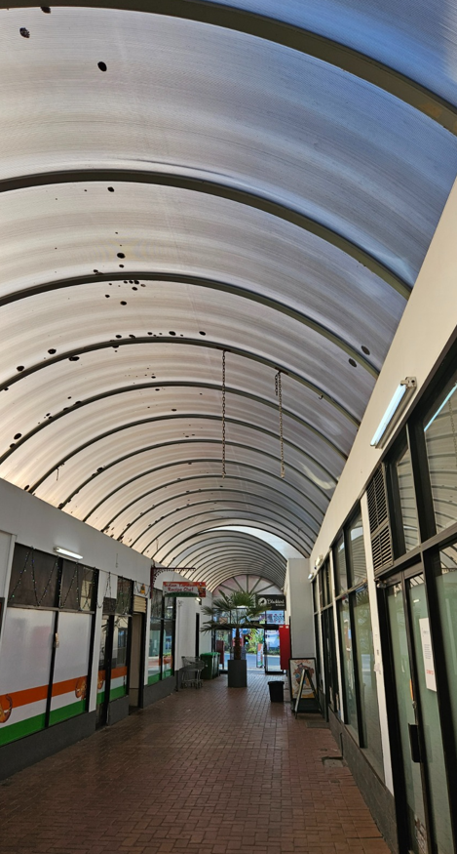
Photo of an undercover shopping area, submitted by a community member
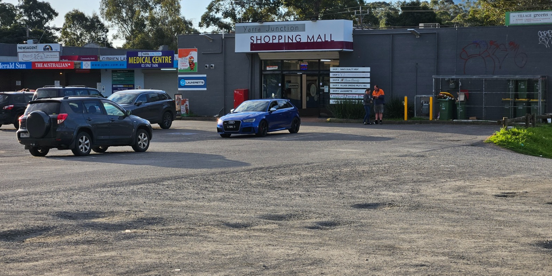
Photo of a car park behind the shopping mall in Yarra Junction, submitted by community member

What we heard

PRINCIPLE C: Transport, movement & public space
Feedback has told us that the community of Yarra Junction:

Roads & transport
- is concerned about the increase in use of Warburton Highway and see many opportunities to improve safety, amenity and improve congestion.
- are not satisfied with the maintenance of roads infrastructure in the area and can see many opportunities to improve safety and amenity.
- are concerned about the speed of some vehicles and growing amount of traffic through the centre of town, and would like to see measures put into place the protect the community.

Pedestrian movement & trails
- see many safety concerns regarding pedestrian movement around the activity centre. They would like to see infrastructure improvements that encourage and support pedestrian movement, with a strong focus on increased paths and pedestrian crossings.
- would like to see big improvements to the footpath network in and around town. They also see many opportunities to improve the trails network in the wider area.

Accessibility
- would like to see improvements to infrastructure to allow accessible and safe movement into and around the centre.

Parking
- would like to see more parking options around town, that move cars away from parking on the side of the Highway. They would also like to see improvements to the current parking provision.

Transport
- would like to see more regular public transport options to service the area and feel that safety is a concern.
- want better access to transport that can support the local community.

Current facilities
- See a lot of potential to upgrade and improve current community facilities and infrastructure in Yarra Junction.
- The community love the Yarra Centre and recreation reserve and would encourage further investment in this precinct.

Levels of service
- would like more emphasis on accessible design in current and future infrastructure.
- would like to see environmentally sustainable design principles considered in future development of the township.
- see a lot of opportunities for enhancements & upgrades in the streetscape and public spaces, that will increase safety, amenity, and liveability in Yarra Junction.

Public infrastructure
- want to see upgrades and more regular maintenance of the drainage network.
- want to ensure that public infrastructure is upgraded to support the growth expected through housing developments.

Quotes from feedback
“Highway is too busy for the middle of town, creates a pedestrian barrier”
“Seal our dirt roads, especially when you are allowing massive subdivisions to take place”
“Fix the pot holes”
“Crossing Warby Hwy is really dangerous - need extra crossings”
“The highway is very busy with large trucks passing very close to pedestrians”
“Wheelchair access is very difficult around Yarra Junction. A wheelchair access audit is needed.”
“Accessibility / and people flow – specifically not great for aging and people with a disability”
“Manage the water ways better”
“ESD - decarbonising and Transition to environmentally efficient energies - particularly in community infrastructure and business centre, also new developments”
“Street lighting improved with landscaping and signage”
“Bins located along walking trail - too much rubbish currently be left along the rail trail and ending up in the river”

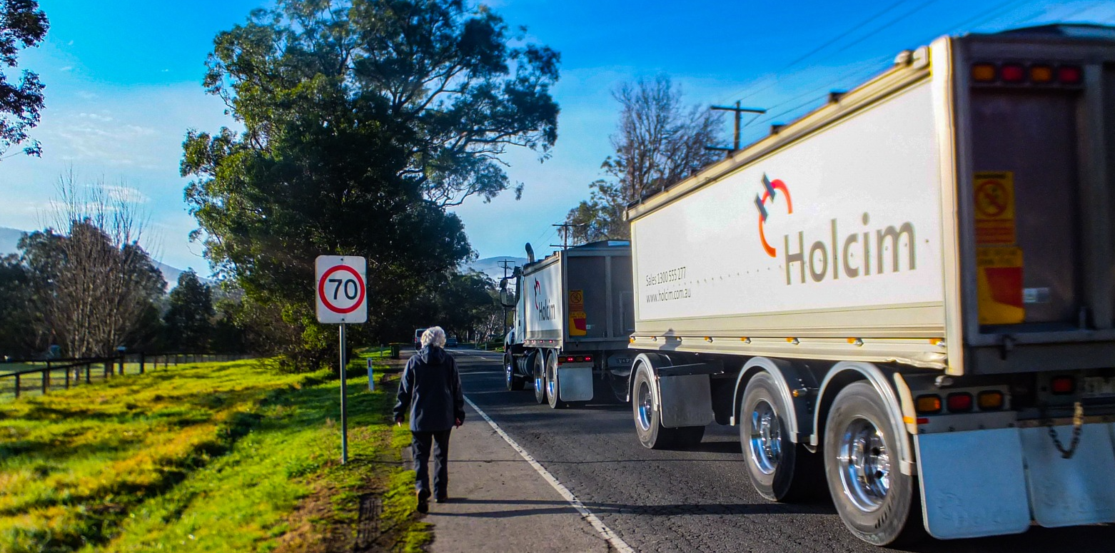
Photo of a pedestrian walking along the highway near a large truck passing by, submitted by a community member

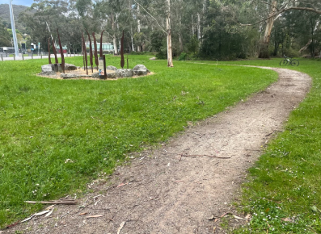
Photo of a path through a local park, submitted by a community member

What we heard

PRINCIPLE D: Future-oriented land use & development
Feedback has told us that the community of Yarra Junction:

Planning & development
- would like to see controlled development that does not exceed infrastructure upgrades and maintains the neighbourhood character.
- would like a review of current zoning to allow for controlled growth in housing and industry.
- have concerns with the reliability of power and communications in the area.
- are unhappy with the drainage system in the area and believe incidents of flooding are increasing due to developments in the area.

Housing
- are concerned about the affordability and diversity of housing in the area.
- Environmentally sustainable energies and developments are important to the community of Yarra Junction, who want to protect the natural environment around them.

Quotes from feedback
“Careful balance with developments - appreciating the character of the town”
“Rezone some of these big parcels of land to allow more housing”
“Regular power outages a problem - effecting my neighbour who has a pace maker”
“Generally drainage is a big problem – more subdivision = less capacity to manage heavy rains – LOTS of flooding issues in YJ”
“FIX THE DRAINS”
“Some more units and housing diversity needed”
“YJ used to be affordable, but families and single parents can't keep up with the increase in rents now.”
“Continued protection of environmental assets”

What we heard

PRINCIPLE E: Leadership & governance
Feedback has told us that the community of Yarra Junction:
- have suggestions on how Council could improve leadership and governance.
- see opportunities for development of communication and unity within the community.
- would like to see local businesses work together to improve community outcomes.

Quotes from feedback
“Change the classification of the area to Rural - we are not Urban.”
“Weed management needs to improve, especially around the water ways - DEWLP & Council need to work together.”
“Want to see better unity with clubs and increased township pride”

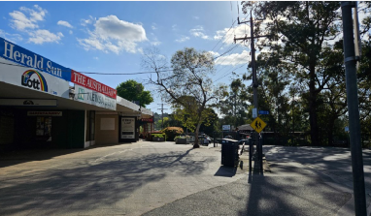
Photo of shops on main street, submitted by a community member

Glossary

Accessibility - The ease of reaching destinations. Highly accessible locations, enable a person, regardless of age, ability or income, to reach many activities or destinations quickly. People in places with low accessibility can reach fewer places in the same amount of time.
Activity centre - Activity centres are a focus for services, shopping, employment and social interaction. They are where people meet, relax, work and often live. Usually well-served by public transport, they range in size and mix of uses from local strip shopping centres to traditional town centres and major regional centres.
Aesthetic - Urban aesthetics refers to the way we perceive, asses and feel about towns and cities. This can include the buildings, the use of space, the overall population density. Urban aesthetics includes both the appearance (beauty) and the functionality (accessibility, services, etc.).
Affordable housing - Housing that is appropriate for the needs of a range of low to moderate income households, and priced so these households are able to meet their other essential basic living costs.
Collaboration – The action of working together to achieve something.
Community Infrastructure – Infrastructure provided in the public domain for community use, which is generally maintained by Council. This could range from facilities or parks through to park benches and bins.
Governance – The system by which something is controlled or operates, and the way in which authorities or people are responsible for something.
Land use - The purpose for which the land has been or is being or may be developed. The activity on the land.
Neighbourhood activity centres - Local centres that provide access to local goods, services and employment opportunities and serve the needs of the surrounding community.
Precinct - The designated area of a town highlighted due to similar land uses or defined by major edges including roads, rivers, or land uses.
Priorities – The things that are regarded as the most important.
Quality-of-life – A perception or measure of a community’s wellbeing in the context of the place that they live.
Stewardship – The job of supervising or taking care of something, in the context of Place Planning this may include working towards a shared vision established to achieve a thriving community.
Subdivision - The act of subdivision means the division of a land parcel into two or more parts. It is also a term used for the resulting pattern of blocks and lots, and streets.
Traffic calming - Devices, such as speed humps, installed in streets to slow or reduce vehicle traffic and improve safety for pedestrians and cyclists. These measures can slow cars speed to between 15 and 40km per hour.
Vision – Is a statement defining the future priorities for a township or place, it should be aspirational yet realistic. The vision sets a direction, outlining goals and priorities to be worked towards over time.
Walkability - Walking environments that best balance safety, connection, accessibility and enjoyment.

Australian Bureau of Statistics (2023). Socio-Economic Indexes for Areas (SEIFA), Australia. https://www.abs.gov.au/statistics/people/people-and-communities/socio-economic-indexes-areas-seifa-australia/2021

